Necessary Changes on V1.0 Board

# Drain and Soruce of Q201 are reversed

1. Desolder Q201
2. Cut the traces as shown by the red marks in the following image: 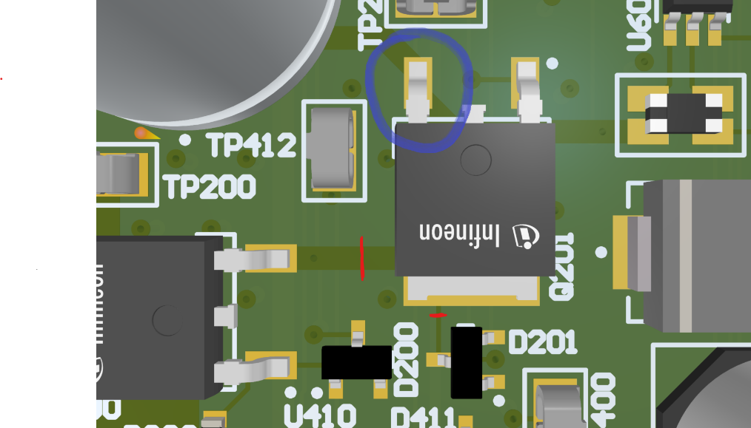
3. Straighten the leg of Q201 that is marked blue. Q201 has to be desoldered for this! Use flat pliers and just hold down on the leg, not at the case. Otherwise you will damage the transistor.
4. Use a piece of desoldering braid or something similar to connect the two pads of Q201 as shown below:  
   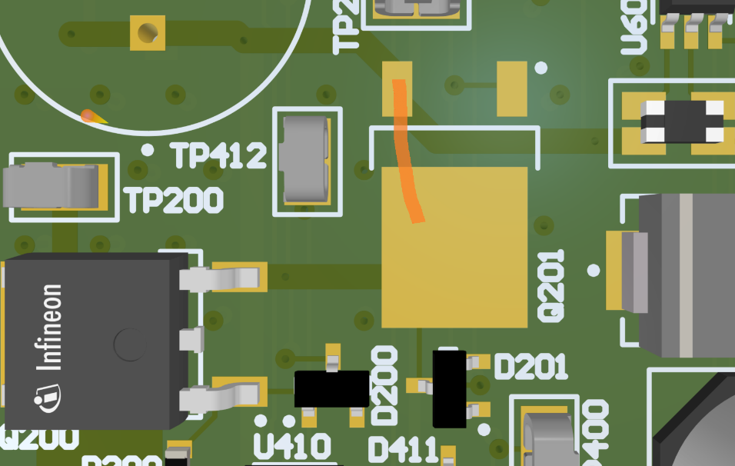
5. Now resolder Q201 (just on the two pads, the bent pin is left open)
6. Now use some thick copper wire to connect the bent leg of Q201 (not the pad below) and Q200 as shown below and finally some thin copper wire to connect Q201 to the Diode D201:  
   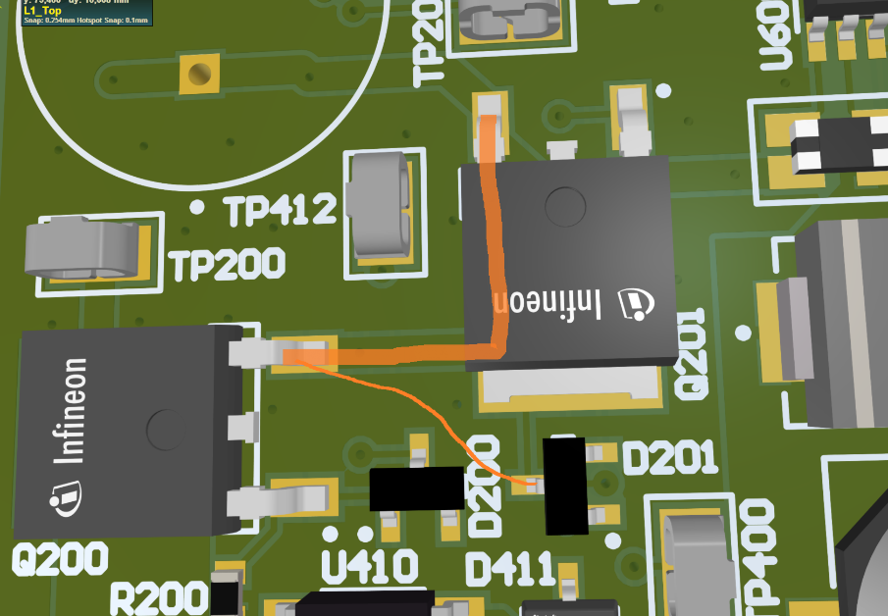

# Arduino powers logic supply through its Vin

Cut the trace in the shown location (red). Scrape off solder mask on both sides and solder the diode in place as shown. I used an MBR120ESFT1G (20V, 1A Schottky). But the diode can also be soldered somewhere else between Arduino 12V and Board 12V.

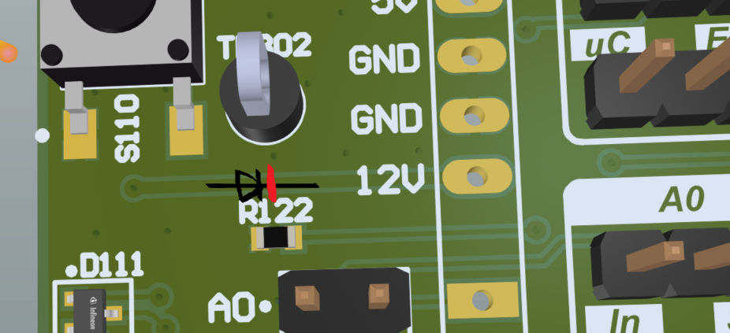

# Floating Boost_Cntrl

Rotate R123 90° and then connect its left leg to the center pin of the Boost Cntrl Header (run wire to the back side of the PCB)  
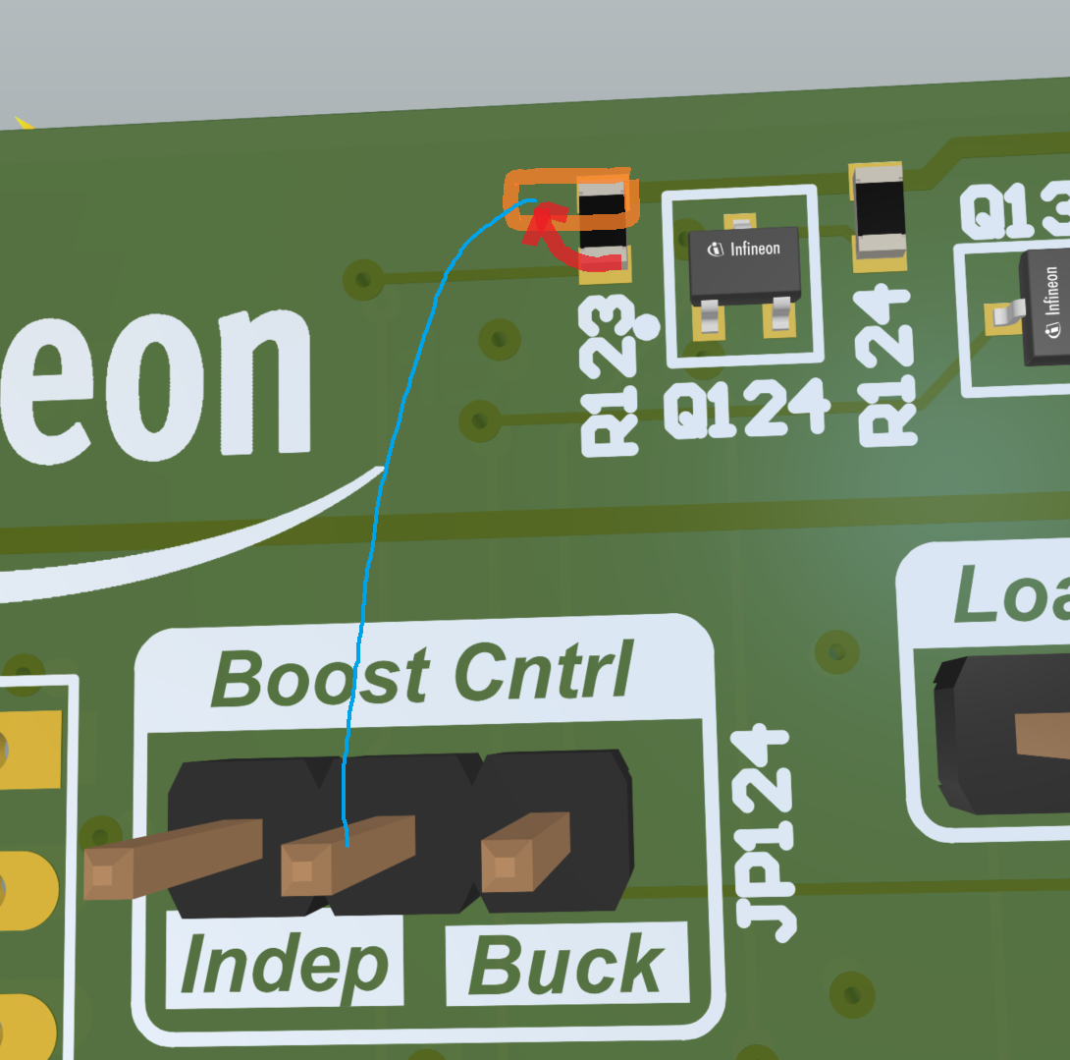

# Arduino powers logic supply through gate drivers

1. Option 1:
   1. Desolder U400 and U430
   2. Straighten Pin 1 or bend slightly upwards
   3. Resolder U400 and U430
   4. Insert a 4k7 resistor between Pin 1 and the pad below
2. Option 2:
   1. Cut the trace on the back, scrape off solder mask and insert 4k7 resistor (the banana plugs are the top ones)  
      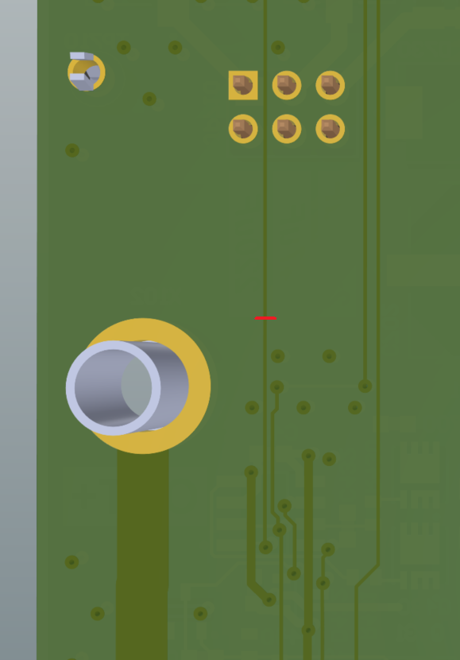 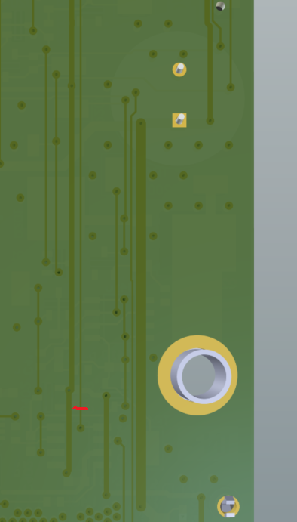
3. Add clamping diodes as shown below (make sure to use diodes with low leakage current and low capacitance)  
   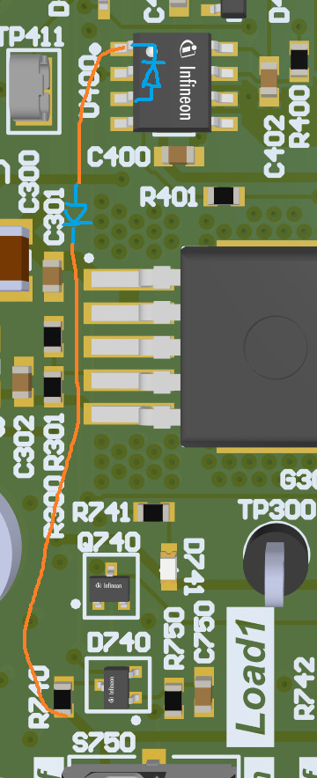   
     
   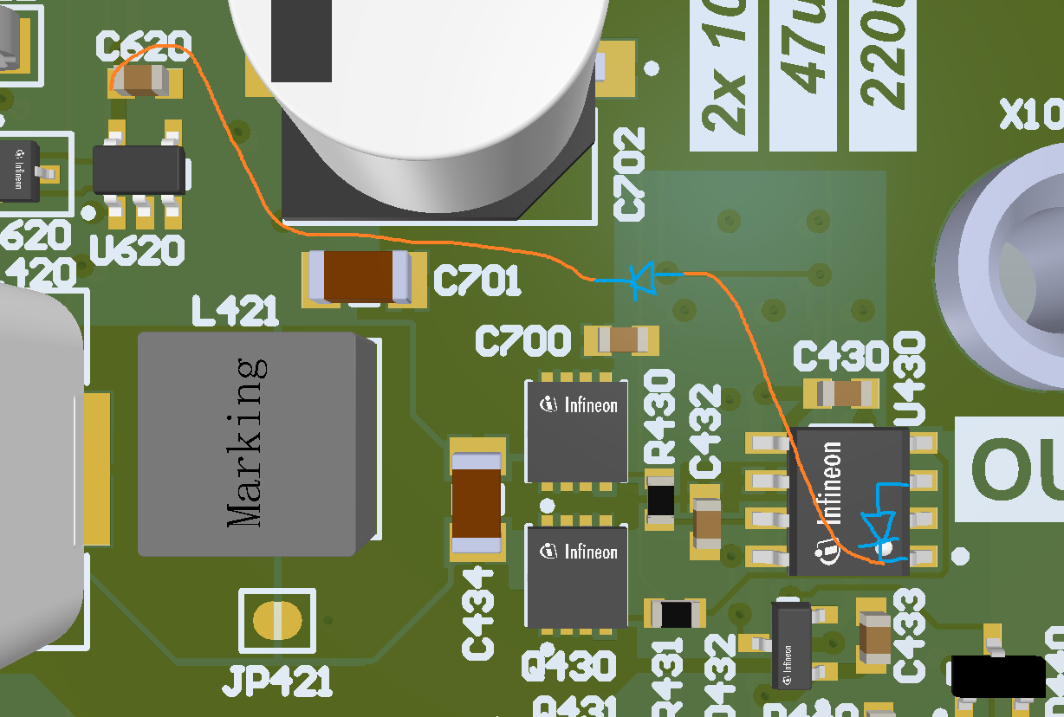

# Boost shutdown

Cut the trace going to D440 as shown. Add the clamping 15V Zener diode on top of U430. Then add the two diodes: VB->D440 and 12V->D440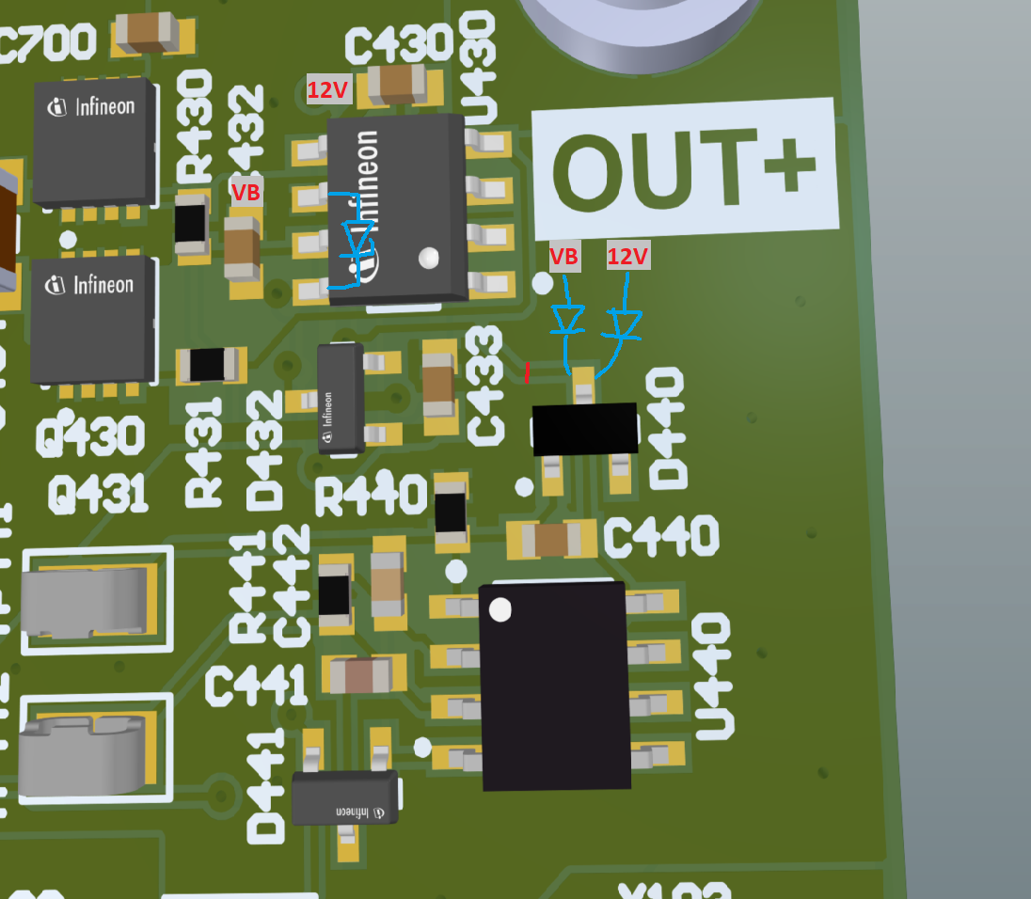

# Change Vcc of U500 to 12V

Cut the trace on the back side of the board: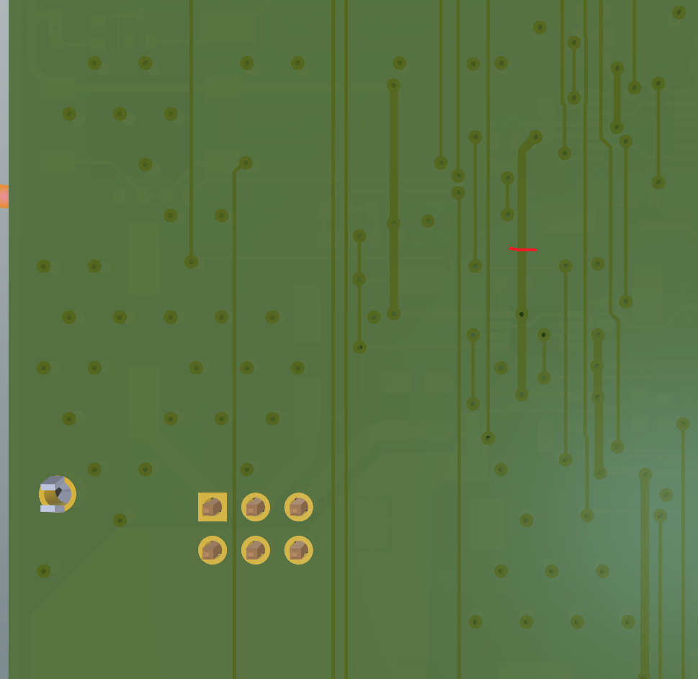  
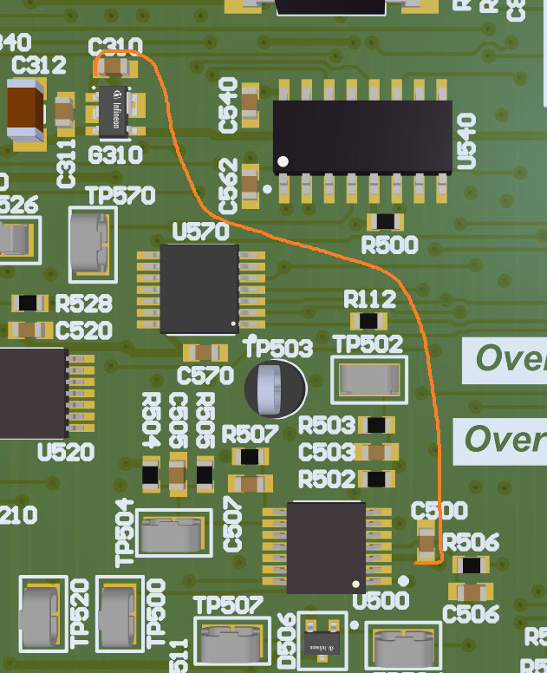

Rotate R502 180° and connect to D506