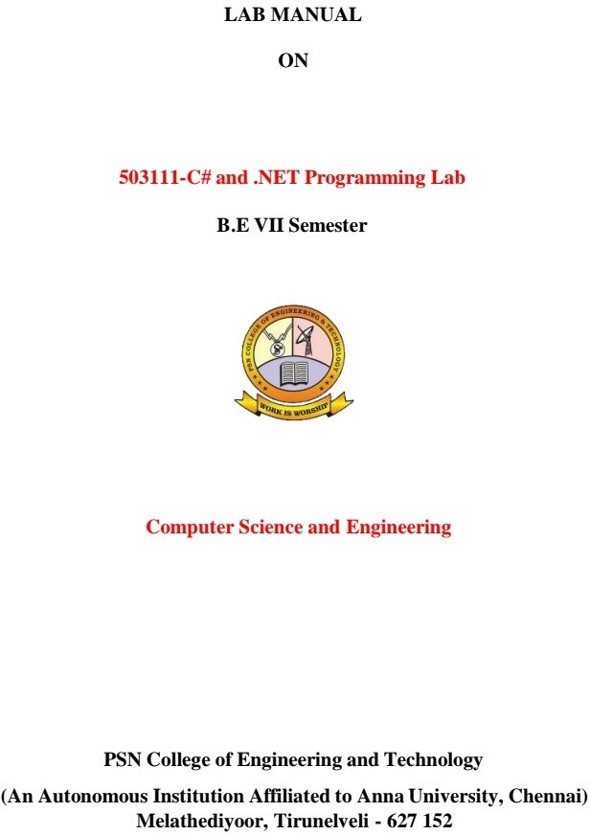



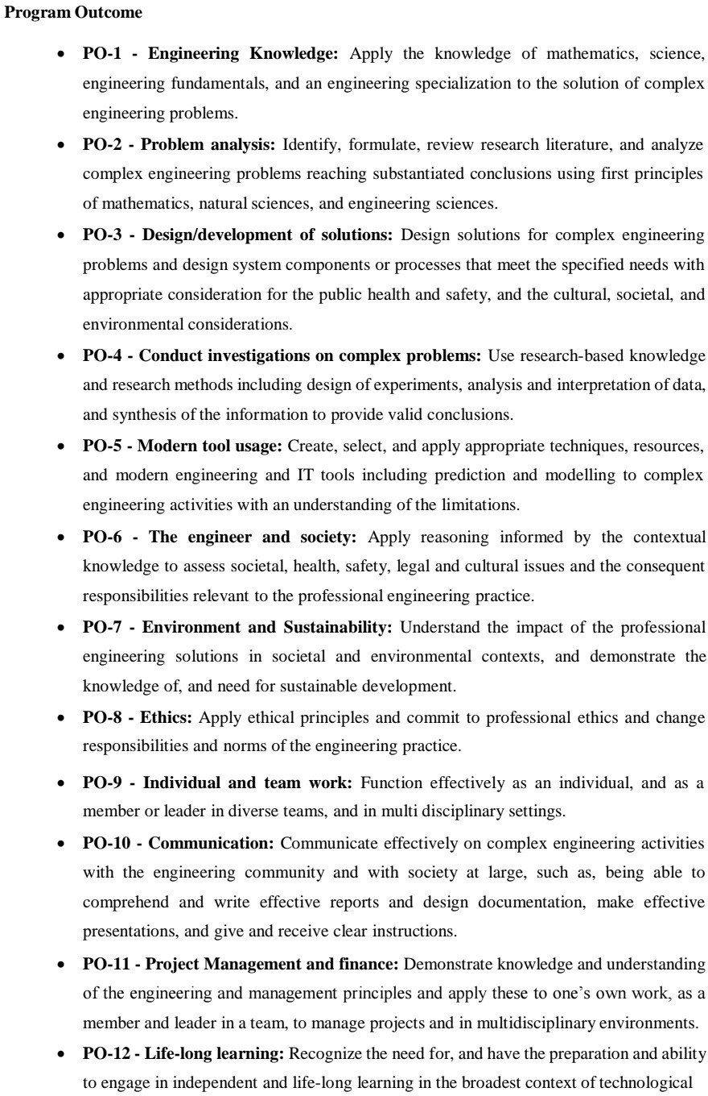

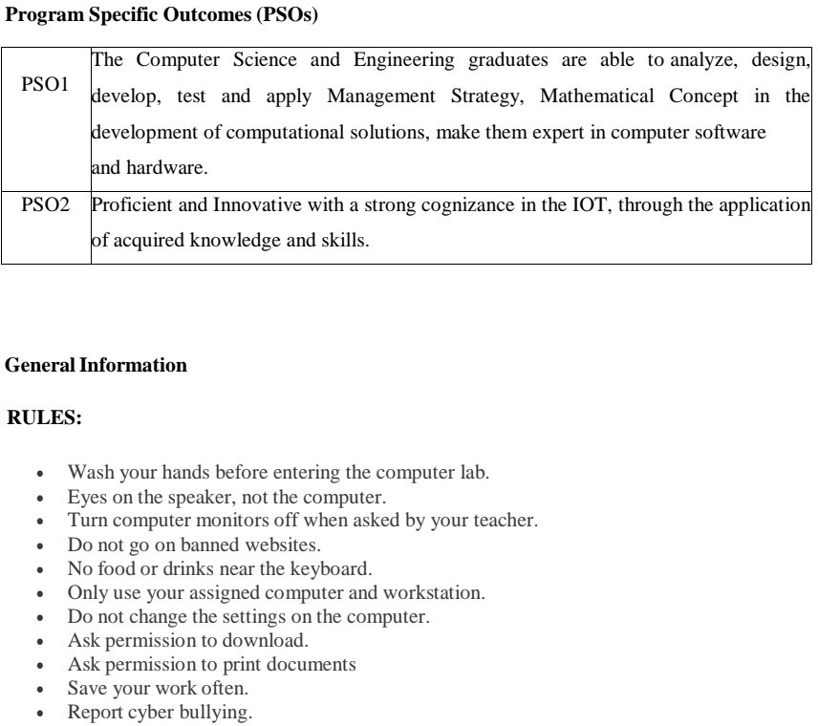

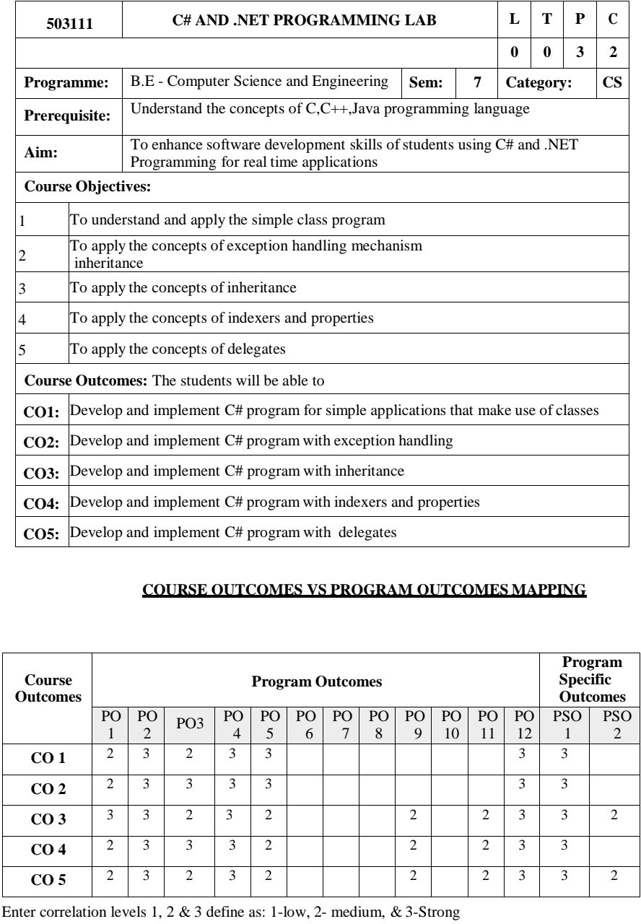

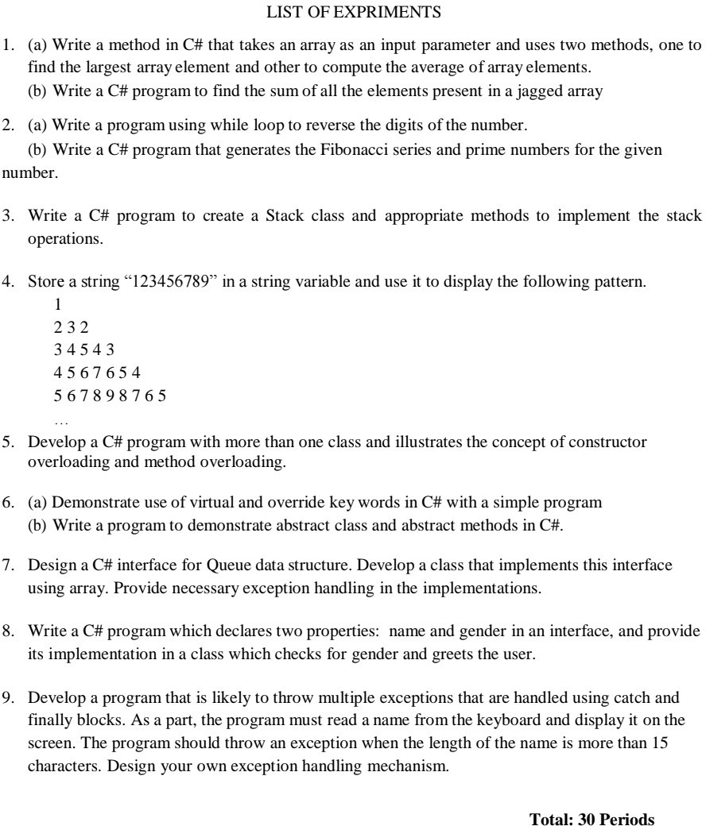

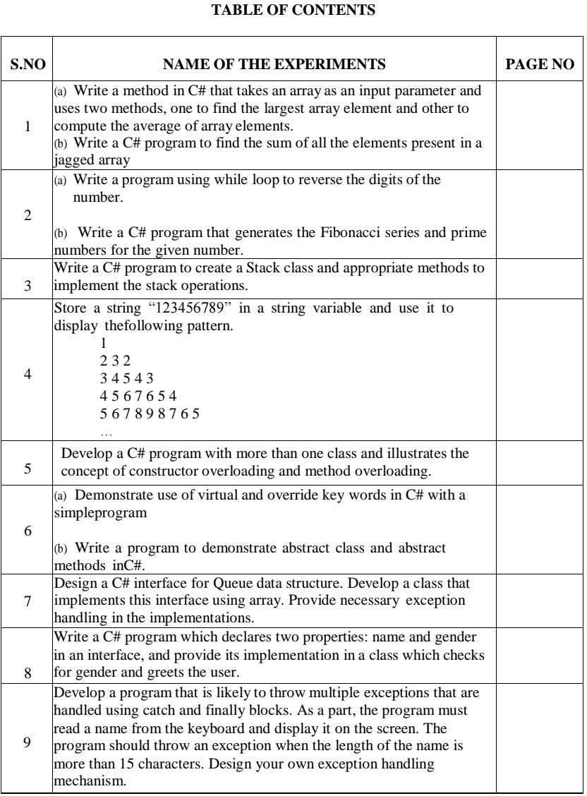

1. (a) Write a method in C# that takes an array as an input parameter and uses two methods, one to find the largest array element and other to compute the average of array elements.

Aim :

To write a method in C# that takes an array as an input parameter and uses two methods, one to find the largest array element and other to compute the average of array elements.

Algorithm :

1. Start Program
2. Declare the necessary variables.
3. This program takes n number of elements from the user and stores it in the arr array. To find the largest element,
4. the first two elements of array are checked and the largest of these two elements are placed in arr[0]
5. The first and third elements are checked and largest of these two elements is placed in arr[0]. This process continues until the first and last elements are checked
6. The largest number will be stored in the arr[0] position
7. Declare new variable sum as 0 and add elements in the array and store in sum
8. divide sum by total number of elements in array
9. return the results and print the result.

Program :

**using System;**

**namespace CS1A**

**{**

**class ArrayLargest**

**{**

**int large(int[] a, int n)**

**{**

**int large = a[0];**

**for (int i = 1; i < n; i++)**

**{**

**if (a[i] > large)**

**large = a[i];**

**}**

**return large;**

**}**

**float avg(int[] a, int n)**

**{**

**float avg = 0;**

**for (int i = 0; i < n; i++)**

**avg += a[i];**

**avg /= n;**

**return avg;**

**}**

**public static void Main()**

**{**

**ArrayLargest obj = new ArrayLargest();**

**int n;**

**float large, avg;**

**int[] a = new int[50];**

**Console.Write("Enter the size of Array : ");**

**string s, s1;**

**s = Console.ReadLine();**

**n = Int32.Parse(s);**

**Console.WriteLine("Enter the array elements");**

**for (int i = 0; i < n; i++)**

**{**

**s1 = Console.ReadLine();**

**a[i] = Int32.Parse(s1);**

**}**

**Console.Write("");**

**large = obj.large(a, n);**

**avg = obj.avg(a, n);**

**Console.WriteLine("Largest element in the given array is {0}", large);**

**Console.WriteLine("Average of elements in the given array is {0}", avg);**

**}**

**}**

**}**

**Output :**

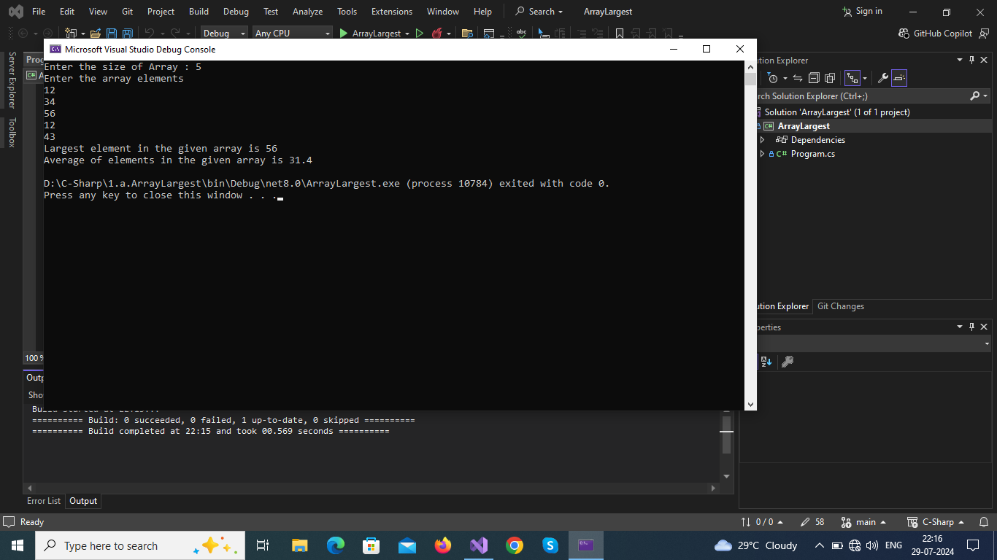

**Result :**

Thus the program executed successfully and ouput was verified.

1. (b) Write a C# program to find the sum of all the elements present in a jagged array

Aim:

To write a C# program to find the sum of all the elements present in a jagged array

Algorithm:

1. Start Program
2. Jagged Array : Collection of array is known with different size is known as jagged arraay
3. Each element of an array is accessed by a subscript operator([]).
4. Similiarly in jagged array each array is a element of jagged array and each array elements accessed by 2D accessing(ja[array_index][array_element_index])
5. Declaration of jagged array:

Syntax

data_type[][] variable_name = new data_type[Size_of_jagged_array][]

1. Traverse over each elements of each array in jagged array add each of them together and store them in variable (eg;sum+=jagged_array[i][j])
2. Print value of sum
3. Stop program

Program:

using System;

namespace CS1B

{

public class SumOfElementsInJaggedArray

{

static void Main(string[] args)

{

int sum = 0;

int n, val, k;

Console.Write("Enter How Many Arrays in Jagged Array : ");

n = Convert.ToInt32(Console.ReadLine());

int[][] jagged_array = new int[n][];

for (int i = 0; i < jagged_array.Length; i++)

{

Console.Write("\nEnter How Many Elements in ({0}) - Array in Jagged Array : ", i + 1);

k = Convert.ToInt32(Console.ReadLine());

jagged_array[i] = new int[k];

}

for (int i = 0; i < jagged_array.Length; i++)

{

Console.WriteLine("\nEnter Elements of ({0}) - Array in Jagged Array ", i + 1);

for (int j = 0; j < jagged_array[i].Length; j++)

{

Console.Write(" Enter Element {0} : ", j + 1);

jagged_array[i][j] = Int32.Parse(Console.ReadLine());

}

}

for (int i = 0; i < jagged_array.Length; i++)

{

val = 0;

for (int j = 0; j < jagged_array[i].Length; j++)

{

val += jagged_array[i][j];

}

Console.WriteLine("\nThe Sum of array ({0}) = {1}", i + 1, val);

sum += val;

}

Console.WriteLine("\nThe Sum of Elements in Jagged Array is {0} \n", sum);

}

}

}

Output:

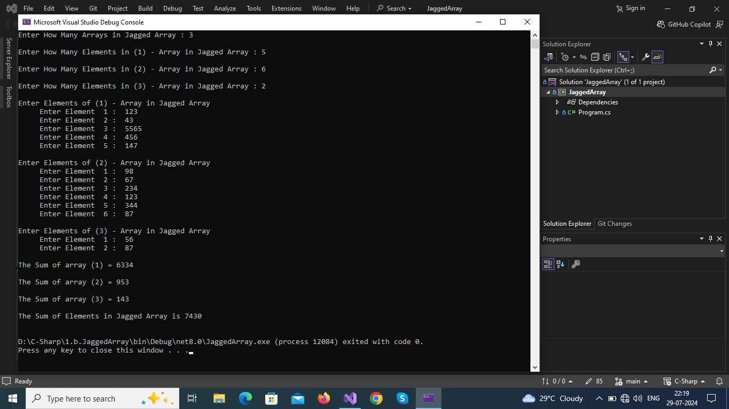

**Result :**

Thus the program executed successfully and ouput was verified.

(a) Write a program using while loop to reverse the digits of the

number.

(b) Write a C# program that generates the Fibonacci series and prime numbers for the given number.

Write a C# program to create a Stack class and appropriate methods to implement the stack operations.

Store a string "123456789" in a string variable and use it to display thefollowing pattern.

1

232

4

34543

5

6

7

8

9

4567654

567898765

Develop a C# program with more than one class and illustrates the concept of constructor overloading and method overloading.

(a) Demonstrate use of virtual and override key words in C# with a simpleprogram

(b) Write a program to demonstrate abstract class and abstract methods inC#.

Design a C# interface for Queue data structure. Develop a class that implements this interface using array. Provide necessary exception handling in the implementations.

Write a C# program which declares two properties: name and gender in an interface, and provide its implementation in a class which checks for gender and greets the user.

Develop a program that is likely to throw multiple exceptions that are handled using catch and finally blocks. As a part, the program must read a name from the keyboard and display it on the screen. The program should throw an exception when the length of the name is more than 15 characters. Design your own exception handling mechanism.

PAGE NO

