Q1.

a) pi+1 should also send a heartbeat every T seconds to pi, with process p1 sending a heartbeat to pn. The bandwidth cost would become twice of the original because in the new detection scheme twice of the heartbeats are sent.

b) The timeout should be set to T+Δ for each process

The maximum detection time should be n\*(T+Δ) + Δ for n process in total

c) We can set a token like “Pi+1 Crashed” to be sent by the process pi to pi+2 when the pi does not receive a heartbeat after the timeout. Since the process pi+1 crashed, we need to skip it to the next process pi+2 to ensure the failure detection could be normally established again. Therefore if pi could receive the token later from pi+2, it means that we could figure out that the identity failed process pi+1 could be discovered.

Q2.

1. 1.01\*(T+Δ)
2. Δ+1.01\*(T+Δ)
3. RTT/2 + 0.01 \* T = Tsyn, where RTT = 20, Tsyn = 100

By calculation we get T = 9\*10e3 ms

Q3.

1. We could consider to establish a spanning tree with minimum diameter to minimize the worst-case skew, where RRT serves as the total distance among the servers. RTT can be calculated by the tree weight.

5

10

5

10

By the figure above, we can find that the server could synchronize with ABED with the order of C -> A -> B -> E -> D, the largest distance is 5+5+10+10=30 with the tree weight is also 30, the worst-case skew should be RTT/2 = 15

Another solution is shown as follows, the node A is served as the root node of the tree, A is synchronized with B, C, D, E. The largest distance is 5+10+15=30 with the tree weight is 5+10+15+5=35, the worst-case skew should be RTT/2 = 15

5

10

5

15

In all, the worst case skew is 15

1. Assume t=(t1, t2, t3, t4, t5, t6) represent the one-way transmission time array among the messages. According to the figure of the question, we can get

t1+t2=(25-10)-(18-12) = 9, t1,t2<=9

t1+t4=(37-10)-(29-12) = 10, t1,t4<=10

t1+t6=(56-10)-(45-12) = 13, t1,t2<=13

t2+t3=(23-18)-(27-25) = 3, t2,t3<=3

t2+t5=(40-18)-(39-25) = 8, t2,t5<=8

t3+t4=(37-27)-(29-23) = 4, t3,t4<=4

t3+t6=(56-27)-(45-23) = 7, t3,t6<=7

t4+t5=(40-29)-(39-37) = 9, t4,t5<=9

t5+t6=(56-39)-(45-40) = 12, t5,t6<=12

By the equations above we get the upper bound:

t1<=9, t2<=3, t3<=3, t4<=4, t5<=8, t6<=7

1. According to part a)

The maximum skew between A and B is 20+10+25+5=60

The minimum skew between A and B is 10

Assume tα is the time skew difference between A and B, time(A) = time(B) - tα

According to part b) we know

12–10 = t1+tα

25-18 = t2+tα

27-23 = t3+tα

37-29 = t4+tα

40-39 = t5+tα

56-45 = t6+tα

By the upper bound of t we can know 4<=tα<=7, to minimize the skew we can get

4-(4+7)/2<=tα<=7-(4+7)/2

-1.5<=tα<=1.5, with the time we change is (4+7)/2=5.5

Q4

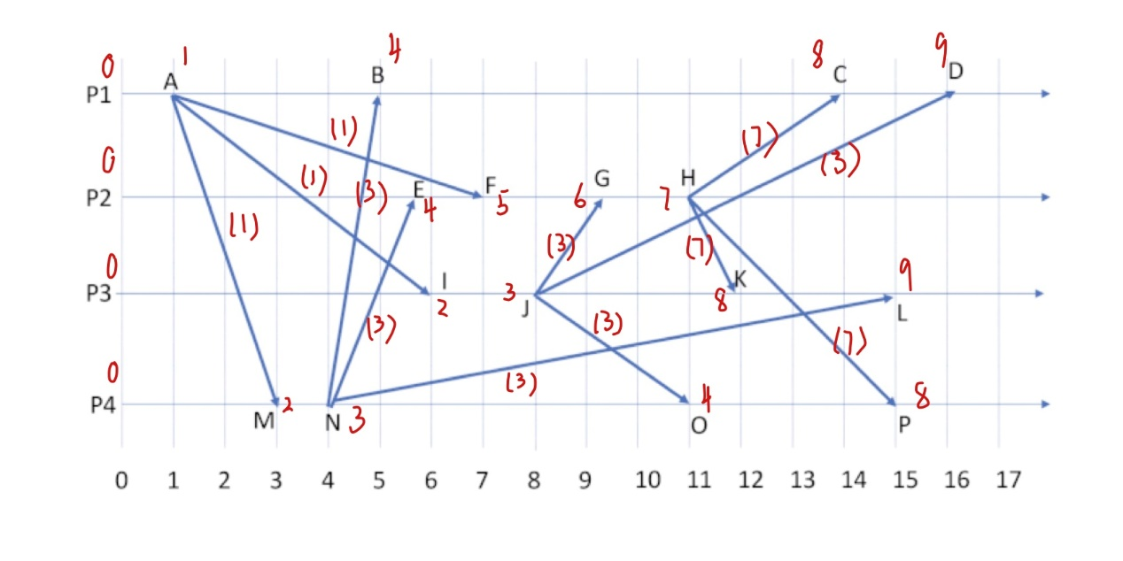a)

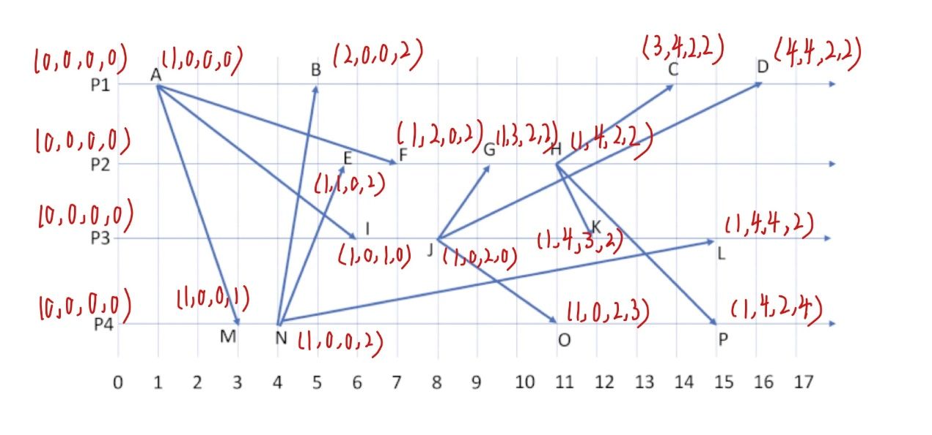b)

c) i) C||K, C||L, C||O, C||P

ii) I||B, I||M, I||N, I||E, I||F

iii) O||G, O||H, O||K, O||L, O||C, O||D, O||B, O||E, O||F

Q5

1) B,F,J,N

2) B,F,J,O

3) B,G,J,N

4) B,G,J,O

5) B,H,J,N

6) B,H,J,O

7) B,H,J,P

8) C,H,J,P

9) D,H,J,P

The possible consistent cuts that satisfied the requirement are listed as above.