MP3 Report

Course: ECE448-LE1

Team: Yuhang Chen

Jiakai Lin

Wenbo Ye

Date: Apr. 24th, 2023

**Section I: Image Classification**

Report average classification rate, the classification rate for each class and the confusion matrix. For each class, show the test examples from that class that have the highest and

lowest posterior probabilities according to your classifier. Show the ten visualization plots both feature likelihoods.

**Section II:** **Text Classification**

Text Classification. Report all your results, confusion matrix, recall, precision, F1 score for all the 14 classes. Include the top feature words for each of the classes. Also, report the change in accuracy results when the class prior changes to uniform distribution and when its removed. Provide the reasoning for these observations

**Section III:**

In part 3, we use sigmoid function as the logistic regression function. And we design the Loss function L(w) as the

$$L\left(w\right)=ln⁡(P\left(total\right)=ln(\prod_{n=1}^{N}{p^{y_{n}}{\left(1-p\right)}^{1-y_{n}})}$$

where, $p= \frac{1}{1+e^{-w^{T}x}}$

And we use Gradient Descent Method(GD) to get the parameter w by updating the w in iteration. The gradient is defined as:

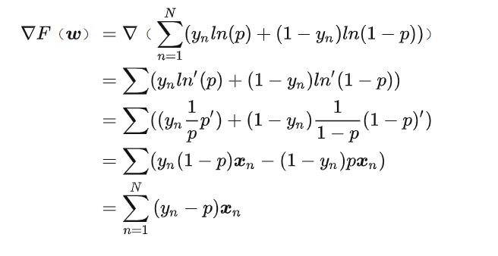

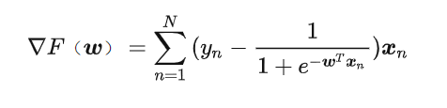Substituting sigmoid function to the above equation, we get:

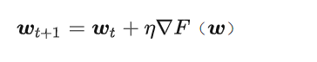By using $η$ = 1/iteration_num as the learning rate, we get the updated w by the iteration:

The testing results are shown in the following figures:

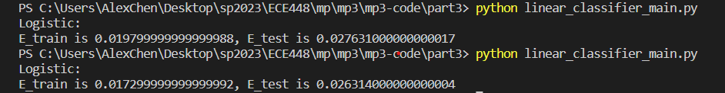

Figure 3.1. The error of Train and Test of Logistic Regression in Test1&Test2



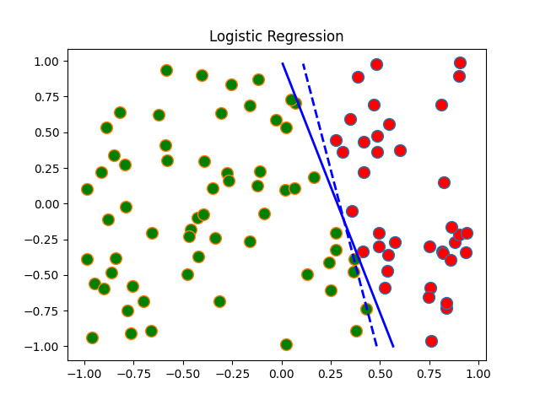

Figure 3.1. The Running Result Plot of Logistic Regression Test 1

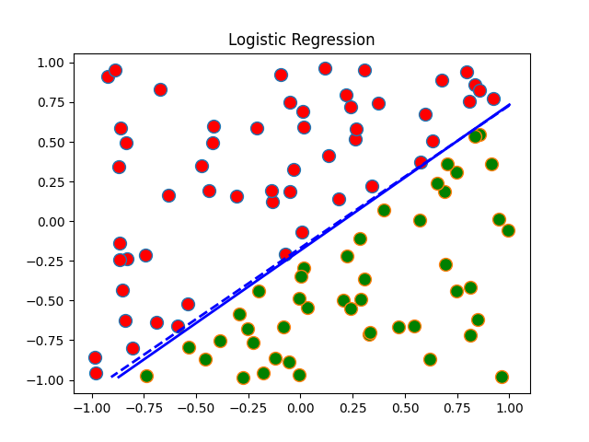

Figure 3.2. The Running Result Plot of Logistic Regression Test 2

**Extra Credit:**

If you have done any work which you think should get extra credit, describe it here

**Statement of Contribution:**

###Wenbo mainly implemented the evaluatePredifined function, including three predefined rules. These algorithms have been understood by all team members.

And he was also responsible for the checkMovesLeft function, the checkWinner function, the alphabeta function and the minimax function. Firstly, he debugs himself, and then everyone debugs together.

###Jiakai mainly implemented the playGamePredifinedAgent function, the playGameYourAgent function, and the playGameHuman function. The test function was mainly written by Jiakai and Yuhang, and all team members participated in testing our agent.

Yuhang mainly implement the algorithm and do the programing for part 3. Yuhang’ code is debugged by himself and tested well, so his code for part 3 is submitted.

The report of Section III is written by Yuhang.

The extra credit part was implemented by all three of us.