1. Andre Christian Manghi

MORNING ATTENDANCE

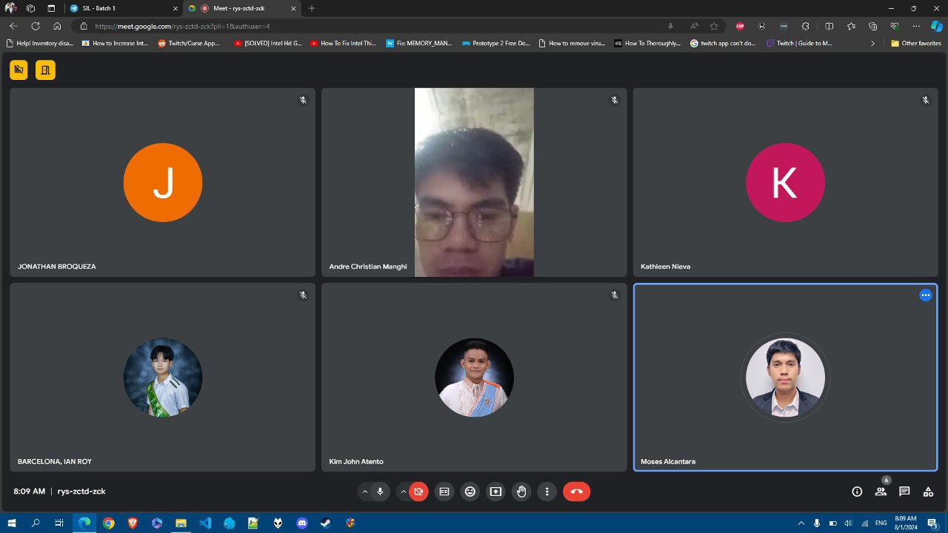

AFTERNOON MEETING – PROGRESS REPORT (INVENTORY MANAGEMENT SYSTEM)

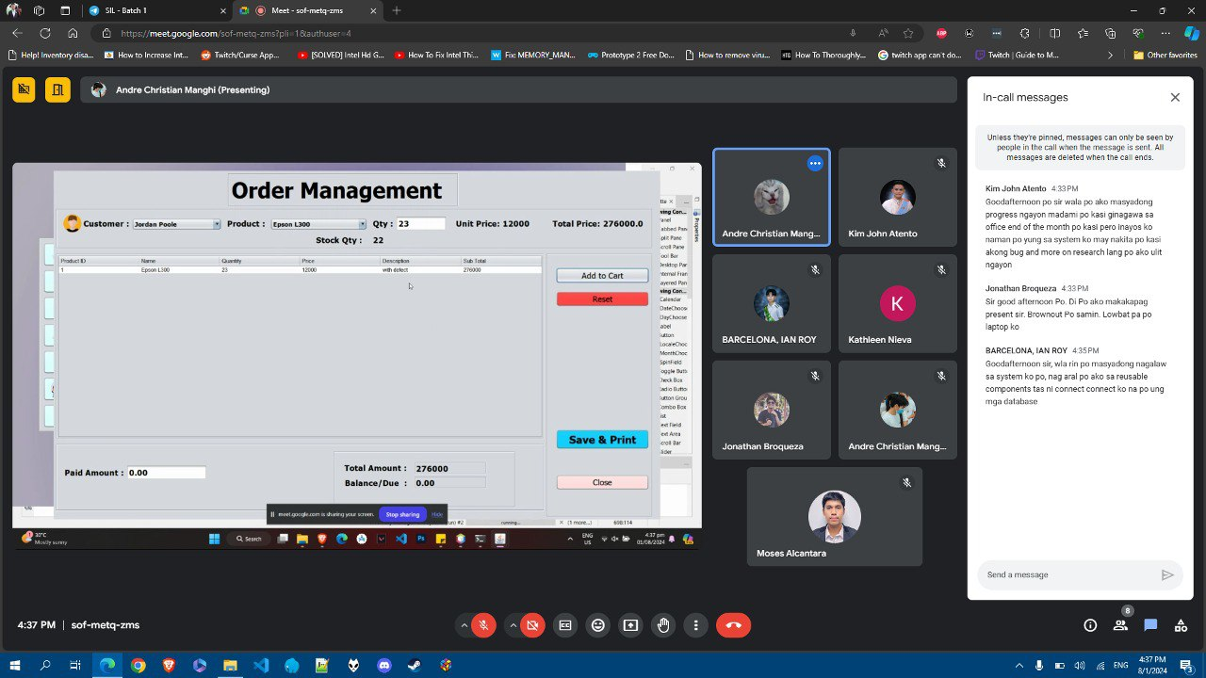

Update: Fixed Errors in the Cart Page

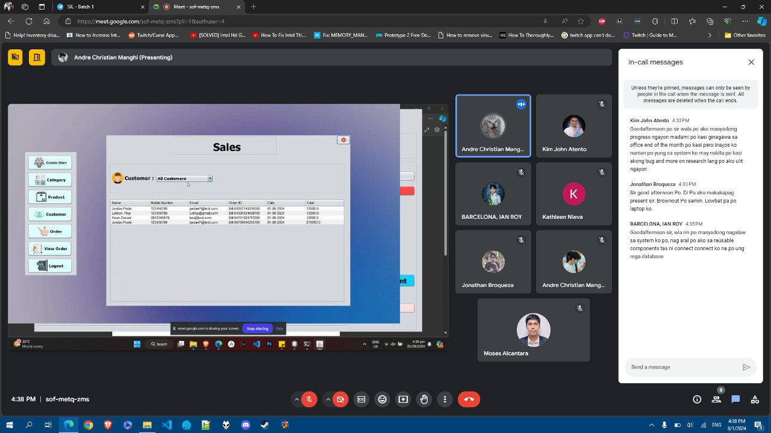

Update: Started the Sales Page

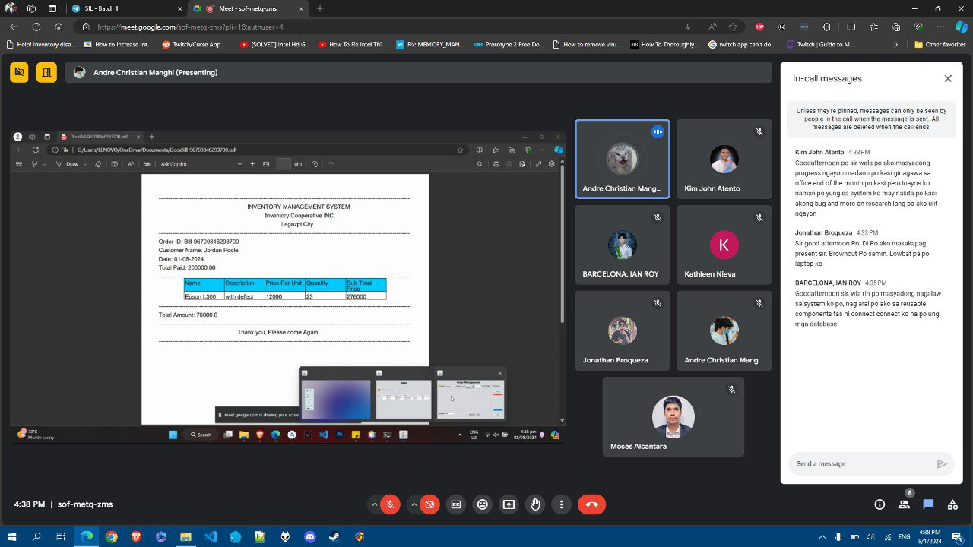

Update: Started the Export Receipt Function

AFTERNOON ATTENDANCE

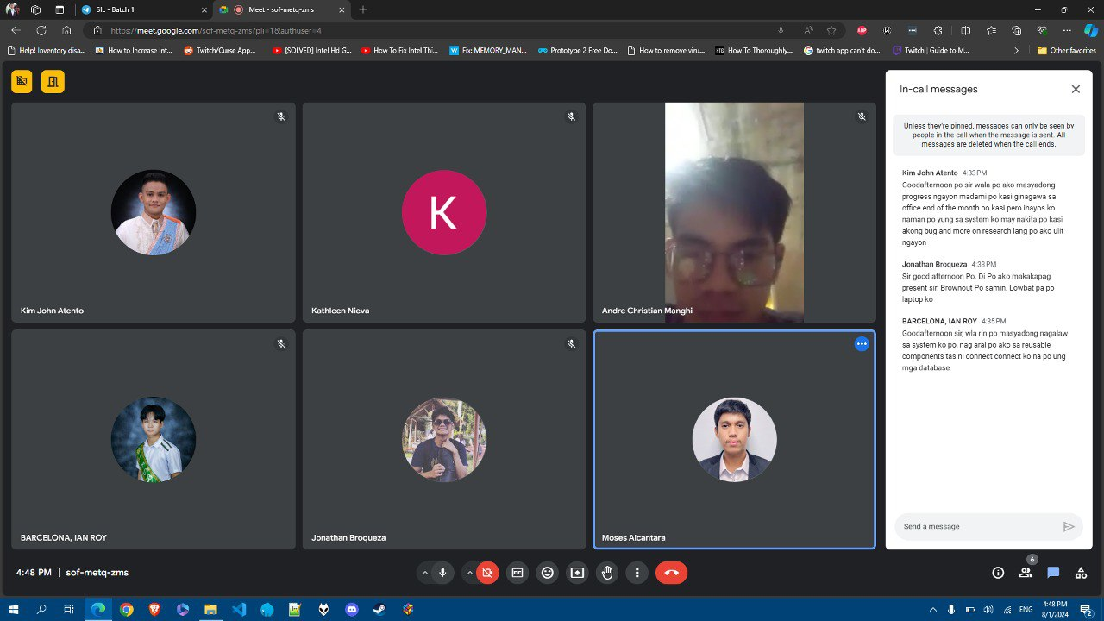

1. Ian Roy Barcelona

MORNING ATTENDANCE

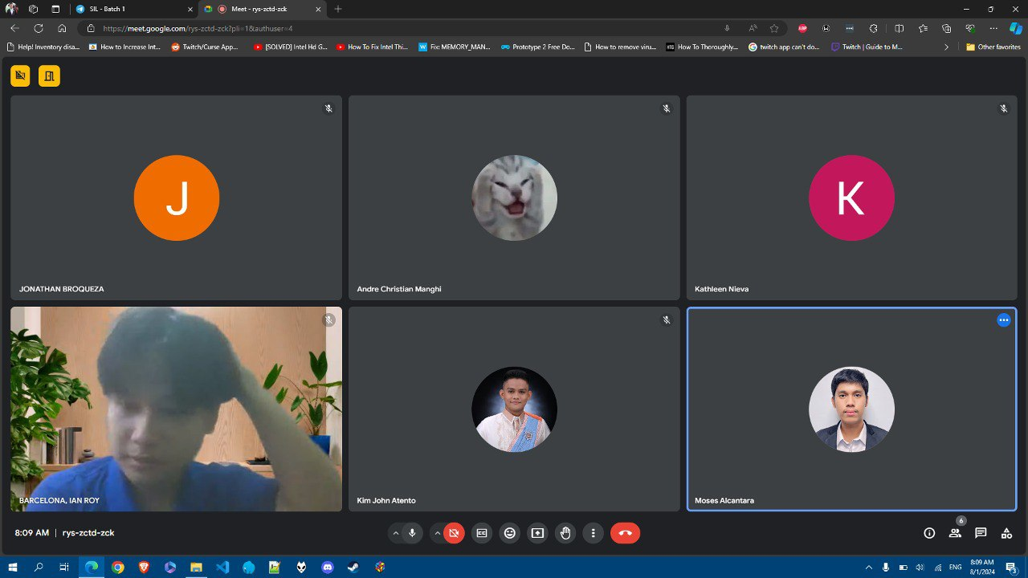

AFTERNOON MEETING – PROGRESS REPORT (ORDERING MANAGEMENT SYSTEM)

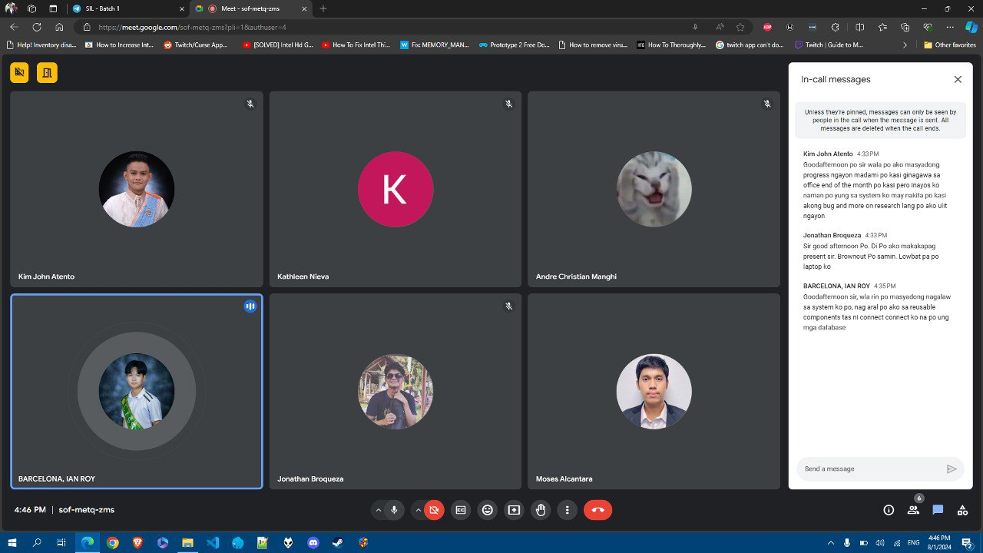

Update: Researched and Practiced Reusable Components

AFTERNOON ATTENDANCE

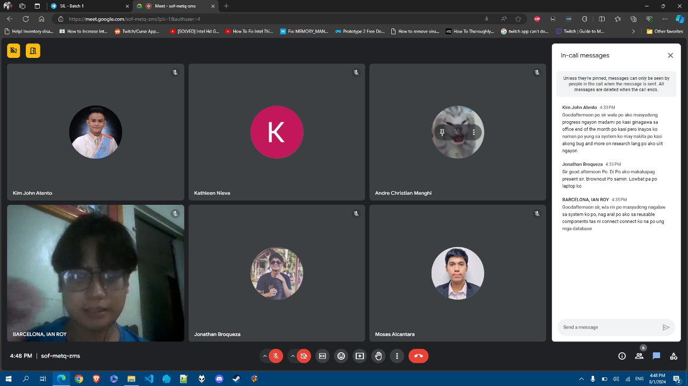

1. Jonathan Broqueza

MORNING ATTENDANCE

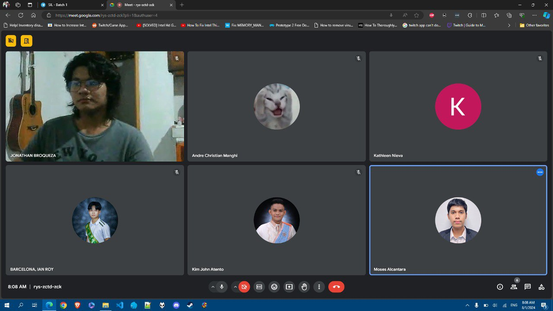

AFTERNOON MEETING – PROGRESS REPORT (HOTEL RESERVATION SYSTEM)

Note: Jonathan could not present his progress because of a power outage.

AFTERNOON ATTENDANCE

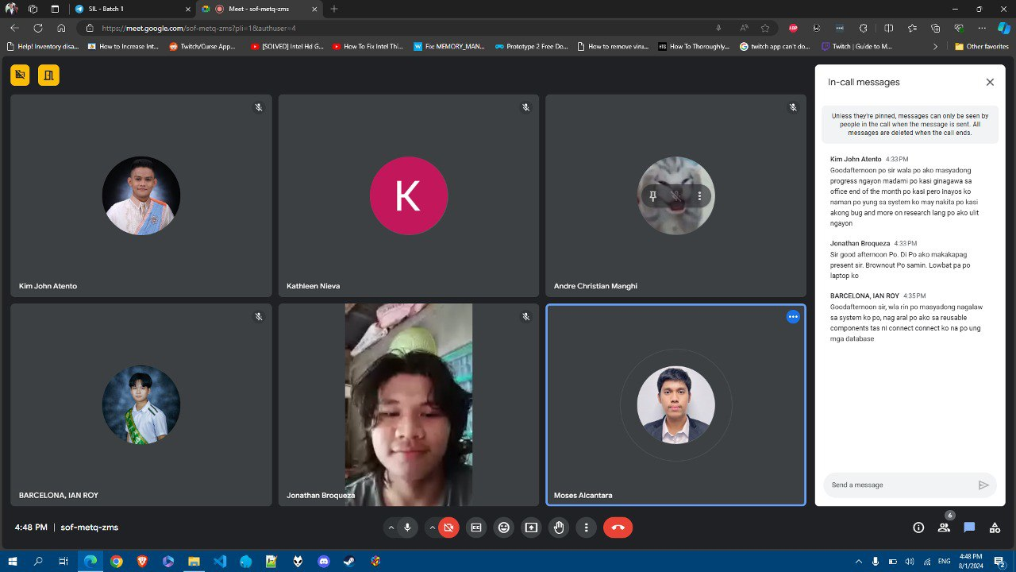

1. Kathleen Nieva

MORNING ATTENDANCE

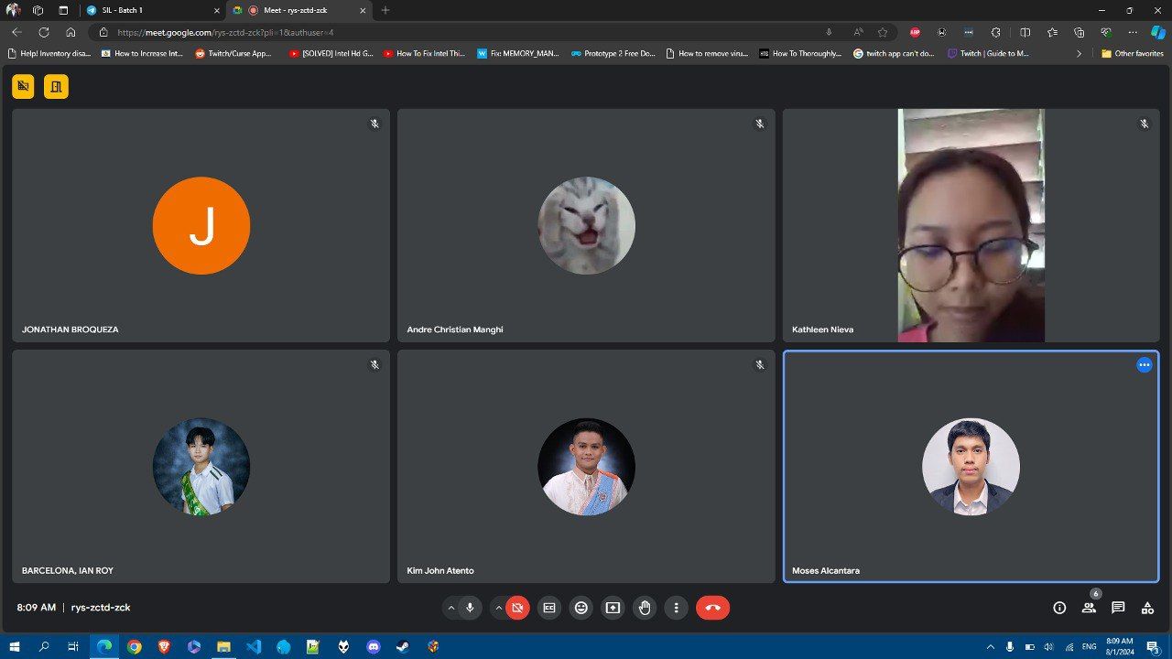

AFTERNOON MEETING – PROGRESS REPORT (REAL ESTATE WEBSITE)

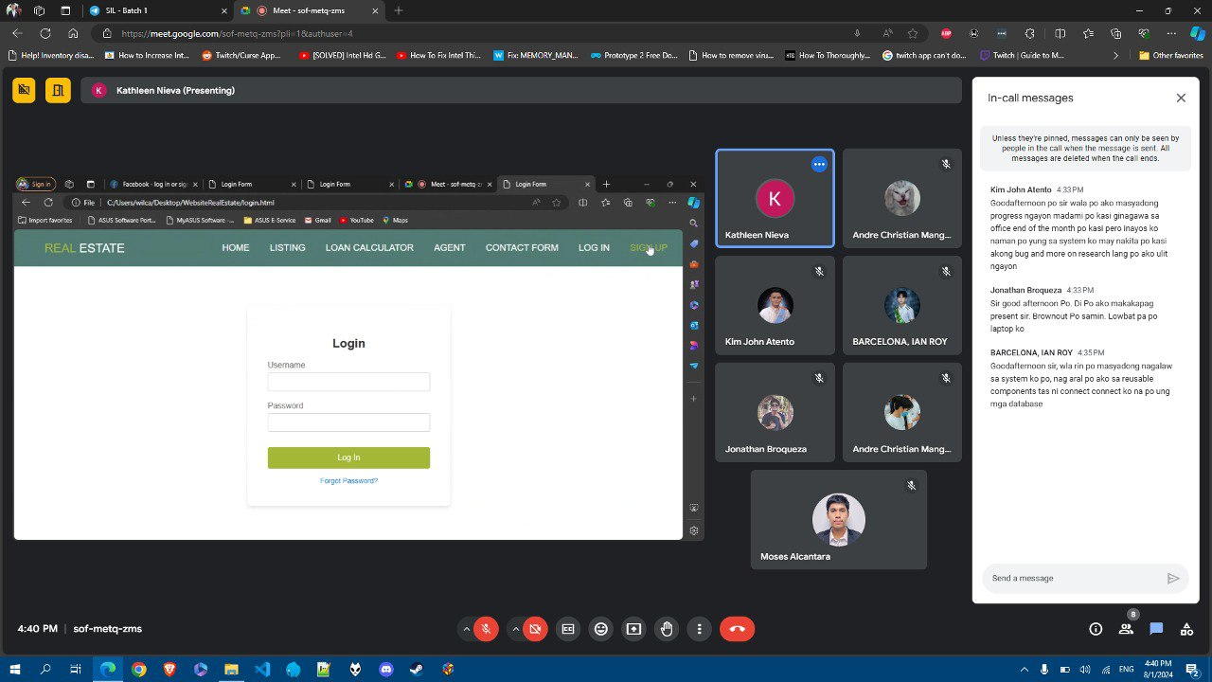

Update: Started the Login Form

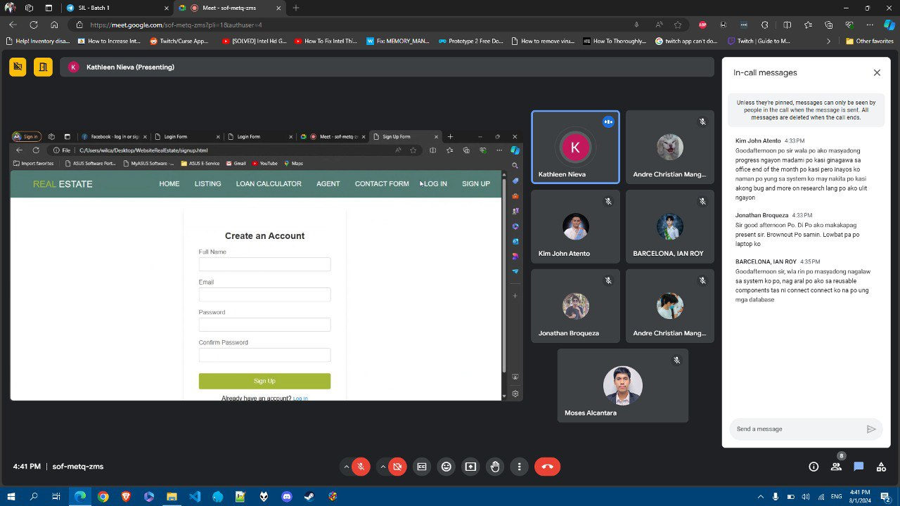

Update: Started the Sign Up Form

AFTERNOON ATTENDANCE

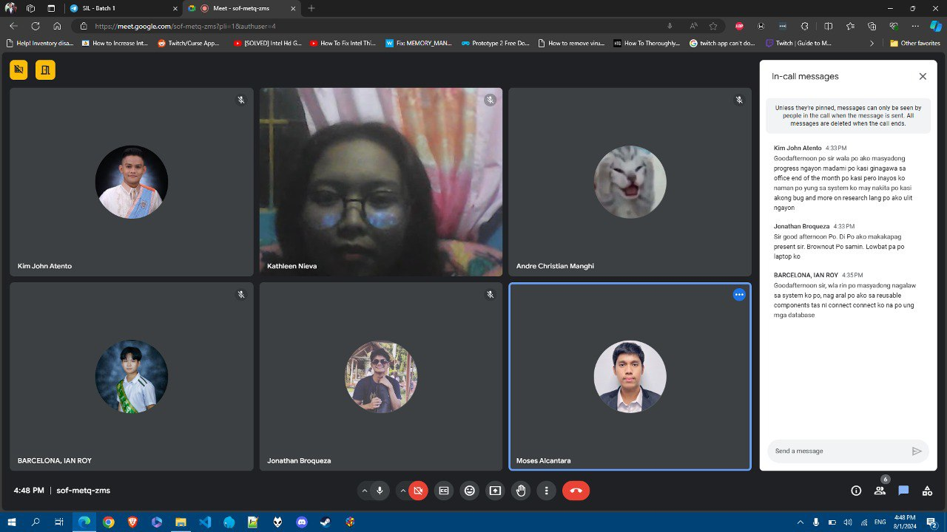

1. Kim John Atento

MORNING ATTENDANCE

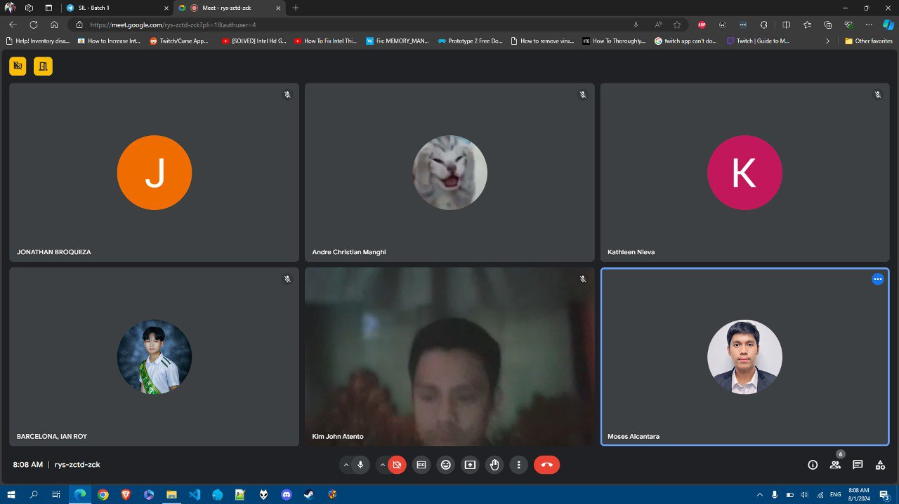

AFTERNOON MEETING – PROGRESS REPORT (FILE MANAGEMENT SYSTEM)

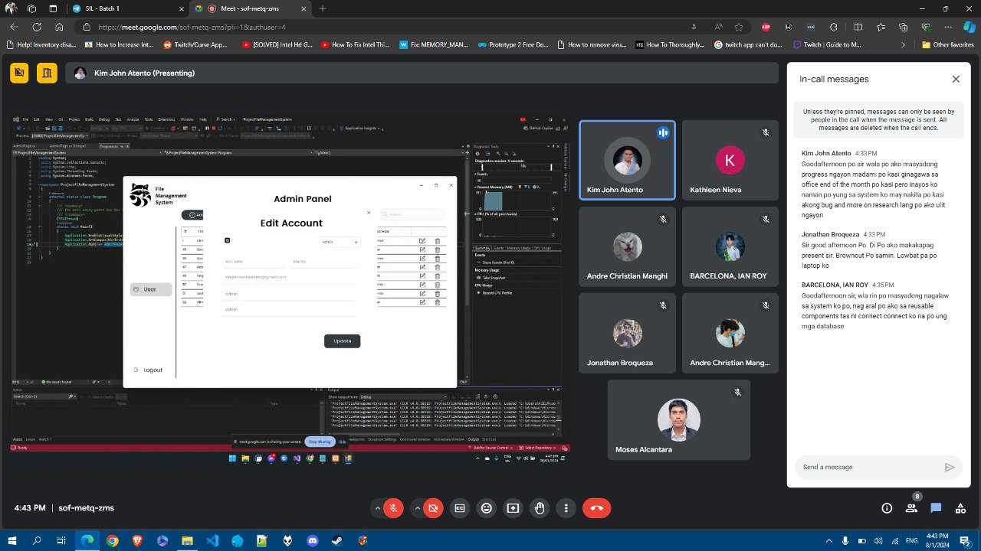

Update: Fixed the Index Error in the Edit Forms

AFTERNOON ATTENDANCE

