- Andre Christian Manghi
MORNING ATTENDANCE
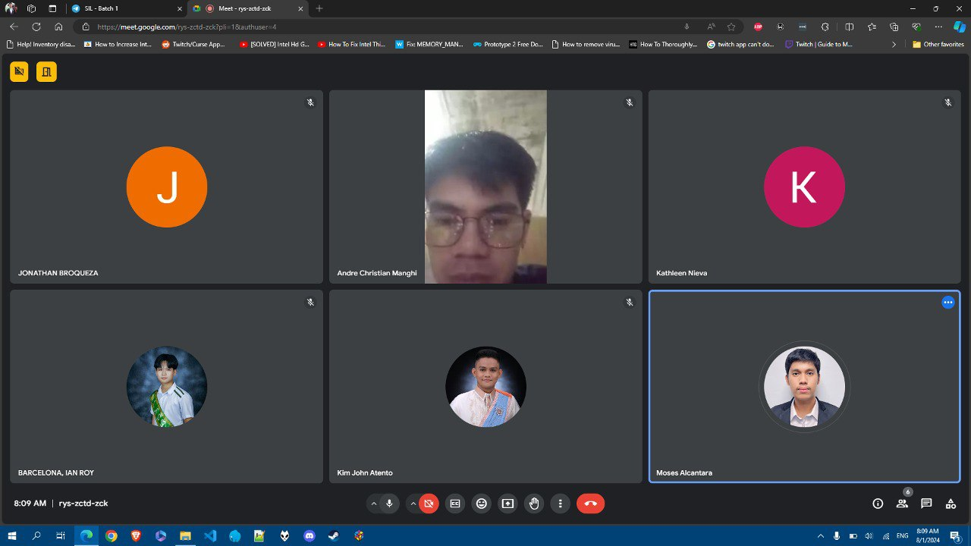

AFTERNOON MEETING – PROGRESS REPORT (INVENTORY MANAGEMENT SYSTEM)
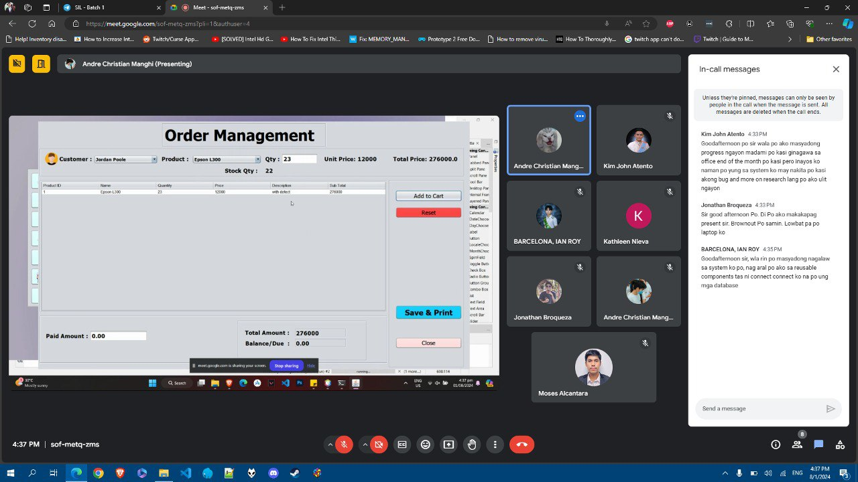
Update: Fixed Errors in the Cart Page

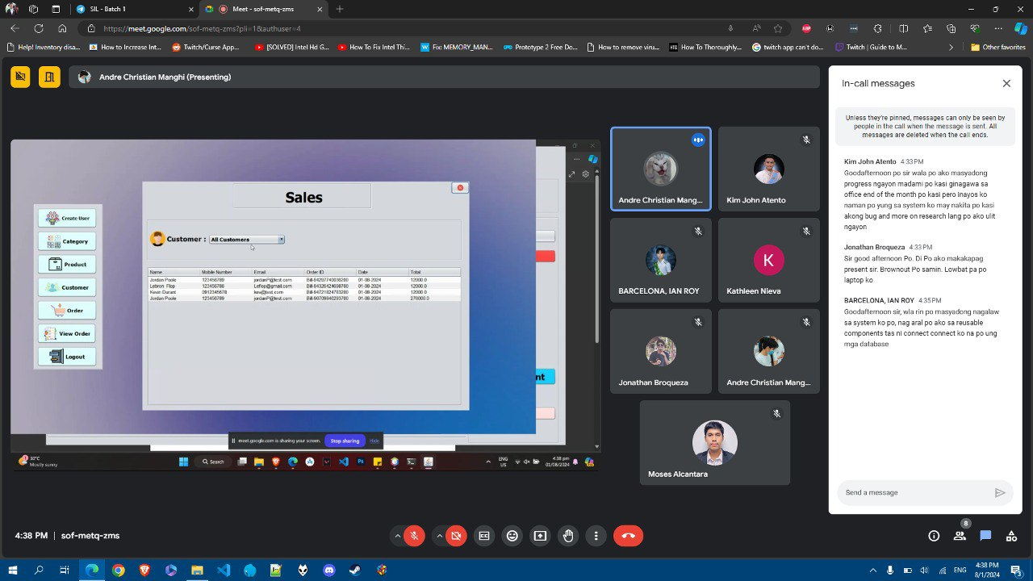
Update: Started the Sales Page

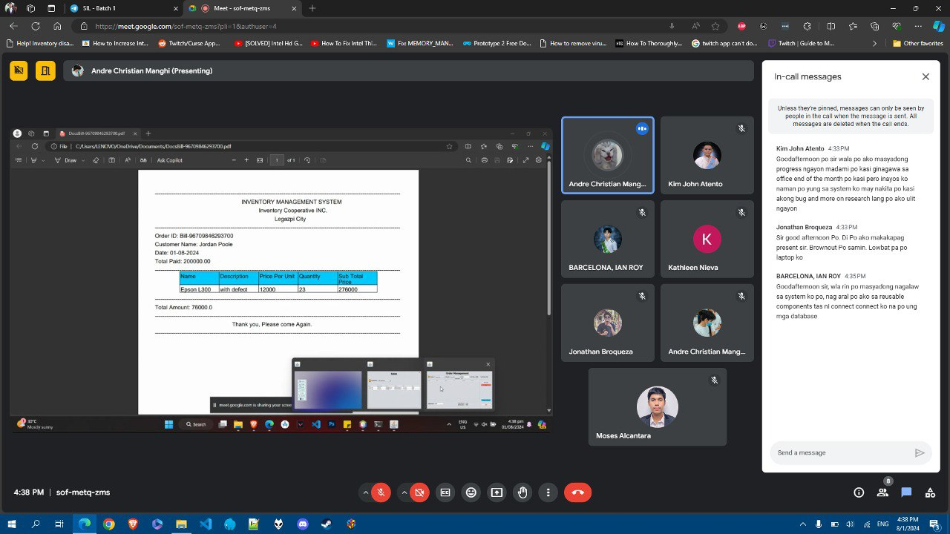
Update: Started the Export Receipt Function

AFTERNOON ATTENDANCE
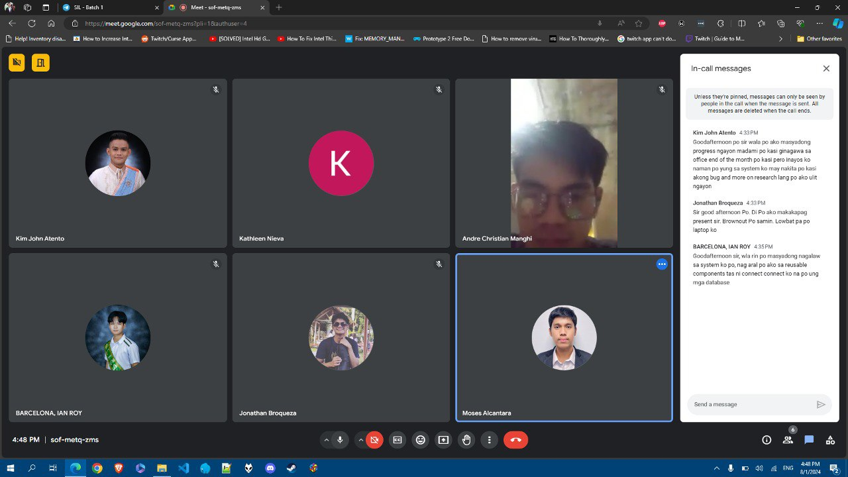

- Ian Roy Barcelona
MORNING ATTENDANCE
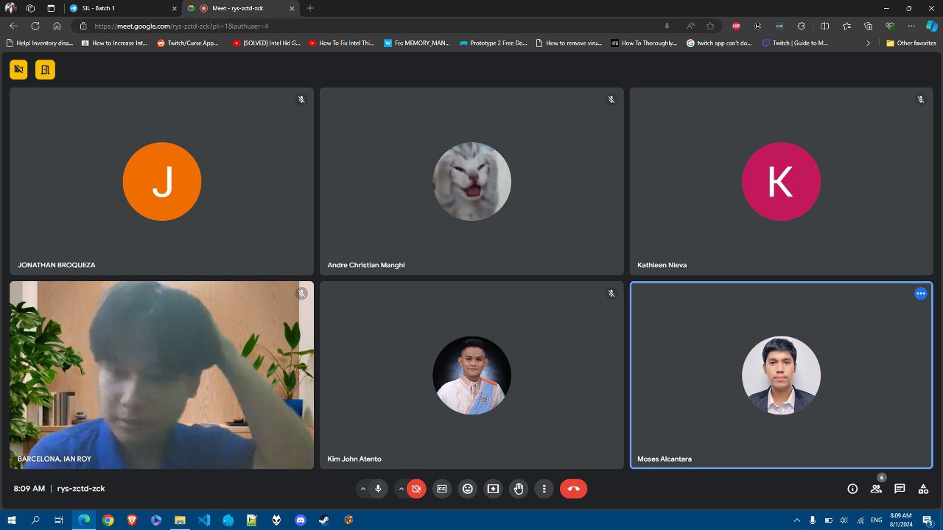

AFTERNOON MEETING – PROGRESS REPORT (ORDERING MANAGEMENT SYSTEM)
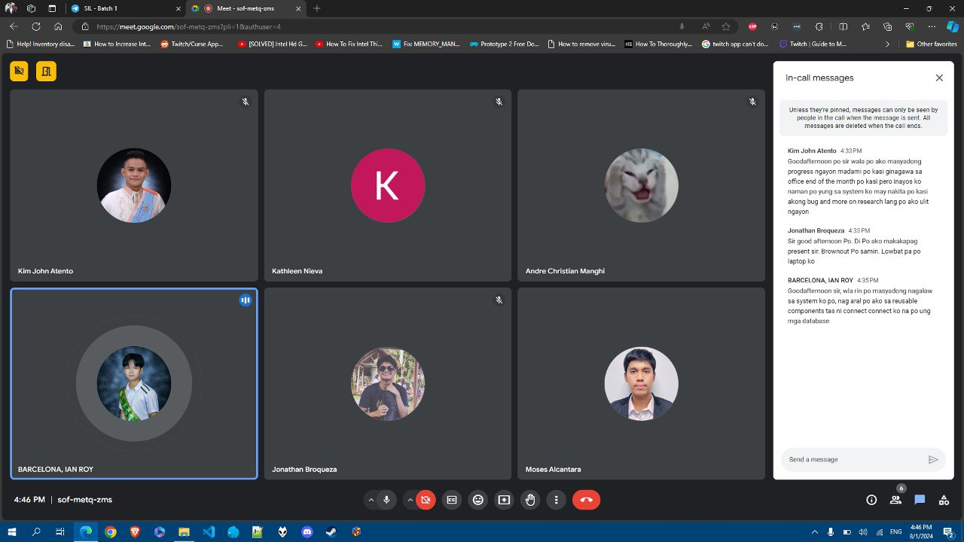
Update: Researched and Practiced Reusable Components

AFTERNOON ATTENDANCE
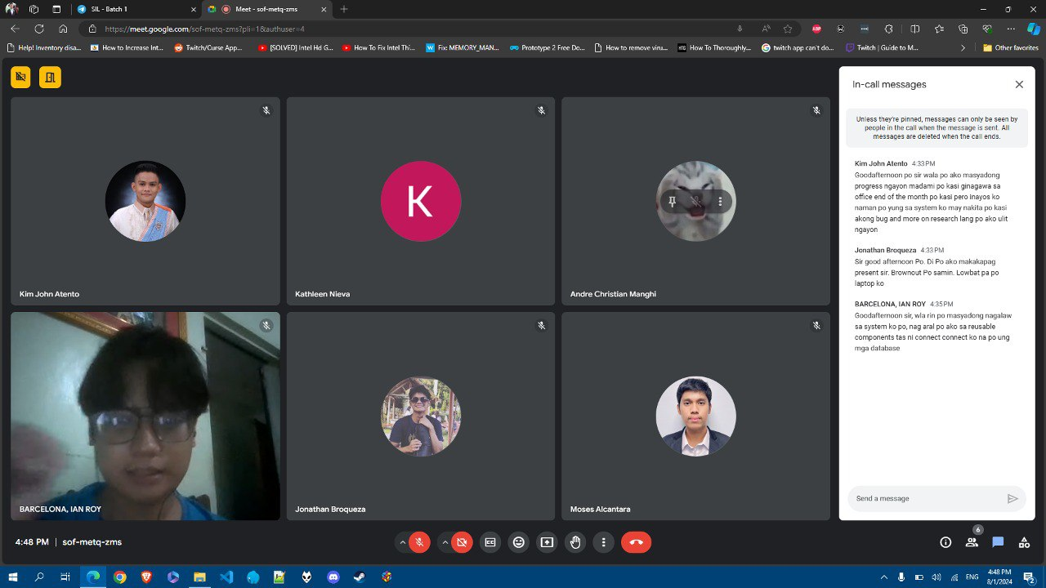

- Jonathan Broqueza
MORNING ATTENDANCE
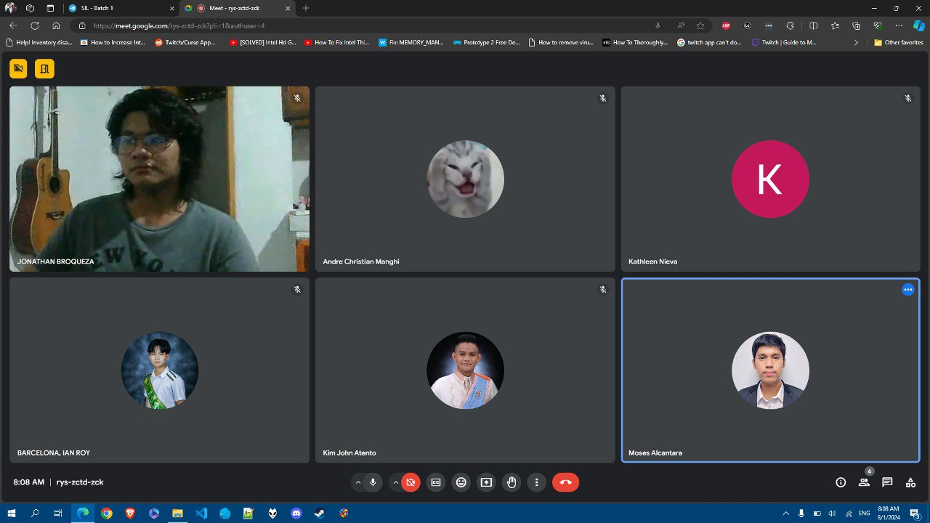

AFTERNOON MEETING – PROGRESS REPORT (HOTEL RESERVATION SYSTEM)
Note: Jonathan could not present his progress because of a power outage.

AFTERNOON ATTENDANCE
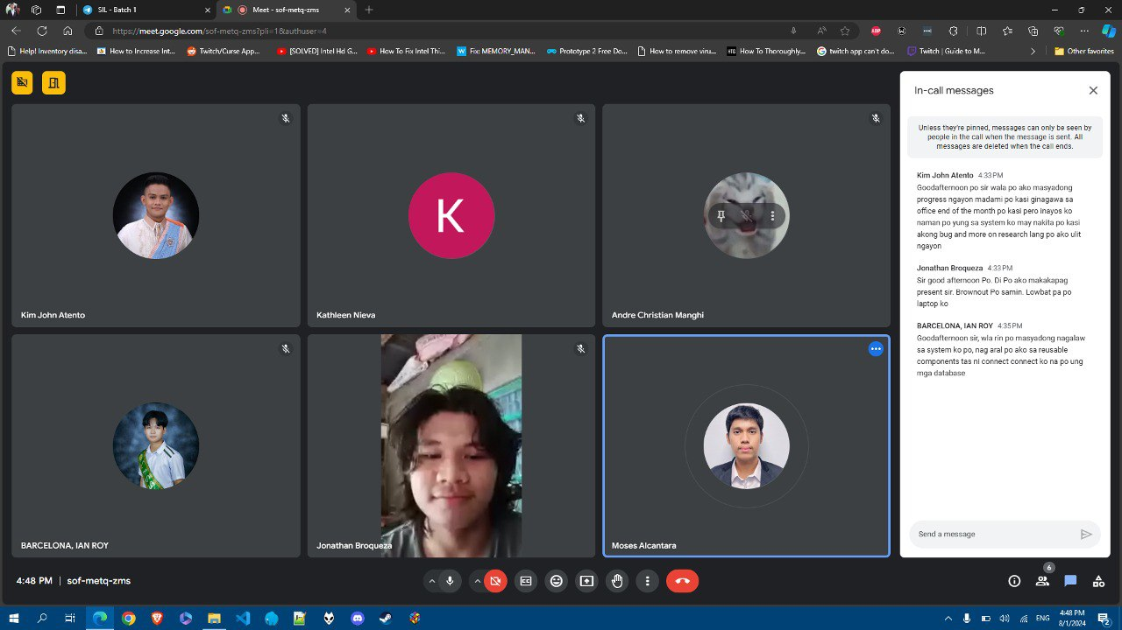

- Kathleen Nieva
MORNING ATTENDANCE
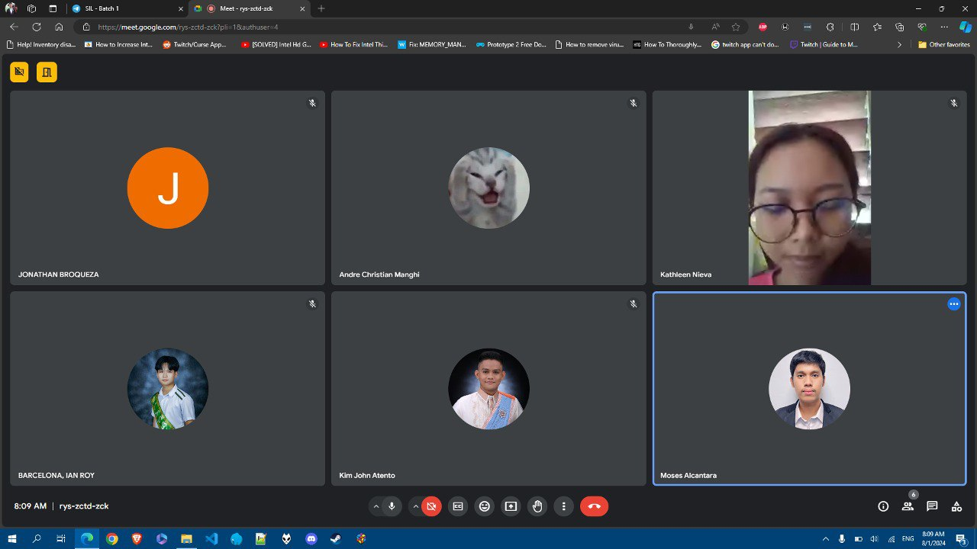

AFTERNOON MEETING – PROGRESS REPORT (REAL ESTATE WEBSITE)
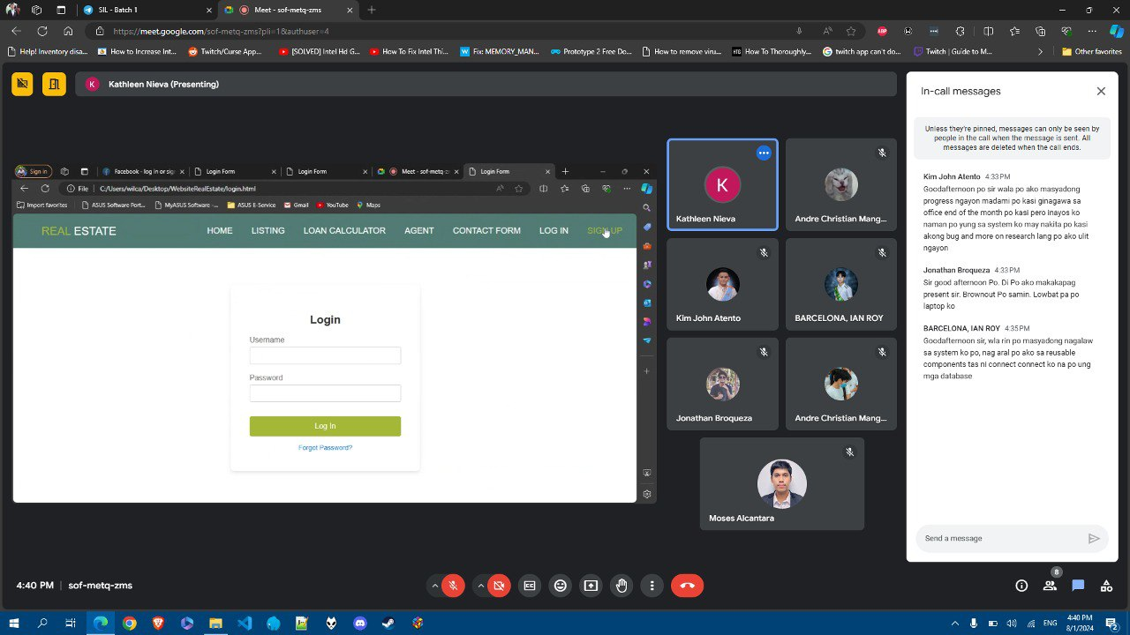
Update: Started the Login Form

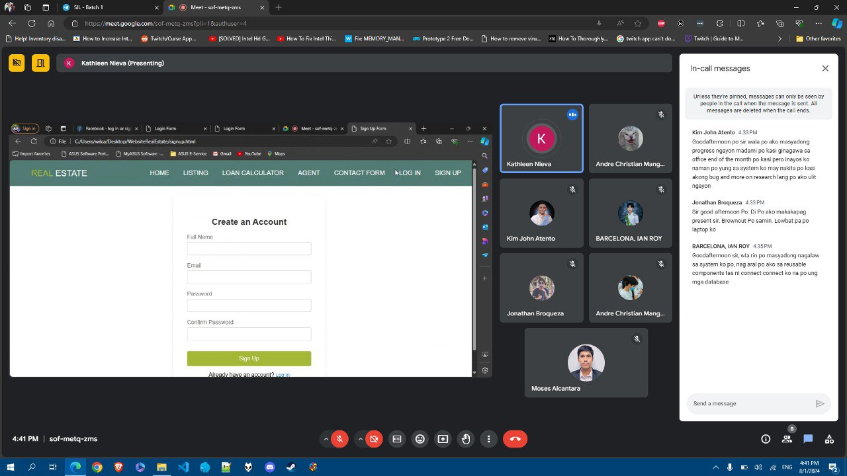
Update: Started the Sign Up Form

AFTERNOON ATTENDANCE
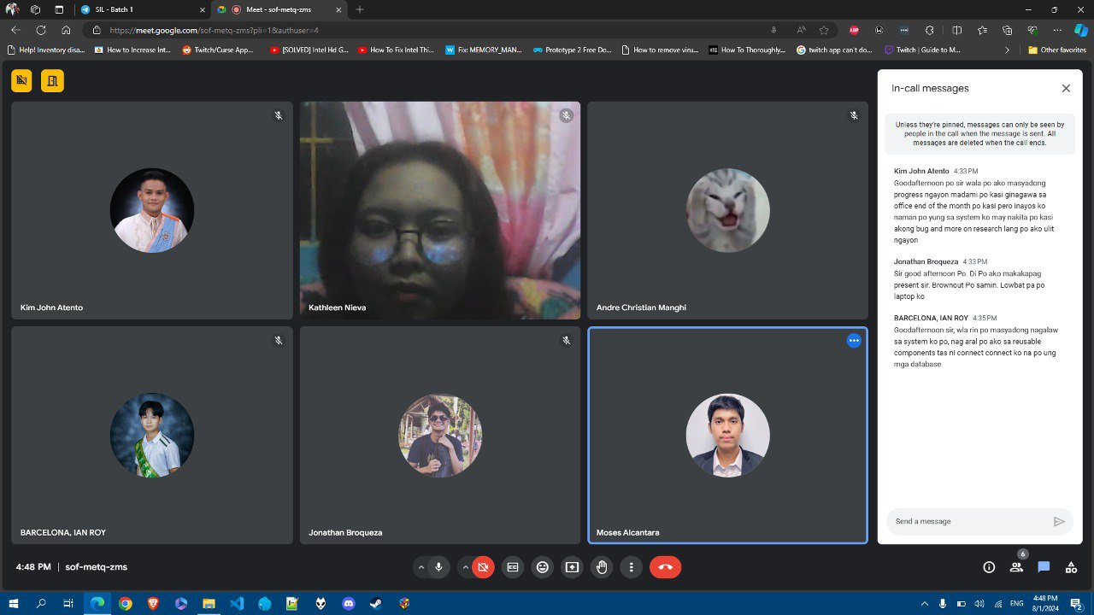

- Kim John Atento
MORNING ATTENDANCE
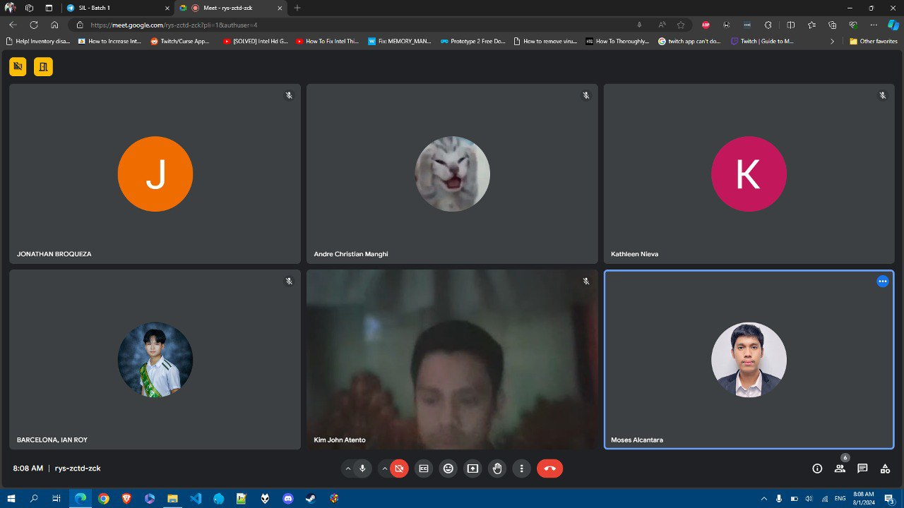

AFTERNOON MEETING – PROGRESS REPORT (FILE MANAGEMENT SYSTEM)
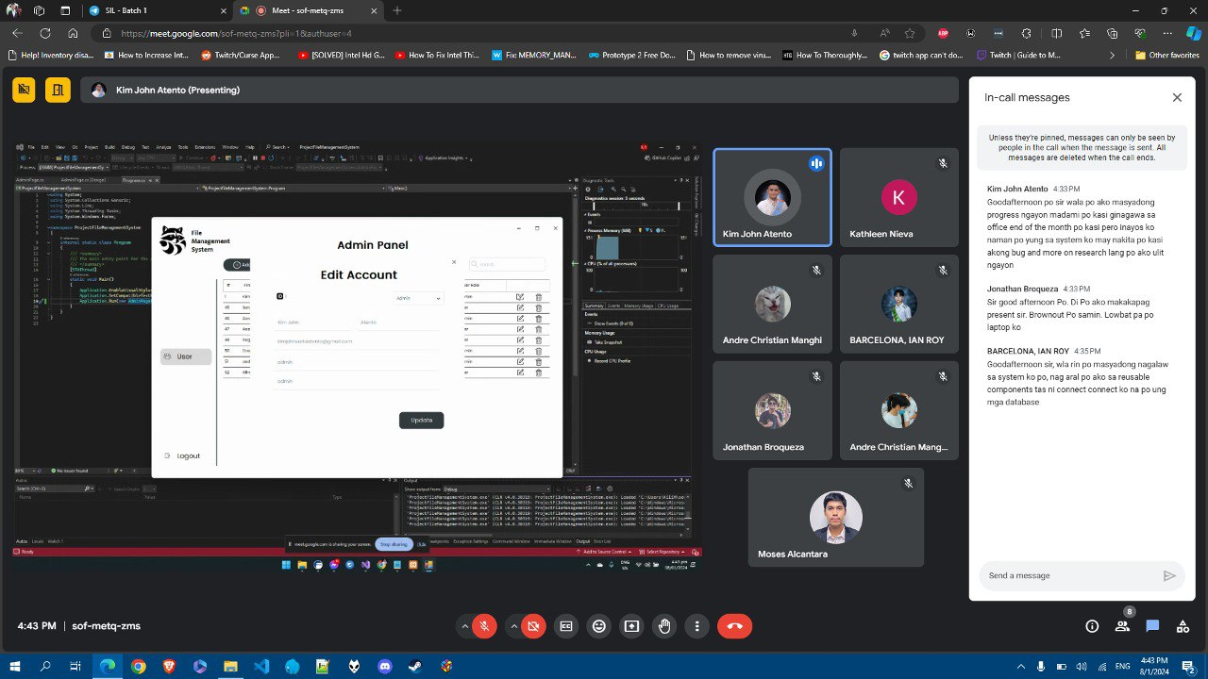
Update: Fixed the Index Error in the Edit Forms

AFTERNOON ATTENDANCE
