Predicting EV Charging Demand and Peak Events
An Experimental Report on the CHARGED Dataset
City-scale hourly data · demand regression · peak classification · error analysis
Data source: CHARGED (Scientific Data, 2025)
Cities modelled: Los Angeles (LOA) and Melbourne (MEL)
November 2026

Abstract
This report uses CHARGED, a city-scale dataset of electric-vehicle (EV) charging records from six cities (hourly, 1 April – 30 September 2023), to answer three questions: whether historical charging data can predict next-hour demand and peak events, how accurate such predictions are, and whether machine learning can identify potential peak periods. We build a site-hour panel (about 1.28 million records) for Los Angeles and Melbourne, the two cities with genuine intraday dynamics, and compare naive baselines, Ridge regression, gradient-boosted trees and an LSTM under causal feature engineering and rolling-origin validation. Demand forecasts reduce WAPE by roughly 35%–45% relative to the same-hour-yesterday baseline (Los Angeles 0.281 → 0.153; Melbourne 0.442 → 0.306). Peak events are identifiable at the ranking level (PR-AUC is 3–8 times the base rate), but probability calibration is severely limited by month-to-month drift in the peak rate. Errors are concentrated in near-zero-demand hours. The report also documents data-quality checks, definition-sensitivity analysis and reproducibility details.

1 Research Questions
This study is organised around three questions:
- Q1: Can historical EV charging data predict next-hour demand and peak events?
- Q2: How accurately can next-hour demand be predicted?
- Q3: Can machine learning identify potential peak charging periods?
The three questions correspond respectively to feasibility (Q1), regression accuracy (Q2) and classification/identification capability (Q3). Each is answered explicitly in Section 5, together with the conditions under which the answer holds.

2 Dataset

2.1 Source and scale
CHARGED is a city-scale EV charging dataset covering six cities: Amsterdam (AMS), Johannesburg (JHB), Los Angeles (LOA), Melbourne (MEL), São Paulo (SPO) and Shenzhen (SZH). Each city provides ten tables covering 1 April – 30 September 2023, i.e. 4,392 hourly timestamps. The core tables are site-level hourly matrices (volume, duration, electricity price, service price), accompanied by site, charger, weather, POI and inter-site distance tables.
Scale: 4,280 sites and 6,402 charger records. Of the sites, 3,127 produced non-zero volume at some point (active sites) and 1,153 are zero throughout (27%). The site-level hourly matrices contain about 18.8 million observations in total.

2.2 Data quality and characteristics
A full inspection of all sixty files shows that structural quality is good: the four time-series matrices contain no missing values, no duplicated timestamps and no gaps; the only missing column in the weather table is preciptype (empty when there is no precipitation, which is expected); the distance matrices are symmetric. The informational content, however, differs enormously across cities.
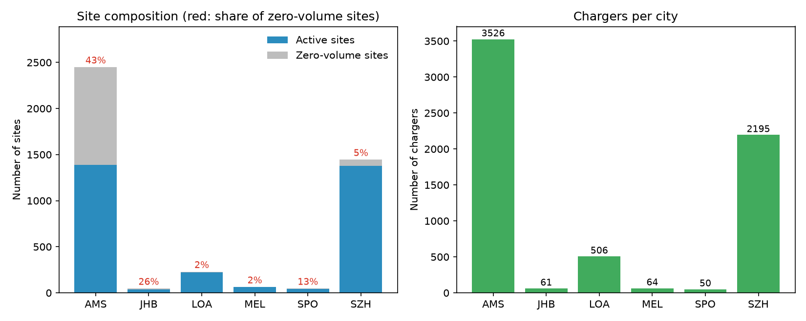
Figure 1. Site composition and charger counts. AMS has 43% zero-volume sites; LOA and MEL have 1%–2%.
Figure 1 shows that 43% of Amsterdam's sites never produced any volume, whereas the share is below 2% in Los Angeles and Melbourne. Whether a site is active is therefore itself a city-level dimension, and it directly affects how the metrics should be read.
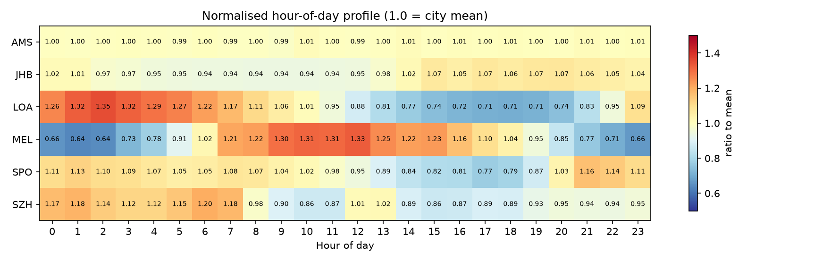
Figure 2. Hour-of-day profile relative to each city's mean. AMS is almost flat; LOA and MEL show clear intraday structure.
Figure 2 is the main reason for selecting the modelling cities. In Amsterdam all 24 hours are essentially 1.00, so the hourly series is closer to a daily level or an interpolation than to measured behaviour. Los Angeles peaks in the early morning (1.26–1.35) and Melbourne peaks around noon (1.33). Quantitatively, the share of sites with an intraday coefficient of variation below 0.05 is 94% in AMS, 57% in JHB, 51% in SPO, 50% in SZH, 11% in MEL and 8% in LOA.

2.3 Why only two cities are modelled
City | Sites | Active | Eligible* | Intraday CV<0.05 | Peak rate | Role in this report
AMS | 2,449 | 1,388 | ≈81 | 94.2% | — | Counter-example; not modelled
JHB | 47 | 35 | 17 | 57.1% | 5.0% | Pooling ablation only
LOA | 229 | 224 | 204 | 7.6% | 4.4% | Primary city
MEL | 63 | 62 | 51 | 11.3% | 5.0% | Primary city
SPO | 47 | 41 | 19 | 51.2% | 5.8% | Pooling ablation only
SZH | 1,445 | 1,377 | 691 | 49.5% | 2.7% | Pooling ablation (large-scale control)

Table 1. Overview of the six cities. *Eligible = sites with intraday CV ≥ 0.05, i.e. genuine hourly variation. The peak rate for AMS is not computed because it is not modelled.
Amsterdam is excluded for three reasons. First, 94% of its active sites show almost no intraday variation, so the hourly series is largely a daily value spread over 24 hours or an interpolation. Second, its city-level daily total moves in three steps (roughly 50k → 250k → 1.2M kWh/day), which reflects data coverage being connected in three stages rather than demand growth. Third, the same-hour-yesterday baseline already achieves a WAPE of 0.6% there, so any model can 'win' and the conclusion carries no information. It is therefore kept as a counter-example in the data description but excluded from training and evaluation.

3 Methods

3.1 Panel construction and feature engineering
The raw data are wide tables of sites × hours. We reshape them into a long site-hour panel in which each row is one observation, containing the target, lagged values, rolling statistics, calendar features and site attributes. The modelling panel (LOA + MEL) contains about 1.28 million rows and 286 sites.
Feature engineering follows two rules: every feature must be available at prediction time (causality), and any threshold-like statistic may only be computed on the training period. The features are:
Category | Fields | Description
Lags | lag1, lag24, lag168 | Volume one hour, one day and one week earlier
Rolling | roll24_mean, roll24_std, roll168_mean | Mean/std over the past 24 h and mean over the past 7 days (all shifted by 1)
Calendar | hour, dow, doy | Hour of day, day of week, day of year
Site statics | charger_num, area, poi_density, lon, lat | Charger count, cluster area, POI count within a 500 m grid, coordinates
(Dropped) weather | temp, precip, humidity, wind, solar, cloud | Excluded because of time-zone ambiguity (Section 3.3)

Table 2. Feature set. All lags and rolling statistics use only information before time t.
Leakage controls: the period-aggregated columns in sites.csv (total_volume, total_duration, avg_power) are never used as features; month is excluded because the test set contains a single month; rolling statistics are shifted by one hour; winsorisation thresholds (P99.9) are computed on the training data only.
Weather was dropped deliberately. A time-zone check compared the intraday peak of charging volume with that of solar radiation: the two coincide in Melbourne (offset 0 h) but differ by 13 h in Los Angeles, implying that the timestamps are not on the same clock. Since the alignment cannot be established, weather features are excluded for both cities rather than risking a misaligned covariate.

3.2 Peak-event definition
'Peak' is not a column in the data; it must be defined. Our primary definition is: for each site and each hour, take the mean and standard deviation of the same hour over the previous 28 days, and label the current hour as a peak event if its volume exceeds mean + 2 standard deviations. The rule is causal (the threshold uses only past data and excludes the current hour) and adapts to each site's own level. Two alternative definitions are used as sensitivity checks: the rolling 28-day same-hour median multiplied by 4, and a static P95 of positive hours during the training period.

3.3 Data splits
Time series must not be split at random. We use expanding-window rolling-origin validation: the training set starts in April and grows month by month, with June, July, August and September used as test months in turn, and a one-day gap between training and test. For classification, probability calibration is fitted on the two months preceding the test month.
Fold | Training period | Test month
1 | 2023-04-01 – 2023-05-31 | 2023-06
2 | 2023-04-01 – 2023-06-30 | 2023-07
3 | 2023-04-01 – 2023-07-31 | 2023-08
4 | 2023-04-01 – 2023-08-31 | 2023-09

Table 3. Rolling-origin splits.

3.4 Models
For regression we compare four families: naive baselines (constant mean, same-hour yesterday t-24, same-hour last week t-168), Ridge regression, gradient-boosted trees (HistGradientBoosting) and an LSTM. For classification we compare the base rate, an hour × weekday frequency table, logistic regression and gradient-boosted trees with isotonic calibration.
Task | Model | Key settings
Regression | Constant / t-24 / t-168 | No fitting; the pass mark
Regression | Ridge | Standardised features, alpha = 1.0, raw-volume target
Regression | HistGradientBoosting | 250 iterations, lr 0.08, 31 leaves, min_samples_leaf 40
Regression | LSTM | One layer, 64 hidden units, 24-hour input (per-site z-score), batch 4096, 30 epochs
Classification | Base rate / hour × weekday | Training-period frequencies, no fitting
Classification | Logistic regression | Standardised features, balanced class weights
Classification | HistGradientBoosting | Same configuration as regression, isotonic calibration (previous two months)

Table 4. Model configurations. The LSTM was trained on an NVIDIA RTX 3060 (6 GB) with PyTorch 2.14.1 and CUDA 12.6.

3.5 Evaluation metrics
Regression is evaluated with MAE, RMSE, R² and WAPE, where WAPE = Σ|predicted − actual| / Σ|actual|. WAPE is scale-free and is our primary metric for cross-city comparison. R² is computed within sites, and we report the median and the share of sites with R² > 0, avoiding the illusion that 'guessing site size' is good forecasting. Classification is evaluated with the Brier score, log loss, PR-AUC and F1; PR-AUC is more informative than accuracy when the positive rate is only 2%–8%, and the F1 threshold is selected on the validation window.

4 Results

4.1 Demand regression
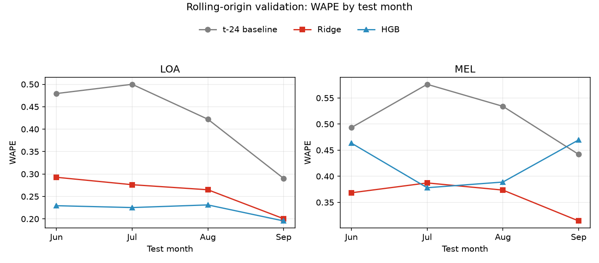
Figure 3. WAPE over the rolling-origin folds. All models consistently beat the t-24 baseline in both cities.
City | Model | Jun | Jul | Aug | Sep
LOA | t-24 | .479 | .500 | .422 | .290
LOA | Ridge | .293 | .276 | .265 | .200
LOA | HGB | .229 | .225 | .231 | .195
MEL | t-24 | .493 | .576 | .534 | .442
MEL | Ridge | .368 | .387 | .374 | .314
MEL | HGB | .463 | .378 | .389 | .470

Table 5. WAPE over the rolling-origin folds (lower is better).
All models beat the same-hour-yesterday baseline substantially in both cities. The best model, however, depends on the city: on Los Angeles (224 sites) the gradient-boosted trees win, whereas on Melbourne (62 sites) the trees lose to the baseline in September while Ridge remains stable. Model complexity must match sample size — with few sites, trees memorise noise.

4.2 Pooling and external-city ablation
Training scheme | LOA WAPE | MEL WAPE
Single city (Ridge / HGB) | .205 / .217 | .352 / .452
Pooled LOA+MEL | .235 / .211 | .346 / .429
Pooled + SZH | .236 / .208 | .350 / .392

Table 6. Mean WAPE over August and September. Pooling does not help LOA; it helps MEL's tree model but still does not beat a single-city Ridge.
Pooling does not help Los Angeles, which already has enough of its own data. It does improve Melbourne's tree model (.452 → .392), but even after adding 6.34 million rows from Shenzhen the tree model remains worse than a single-city Ridge. Shenzhen is large, but half of its sites are flat, so the additional information is limited.

4.3 Peak-event identification
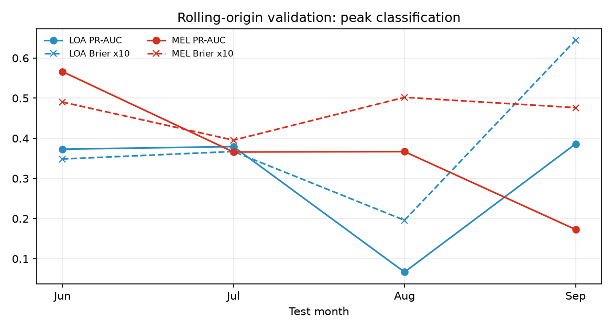
Figure 4. Peak classification over the rolling folds (PR-AUC and Brier × 10). August is clearly the difficult month.
Test month | City | Event rate | Brier | PR-AUC | F1
Jun | LOA | 4.5% | .035 | .373 | .416
Jul | LOA | 4.5% | .037 | .379 | .420
Aug | LOA | 2.0% | .020 | .067 | .130
Sep | LOA | 8.5% | .064 | .386 | .425
Jun | MEL | 7.8% | .049 | .566 | .563
Jul | MEL | 4.8% | .040 | .366 | .417
Aug | MEL | 5.9% | .050 | .367 | .443
Sep | MEL | 4.6% | .048 | .173 | .287

Table 7. Peak-classification results over the rolling folds.
Ranking capability is real: PR-AUC is typically 3–8 times the event base rate, so the model does put more likely peak hours near the top. But August almost fails (PR-AUC .067 on LOA) because the peak rate itself moves from 2% to 8.5% across months; a probability calibrated on the previous two months cannot transfer to a test month with a completely different event rate.

4.4 Sensitivity to the peak definition
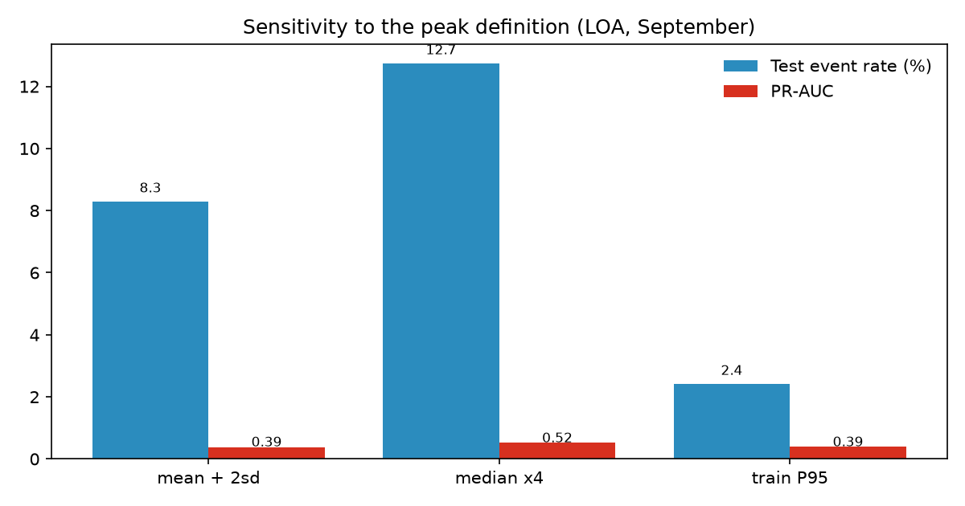
Figure 5. Comparison of three peak definitions on Los Angeles in September.
Definition | All-period rate | Train | Test | Brier | PR-AUC | F1
Rolling mean + 2σ | 4.7% | 3.9% | 8.3% | .064 | .385 | .412
Rolling median × 4 | 8.7% | 7.9% | 12.7% | .080 | .517 | .550
Training-period P95 | 2.2% | 2.2% | 2.4% | .019 | .389 | .400

Table 8. Comparison of three peak definitions (LOA, September).
An 'adaptive' rolling threshold drifts with the overall demand level: the event rate rises from 3.9% in training to 8.3% in the test month, which breaks probability calibration. The static P95, although simpler, keeps the event rate almost unchanged (2.2% vs 2.4%) and achieves the best Brier score (.019). If interpretable probabilities matter, P95 is preferable; if the goal is not to miss unusual days, the ×4 median has the highest recall (F1 .550).

4.5 Model comparison on identical test rows
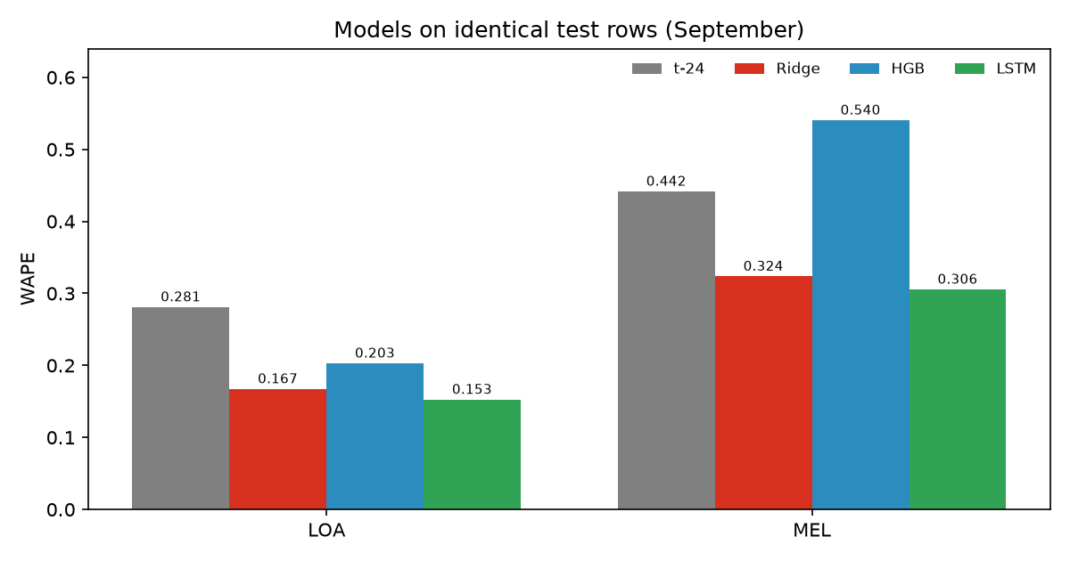
Figure 6. Regression models on the same test rows (September).
City | t-24 | Ridge | HGB | LSTM | LSTM 95% bootstrap CI
LOA | .281 | .167 | .203 | .153 | [0.13, 0.18]
MEL | .442 | .324 | .540 | .306 | [0.16, 0.44]

Table 9. WAPE on identical test rows (LOA 164,880 rows; MEL 45,360 rows) with bootstrap intervals.
The LSTM achieves the lowest WAPE in both cities: 0.153 on LOA and 0.306 on MEL. The bootstrap intervals, however, show that the difference from Ridge is not robust (LOA intervals [0.13, 0.18] and [0.14, 0.20] overlap, and MEL overlaps even more), whereas both are clearly better than HGB (MEL HGB interval [0.40, 0.68]). In other words, 'sequence models beat linear models' is weak evidence; 'both beat tree models' is strong.

4.6 Error analysis
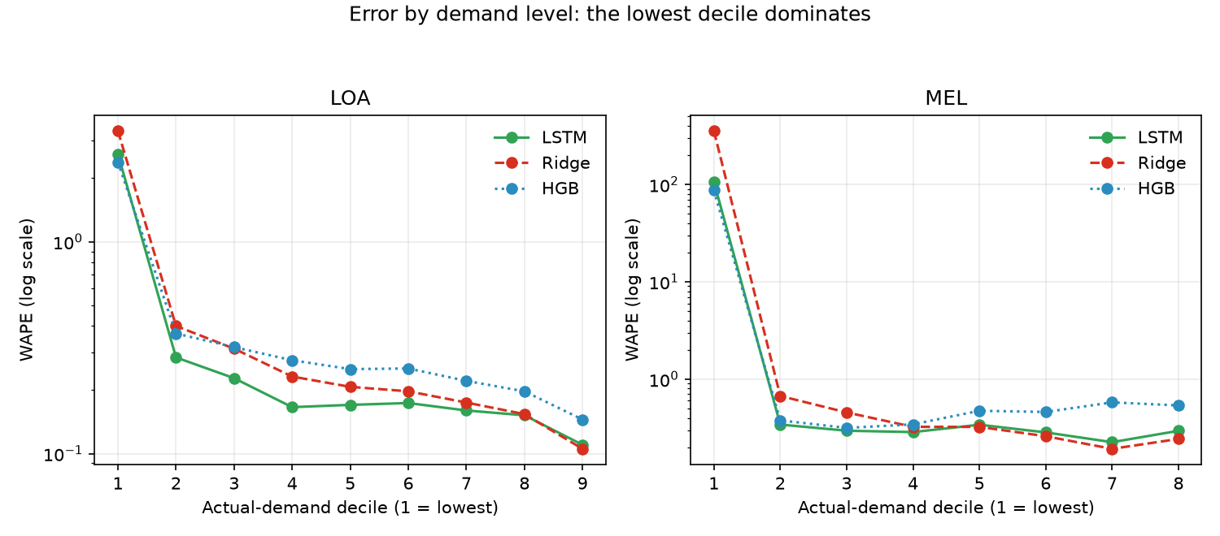
Figure 7. Error by actual demand level (log scale). The lowest decile is 1–2 orders of magnitude worse.
Errors are almost entirely driven by near-zero hours: the lowest decile has WAPE 2.4–3.3 on LOA (the model over-predicts by a factor of 2.3–3.2) and 87–354 on MEL (over-prediction by 86–354 times). All other deciles have WAPE between 0.11 and 0.67. The aggregate WAPE looks modest only because high-demand hours pull the average down.
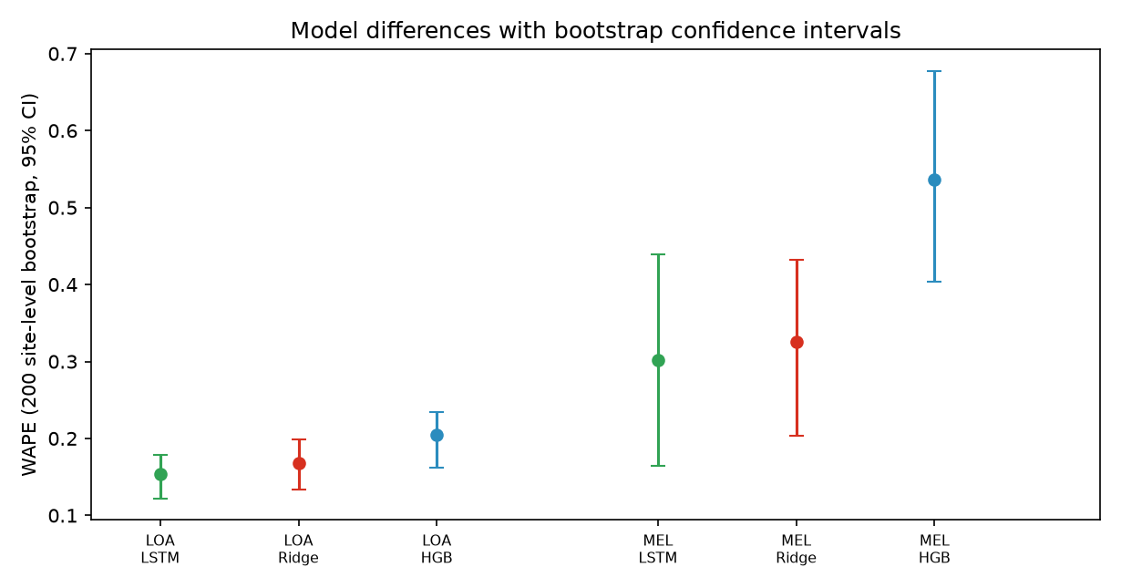
Figure 8. WAPE with 95% confidence intervals from 200 site-level bootstrap resamples.
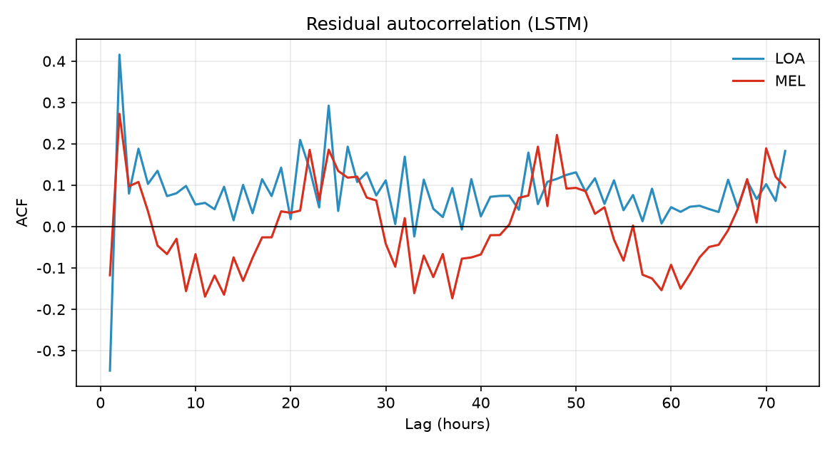
Figure 9. Autocorrelation of the LSTM residuals.
Residuals still contain clear daily structure: on LOA the autocorrelation is −0.35 at lag 1 and +0.29 at lag 24, meaning the model over-corrects the previous hour and does not fully capture the daily cycle. This points directly to the next improvements: a two-part model, residual modelling, or stronger seasonal features.
Decomposing by site type: eligible sites (CV ≥ 0.05) have WAPE 0.178 on LOA and 0.323 on MEL, whereas flat sites have only 0.012 and 0.185. Flat sites are almost trivially predictable, so any cross-dataset comparison of metrics must state the site composition.

4.7 Interpretability
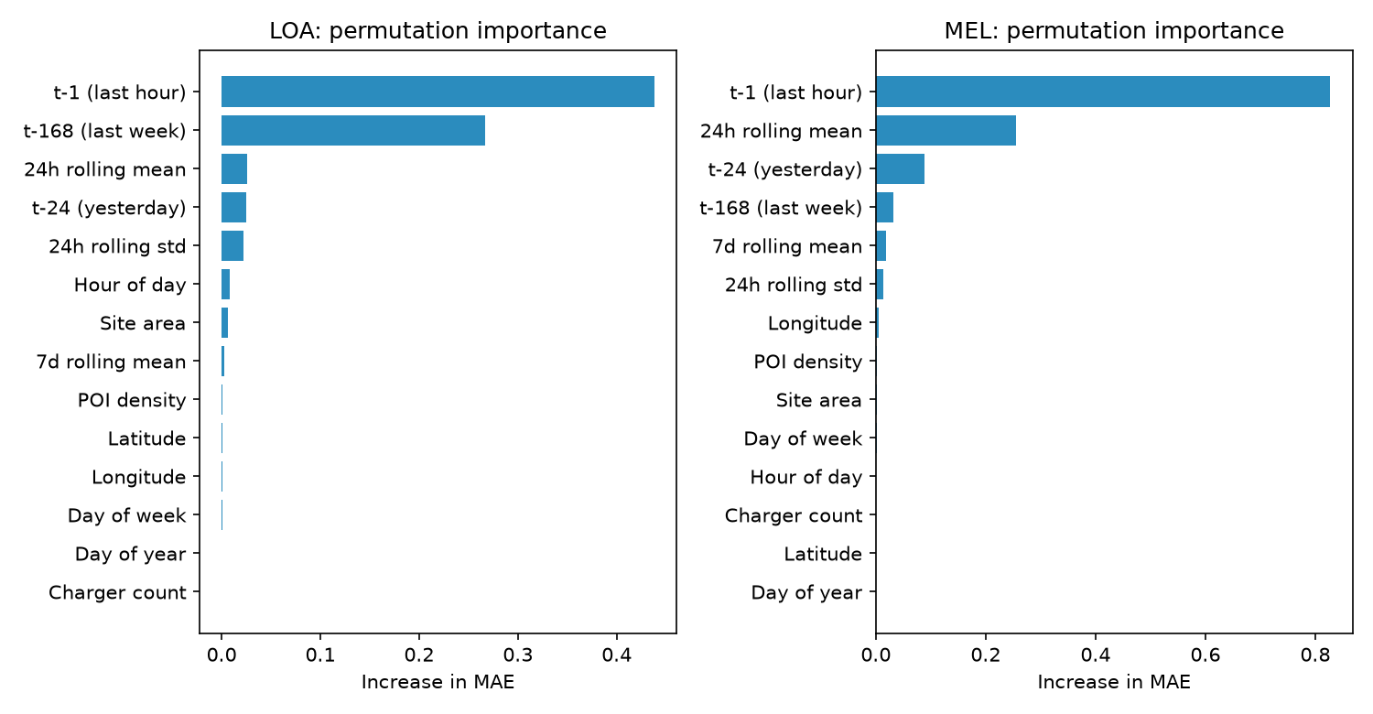
Figure 10. Permutation feature importance (increase in MAE). The previous hour and last week dominate.
Permutation importance shows that the models rely almost entirely on autoregressive information: t-1 is dominant, followed by last week's value and the 24-hour rolling mean, while POI density, site area, longitude and latitude contribute almost nothing. On this dataset, forecasting is essentially persistence modelling, and spatial or static attributes add no marginal information.

5 Answers to the Research Questions
Q1: Can historical EV charging data predict next-hour demand and peak events?
Yes, under conditions. On the demand side, historical series are sufficient for next-hour forecasting in cities with genuine intraday dynamics (LOA, MEL); all models consistently beat the naive baseline. On the peak side, the model can rank more likely peak periods, but the reliability of the probabilities is limited by label drift. The condition is that not every city qualifies: in Amsterdam, 94% of sites are flat intraday and the same-hour-yesterday baseline already has a WAPE of 0.6%, so hourly forecasting there is meaningless. The accurate statement is therefore: 'where the data contain genuine hourly dynamics, historical data support demand forecasting and peak ranking; otherwise they do not.'
Q2: How accurately can next-hour demand be predicted?
On the same test set, the best WAPE is 0.153 for Los Angeles (MAE about 1.10 kWh per site-hour) and 0.306 for Melbourne (MAE about 15.5 kWh), corresponding to improvements of about 46% and 31% over the same-hour-yesterday baseline. Accuracy is not uniform: WAPE is 0.11–0.40 in high-demand hours but reaches 2.4–354 in near-zero hours. For capacity planning one should focus on high-demand hours; for detecting 'whether charging will occur at all', the over-prediction at low demand must be addressed first.
Q3: Can machine learning identify potential peak charging periods?
Yes for ranking, but not directly for probability. At the ranking level, PR-AUC is 3–8 times the base rate and F1 is 0.42–0.43 on LOA and 0.29–0.56 on MEL, so the model does prioritise more likely peak hours. At the probability level, because the peak rate varies between 2% and 8.5% across months, cross-month calibration degrades sharply and August nearly fails. The conclusion also depends on the definition: +2σ drifts, P95 is the most stable (Brier .019), and the ×4 median has the highest recall (F1 .550). The accurate statement is: 'machine learning can rank and flag peak periods, but any reported probability must specify the definition and the calibration window.'

6 Limitations
- The time span is only six months (April–September), so winter and seasonal extrapolation are not covered.
- Cities span both hemispheres: Melbourne is in the southern hemisphere, where the same months are autumn/winter; the seasons are not aligned when pooling cities.
- Weather features were dropped because of time-zone ambiguity, so the models contain no meteorological input.
- Only LOA and MEL are modelled; AMS is excluded for data degradation, and JHB/SPO/SZH are used only in ablations.
- The peak label is constructed by a threshold rule rather than annotated in the data; different definitions produce different event rates and conclusions.
- The LSTM was trained on a single fold (September) for 30 epochs without early stopping or hyper-parameter search, so the robustness of its advantage is limited.
- Melbourne has only 62 sites, which widens the confidence intervals of city-level conclusions.

7 Conclusion
This report covers the full workflow on CHARGED, from data inspection and feature engineering to rolling validation and error analysis. The main conclusions are:
- Demand is predictable: in cities with genuine hourly dynamics, WAPE falls from 0.28–0.44 at the baseline to 0.15–0.31, an improvement of about 31%–46%.
- Model complexity must match sample size: trees overfit in the small city, while LSTM and Ridge remain stable; the LSTM–Ridge difference is not significant under bootstrap, and both clearly beat the tree model.
- The signal is predominantly autoregressive: lagged features explain almost all variance, and spatial/static features add essentially nothing.
- The bottleneck for peak identification is label drift, not model capacity: ranking works, but probabilities cannot be used across months without recalibration.
- The peak definition determines the conclusion: the three definitions differ by a factor of about five in event rate, so every 'peak' result must state its definition.
- Errors are concentrated in near-zero-demand hours, which suggests a two-part model or a Tweedie loss as the most direct next improvement.

8 Reproducibility
All processing and modelling steps are saved as scripts; data and results are separated, and random seeds are fixed. The environment is:
Item | Version / note
Python | 3.12.14
pandas / numpy | 3.0.1 / 2.3.5
scikit-learn | 1.9.1
PyTorch | 2.14.1 + cu126 (GPU: RTX 3060 Laptop 6 GB)
matplotlib | 3.11.2
Data | Six city folders under data/; malformed headers were repaired, with the originals backed up in scripts/header_backup.json

Table 10. Runtime environment.
Scripts and execution order:
Script | Purpose
scripts/build_panel.py | Build the site-hour panel (causal features and peak labels)
scripts/rolling_cv.py | Rolling 4-fold regression and classification
scripts/ablation.py | Single-city / pooled / +SZH ablation
scripts/interpret.py | Feature importance, partial dependence, error decomposition
scripts/peak_defs.py | Sensitivity to three peak definitions
scripts/lstm_model.py | LSTM training and prediction on GPU
scripts/compare_lstm.py | Aligned model comparison on identical test rows
scripts/error_analysis.py | Decile errors, residual ACF, bootstrap intervals
scripts/make_figures.py | Data-characterisation figures
scripts/make_figures_en.py | English versions of all report figures

Table 11. Script list; executing them in this order reproduces every result.
Splits, random seeds (0), hyper-parameters and thresholds are fixed in the scripts. Panels and result tables are stored in panel/ and results/, and figures in figures/ and results/, so every number in this report can be traced back to a file.

