National Higher School of Autonomous Systems Technology
Electronics Final Exam/ Tuesday, June 24th, 2025
Duration: 1h30

Exercise 1:
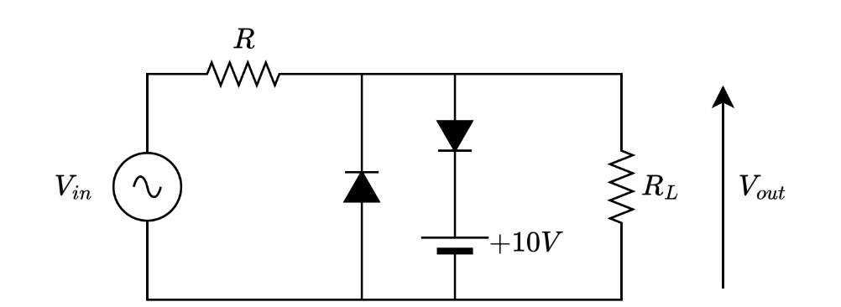
Consider the circuit below. Assume the diode is ideal, and the input voltage is a sine wave with amplitude of $20V$ and a frequency $f=100 Hz$ . With $R_{L}=10 kΩ$ .

- Draw approximately the output voltage $V_{out}$ for the first period, and precise the time and voltage values knowing that $=5 kΩ$ .
We replace the resistor $R$ with a capacitor $=1 μF$ :
- Draw approximately the output voltage $V_{out}$ for the first period.
- Indicate below your graph the intervals when the capacitor is charging and discharging.
For the voltage source $V_{in}$ with an amplitude of $15V$ and a period $T=20ms$, and for the same output load $R_{L}$ :
Draw the circuit that gives the following output voltage. Precise the value of each element (1 point)
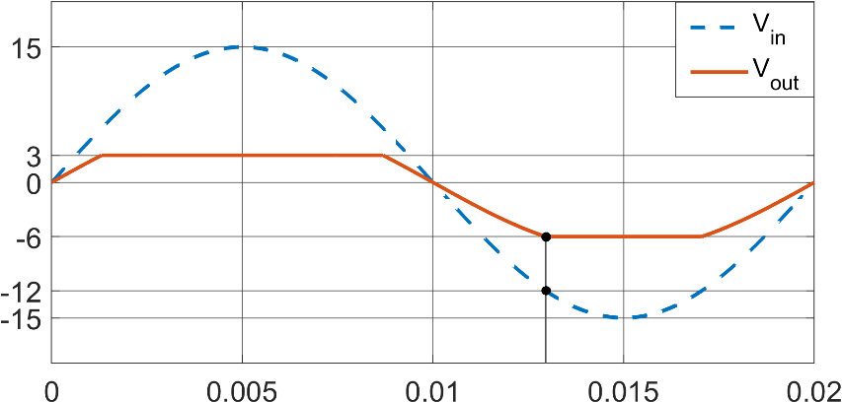

Exercise 2
Consider the two-port network (quadripole) shown in the figure below, constructed with two coupled voltage generators and four identical resistors of value R.
- Express the impedance matrix [Z] in terms of R,
- Draw the equivalent circuit that represents this impedance matrix. Show all impedance elements clearly.
- For the two-port network loaded with a resistance R_{L} at the output port, express in terms of E, R, and R_{L}:
- Voltage gain (A_{v})
- Input impedance (Z_{in})
- Output impedance (Z_{out})
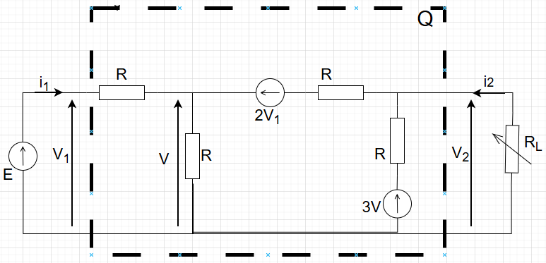
Problem:
Two electronics designers created two different circuits (A and B) to solve the same problem. The circuits (A) and (B) are depicted in the Figure 4 and 5. The designers Fixed the Quiescent point (Q-point) in the middle of the load line. ($β_{DC}=213$ for the 2N2222 and $β_{DC}=141$ for the 2N3904 )
Part1: DESIGN A
- Knowing that: R_{C}=1.65kΩ and R₂=2.7kΩ and the saturation current is: 2.34mA, calculate the values of R₁, and R_{E}. Deduce the value of I_{E}.
- What is the name of this biasing circuit?
- What is the purpose of this circuit?
- How do we call capacitors C₁, C₂? How do we call capacitor C₃?
- Give the ac-equivalent circuit. (Recall that $\grave{r_{e}}$=$\frac{25mV}{I_{E}}$).
- Calculate the ac-voltage gain (G_{V}).
- Give the input impedance (Z_{in}) and output impedance (Z_{out}) of the circuit.
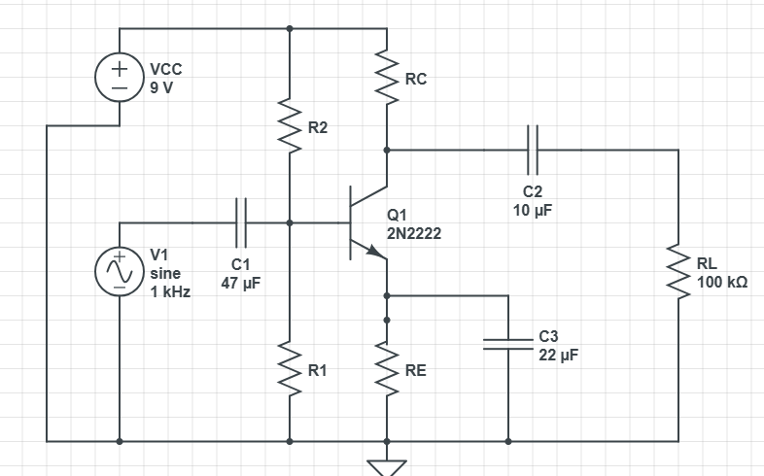
Figure 4: Design A
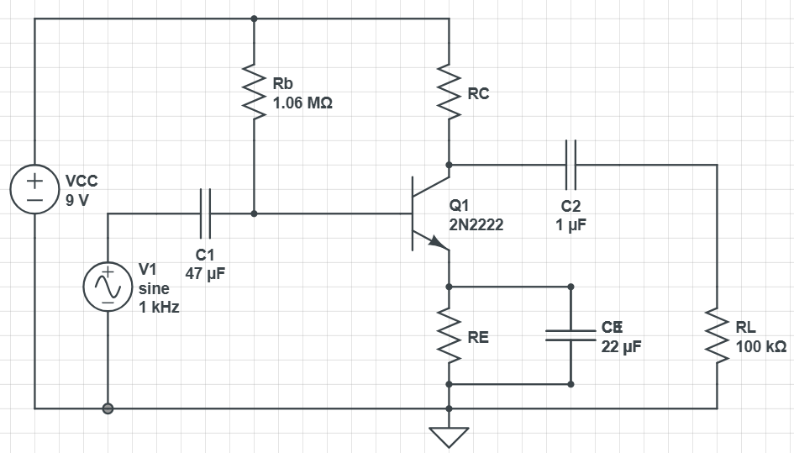
Figure 5: Design B
Part2: Comparison between designs A and B
Note that the Q-point for the Design B is the same as for the Design A
- What is the name of the biasing circuit in Design B?
- Transistor 2N2222 burned and the technician found in his possession a 2N3904. He replaced it in the circuit.
2. a what happens if the original circuit was the one of Design A
2. b what happens if the original circuit was the one of Design B
- Which is the best design? Justify.

