National Higher School of Autonomous Systems Technology
Electronics Mid-Term/ Sunday, June 15th, 2025
Duration: 1h30

Exercise 1:
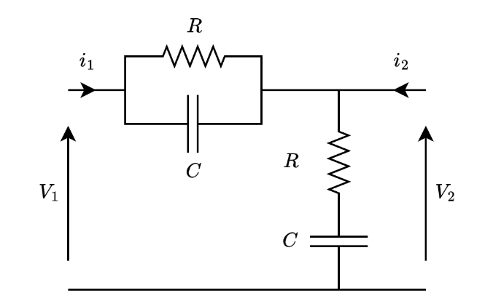
Given the quadripole in the following figure:

- Calculate the impedance matrix$Z$.
- Calculate the hybrid matrix$H$.
- Using the hybrid parameters, give the equivalent circuit of the quadripole.
A load $R_{L}$ is connected to the output of the quadripole:
- Determine the voltage gain $A_{v}=\frac{V_{2}}{V_{1}}$ .
Exercise 2
1. Consider a quadripole (two-port network) Q defined by its hybrid matrix $H=\left[\begin{matrix}h_{11} & h_{12} \\ h_{21} & h_{22}\end{matrix}\right]$. Determine its impedance matrix Z as a function of the parameters h₁₁, h₁₂, h₂₁, and h₂₂. Specify the conditions for the existence of this transformation.
2. Consider a quadripole Q defined by its impedance matrix $Z=\left[\begin{matrix}z_{11} & z_{12} \\ z_{21} & z_{22}\end{matrix}\right]$.. Determine its hybrid matrix H as a function of the parameters z₁₁, z₁₂, z₂₁, and z₂₂. Specify the conditions for the existence of this transformation.
3. Consider two quadripoles Q₁ and Q₂ defined respectively by their hybrid matrices:
$H_{1}=\left[\begin{matrix}1 & 2 \\ 3 & 4\end{matrix}\right]$ and $H_{2}=\left[\begin{matrix}1 & 1 \\ 2 & 4\end{matrix}\right]$.
We form quadripole Qt by the series-series connection of the two quadripoles Q₁ and Q₂.
a) Draw the schematic diagram showing the series-series connection of the two quadripoles Q₁ and Q₂.
b) Find the equivalent hybrid matrix of quadripole Qt.
Exercise 3: (5pts):
Given the quadripole in the following figure, answer the questions:
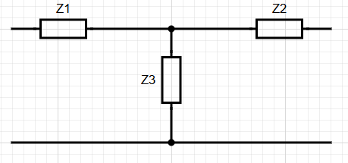
- True or false, this configuration is known as the π-Form quadripole
- Which of the following stands for symmetrical quadripole:
a) Z₁=Z₂=Z₃; b) Z₁=Z₃; c) Z₂=Z₃; d) Z₁=Z₂;
- Let Z₁=Z₂=R and Z₃ a capacitor. What is the of role of this circuit? Justify with simple reasoning.
- Which matrix is better to study this circuit:
a) Z-matrix; b) Y-matrix; c) H-matrix; d) G-matrix; Justify
- Let Z₁, Z₂ and Z₃ resistors. The quadripole issymmetrical ended with R_{L}, a load. By carefully choosing their values we can:
a) get an amplification of the input voltage; b) get an attenuation of the input voltage
c) get impedance matching; d) inverse the polarity; Justify with quick calculations.

