National Higher School of Autonomous Systems Technology
Electronics Mid-Term/ Sunday, June 15th, 2025
Duration: 1h30
Exercise 3: (5pts): (0.5, 2*0.5, 2*0.5, 2*0.5, 3*0.5)
Given the quadripole in the following figure, answer the questions:
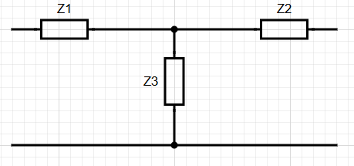
- True or false, this configuration is known as the π-Form quadripole
- Which of the following stands for symmetrical quadripole:
a) Z₁=Z₂=Z₃; b) Z₁=Z₃; c) Z₂=Z₃; d) Z₁=Z₂;
- Let Z₁=Z₂=R and Z₃ a capacitor. What is the of role of this circuit? Low Pass Filter
Justify: Z₃=1/jc𝟂 goes to infinity for small frequencies (𝟂 0) and it becomes open circuit which means the output equals the input minus voltage drop caused by resistances. Z₃=1/jc𝟂 goes to zero for high frequencies (𝟂 ∞) and it becomes short circuit which means the output equals 0.
- Which matrix is better to study this circuit:
a) Z-matrix; b) Y-matrix; c) H-matrix; d) G-matrix; Justify: it consists of impedances.
- Let Z₁, Z₂ and Z₃ resistors. The quadripole is symmetrical ended with R_{L}, a load. By carefully choosing their values we can:
a) get an amplification of the input voltage; b) get an attenuation of the input voltage
c) get impedance matching; d) inverse the polarity; Justify: give the voltage gain in function of resistances and show that it is less than 1 and that it is positive.

