

Thyroid Disease Detection

Revision Number: Last date of revision:

**Document Version Control**

High Level Design (HLD)



|  |  |  |  |
| --- | --- | --- | --- |
| **Date Issued** | **Version** | **Description** | **Author** |
| 18-09-2022 | 1 | Initial HLD-V1.0 | Akash Soni & Archana Joshi |
|  |  |  |  |
|  |  |  |  |
|  |  |  |  |
|  |  |  |  |



**Contents**

High Level Design (HLD)

Document Version Control 2 Abstract 4 1 Introduction 5

* 1. Why this High-Level Design Document 5
  2. Scope 5
  3. Definitions 5 2 General Description 6
  4. Product Perspective 6
  5. Problem Statement 6
  6. Proposed Solution 6
  7. Further Improvements 6
  8. Data Requirements 7
  9. Tools Used 8
  10. Constraints 9
  11. Assumptions 9

1. Design Details 9
   1. Process Flow 9 3.1.1 Model Training and Evaluation 10

3.1.2 Deployment Process 10

* 1. Event log 11
  2. Error Handling 11 4 Performance 12
  3. Reusability 12
  4. Application Compatibility 12
  5. Resource Utilization 12
  6. Deployment 12

1. Conclusion 13
2. References 13



**Abstract**

High Level Design (HLD)

At least a person out of ten is suffered from thyroid disease in India. The disorder of thyroid disease primarily happens in the women having the age of 17–54. The extreme stage of thyroid results in cardiovascular complications, increase in blood pressure, maximizes the cholesterol level, depression and decreased fertility. The hormones, **total serum thyroxin (T4)** and **total serum triiodothyronine (T3)** are the two active thyroid hormones produced by the thyroid gland to control the metabolism of body. For the functioning of each cell and each tissue and organ in a right way, in overall energy yield and regulation and to generate proteins in the ordnance of body temperature, these hormones are necessary .

The basis of classification of thyroid disease is **euthyroidism**, **hyperthyroidism** and **hypothyroidism** which are denoting normal, excessive or defective levels of thyroid hormones. The state euthyroidism depicts the normal production of thyroid hormones and normal levels at the cellular level by the thyroid gland. The state hyperthyroidism is clinical symptom due to excessive circulation and intracellular thyroid hormones. The state hypothyroidism is most of due to the lack of thyroid hormone generation and poor alternate therapy.

Cure of disease is a regular concern for the health care practitioners, and the errorless diagnostic at the right time for a patient is very important. Recently, by some advanced diagnosis methods, the common medical report can be generated with an additional report based on symptoms. The different questions like ‘‘what are the causes for affecting the thyroid?’’, ‘‘Which age group of people are affected due to thyroid?’’, ‘‘what is the relevant treatment for a disease?’’. **All these answers we can find on implementing machine learning methods on Health care data**. Health care data can be processed and after implementing with certain methodologies; it can provide information that can be used in diagnosis and treatment of diseases more efficiently and accurately with better decision making and minimizing the death risk.

# Introduction

High Level Design (HLD)



* + 1. **Why this High-Level Design Document?**

The purpose of this High Level Design (HLD) Document is to add the necessary details to the current project description to represent a suitable model for coding. This document is also intended to help detect contradictions prior to coding, and can be used as reference manual for how the modules interact at a high level.

## The HLD will

* + - * Present all of the design aspects and define them in detail
      * Describe the user interface being implemented
      * Describe the hardware and software interfaces
      * Describe the performance requirements
      * Include design feature and the architecture of the project
      * List and describe the non-functional attribute like:
        + Security
        + Reliability
        + Maintainability
        + Portability
        + Reusability
        + Application compatibility
        + Resource utilization
        + Serviceability

# Scope

The HLD document presents the structure of the system, such as the database architecture, application architecture (layers), application flow (Navigation), and technology architecture. The HLD uses non-technical to mildly-technical terms which should be understandable to the administrators of the system.

# Definitions

* + - * TDD – Thyroid Disease Detection



* 1. **General Description**

High Level Design (HLD)

* + 1. **Product Perspective**

The Thyroid Disease Detection solution system is a data science-based machine learning model which help us to detect the thyroid disease in people and take necessary action.

# Problem Statement

To create an AI solution for detecting thyroid disease and to implement the following use cases.

* To detect thyroid disease and its type in healthy person.
* To detect thyroid disease and its type in unhealthy person.

Here unhealthy person means person already affected by thyroid disease.

# Proposed Solution

The solution proposed here is a data science model based on machine learning can be implemented to perform above mention use cases. In first use case , we will take input from a healthy person who is not suffering from thyroid disease and see whether proposed solution is going to detect it or not. And in second use case, we will take input from an unhealthy person, already suffering from thyroid disease and check our solution whether it is performing or not in right way.

# Further Improvements

The Thyroid disease detection solution can be added with more use cases in health care domain. TDD solution can also be synchronized with other health care domain solution to give one step extra confirmation of health to those people who has little symptoms of thyroid disease also.



# Data Requirements

High Level Design (HLD)

Data requirement completely depend on our problem statement.

we need data of people who have already gone with thyroid blood test to know whether they are suffering from thyroid disease or not. If yes then what kind of thyroid disease they are suffering from. We will be required these many attributes, in which some will be personal details and some will be attributes from blood test.

* Age: Because thyroid depend on age, older than 60, especially in women.
* Gender: A woman is about five to eight times more likely to be diagnosed with a thyroid condition than a man.
* People already on thyroxin treatment or not
* People already on anti thyroid medication or not
* Pregnancy if gender is female: Postpartum thyroiditis is a condition occurs in 5% to 9% of women after childbirth.
* Whether person is sick at the time of diagnosis.
* Iodine test: Excess and low amount both can cause thyroid disease.
* Lithium test: Lithium is concentrated by the thyroid and inhibits thyroidal iodine uptake
* Goitre test: A goitre can sometimes occur when your thyroid gland produces too much thyroid hormone (hyperthyroidism).
* Tumour test: Thyroid cancer occurs when cells in your thyroid undergo genetic changes (mutations). The mutations allow the cells to grow and multiply rapidly. The cells also lose the ability to die, as normal cells would. The accumulating abnormal thyroid cells form a tumour.
* TSH level measure: It supervise thyroid gland, TSH released by pituitary gland. Normal TSH range for an adult:
* 0.40 - 4.50 mIU/mL (milli-international units per litre of blood).
* T3 level measure: Hormone released by thyroid, should be in normal range.
* T4 level measure: Low T4 is seen with hypothyroidism, whereas high T4 levels may indicate hyperthyroidism. Normal T4 range for an adult: 5.0 – 11.0 ug/dL (micrograms per decilitre of blood).
* FTI(Free T4 or Free Thyroxine: The free T4 index (FTI) is a blood test used to diagnose thyroid disorders. The FTI is obtained by multiplying the (Total T4) times (T3 Uptake) to obtain an index. Normal FT3 range: 2.3 - 4.1 pg/mL (picograms per millilitre of blood).
  + Thyroxine-binding globulin (TBG): The TBG blood test measures the level of a protein that moves thyroid hormone throughout your body.

High Level Design (HLD)



In all the above mentioned attributes if attribute is having binary answer then we need it in Boolean and for measures we need them in float values.

# Tools used

Python programming language and frameworks such as NumPy, Pandas, Scikit-learn, Matplotlib, Plotly, Flask etc are used to build the whole model.





* + - * PyCharm is used as IDE
      * Virtual Studio Code is also used as IDE
      * For visualization of the plots, Matplotlib, Seaborn and Plotly are used.
      * AWS is used for deployment of the model.
      * Heroku is also used for deployment of the model.
      * Tableau/Power BI is used for dashboard creation.
      * Cassandra database is used DB operations
      * Python, Flask is used for backend development
      * Github is used as Version Contol System.



# Constraints

High Level Design (HLD)

The Thyroid Disease Detection solution system must be correct enough that it not mislead any report and as automated as possible and users should not be required to know any of the workings.

# Assumptions

The main objective of the project is to implement the use cases as previously mentioned for new dataset that comes through Hospitals which has this solution install in their campus to capture people reports.

# Design Details

* + 1. **Process Flow**

For detecting thyroid disease, we will use machine learning base model. Below is the process flow diagram is as shown below

**Proposed methodology**

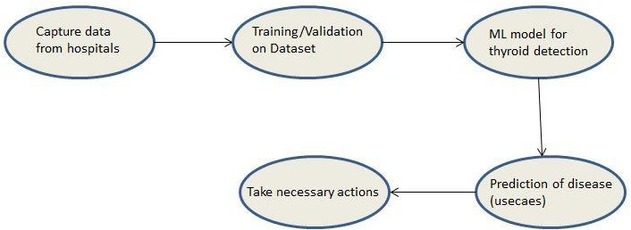

**Handling Imbalance Class**



* + 1. Model Training and Evaluation

High Level Design (HLD)

**Data Cleansing**

**Create a Test Set**

**Data Collection**

**Feature Engineering**

**Imputation of Missing value**

**Same Process on Test**

**Set**

**Select & Train Models**

**Training & Evaluating on Training Set**

**Evaluate Our System on Test Set**

**Model Deployment**

**Fine Tune Best Model**

* + 1. Deployment Process

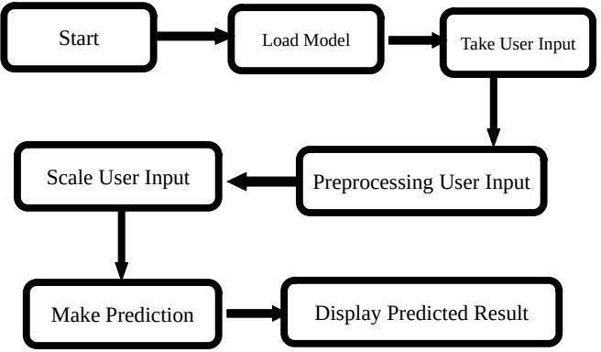



* + 1. **Event log**

High Level Design (HLD)

The system should log every event so that the user will know what process is running internally.

## Initial Step-By-Step Description:

1. The System identifies at what step logging required.
2. The System should be able to log each and every system flow.
3. Developer can choose logging method. You can choose database logging/ File logging s well.
4. System should not hang even after using so many loggings. Logging just because we can easily debug issues so logging is mandatory to do.

# Error Handling

Should errors be encountered, an explanation will be displayed as to what went wrong? An error will be defined as anything that falls outside the normal and intended usage.





# Performance

High Level Design (HLD)

The machine learning based Thyroid Disease Detection solution will used for detection of thyroid disease in patients having symptoms of thyroid. So that necessary action will be taken ASP. Also model retraining is very important to improve performance.

# Reusability

The code written and the components used should have the ability to be reused with no problems.

# Application Compatibility

The different components for this project will be using python as an interface between them. Each component will have its own task to perform, and it is the job of the Python to ensure proper transfer of information.

# Resource utilization

When any task is performed, it will likely use all the processing power available until that function is finished.

# Deployment





* 1. **Conclusion**

High Level Design (HLD)



Thyroid Disease Detection solution will take health-care domain data of those patients who have undergone diagnosis for thyroid to train our machine learning model and will evaluate its performance over usecaes mentioned above. And then leverage its prediction to detect thyroid disease in people having symptoms of thyroid and able to alert people who is on positive side so that medical attention along with treatment will be given to that particular people as soon as possible. This solution should be as accurate as possible, so that chances of misleading reports will be taken good care of.

# References

[UCI Machine Learning Repository For Data Set](https://archive.ics.uci.edu/)

URL: https://archive.ics.uci.edu/ml/datasets/thyroid+disease

