**Overview and Motivation**

Provide an overview of the project goals and the motivation for it. Consider that this will be read by people who did not see your project proposal.

As avid gamers we were looking to create and visualize the data corresponding to a player’s performance in a game they played. While we had a multitude of potential candidates for the game to visualize, we ended up deciding on League of Legends. This decision came from our own experiences with this title, as well as the ease of data presented by the multitude of API calls that Riot Games as access to.

**Related Work**

Anything that inspired you, such as a paper, a web site, visualizations we discussed in class, etc.

There are many sites that already exist to portray a large variety of data for a user to learn from their past games. These websites were the largest inspiration and what we aim to recreate with our data. The pure amount of data given by the API calls allows us to explore multiple avenues in how different strategies and changes in games impact how a user performs.

**Questions**

What questions are you trying to answer? How did these questions evolve over the course of the project? What new questions did you consider in the course of your analysis?

We are aiming to show a user multitude of data based on their own performance and how it contributed to their wins or losses.

**Data**

Source, scraping method, cleanup, etc.

Our original data was going to come from an entirely separate game in Apex Legends. However, the API calls for both casual players, and professional tournaments were lacking in their ability and magnitude of data. As such we pivoted to League of Legends as the API is significantly more supported and provides a better overview of how a game progressed. This new data required little cleanup as the APIs already provide a clean and efficient space. However, multiple calls were needed to capture the scope of the data we desired.

**Exploratory Data Analysis**

What visualizations did you use to initially look at your data? What insights did you gain? How did these insights inform your design?

Initially we are exploring many of the graphs used in assignment 3, these graphs are a wonderful baseline to assimilate the data we have and graphing in D3 that we are familiar with. We also just looked a lot at the json of the data to gain an idea of what aspects of the game were even workable. There is no time scalar so any visualizations that revolve around something in the middle of the game were out of the question. This led us to a multiple game approach where we compare different games together for an overall strategy.

**Design Evolution**

What are the different visualizations you considered? Justify the design decisions you made using the perceptual and design principles you learned in the course. Did you deviate from your proposal?

One visualization we knew that we wanted was to display the characters that had been played. This would give the user an idea of where their strength lye, and by giving some sort of win percentage, we would further gain an idea of how their performance was impacted.

We also decided on a calendar heatmap since that would provide an easy way to visualize their performance history. The calendar heatmap is able to concisely show a lot of different data such as wins/losses, games played, and date those games were played on.

**Implementation**

Describe the intent and functionality of the interactive visualizations you implemented. Provide clear and well-referenced images showing the key design and interaction elements.

Focused mainly on utilizing the graphs from homework 3, we already have a baseline of multiple statistics and how it might impact play. The user can see their efficiency in how much gold they are earning a second on average over their last games. They also can see how their risk of playing impacts the number of kills in respect to how often they die.

We also added a calendar heatmap similar to what GitHub uses for the commit history. This is pretty cool since it allows the user to see generally how they are playing each day and can see any progress that they may be making. This graph is also interactable and allows the user to hover over the various cells to show the date and wins/losses on that day. The user can also select the colors on the bottom to filter by those values.

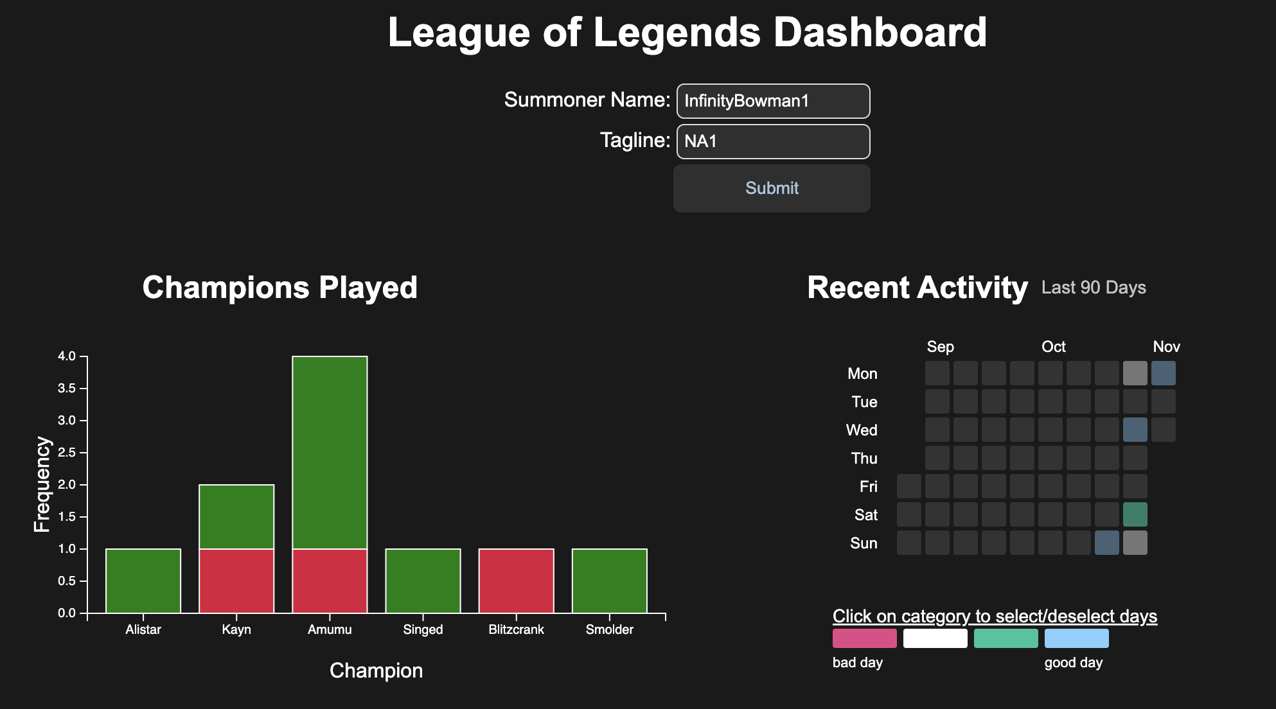

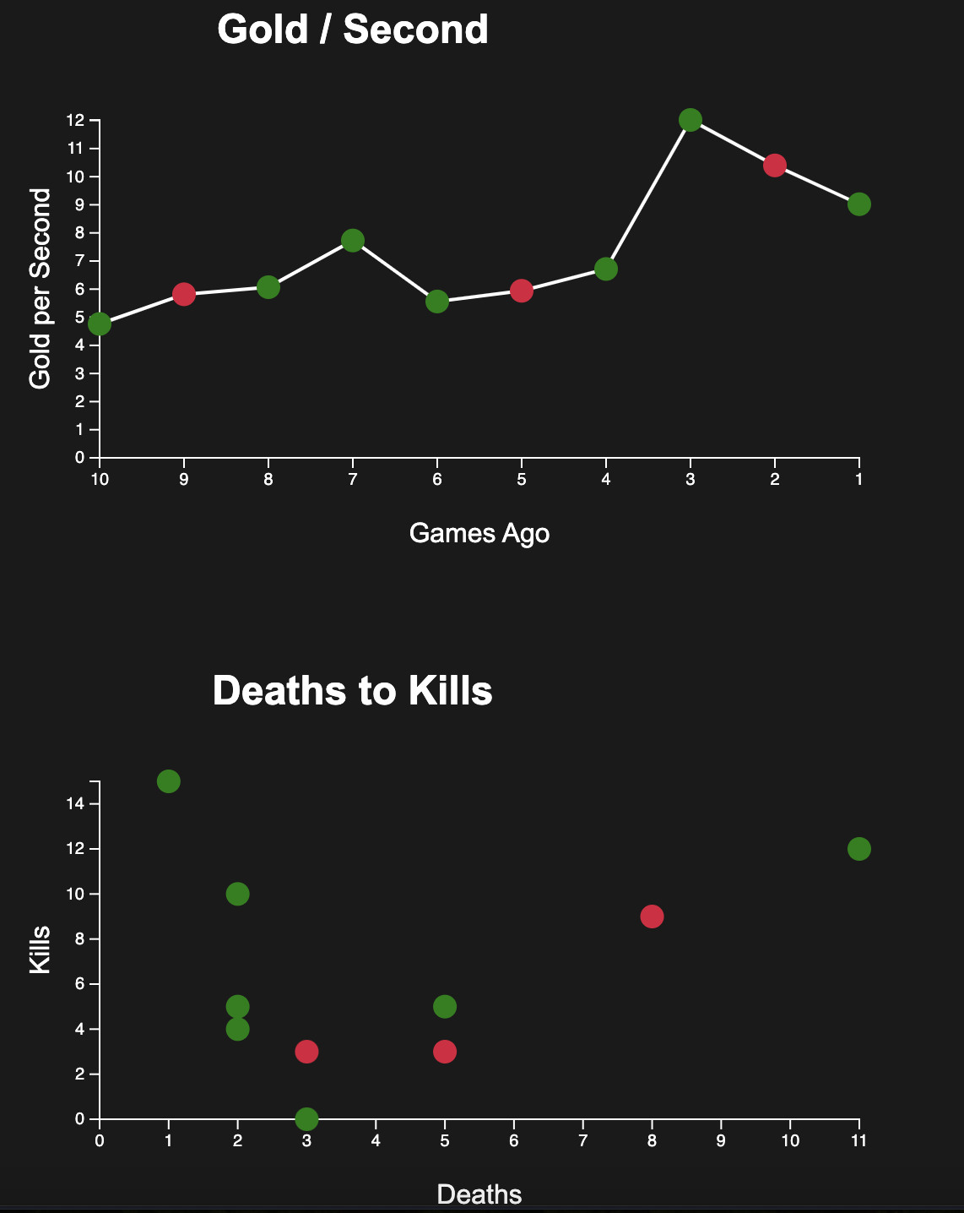

**Evaluation**

What did you learn about the data by using your visualizations? How did you answer your questions? How well does your visualization work, and how could you further improve it?