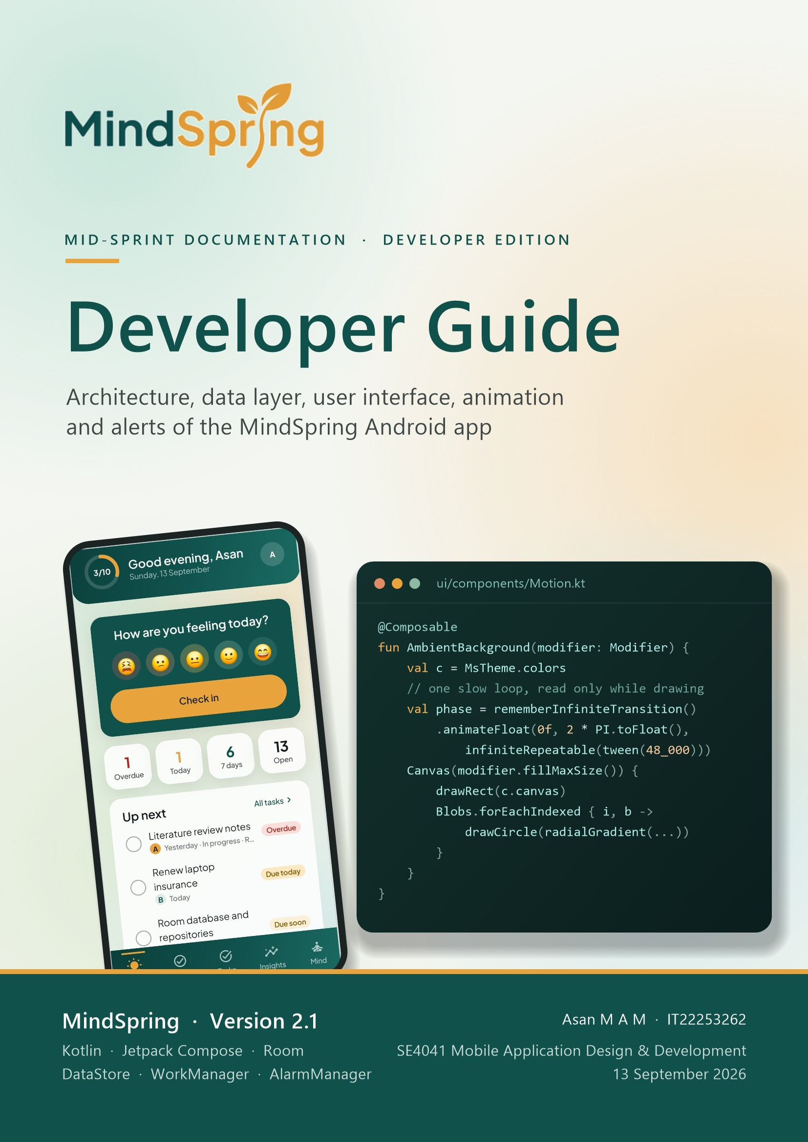
Contents
How this guide is organised: chapters 1–3 set up the project and explain its architecture, chapters 4–5 cover the data layer and domain logic, chapters 6–8 the user interface, design system and animation, chapter 9 reminders and alarms, and chapters 10–12 testing, extension recipes and a source index.
1 Introduction 4
1.1 Who this guide is for 4
1.2 MindSpring in one page 4
1.3 Technology stack 4
1.4 The codebase at a glance 5
2 Project Setup and Build 6
2.1 Prerequisites 6
2.2 Build configuration 6
2.3 Common Gradle tasks 7
2.4 Running the app 7
2.5 Tooling inside the IDE 7
3 Architecture 8
3.1 Layers and responsibilities 8
3.2 Application start-up 9
3.3 Dependency injection with AppContainer 10
3.4 Unidirectional data flow 11
3.5 The Screen / Content pattern 11
4 Data Layer (Backend) 13
4.1 Domain models 13
4.2 The Room database 14
4.3 User scoping with Session 17
4.4 Repositories 18
4.5 Settings with DataStore 18
4.6 Authentication 19
4.7 Backup and restore 19
4.8 Sample data 20
5 Domain Logic 21
5.1 HabitStats: judging habits 21
5.2 TaskLogic: flags, groups and repeats 22
5.3 Analytics: month rollups 22
5.4 InsightEngine: the key insight 23
5.5 Smaller rules 23
6 User Interface (Frontend) 24
6.1 Navigation 24
6.2 ViewModels and UI state 25
6.3 Screen catalogue 25
6.4 Forms and one-shot events 26
6.5 Permissions and system integration 27
7 Design System 28
7.1 Colour tokens 28
7.2 Typography, shapes and spacing 29
7.3 Component library 29
7.4 Light and dark themes 31
7.5 Previews 31
8 Animation and Motion 32
8.1 Principles 32
8.2 Animation catalogue 32
8.3 Ambient background 33
8.4 Staggered card entrance 34
8.5 Navigation transitions and the tab indicator 34
8.6 Feedback micro-interactions 35
8.7 Charts that draw themselves 35
8.8 The breathing exercise 36
8.9 Celebration and the alarm gesture 36
8.10 Reduced motion 37
9 Reminders and Alerts 38
9.1 Overview 38
9.2 Keeping alarms in step with data 39
9.3 Firing an alert 40
9.4 Notification channels and tones 41
9.5 The full-screen alarm activity 41
9.6 Answering: Done, Snooze and Stop 42
9.7 Surviving reboots and clock changes 42
9.8 Daily nudges with WorkManager 42
10 Testing 44
10.1 Test suite 44
10.2 The test application 44
10.3 Domain tests 44
10.4 Migration test 45
10.5 Screenshot tests 45
11 Extending the App 47
11.1 Add a new screen 47
11.2 Add a field to a stored model 47
11.3 Add a setting 47
11.4 Add an animation 48
11.5 Add a habit icon or life-area colour 48
11.6 Coding conventions 48
12 Source File Index 49

1 Introduction
This guide explains how MindSpring is built: the project setup, the architecture, the Room and DataStore data layer, the pure-Kotlin domain logic, the Jetpack Compose user interface and design system, every animation, and the reminder and alarm system.

1.1 Who this guide is for
It is written for developers who will read, maintain or extend the code, and for assessors who want to see how the features described in the User Manual are implemented. It assumes working knowledge of Kotlin, coroutines and Flow, and the basics of Jetpack Compose. Every class, function and file named here exists in the repository; code excerpts are copied from the source and shortened only where marked with ….
NOTE The companion MindSpring User Manual describes what each screen does from the user’s point of view. This guide describes how it works. Where behaviour is explained in detail there, this guide refers to it rather than repeating it.

1.2 MindSpring in one page
MindSpring is a single-module, offline-first Android application. All data stays on the phone. The main technical characteristics are:
- 100% Kotlin and Jetpack Compose. There are no XML layouts; the UI is Material 3 with a custom design system on top.
- Offline-first storage. A Room (SQLite) database holds user data; Preferences DataStore holds settings and the signed-in session. There is no network code at all.
- Unidirectional data flow. Room exposes Flows, repositories map them to domain models, ViewModels combine them into immutable UI state, and composables render that state and send events back.
- Manual dependency injection. One AppContainer object builds every repository. No DI framework is needed for an app of this size.
- Pure domain logic. Streaks, completion rates, task flags, analytics and the mood insight live in plain Kotlin objects with no Android imports, and are unit tested directly.
- Exact-time alerts. Task alerts and habit reminders use AlarmManager, notification channels and a full-screen alarm activity; daily nudges use WorkManager.
- Motion with restraint. Animations use Compose’s animation APIs and honour both an in-app switch and the system “remove animations” setting.

1.3 Technology stack
Versions come from gradle/libs.versions.toml, the single place where dependency versions are declared.
Area | Library / tool | Version | Used for
Build | Android Gradle Plugin | 9.4.0 | Build system; compiles Kotlin (built-in Kotlin support)
Language | Kotlin + Compose compiler plugin | 2.2.10 | Language and Compose code generation
Annotation processing | KSP | 2.3.12 | Generates Room DAO and database code
UI | Compose BOM | 2026.09.00 | Compose UI, Material 3, extended icons, tooling
UI | Activity Compose | 1.13.0 | setContent, activity result launchers
Architecture | Lifecycle (ViewModel, runtime-compose) | 2.11.0 | ViewModels, collectAsStateWithLifecycle
Navigation | Navigation Compose | 2.10.1 | NavHost, typed arguments, transitions
Storage | Room | 2.8.5 | SQLite database, DAOs, auto-migrations
Storage | DataStore Preferences | 1.2.1 | Settings and session
Background | WorkManager | 2.11.2 | Daily evening and morning nudges
Testing | JUnit 4 / Robolectric | 4.13.2 / 4.17 | Unit and JVM Android tests
Testing | Roborazzi | 1.74.0 | Screenshot capture of every screen

1.4 The codebase at a glance
The app module contains 72 Kotlin source files (about 14,100 non-blank lines) and 8 test files (about 840 lines). Code is organised by layer first and by feature inside the UI layer:
Package (under com.mindspring.app) | Files | Lines | Responsibility
(root) | 3 | 115 | MindSpringApp, MainActivity, AppContainer
data.model | 1 | 194 | Immutable domain models and enums
data.repository | 1 | 105 | Repository interfaces the UI depends on
data.local | 6 | 1,110 | Room entities and DAOs, repository implementations, DataStore, backup, demo data
domain | 7 | 672 | Pure business logic: habits, tasks, analytics, insights, validation, hashing
reminders | 4 | 649 | Alerts, alarm activity, notification channels, WorkManager nudges
ui (AppViewModel) | 1 | 21 | ViewModel factory helper
ui.navigation | 1 | 371 | Routes, NavHost, bottom bar chrome, transitions
ui.theme | 3 | 246 | Colours, typography, shapes, spacing, MindSpringTheme
ui.components | 13 | 2,001 | Design-system components, charts and motion
ui.screens.* | 28 | 7,825 | Feature screens and their ViewModels
ui.preview / ui.util | 4 | 755 | Preview host and sample data, formatters

2 Project Setup and Build
Everything needed to open, build, run and ship the project.

2.1 Prerequisites
- Android Studio with support for Android Gradle Plugin 9.4 (the Gradle wrapper downloads the matching Gradle version).
- JDK 17 or newer for Gradle. Source and target compatibility are set to Java 17.
- Android SDK platform 37 (compileSdk). The app targets SDK 36 and runs on Android 8.0 (API 26) and later.
- A phone or emulator on API 26+ to run the app. Unit and screenshot tests run on the JVM and need no device.

2.2 Build configuration
The single application module is configured in app/build.gradle.kts. Only three plugins are applied: the Android application plugin, the Kotlin Compose compiler plugin and KSP for Room.
app/build.gradle.kts (excerpt)
plugins {
alias(libs.plugins.android.application)
alias(libs.plugins.kotlin.compose)
alias(libs.plugins.ksp)
}

android {
namespace = "com.mindspring.app"
compileSdk = 37
defaultConfig {
applicationId = "com.mindspring.app"
minSdk = 26
targetSdk = 36
versionCode = 2
versionName = "2.1"
}
buildTypes {
release {
isMinifyEnabled = true
isShrinkResources = true
// Signed with the debug key so the release APK installs directly on a phone.
signingConfig = signingConfigs.getByName("debug")
}
}
buildFeatures { compose = true }
}

// Room writes one JSON file per schema version into app/schemas (kept in git).
ksp {
arg("room.schemaLocation", "$projectDir/schemas")
arg("room.generateKotlin", "true")
}

IMPORTANT The release build is signed with the debug key so that a coursework APK installs directly on a phone. Replace signingConfig with a real keystore before publishing to any store.

2.3 Common Gradle tasks
Command | What it does
./gradlew assembleDebug | Builds a debuggable APK in app/build/outputs/apk/debug/.
./gradlew installDebug | Builds and installs the debug APK on the connected device.
./gradlew assembleRelease | Builds the minified, resource-shrunk release APK (R8).
./gradlew testDebugUnitTest | Runs all JVM tests: domain, repository, migration, alert and screenshot tests.
./gradlew testDebugUnitTest --tests "*ScreenshotTest*" | Renders every screen to app/build/screenshots/*.png with Roborazzi.
./gradlew kspDebugKotlin | Regenerates Room code and exports the schema JSON after entity changes.

On Windows use gradlew.bat instead of ./gradlew. The repository’s .gitattributes keeps the gradlew script’s Unix line endings so it runs on macOS and Linux.

2.4 Running the app
- Open the project folder in Android Studio and let Gradle sync.
- Select the app run configuration and a device on API 26 or later, then run.
- On first launch, swipe through the welcome slides, then either register or tap Explore with sample data.
The sample account is created on demand by DemoData.seed() with a fixed random seed, so every run — and every screenshot — shows the same six weeks of history. Its credentials are asan@mindspring.app / mindspring; registering with that email is blocked so it can never clash with a real account.

2.5 Tooling inside the IDE
- Compose previews. Every screen file ends with @Preview functions (light, dark and edge-case states) that render against ui/preview/PreviewData.kt without a ViewModel. ComponentPreviews.kt previews the component library.
- Database Inspector. The database file is mindspring.db; Android Studio’s App Inspection shows all nine tables live while the app runs.
- Schema history. app/schemas/com.mindspring.app.data.local.MindSpringDatabase/1.json, 2.json and 3.json record each database version and are what the auto-migrations are generated from.

3 Architecture
MindSpring follows the layered architecture recommended for Android: a Compose UI layer, ViewModels holding UI state, a data layer behind repository interfaces, and a pure domain layer shared by both.

3.1 Layers and responsibilities
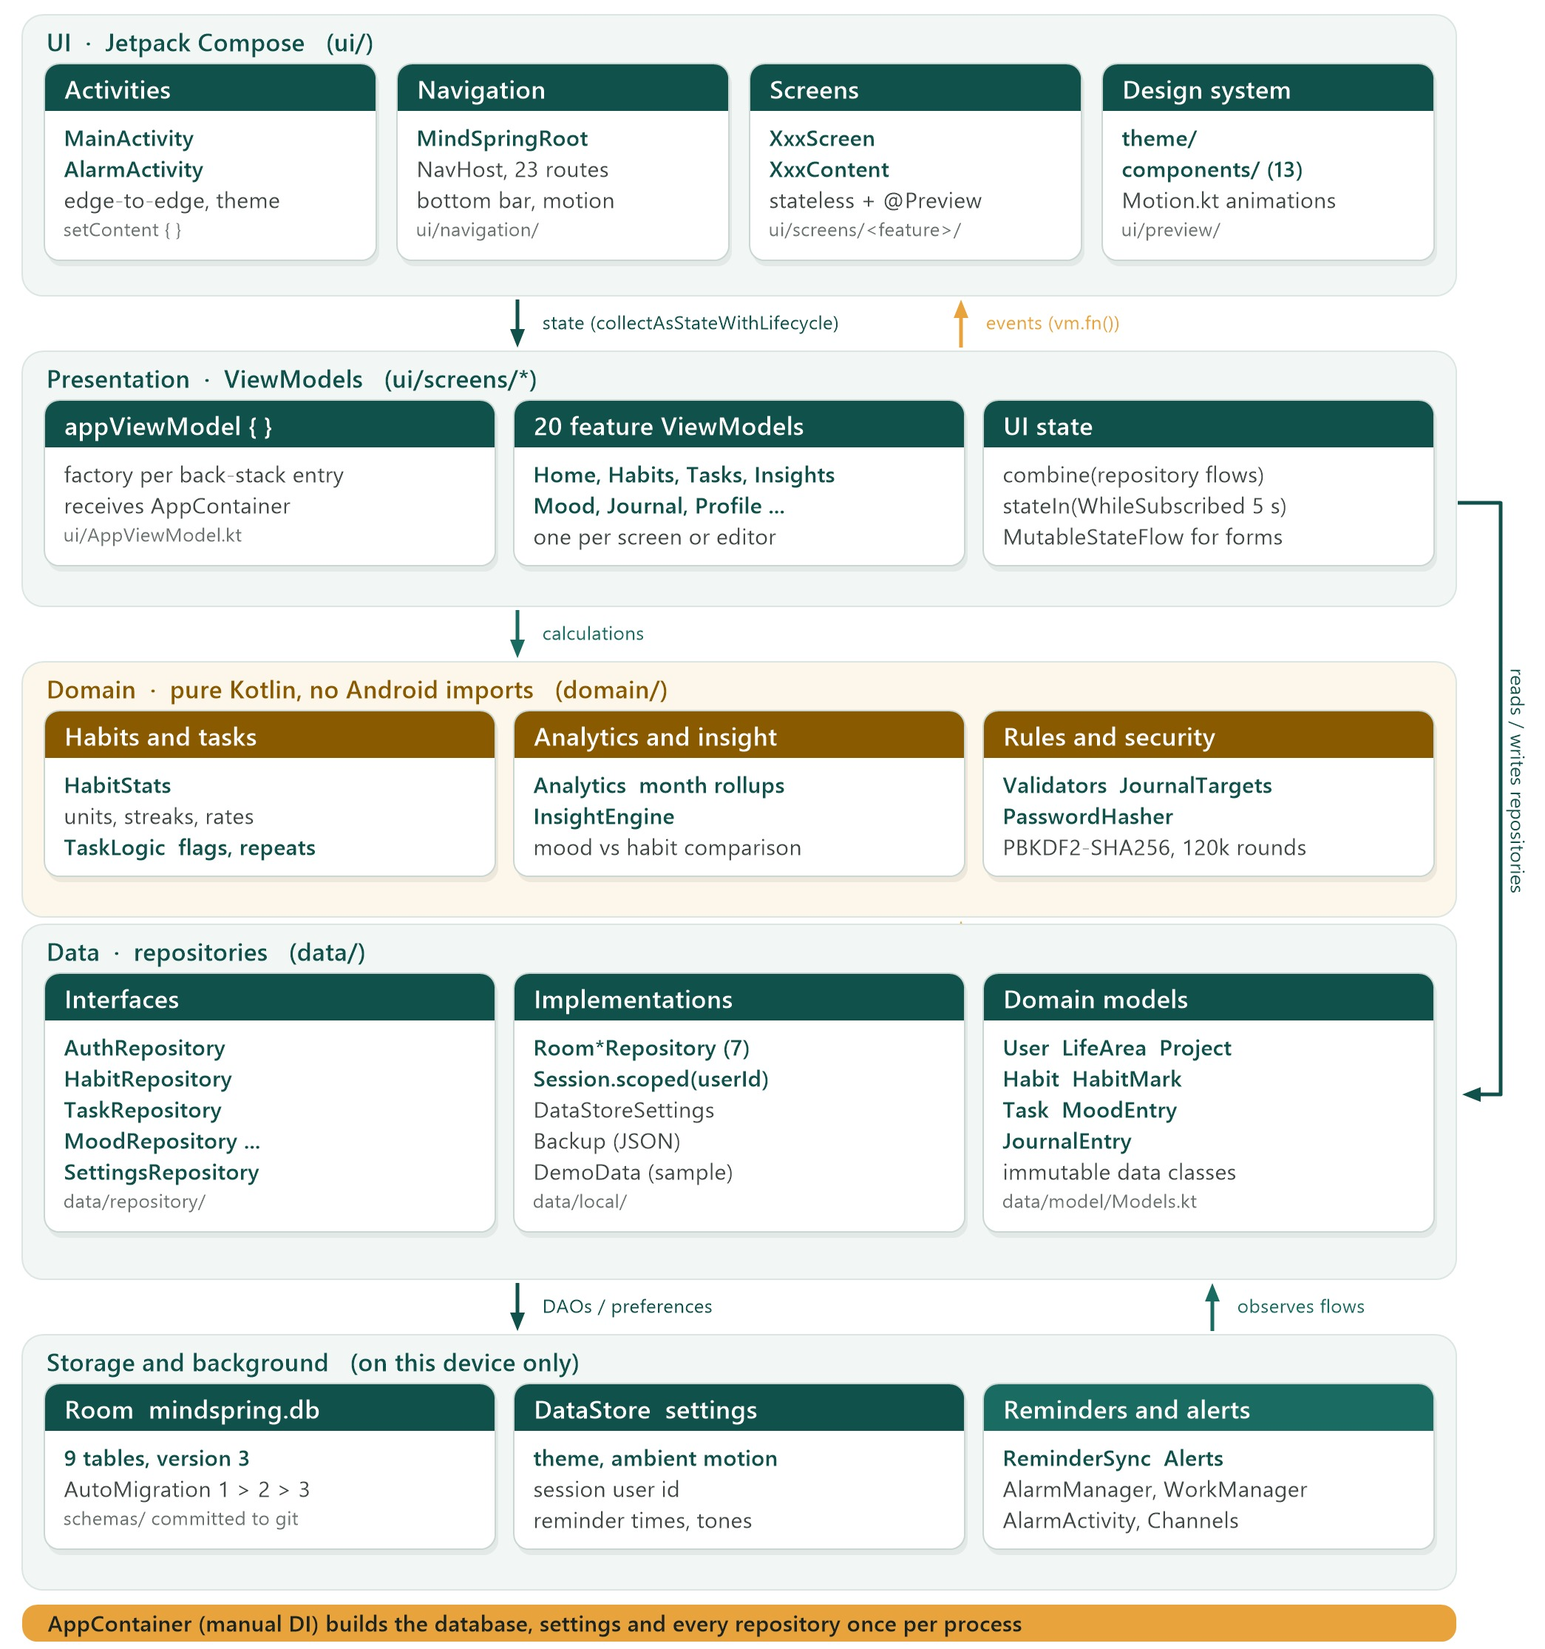
Figure 3.1 Layered architecture of the app module
Layer | Knows about | Never knows about
UI (screens, components, navigation) | UI state classes, ViewModel functions, the theme | Room, DataStore, AlarmManager
Presentation (ViewModels) | Repository interfaces, domain objects, AppContainer | Composables, Android views, entities
Domain (domain/) | Domain models only | Android framework, storage, UI
Data (data/) | Room, DataStore, domain models, domain rules it enforces | ViewModels and UI
Reminders (reminders/) | Repositories, domain, Android alarm and notification APIs | Screens (it launches activities by intent)

3.2 Application start-up
The Application subclass builds the container once per process and starts the background synchronisation of reminders. Both steps are open so tests can replace them.
MindSpringApp.kt
open class MindSpringApp : Application(), Configuration.Provider {
lateinit var container: AppContainer
private set

/** Lives as long as the process; used for work that outlasts any screen. */
val appScope = CoroutineScope(SupervisorJob() + Dispatchers.Default)

override fun onCreate() {
super.onCreate()
container = createContainer()
startBackgroundWork()
}

protected open fun createContainer(): AppContainer = AppContainer(this)

/** Keeps scheduled reminders in step with settings and habits. Tests turn this off. */
protected open fun startBackgroundWork() {
ReminderSync.start(this, container, appScope)
}

// WorkManager starts on first use with this configuration instead of at process start.
override val workManagerConfiguration: Configuration
get() = Configuration.Builder().build()
}

MainActivity enables edge-to-edge drawing, reads the theme mode and ambient-motion settings as state, and hosts the whole UI. It also turns an alert’s “open” intent into a navigation target, so tapping a notification opens the right task or habit.
MainActivity.kt (excerpt)
override fun onCreate(savedInstanceState: Bundle?) {
super.onCreate(savedInstanceState)
enableEdgeToEdge()
// On a rotation the launch intent is still there; it was already opened.
if (savedInstanceState == null) openTarget.value = targetFrom(intent)
val settings = (application as MindSpringApp).container.settings
// Respect the system "remove animations" setting as well as the in-app switch.
val systemAnimations = Settings.Global.getFloat(
contentResolver, Settings.Global.ANIMATOR_DURATION_SCALE, 1f) > 0f
setContent {
val mode by settings.themeMode.collectAsStateWithLifecycle(ThemeMode.System)
val ambient by settings.ambientMotion.collectAsStateWithLifecycle(true)
val pending by openTarget.collectAsStateWithLifecycle()
val dark = when (mode) {
ThemeMode.System -> isSystemInDarkTheme()
ThemeMode.Light -> false
ThemeMode.Dark -> true
}
MindSpringTheme(darkTheme = dark, ambientMotion = ambient && systemAnimations) {
MindSpringRoot(openTarget = pending, onOpened = { openTarget.value = null })
}
}
}

3.3 Dependency injection with AppContainer
Instead of Hilt or Koin, one small class decides which implementation of each interface runs. Screens obtain the container through the Application, never by constructing repositories themselves.
AppContainer.kt
class AppContainer(
context: Context,
val db: MindSpringDatabase = MindSpringDatabase.build(context),
) {
val settings: SettingsRepository = DataStoreSettings(context)
private val session = Session(settings)

val auth: AuthRepository = RoomAuthRepository(db, settings, session)
val areas: AreaRepository = RoomAreaRepository(db, session)
val habits: HabitRepository = RoomHabitRepository(db, session)
val tasks: TaskRepository = RoomTaskRepository(db, session)
val moods: MoodRepository = RoomMoodRepository(db, session)
val gratitude: GratitudeRepository = RoomGratitudeRepository(db, session)
val journal: JournalRepository = RoomJournalRepository(db, session)
val reset: DataReset = RoomDataReset(db, session)
val backup = Backup(db, session)
}

ViewModels are created with a one-line helper that scopes them to the current navigation entry and passes them the container:
ui/AppViewModel.kt
@Composable
inline fun <reified VM : ViewModel> appViewModel(
key: String? = null,
crossinline create: (AppContainer) -> VM,
): VM {
val container = (LocalContext.current.applicationContext as MindSpringApp).container
return viewModel(key = key, factory = viewModelFactory { initializer { create(container) } })
}

// Usage inside a screen:
val vm = appViewModel { HabitDetailViewModel(it, habitId) }

TIP Because the database is a constructor parameter with a default, tests build AppContainer(this, MindSpringDatabase.inMemory(this)) and get the real repositories over an in-memory database.

3.4 Unidirectional data flow
State only ever flows up from the database to the screen, and events only flow down. Nothing in the UI mutates shared state directly; it calls a ViewModel function, which writes through a repository, and the resulting database change flows back up as new state.
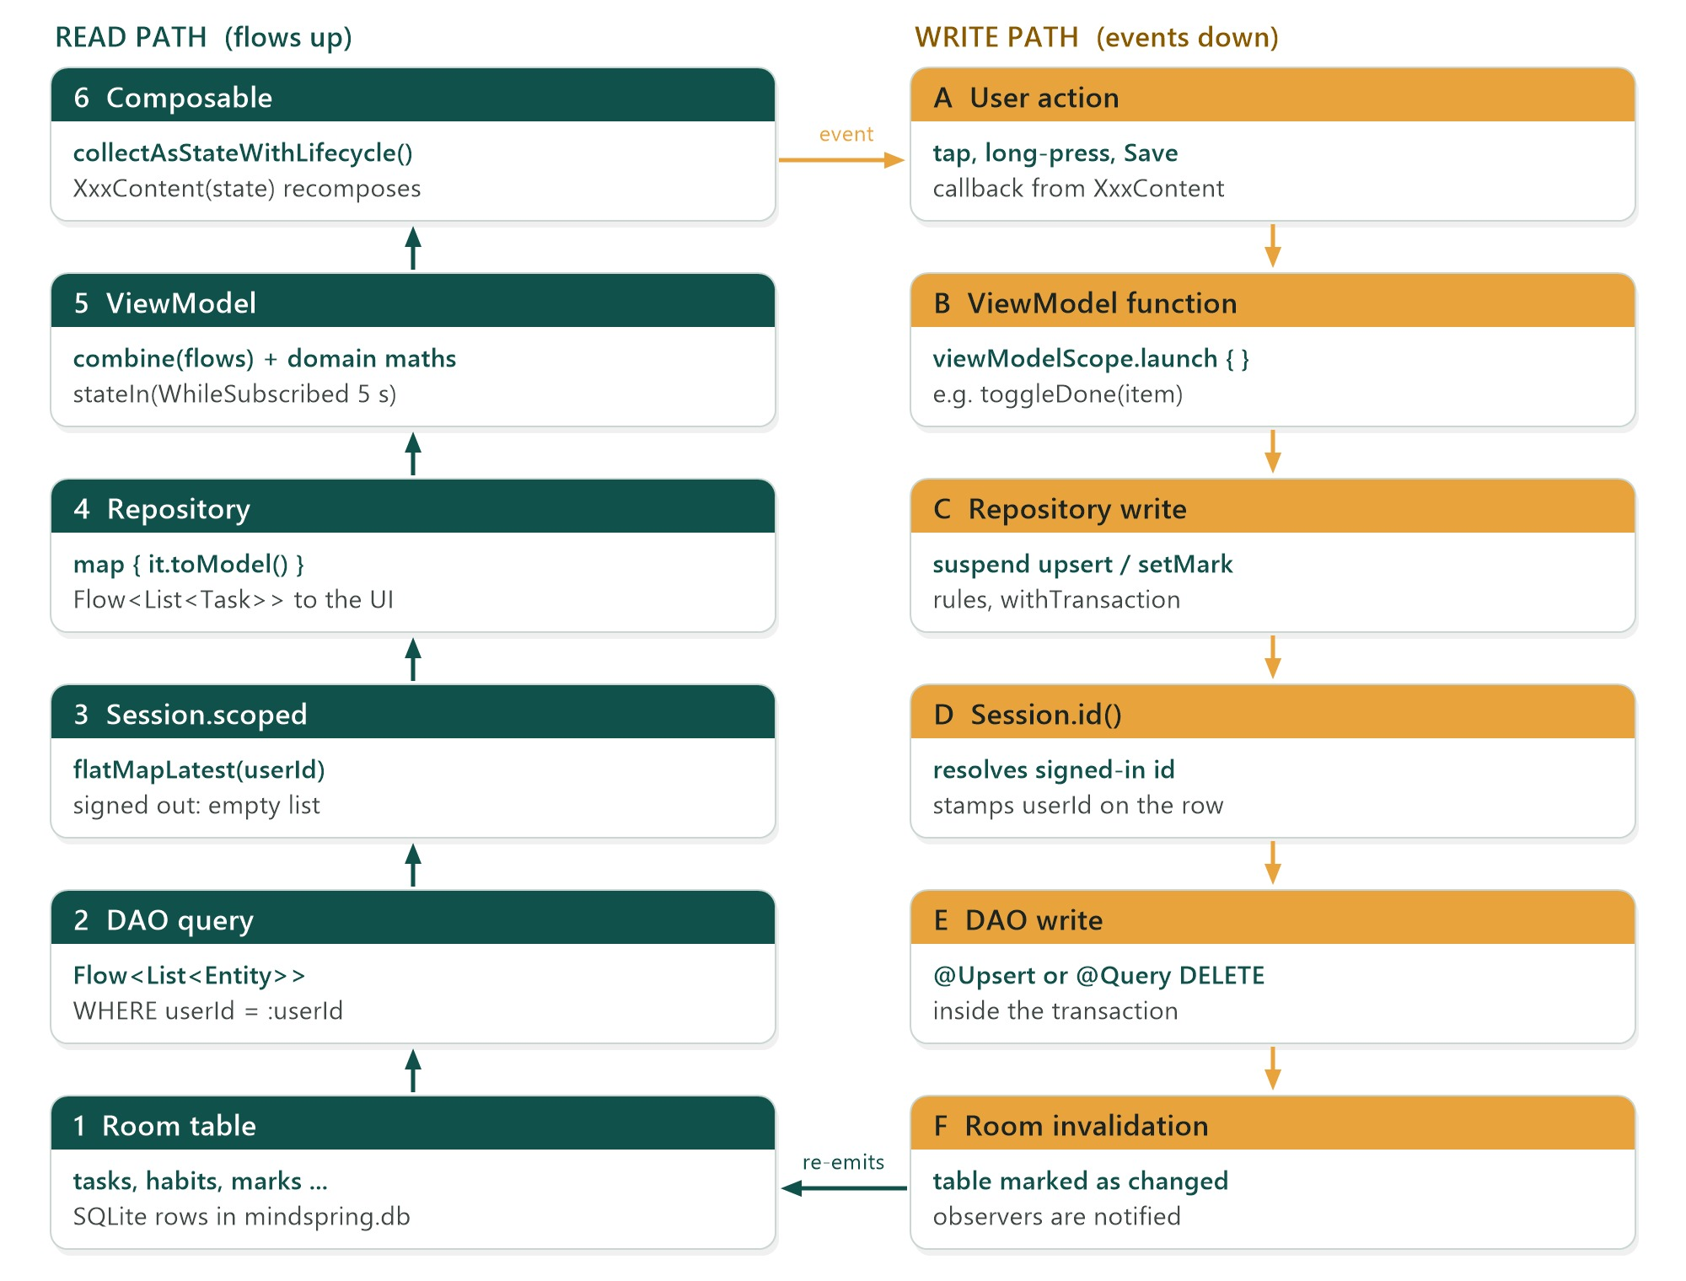
Figure 3.2 Read path and write path through the layers
- Room re-runs any observed query when one of its tables changes, so there is never a manual “refresh”.
- Session.scoped switches every query to the signed-in user and emits an empty value while signed out.
- ViewModels combine several repository flows and run domain calculations inside the combine lambda, then expose a single StateFlow with stateIn(viewModelScope, SharingStarted.WhileSubscribed(5_000), initial). The five-second grace keeps the upstream alive across rotations.
- Composables collect with collectAsStateWithLifecycle(), which stops collecting when the screen is in the background.

3.5 The Screen / Content pattern
Every screen is split into two composables in the same file. The public XxxScreen obtains the ViewModel and collects state; XxxContent takes plain state and callbacks and contains all the layout. This keeps the layout previewable and testable without a database.
ui/screens/mood/MoodCheckInScreen.kt (excerpt)
@Composable
fun MoodCheckInScreen(entryId: Long?, initialRating: Int?, onDone: () -> Unit) {
val vm = appViewModel { MoodCheckInViewModel(it.moods, entryId, initialRating) }
val s by vm.state.collectAsStateWithLifecycle()

LaunchedEffect(s.saved) { if (s.saved) onDone() } // one-shot navigation

MoodCheckInContent(
s = s,
onMood = vm::onMood,
onToggleFeeling = vm::onToggleFeeling,
onNote = vm::onNote,
onSave = vm::save,
onDone = onDone,
)
}

@Preview(name = "Mood check-in · dark", showBackground = true, widthDp = 393, heightDp = 900)
@Composable
private fun MoodCheckInDarkPreview() = PreviewScreen(dark = true) {
MoodCheckInContent(
s = CheckInState(mood = Mood.Great, feelings = setOf("Calm")),
onMood = {}, onToggleFeeling = {}, onNote = {}, onSave = {}, onDone = {},
)
}

Editors with many fields (habit, task) pass an actions interface instead of a dozen lambdas. The ViewModel implements it, and a no-op object None implements it for previews:
ui/screens/habits/HabitsViewModels.kt (excerpt)
interface HabitEditorActions {
fun onName(v: String)
fun onArea(v: Long?)
fun onSubArea(v: String)
// … frequency, days, target, reminder, icon, active …
fun save()

/** Does nothing; for previews, where there is no data layer to write to. */
object None : HabitEditorActions { /* every function = Unit */ }
}

class HabitEditorViewModel(app: AppContainer, habitId: Long?) : ViewModel(), HabitEditorActions

4 Data Layer (Backend)
MindSpring has no server: its “backend” is an on-device data layer. This chapter covers the domain models, the Room database, repositories and user scoping, settings, authentication, backups and the sample data.

4.1 Domain models
data/model/Models.kt defines immutable data classes used everywhere above the database. They use java.time types and Kotlin enums, never database types, so screens and domain logic stay independent of Room.
Model | Key fields | Notes
User | id, name, email, memberSince | No password: the hash never leaves the data layer.
LifeArea | id, name, colorIndex, sortOrder | colorIndex indexes AreaPalette.
Habit | name, areaId, subArea, icon, frequency, customDays, target, reminderEnabled, reminderTime, reminderStyle, active, createdAt | days is derived from frequency.
HabitMark | habitId, date, state | MarkState is Done or Skipped; a blank day has no row.
Task | title, notes, areaId, subArea, projectId, start, due, priority, status, doneOn, repeat, alertAt, alertStyle | code = "T%03d"; upcomingAlert(now).
Project | name, areaId, subArea, colorIndex, notes, archived | Progress is computed, never stored.
MoodEntry | mood, feelings, note, loggedAt | Mood enum carries rating 1–5 and label.
JournalEntry | date, rating, energy, highlight, monologue, tomorrowTop, updatedAt | One per date; words is computed.
GratitudeEntry | text, createdAt
AlertSounds | reminderTone, alarmTone, vibrate, snoozeMinutes | Tones are content URIs; null = silent.

data/model/Models.kt (excerpt)
enum class HabitFrequency(val label: String) {
Daily("Daily"), Weekdays("Weekdays"), Weekends("Weekends"),
Custom("Custom"), Weekly("Weekly"), Monthly("Monthly");

val isDayBased: Boolean get() = this != Weekly && this != Monthly
}

data class Habit(
val id: Long = 0,
val name: String,
val frequency: HabitFrequency = HabitFrequency.Daily,
/** Only read for Custom; the other frequencies imply their own days. */
val customDays: Set<DayOfWeek> = DayOfWeek.entries.toSet(),
/** Retired habits keep their history but stop appearing and stop counting. */
val active: Boolean = true,
val createdAt: LocalDate,
// … area, sub-area, icon, target, reminder fields …
) {
val days: Set<DayOfWeek>
get() = when (frequency) {
HabitFrequency.Daily, HabitFrequency.Weekly, HabitFrequency.Monthly -> DayOfWeek.entries.toSet()
HabitFrequency.Weekdays -> Weekdays
HabitFrequency.Weekends -> Weekend
HabitFrequency.Custom -> customDays
}
}

4.2 The Room database
MindSpringDatabase (version 3) declares nine entities, eight DAOs and one set of type converters. The schema is shown below.
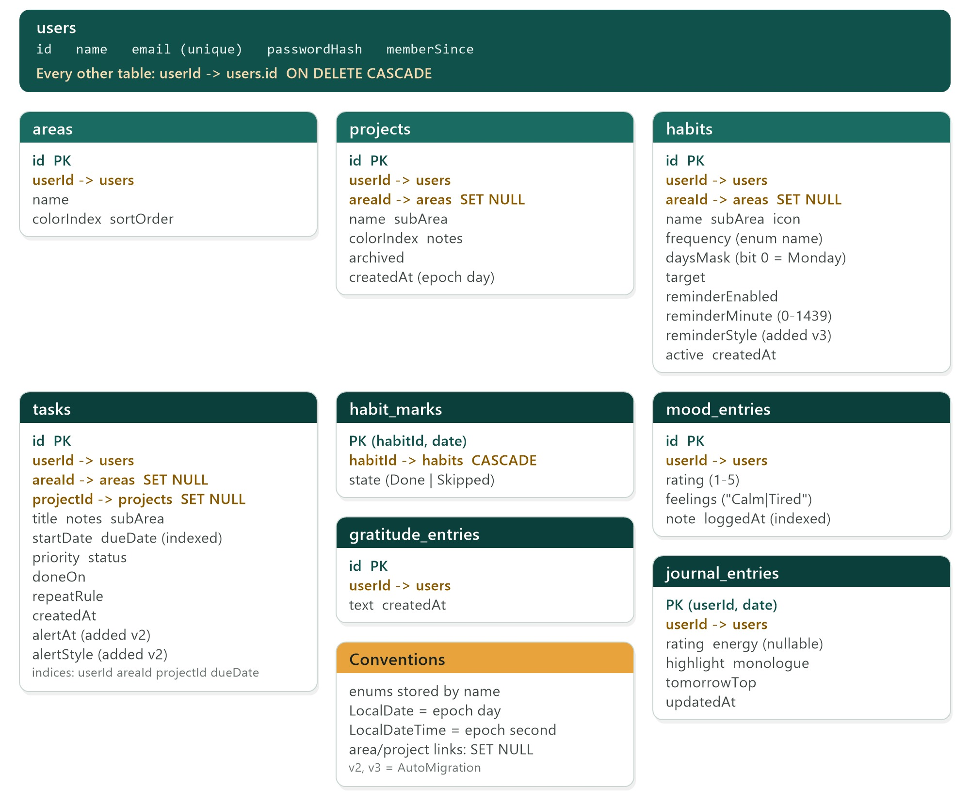
Figure 4.1 Database schema: tables, keys and foreign-key behaviour

Storage conventions
Convention | Why
Every table carries userId with ON DELETE CASCADE (habit marks via their habit) | Several accounts can share a phone; deleting a user removes all of their rows.
Links to areas and projects use ON DELETE SET NULL | Removing an area or project keeps its habits and tasks, just unfiled.
Enums are stored by name, read back with enumOr(name, fallback) | Reordering or adding enum constants can never reinterpret stored data.
LocalDate → epoch day, LocalDateTime → epoch second (UTC clock reading) | SQLite can sort and range-filter dates as integers.
Custom habit days → 7-bit daysMask (bit 0 = Monday) | One integer column instead of a join table.
Reminder time → reminderMinute (minutes after midnight) | Simple, sortable and time-zone free.
Mood feelings → one string joined with | | Tags are fixed words that never contain the separator.
Composite keys for habit_marks (habitId, date) and journal_entries (userId, date) | The database itself guarantees one mark per habit per day and one reflection per day.

data/local/MindSpringDatabase.kt (excerpt)
class Converters {
@TypeConverter fun dateToLong(d: LocalDate?): Long? = d?.toEpochDay()
@TypeConverter fun longToDate(v: Long?): LocalDate? = v?.let(LocalDate::ofEpochDay)
@TypeConverter fun dateTimeToLong(d: LocalDateTime?): Long? = d?.toEpochSecond(ZoneOffset.UTC)
@TypeConverter fun longToDateTime(v: Long?): LocalDateTime? =
v?.let { LocalDateTime.ofEpochSecond(it, 0, ZoneOffset.UTC) }
}

@Database(
entities = [UserEntity::class, AreaEntity::class, ProjectEntity::class, HabitEntity::class,
HabitMarkEntity::class, TaskEntity::class, MoodEntity::class, GratitudeEntity::class,
JournalEntity::class],
version = 3,
exportSchema = true,
// 2: tasks gain an alert time and style. 3: habit reminders gain a style.
autoMigrations = [AutoMigration(from = 1, to = 2), AutoMigration(from = 2, to = 3)],
)
@TypeConverters(Converters::class)
abstract class MindSpringDatabase : RoomDatabase() {
abstract fun users(): UserDao
abstract fun habits(): HabitDao
abstract fun tasks(): TaskDao
// … areas, projects, moods, gratitude, journal …
companion object {
fun build(context: Context) =
Room.databaseBuilder(context, MindSpringDatabase::class.java, "mindspring.db").build()
fun inMemory(context: Context) =
Room.inMemoryDatabaseBuilder(context, MindSpringDatabase::class.java)
.allowMainThreadQueries().build()
}
}

Entities and mapping
Entities live in data/local/Entities.kt next to their mapping functions: toModel() turns a row into a domain model and companion from(model, userId) turns a model into a row, trimming text on the way in.
data/local/Entities.kt (excerpt)
@Entity(
tableName = "habits",
foreignKeys = [
ForeignKey(UserEntity::class, ["id"], ["userId"], onDelete = ForeignKey.CASCADE),
ForeignKey(AreaEntity::class, ["id"], ["areaId"], onDelete = ForeignKey.SET_NULL),
],
indices = [Index("userId"), Index("areaId")],
)
data class HabitEntity(
@PrimaryKey(autoGenerate = true) val id: Long = 0,
val userId: Long,
val frequency: String,
/** Bit n set = DayOfWeek with value n+1 (Monday = bit 0). */
val daysMask: Int,
/** Minutes after midnight. */
val reminderMinute: Int,
/** Added in version 3. */
@ColumnInfo(defaultValue = "Reminder") val reminderStyle: String = AlertStyle.Reminder.name,
// … name, areaId, subArea, icon, target, reminderEnabled, active, createdAt …
)

internal inline fun <reified E : Enum<E>> enumOr(name: String, fallback: E): E =
enumValues<E>().firstOrNull { it.name == name } ?: fallback

internal fun maskFromDays(days: Set<DayOfWeek>): Int =
days.fold(0) { acc, d -> acc or (1 shl (d.value - 1)) }

DAOs
Each DAO offers two kinds of read: a Flow for screens (observe…) and a one-shot suspend read for back-up, alerts and transactions (all, one). Writes use @Upsert, so the same call inserts a new row (id 0) or replaces an existing one. Every query that takes an id also filters by userId.
data/local/MindSpringDatabase.kt (HabitDao)
@Dao
interface HabitDao {
@Query("SELECT * FROM habits WHERE userId = :userId ORDER BY id")
fun observe(userId: Long): Flow<List<HabitEntity>>

@Query("SELECT * FROM habits WHERE id = :id AND userId = :userId")
fun observeOne(userId: Long, id: Long): Flow<HabitEntity?>

@Upsert suspend fun upsert(habit: HabitEntity): Long

@Query("SELECT m.* FROM habit_marks m JOIN habits h ON h.id = m.habitId WHERE h.userId = :userId")
fun observeMarks(userId: Long): Flow<List<HabitMarkEntity>>

@Upsert suspend fun upsertMark(mark: HabitMarkEntity)

@Query("DELETE FROM habit_marks WHERE habitId = :habitId AND date = :date")
suspend fun deleteMark(habitId: Long, date: LocalDate)
}

Schema migrations
Room exports the schema of every version to app/schemas/, and those files are committed. Because each change so far only added columns with defaults, Room generates the SQL for AutoMigration(1 → 2) (tasks gain alertAt and alertStyle) and AutoMigration(2 → 3) (habits gain reminderStyle). MigrationTest builds a real version-1 database from 1.json, inserts a task and opens it with the current code to prove the upgrade keeps data.

4.3 User scoping with Session
Several people can have accounts on one phone, so every repository must only ever see the signed-in user’s rows. Session centralises this: it reads the signed-in id from DataStore and switches each query whenever it changes.
data/local/RoomRepositories.kt (Session)
/** Resolves the signed-in account for every repository, so no query can read another user's rows. */
class Session(settings: SettingsRepository) {
val userId: Flow<Long?> = settings.sessionUserId

@OptIn(ExperimentalCoroutinesApi::class)
fun <T> scoped(empty: T, query: (Long) -> Flow<T>): Flow<T> =
userId.flatMapLatest { id -> if (id == null) flowOf(empty) else query(id) }

suspend fun id(): Long = userId.first() ?: throw IllegalStateException("No user is signed in")
}

class RoomHabitRepository(private val db: MindSpringDatabase, private val session: Session) : HabitRepository {
override val habits = session.scoped(emptyList()) { id ->
db.habits().observe(id).map { list -> list.map { it.toModel() } }
}

override suspend fun upsert(habit: Habit): Long {
val rowId = db.habits().upsert(HabitEntity.from(habit, session.id()))
return if (habit.id != 0L) habit.id else rowId
}

override suspend fun setMark(habitId: Long, date: LocalDate, state: MarkState?) {
if (state == null) db.habits().deleteMark(habitId, date)
else db.habits().upsertMark(HabitMarkEntity(habitId, date, state.name))
}
}

A side effect worth knowing: logging out sets the session to null, every flow in the app emits empty lists, and ReminderSync sees no tasks or habits and cancels every alarm — without any code specifically for logout.

4.4 Repositories
data/repository/Repositories.kt declares the interfaces the rest of the app depends on. The Room implementations add a few business rules that must hold no matter which screen triggers the write:
Repository | Rule enforced in the data layer
TaskRepository.setStatus | Runs in a transaction: stamps doneOn when finishing and clears it when reopening; finishing a repeating task inserts its next occurrence (TaskLogic.nextOccurrence).
TaskRepository.upsert | Saving a repeating task as Done from the editor also rolls it forward, by comparing with the stored row.
TaskRepository.deleteProject | Tasks survive as standalone tasks (foreign key SET NULL).
AreaRepository.upsert | New areas get sortOrder = max + 1.
MoodRepository.upsert | Keeps the entry’s id, so Undo after a swipe-delete re-inserts exactly the same row.
JournalRepository.upsert | Stamps updatedAt; the composite key makes it one entry per day.
DataReset.clearUserData | Deletes tasks, projects, habits, moods, gratitude and journal in one transaction; keeps the account and life areas.

data/local/RoomRepositories.kt (RoomTaskRepository.setStatus)
override suspend fun setStatus(id: Long, status: TaskStatus, today: LocalDate) {
val userId = session.id()
db.withTransaction {
val task = db.tasks().one(userId, id)?.toModel() ?: return@withTransaction
if (task.status == status) return@withTransaction
val doneOn = if (status == TaskStatus.Done) today else null
db.tasks().upsert(TaskEntity.from(task.copy(status = status, doneOn = doneOn), userId))
if (status == TaskStatus.Done) {
TaskLogic.nextOccurrence(task, today)?.let { db.tasks().upsert(TaskEntity.from(it, userId)) }
}
}
}

4.5 Settings with DataStore
DataStoreSettings implements SettingsRepository on a single Preferences DataStore named settings. Each setting is a Flow with a default and distinctUntilChanged(), so collectors only react to real changes.
Key | Type | Default | Meaning
theme_mode | String | System | System / Light / Dark
ambient_motion | Boolean | true | Drifting background and decorative motion
onboarding_done | Boolean | false | Welcome slides seen
session_user_id | Long? | absent | Signed-in account; removed on logout
checkin_enabled / checkin_minute | Boolean / Int | true / 1200 | Evening check-in at 20:00
digest_enabled / digest_minute | Boolean / Int | true / 480 | Morning summary at 08:00
reminder_tone / alarm_tone | String | system default | Tone URI; empty string = Silent
alert_vibrate / snooze_minutes | Boolean / Int | true / 10 | Vibration and snooze length

4.6 Authentication
Accounts are local, but passwords are still never stored. PasswordHasher derives a 256-bit key with PBKDF2-HMAC-SHA256, 120,000 iterations and a random 16-byte salt, and stores iterations:salt:hash in Base64. Verification uses a constant-time comparison.
domain/PasswordHasher.kt
object PasswordHasher {
private const val ITERATIONS = 120_000
private const val KEY_BITS = 256
private const val ALGORITHM = "PBKDF2WithHmacSHA256"

fun hash(password: String): String {
val salt = ByteArray(16).also { SecureRandom().nextBytes(it) }
val hash = derive(password, salt, ITERATIONS)
val b64 = Base64.getEncoder()
return "$ITERATIONS:${b64.encodeToString(salt)}:${b64.encodeToString(hash)}"
}

fun verify(password: String, stored: String): Boolean {
val parts = stored.split(":")
if (parts.size != 3) return false
val iterations = parts[0].toIntOrNull() ?: return false
val salt = runCatching { Base64.getDecoder().decode(parts[1]) }.getOrNull() ?: return false
val expected = runCatching { Base64.getDecoder().decode(parts[2]) }.getOrNull() ?: return false
return MessageDigest.isEqual(derive(password, salt, iterations), expected)
}
}

- Register lower-cases and trims the email, rejects duplicates (unique index) and the demo address, hashes on Dispatchers.Default, inserts the user and seeds the eight default life areas in one transaction, then writes the session id.
- Login looks the account up by email and verifies the hash; the same message (“Incorrect email or password.”) is returned whether the email or the password was wrong.
- Form validation (domain/Validators.kt) is pure: non-blank name, a regex-checked email, at least six password characters, matching confirmation.
- Start route is decided once in RootViewModel: onboarding if not done, login if there is no session, otherwise Home.

4.7 Backup and restore
Backup exports the signed-in user’s data as one JSON document ("app": "MindSpring", "format": 1) with arrays for areas, projects, habits, marks, tasks, moods, gratitude and journal. Import runs in a single transaction: it clears the user’s data, then re-inserts everything with new ids, remapping area, project and habit references through maps. That is why a backup can be restored into any account, including a fresh one after reinstalling. Missing fields from older backups (for example alert columns) fall back to defaults.
data/local/Backup.kt (import, excerpt)
suspend fun import(json: String): ImportSummary {
val root = JSONObject(json)
require(root.optString("app") == "MindSpring") { "This file is not a MindSpring backup." }
val userId = session.id()
return db.withTransaction {
db.tasks().clear(userId); db.projects().clear(userId); db.habits().clear(userId)
// … moods, gratitude, journal, areas …
val areaIds = mutableMapOf<Long, Long>()
root.objects("areas").forEach { o ->
areaIds[o.getLong("id")] = db.areas().upsert(
AreaEntity(0, userId, o.getString("name"), o.optInt("color"), o.optInt("sort")))
}
fun area(o: JSONObject) = o.optLongOrNull("areaId")?.let(areaIds::get)
// … projects and habits remapped the same way, then marks, tasks, moods, journal …
ImportSummary(habitIds.size, tasks.size, moods.size, journal.size)
}
}

The Profile screen connects this to Android’s Storage Access Framework: ActivityResultContracts.CreateDocument("application/json") for export and OpenDocument() for import, reading and writing through contentResolver on Dispatchers.IO.

4.8 Sample data
DemoData.seed() builds a believable account relative to today: 13 habits across seven life areas with 45 days of marks, four projects with dated tasks (including one alert and one alarm), mood check-ins, gratitude notes and journal entries. It uses Random(42), so output is identical on every run. Two details are deliberate: the first habits are forced to be done over the last five days so streaks are running, and mood ratings get a lift on days the Workout habit was done, so the Insights correlation has a genuine pattern to find.

5 Domain Logic
The rules that make MindSpring more than a list: how habits are judged, how tasks are flagged and repeated, how months are summarised and how the mood insight is found. All of it is pure Kotlin in domain/.

5.1 HabitStats: judging habits
HabitStats works on one habit and a map of its marks (Map<LocalDate, MarkState>). Its central idea is the unit: day-based habits are judged per day on the weekdays they cover, weekly habits per Monday-to-Sunday week, and monthly habits per calendar month.
domain/HabitStats.kt (excerpt)
data class Tally(val done: Int, val possible: Int) {
val rate: Float get() = if (possible == 0) 0f else done.toFloat() / possible
operator fun plus(other: Tally) = Tally(done + other.done, possible + other.possible)
}

private enum class UnitState { Done, Skipped, Missed, Pending, NotDue }

fun tally(habit: Habit, marks: Map<LocalDate, MarkState>, from: LocalDate, to: LocalDate, today: LocalDate): Tally {
var done = 0; var possible = 0
for (span in units(habit, maxOf(from, habit.createdAt), minOf(to, today))) {
when (unitState(habit, marks, span, today)) {
UnitState.Done -> { done++; possible++ }
UnitState.Missed -> possible++
else -> Unit // skipped, pending or not due: not counted
}
}
return Tally(done, possible)
}

/** Consecutive done units back from today; pending and skipped units are passed over. */
private fun streakUnits(habit: Habit, marks: Map<LocalDate, MarkState>, today: LocalDate): List<ClosedRange<LocalDate>> {
val out = mutableListOf<ClosedRange<LocalDate>>()
var span = unitSpan(habit, today)
while (!span.endInclusive.isBefore(habit.createdAt)) {
when (unitState(habit, marks, span, today)) {
UnitState.Done -> out += span
UnitState.Missed -> break
else -> Unit
}
span = unitSpan(habit, span.start.minusDays(1))
}
return out
}

Function | Returns
unit(habit) / unitSpan(habit, date) | Day, Week or Month, and the date range containing a date.
belongsOn(habit, date) | Whether the habit appears on that day’s list (weekly/monthly habits belong on every day of their period).
isScheduled(habit, date) | Whether a day-based habit is due that day (used for the day score).
tally / completionRate | Done out of possible over a range; only elapsed time counts.
currentStreak / bestStreak / streakDates | Running streak, record, and the done dates inside the running streak (amber dots).
weekProgress | Done / due within the current week.
dayScore(habits, marks, date) | Share of that day’s due day-based habits that were done; null if nothing was due.
nextReminder(habit, marks, now) | The next reminder time on a day the habit belongs on and is not yet handled (searches 62 days).

NOTE Two deliberate differences from a paper tracker: a skip is excused (it leaves the denominator and a streak passes over it), and the current day, week or month only joins the denominator once it is done — so a rate on the 11th is out of 11 days, not 30.

5.2 TaskLogic: flags, groups and repeats
domain/TaskLogic.kt (excerpt)
fun flag(task: Task, today: LocalDate): TaskFlag = when {
task.status == TaskStatus.Dropped -> TaskFlag.Dropped
task.status == TaskStatus.Done -> when {
task.doneOn == null || task.due == null -> TaskFlag.Done
!task.doneOn.isAfter(task.due) -> TaskFlag.DoneOnTime
else -> TaskFlag.DoneLate
}
task.due == null -> TaskFlag.NoDeadline
task.due.isBefore(today) -> TaskFlag.Overdue
task.due == today -> TaskFlag.DueToday
!task.due.isAfter(today.plusDays(SOON_DAYS)) -> TaskFlag.DueSoon // SOON_DAYS = 3
task.start != null && task.start.isAfter(today) -> TaskFlag.Upcoming
else -> TaskFlag.Open
}

/** Most urgent first: earliest deadline, undated last, then priority. */
val urgency: Comparator<Task> =
compareBy({ it.due ?: LocalDate.MAX }, { it.priority.ordinal }, { it.id })

fun nextOccurrence(task: Task, today: LocalDate): Task? {
if (task.repeat == Repeat.None) return null
// … step() adds a day, week or month …
do {
start = start?.let(::step)
due = due?.let(::step)
alert = alert?.let { step(it.toLocalDate()).atTime(it.toLocalTime()) }
} while ((due ?: start)!!.isBefore(today)) // skip slots already in the past
return task.copy(id = 0, start = start, due = due, status = TaskStatus.NotStarted,
doneOn = null, createdAt = today, alertAt = alert)
}

group(task, today) places open tasks into Overdue, Today, Tomorrow, Next 7 days, Later or No deadline; rollup(tasks, today) counts total, done, open, overdue and dropped tasks and computes progress as done out of everything not dropped. groupKey(label) trims and lower-cases sub-area names so “Research ” and “research” group together.

5.3 Analytics: month rollups
Analytics turns lists of habits, marks, tasks, moods and journal entries into the data classes behind Insights, Projects and Life Areas. Every function takes month and today explicitly, which makes them deterministic and easy to test.
Function | Produces | Used by
habitMonth(...) | HabitMonth: total tally, per-habit rates, best and weakest, per-area tallies, day scores, longest live streak | Insights → Habits
taskMonth(...) | TaskMonth: open, overdue, due today / next 7, completed, on-time rate, average days early, deadlines per day | Today counters, Insights → Tasks
journalMonth(...) | JournalMonth: days written, elapsed days, average rating, energy and words | Insights → Mind, Daily Reflection
monthRows(...) | MonthRow per month: habit rate, average mood, days journalled, tasks done | Insights → Month by month
projects(...) | ProjectRollup per project | Insights → Tasks
areas(...) | AreaRollup per area with nested SubAreaRollups, plus an unfiled bucket | Life Areas

5.4 InsightEngine: the key insight
The sentence “You rate your mood 37% higher on days you complete Workout” comes from a simple, explainable comparison rather than a model:
domain/InsightEngine.kt
fun keyInsight(
habits: List<Habit>, marks: List<HabitMark>, entries: List<MoodEntry>,
from: LocalDate, to: LocalDate, minDaysEachSide: Int = 2,
): KeyInsight? {
val moodByDay = dailyMood(entries, from, to).toMap() // average rating per day
if (moodByDay.size < minDaysEachSide * 2) return null
val doneByHabit = marks.filter { it.state == MarkState.Done }
.groupBy({ it.habitId }, { it.date }).mapValues { it.value.toSet() }

return habits.mapNotNull { habit ->
val done = doneByHabit[habit.id].orEmpty()
val (withHabit, without) = moodByDay.entries.partition { it.key in done }
if (withHabit.size < minDaysEachSide || without.size < minDaysEachSide) return@mapNotNull null
val avgWith = withHabit.map { it.value }.average()
val avgWithout = without.map { it.value }.average()
val percent = ((avgWith - avgWithout) / avgWithout * 100).roundToInt()
if (percent >= 5) KeyInsight(habit.name, percent) else null
}.maxByOrNull { it.percentHigher }
}

InsightsViewModel calls it over the selected month; for the current month it looks back at least 30 days so the insight is available early in the month.

5.5 Smaller rules
- JournalTargets: a goal of 150 words; under 120 is “A little short”, 120–180 “Good length”, over 180 “Running long”. countWords splits on whitespace.
- Validators: registration rules with user-facing messages, kept free of Android types.
- ui/util/Formatters.kt (Fmt): greetings by time of day, friendly relative dates (“Tomorrow”, “Yesterday, 12:45 pm”), percentages, countdowns and alert labels.

6 User Interface (Frontend)
How screens are wired together: navigation, ViewModels and UI state, forms, one-shot events and permissions.

6.1 Navigation
ui/navigation/MindSpringNavHost.kt holds the whole navigation graph. Routes are string constants with optional arguments, plus builder functions so callers never format route strings by hand.
ui/navigation/MindSpringNavHost.kt (excerpt)
object Routes {
const val HOME = "home"
const val HABIT_DETAIL = "habit-detail/{id}"
const val TASK_EDITOR = "task-editor?id={id}&project={project}"
const val MOOD_CHECKIN = "mood-checkin?id={id}&rating={rating}"
const val BREATHING = "breathing/{technique}"
const val JOURNAL_ENTRY = "journal-entry/{day}"
// … 23 routes in total …
fun habitDetail(id: Long) = "habit-detail/$id"
fun taskEditor(id: Long? = null, project: Long? = null) = "task-editor?id=${id ?: -1}&project=${project ?: -1}"
fun journalEntry(date: LocalDate) = "journal-entry/${date.toEpochDay()}"
}

/** Which tab is highlighted, whether the bottom bar shows, and whether the top edge is light. */
private data class Chrome(val tab: MainTab?, val bottomBar: Boolean, val lightTop: Boolean)

private fun chromeFor(route: String?): Chrome = when (route) {
Routes.HOME -> Chrome(MainTab.Today, true, false)
Routes.HABITS -> Chrome(MainTab.Habits, true, false)
Routes.CALM, Routes.GRATITUDE, Routes.MOOD_HISTORY, Routes.JOURNAL -> Chrome(MainTab.Mind, true, false)
Routes.ONBOARDING, Routes.LOGIN, Routes.REGISTER, Routes.MOOD_CHECKIN, Routes.HABIT_DONE ->
Chrome(null, false, true)
else -> Chrome(null, false, false)
}

- One Scaffold for the app. MindSpringRoot draws AmbientBackground once behind everything, then a transparent Scaffold whose bottom bar is shown or hidden by chromeFor(route). Detail screens, editors and immersive screens therefore hide the bar automatically.
- Tab switching navigates with popUpTo(HOME) { saveState = true }, launchSingleTop and restoreState, so each tab keeps its scroll position and view state.
- Optional arguments use -1 as “absent”; optionalLong(name) converts non-positive values to null.
- System bar icons are switched between light and dark per route with SystemBarIcons, because some screens have a teal top edge and others a light one.
- Deep links from alerts. When MainActivity receives an alert’s open intent, a LaunchedEffect navigates to taskEditor(id) or habitDetail(id) once the graph is ready, but only if the user is signed in.
- Notification permission is requested once per launch, the first time the Home route is shown, on Android 13 and later.

6.2 ViewModels and UI state
Each ViewModel exposes one immutable UI state class. List and dashboard screens derive state reactively; editors hold a MutableStateFlow that the user edits and save explicitly. The Today screen is a representative example:
ui/screens/home/HomeViewModel.kt (excerpt)
class HomeViewModel(private val app: AppContainer) : ViewModel() {
private val tasksAndProjects = combine(app.tasks.tasks, app.tasks.projects) { t, p -> t to p }
private val habitData = combine(app.habits.habits, app.habits.marks, app.areas.areas) { h, m, a -> Triple(h, m, a) }

val state: StateFlow<HomeUiState> = combine(
app.auth.currentUser, habitData, tasksAndProjects, app.moods.entries, app.journal.entries,
) { user, (habits, marks, areas), (tasks, projects), moods, journal ->
val today = LocalDate.now()
val taskStats = Analytics.taskMonth(tasks, YearMonth.from(today), today)
HomeUiState(
loaded = true,
firstName = user?.name?.substringBefore(' ').orEmpty(),
todayMood = moods.firstOrNull { it.loggedAt.toLocalDate() == today },
habits = todayHabits(habits, marks.byHabit(), areas.associate { it.id to it.colorIndex }, today),
overdue = taskStats.overdue,
upNext = tasks.filter { it.status.isOpen }.sortedWith(TaskLogic.urgency).take(4).map { /* … */ },
// … due today, due this week, journal, top three streaks …
)
}.stateIn(viewModelScope, SharingStarted.WhileSubscribed(5_000), HomeUiState())

fun toggleDone(item: TodayHabit) {
viewModelScope.launch {
app.habits.setMark(item.habit.id, LocalDate.now(),
if (item.mark == MarkState.Done) null else MarkState.Done)
}
}
}

TIP combine accepts at most five flows with a destructuring lambda, so ViewModels first pre-combine related flows into pairs and triples (habitData, tasksAndProjects) and destructure them in the final lambda.

6.3 Screen catalogue
Screen (file) | ViewModel | State source
Onboarding (OnboardingScreen.kt) | — (RootViewModel marks done) | HorizontalPager state
Login / Register (AuthScreens.kt) | AuthViewModel | Form state + AuthRepository
Today (HomeScreen.kt) | HomeViewModel | Auth, habits, marks, areas, tasks, projects, moods, journal
Habits: Today / Week / All (HabitsScreen.kt) | HabitsViewModel | Habits, marks, areas, tasks, week offset, view
Add / Edit Habit (HabitEditorScreen.kt) | HabitEditorViewModel | Editable form state, areas, sub-area suggestions
Habit detail / completed | HabitDetailViewModel, HabitCompletedViewModel | One habit, its marks, 5-week grid
Tasks and Projects (TasksScreen.kt) | TasksViewModel | Tasks, projects, areas, filter, view
Task editor (TaskEditorScreen.kt) | TaskEditorViewModel | Editable form state, projects, areas
Project detail / editor (ProjectScreens.kt) | ProjectDetailViewModel, ProjectEditorViewModel | One project and its tasks
Mood check-in / history | MoodCheckInViewModel, MoodHistoryViewModel | One entry; entries filtered by period
Mind, Breathing (CalmScreen.kt, BreathingScreen.kt) | — (local UI state) | rememberSaveable timer state
Daily reflection (JournalScreens.kt) | JournalListViewModel, JournalEditorViewModel | Journal entries; one day’s entry
Gratitude (GratitudeScreen.kt) | GratitudeViewModel | Gratitude entries
Insights (InsightsScreen.kt) | InsightsViewModel | Everything, month, section
Life Areas (LifeAreasScreen.kt) | LifeAreasViewModel | Areas, habits, marks, tasks, month
Profile, Alerts & Sounds | ProfileViewModel, AlertSettingsViewModel | Settings flows, permission checks
Alarm (AlarmScreen.kt) | — (AlarmActivity) | Alerts.info() via produceState

6.4 Forms and one-shot events
Editors keep validation inside the state class, so the button’s enabled state and error messages are derived rather than stored:
ui/screens/tasks/TasksViewModels.kt (TaskEditorState, excerpt)
data class TaskEditorState(
val id: Long = 0,
val title: String = "",
val start: LocalDate? = null,
val due: LocalDate? = null,
val saved: Boolean = false,
val showErrors: Boolean = false,
// … notes, area, project, priority, status, repeat, alert …
) {
val isEditing: Boolean get() = id != 0L
val dateError: String? get() =
if (start != null && due != null && due.isBefore(start)) "The deadline is before the start date." else null
val titleError: String? get() = if (title.isBlank()) "Give the task a name." else null
val canSave: Boolean get() = titleError == null && dateError == null
}

- Saving sets saved = true; the screen reacts with LaunchedEffect(s.saved) { if (s.saved) onDone() }, which navigates back exactly once.
- Input limits are applied in the ViewModel (v.take(120) for task titles, 500 for notes), so no screen can bypass them.
- Messages such as “Skipped Walk for today” and “Entry deleted · Undo” go through a SnackbarHostState provided app-wide as LocalSnackbar, so any composable can show one without plumbing callbacks.
- Mood history deletion is optimistic: the row is deleted immediately and the snackbar’s Undo re-upserts the same MoodEntry with its original id.

6.5 Permissions and system integration
Need | Implementation
Notifications (API 33+) | ActivityResultContracts.RequestPermission() on Home, in editors when an alert is switched on (rememberAskForNotifications), and in Alerts & Sounds.
Exact alarms | USE_EXACT_ALARM (API 33+) and SCHEDULE_EXACT_ALARM (API 31–32); checked with canScheduleExactAlarms().
Full-screen alerts | USE_FULL_SCREEN_INTENT; checked with canUseFullScreenIntent() on API 34+.
Battery optimisation | Optional request with ACTION_REQUEST_IGNORE_BATTERY_OPTIMIZATIONS.
Tone picker | A custom ActivityResultContract around RingtoneManager.ACTION_RINGTONE_PICKER.
Backup files | Storage Access Framework (CreateDocument, OpenDocument); no storage permission is needed.
Re-checking after Settings | LifecycleEventEffect(ON_RESUME) re-reads permission state when the user returns from Android settings.

7 Design System
The visual language from the Figma prototype translated into code: semantic colours for light and dark themes, typography, shapes, spacing and a library of reusable components.

7.1 Colour tokens
Screens never use raw colours. ui/theme/Color.kt defines a semantic palette, MsColors, with one instance per theme. It follows the 60-30-10 rule: canvas and cards (~60%), teal structure (~30%) and amber for the one primary action (~10%). The Material 3 colour scheme is derived from these tokens so standard components match.
Token | Light | Dark | Role
canvas | #F4F6F1 | #141C1A | Screen background beneath the ambient glow
card | white 84% | #26312E 86% | Frosted content cards
teal / hero | #10514C | #10514C / #1D5550 | App bars, navigation, hero cards
tealInk | #10514C | #7CC4B9 | Teal used as ink: ticks, progress, links
amber / onAmber | #E8A33D / #1B2422 | same | Primary buttons, active tab, streaks
textPrimary | #141D1B | #E9F3EF | Body text
textSecondary / textTertiary | #404947 / #6A7371 | #B5C2BE / #8A9894 | Supporting text, captions
danger / dangerSoft | #B3261E / #F9DEDC | #FFB4AB / #4A2522 | Destructive actions and overdue only
ambient | mint, peach, sage, lagoon | deep teal, amber, blue-green | The four drifting light sources

ui/theme/Theme.kt (excerpt)
private val LocalMsColors = staticCompositionLocalOf { LightMsColors }

/** Whether decorative motion runs. Off in tests and when the user turns it off. */
val LocalAmbientMotion = staticCompositionLocalOf { true }

object MsTheme {
val colors: MsColors
@Composable @ReadOnlyComposable get() = LocalMsColors.current

/** The teal chrome: a gentle diagonal from deep to bright teal. */
val chrome: Brush
@Composable @ReadOnlyComposable get() = Brush.linearGradient(listOf(TealDeep, Teal, TealBright))
}

@Composable
fun MindSpringTheme(darkTheme: Boolean = isSystemInDarkTheme(), ambientMotion: Boolean = true,
content: @Composable () -> Unit) {
val colors = if (darkTheme) DarkMsColors else LightMsColors
CompositionLocalProvider(LocalMsColors provides colors, LocalAmbientMotion provides ambientMotion) {
MaterialTheme(colorScheme = colors.toMaterial(), typography = MsTypography,
shapes = MsShapes, content = content)
}
}

Mood colours (MoodColors) and a ten-colour AreaPalette for life areas and projects are defined alongside; areas store only an index, read with areaColor(index).

7.2 Typography, shapes and spacing
Plus Jakarta Sans is bundled as a single variable font (res/font/plus_jakarta_sans.ttf) and instantiated at five weights with FontVariation.weight, so the app never downloads fonts.
Style | Size / line height | Weight | Typical use
headlineLarge / headlineMedium | 30/38, 28/36 | Bold / SemiBold | Onboarding titles, sign-in wordmark
headlineSmall | 24/32 | SemiBold | Tab page titles (Habits, Tasks)
titleLarge / titleMedium | 20/28, 17/24 | SemiBold | Card titles, bar titles
bodyLarge / bodyMedium / bodySmall | 16/24, 15/22, 13/18 | Normal | Content and descriptions
labelLarge / labelMedium / labelSmall | 16/22, 13/18, 12/16 | SemiBold / Medium | Buttons, chips, captions

- Shapes: cards 20 dp (CardShape), inputs 8 dp (InputShape), Material small/medium/large/extra-large 8/12/20/28 dp; buttons and chips are fully rounded pills.
- Spacing (`Dimens`): 24 dp screen gutter, 20 dp card padding, 16 dp gutter, and an 8 / 16 / 32 dp vertical rhythm.

7.3 Component library
ui/components/ contains every reusable piece. Screens compose these rather than raw Material components, which keeps the look consistent.
File | Components | Notes
Surfaces.kt | MsCard, softShadow, IconCircle, AvatarCircle, TagChip, SectionTitle, FieldLabel, EmptyState | Frosted translucent card with hairline border; shadow drawn only outside the shape.
Buttons.kt | PrimaryButton, SecondaryButton, OutlinePillButton, GhostButton | Amber primary (56 dp), teal secondary, text-only ghost.
Inputs.kt | MsTextField, SegmentedTabs, SelectChip, DayToggle, msSwitchColors | Password visibility toggle, inline error text.
Pickers.kt | DateField, MsDatePicker, TimePickerDialog, SmallChip, MonthSwitcher, SuggestionField, AreaChooser, DotChip | Quick-pick chips around Material pickers.
Rows.kt | HabitRow, TaskRow, GroupHeader | Long-press to skip on habit rows.
Tags.kt | Pill, FlagPill, FrequencyPill, PriorityBadge, AreaTag, Tint | Colour pairs per flag, frequency and priority.
Bars.kt | TealTopBar, BrandTopBar, TaskTopBar, MsBottomBar, BarIconButton | Chrome gradient; animated tab indicator.
Charts.kt | MoodTrendChart, ActivityBars | Canvas-drawn, animated in.
Motion.kt | AmbientBackground, Modifier.appear, AnimatedCount, ProgressRing, TickButton | See Chapter 8.
Visuals.kt | MoodFaceButton, Wordmark, WeekDots, MsProgressBar, mood and icon mappings | HabitIcon.vector maps stored keys to icons.
AlertControls.kt | AlertStylePicker, rememberAskForNotifications | Warns when notifications or lock-screen alerts are off.
Snackbar.kt, SystemBars.kt | LocalSnackbar, MsSnackbarHost, SystemBarIcons | App-wide snackbar and status-bar icon colour.

ui/components/Surfaces.kt (MsCard, excerpt)
@Composable
fun MsCard(
modifier: Modifier = Modifier,
color: Color = MsTheme.colors.card,
onClick: (() -> Unit)? = null,
contentPadding: PaddingValues = PaddingValues(Dimens.card),
content: @Composable ColumnScope.() -> Unit,
) {
val c = MsTheme.colors
val interaction = remember { MutableInteractionSource() }
val pressed by interaction.collectIsPressedAsState()
val scale by animateFloatAsState(if (pressed) 0.98f else 1f, label = "cardPress")
Column(
modifier = modifier
.graphicsLayer { scaleX = scale; scaleY = scale }
.then(if (c.isDark) Modifier else Modifier.softShadow(CardShape))
.clip(CardShape)
.background(color)
.then(if (color.alpha < 1f) Modifier.border(1.dp, c.cardBorder, CardShape) else Modifier)
.then(if (onClick != null) Modifier.clickable(interaction, indication = null, onClick = onClick) else Modifier)
.padding(contentPadding),
content = content,
)
}

softShadow paints a blurred shadow with Android’s Paint.setShadowLayer, clipped with ClipOp.Difference to outside the card outline. A normal elevation shadow would show through the translucent card and grey its face.

7.4 Light and dark themes
The dark theme re-assigns roles instead of inverting colours: a near-black canvas, cards one step lighter, the same teal chrome and full-strength amber. Because every screen reads semantic tokens, no screen contains theme-specific code apart from a handful of contrast adjustments (if (c.isDark)).
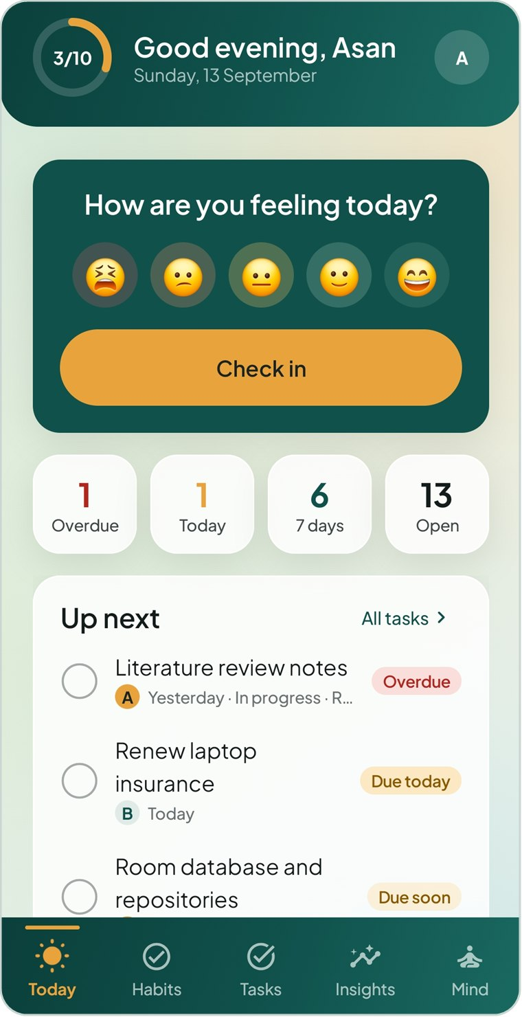  Figure 7.1 Today, light theme | 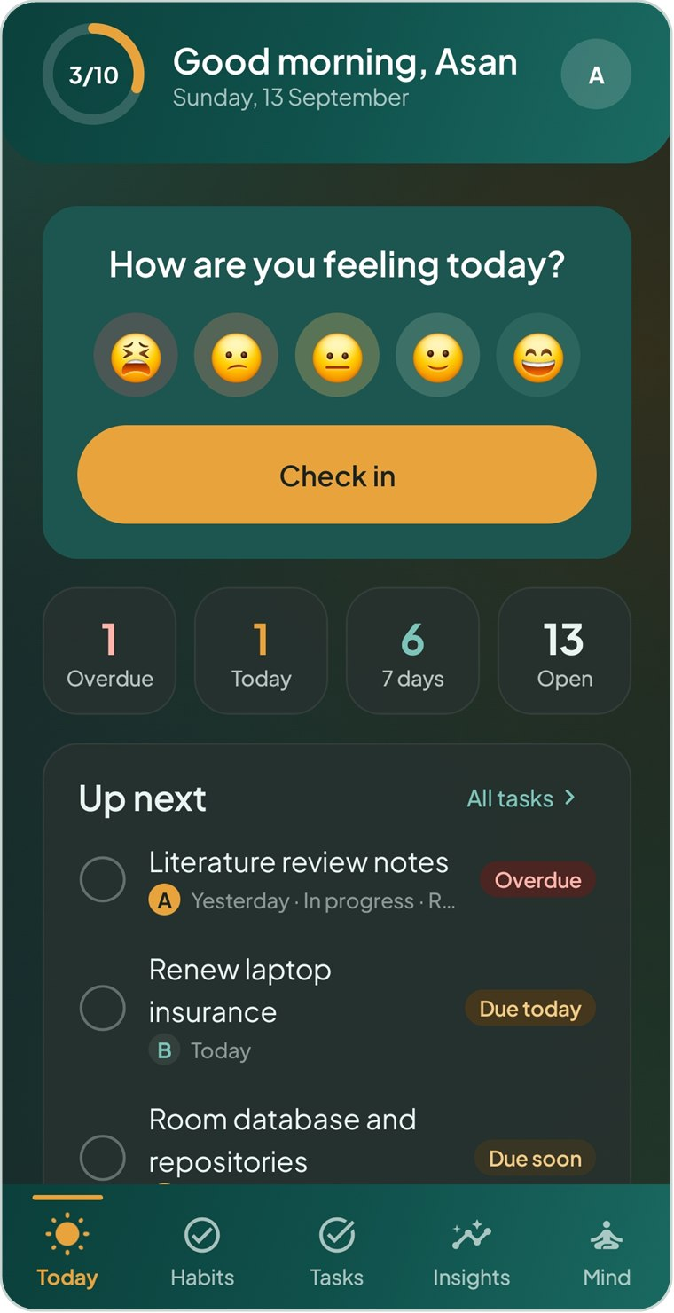  Figure 7.2 Today, dark theme | 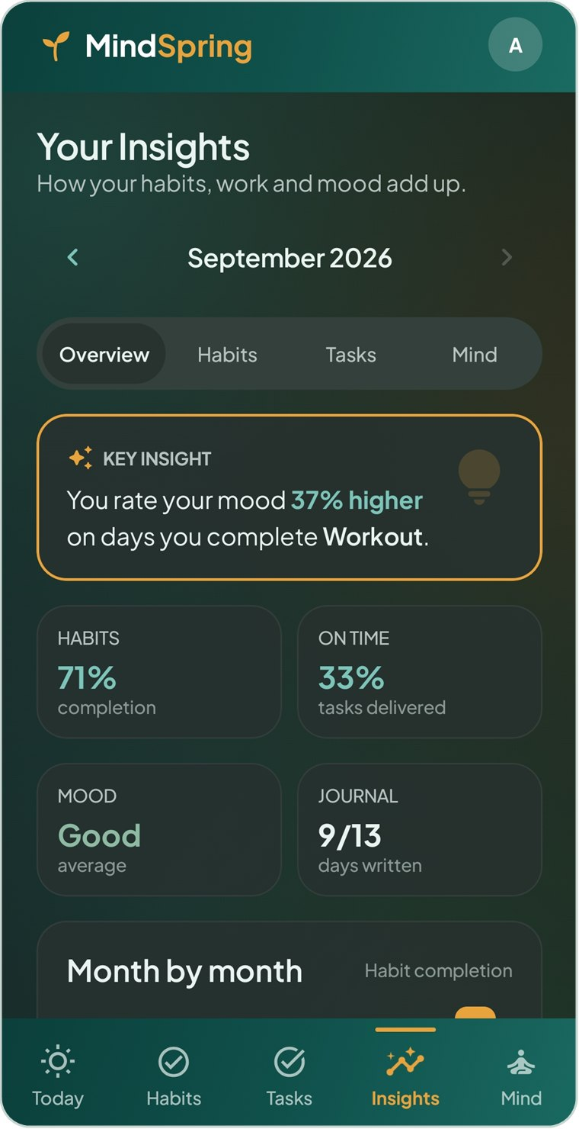  Figure 7.3 Insights, dark theme

7.5 Previews
- PreviewScreen(dark) wraps a preview in MindSpringTheme on the canvas colour with ambient motion off, so previews settle into a still frame.
- PreviewData.kt holds a complete, consistent sample state (habits, tasks, projects, moods, insights) built around a fixed PreviewToday.
- ComponentPreviews.kt shows the component library in one place: buttons, chips, cards, pills, charts and rows in both themes.

8 Animation and Motion
Motion in MindSpring is used to calm, to explain change and to pace breathing — never to decorate for its own sake. This chapter catalogues every animation and shows how the important ones are built.

8.1 Principles
- Explain state changes. Numbers count to their new value, rings sweep, ticks pop, tabs glide — so the user sees what changed.
- Short and soft. Most transitions last 160–420 ms with FastOutSlowInEasing or gentle springs; only ambient and breathing motion are slow.
- Cheap to run. Continuous animations are read inside draw or graphicsLayer lambdas, so they redraw a layer without recomposing the screen.
- Respect the user. Decorative motion stops when Ambient motion is off, when the system animator duration scale is 0 (“Remove animations”), in previews and in screenshot tests.

8.2 Animation catalogue
Animation | API and timing | Where
Ambient background drift | rememberInfiniteTransition → animateFloat 0…2π, tween(48 000, Linear) | Behind every screen (Motion.kt)
Card cascade on appear | Animatable 0→1, tween(420, delay 40 ms × index), alpha + 14 dp lift | Cards on Today, Habits, Insights…
Screen transitions | fadeIn(280) + slideInVertically(320, 1/18) + scaleIn(0.985); tab↔tab fadeIn(260); back fadeOut + slideOut | NavHost in MindSpringNavHost.kt
Bottom-bar indicator | animateDpAsState with spring(LowBouncy, MediumLow); icon animateFloatAsState 1→1.12 bouncy | MsBottomBar
Tick button pop | animateFloatAsState 0.94→1 spring(MediumBouncy) + animateColorAsState fill | TickButton, week grid cells
Counters | animateIntAsState, tween(700) | AnimatedCount in stat tiles
Progress ring / bar | animateFloatAsState, tween(900) sweep; bars default spring | ProgressRing, MsProgressBar
Chart reveal | Animatable 0→1 tween(900); PathMeasure.getSegment | MoodTrendChart
Bars grow | Animatable 0→1 tween(700) scales bar heights | ActivityBars
View and month switches | AnimatedContent: fade + horizontal slide, direction from ordinal | Habits, Tasks, Insights, MonthSwitcher
Expand / collapse | AnimatedVisibility, animateContentSize | Handled habits, reminder options, life areas
Chips, segments, mood faces | animateColorAsState, animateFloatAsState 1→1.12 | Inputs and MoodFaceButton
Card press | animateFloatAsState 1→0.98 while pressed | MsCard
Onboarding dots | animateDpAsState 8→24 dp width, animateColorAsState | OnboardingScreen
Breathing orb | Frame clock (withFrameMillis) + FastOutSlowInEasing per phase | BreathingScreen
Celebration | Animatable pop 0.3→1 spring(MediumBouncy, Low); text fade tween(600, delay 250); infinite twinkle 1400 ms | HabitCompletedScreen
Swipe to dismiss alarm | detectDragGestures → Animatable.snapTo; spring back; pulse 2000 ms | AlarmScreen
Swipe to delete | Material SwipeToDismissBox with red background | Mood history

8.3 Ambient background
Four large radial gradients drift on slow closed loops. Each blob’s offset is a sine and cosine of the same phase with whole-number frequencies, so after 48 seconds every blob is back where it started and the loop is seamless. The phase value is only read inside the Canvas draw lambda, so the animation invalidates drawing but never recomposition.
ui/components/Motion.kt (AmbientBackground)
private data class Blob(val x: Float, val y: Float, val radius: Float, val dx: Float, val dy: Float,
val fx: Int, val fy: Int, val alpha: Float)

@Composable
fun AmbientBackground(modifier: Modifier = Modifier) {
val c = MsTheme.colors
val moving = LocalAmbientMotion.current
val phase = if (moving) {
rememberInfiniteTransition(label = "ambient").animateFloat(
initialValue = 0f, targetValue = (2 * PI).toFloat(),
animationSpec = infiniteRepeatable(tween(48_000, easing = LinearEasing)),
label = "ambientPhase",
)
} else null
Canvas(modifier.fillMaxSize()) {
drawRect(c.canvas)
val t = phase?.value ?: 0.9f // a fixed, pleasant frame when still
Blobs.forEachIndexed { i, b ->
val center = Offset(
size.width * (b.x + b.dx * sin(t * b.fx + i * 1.3f)),
size.height * (b.y + b.dy * cos(t * b.fy + i * 0.7f)),
)
val radius = size.maxDimension * b.radius
val color = c.ambient[i % c.ambient.size]
drawCircle(
brush = Brush.radialGradient(
0f to color.copy(alpha = b.alpha), 0.55f to color.copy(alpha = b.alpha * 0.35f),
1f to Color.Transparent, center = center, radius = radius),
radius = radius, center = center,
)
}
}
}

It is drawn once in MindSpringRoot, behind the NavHost, so the drift continues smoothly while screens change on top of it.

8.4 Staggered card entrance
ui/components/Motion.kt (Modifier.appear)
@Composable
fun Modifier.appear(index: Int = 0): Modifier {
val progress = remember { Animatable(0f) }
var played by rememberSaveable { mutableStateOf(false) }
LaunchedEffect(Unit) {
if (played) progress.snapTo(1f) // no replay after rotation or back navigation
else {
progress.animateTo(1f, tween(420, delayMillis = 40 * index.coerceAtMost(8),
easing = FastOutSlowInEasing))
played = true
}
}
val lift = with(LocalDensity.current) { 14.dp.toPx() }
return graphicsLayer {
alpha = progress.value
translationY = (1f - progress.value) * lift
}
}

Screens pass increasing indexes (Modifier.appear(0), appear(1), …) so cards arrive as a soft cascade. The delay is capped at eight steps so long lists do not wait.

8.5 Navigation transitions and the tab indicator
ui/navigation/MindSpringNavHost.kt (transitions)
// Tab to tab is a quiet cross-fade; going deeper rises gently into place; coming back sinks away.
private fun AnimatedContentTransitionScope<NavBackStackEntry>.isTabSwitch() =
initialState.destination.route in TabRoutes && targetState.destination.route in TabRoutes

private val enter: AnimatedContentTransitionScope<NavBackStackEntry>.() -> EnterTransition = {
if (isTabSwitch()) fadeIn(tween(260))
else fadeIn(tween(280)) + slideInVertically(tween(320)) { it / 18 } +
scaleIn(tween(320), initialScale = 0.985f)
}
private val exit: AnimatedContentTransitionScope<NavBackStackEntry>.() -> ExitTransition = { fadeOut(tween(180)) }
private val popExit: AnimatedContentTransitionScope<NavBackStackEntry>.() -> ExitTransition = {
fadeOut(tween(200)) + slideOutVertically(tween(260)) { it / 18 }
}

ui/components/Bars.kt (MsBottomBar, excerpt)
val slot = maxWidth / tabs.size
val indicatorX by animateDpAsState(
slot * index.coerceAtLeast(0) + (slot - 40.dp) / 2,
spring(dampingRatio = Spring.DampingRatioLowBouncy, stiffness = Spring.StiffnessMediumLow),
label = "navIndicator",
)
// … for each tab:
val color by animateColorAsState(if (active) c.amber else c.onTealMuted, label = "navColor")
val pop by animateFloatAsState(if (active) 1.12f else 1f,
spring(dampingRatio = Spring.DampingRatioMediumBouncy), label = "navPop")

The active tab is signalled by a filled icon and amber colour, so state never depends on colour alone.

8.6 Feedback micro-interactions
ui/components/Motion.kt (TickButton and ProgressRing, excerpt)
val scale by animateFloatAsState(
if (state == TickState.Done) 1f else 0.94f,
spring(dampingRatio = Spring.DampingRatioMediumBouncy, stiffness = Spring.StiffnessMediumLow),
label = "tickScale",
)
val fill by animateColorAsState(
when (state) { TickState.Done -> doneColor; TickState.Skipped -> c.cardMuted; else -> Color.Transparent },
label = "tickFill",
)

// ProgressRing: the arc sweeps to its value.
val sweep by animateFloatAsState(progress.coerceIn(0f, 1f), tween(900, easing = FastOutSlowInEasing), label = "ring")
Canvas(Modifier.fillMaxSize()) {
drawArc(trackColor, 0f, 360f, false, style = Stroke(w))
if (sweep > 0f) drawArc(color, -90f, 360f * sweep, false, style = Stroke(w, cap = StrokeCap.Round))
}

8.7 Charts that draw themselves
MoodTrendChart builds a smooth path with cubic Bézier segments between points (control points at the horizontal midpoint), then draws only a growing fraction of it using PathMeasure. Data points appear as the line reaches them.
ui/components/Charts.kt (MoodTrendChart, excerpt)
val reveal = remember { Animatable(0f) }
LaunchedEffect(values) { // replays whenever the data changes (e.g. new month)
reveal.snapTo(0f)
reveal.animateTo(1f, tween(900))
}
Canvas(Modifier.fillMaxWidth().height(height)) {
val points = values.mapIndexed { i, v -> Offset(x(i), y(v)) }
val path = Path().apply {
moveTo(points.first().x, points.first().y)
for (i in 1 until points.size) {
val p0 = points[i - 1]; val p1 = points[i]
val midX = (p0.x + p1.x) / 2
cubicTo(midX, p0.y, midX, p1.y, p1.x, p1.y)
}
}
val measure = PathMeasure().apply { setPath(path, false) }
val partial = Path()
measure.getSegment(0f, measure.length * reveal.value, partial, true)
drawPath(partial, c.tealInk, style = Stroke(width = 3.dp.toPx(), cap = StrokeCap.Round))
}

ActivityBars uses the same pattern with a 700 ms grow value multiplying each bar’s height; only the highlighted bar (today or the current month) is amber. For month-long charts the labels are measured and drawn on a Canvas with rememberTextMeasurer, centred under their bars.

8.8 The breathing exercise
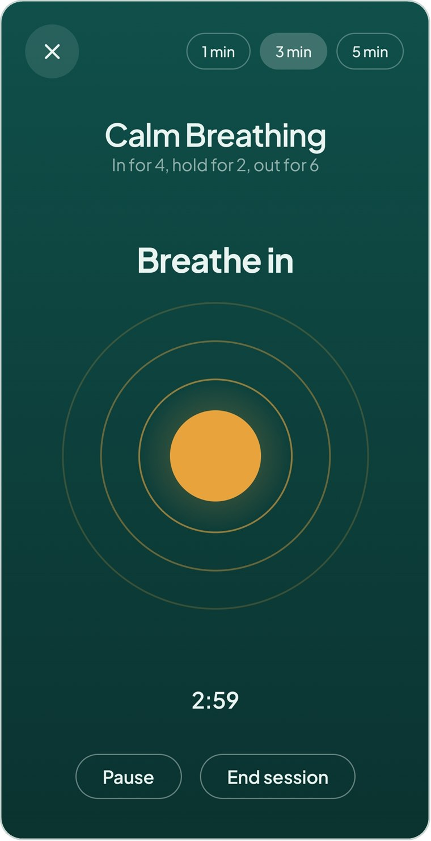  Figure 8.1 Calm Breathing: the orb is the pacing mechanism | The orb’s size is the instruction, so its timing must be exact. Instead of chaining animations, the screen runs its own clock on the frame clock and derives everything from elapsed milliseconds:  - A LaunchedEffect(running, minutes) loops on withFrameMillis, adding frame deltas to elapsed (saved with rememberSaveable, so rotation keeps the session).  - The position inside the breath cycle picks the phase: Calm is in 4 s → hold 2 s → out 6 s; Box is 4-4-4-4.  - Within a phase, progress goes through FastOutSlowInEasing; the orb scales from 0.55 to 1.0 on the inhale and back on the exhale.  - Pausing simply cancels the effect; changing the duration resets elapsed.  - The phase label cross-fades with AnimatedContent and the countdown is derived from the same clock.

ui/screens/calm/BreathingScreen.kt (excerpt)
LaunchedEffect(running, minutes) {
if (!running) return@LaunchedEffect
var last = withFrameMillis { it }
while (elapsed < totalMs) {
withFrameMillis { now ->
elapsed = (elapsed + (now - last)).coerceAtMost(totalMs)
last = now
}
}
}

var inCycle = elapsed % t.cycleMs
var phase = t.steps.first().first
var phaseProgress = 0f
for ((p, secs) in t.steps) {
val len = secs * 1000L
if (inCycle < len) { phase = p; phaseProgress = inCycle.toFloat() / len; break }
inCycle -= len
}
val eased = FastOutSlowInEasing.transform(phaseProgress)
val orb = when (phase) {
Phase.In -> 0.55f + 0.45f * eased
Phase.HoldFull -> 1f
Phase.Out -> 1f - 0.45f * eased
Phase.HoldEmpty -> 0.55f
}

8.9 Celebration and the alarm gesture
HabitCompletedScreen is the only celebratory moment. The tick circle pops from 30% scale on a low-stiffness bouncy spring, the message fades and rises 250 ms later, and three sparkle icons twinkle on an infinite reversing scale between 0.85 and 1.15.
The full-screen alarm must never be dismissed by a pocket tap, so dismissal is a drag gesture, like the phone’s clock:
ui/screens/alarm/AlarmScreen.kt (SwipeToDismiss, excerpt)
.pointerInput(Unit) {
detectDragGestures(
onDragStart = { drag = Offset.Zero },
onDragEnd = {
if (pull.value >= 1f) dismiss()
else scope.launch { pull.animateTo(0f, spring(dampingRatio = 0.6f)) } // spring back
},
onDragCancel = { scope.launch { pull.animateTo(0f, spring()) } },
) { change, amount ->
change.consume()
drag += amount
scope.launch {
pull.snapTo((drag.getDistance() / reachPx).coerceIn(0f, 1f)) // 80 dp to dismiss
if (pull.value >= 1f) dismiss()
}
}
}
.semantics {
contentDescription = "Swipe to dismiss"
onClick(label = "Dismiss") { dismiss(); true } // screen readers get a plain action
}

While idle, a teal ring pulses outwards every two seconds to invite the gesture (only when ambient motion is on). During the drag a disc grows with the finger, the handle scales by up to 8% and a haptic long-press confirms dismissal. ScreenshotTest.alarmIsDismissedBySwipeNotTap verifies that a tap does nothing and a swipe dismisses.

8.10 Reduced motion
Switch | Effect
Profile → Appearance → Ambient motion off | LocalAmbientMotion = false: background holds still, the alarm handle stops pulsing.
Android “Remove animations” (animator duration scale 0) | MainActivity passes ambientMotion = false; Compose also shortens its own animations to zero.
Previews (PreviewScreen) | Ambient motion off so previews render a still frame.
Screenshot tests | MindSpringTheme(ambientMotion = false); frame-clock screens are captured after advancing the test clock by a fixed time.

9 Reminders and Alerts
Alerts must fire at the exact minute, with the app closed, after reboots and time-zone changes, and must stay silent once the task or habit is dealt with. This chapter explains how.

9.1 Overview
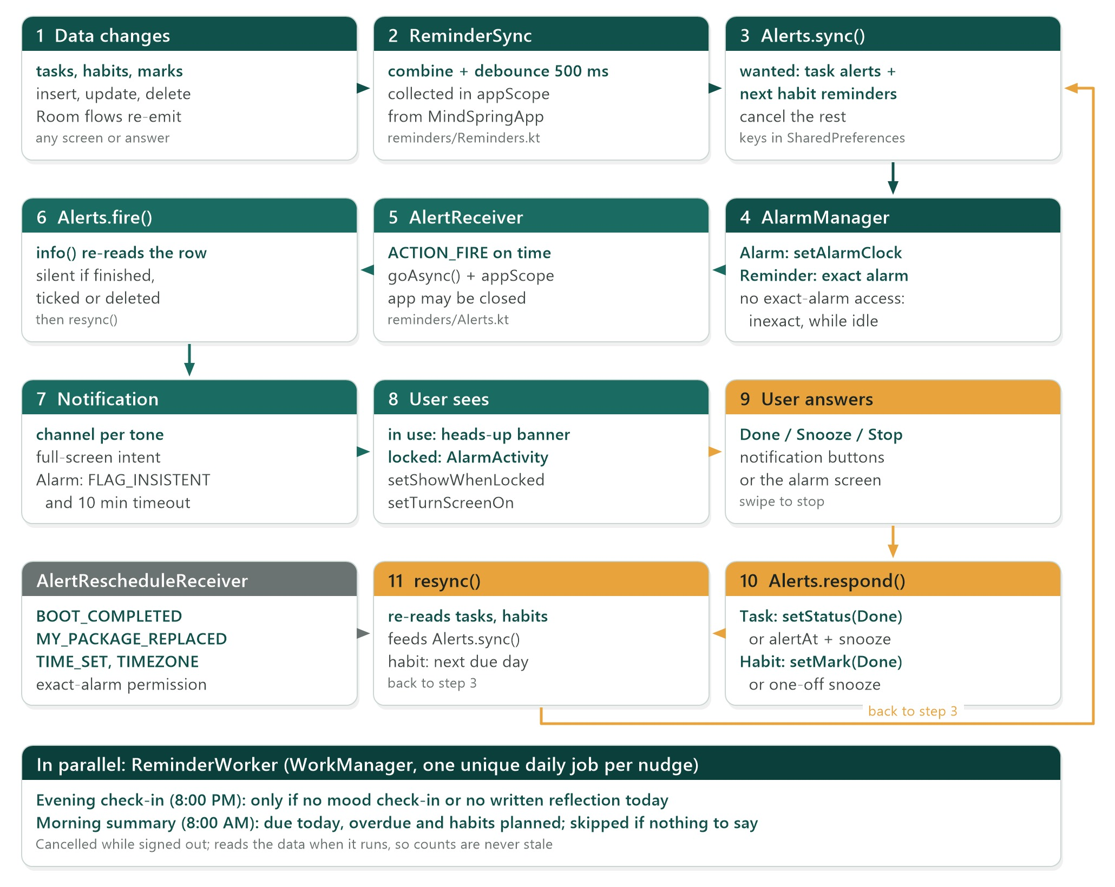
Figure 9.1 From a data change to a ringing alarm and back
Mechanism | Used for | Why this API
AlarmManager exact alarms | Task alerts and habit reminders | Fires at the exact minute even in Doze; setAlarmClock for the Alarm style is the most punctual kind.
WorkManager periodic work | Evening check-in and morning summary | Daily, not time-critical, survives reboots automatically.
Notification channels | Sound, vibration and importance | Required on API 26+; the only way to control sound.
Full-screen intent + AlarmActivity | Showing the alert over the lock screen | The standard alarm-clock pattern.
BroadcastReceivers | Firing, answering and rescheduling | Run without the UI; goAsync() for coroutine work.

9.2 Keeping alarms in step with data
ReminderSync.start() is launched from MindSpringApp.onCreate in the process-wide appScope. It observes three things:
reminders/Reminders.kt (ReminderSync.start)
fun start(context: Context, container: AppContainer, scope: CoroutineScope) {
scope.launch {
container.settings.alertSounds.collect { Channels.ensure(context, it) }
}
scope.launch {
// The data is scoped to the signed-in user, so signing out empties it and cancels every alert.
combine(container.tasks.tasks, container.habits.habits, container.habits.marks, ::Triple)
.debounce(500)
.collect { (tasks, habits, marks) -> Alerts.sync(context, tasks, habits, marks) }
}
scope.launch {
combine(container.settings.sessionUserId, container.settings.checkInReminder,
container.settings.taskDigest) { user, checkIn, digest -> Plan(user != null, checkIn, digest) }
.debounce(750)
.collect { apply(context, it) } // enqueue or cancel the two daily workers
}
}

Alerts.sync() is idempotent. It computes the set of alarms that should exist — every open task whose alertAt is still to come, and each active habit’s HabitStats.nextReminder — cancels alarms that were scheduled before but are no longer wanted, and (re)schedules the rest. Scheduled keys (task:12, habit:3) are remembered in SharedPreferences so cancellation works across process restarts.
reminders/Alerts.kt (sync and schedule)
fun sync(context: Context, tasks: List<Task>, habits: List<Habit>, marks: List<HabitMark>,
now: LocalDateTime = LocalDateTime.now()) {
val marksByHabit = marks.groupBy { it.habitId }.mapValues { (_, l) -> l.associate { it.date to it.state } }
val wanted = buildMap {
tasks.forEach { t -> t.upcomingAlert(now)?.let { put(AlertTarget(AlertKind.Task, t.id), it to t.alertStyle) } }
habits.forEach { h ->
HabitStats.nextReminder(h, marksByHabit[h.id].orEmpty(), now)
?.let { put(AlertTarget(AlertKind.Habit, h.id), it to h.reminderStyle) }
}
}
val prefs = context.getSharedPreferences(PREFS, Context.MODE_PRIVATE)
val before = prefs.getStringSet(KEY_SCHEDULED, emptySet()).orEmpty().mapNotNull(AlertTarget::parse)
(before - wanted.keys).forEach { cancel(context, it) }
// Setting an alarm with the same PendingIntent replaces it, so rescheduling everything is safe.
wanted.forEach { (target, v) -> schedule(context, target, v.first.toEpochMillis(), v.second) }
prefs.edit().putStringSet(KEY_SCHEDULED, wanted.keys.map { it.key }.toSet()).apply()
}

private fun schedule(context: Context, target: AlertTarget, trigger: Long, style: AlertStyle, …) {
val am = context.getSystemService(AlarmManager::class.java)
val fire = broadcast(context, ACTION_FIRE, target, snooze)
try {
when {
!AlertAccess.exactAllowed(context) -> am.setAndAllowWhileIdle(AlarmManager.RTC_WAKEUP, trigger, fire)
style == AlertStyle.Alarm -> am.setAlarmClock(AlarmManager.AlarmClockInfo(trigger, open(context, target)), fire)
else -> am.setExactAndAllowWhileIdle(AlarmManager.RTC_WAKEUP, trigger, fire)
}
} catch (_: SecurityException) {
am.setAndAllowWhileIdle(AlarmManager.RTC_WAKEUP, trigger, fire) // permission revoked meanwhile
}
}

TIP Each PendingIntent gets a unique data URI (mindspring://task/12) and a request code derived from the target, so alarms for different tasks never overwrite each other, while re-scheduling the same task replaces its alarm.

9.3 Firing an alert
AlertReceiver receives ACTION_FIRE, calls goAsync() and continues in appScope. Alerts.fire() first calls info(), which re-reads the task or habit: if the task has been finished or deleted, or the habit has already been ticked or skipped today (or its week or month is already done), nothing is shown. This double-check makes stale alarms harmless.
reminders/Alerts.kt (notification, excerpt)
val alarm = a.style == AlertStyle.Alarm
val builder = NotificationCompat.Builder(context, if (alarm) channels.alarm else channels.task)
.setSmallIcon(R.drawable.ic_notification)
.setContentTitle(a.title)
.setContentText(a.detail)
.setPriority(if (alarm) NotificationCompat.PRIORITY_MAX else NotificationCompat.PRIORITY_HIGH)
.setCategory(if (alarm) NotificationCompat.CATEGORY_ALARM else NotificationCompat.CATEGORY_REMINDER)
.addAction(0, "Snooze $snoozeMinutes min", broadcast(context, ACTION_SNOOZE, a.target))
.addAction(0, "Done", broadcast(context, ACTION_DONE, a.target))
// On a locked or sleeping phone both styles take over the screen; in use, Android shows a banner.
.setFullScreenIntent(alarmScreen(context, a), true)
if (!alarm) return builder.setContentIntent(open(context, a.target)).setAutoCancel(true).build()
return builder
.setContentIntent(alarmScreen(context, a))
.setOngoing(true)
.setTimeoutAfter(RING_TIMEOUT.toMillis()) // 10 minutes
.addAction(0, "Stop", broadcast(context, ACTION_STOP, a.target))
.build()
.apply { flags = flags or Notification.FLAG_INSISTENT } // repeat the tone until answered

9.4 Notification channels and tones
Android fixes a channel’s sound when the channel is created, so a user who picks a new tone needs a new channel. Channels.ensure() appends a short fingerprint of the tone and vibration setting to each channel id, creates the three channels, and deletes any of the app’s older channels.
Channel id | Name | Importance | Audio usage
daily-<fingerprint> | Daily reminders | Default | Notification (reminder tone)
task-<fingerprint> | Reminders | High (heads-up) | Notification (reminder tone)
alarm-<fingerprint> | Alarms | High | Alarm — plays on the alarm volume, with a vibration pattern

reminders/Channels.kt (fingerprint)
private fun fingerprint(tone: String?, vibrate: Boolean): String =
"${tone ?: "silent"}|$vibrate".hashCode().toUInt().toString(36)

9.5 The full-screen alarm activity
AlarmActivity is declared with launchMode="singleInstance", its own task affinity and excludeFromRecents, so answering it returns the user to whatever they were doing. It shows over the lock screen and turns the screen on:
reminders/AlarmActivity.kt (excerpt)
private fun showOverLockScreen() {
if (Build.VERSION.SDK_INT >= 27) {
setShowWhenLocked(true)
setTurnScreenOn(true)
} else {
@Suppress("DEPRECATION")
window.addFlags(WindowManager.LayoutParams.FLAG_SHOW_WHEN_LOCKED or WindowManager.LayoutParams.FLAG_TURN_SCREEN_ON)
}
window.addFlags(WindowManager.LayoutParams.FLAG_KEEP_SCREEN_ON)
}

// In setContent: load what to show, and close with the notification's own timeout.
val alert by produceState(initialValue = null as AlertInfo?, r) { value = Alerts.info(app, r.target, r.testStyle) }
LaunchedEffect(r) { delay(Alerts.RING_TIMEOUT.toMillis()); finish() }

9.6 Answering: Done, Snooze and Stop
Action | Task alert | Habit reminder
Done | tasks.setStatus(id, Done) — also rolls a repeating task forward | habits.setMark(id, today, Done)
Snooze | alertAt = now + snooze minutes, saved on the task | One-off alarm at now + snooze; the habit’s reminder time is unchanged
Stop / swipe | Notification cancelled; task unchanged | Notification cancelled; habit unchanged

After any answer, resync() re-reads the data and calls Alerts.sync(), because the app may not be running to observe the change. For a habit this also schedules its next reminder day.

9.7 Surviving reboots and clock changes
Android clears all alarms on reboot and after an app update. AlertRescheduleReceiver (exported, with RECEIVE_BOOT_COMPLETED) listens for BOOT_COMPLETED, MY_PACKAGE_REPLACED, TIME_SET, TIMEZONE_CHANGED and SCHEDULE_EXACT_ALARM_PERMISSION_STATE_CHANGED, and calls Alerts.resync(). Times are stored as local clock readings, so after a time-zone change an 8:00 reminder still rings at 8:00 local time.

9.8 Daily nudges with WorkManager
reminders/Reminders.kt (ReminderWorker, excerpt)
class ReminderWorker(context: Context, params: WorkerParameters) : CoroutineWorker(context, params) {
override suspend fun doWork(): Result {
val container = (applicationContext as MindSpringApp).container
container.settings.sessionUserId.first() ?: return Result.success()
val today = LocalDate.now()
when (inputData.getString(ReminderSync.KEY_KIND)) {
ReminderSync.KIND_CHECKIN -> {
val checkedIn = container.moods.entries.first().any { it.loggedAt.toLocalDate() == today }
val wrote = container.journal.entry(today).first()?.let { it.words > 0 } == true
if (!checkedIn || !wrote) ReminderSync.notify(applicationContext, channel, 1, "How was your day?", …)
}
ReminderSync.KIND_DIGEST -> { /* "Your day ahead": due today, overdue, habits planned */ }
}
return Result.success()
}
}

Each nudge is a unique periodic job (enqueueUniquePeriodicWork with CANCEL_AND_REENQUEUE) with an initial delay to its chosen time. The chosen time is stored as a signature in SharedPreferences, and a job is only re-enqueued when that signature changes, so opening the app does not keep resetting the schedule. MindSpringApp implements Configuration.Provider and the manifest removes the default initializer, so WorkManager starts lazily.

10 Testing
89 automated tests run on the JVM with no emulator: pure domain tests, repository and migration tests on an in-memory database, alert tests, and screenshot tests for every screen.

10.1 Test suite
Test class | Kind | Tests | What it proves
domain/HabitStatsTest | Pure JUnit | 13 | Rates count only elapsed time, skips are excused, weekly and monthly units, streaks, reminders.
domain/TaskLogicTest | Pure JUnit | 10 | Flags, on-time delivery, urgency order, repeats skipping past slots, alert carry-over, rollups.
domain/AnalyticsTest | Pure JUnit | 4 | Month rollups by area, task delivery, journal counts, sub-area grouping ignoring case.
data/RepositoryTest | Robolectric + in-memory Room | 9 | Register seeds areas, password hashing, per-account isolation, marks, repeats, project deletion, backup round trip, one reflection per day, clearing data.
data/MigrationTest | Robolectric + SQLite | 1 | A real version-1 database upgrades to version 3 with its tasks intact.
reminders/AlertsTest | Robolectric | 8 | Only upcoming alerts on open tasks are scheduled, habit next day, both styles use full-screen intents, only alarms are insistent, snooze and done, channels follow tones.
ScreenshotTest | Robolectric + Roborazzi | 44 | Every screen in light and dark renders with the demo account; the alarm is dismissed by swipe but not by tap.

10.2 The test application
Robolectric tests run against TestApp, which swaps in an in-memory database and turns off background work, so tests are fast, isolated and never schedule real alarms.
test/…/TestApp.kt
/** The app under Robolectric: an in-memory database and no scheduled reminders. */
class TestApp : MindSpringApp() {
override fun createContainer(): AppContainer = AppContainer(this, MindSpringDatabase.inMemory(this))
override fun startBackgroundWork() = Unit
}

10.3 Domain tests
Domain tests fix today to a known date and build marks with small helpers, so each rule reads like a sentence:
test/…/domain/HabitStatsTest.kt (excerpt)
class HabitStatsTest {
// Friday 11 September 2026.
private val today = LocalDate.of(2026, 9, 11)
private fun habit(freq: HabitFrequency = HabitFrequency.Daily) =
Habit(id = 1, name = "h1", frequency = freq, createdAt = LocalDate.of(2026, 8, 1))
private fun done(vararg days: Int) = days.associate { today.withDayOfMonth(it) to MarkState.Done }

@Test fun rateCountsOnlyElapsedDays() {
// Done 9 of the 10 finished days in September; today is still open and not counted.
val marks = (1..10).filter { it != 4 }.associate { today.withDayOfMonth(it) to MarkState.Done }
val t = HabitStats.tally(habit(), marks, today.withDayOfMonth(1), today.withDayOfMonth(30), today)
assertEquals(Tally(9, 10), t)
}

@Test fun streakPassesOverSkipsAndPendingToday() {
val marks = done(8, 10) + (today.withDayOfMonth(9) to MarkState.Skipped)
assertEquals(2, HabitStats.currentStreak(habit(), marks, today))
}
}

10.4 Migration test
test/…/data/MigrationTest.kt (excerpt)
@Test fun version1DatabaseUpgradesWithItsTasks() = runBlocking {
val schema = JSONObject(File("schemas/com.mindspring.app.data.local.MindSpringDatabase/1.json").readText())
.getJSONObject("database")
SQLiteDatabase.openOrCreateDatabase(file, null).use { db ->
// create every version-1 table and index from the exported schema …
db.execSQL("INSERT INTO tasks (id, userId, title, …) VALUES (7, 1, 'Written by version 1', …)")
db.version = 1
}
val room = Room.databaseBuilder(context, MindSpringDatabase::class.java, file.absolutePath)
.allowMainThreadQueries().build()
val task = room.tasks().one(1, 7)!!.toModel()
assertEquals("Written by version 1", task.title)
assertNull(task.alertAt)
assertEquals(AlertStyle.Reminder, task.alertStyle)
}

10.5 Screenshot tests
ScreenshotTest signs in to the demo account, renders each screen at 393 × 1200 dp (xxhdpi) with Robolectric’s native graphics, and saves a PNG with Roborazzi. Helpers wait for Room and DataStore to deliver, tap a segment label when a specific view is needed, and advance the frame clock for animated screens. The images in this guide and the User Manual for onboarding, habit detail and alarms come from this test.
test/…/ScreenshotTest.kt (excerpt)
@RunWith(AndroidJUnit4::class)
@GraphicsMode(GraphicsMode.Mode.NATIVE)
@Config(sdk = [36], qualifiers = "w393dp-h1200dp-xxhdpi", application = TestApp::class)
class ScreenshotTest {
@get:Rule val compose = createComposeRule()

@Before fun signIn() = runBlocking { app.container.auth.loginDemo(); Unit }

@Test fun habitsWeek() = shootAfterTap("05_habits_week", "Week", tab = MainTab.Habits) {
HabitsScreen("Asan", {}, {}, {})
}

@Test fun breathingBox() {
compose.mainClock.autoAdvance = false
shootAfter("27_breathing_box", 6_000) { BreathingScreen(TECHNIQUE_BOX, onClose = {}) }
}
}

Run | Command
Everything | ./gradlew testDebugUnitTest
One class | ./gradlew testDebugUnitTest --tests "com.mindspring.app.domain.HabitStatsTest"
Screenshots only | ./gradlew testDebugUnitTest --tests "*ScreenshotTest*" → app/build/screenshots/
HTML report | app/build/reports/tests/testDebugUnitTest/index.html

NOTE build.gradle.kts adds --add-exports and --add-opens JVM arguments for unit tests because Robolectric reaches into JDK internals that recent JDKs no longer expose by default.

11 Extending the App
Step-by-step recipes for the changes developers most often need to make, following the patterns already in the codebase.

11.1 Add a new screen
- Create ui/screens/<feature>/<Name>Screen.kt with a <Name>Screen composable (gets the ViewModel with appViewModel { … } and collects state) and a stateless <Name>Content(state, callbacks).
- Create a ViewModel that exposes StateFlow<UiState> built with combine(...).stateIn(viewModelScope, SharingStarted.WhileSubscribed(5_000), initial).
- Add a route constant (and a builder function if it takes arguments) to Routes in MindSpringNavHost.kt, and a composable(...) entry in the NavHost.
- Decide the chrome in chromeFor(route): which tab is highlighted, and whether the bottom bar shows.
- Build the layout from ui/components (MsCard, TealTopBar, PrimaryButton…) and colours from MsTheme.colors; add Modifier.appear(index) to cards.
- Add @Previews for light, dark and empty states using PreviewScreen, and a capture in ScreenshotTest.

11.2 Add a field to a stored model
- Add the property to the domain model in Models.kt with a sensible default.
- Add the column to the entity in Entities.kt. Give it a Kotlin default and @ColumnInfo(defaultValue = …) for non-null columns, and update toModel() and from().
- Increase version in @Database and add AutoMigration(from = N, to = N + 1). For renames or deletions, supply an AutoMigrationSpec or a manual Migration.
- Build once so KSP exports schemas/…/<N+1>.json, and commit that file.
- Include the field in Backup.export() and read it with a default in import() so older backups still restore.
- Extend MigrationTest to cover the new version.
Example: how version 3 added reminderStyle
// Entities.kt
/** Added in version 3. */
@ColumnInfo(defaultValue = "Reminder") val reminderStyle: String = AlertStyle.Reminder.name,

// MindSpringDatabase.kt
version = 3,
autoMigrations = [AutoMigration(from = 1, to = 2), AutoMigration(from = 2, to = 3)],

// Backup.kt (import)
o.optString("reminderStyle", AlertStyle.Reminder.name)

11.3 Add a setting
- Add a property and setter to SettingsRepository.
- Implement both in DataStoreSettings with a new key in Keys and a default in read { … }.
- Expose it from the relevant ViewModel with stateIn and add a row to ProfileContent or AlertSettingsContent.
- If it affects reminders, add it to one of the combine calls in ReminderSync.start().

11.4 Add an animation
- Prefer animate*AsState for value changes and AnimatedVisibility / AnimatedContent for appearing content.
- For continuous motion, read the animated value inside Canvas, drawBehind or graphicsLayer so it does not recompose.
- Gate decorative motion with LocalAmbientMotion.current and provide a still fallback frame.
- Always pass a label to animation APIs so they are identifiable in Android Studio’s Animation Preview.

11.5 Add a habit icon or life-area colour
- Icons: add a constant to HabitIcon in Models.kt and map it in HabitIcon.vector (Visuals.kt). Because icons are stored by name, no migration is needed, and unknown names fall back to Spa.
- Colours: append to AreaPalette in Color.kt. Areas store an index and areaColor() wraps with floorMod, so existing data keeps working.

11.6 Coding conventions
- Keep the domain layer free of Android imports so it stays unit-testable.
- Screens talk to repositories only through ViewModels; ViewModels talk to Room only through repositories.
- Every query must be scoped through Session; never query by id alone.
- Store enums by name and dates as epoch values; never rely on enum ordinals in the database.
- Pass LocalDate/LocalDateTime (today, now) into logic as parameters instead of calling now() deep inside, so behaviour can be tested at any date.
- Comments explain why; code already shows what.

12 Source File Index
Every Kotlin file in the app module, with its size (non-blank lines) and purpose. Paths are relative to app/src/main/java/com/mindspring/app/.
File | Lines | Purpose
MindSpringApp.kt | 26 | Application: builds AppContainer, starts ReminderSync, WorkManager configuration
MainActivity.kt | 48 | Single activity: edge-to-edge, theme, alert deep links
AppContainer.kt | 41 | Manual dependency injection
data/model/Models.kt | 194 | Domain models and enums
data/repository/Repositories.kt | 105 | Repository and settings interfaces
data/local/Entities.kt | 281 | Room entities, mapping, enum and day-mask helpers
data/local/MindSpringDatabase.kt | 174 | Database, DAOs, type converters
data/local/RoomRepositories.kt | 207 | Session, default areas, Room repository implementations
data/local/DataStoreSettings.kt | 81 | Settings on Preferences DataStore
data/local/Backup.kt | 146 | JSON export and import with id remapping
data/local/DemoData.kt | 221 | Deterministic sample account
domain/HabitStats.kt | 188 | Habit units, tallies, streaks, day score, next reminder
domain/TaskLogic.kt | 132 | Task flags, groups, urgency, repeats, rollups
domain/Analytics.kt | 228 | Month rollups for Insights, Projects and Life Areas
domain/InsightEngine.kt | 48 | Daily mood averages and the key insight
domain/JournalTargets.kt | 19 | Word-count targets and status
domain/Validators.kt | 19 | Registration form rules
domain/PasswordHasher.kt | 38 | PBKDF2 password hashing
reminders/Alerts.kt | 343 | Alarm scheduling, firing, notifications, answers, receivers
reminders/AlarmActivity.kt | 91 | Full-screen alarm over the lock screen
reminders/Channels.kt | 61 | Notification channels per tone
reminders/Reminders.kt | 154 | ReminderSync and the daily ReminderWorker
ui/AppViewModel.kt | 21 | ViewModel factory helper
ui/navigation/MindSpringNavHost.kt | 371 | Routes, root scaffold, NavHost, transitions, permission prompt
ui/theme/Color.kt | 112 | Brand palette, MsColors light/dark, mood and area colours
ui/theme/Theme.kt | 85 | MindSpringTheme, shapes, spacing, Material mapping
ui/theme/Type.kt | 49 | Plus Jakarta Sans variable font and type scale
ui/components/AlertControls.kt | 94 | Alert style picker and permission helpers
ui/components/Bars.kt | 214 | Top bars and the animated bottom bar
ui/components/Buttons.kt | 111 | Button family
ui/components/Charts.kt | 155 | Mood trend line and activity bars
ui/components/Inputs.kt | 193 | Text field, segmented tabs, chips, day toggle, switch colours
ui/components/Motion.kt | 217 | Ambient background, appear, counters, ring, tick button
ui/components/Pickers.kt | 279 | Date and time pickers, month switcher, suggestions, area chooser
ui/components/Rows.kt | 210 | Habit and task rows, group header
ui/components/Snackbar.kt | 22 | App-wide snackbar host
ui/components/Surfaces.kt | 194 | Cards, shadow, avatars, labels, empty state
ui/components/SystemBars.kt | 22 | Status and navigation bar icon colours
ui/components/Tags.kt | 102 | Pills, badges and colour tints
ui/components/Visuals.kt | 188 | Mood faces, wordmark, week dots, progress bar, icon mapping
ui/preview/* (3 files) | 687 | Preview host, sample data, component previews
ui/util/Formatters.kt | 68 | Date, time, percentage and greeting formatting
ui/screens/alarm/AlarmScreen.kt | 261 | Alarm UI and swipe-to-dismiss
ui/screens/areas/LifeAreasScreen.kt | 299 | Life areas with sub-areas; area dialog
ui/screens/auth/* (2 files) | 357 | Login, register and their ViewModel
ui/screens/calm/* (3 files) | 628 | Mind hub, breathing, gratitude
ui/screens/habits/* (5 files) | 1,707 | Habits views, editor, detail, celebration, ViewModels
ui/screens/home/* (2 files) | 691 | Today dashboard and its ViewModel
ui/screens/insights/* (2 files) | 525 | Insights and its ViewModel
ui/screens/journal/* (2 files) | 489 | Reflection list and editor
ui/screens/mood/* (3 files) | 442 | Check-in, history and ViewModels
ui/screens/onboarding/OnboardingScreen.kt | 155 | Welcome slides
ui/screens/profile/* (2 files) | 871 | Profile & Settings, Alerts & Sounds
ui/screens/tasks/* (4 files) | 1,400 | Tasks, projects, editors and ViewModels

End of the MindSpring Developer Guide.

