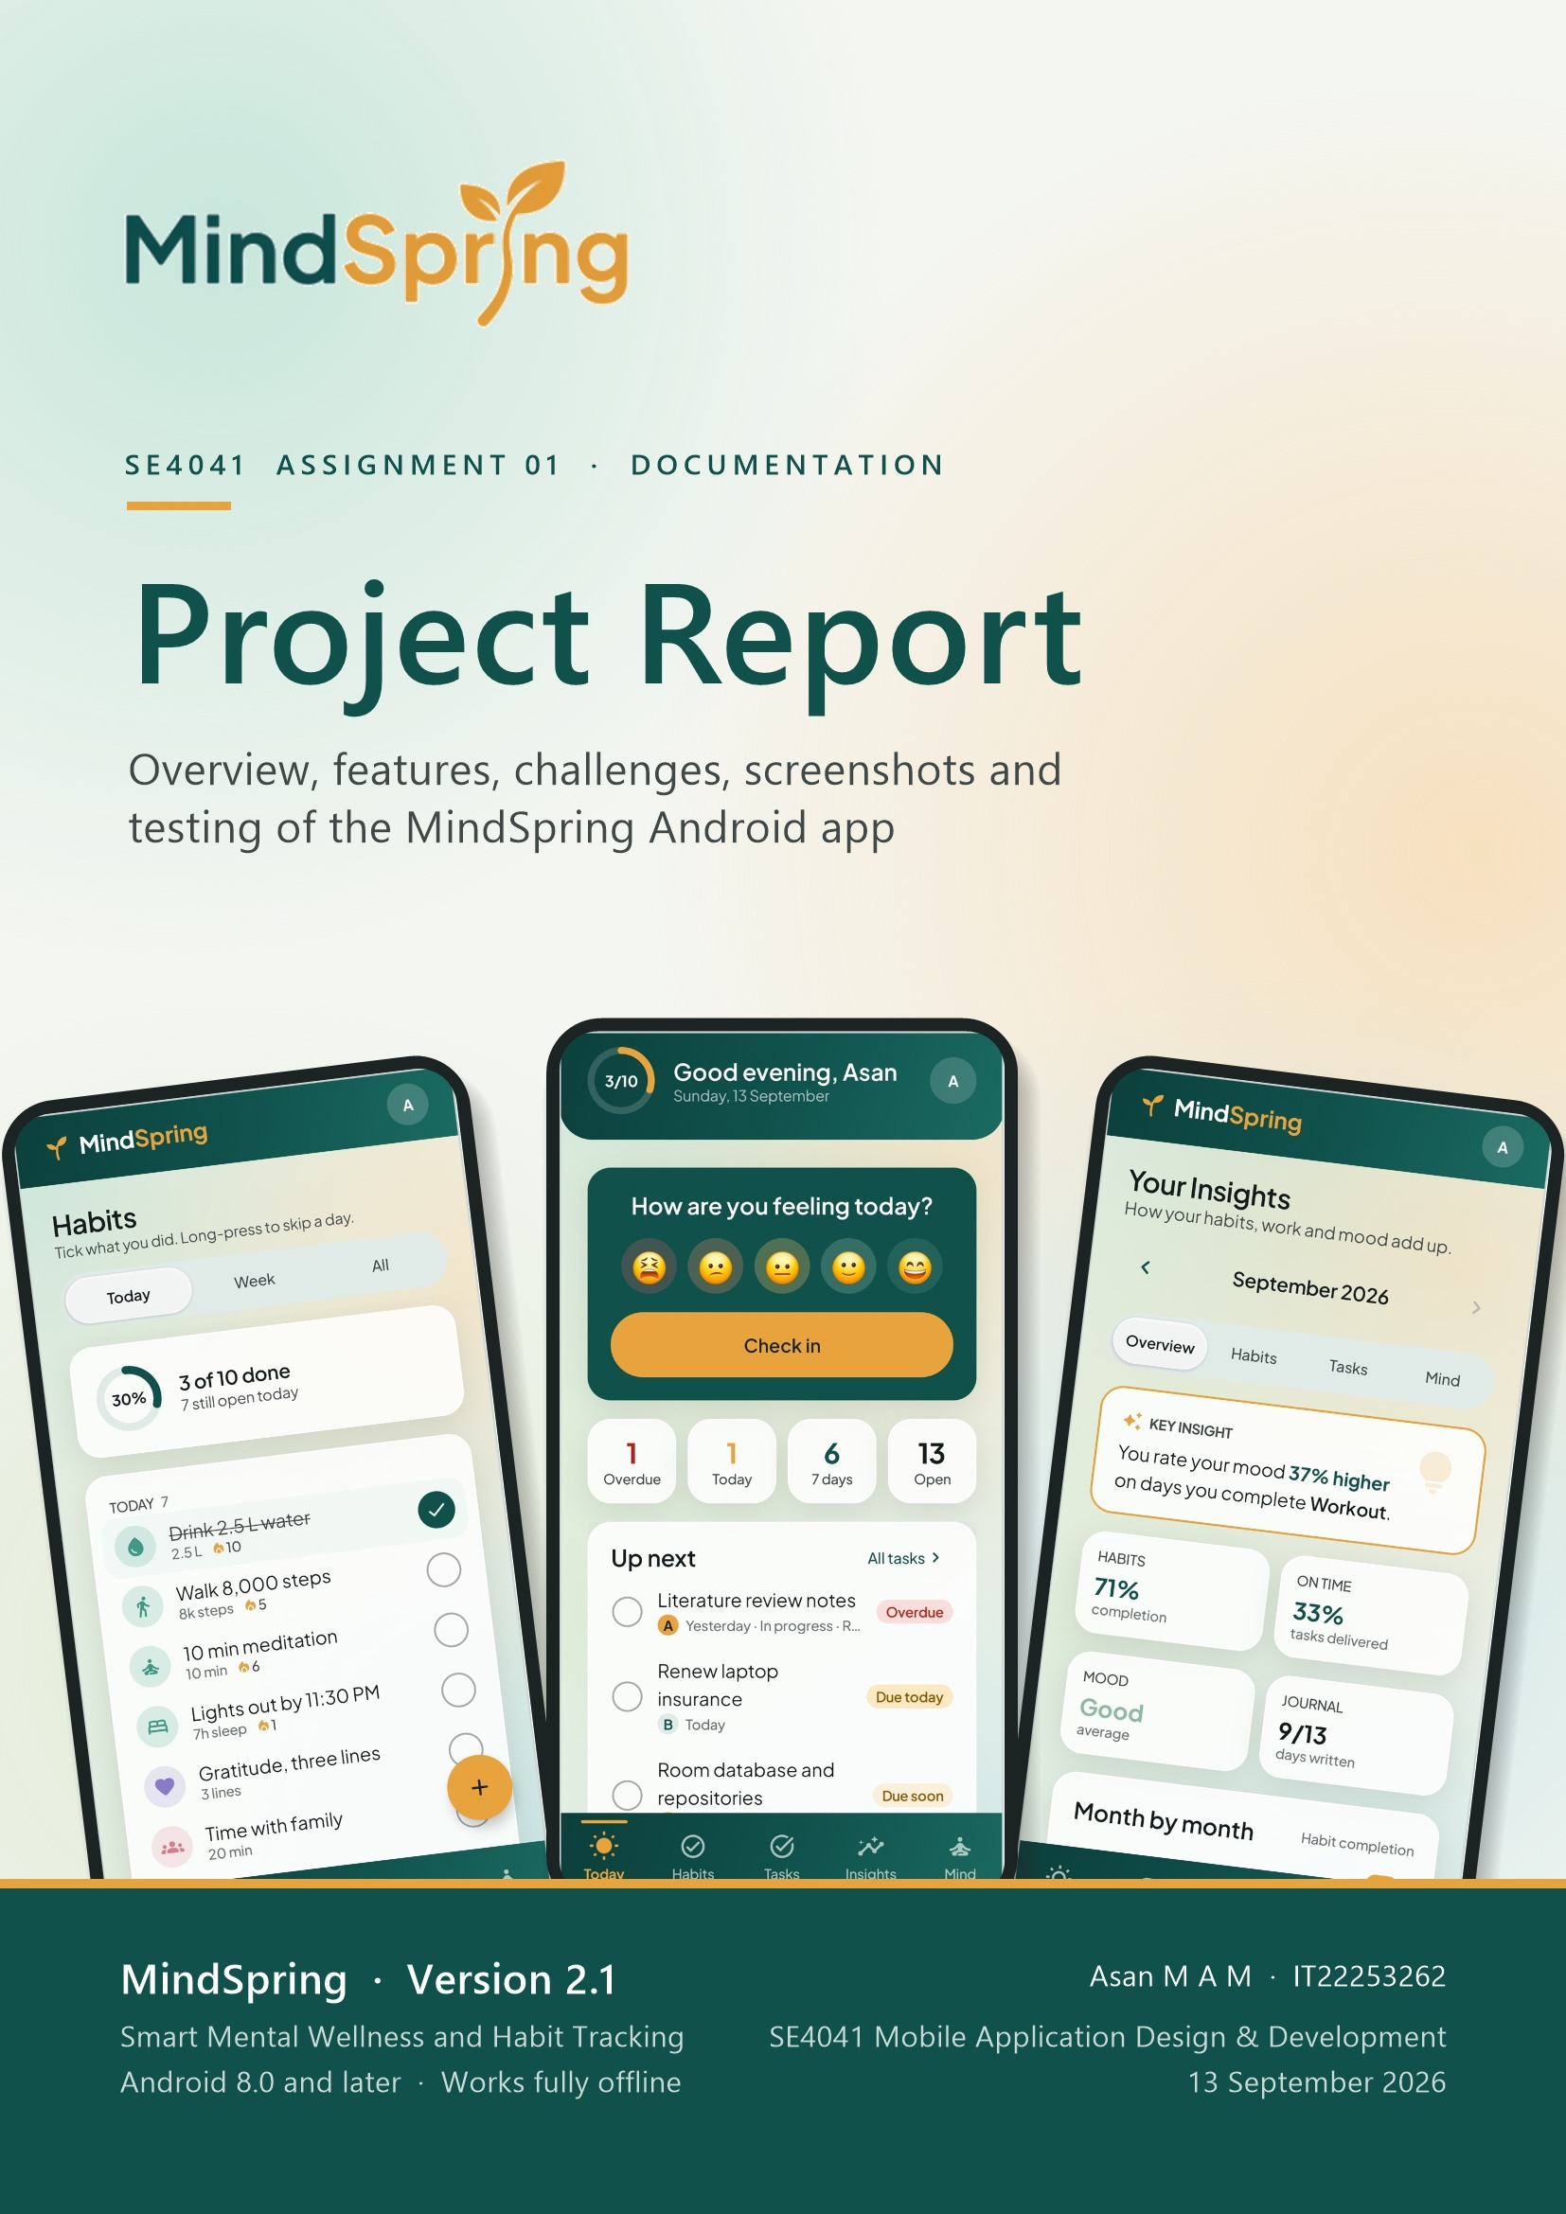
Contents
This report follows the SE4041 documentation criteria in order: an overview of the application, its features and functionalities, labelled application screenshots, the challenges faced and how they were solved, and the testing procedures and results. The public GitHub repository link is given in Section 1.6.
1 Overview of the Application 4
1.1 Problem addressed 4
1.2 Target audience 4
1.3 Solution at a glance 5
1.4 Scope 6
1.5 Technology and architecture 6
1.6 GitHub repository 7
2 Features and Functionalities 8
2.1 Feature summary 8
2.2 Accounts and onboarding 9
2.3 Today dashboard 9
2.4 Mood check-in and history 10
2.5 Habit tracking 10
2.6 Tasks and projects 11
2.7 Insights and life areas 11
2.8 Mind: breathing, reflection and gratitude 12
2.9 Reminders and alarms 12
2.10 Personalisation, backup and privacy 12
2.11 Design: the 60-30-10 colour rule 13
2.12 Non-functional requirements 13
3 Application Screenshots 14
3.1 Onboarding and authentication 14
3.2 Today dashboard 15
3.3 Mood check-in 15
3.4 Habits 16
3.5 Tasks and projects 17
3.6 Insights 19
3.7 Mind 20
3.8 Profile, settings and alerts 22
3.9 Dark theme 23
4 Challenges Faced 24
4.1 Alerts that ring on time with the app closed 24
4.2 Stale alarms after data changes 24
4.3 Android permission changes across versions 25
4.4 Notification sounds that cannot be changed 25
4.5 Fair and correct habit statistics 25
4.6 Changing the database without losing data 26
4.7 Privacy with several accounts on one phone 26
4.8 A calm, animated UI that stays smooth and testable 26
4.9 Managing scope in a short timeline 27
5 Testing Procedures and Results 28
5.1 Test strategy 28
5.2 Unit testing 28
5.3 Integration testing 29
5.4 UI testing 30
5.5 Manual functional testing 30
5.6 Results summary 32
6 Conclusion 33

1 Overview of the Application
MindSpring is a private, offline Android application for the allocated topic “Smart Mental Wellness and Habit Tracking”. It brings daily habits, deadlines, moods and evening reflections together in one calm place, and then shows the user how they add up.
Item | Details
Student | Asan M A M · IT22253262
Module | SE4041 — Mobile Application Design and Development (MADD), Assignment 01 — Kotlin
Allocated topic | 2 — Smart Mental Wellness and Habit Tracking Mobile Application
Application | MindSpring, version 2.1
Platform | Android 8.0 (API 26) and later; target API 36
Language and IDE | Kotlin, Jetpack Compose, Android Studio
Database | Room (SQLite) on the device — 9 tables, schema version 3
GitHub repository | https://github.com/InfinityBrainNetworks/MindSprint

1.1 Problem addressed
Stress, anxiety and low mood are increasingly common among university students and young working adults, yet the tools available to manage them are often unsuitable for everyday use:
- Mood and routine are tracked in isolation. Journalling apps capture feelings but ignore behaviour, while habit apps count streaks but ignore how the user actually feels.
- Users receive data, not insight. Most apps show raw logs and leave the user to work out the connection between routines and wellbeing.
- Barriers to consistent use. Subscriptions, constant internet connectivity and long daily entries cause people to abandon these apps within a week.
- Privacy concerns. Mood and journal data are deeply personal, and many users are unwilling to store them on third-party servers.
MindSpring answers this with a lightweight, offline application in which a daily check-in takes seconds, and the recorded data is turned into a clear picture of the user’s wellbeing over time — for example, “You rate your mood 37% higher on days you complete Workout”.

1.2 Target audience
Audience | Description | Need addressed
Primary: university students (18–25) | Students managing academic pressure, irregular sleep and inconsistent routines. | A fast, free way to notice stress patterns, keep on top of deadlines and build stable daily habits.
Secondary: young working adults (25–35) | Early-career professionals coping with workload and work–life balance. | Lightweight self-monitoring that fits into a busy schedule.
Tertiary: general self-improvement users | Anyone building habits such as exercise, reading, hydration or less screen time. | Streaks with visible feedback on how routines affect mood.

IMPORTANT MindSpring is a self-reflection tool for the general public. It is not a medical product, does not diagnose or treat any condition, and says so inside the app.

1.3 Solution at a glance
The application is organised into five areas, each a tab on the bottom navigation bar, plus a Profile & Settings area opened from the avatar on every main screen:
Area | Purpose
Today | The day at a glance: mood check-in, task counters, what is due next, today’s habits, streaks, tonight’s reflection and a gratitude note.
Habits | Routines repeated daily, on chosen weekdays, weekly or monthly, with streaks, completion rates and reminders.
Tasks | One-off work with deadlines, priorities, alerts and repeats, grouped into projects.
Insights | Monthly statistics and charts for habits, tasks, mood and journalling, the key mood insight and a life-area breakdown.
Mind | Guided breathing, the daily reflection journal, the gratitude journal and mood history.
Profile & Settings | Profile, reminder times, alert sounds, light/dark appearance, backup and restore, data reset and log out.

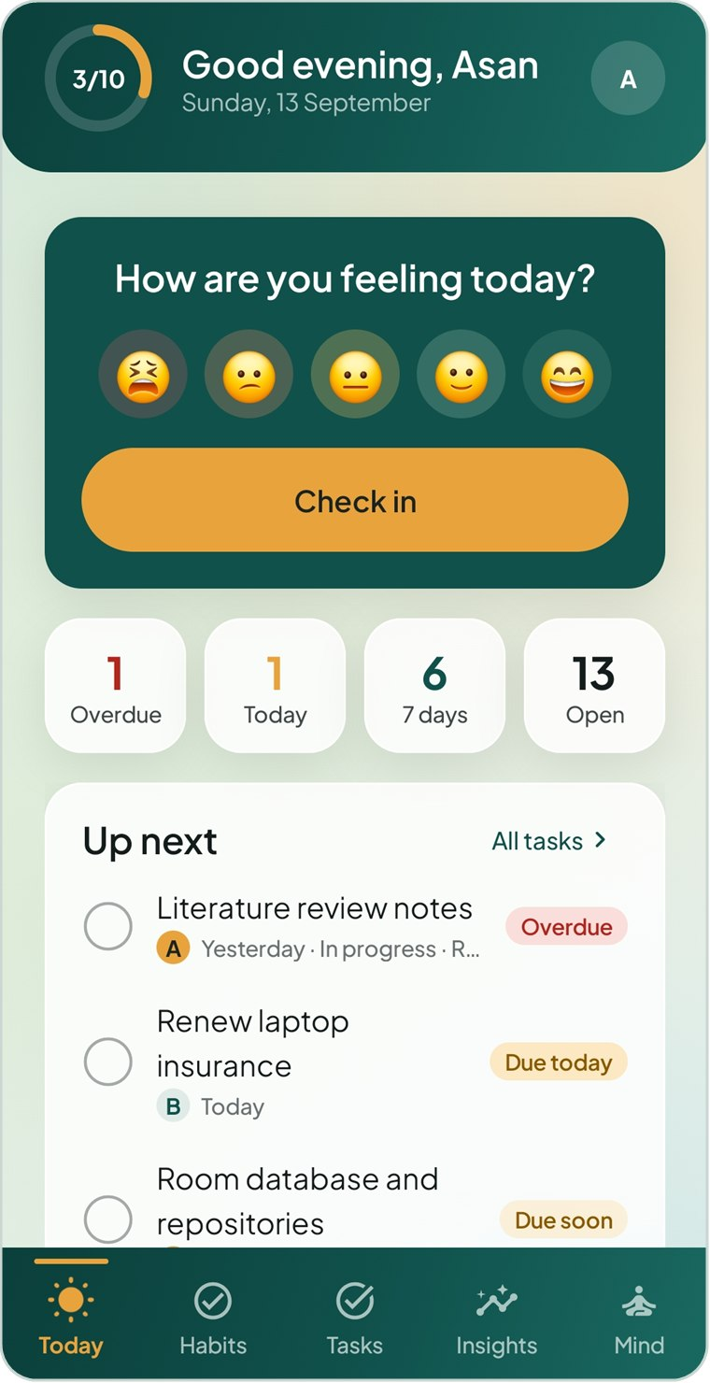  Figure 1.1 Today dashboard | 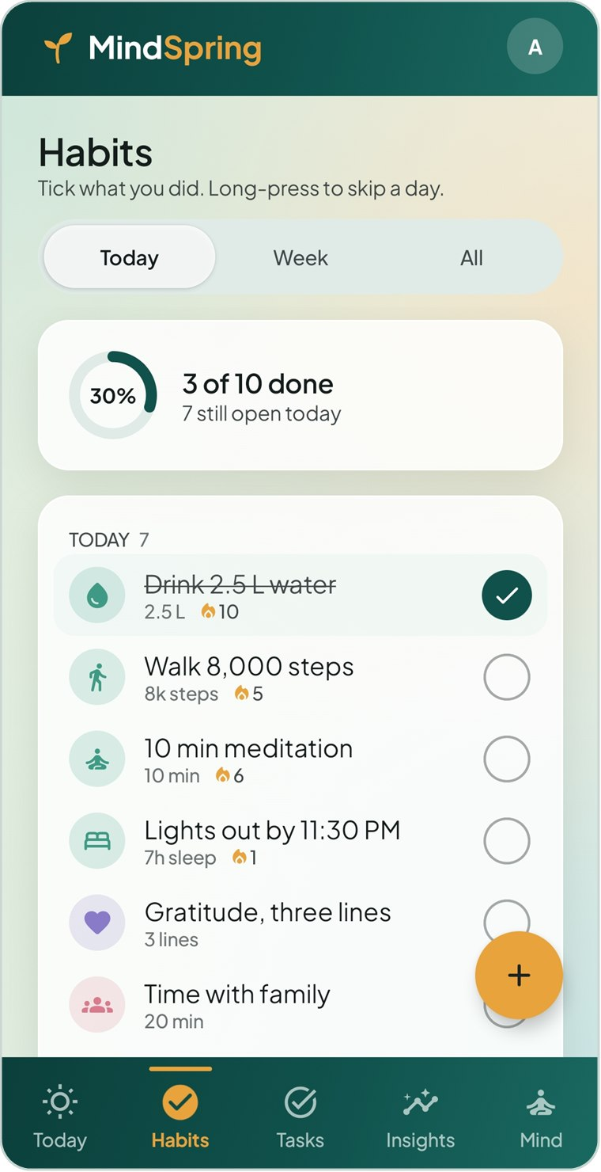  Figure 1.2 Habits — Today view | 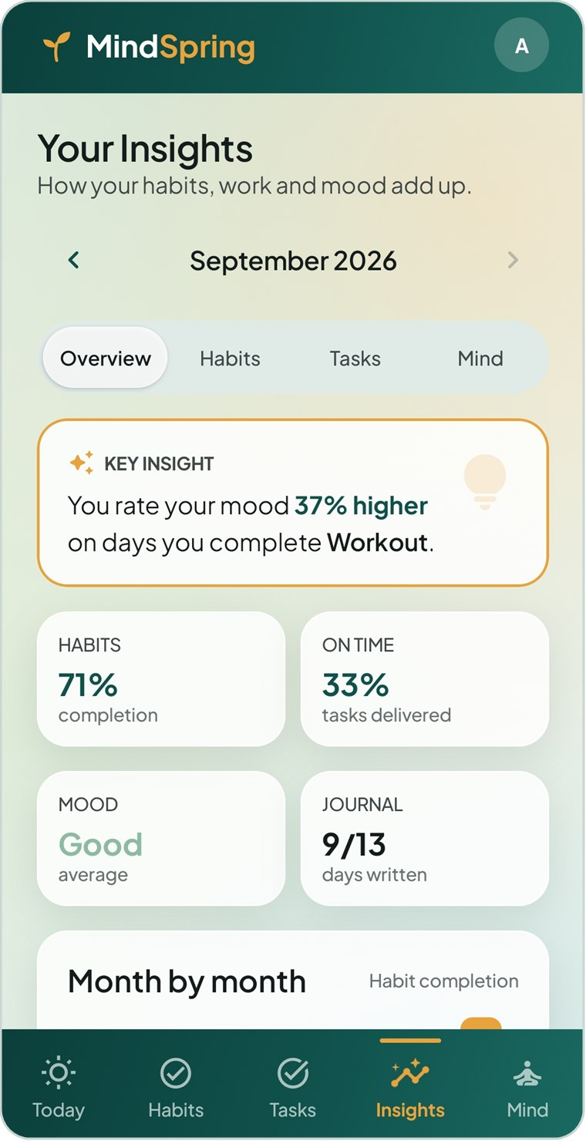  Figure 1.3 Insights with the key insight

1.4 Scope
In scope (delivered) | Out of scope
Local registration and log-in with hashed passwords, plus a sample-data demo account | Clinical diagnosis, screening or medical advice
Mood check-in, history, editing and deletion | Chat or consultation with therapists
Habits with frequencies, skips, streaks, rates and reminders | Cloud synchronisation across devices
Tasks and projects with deadlines, priorities, repeats and exact-time alerts | Wearables and third-party health platforms
Insights dashboard, key mood insight and life areas | Social feeds or content sharing
Breathing exercises, daily reflection and gratitude journal | iOS and web versions
Light and dark themes, backup/restore and data reset

1.5 Technology and architecture
MindSpring is written entirely in Kotlin with Jetpack Compose and Material 3 — about 14,000 lines of code in 72 Kotlin files, with no XML layouts. It follows the MVVM architecture recommended for Android:
Layer | Technology | Responsibility
UI | Jetpack Compose, Navigation Compose, custom design system | Screens and reusable components render immutable UI state and send user events up.
ViewModel | AndroidX ViewModel, Kotlin Coroutines and Flow | Combines data streams into one UI state per screen; runs work off the main thread.
Domain | Plain Kotlin objects | Streaks, completion rates, task flags, repeats, monthly analytics and the mood insight.
Data | Room (SQLite), Preferences DataStore | Nine-table database with DAOs and repositories; settings and the signed-in session.
System | AlarmManager, WorkManager, notification channels | Exact-time task and habit alerts, a full-screen alarm and daily check-in nudges.

Database integration. All user data is stored in a Room database named mindspring.db, created by MindSpringDatabase and shared by the whole app. Its nine tables — users, areas, projects, habits, habit_marks, tasks, mood_entries, gratitude_entries and journal_entries — are linked by foreign keys, and every row belongs to a user so several accounts can share one phone. Screens observe the database through Flows, so any change appears on every screen immediately. The app requests no internet permission: nothing leaves the device.

1.6 GitHub repository
Repository link: https://github.com/InfinityBrainNetworks/MindSprint
The source code has been version-controlled with Git from the first day of the project. The commit history so far:
Date | Commit | Work recorded
11 Sep 2026 | initial commit | Repository created
11 Sep 2026 | Organise the repo into docs, design and report folders | Project structure for documentation, design assets and reports
11 Sep 2026 | Add the Stitch design exports | UI design exports used to build the screens
11 Sep 2026 | Build the MindSpring Android app UI | Compose screens, navigation, theme and components
12 Sep 2026 | Keep gradlew’s line endings Unix-style | Build script fix for cross-platform builds
12 Sep 2026 | Store data on the device and add tasks, projects and a journal | Room database, repositories, authentication, new features
12 Sep 2026 | Add exact-time alerts for tasks and habits | AlarmManager alerts, full-screen alarm, notification channels

2 Features and Functionalities
Each feature below is described together with the reason it exists — the user need it answers — and the functional requirement from the project proposal (FR-01 to FR-12) that it fulfils.

2.1 Feature summary
Feature | What the user can do | Req.
Accounts | Register, log in, stay signed in, log out; explore a sample-data account | FR-01
Mood check-in | Rate mood on a five-face scale, add feeling tags and a note; view, edit and delete entries | FR-02, FR-03
Habit tracking | Create, edit, retire and delete habits; mark done or skipped; streaks and rates | FR-04, FR-05
Today dashboard | See mood, due tasks, today’s habits, streaks, reflection and gratitude in one place | FR-06
Insights | Monthly habit, task and mind statistics, mood trend chart and key insight | FR-07
Breathing exercises | Calm and box breathing with an animated, timed visual guide | FR-08
Gratitude journal | Record and review short daily positive notes | FR-09
Reminders and alarms | Evening check-in and morning summary; exact-time habit reminders and task alarms | FR-10
Local database | All data stored persistently on the device in Room | FR-11
Personalisation | Light/dark theme, editable profile, alert tones, backup/restore, data reset | FR-12
Tasks and projects | Deadlines, priorities, statuses, repeats and alerts, grouped into projects | Extension
Daily reflection | One structured journal entry per day with rating, energy, highlight and priority | Extension
Life areas | File habits, tasks and projects under areas of life and compare them | Extension

2.2 Accounts and onboarding
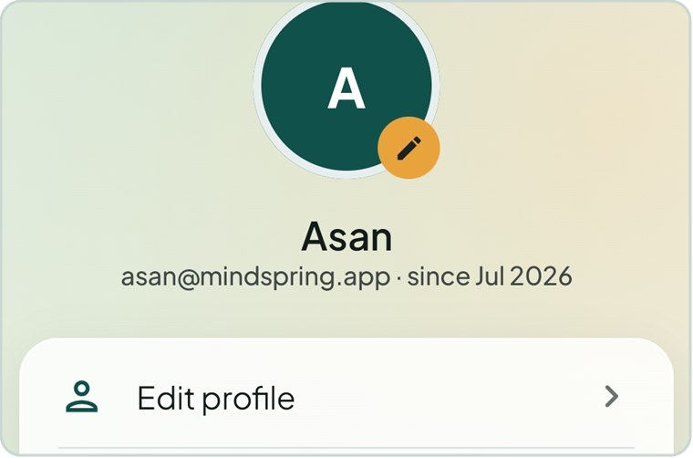  Figure 2.1 Profile header of a signed-in account | Three welcome slides introduce the app on first launch. Users then create an account (name, email, password, confirmation and privacy consent) or log in. Clear inline messages explain every validation error, and the session is remembered until the user logs out.  Explore with sample data opens a demonstration account filled with about six weeks of realistic habits, tasks, moods and journal entries.  Justification: a local account keeps each person’s data separate on a shared phone without needing a server, and passwords are stored only as a salted PBKDF2 hash. The sample account lets a new user — or an examiner — see every chart and insight working immediately instead of after weeks of logging.

2.3 Today dashboard
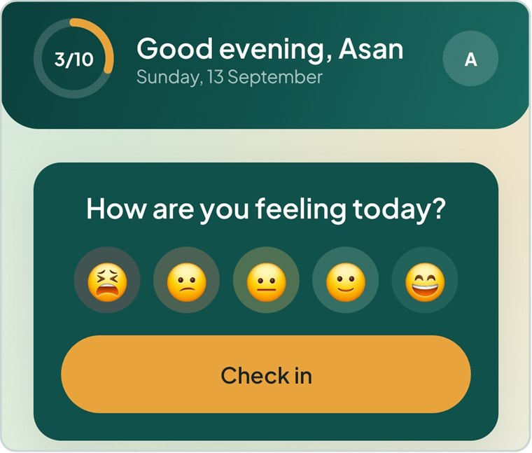  Figure 2.2 Greeting, progress ring and mood card | Today answers one question: what needs attention today? From top to bottom it shows a greeting with a progress ring, the mood card, four task counters (Overdue, Today, 7 days, Open), Up next, today’s habits, tonight’s reflection, current streaks and a quick gratitude note.  Habits and tasks can be ticked off directly on this screen.  Justification: the proposal requires a check-in in under a minute (NFR-01). Putting every daily action on one scrolling screen removes navigation and makes the daily routine realistic to sustain.

2.4 Mood check-in and history
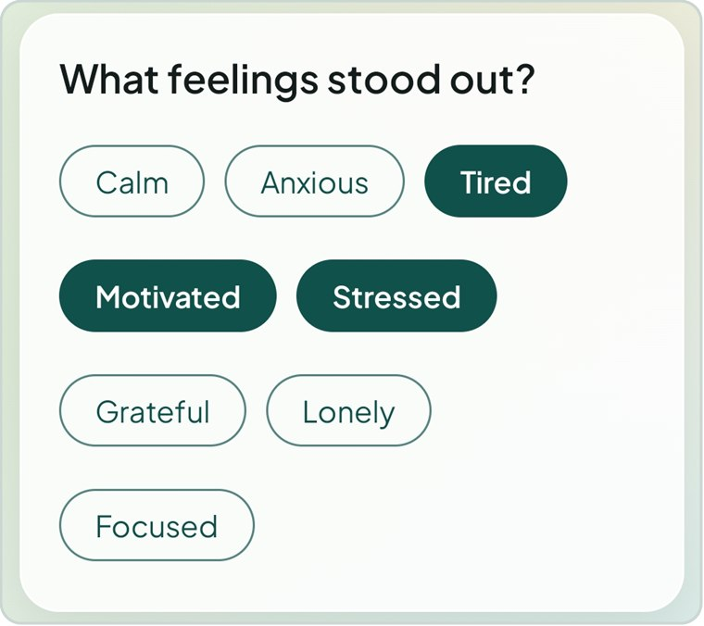  Figure 2.3 Feeling tags on the check-in screen | A check-in takes three steps: tap one of five faces, optionally pick feeling tags such as Calm, Anxious or Motivated, and optionally write a note. Mood History lists every entry newest first; tapping an entry edits it and swiping deletes it, with Undo.  Justification: a five-point face scale is quick and language-independent, while tags and notes add context only when the user wants to. Consistent daily ratings are what make the insight engine possible.

2.5 Habit tracking
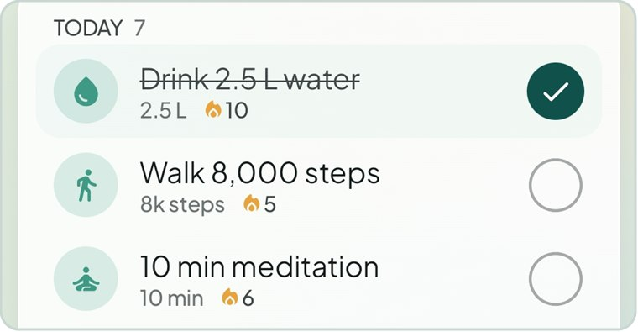  Figure 2.4 Habit rows with streaks; the first is done | Habits can repeat daily, on weekdays or weekends, on chosen days, weekly or monthly, and carry an icon, a target, a life area and an optional reminder. A tap marks a habit done; a long-press marks it skipped. Three views — Today, Week and All — plus a detail screen show streaks, best streak, completion rate and a calendar of activity.  Justification: streaks give visible feedback that encourages consistency. A skip is excused and never breaks a streak, because illness or travel should not punish the user — an important choice for a wellbeing app, where guilt drives people away.

2.6 Tasks and projects
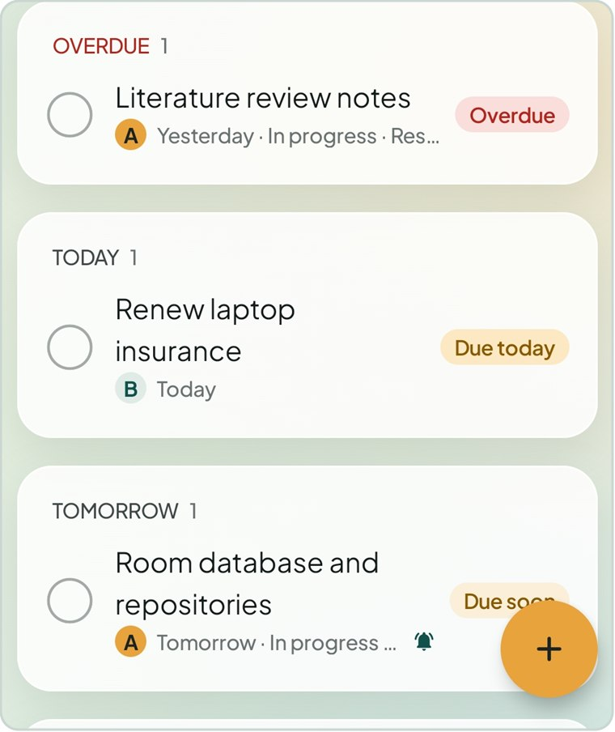  Figure 2.5 Tasks grouped by deadline | Tasks have a deadline, optional start date, priority (A, B or C), status, repeat rule, life area, notes and an optional alert. The list groups tasks by urgency, and filter chips show live counts. Projects group tasks into a larger deliverable with a colour and a progress bar. Finishing a repeating task automatically creates its next occurrence.  Justification: for the primary audience, academic deadlines are a leading source of stress. Keeping tasks next to habits and mood lets the app relate workload to wellbeing, which a separate to-do app cannot do.

2.7 Insights and life areas
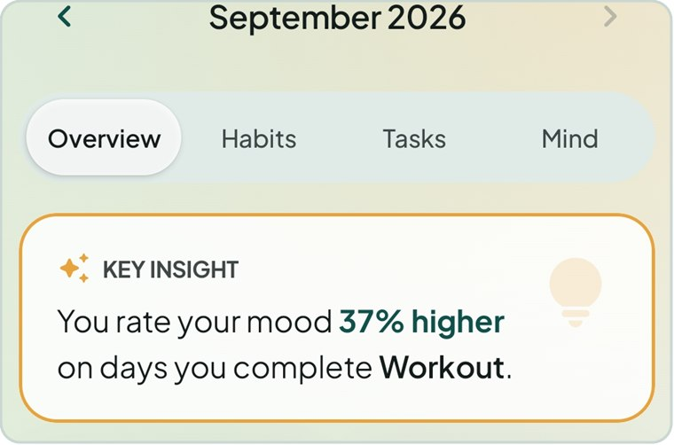  Figure 2.6 The key insight on the Insights overview | Insights summarises one month at a time in four sections — Overview, Habits, Tasks and Mind — with completion rates, on-time delivery, mood trend charts, journalling counts and month-by-month comparisons. The key insight compares average mood on days a habit was done with days it was not, and reports the strongest difference in a plain sentence. Life Areas compares progress across areas such as Health, Study and Finance.  Justification: this is the core of the problem statement — turning data into insight — so users can see which routines accompany their better days.

2.8 Mind: breathing, reflection and gratitude
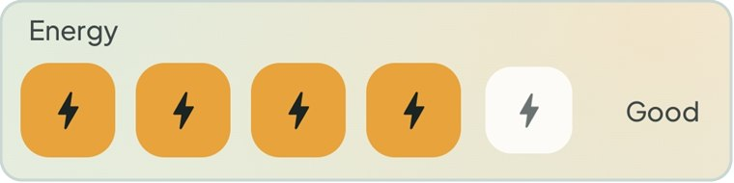  Figure 2.7 Day rating and energy in the daily reflection | Breathing exercises (Calm Breathing and Box Breathing) guide each breath with an animated circle and a timer. The daily reflection records a day rating, energy level, highlight, a short free-writing monologue and tomorrow’s top priority — one entry per day. The gratitude journal stores short positive notes.  Justification: these tools give the user an immediate action to take when stressed, not just a record to read. Guided breathing and gratitude writing are simple, widely used self-help techniques that suit short daily sessions.

2.9 Reminders and alarms
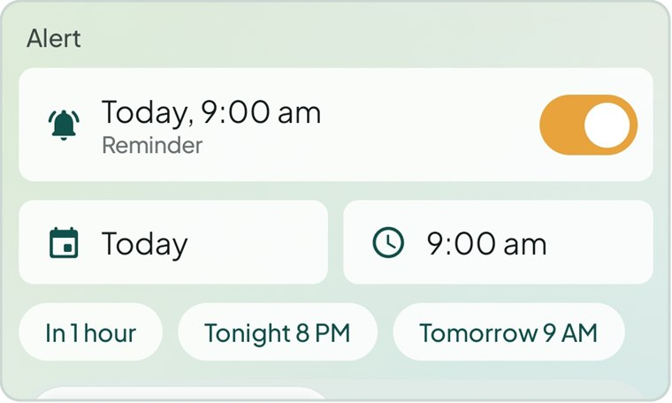  Figure 2.8 A task alert set for 9:00 am | A daily evening check-in and a morning summary are sent by WorkManager. Each habit and task can also have an exact-time alert in one of two styles: a reminder that sounds once, or an alarm that keeps ringing, fills the lock screen and offers Done, Snooze and Stop. Alerts survive reboots and time-zone changes, and fall silent automatically once the habit or task is dealt with.  Justification: habits are built by repetition at the right moment. A reminder the user can rely on — but that never nags about something already done — keeps the app helpful rather than annoying.

2.10 Personalisation, backup and privacy
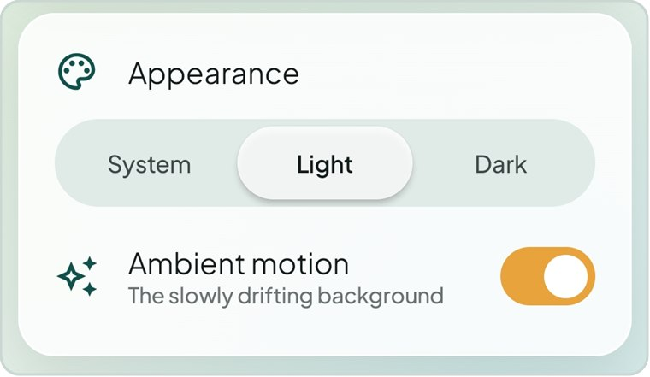  Figure 2.9 Appearance settings | Profile & Settings lets the user edit their name, choose light, dark or system appearance, turn ambient motion off, pick reminder and alarm tones, set snooze length and reminder times, export or import a JSON backup, clear all data and log out.  Justification: dark mode and reduced motion improve comfort and accessibility (NFR-08). Because data never leaves the phone, a user-controlled backup is the only safe way to move data to a new device.

2.11 Design: the 60-30-10 colour rule
The interface follows the colour scheme approved in the Figma prototype. About 60% of every screen is a soft off-white canvas and frosted white cards, 30% is deep teal (#10514C) for app bars, navigation and structure, and 10% is warm amber (#E8A33D), reserved for the single primary action, the active tab and streak highlights. Red is used only for destructive actions and overdue work. The dark theme re-assigns the same roles instead of inverting colours.

Figure 2.10 Teal structure with an amber accent on the active tab

2.12 Non-functional requirements
ID | Requirement | How MindSpring meets it
NFR-01 | Check-in under one minute | One tap on a face and one tap on Save; tags and note are optional.
NFR-02 | Responsive, off the main thread | Room queries run in coroutines; screens observe Flows and never block.
NFR-03 | No data loss | Every save is written to the database immediately; multi-step changes run in transactions.
NFR-04 | Security and privacy | No internet permission; passwords stored as PBKDF2-SHA256 hashes; each query is scoped to the signed-in user.
NFR-05 | Works offline | All features work with no connection.
NFR-06 | Maintainable MVVM | Separate UI, ViewModel, domain and data layers behind repository interfaces.
NFR-07 | Android 8.0+ | minSdk 26, target SDK 36.
NFR-08 | Accessibility | Semantic colour tokens with readable contrast, dark theme, scalable text and a reduced-motion switch.

3 Application Screenshots
The screenshots below show the final build using the app’s sample-data account. Most were captured on an Android phone; a few (onboarding, habit detail and the alarm) come from the automated screenshot tests. They are grouped by area of the app and labelled with the screen they show.

3.1 Onboarding and authentication
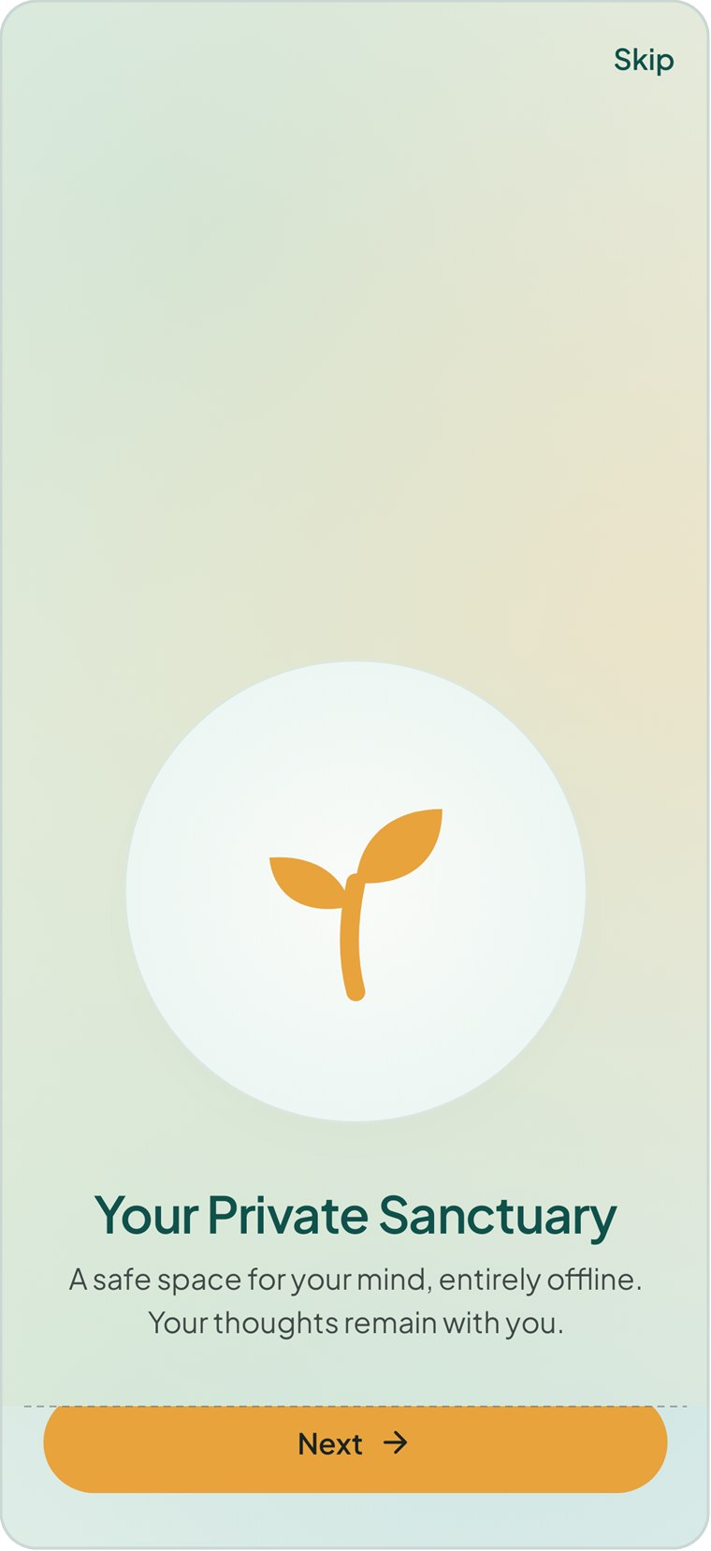  Figure 3.1 Welcome slide | 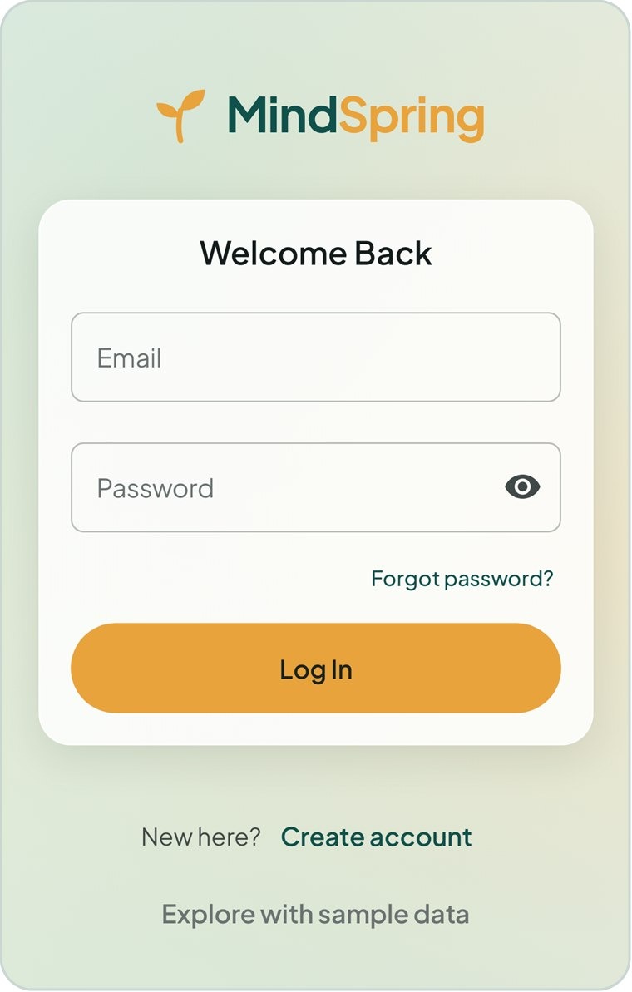  Figure 3.2 Log in | 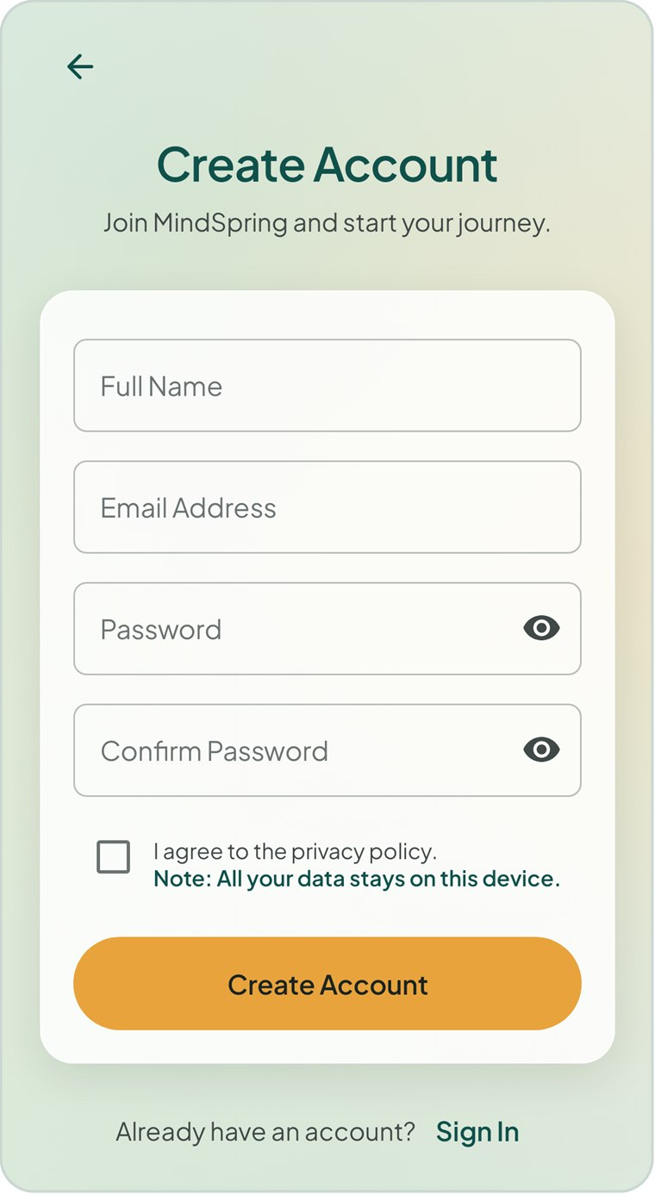  Figure 3.3 Create account

3.2 Today dashboard
Figure 3.4 Today — top | 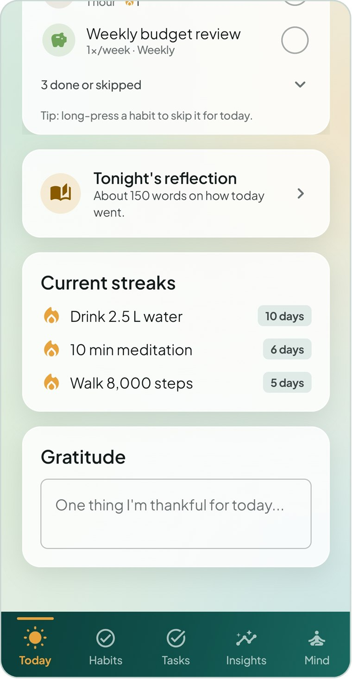  Figure 3.5 Today — habits, reflection, streaks | 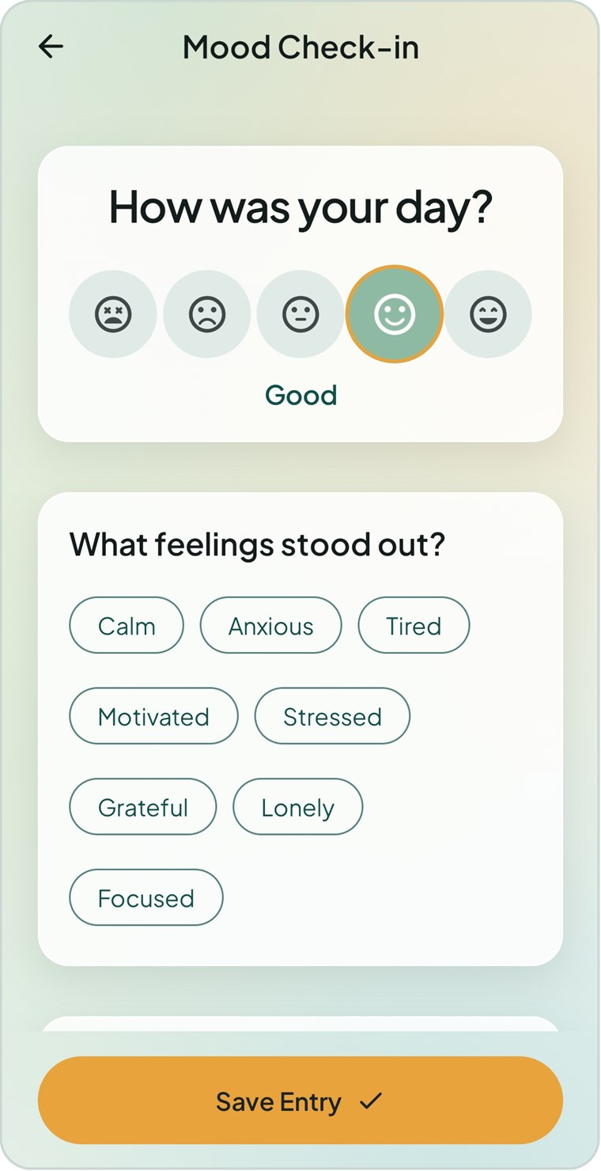  Figure 3.6 Mood check-in — Good selected

3.3 Mood check-in
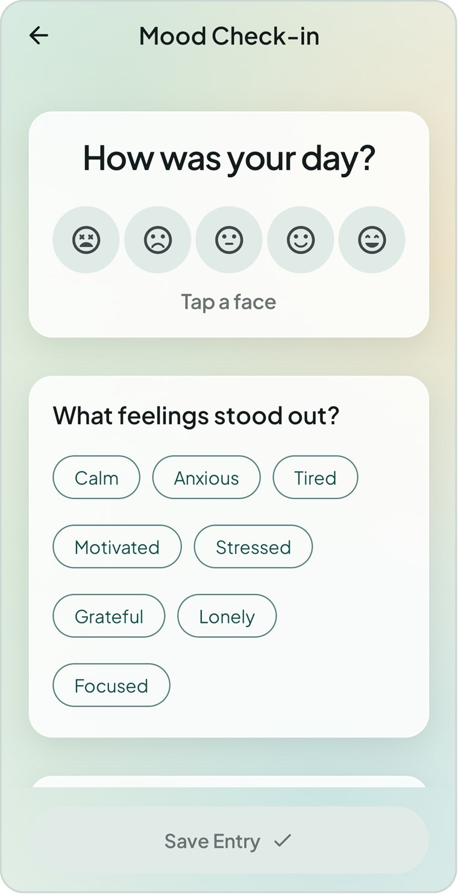  Figure 3.7 Check-in — choose a face | 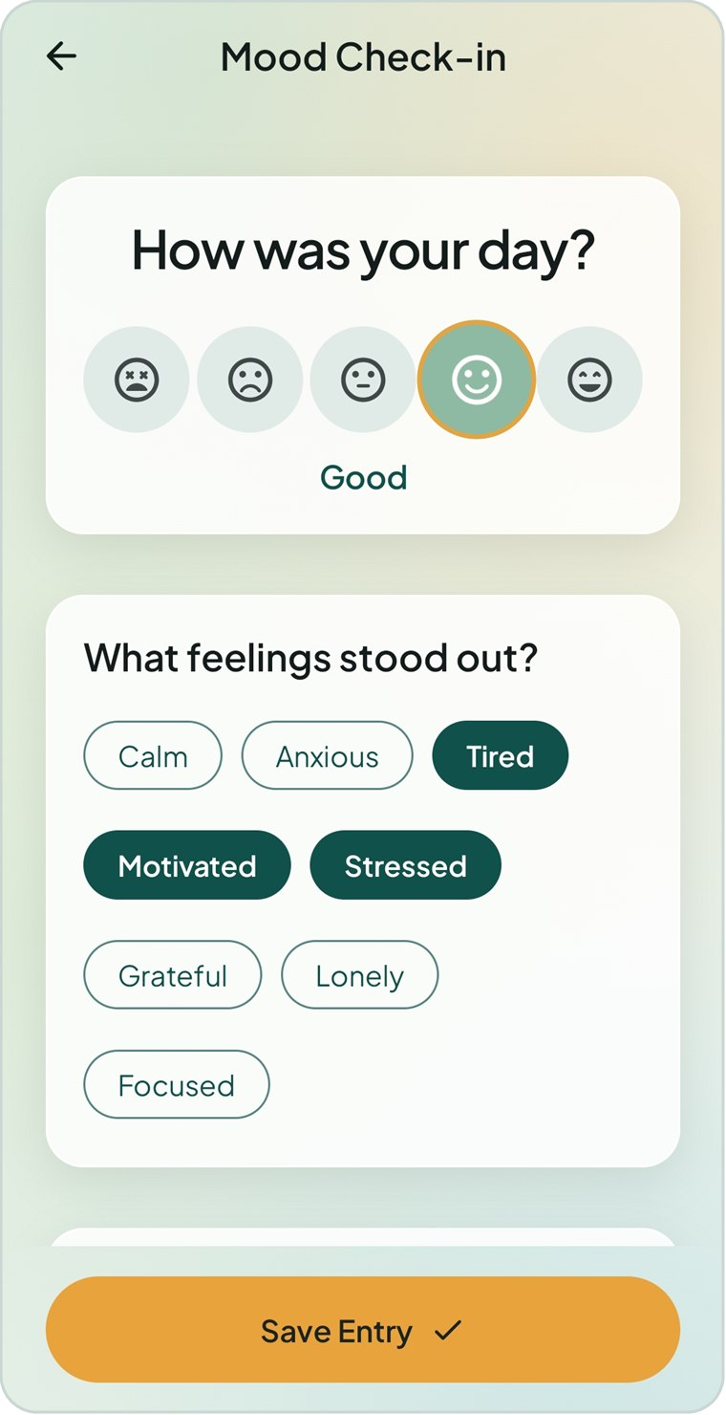  Figure 3.8 Check-in — feeling tags | 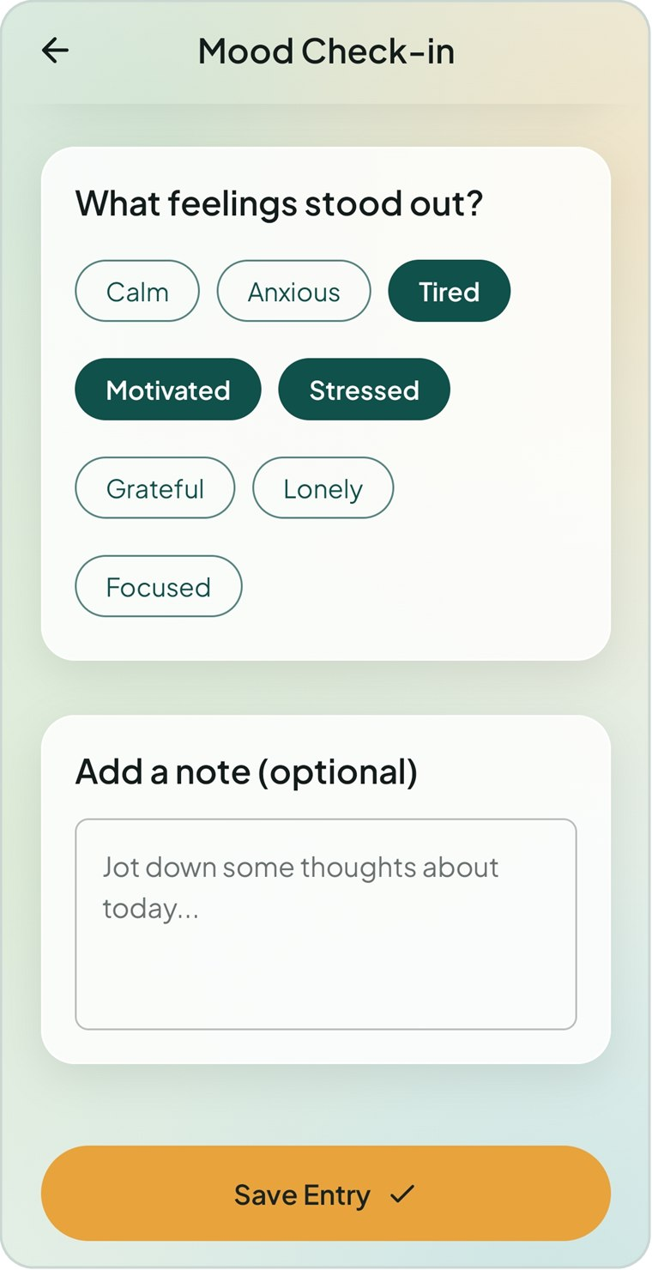  Figure 3.9 Check-in — add a note

3.4 Habits
Figure 3.10 Habits — Today view | 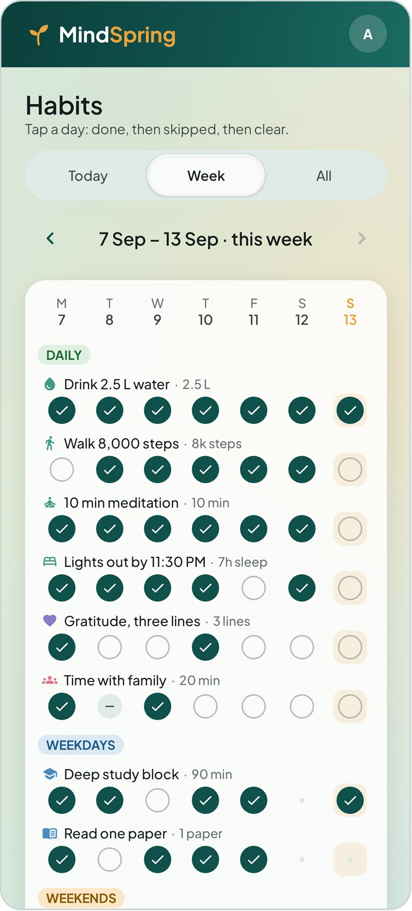  Figure 3.11 Habits — Week view | 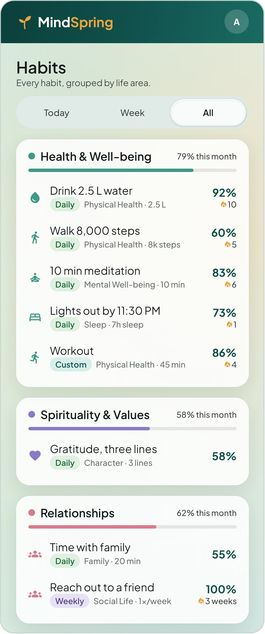  Figure 3.12 Habits — All view

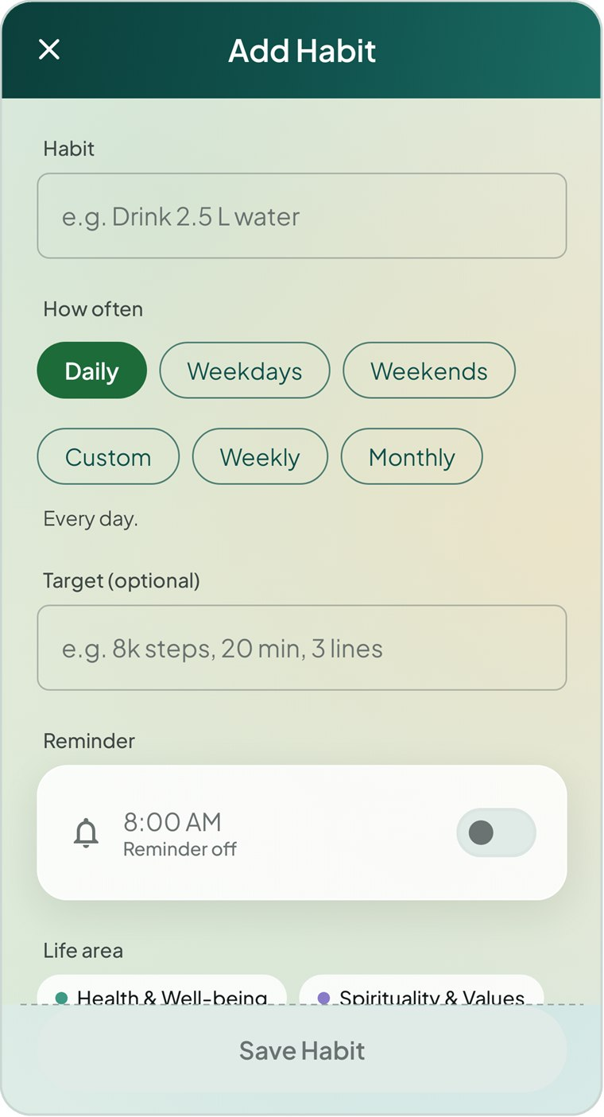  Figure 3.13 Add habit | 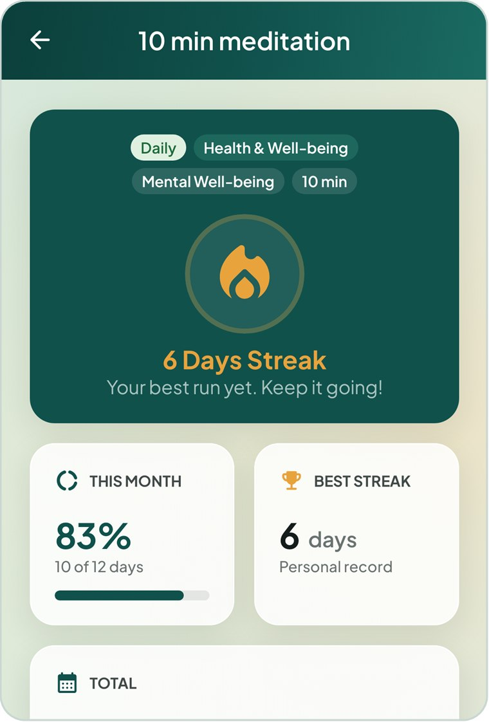  Figure 3.14 Habit detail — statistics | 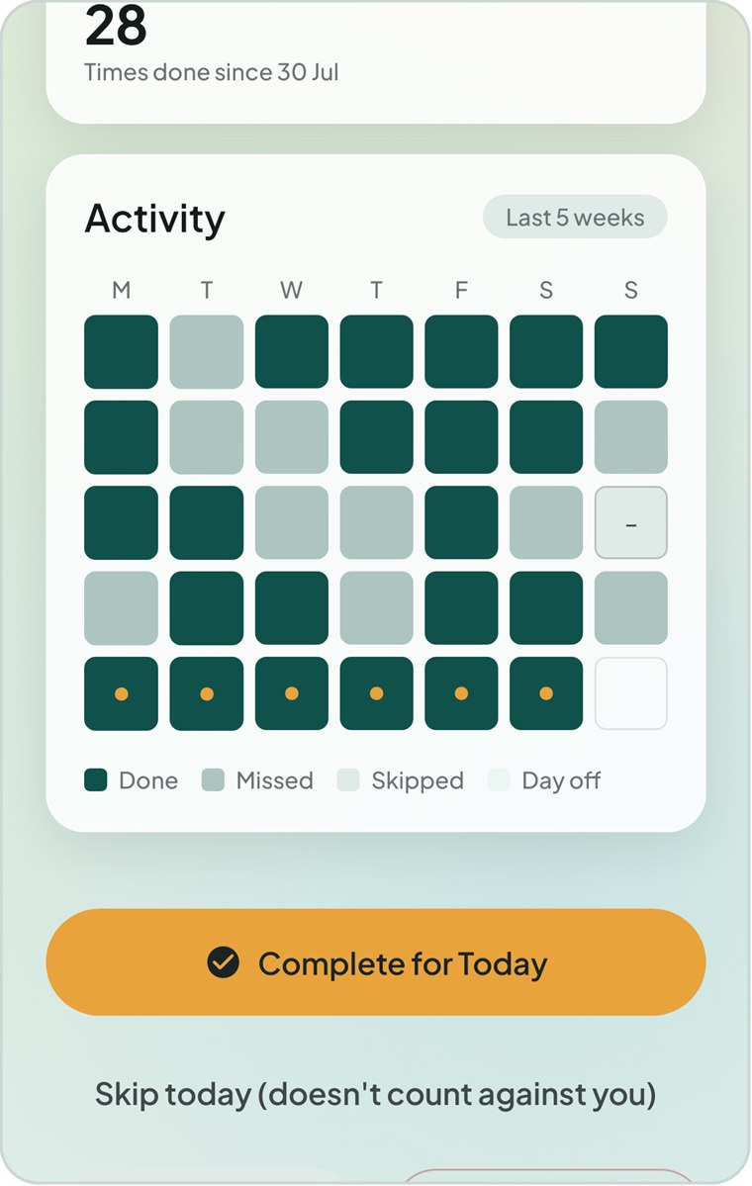  Figure 3.15 Habit detail — activity calendar

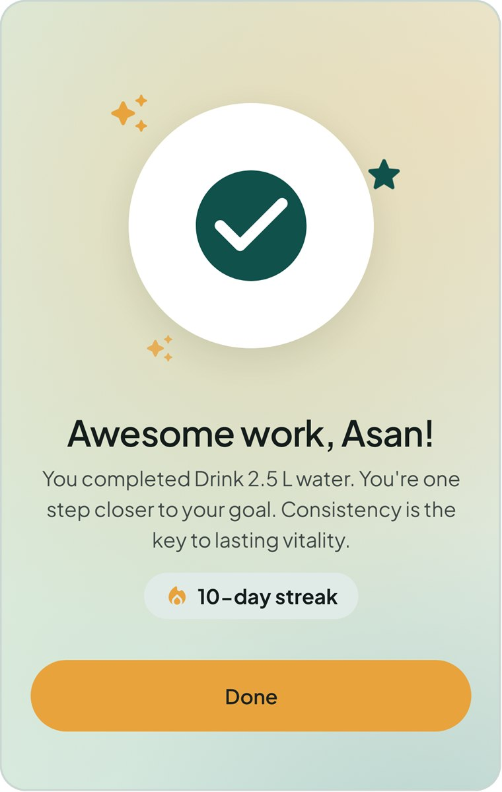  Figure 3.16 Habit completed celebration | 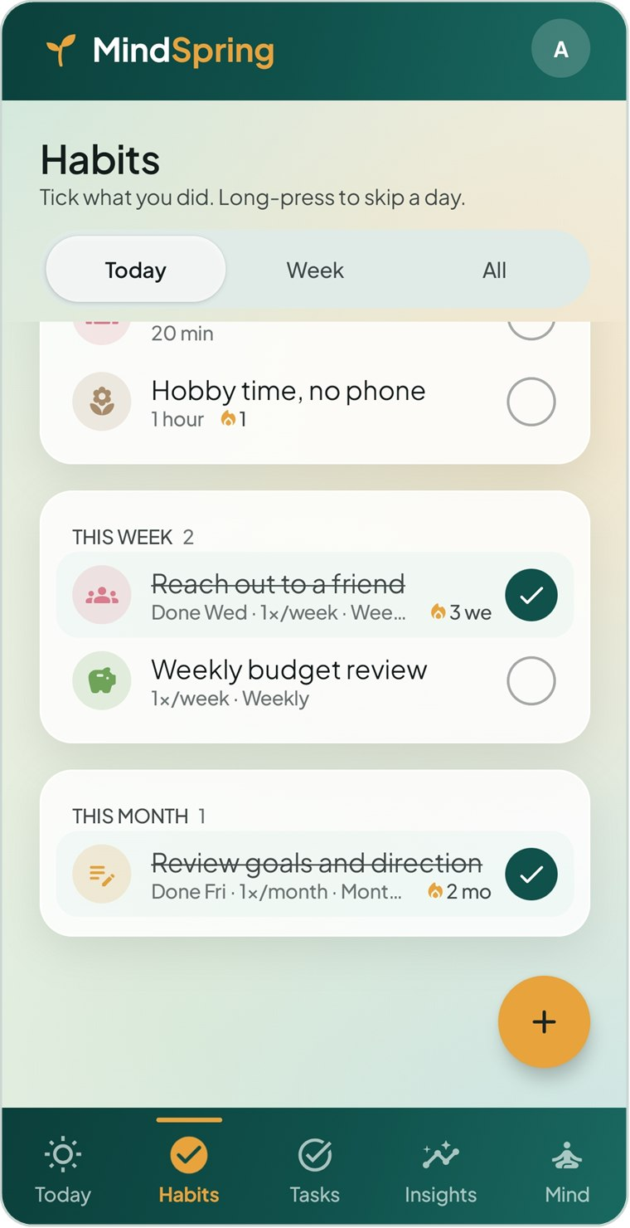  Figure 3.17 Habits — this week and this month | 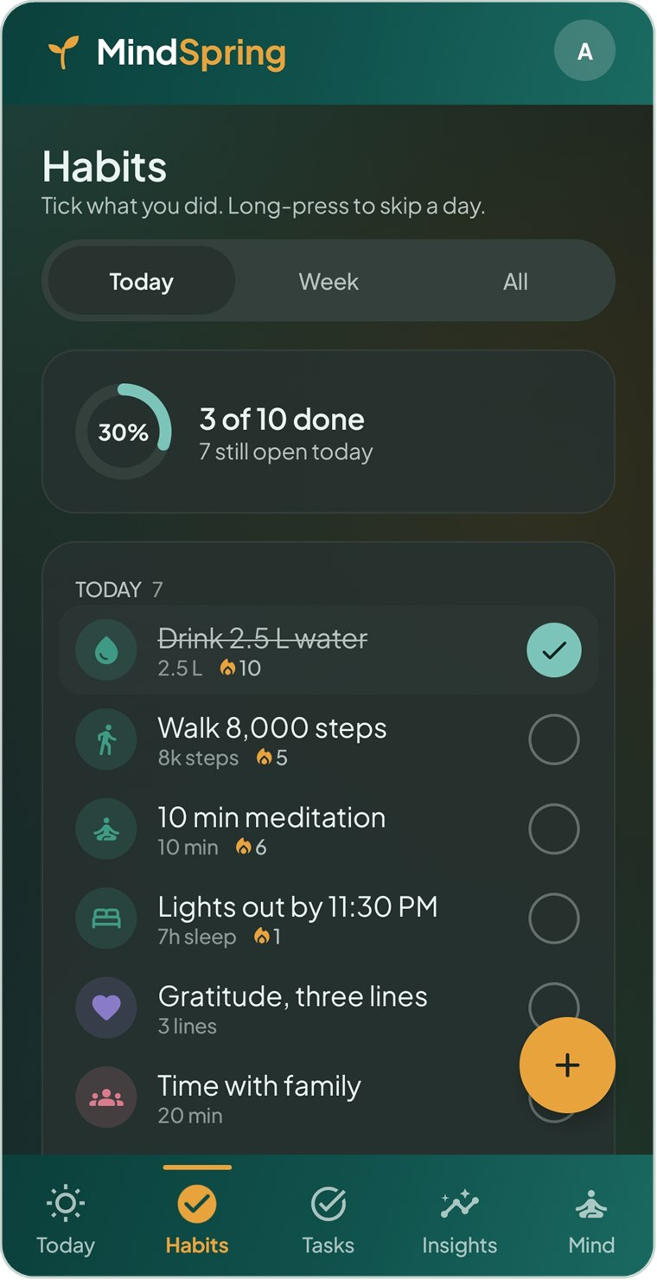  Figure 3.18 Habits — dark theme

3.5 Tasks and projects
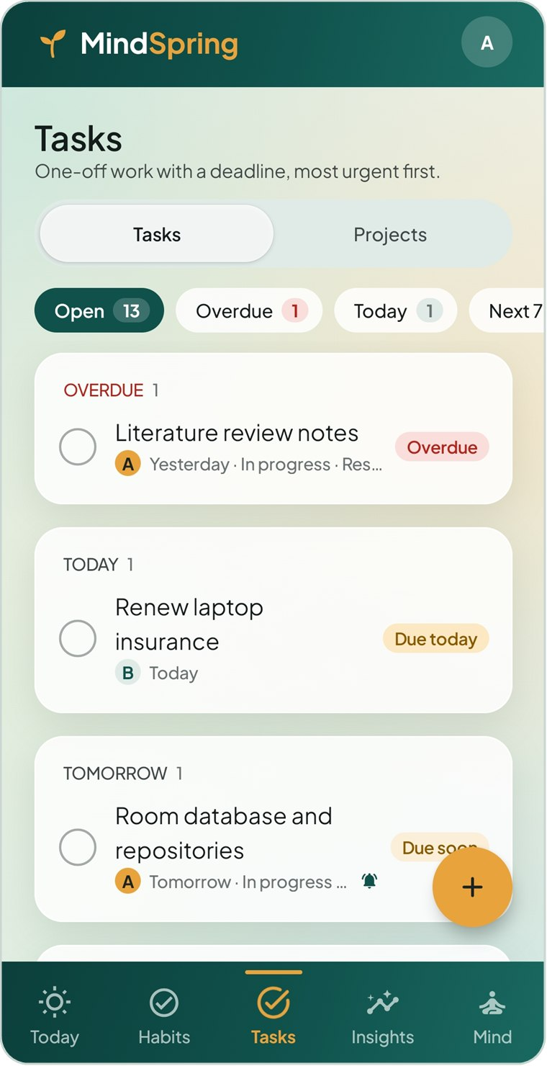  Figure 3.19 Task list | 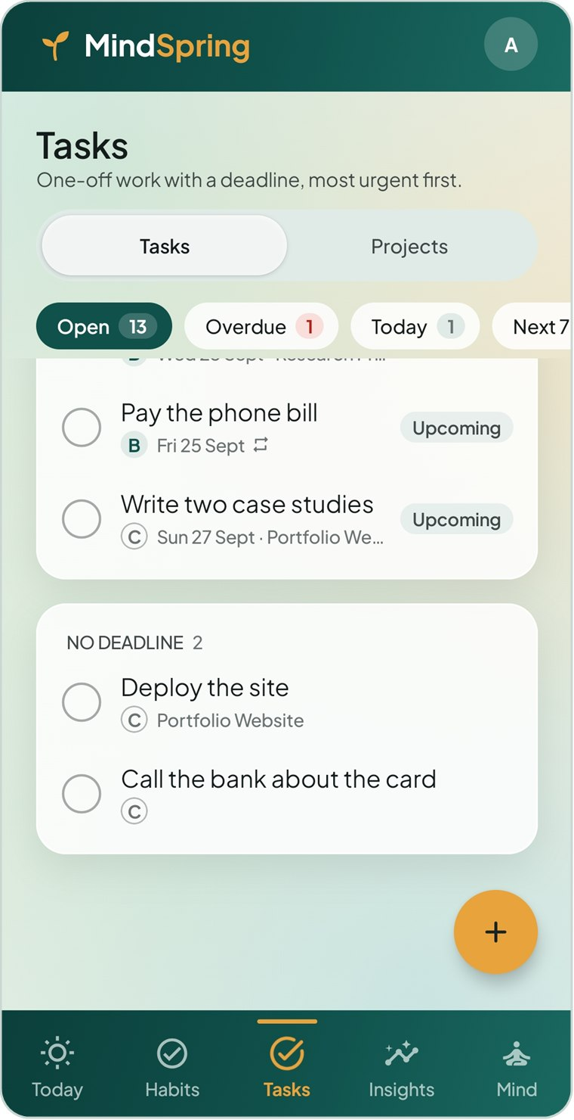  Figure 3.20 Task list — upcoming | 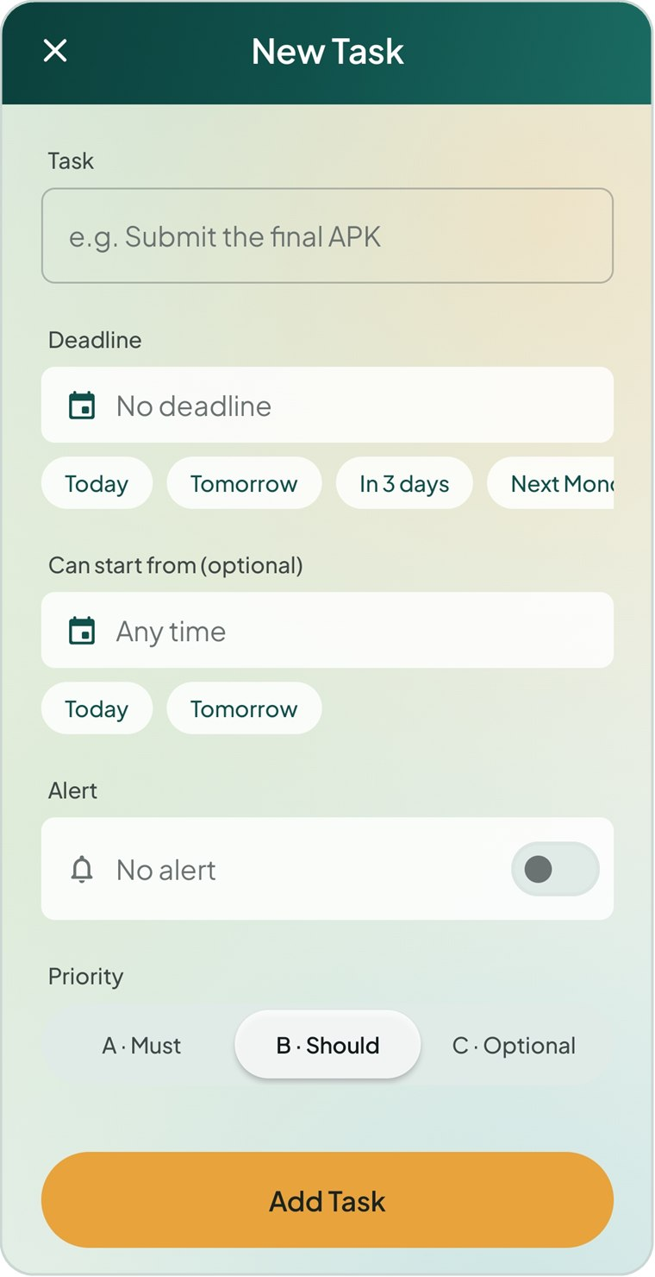  Figure 3.21 New task

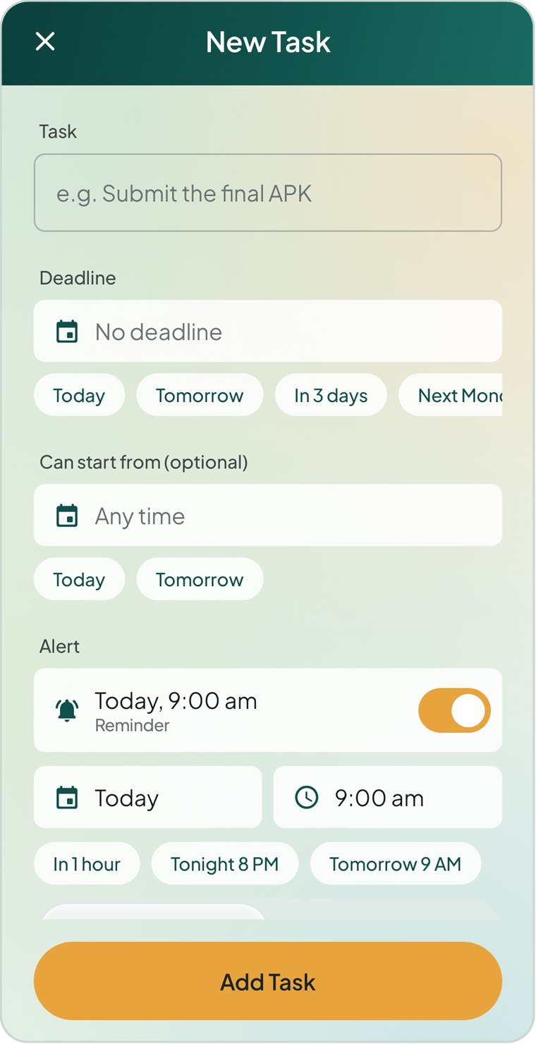  Figure 3.22 New task — deadline and alert | 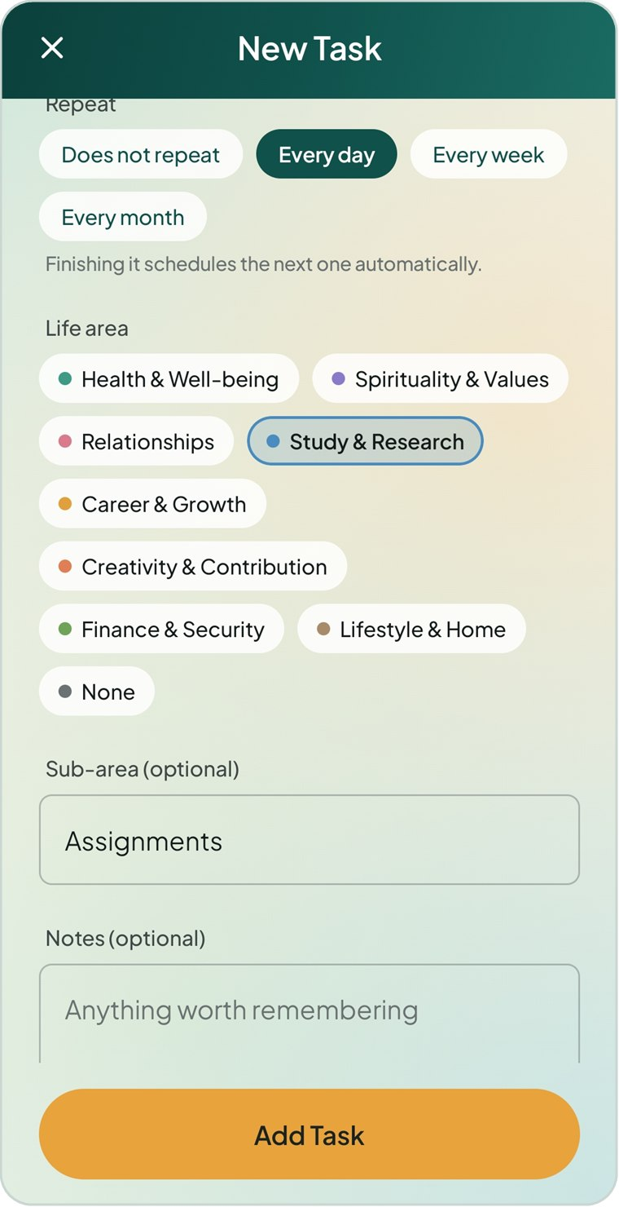  Figure 3.23 New task — repeat | 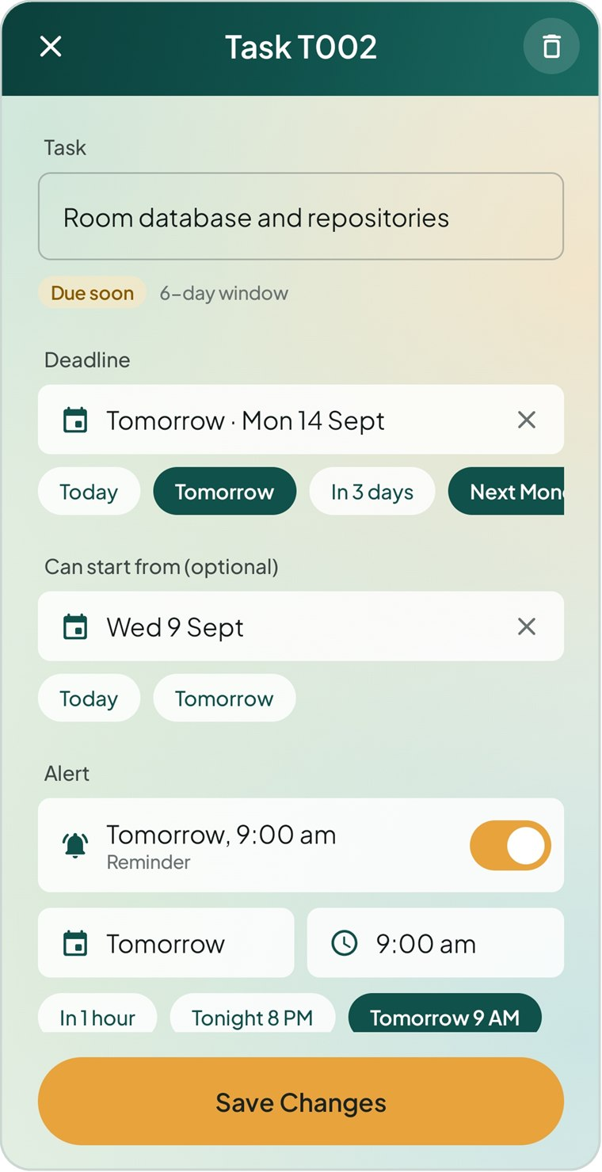  Figure 3.24 Edit task

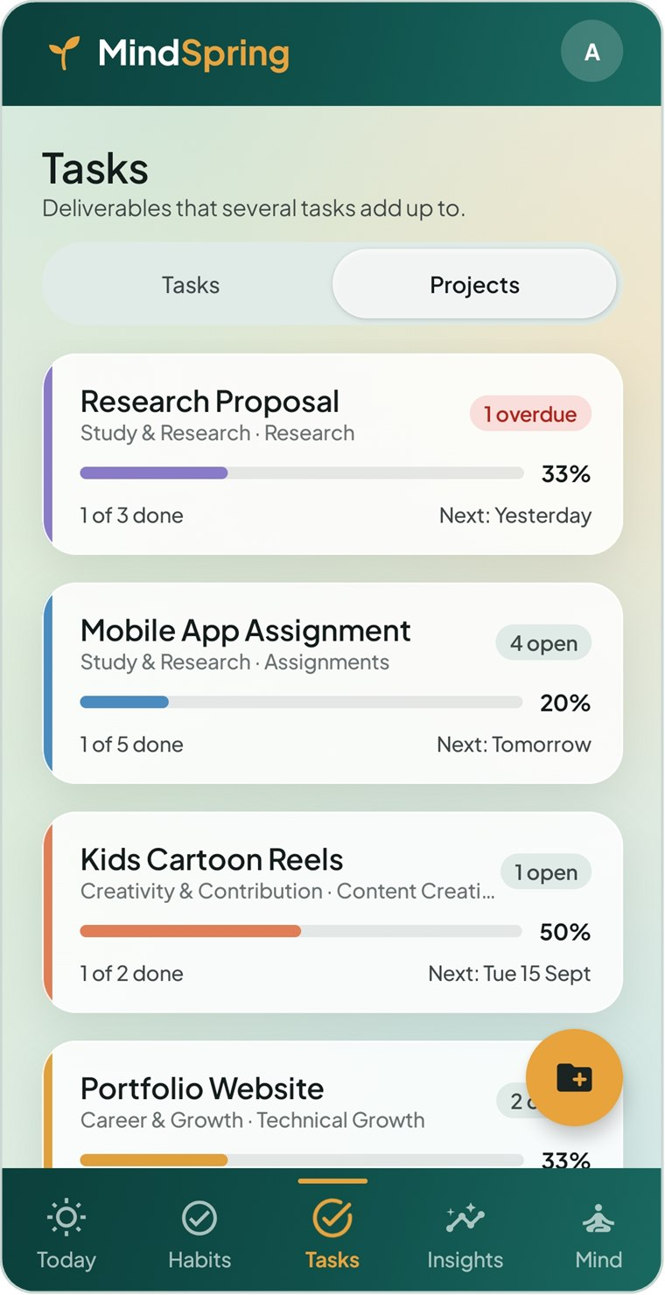  Figure 3.25 Projects | 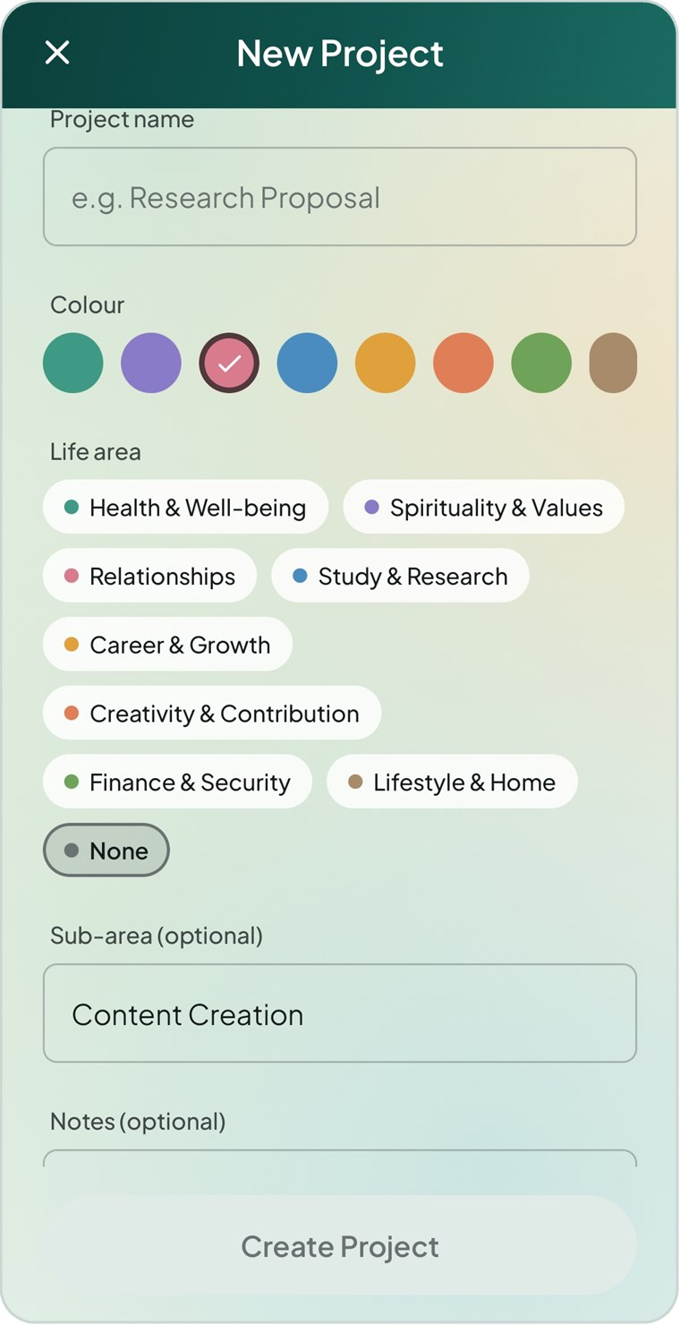  Figure 3.26 New project | 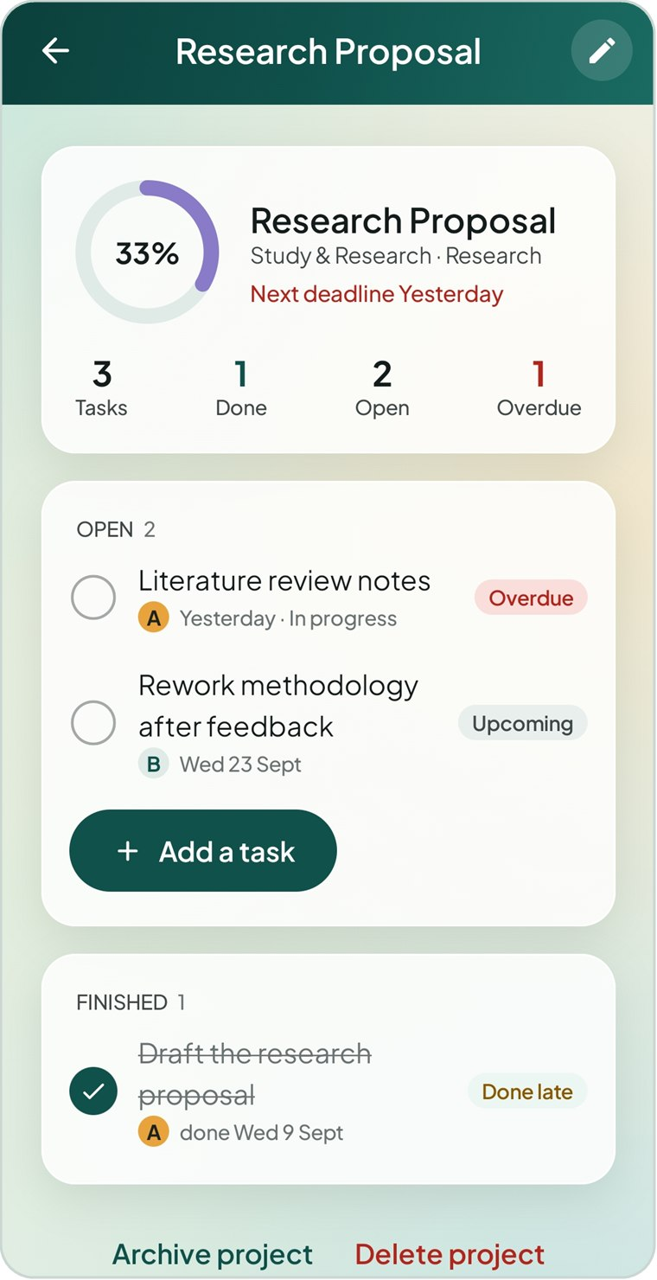  Figure 3.27 Project detail

3.6 Insights
Figure 3.28 Insights — Overview | 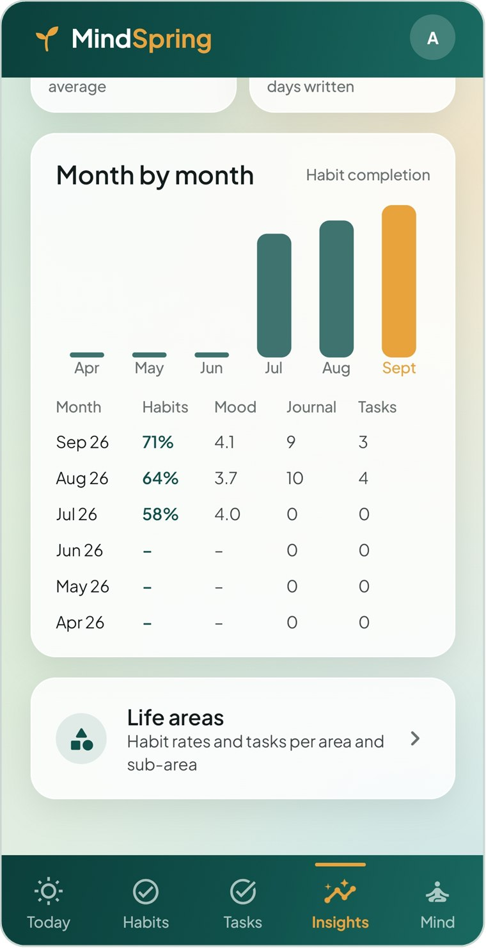  Figure 3.29 Insights — month by month | 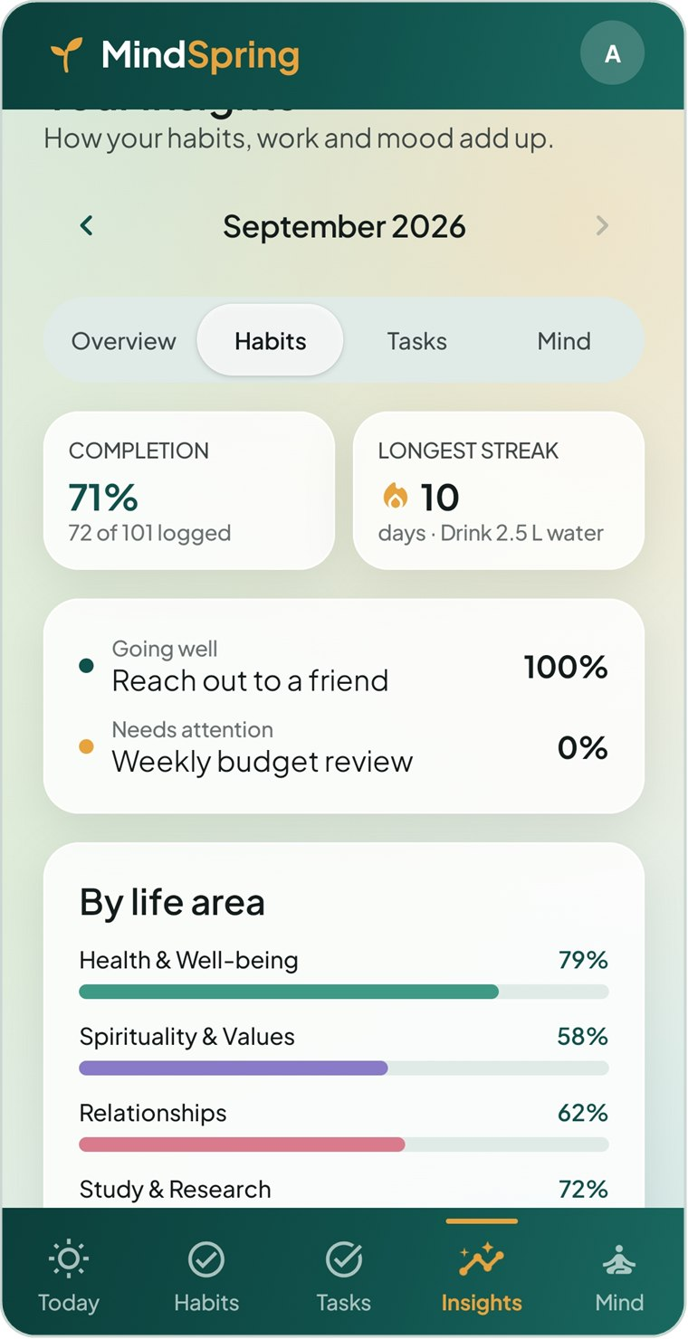  Figure 3.30 Insights — Habits

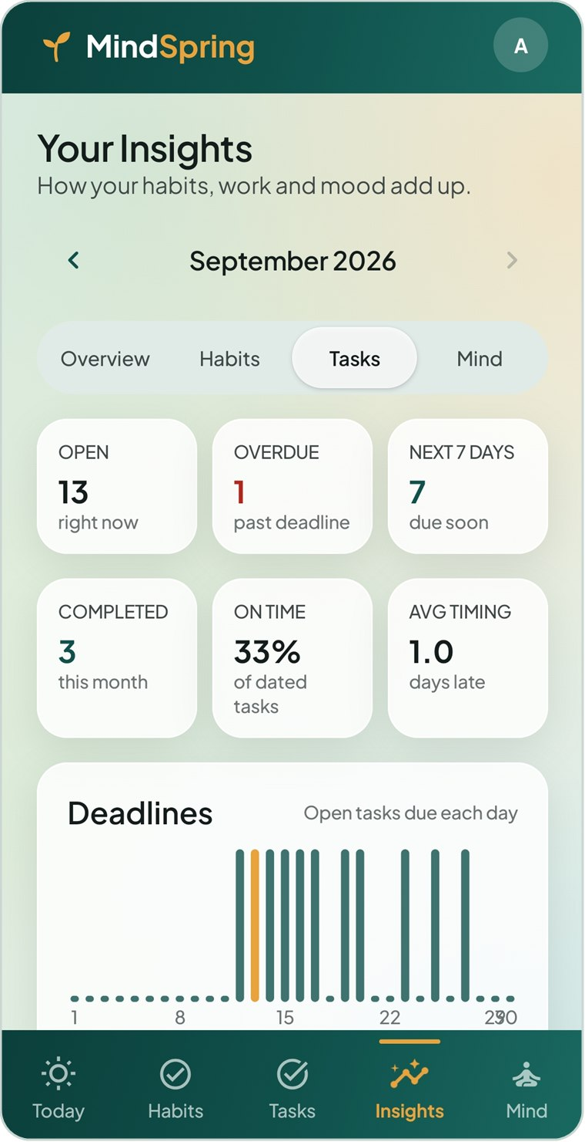  Figure 3.31 Insights — Tasks | 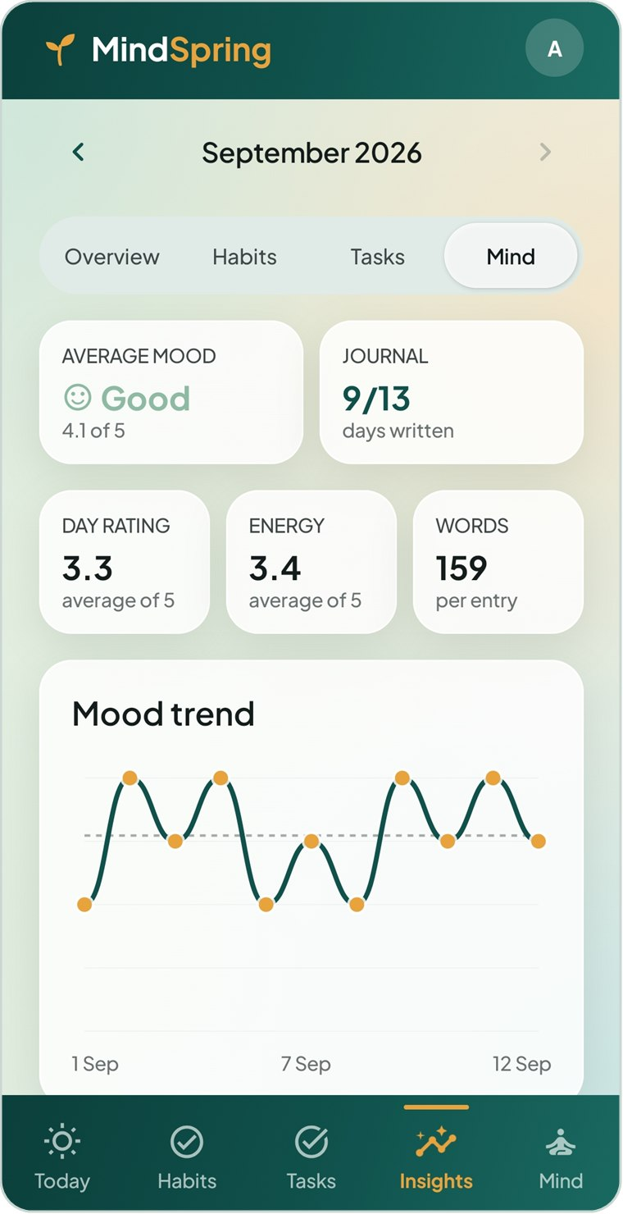  Figure 3.32 Insights — Mind | 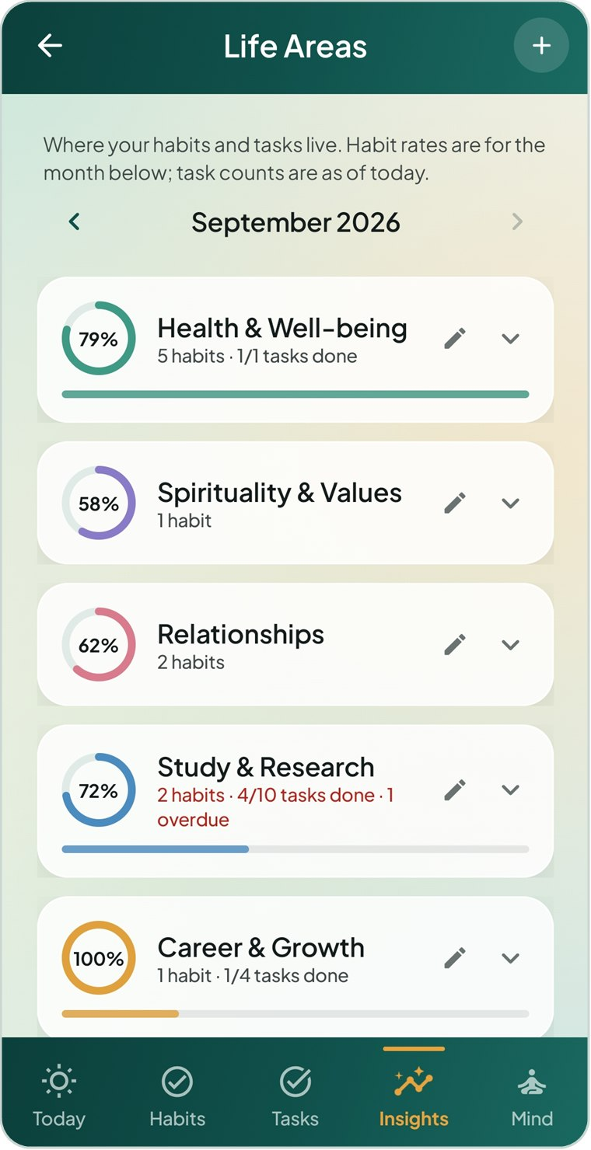  Figure 3.33 Life areas

3.7 Mind
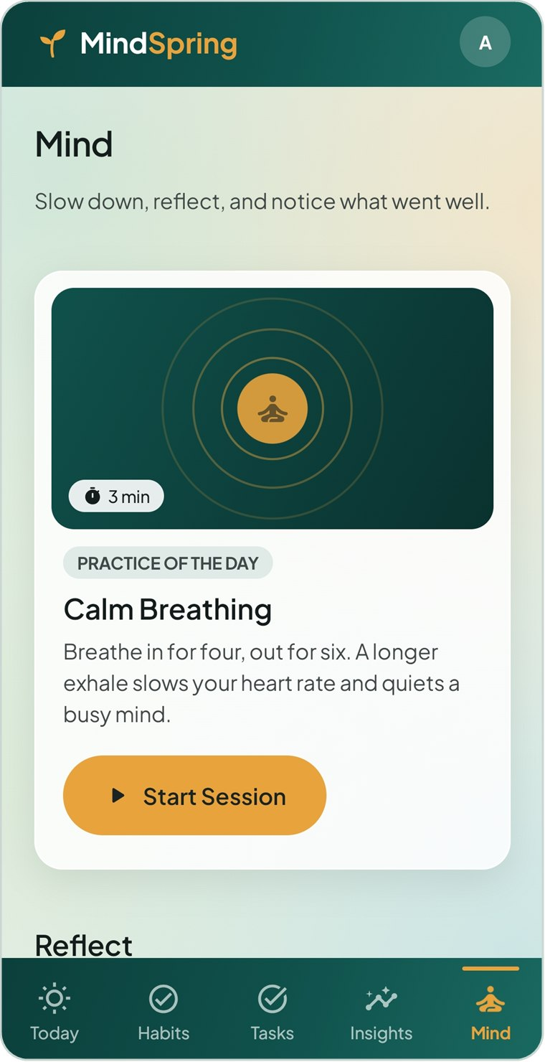  Figure 3.34 Mind — practice of the day | 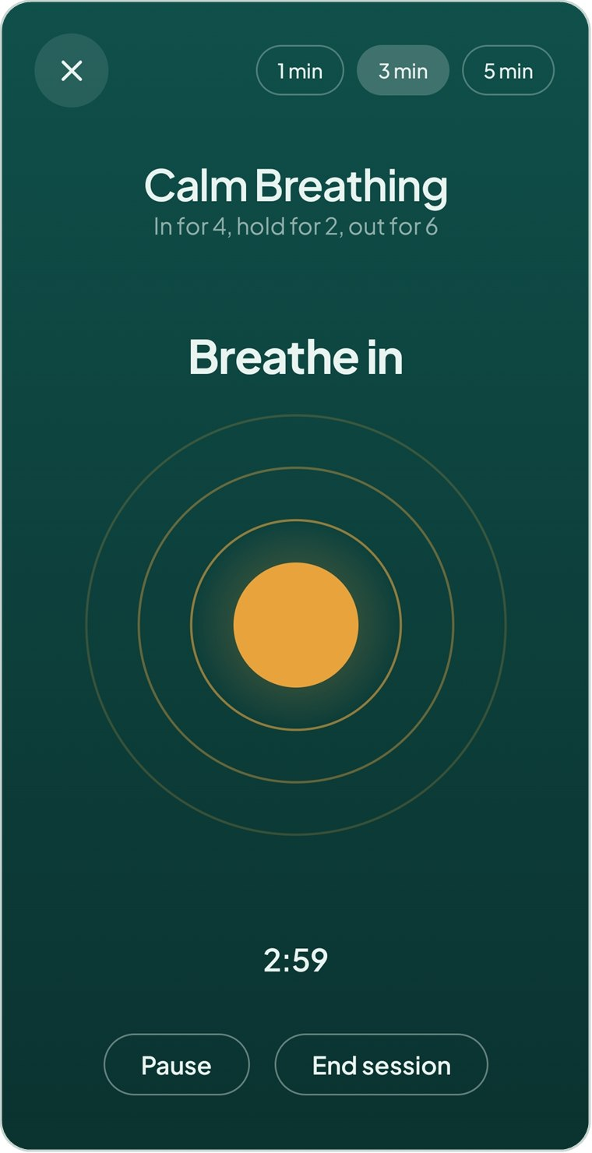  Figure 3.35 Calm breathing session | 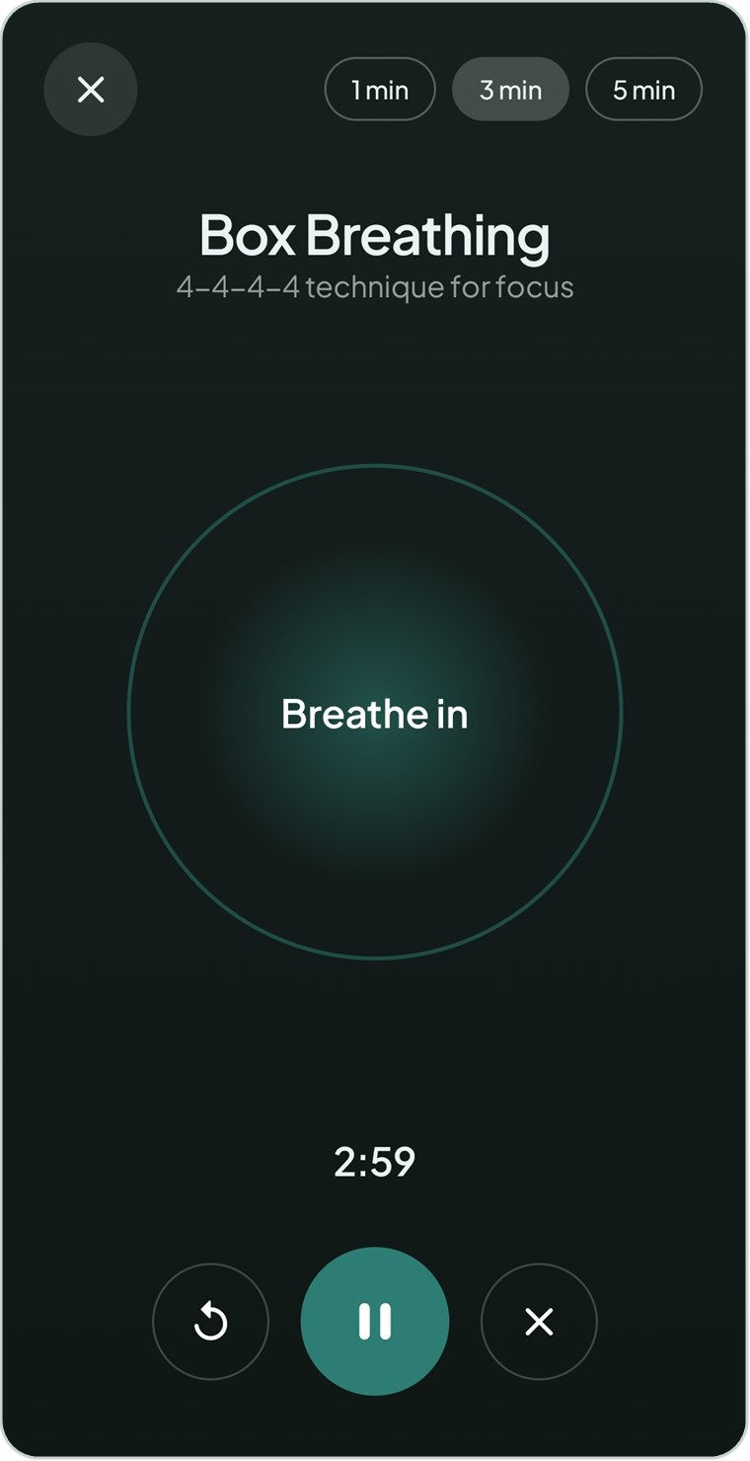  Figure 3.36 Box breathing session

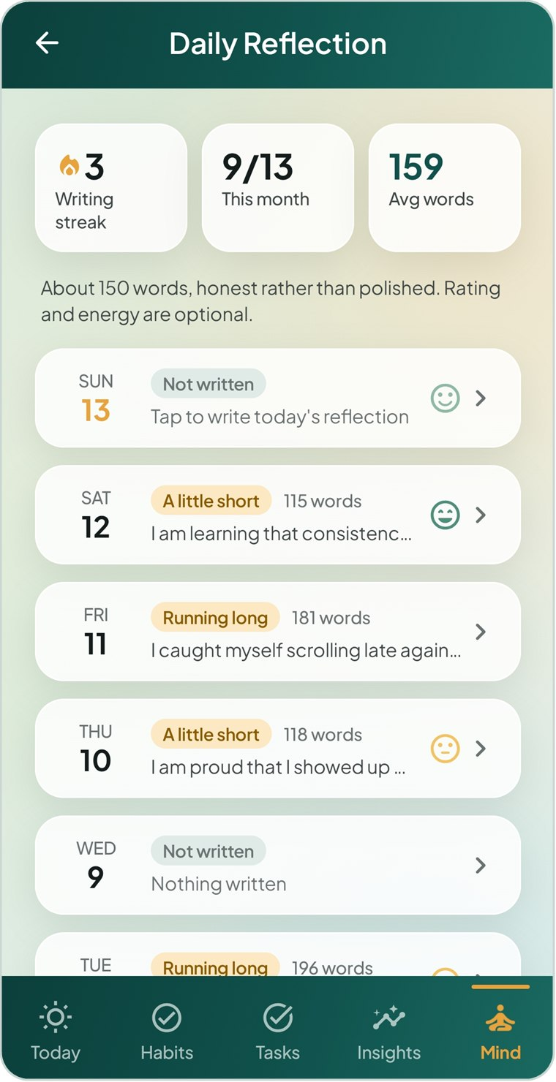  Figure 3.37 Daily reflection list | 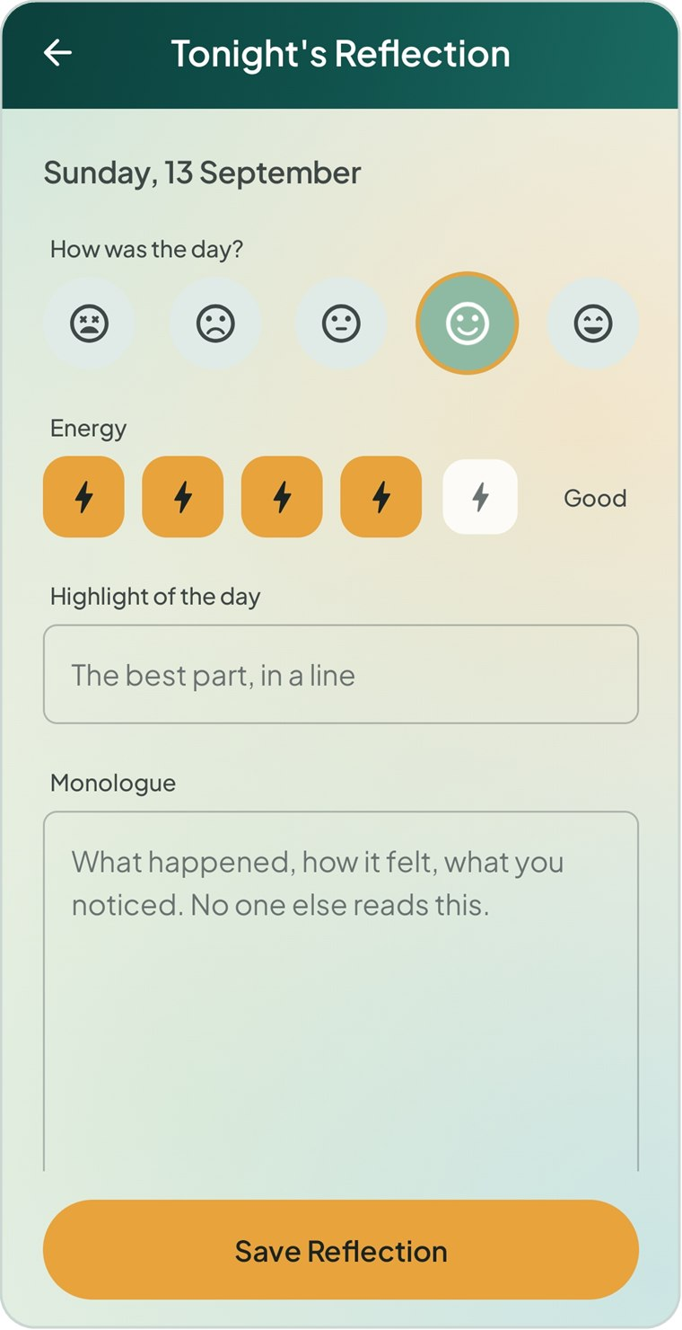  Figure 3.38 Tonight’s reflection | 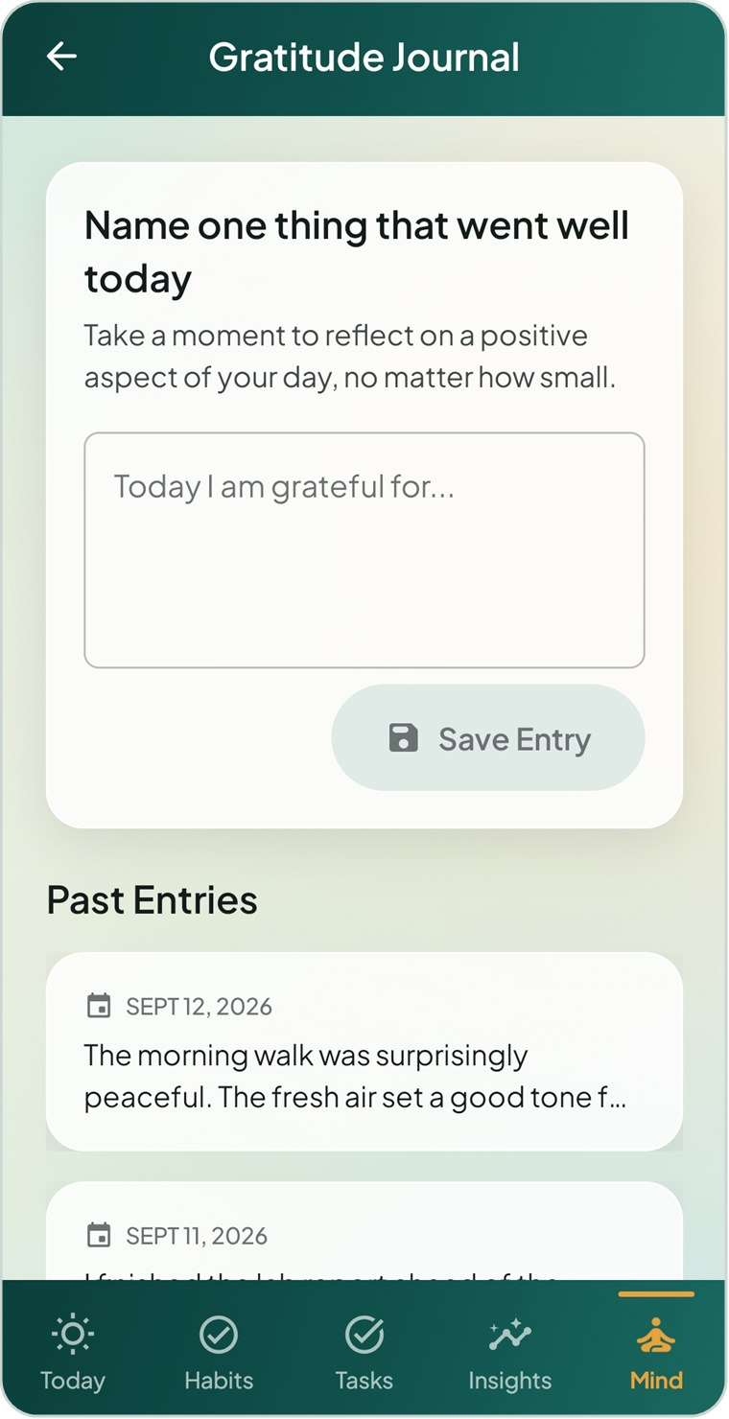  Figure 3.39 Gratitude journal

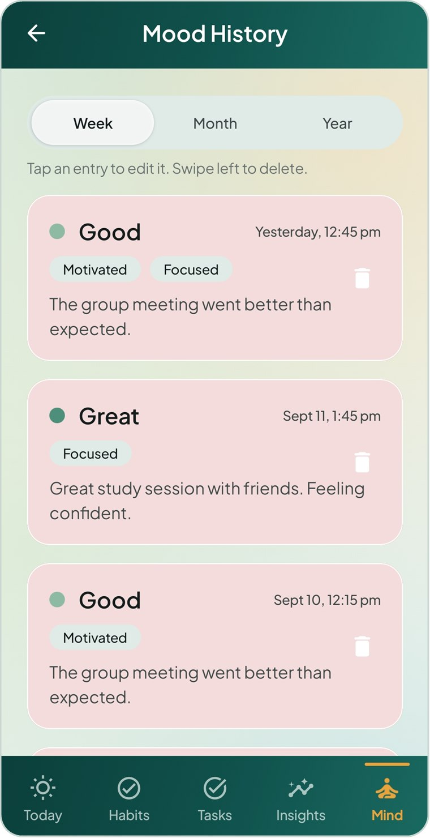  Figure 3.40 Mood history | 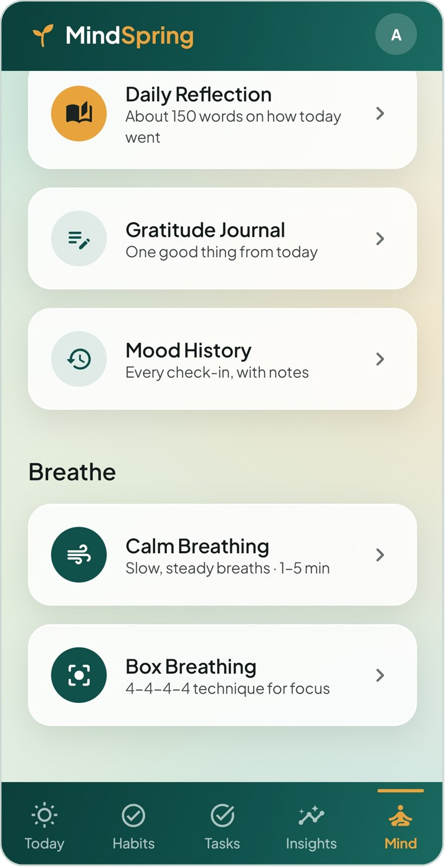  Figure 3.41 Mind — reflect and breathe | 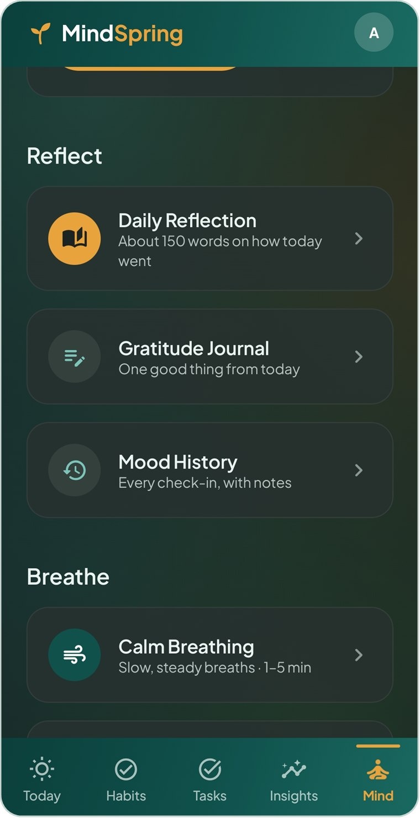  Figure 3.42 Mind — dark theme

3.8 Profile, settings and alerts
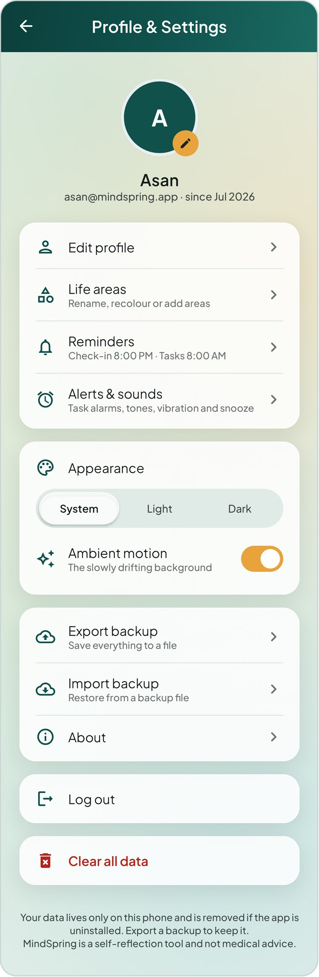  Figure 3.43 Profile & settings | 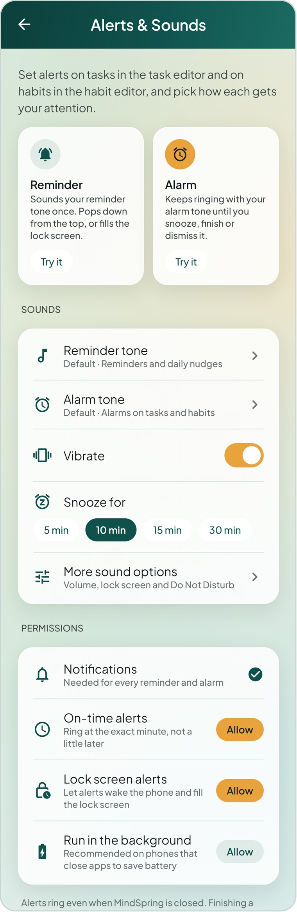  Figure 3.44 Alerts & sounds | 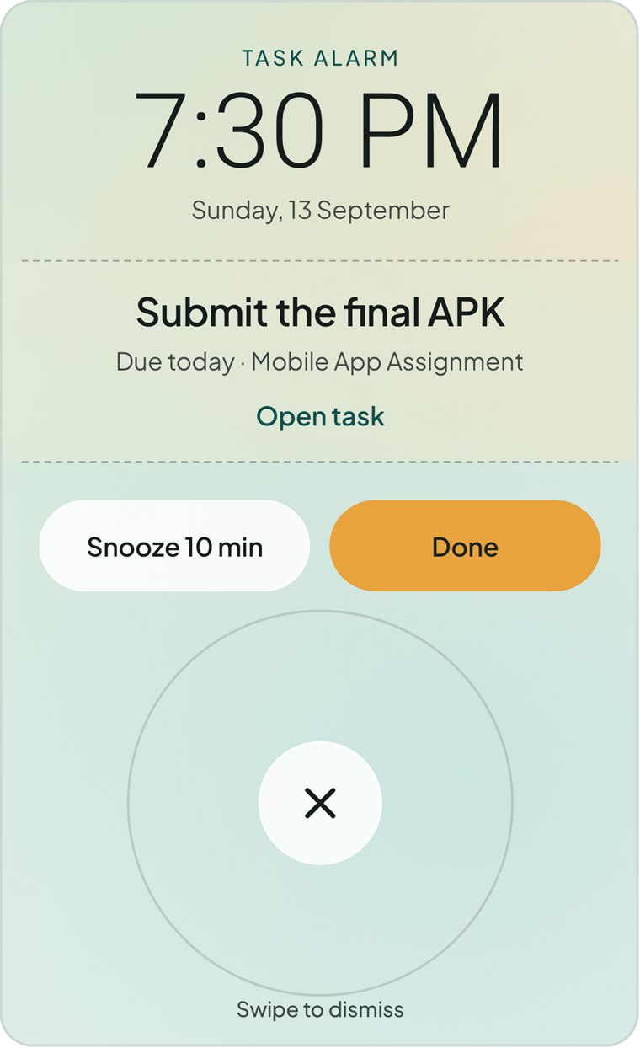  Figure 3.45 Full-screen task alarm

3.9 Dark theme
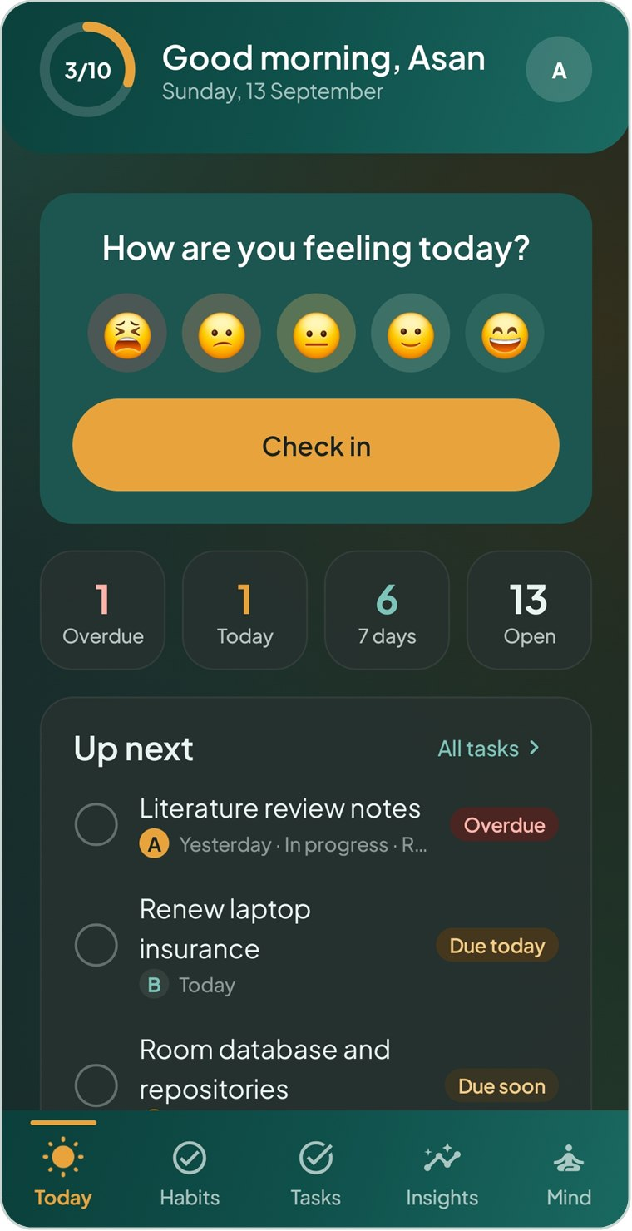  Figure 3.46 Today — dark theme | 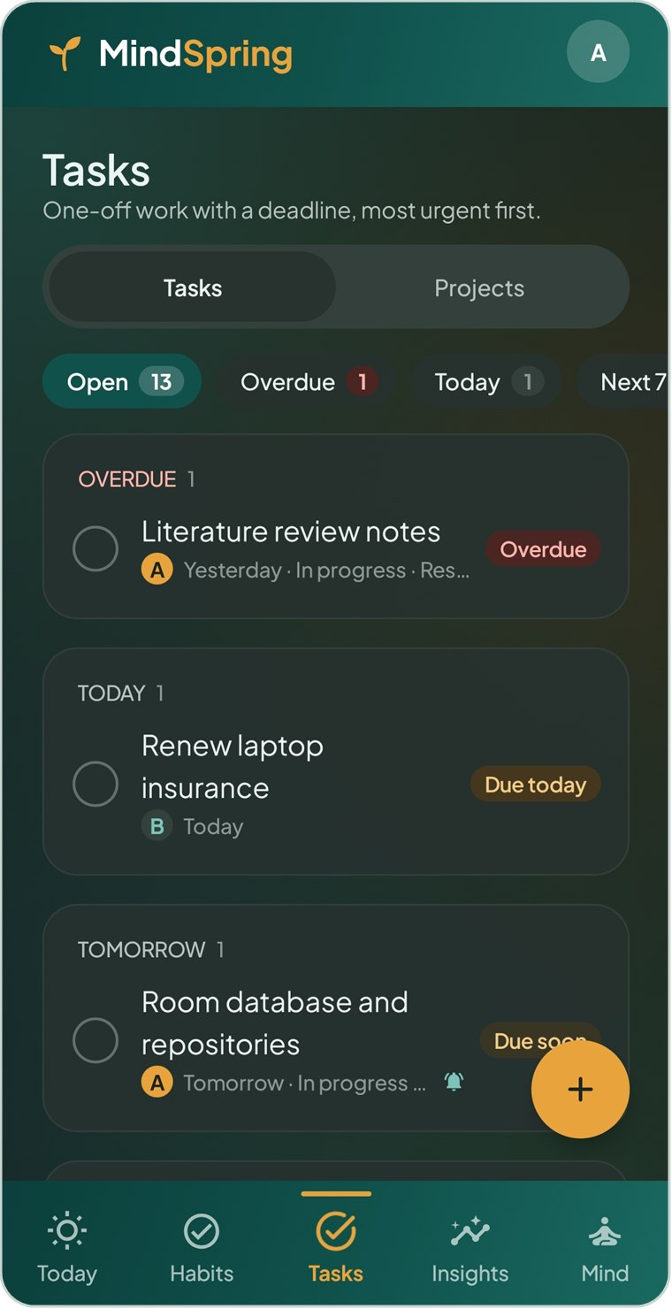  Figure 3.47 Tasks — dark theme | 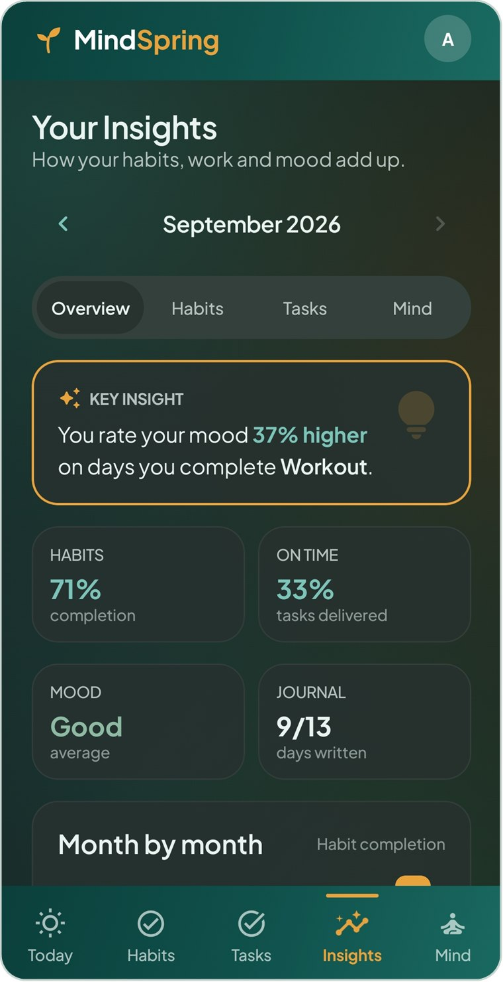  Figure 3.48 Insights — dark theme

4 Challenges Faced
Building MindSpring raised technical, design and process problems. Each is described below with the solution chosen, the result, and a critical reflection on its trade-offs.

4.1 Alerts that ring on time with the app closed
Aspect | Discussion
Challenge | Habit reminders and task alarms had to fire at the exact minute even when the app was closed, the phone was in Doze mode, after a reboot, or after a time-zone change. WorkManager, first proposed for reminders, can delay work by several minutes, which is unacceptable for an alarm.
Solution | Exact alerts were moved to AlarmManager (setAlarmClock for the Alarm style, setExactAndAllowWhileIdle for reminders), with a fallback to inexact alarms if permission is revoked. A boot and time-change receiver re-schedules everything. WorkManager is kept only for the daily check-in and morning summary, where a few minutes’ delay does not matter.
Result | Alerts fire at the chosen minute and return after restarts. AlertsTest verifies scheduling, snooze and Done behaviour.

NOTE Critical reflection: Choosing the right API per job was more effective than forcing one tool to do everything. The trade-off is that some manufacturers still kill background apps aggressively; the app can only guide users to allow battery exemptions, not guarantee delivery on every device.

4.2 Stale alarms after data changes
Aspect | Discussion
Challenge | An alarm scheduled for a task could still ring after the user had finished or deleted that task, or ticked the habit earlier in the day. Keeping hundreds of alarms manually in step with every edit screen would be fragile.
Solution | Alert scheduling was made idempotent: one sync function observes tasks, habits and marks, calculates the set of alarms that should exist, cancels the rest and re-schedules the remainder. As a second safeguard, an alarm re-reads its task or habit at the moment it fires and stays silent if it is no longer needed.
Result | No screen contains alarm code, and logging out automatically cancels every alert because the user’s data becomes empty.

NOTE Critical reflection: Deriving alarms from data, rather than issuing commands from screens, removed a whole class of bugs. The trade-off is that alarms are re-scheduled more often than strictly necessary; for the small number of alerts a personal app holds, simplicity and correctness were judged more valuable.

4.3 Android permission changes across versions
Aspect | Discussion
Challenge | Android 13 requires runtime permission for notifications, Android 12–14 restrict exact alarms, and Android 14 restricts full-screen alerts. A user who denies any of these would see alerts silently fail, with no idea why.
Solution | The app asks for notification permission when it is first needed (on Today, or when an alert is switched on). Alerts & Sounds shows the state of every permission with an Allow button, the alert editors warn when lock-screen alerts are off, and permission state is re-checked when the user returns from Android settings.
Result | Users can see and fix the cause of missing alerts themselves, and the app degrades gracefully instead of crashing.

NOTE Critical reflection: Permissions cannot be solved once; they must be handled continuously. More testing on physical devices from different manufacturers would strengthen confidence here.

4.4 Notification sounds that cannot be changed
Aspect | Discussion
Challenge | Letting users choose their own reminder and alarm tones seemed simple, but Android fixes a notification channel’s sound when the channel is created, so a changed tone was ignored.
Solution | Each channel id now includes a short fingerprint of the chosen tone and vibration setting. When the user changes a tone, a new channel is created and the old one is deleted.
Result | Tone changes take effect immediately. AlertsTest checks that channels follow the chosen tones.

NOTE Critical reflection: This is a workaround for a platform constraint. It works reliably, but it means the Android system settings may briefly list recreated channels, which a production app would document for users.

4.5 Fair and correct habit statistics
Aspect | Discussion
Challenge | Streaks and completion rates are easy to get subtly wrong: weekly and monthly habits, weekday-only habits, days before a habit was created, genuine skip days and the current, still-open day all need different treatment. Wrong numbers would destroy user trust.
Solution | All rules were written as pure Kotlin in a domain layer (HabitStats, TaskLogic, Analytics) with no Android dependencies, and pinned down by unit tests using fixed dates. Skips leave the denominator and never break a streak; today only counts once it is done.
Result | 27 domain unit tests pass, covering every frequency and edge case, and the same logic powers Today, Habits and Insights so numbers always agree.

NOTE Critical reflection: Separating logic from UI made it testable in milliseconds. Defining “fair” was a design decision as much as a coding one — for example, whether a skip should count — and was decided in favour of the user’s wellbeing.

4.6 Changing the database without losing data
Aspect | Discussion
Challenge | Task alerts and habit reminder styles were added after the database was already storing data. Changing a Room schema without a migration crashes the app or wipes the user’s data on update.
Solution | The Room schema is exported for every version and committed to Git. Room AutoMigrations upgrade version 1 → 2 → 3, and new columns have defaults. A migration test builds a real version-1 database, opens it with the current code and checks the stored task is intact.
Result | Existing users keep all their data across updates; MigrationTest passes.

NOTE Critical reflection: Exporting schemas from the first version would have been easy to skip, and would have made later migrations guesswork. Future schema changes that rename or split columns will need hand-written migrations.

4.7 Privacy with several accounts on one phone
Aspect | Discussion
Challenge | Accounts are local, but data from one account must never appear in another, and passwords must not be readable even by someone who copies the database file.
Solution | Every table carries a user id with cascading deletes, and a Session helper switches every query to the signed-in user so no screen can forget the filter. Passwords are hashed with PBKDF2-HMAC-SHA256 (120,000 iterations, random salt) and compared in constant time. Log-in errors never reveal whether the email exists.
Result | RepositoryTest confirms each account sees only its own data and that log-in checks the hash.

NOTE Critical reflection: A local-only design cannot offer password recovery; this is explained in the app and mitigated by backups. The database file itself is not encrypted, so encrypting it would be a worthwhile future improvement.

4.8 A calm, animated UI that stays smooth and testable
Aspect | Discussion
Challenge | The design uses translucent cards, a slowly drifting background, animated counters and a breathing animation. Standard shadows showed through translucent cards, continuous animation could waste battery, and moving screens cannot be screenshot-tested or previewed reliably.
Solution | A custom shadow is drawn only outside each card. Continuous animations are read in the draw phase so they do not rebuild the screen, and all decorative motion stops when the user turns Ambient motion off, when Android’s “Remove animations” setting is on, in previews and in tests. Screens were split into a data-connected Screen and a stateless Content composable so previews and tests can supply sample state.
Result | The look matches the Figma prototype, and 44 screenshot tests render every screen in light and dark themes.

NOTE Critical reflection: Visual polish added real engineering cost, and every animated element had to be made controllable for accessibility and testing. Planning motion, previews and testability together from the first screen would reduce that cost in future projects.

4.9 Managing scope in a short timeline
Aspect | Discussion
Challenge | The proposal set a 12-week plan, but features such as tasks, projects, a daily reflection and exact alarms emerged as important for the student audience, which risked delaying the core requirements.
Solution | Core requirements FR-01 to FR-12 were built first, then extensions were added in small, working commits. Shared components and a single design system meant new screens could reuse existing parts.
Result | All twelve functional requirements are delivered, plus the extensions, with automated tests passing.

NOTE Critical reflection: Adding features beyond the proposal increased the testing and documentation load. Clearer written acceptance criteria for each extension would have made the scope easier to control.

5 Testing Procedures and Results
MindSpring was tested at four levels: automated unit tests of the business rules, automated integration tests of the database, alerts and screens, and manual functional testing of every feature on a physical Android phone. All 89 automated tests and all manual test cases passed.

5.1 Test strategy
Level | What is tested | Tools | Count
Unit testing | Pure business rules: habit streaks and rates, task flags and repeats, monthly analytics | JUnit 4 | 27
Integration testing | Repositories on a real Room database, schema migration, alert scheduling with notifications | JUnit 4, Robolectric, Room in-memory database | 18
UI testing | Every screen rendered with real data in light and dark themes; alarm gesture | Robolectric, Compose UI test, Roborazzi | 44
Manual functional testing | End-to-end user journeys for each functional requirement on a physical phone | Android phone, final debug build | 30

Test environment
- Automated tests: Android Studio JDK 25, Gradle 9.7.1, Robolectric emulating Android API 36; run with ./gradlew testDebugUnitTest.
- Robolectric tests use a test application with an in-memory database and background work disabled, so every test starts from a clean state and never schedules real alarms.
- Manual tests: the final build installed on a physical Android phone, using both a newly registered account and the sample-data account.

5.2 Unit testing
Procedure. Each business rule was written as a pure Kotlin function and tested with a fixed “today” (Friday 11 September 2026) so results are repeatable. Each test arranges a small set of habits, marks or tasks, calls the function and asserts the exact expected value.
Test class | Test cases | Result
HabitStatsTest (13) | Rate counts only elapsed days · Today counts once done · Skip leaves the denominator · Weekday habit ignores weekends · Streak passes over skips and pending today · Missed day breaks streak · Weekly habit judged per week · Monthly habit done once covers the month · Best streak finds longest run · Day score uses only habits due that day · Reminder goes to next open due day · Weekly reminder rests once week is done · Nothing counts before creation | 13 / 13 passed
TaskLogicTest (10) | Flags follow the rules (overdue, due today, due soon) · Delivery judged on the done date · Window and days left · Urgency puts earliest first and undated last · Weekly repeat moves to next slot · Repeat carries the alert forward · Default alert time · Late repeat skips past slots · Roll-up ignores dropped work · Group key trims and ignores case | 10 / 10 passed
AnalyticsTest (4) | Habit month rolls up by area and picks best and worst · Task month measures delivery · Journal month counts written days · Sub-areas join habits and tasks ignoring case | 4 / 4 passed

5.3 Integration testing
Procedure. Integration tests run the real repositories, Room database, authentication and alert code together inside Robolectric. Each test registers a fresh account, performs a user action through the repository API, then reads the result back from the database or from Android’s notification and alarm services.
Test class | Test case | Expected result | Result
RepositoryTest | Register seeds areas and signs in | Account created, email normalised, eight default life areas, session set | Pass
RepositoryTest | Login checks the password hash | Correct password accepted, wrong password rejected | Pass
RepositoryTest | Each account sees only its own data | Habits of account A never visible to account B | Pass
RepositoryTest | Marks can be set, skipped and cleared | Done, Skipped and cleared states stored per day | Pass
RepositoryTest | Finishing a repeating task schedules the next one | Task marked done and next occurrence inserted | Pass
RepositoryTest | Deleting a project keeps its tasks | Tasks remain as standalone tasks | Pass
RepositoryTest | Backup round-trips into a fresh account | Exported JSON imports with all records and links | Pass
RepositoryTest | Journal entry is one per day | Second save on the same day updates, not duplicates | Pass
RepositoryTest | Clearing data keeps the account and areas | User data deleted; account and life areas kept | Pass
MigrationTest | Version-1 database upgrades with its tasks | Real v1 database opens at v3 with task intact and new columns defaulted | Pass
AlertsTest | Sync schedules only upcoming alerts on open tasks | Past, finished and alert-less tasks not scheduled | Pass
AlertsTest | Habit reminder scheduled for its next open day | Reminder skips days already done | Pass
AlertsTest | Both styles fill the lock screen; only the alarm keeps ringing | Full-screen intent on both; insistent flag only on alarm | Pass
AlertsTest | Finished task stays quiet | No notification for a completed task | Pass
AlertsTest | Snooze moves the task alert and Done finishes the task | Alert time moved by snooze length; Done completes task | Pass
AlertsTest | Habit alarm rings until ticked and Done ticks it | Done marks the habit for today | Pass
AlertsTest | Targets read back including the old format | Stored alert keys parse correctly | Pass
AlertsTest | Channels follow the chosen tones | Notification channels recreated with the selected sound | Pass

5.4 UI testing
Procedure. ScreenshotTest signs in to the sample-data account, renders each screen at phone size (393 × 1200 dp) using Robolectric’s native graphics, waits for the database to deliver data, and saves an image with Roborazzi. Animated screens advance the frame clock to a fixed moment so images are repeatable. The tests cover onboarding, log in, registration, Today, all habit views and editors, tasks and projects, mood, Mind, breathing, journals, Insights, life areas, profile, alert settings and the alarm screen, in both light and dark themes.
Result. 44 of 44 UI tests passed; every screen rendered without a crash. One test also verifies that the full-screen alarm is dismissed by a drag gesture but not by an accidental tap.

5.5 Manual functional testing
Procedure. Each functional requirement was exercised end to end on a physical Android phone by following the steps below with a newly registered account and with the sample-data account. The actual behaviour was compared with the expected result and recorded as Pass or Fail.
ID | Req. | Test steps | Expected result | Status
TC-01 | FR-01 | Open app first time; swipe welcome slides; tap Get Started | Three slides shown once; sign-in screen opens | Pass
TC-02 | FR-01 | Create account with valid name, email and matching passwords | Account created; Today screen opens | Pass
TC-03 | FR-01 | Create account with invalid email, short or mismatched password, or no consent | Inline error shown for each field; no account created | Pass
TC-04 | FR-01 | Log in with correct, then incorrect password | Correct logs in; incorrect shows “Incorrect email or password.” | Pass
TC-05 | FR-01 | Close and reopen the app; then log out | Stays signed in; log out returns to sign-in | Pass
TC-06 | FR-01 | Tap Explore with sample data | Demo account opens with habits, tasks, moods and journal | Pass
TC-07 | FR-02 | On Today tap a face, pick feeling tags, add note, save | Entry saved; mood card updates | Pass
TC-08 | FR-03 | Mind → Mood History; edit an entry; swipe to delete; tap Undo | Edit saved; entry removed then restored | Pass
TC-09 | FR-04 | Habits → + ; enter name, frequency, days, target; save | Habit appears in Today and All views | Pass
TC-10 | FR-04 | Edit a habit; retire it; delete another | Changes saved; retired habit hidden from today; deleted habit removed | Pass
TC-11 | FR-05 | Tap habit circle; long-press another habit | First marked done with streak increased; second marked skipped | Pass
TC-12 | FR-05 | Habits → Week; tap past days to cycle done / skipped / clear | Marks update; streak and rate recalculate | Pass
TC-13 | FR-05 | Open habit detail; tap Complete for Today | Celebration screen shown; habit marked done | Pass
TC-14 | FR-06 | View Today with tasks and habits due | Counters, Up next, habits, streaks and reflection cards correct | Pass
TC-15 | — | Tasks → + ; add title, deadline, priority, status; save | Task listed in the correct deadline group | Pass
TC-16 | — | Apply Overdue, Today and other filter chips | List and live counts match the filter | Pass
TC-17 | — | Finish a weekly repeating task | Task done and next week’s occurrence created | Pass
TC-18 | — | Create a project; add tasks; finish one; delete project | Progress updates; tasks kept after project deletion | Pass
TC-19 | FR-07 | Insights; switch month and Overview / Habits / Tasks / Mind | Statistics, charts and key insight shown for selected month | Pass
TC-20 | — | Insights → Life areas; add or rename an area | Area progress shown; changes saved | Pass
TC-21 | FR-08 | Mind → Calm Breathing and Box Breathing | Animated guide and timer follow the breathing pattern | Pass
TC-22 | FR-09 | Add a gratitude note from Today and from the journal | Note saved and listed newest first | Pass
TC-23 | — | Write tonight’s reflection; save; reopen same day | One entry per day; reopening edits it | Pass
TC-24 | FR-10 | Set a task alert as Reminder a few minutes ahead; close app | Notification sounds once at the chosen minute | Pass
TC-25 | FR-10 | Set a task alert as Alarm; lock phone | Full-screen alarm rings; Done, Snooze and drag-to-stop work | Pass
TC-26 | FR-10 | Set a habit reminder; tick the habit before the time | Reminder does not ring for the completed habit | Pass
TC-27 | FR-11 | Add data; force-close app; restart phone; reopen | All data still present; alerts restored | Pass
TC-28 | FR-12 | Profile → Appearance: Light, Dark, System; toggle Ambient motion | Theme and motion change immediately across the app | Pass
TC-29 | FR-12 | Export backup; clear data; import backup | Data cleared, then fully restored from the file | Pass
TC-30 | NFR-05 | Turn on airplane mode and use every tab | All features work without a connection | Pass

5.6 Results summary
Test level | Executed | Passed | Failed | Pass rate
Unit tests | 27 | 27 | 0 | 100%
Integration tests | 18 | 18 | 0 | 100%
UI screenshot tests | 44 | 44 | 0 | 100%
Manual functional tests | 30 | 30 | 0 | 100%
Total | 119 | 119 | 0 | 100%

The automated suite was run on 13 September 2026 with ./gradlew testDebugUnitTest: 89 tests, 0 failures, 0 skipped, BUILD SUCCESSFUL. The Gradle test report below is the evidence of that run.
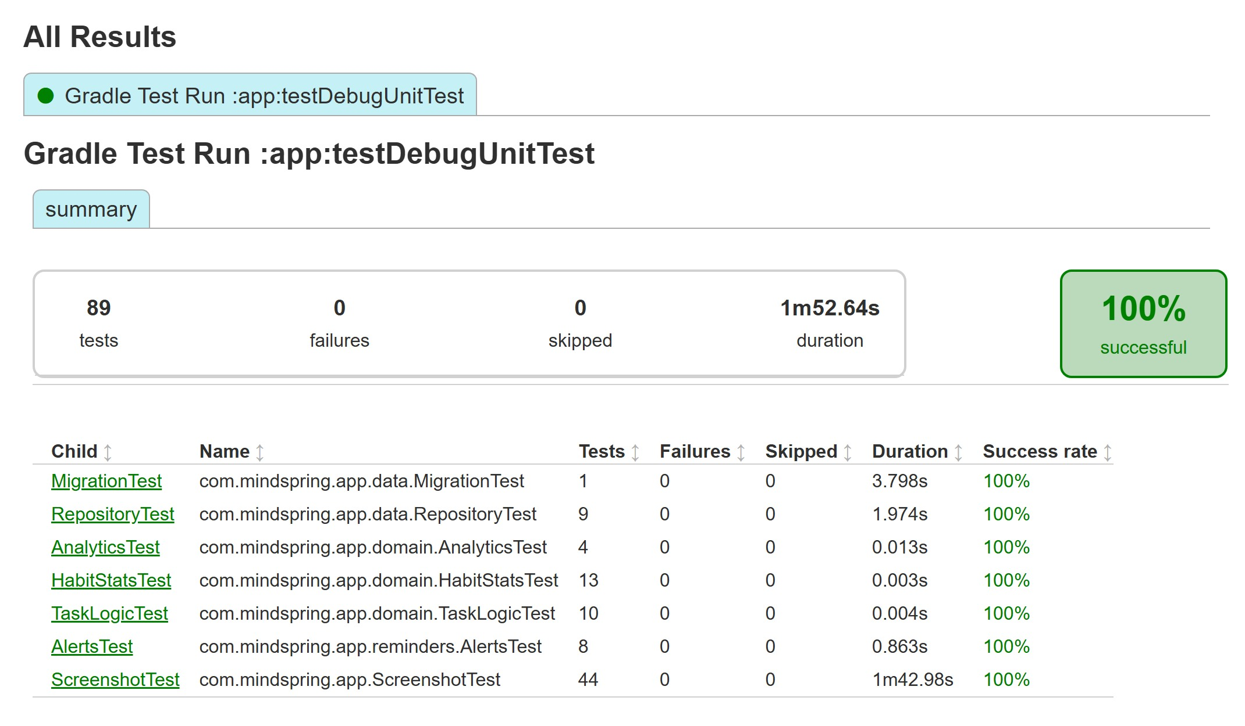
Figure 5.1 Gradle test report — 89 automated tests, 0 failures, 100% successful

Reproducing the results
Action | Command or location
Run every automated test | ./gradlew testDebugUnitTest
Run one test class | ./gradlew testDebugUnitTest --tests "com.mindspring.app.domain.HabitStatsTest"
HTML test report | app/build/reports/tests/testDebugUnitTest/index.html
Screenshot images | app/build/screenshots/

6 Conclusion
MindSpring meets the goals set in the project proposal and extends them where the target audience needed more.
The application delivers all twelve functional requirements: accounts, mood check-in and history, habit tracking with fair streaks, a Today dashboard, an Insights dashboard with a key mood insight, breathing exercises, a gratitude journal, reliable reminders, persistent local storage in Room, and personalisation. It adds tasks and projects, a daily reflection journal, life areas and exact-time alarms for students balancing deadlines with wellbeing.
The main lessons were to choose platform APIs to fit each job, to derive system state such as alarms from data instead of scattering commands through screens, and to keep business rules in a pure, tested layer. All 89 automated tests and all 30 manual test cases passed.
Future work could add optional encrypted cloud backup, home-screen widgets and wider testing on devices from more manufacturers.
GitHub repository: https://github.com/InfinityBrainNetworks/MindSprint
MindSpring is a self-reflection tool, not medical advice.

