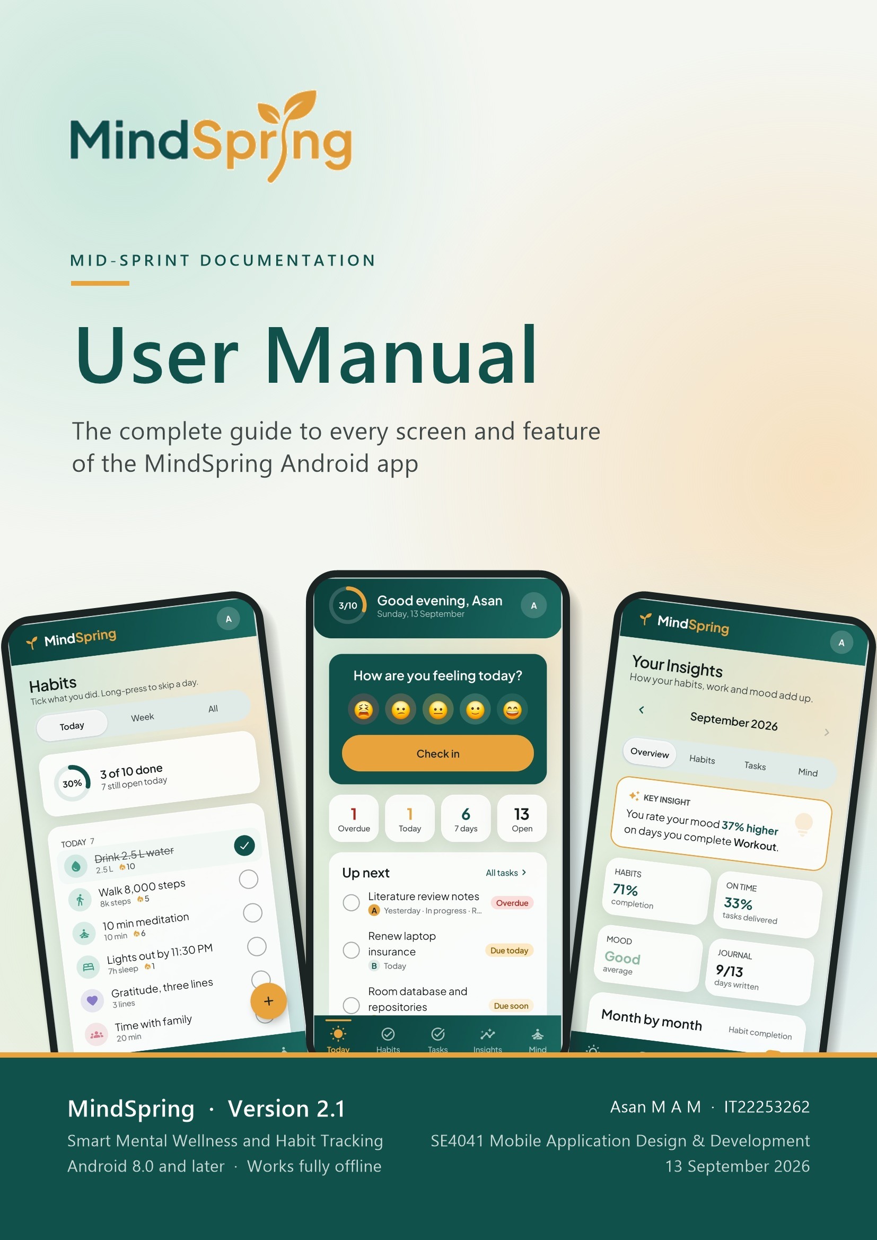
Contents
How this manual is organised: chapters 1–3 introduce the app and its layout, chapters 4–10 walk through each part of the app screen by screen, and chapters 11–13 cover alerts, troubleshooting and a quick reference.
1 Introduction 4
1.1 What MindSpring does 4
1.2 About this manual 5
1.3 Key concepts 5
1.4 Your privacy 6
2 Getting Started 7
2.1 What you need 7
2.2 First launch: the welcome slides 8
2.3 Creating your account 8
2.4 Signing in 9
2.5 Your first few minutes 9
3 Finding Your Way Around 10
3.1 The bottom navigation bar 10
3.2 The top of each screen 10
3.3 Common controls 11
3.4 Map of the app 11
4 The Today Screen 13
4.1 Greeting and daily progress 14
4.2 Checking in your mood 14
4.3 Your day at a glance 14
4.4 Up next 15
4.5 Today’s habits 15
4.6 Reflection, streaks and gratitude 16
5 Habits 17
5.1 The three habit views 17
5.2 Today view 18
5.3 Week view 19
5.4 All view 20
5.5 Creating a habit 21
5.6 Habit reminders 22
5.7 Habit detail 22
5.8 The celebration screen 24
5.9 Editing, retiring and deleting 24
5.10 How streaks and rates are counted 24
6 Tasks and Projects 25
6.1 The task list 25
6.2 Adding a task 27
6.3 Deadlines and start dates 28
6.4 Task alerts 28
6.5 Priority and status 29
6.6 Repeating tasks 29
6.7 Editing, finishing and deleting tasks 30
6.8 Projects 30
6.9 Creating a project 31
6.10 Project detail 32
7 Mood Tracking 33
7.1 Checking in 33
7.2 Changing today’s check-in 34
7.3 Mood history 34
8 The Mind Tab 35
8.1 The Mind screen 35
8.2 Breathing exercises 35
8.3 Daily reflection 36
8.4 Gratitude journal 39
9 Insights 40
9.1 Choosing a month and a section 40
9.2 Overview 41
9.3 Habits section 42
9.4 Tasks section 42
9.5 Mind section 43
9.6 Life areas 43
10 Profile and Settings 45
10.1 Opening Profile & Settings 45
10.2 Editing your profile 45
10.3 Daily reminders 45
10.4 Alerts and sounds 46
10.5 Appearance 47
10.6 Backing up and restoring 47
10.7 Logging out, clearing data and About 48
11 Alerts and Alarms 49
11.1 Reminder or alarm? 49
11.2 The full-screen alert 49
11.3 How alerts behave 50
12 Troubleshooting and FAQ 51
13 Quick Reference 52

1 Introduction
MindSpring is a private, offline Android app that brings your daily habits, your deadlines, your moods and your evening reflections together in one calm place, and then shows you how they add up.

1.1 What MindSpring does
Most people keep a habit tracker, a to-do list and a journal in three different apps, so they never see how one affects the others. MindSpring keeps all of them side by side on your phone. Because everything lives in one place, the app can notice patterns for you — for example, that you rate your mood higher on the days you work out — and tell you in a plain sentence.
The app is organised into five areas, each one a tab at the bottom of the screen:
- Today — your day at a glance: a mood check-in, what is due, today’s habits, streaks and a quick gratitude note.
- Habits — routines you repeat daily, on certain weekdays, weekly or monthly, with streaks and completion rates.
- Tasks — one-off work with deadlines, priorities, alerts and repeats, grouped into projects.
- Insights — monthly statistics and charts for habits, tasks, mood and journalling, plus a per-life-area breakdown.
- Mind — guided breathing, the daily reflection journal, the gratitude journal and your mood history.
A sixth area, Profile & Settings, is opened from the round avatar in the top-right corner of any main screen.
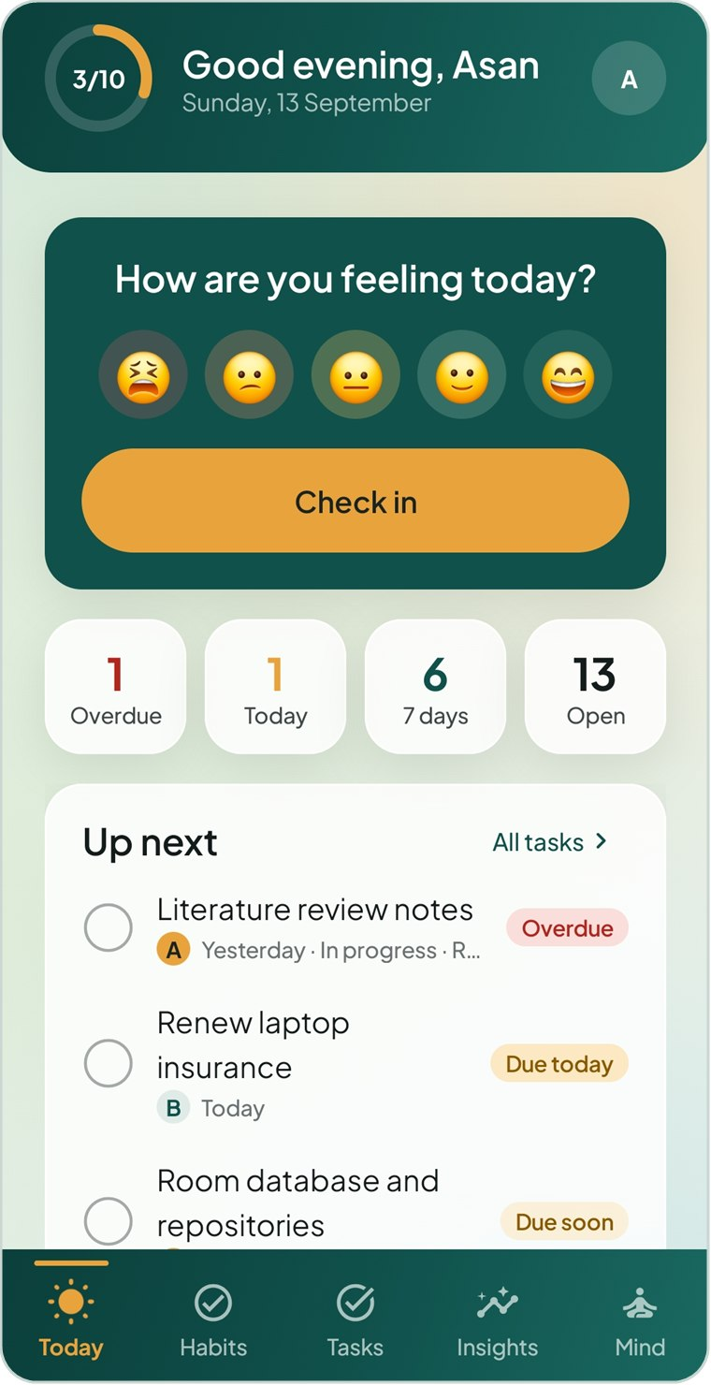  Figure 1.1 The Today dashboard | 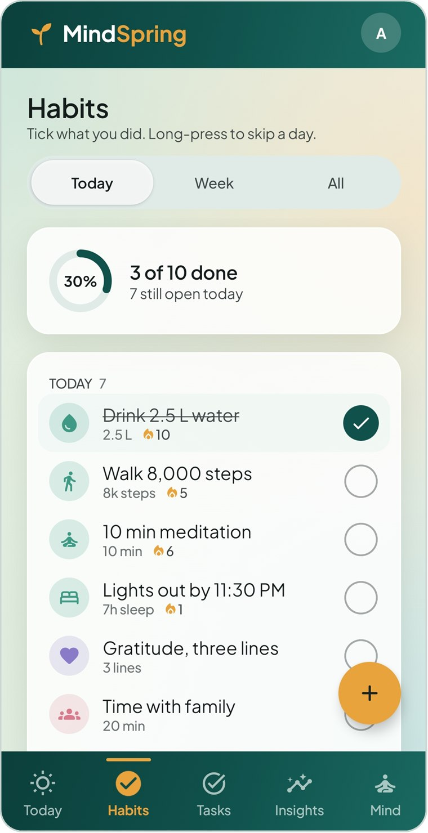  Figure 1.2 Habits, ticked off for the day | 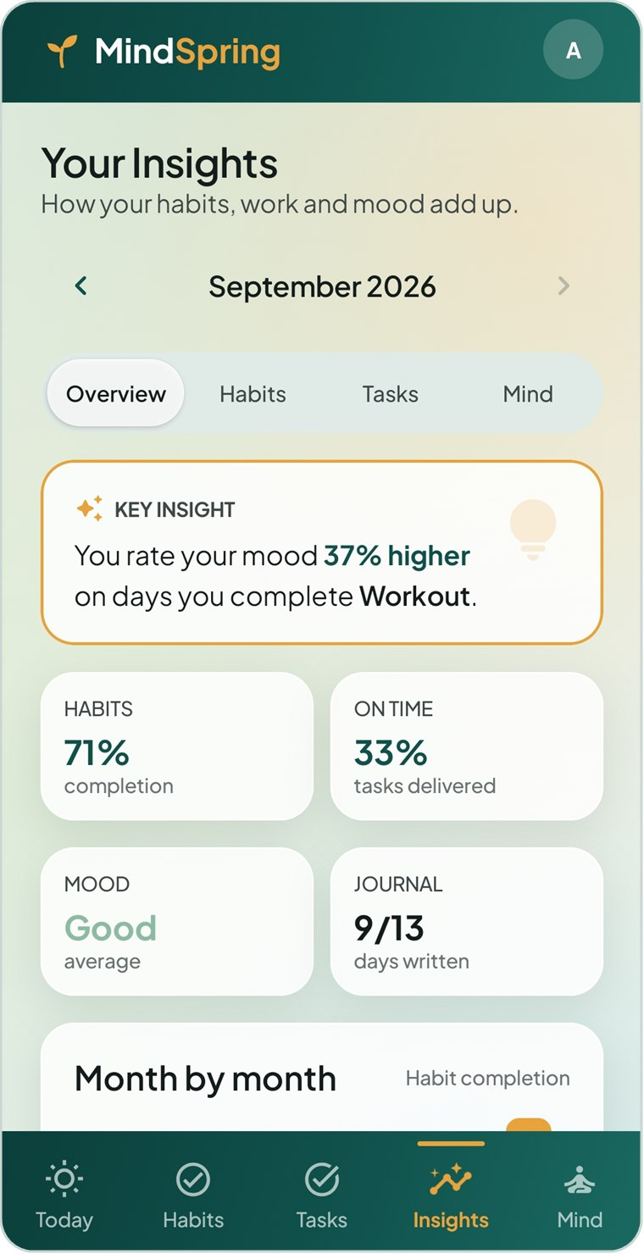  Figure 1.3 Insights with a key insight

1.2 About this manual
This manual is the complete guide to MindSpring version 2.1. Chapters 1–3 explain the ideas behind the app and how to move around it. Chapters 4–10 take each part of the app in turn, describing every screen, what each control does and how to complete common jobs step by step. Chapters 11–13 cover alerts and alarms, troubleshooting and a one-page quick reference.
The following conventions are used throughout:
Convention | Meaning
Save Habit | Words in teal semibold are labels exactly as they appear on screen — buttons, tabs, fields and menu rows.
Tap | Touch an item briefly with one finger.
Long-press | Touch and hold an item for about half a second (used to skip a habit for the day).
Swipe | Drag a finger across an item — for example, swiping a mood entry to the left deletes it.
Tip / Note / Important | Coloured boxes give shortcuts (teal), extra context (amber) or warnings about actions that cannot be undone (red).

NOTE The screenshots in this manual were taken on an Android phone and from the app’s built-in sample account, so names, numbers and dates will differ from what you see on your own device.

1.3 Key concepts
A handful of words have a specific meaning inside MindSpring. Knowing them makes the rest of the manual easier to follow.
Term | What it means in MindSpring
Habit | Something you intend to repeat — daily, on weekdays or weekends, on chosen days, once a week or once a month.
Done / Skipped | Each day a habit is due you can mark it Done or Skipped. A skip means the habit genuinely did not apply (travel, illness); it never counts against you and never breaks a streak.
Streak | How many due days (or weeks, or months) in a row you have completed a habit, counting back from today.
Completion rate | Done out of everything that was due in a period. Only time that has already passed is counted, and skips are left out.
Task | One-off work, optionally with a deadline, a start date, a priority (A, B or C), a status and an alert.
Project | A deliverable that several tasks add up to, such as “Research Proposal”. Its progress is the share of its tasks that are done.
Life area | A broad part of life — Health & Well-being, Study & Research, Finance & Security and so on. Habits, tasks and projects can be filed under one.
Sub-area | A free-text label inside a life area, such as “Assignments” or “Physical Health”, used to group related items further.
Check-in | A quick mood entry: a five-point face scale, optional feeling tags and an optional note.
Daily reflection | One journal entry per day: a day rating, energy level, highlight, a free-writing monologue of about 150 words and tomorrow’s top priority.
Reminder / Alarm | The two alert styles. A reminder sounds once; an alarm keeps ringing until you snooze, finish or dismiss it.

1.4 Your privacy
MindSpring is designed to be a private space. There is no online account, no cloud sync and no advertising.
- Your account, habits, tasks, moods and journal entries are stored only on this phone.
- Passwords are stored as a secure hash, never as plain text.
- Nothing is uploaded. If you want a copy of your data, you create a backup file yourself (see Chapter 10).
- Uninstalling the app removes all of its data, so export a backup first if you want to keep it.
IMPORTANT MindSpring is a self-reflection tool, not a medical product. It does not diagnose or treat any condition. If you are struggling, please reach out to a qualified professional or a local support service.

2 Getting Started
This chapter takes you from installing the app to your first day: the welcome slides, creating an account, signing in and the permissions MindSpring asks for.

2.1 What you need
- An Android phone running Android 8.0 (Oreo) or later.
- No internet connection — the app works completely offline.
- A few megabytes of free storage for your data.
MindSpring may ask for the following permissions. All of them relate to reminders and alarms; the app works without them, but alerts will not appear.
Permission | Why MindSpring needs it | When it is requested
Notifications | Shows habit reminders, task alerts, the evening check-in and the morning summary. | Once, the first time you reach the Today screen (Android 13 and later), and again when you switch on an alert.
Alarms & reminders (exact alarms) | Lets alerts go off at the exact minute you chose instead of a few minutes later. | Granted automatically on most phones; can be checked in Alerts & Sounds.
Full-screen alerts | Lets an alarm wake the phone and fill the lock screen, like the clock app. | Checked in Alerts & Sounds.
Ignore battery optimisation | Optional. Stops some phones from delaying alarms to save battery. | Only if you tap Allow in Alerts & Sounds.
Run at start-up | Puts your alarms back after the phone restarts, the app updates or the clock changes. | Automatic; no prompt.

2.2 First launch: the welcome slides
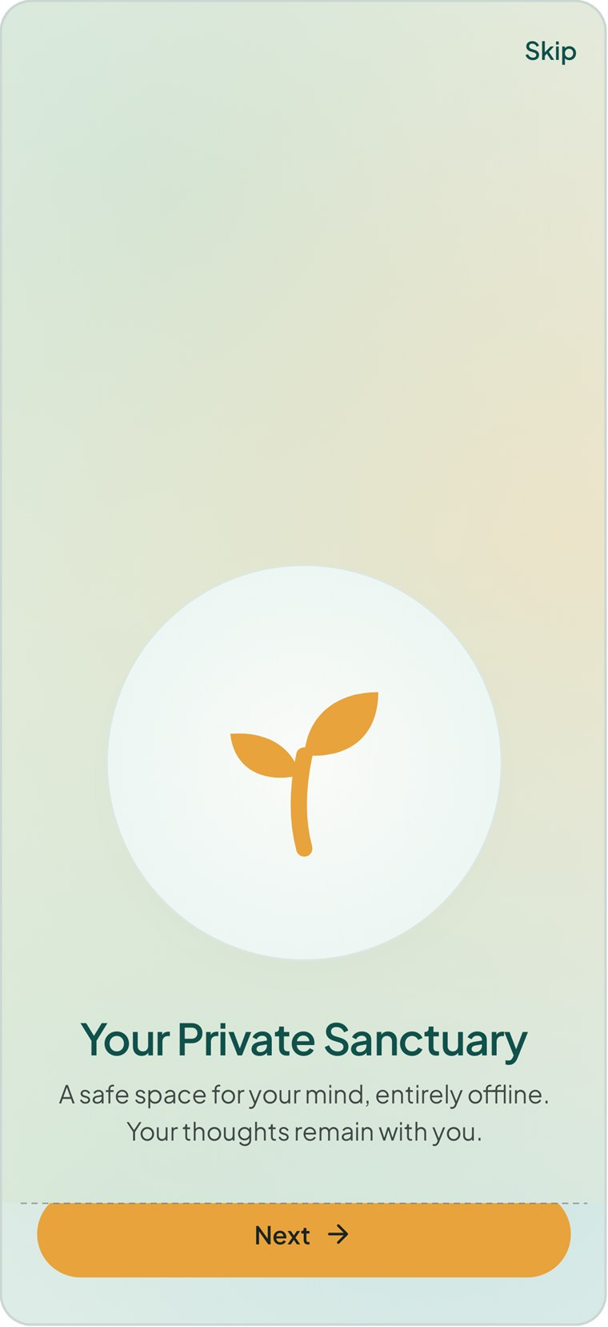  Figure 2.1 The first welcome slide | The first time you open MindSpring you see three short welcome slides:  - Your Private Sanctuary — a safe space for your mind, entirely offline.  - Build Better Habits — routines that nourish your well-being through gentle daily guidance.  - Find Your Center — a moment each day to reflect, breathe and reconnect.  To move through the slides  - Swipe left, or tap the amber Next button, to go to the next slide. The dots above the button show where you are.  - On the last slide tap Get Started.  - To jump straight to sign-in at any time, tap Skip in the top-right corner.  The slides are shown only once. After that, MindSpring opens on the sign-in screen, or directly on Today if you are still signed in.

2.3 Creating your account
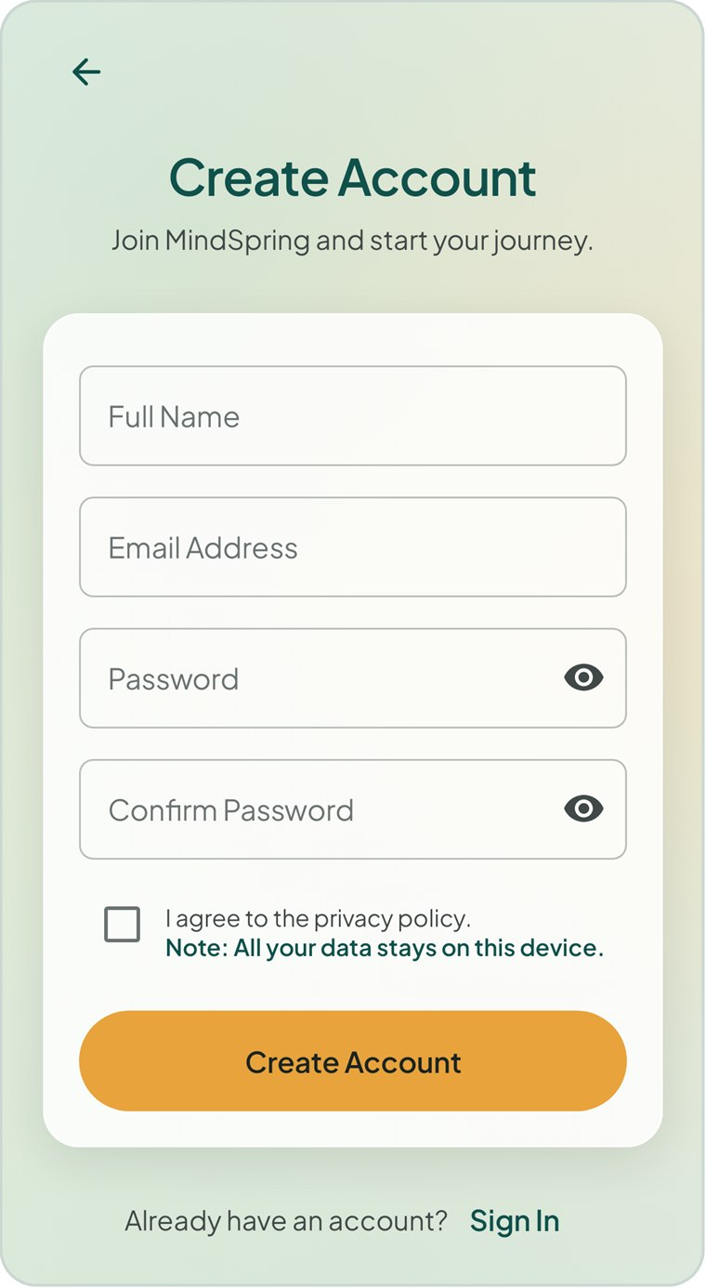  Figure 2.2 The Create Account screen | Your account keeps your data separate if more than one person uses the phone. It exists only on this device.  To create an account  - On the sign-in screen, tap Create account.  - Enter your Full Name. Your first name is used in greetings such as “Good evening, Asan”.  - Enter your Email Address. It is used only as your sign-in name — no email is ever sent.  - Enter a Password of at least six characters, then type it again in Confirm Password. Tap the eye icon to show or hide what you typed.  - Tick I agree to the privacy policy.  - Tap Create Account. You are signed in and taken to the Today screen.  Tap the back arrow or Sign In to return to the sign-in screen without creating an account.

If something is missing or wrong, a red message appears under the field when you tap Create Account:
Message | What to do
Please enter your name. | Type your name in Full Name.
Please enter your email. / That doesn’t look like a valid email. | Enter an address in the form name@example.com.
Use at least 6 characters. | Choose a longer password.
Passwords don’t match. | Retype the same password in both fields.
Please agree to the privacy policy to continue. | Tick the agreement box.
An account with this email already exists. | Sign in instead, or use a different email address.

2.4 Signing in
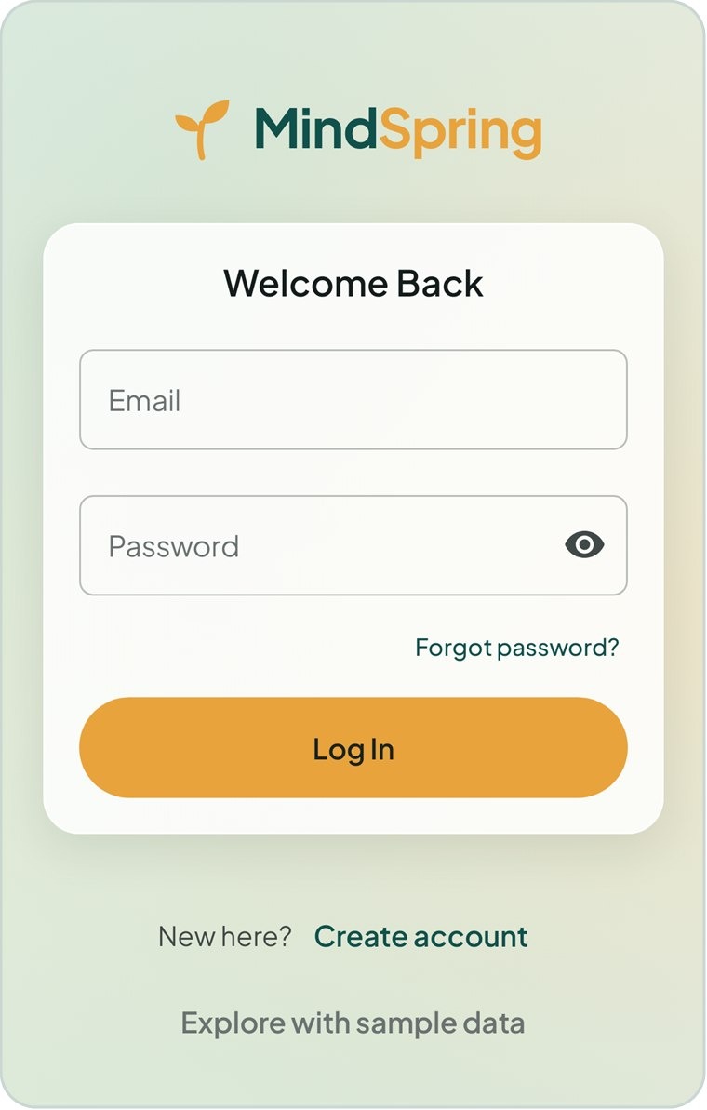  Figure 2.3 The Welcome Back sign-in screen | To sign in  - Enter the Email and Password you registered with.  - Tap Log In.  You stay signed in until you choose Log out in Profile & Settings, so next time the app opens straight on Today.  Forgot your password?  Tap Forgot password? for an explanation. Because the account lives only on this phone, there is no online reset. If you cannot sign in, create a new account.  Try the app with sample data  Tap Explore with sample data to open a demonstration account filled with about six weeks of habits, tasks, projects, moods and journal entries. It is an easy way to see every feature working before you enter your own information.

TIP The sample account is completely separate from your own. Log out from Profile & Settings when you have finished exploring, then sign in with your own account.

2.5 Your first few minutes
A good order for setting MindSpring up (each step is covered later in the manual):
- Allow notifications on the Today screen, then check in your mood (Chapter 7).
- Add two or three habits you already want to build (Chapter 5).
- Add any tasks with upcoming deadlines, and group larger pieces of work into a project (Chapter 6).
- Tonight, write your first daily reflection (Chapter 8).
- Visit Profile & Settings to choose light or dark appearance and your reminder times (Chapter 10).

3 Finding Your Way Around
Every part of MindSpring follows the same layout and uses the same few controls, so once you know one screen you know them all.

3.1 The bottom navigation bar
The teal bar along the bottom of the main screens takes you between the five areas of the app. The tab you are on is shown twice: its icon becomes filled and turns amber, and an amber line sits above it.
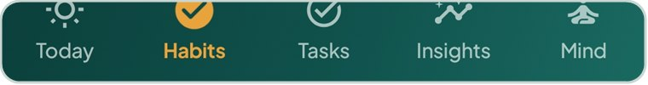
Figure 3.1 The bottom navigation bar, with Habits selected
Tab | What you will find there | Chapter
Today | Greeting and daily progress, mood check-in, task counts, Up next, today’s habits, tonight’s reflection, streaks and a gratitude note. | 4
Habits | Your habits in three views: Today, Week and All. Add, tick, skip and review habits. | 5
Tasks | Your task list with filters, and your projects. | 6
Insights | Monthly statistics for habits, tasks and mind, and the Life Areas breakdown. | 9
Mind | Breathing exercises, Daily Reflection, Gratitude Journal and Mood History. | 8

The bottom bar is hidden on screens that need your full attention — editors, the mood check-in, breathing sessions, the celebration screen and sign-in — so that the only way out is the close or back button at the top.

3.2 The top of each screen
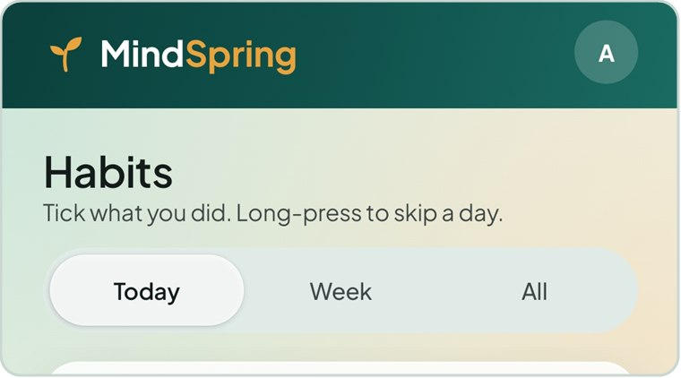  Figure 3.2 Brand bar, title, hint and view switcher | Main screens share the same header:  - The MindSpring name on a teal bar.  - Your avatar (the circle with your initial) on the right. Tap it to open Profile & Settings from anywhere.  - A title and a one-line hint explaining how the screen works.  - On some screens, a view switcher — a rounded bar of choices such as Today · Week · All. The highlighted choice is the current view.  Detail and editor screens instead show a teal bar with the screen’s name, a back arrow (←) or close cross (×) on the left, and sometimes an action such as edit (pencil) or delete (bin) on the right.

3.3 Common controls
The same controls behave the same way everywhere in the app. Colour carries meaning: amber marks the one main action on a screen, teal marks structure and selection, and red is reserved for actions that delete something.
Control | Looks like | How to use it
Primary button | A wide amber pill, usually at the bottom (Save Habit, Add Task, Check in). | Tap to complete the screen’s main action. It is greyed out until the required fields are filled.
Add button | A round amber button with + in the lower-right corner. | Tap to create a new habit, task or project.
Chips | Small rounded labels (Daily, Tomorrow, Calm, Study & Research). | Tap to select. A selected chip turns solid teal. Some groups allow several choices, others only one.
View switcher | A rounded bar with two to four options. | Tap an option to change what the screen shows.
Switch | A toggle that turns amber when on. | Tap to turn a setting on or off, such as a reminder.
Tick circle | An empty circle beside a habit or task. | Tap to mark done; it fills teal with a white tick. Tap again to undo.
Progress ring / bar | A circle or line filling with colour. | Shows how much is complete. Read-only.
Message bar | A dark strip that slides up at the bottom, sometimes with Undo. | Confirms what just happened. Tap Undo to reverse a deletion.
Confirmation dialog | A pop-up asking “Delete this…?”. | Tap the red action to confirm, or Cancel to keep things as they are.

3.4 Map of the app
Use this table to find any screen quickly.
Screen | How to get there
Welcome slides | First launch only
Sign in · Create account | App start when signed out · Log out
Today | Today tab
Mood Check-in | Today → a face or Check in · Mood History → an entry
Habits (Today, Week, All) | Habits tab
Add / Edit Habit | Habits → + · Habit detail → Edit
Habit detail | Tap any habit on Today or Habits
Habit completed | Habit detail → Complete for Today
Tasks · Projects | Tasks tab (switch between Tasks and Projects)
New Task / Task T0nn | Tasks → + · tap any task · Project → Add a task
New / Edit Project · Project detail | Projects → folder button · tap a project card · pencil icon
Your Insights (Overview, Habits, Tasks, Mind) | Insights tab
Life Areas | Insights → Overview → Life areas · Profile → Life areas
Mind | Mind tab
Breathing session | Mind → Start Session, Calm Breathing or Box Breathing
Daily Reflection · Tonight’s Reflection | Mind → Daily Reflection · Today → Tonight’s reflection · Insights → Mind
Gratitude Journal | Mind → Gratitude Journal
Mood History | Mind → Mood History · Insights → Mind → Mood history
Profile & Settings | Avatar in the top-right of any main screen
Alerts & Sounds | Profile & Settings → Alerts & sounds
Alarm screen | Appears by itself when a task or habit alert goes off

4 The Today Screen
Today is the home of MindSpring. It answers one question — what do I need to do today? — and lets you act on most of it without leaving the screen.
The screen scrolls from top to bottom through these cards: the greeting header, the mood card, the four task counters, Up next, Today’s habits, Tonight’s reflection, Current streaks and Gratitude. Cards that have nothing to show, such as Up next when no tasks are due, are left out.
Figure 4.1 Top of the Today screen | 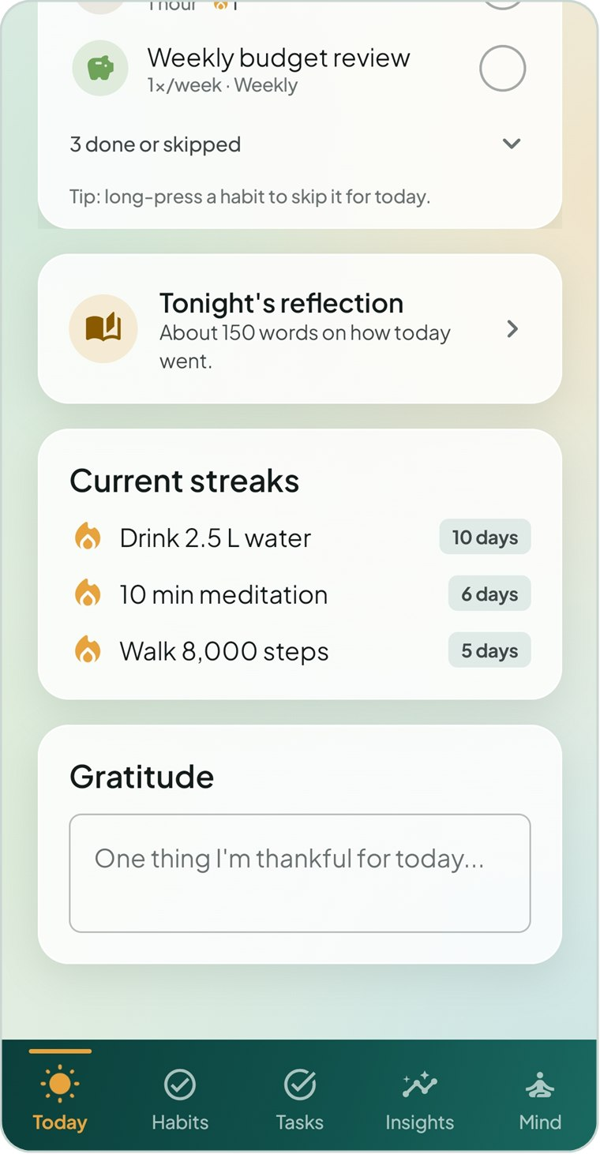  Figure 4.2 Further down: habits, reflection, streaks and gratitude

4.1 Greeting and daily progress
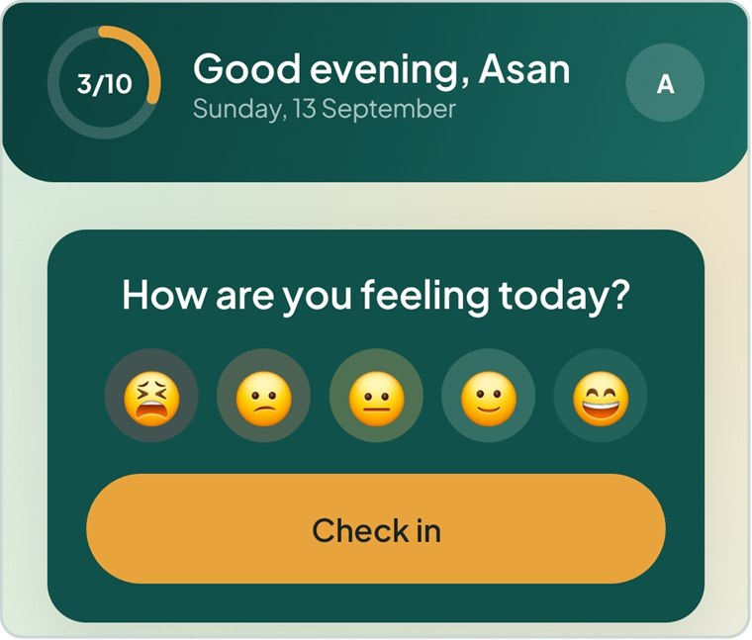  Figure 4.3 Greeting header and mood card | The teal header greets you by first name according to the time of day — Good morning, Good afternoon or Good evening — and shows today’s date.  The amber progress ring on the left counts today’s habits: 3/10 means three of the ten habits that still count today are done. Habits you have skipped are taken out of the total, so skipping never lowers your progress.  Tap your avatar on the right to open Profile & Settings.

4.2 Checking in your mood
Until you have checked in today, the mood card asks How are you feeling today? and shows five faces from awful to great.
- Tap the face that matches how you feel. The Mood Check-in screen opens with that face already selected — or tap Check in to choose there.
- Optionally pick feelings and add a note, then tap Save Entry. (See Chapter 7.)
After you check in, the card changes to Today you’re feeling Good (or whichever mood you chose) with your feeling tags underneath. Tap Update check-in to change it.

4.3 Your day at a glance
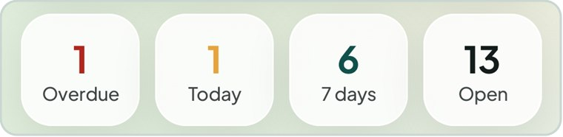
Figure 4.4 The four task counters
Four small tiles count your open tasks. Tap any of them to jump to the Tasks tab.
Tile | What it counts
Overdue | Open tasks whose deadline has passed. The number turns red when it is above zero.
Today | Open tasks due today. The number turns amber when it is above zero.
7 days | Open tasks due within the next seven days.
Open | All tasks that are not yet Done or Dropped.

4.4 Up next
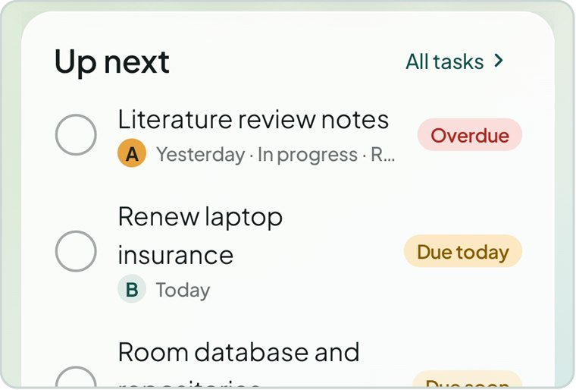  Figure 4.5 Up next lists the most urgent tasks | Up next shows up to four of your most urgent open tasks — those that have started, or are due within a week — earliest deadline first, then by priority.  Each row shows the task name, its priority letter (A, B or C), its deadline, status and project, and a coloured flag such as Overdue, Due today or Due soon.  - Tap the circle to mark the task done. Tap again to reopen it.  - Tap the task name to open it in the task editor.  - Tap All tasks to go to the Tasks tab.

4.5 Today’s habits
This card lists every habit that belongs on today’s list, with a count such as 3 of 10 done. Daily and weekday habits come first, followed by weekly and monthly ones.
- Tap the circle on the right of a habit to mark it done. It moves into the collapsed done or skipped group.
- Long-press a habit to skip it for today. A message confirms “Skipped … for today”.
- Tap the habit’s name to open its detail screen.
- Tap N done or skipped to expand the group and see, or undo, what you have already handled.
When everything is handled the card says All done for today. Nicely handled. If no habits are planned for today, it offers Add a habit.
TIP A weekly or monthly habit you completed earlier in the period shows as done with a note such as “Done Wed”, so you are not asked to do it twice.

4.6 Reflection, streaks and gratitude
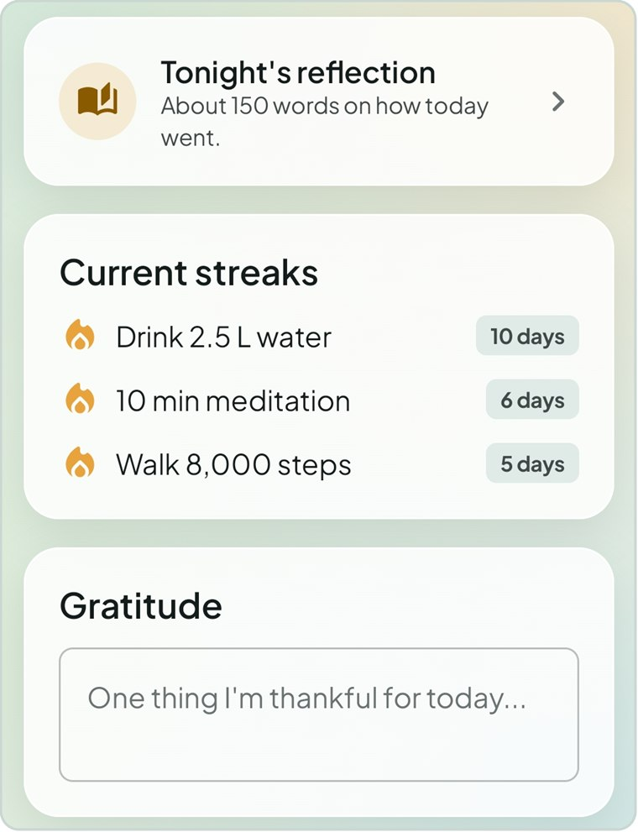  Figure 4.6 The lower cards on Today | Tonight’s reflection  Tap this card to write today’s journal entry. Before you start it suggests about 150 words; afterwards it shows your word count and a status such as Good length.  Current streaks  Your three longest running habit streaks, each with a flame and a count such as 10 days (or weeks, or months for weekly and monthly habits).  Gratitude  Type one thing you are thankful for. A Save button appears as soon as you start typing; tap it to add the note to your Gratitude Journal.

5 Habits
Habits are the routines you want to repeat. MindSpring lets you tick them off in seconds, excuses genuine days off, and keeps streaks and completion rates for you.

5.1 The three habit views
Open the Habits tab and use the switcher under the title to choose a view:
View | Best for
Today | Ticking off what you did today. Shows only habits that belong on today’s list.
Week | Catching up on earlier days and seeing the whole week as a grid, like a paper tracker.
All | Reviewing every habit, grouped by life area, with this month’s rate and streak.

Figure 5.1 Today view | 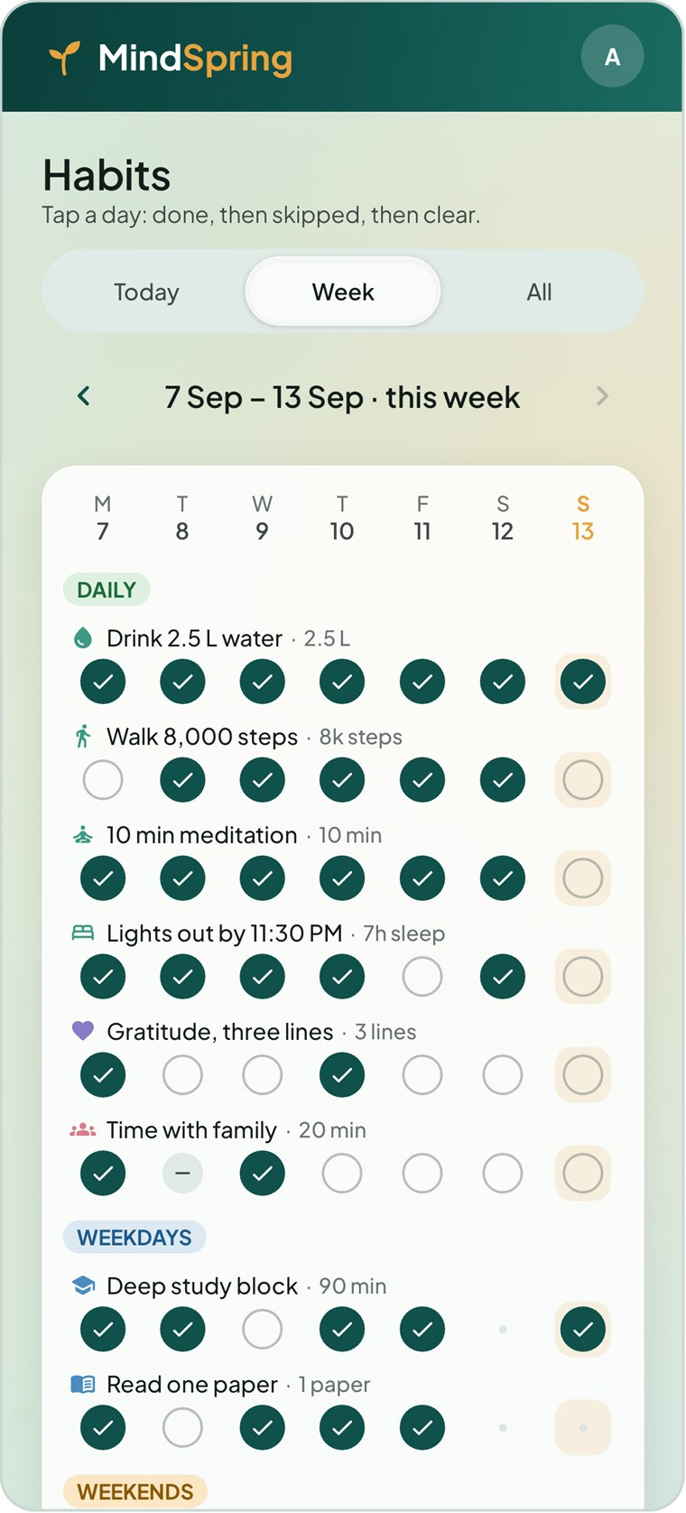  Figure 5.2 Week view | 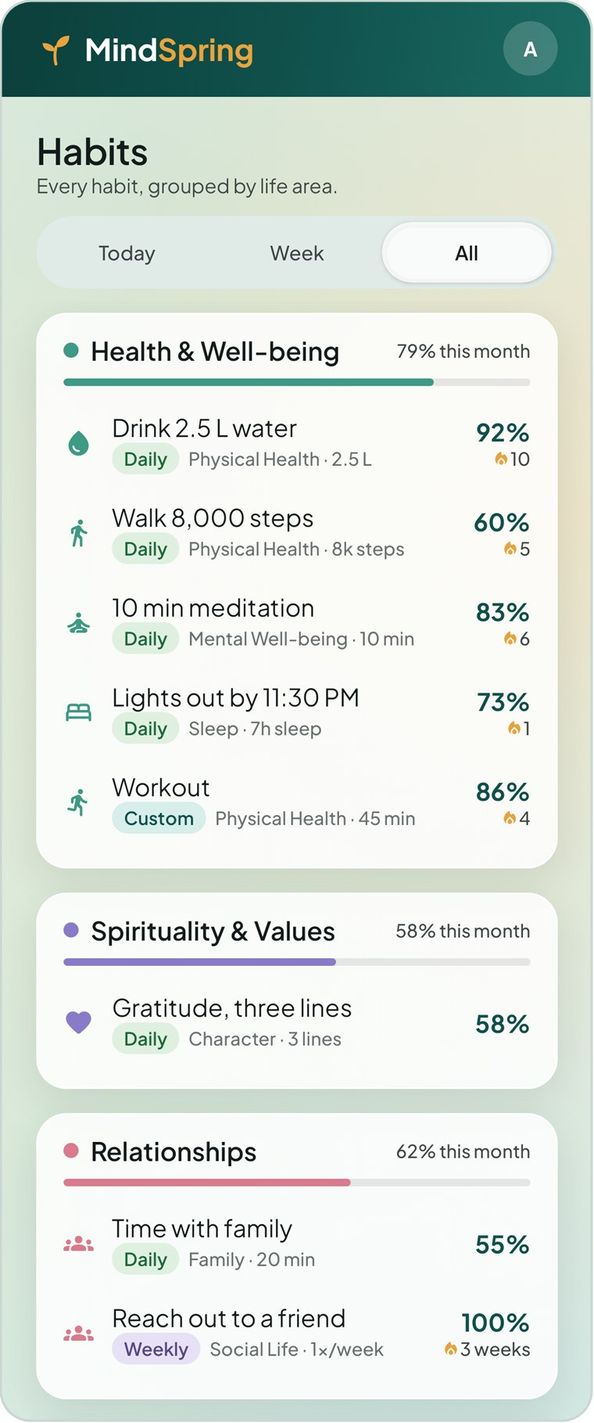  Figure 5.3 All view

5.2 Today view
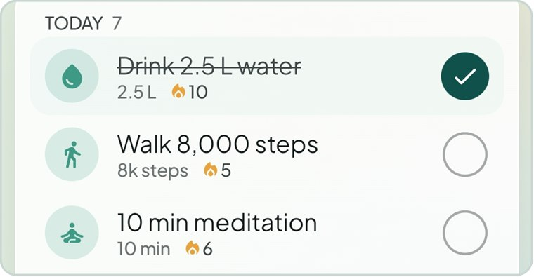  Figure 5.4 Habit rows — the first is done | A summary card at the top shows a percentage ring and a line such as 3 of 10 done · 7 still open today.  Below it, habits are grouped into Today (daily, weekday, weekend and custom habits), This week (weekly habits) and This month (monthly habits).  Each row shows the habit’s icon (tinted with its life-area colour), its name, its target (for example 2.5 L or 20 min) and a small flame with the current streak.  To mark a habit  - Tap the circle on the right. It fills teal with a tick and the name is struck through.  - To undo, tap the circle again.  - To skip the day instead, long-press the row. A skipped habit shows a dash (–).  - Tap the row itself to open the habit’s detail screen.

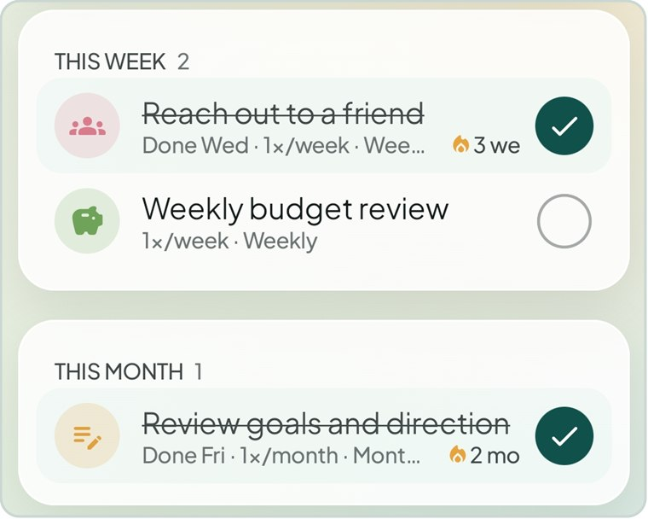
Figure 5.5 Weekly and monthly habits stay on the list for their whole week or month
Tap the amber + button to create a new habit.

5.3 Week view
Figure 5.6 The week grid | The Week view is a grid: one row per habit, one column per day from Monday to Sunday. Today’s column is highlighted in amber.  - Use the ‹ and › arrows beside the date range to move between weeks. You can go back as far as you like, but not beyond the current week.  - Habits are grouped under coloured labels: Daily, Weekdays, Weekends, Custom, Weekly and Monthly.  - Tap a cell to cycle it: done → skipped → clear.  Days in the future, days before the habit was created and days the habit is not due cannot be tapped. For weekly and monthly habits every day of the period is drawn faintly, because any one of them will do.  At the bottom of the grid, Day score shows the share of that day’s habits you completed (teal at 75% or more, amber from 40%, red below), and Task deadlines shows how many open tasks fall due on each day.

Cell | Meaning
Teal circle with a tick | Done
Grey circle with a dash | Skipped — excused, does not count against you
Empty outlined circle | Due but not yet marked
Small dot | Not due that day (or before the habit existed, or in the future)

5.4 All view
Figure 5.7 Every habit grouped by life area | The All view lists every active habit, grouped into a card for each life area. Each card header shows the area’s completion rate for this month with a coloured bar.  Each habit row shows:  - Its frequency label (Daily, Weekdays, Custom, Weekly…).  - Its sub-area and target, for example Physical Health · 2.5 L.  - This month’s completion rate on the right.  - Its current streak beside a small flame.  Retired habits are collected at the bottom under Retired habits (N). Tap that card to show or hide them. Tap any habit to open its detail screen.

5.5 Creating a habit
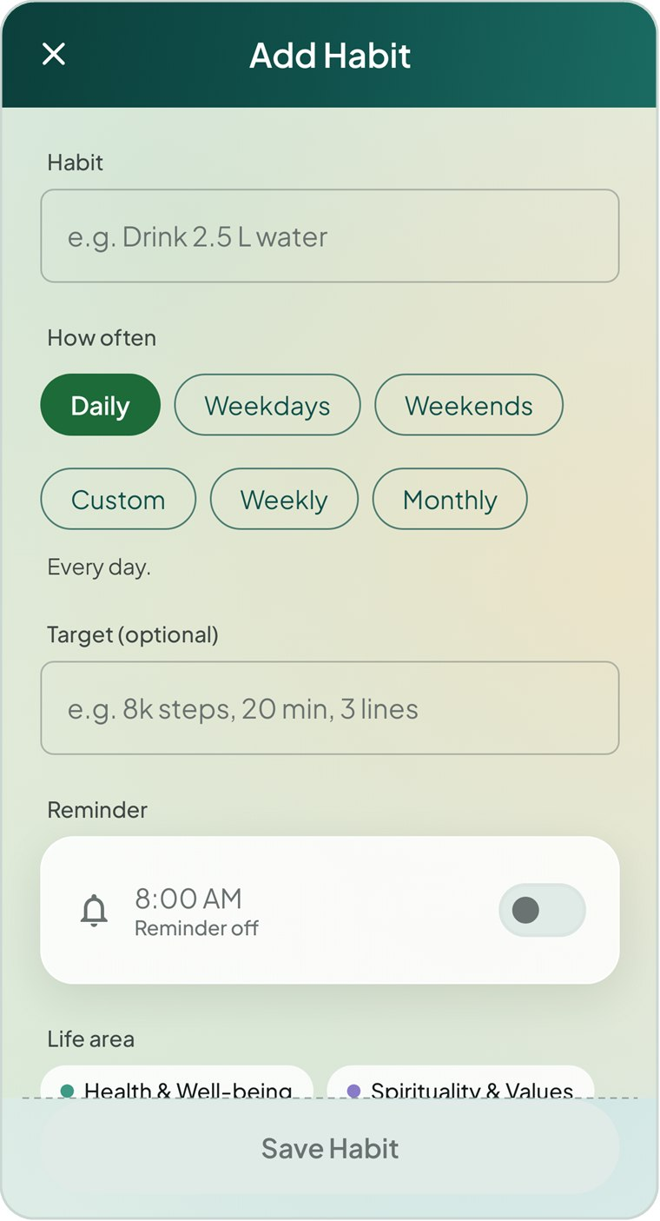  Figure 5.8 The Add Habit screen (top and bottom) | To add a habit  - On the Habits tab, tap the amber + button (or Add a habit on Today).  - Under Habit, type a short name, for example “Drink 2.5 L water”.  - Under How often, choose a frequency (see the table below). For Custom, tap the weekday letters you want.  - Optionally enter a Target such as “8k steps”, “20 min” or “3 lines”.  - Optionally switch on a Reminder and set its time and style (see the next section).  - Choose a Life area, and optionally type or pick a Sub-area.  - Pick an Icon from the grid of eighteen.  - Tap Save Habit.  Save Habit stays greyed out until the habit has a name and, for a custom habit, at least one day.

Frequency | When the habit is due | How it is judged
Daily | Every day. | Each day
Weekdays | Monday to Friday. Weekends are days off. | Each weekday
Weekends | Saturday and Sunday only. | Each weekend day
Custom | Only on the weekdays you pick (for example Mon, Wed, Fri). | Each chosen day
Weekly | Once a week, on any day that suits. | Each Monday–Sunday week
Monthly | Once a month, on any day that suits. | Each calendar month

TIP The Sub-area field suggests labels you have already used on other habits and tasks, which keeps your groupings consistent.

5.6 Habit reminders
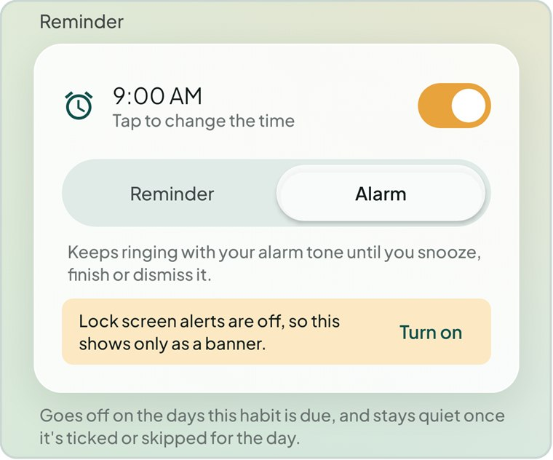  Figure 5.9 A habit reminder set to Alarm | Any habit can remind you at a set time on the days it is due.  - In the habit editor, turn on the switch in the Reminder card.  - Tap the time (for example 9:00 AM) to change it.  - Choose Reminder to sound your tone once, or Alarm to keep ringing until you respond.  The reminder only goes off on days the habit is due, and stays quiet once you have ticked or skipped the habit for the day. A weekly or monthly habit stays quiet once it is done for that period.  If the phone is blocking something the reminder needs, an amber warning appears — for example Lock screen alerts are off, so this shows only as a banner — with a Turn on link to the right Android setting.

5.7 Habit detail
Tap any habit to see how it is going. The detail screen scrolls through a streak card, three statistics, an activity calendar and the actions for the habit.
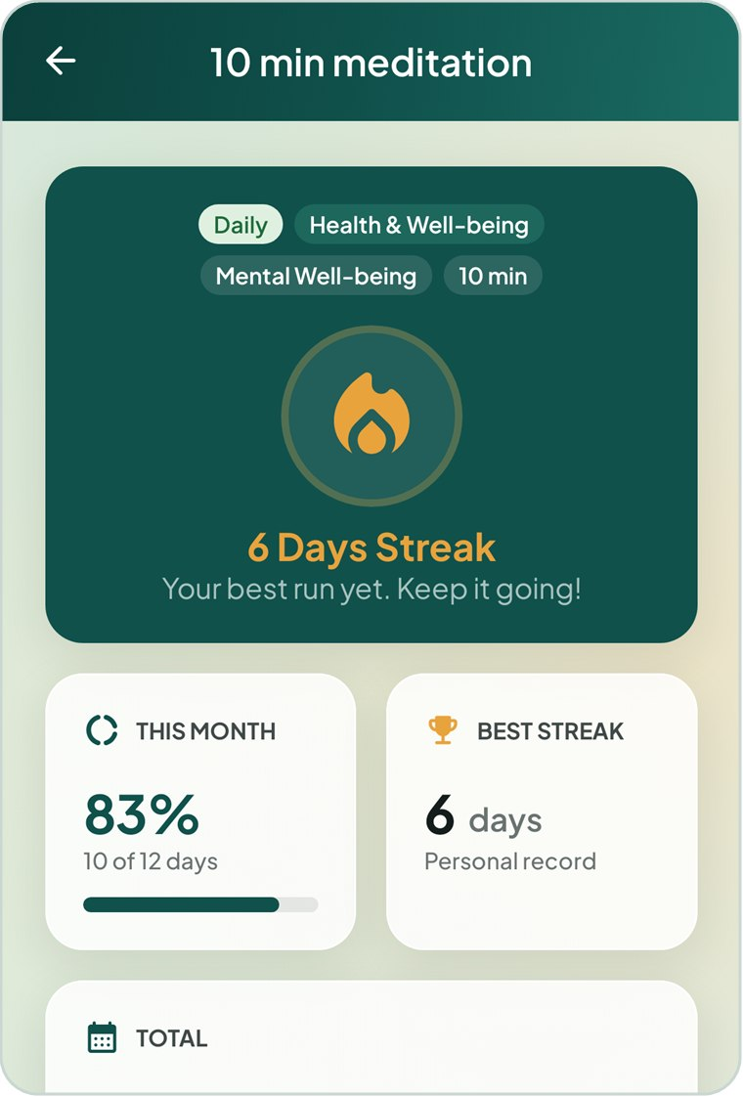  Figure 5.10 Streak card and statistics | 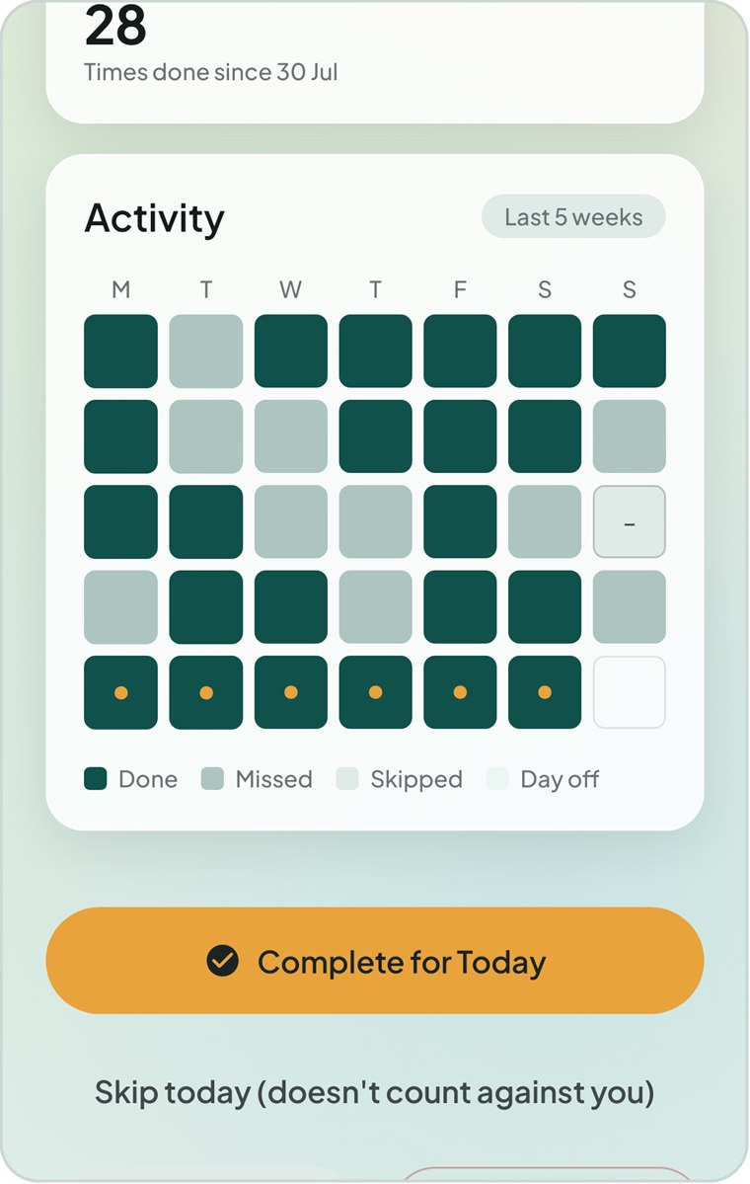  Figure 5.11 Activity calendar and actions

Part of the screen | What it tells you
Labels | Frequency, life area, sub-area and target. Retired appears if the habit is retired.
Streak card | A flame and N Days Streak (or Weeks, or Months). The message underneath changes to Your best run yet when you beat your record, or Complete it to start a streak at zero.
This month | Completion percentage and a line such as 10 of 12 days, with a progress bar.
Best streak | Your longest ever run — your personal record.
Total | How many times you have done the habit since you created it.
Activity | The last five weeks, Monday first. Teal = done, light teal = missed, grey with a dash = skipped, pale = day off (or “any day” for weekly and monthly habits). Amber dots mark the days in your current streak.

NOTE A missed day is shown in a soft teal, never in red. MindSpring treats a missed day as information, not as a failure.

Actions on the detail screen
Button | What it does
Complete for Today | Marks the habit done for today and opens the celebration screen.
Skip today (doesn’t count against you) | Marks today as skipped.
Completed today · tap to undo / Skipped today · tap to undo | Shown after you mark the day. Tap to clear the mark.
Edit | Opens the habit editor with all current settings.
Delete | Removes the habit and its entire history, after confirmation.
Retire this habit (keeps its history) | Stops tracking without losing past data. Changes to Bring this habit back for retired habits.

5.8 The celebration screen
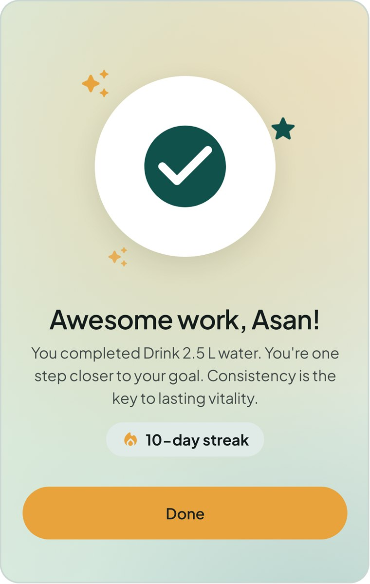  Figure 5.12 Completing a habit from its detail screen | When you tap Complete for Today, MindSpring shows a short celebration: a large tick with sparkles, Awesome work, [your name]!, a message crediting your consistency and, if you have one, your current streak — for example 10-day streak.  Tap Done to return to the habit.  This is the only celebration in the app. Ticking habits from the Today screen or the Habits list marks them silently, so you can move quickly.

5.9 Editing, retiring and deleting
Open a habit and tap Edit to change anything you set when creating it. The editor has one extra switch, Active: turn it off to retire the habit.
 | Retire | Delete
History | Kept. The habit still appears in past weeks and totals. | Permanently removed.
Today list and reminders | Removed. Reminders stop. | Removed.
Completion rates | No longer counted from now on. | Removed from all statistics.
Can be undone? | Yes — tap Bring this habit back. | No.

IMPORTANT Deleting a habit cannot be undone. If you might want the history later, retire the habit instead.

5.10 How streaks and rates are counted
- Day-based habits (Daily, Weekdays, Weekends, Custom) are judged on each day they are due. Weekly habits are judged once per Monday-to-Sunday week, and monthly habits once per calendar month.
- A skip is excused: it is left out of the completion rate and a streak passes over it without breaking.
- A streak counts consecutive done periods back from today. Today, or the current week or month, does not break the streak while it is still in progress.
- Only time that has passed counts. On the 11th of the month, a daily habit’s monthly rate is out of the due days so far — not out of 30 — and days before a habit was created are never counted as missed.

6 Tasks and Projects
Tasks are one-off pieces of work — an assignment, a bill, a phone call. Projects group the tasks that add up to one larger deliverable and show how close it is to done.

6.1 The task list
Open the Tasks tab. The switcher under the title has two views: Tasks and Projects. The Tasks view lists your work with the most urgent first.
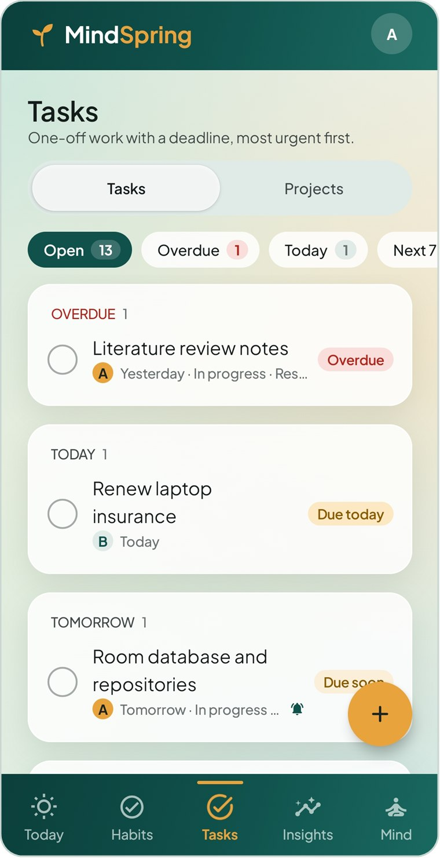  Figure 6.1 Open tasks, grouped by deadline | 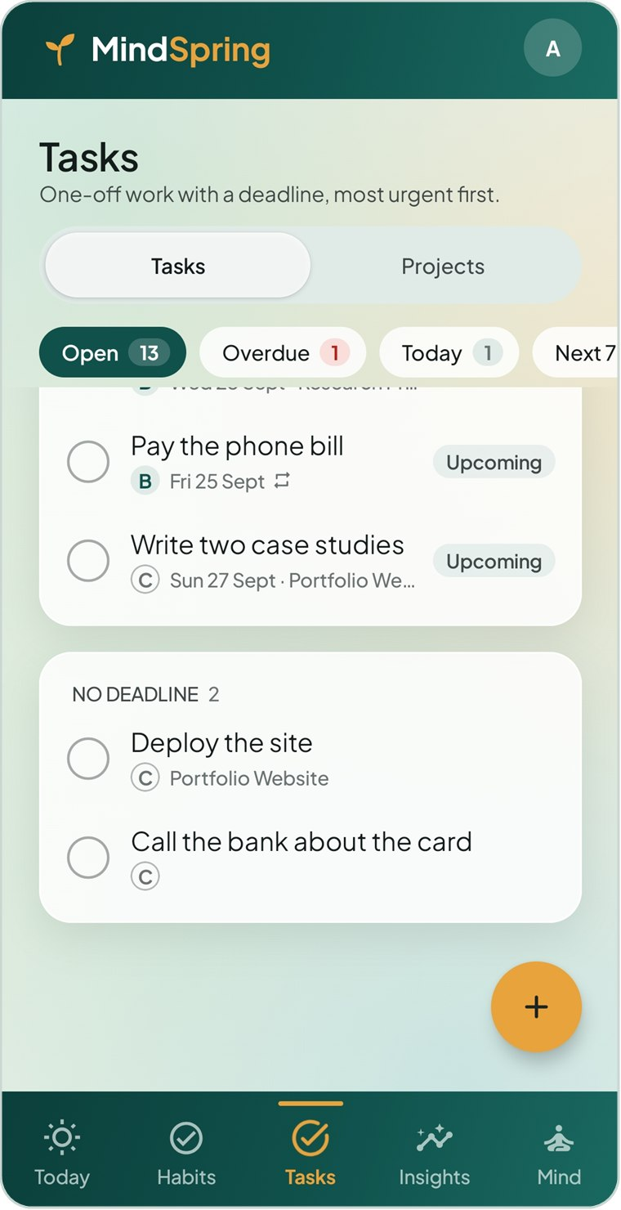  Figure 6.2 Further down: upcoming and undated tasks

Filters
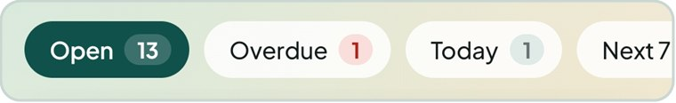
Figure 6.3 Filter chips with live counts (scroll sideways for more)
Filter | Shows
Open | Every task that is not Done or Dropped (the default).
Overdue | Open tasks past their deadline. Its count turns red when above zero.
Today | Open tasks due today.
Next 7 days | Open tasks due between today and a week from now.
Finished | Done and Dropped tasks, most recently finished first.

Groups and flags
Open tasks are shown in cards headed Overdue, Today, Tomorrow, Next 7 days, Later and No deadline. Each task row shows its priority letter, deadline, status, project, a repeat symbol if it repeats and a bell if it has an alert. A coloured flag on the right sums up where it stands:
Flag | Meaning
Overdue | The deadline has passed and the task is still open.
Due today | The deadline is today.
Due soon | The deadline is within the next three days.
Upcoming | The task cannot be started yet — its start date is in the future.
No deadline | The task has no deadline, so it can never be overdue.
Done on time / Done late | Finished on or before the deadline, or after it.
Dropped | Deliberately abandoned. Not counted as a failure.

- Tap the circle beside a task to mark it done; tap again to reopen it.
- Tap the task to open it for editing.
- Tap the amber + button to add a task.

6.2 Adding a task
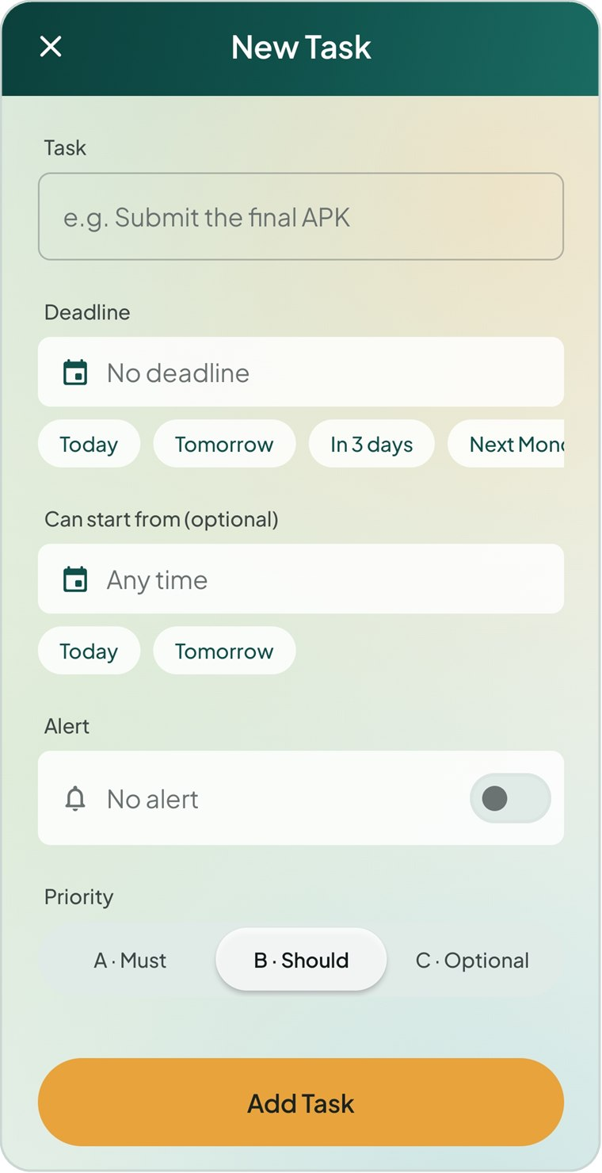  Figure 6.4 A blank New Task | 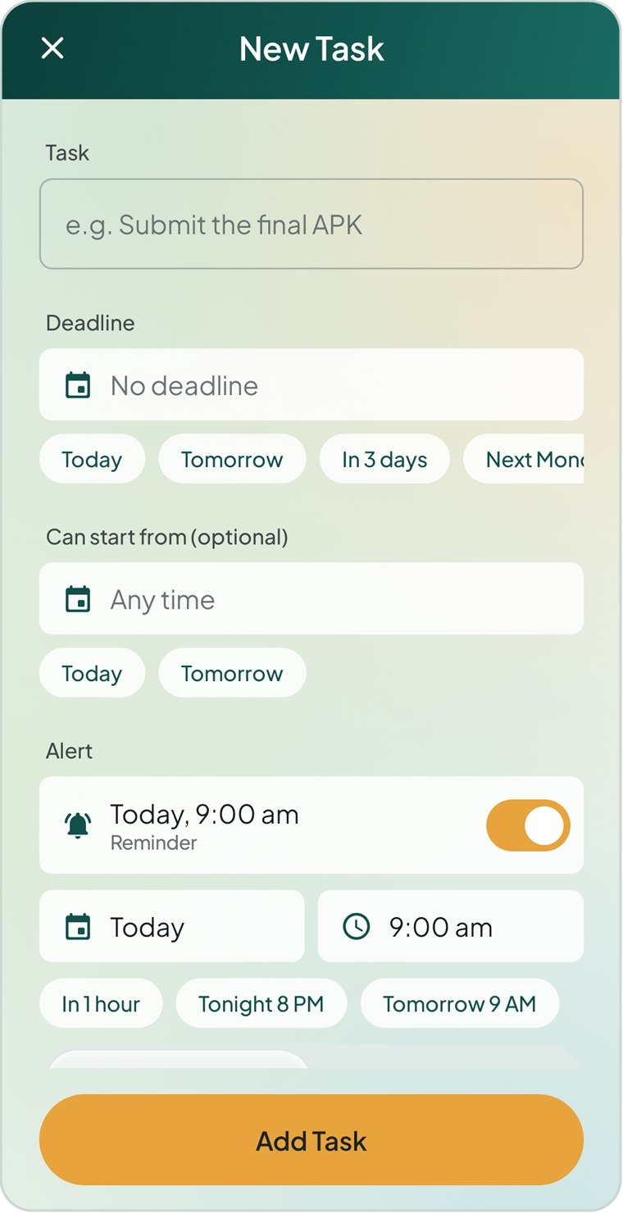  Figure 6.5 Deadline, start date and alert | 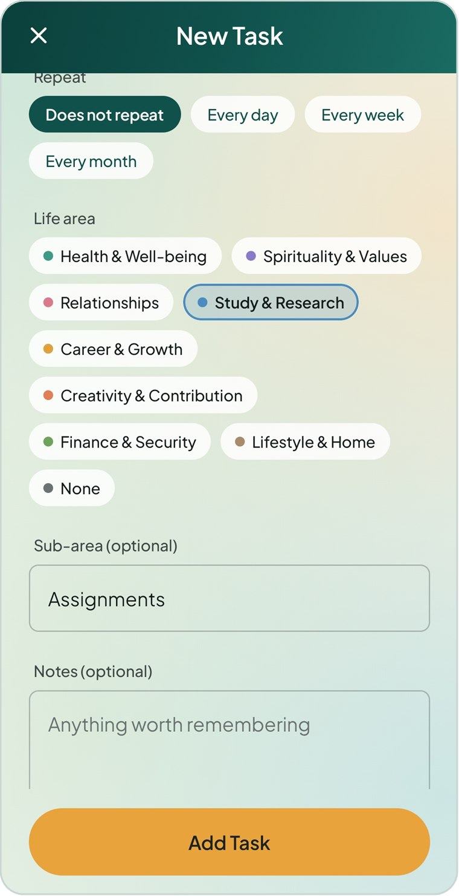  Figure 6.6 Repeat, life area and notes

- On the Tasks tab tap +.
- Under Task, describe the work, for example “Submit the final APK”. This is the only required field.
- Set a Deadline using the quick chips or the calendar, or leave it as No deadline.
- Optionally set Can start from if the task cannot begin until a later date.
- Optionally switch on an Alert (see below).
- Choose a Priority: A · Must, B · Should (the default) or C · Optional.
- If you are editing, set the Status. Choose a Project if the task belongs to one.
- Choose whether it should Repeat, pick a Life area and Sub-area, and add any Notes.
- Tap Add Task.
TIP Choosing a project automatically files the task under that project’s life area and sub-area, unless you have already picked them.

6.3 Deadlines and start dates
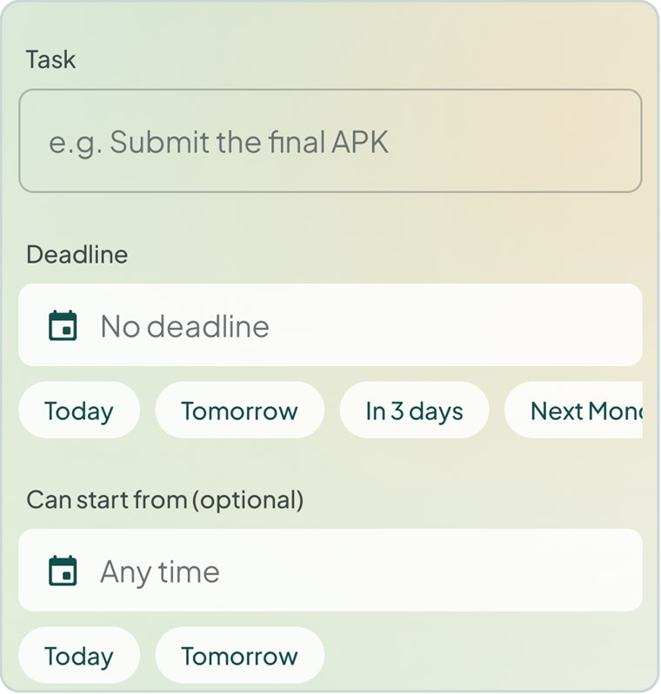  Figure 6.7 Quick date chips | Tap the date field to open a calendar, or tap a chip for a common choice:  - Deadline: Today, Tomorrow, In 3 days, Next Monday, In 2 weeks.  - Can start from: Today, Tomorrow.  Tap the × at the end of a date field to clear it.  If the deadline is earlier than the start date, a red message — The deadline is before the start date. — appears and the task cannot be saved until you fix it.  When you reopen a task, a line under the name shows its flag and its window, for example Due soon · 6-day window.

6.4 Task alerts
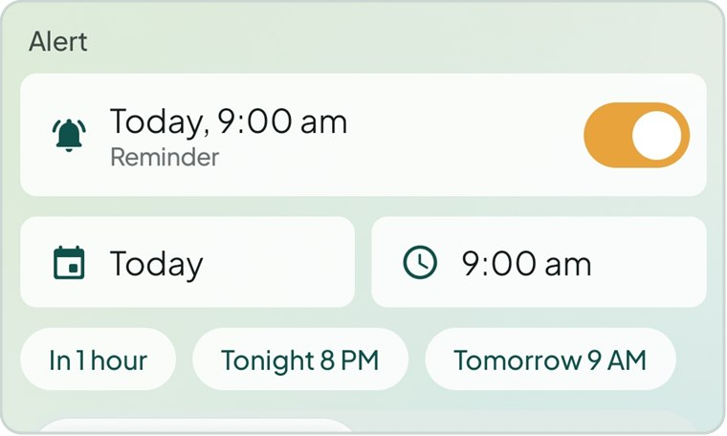  Figure 6.8 An alert set for today at 9:00 am | - Turn on the switch in the Alert row. The alert is set to 9:00 AM on the deadline day, or the next whole hour if that time has passed.  - Tap the date or time pill to change it, or tap a quick chip.  - Choose Reminder or Alarm as the style.  Quick chips include In 1 hour, Tonight 8 PM (before 7 PM only), Tomorrow 9 AM, and — when the deadline is far enough away — Day before deadline and Deadline 9 AM.  Finishing the task silences its alert. If you pick a time that has already gone, the editor warns you that it will not ring.

6.5 Priority and status
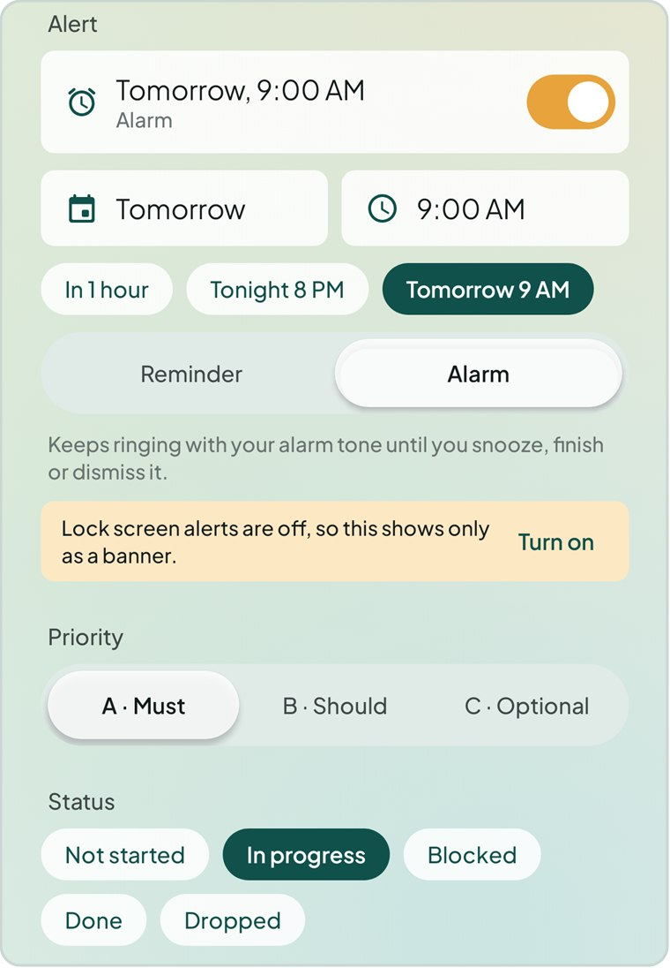  Figure 6.9 Alert style, priority and status | Priority decides the order of tasks that share a deadline: A before B before C.
  Status | Use it when
  Not started | You have not begun (the default).
  In progress | You are working on it.
  Blocked | You are waiting on someone or something.
  Done | It is finished. A Done on date appears, set to today; change it if you finished earlier.
  Dropped | You decided not to do it. It stays on record but is not counted as late or missed.

6.6 Repeating tasks
For work that comes round regularly — a weekly class, a monthly bill — choose Every day, Every week or Every month under Repeat. The editor reminds you: Finishing it schedules the next one automatically.
- When you mark a repeating task done, MindSpring creates the next occurrence with the dates moved forward by one period, and resets its status to Not started.
- If you finish late, missed occurrences are skipped, so the new task is never already overdue.
- Any alert moves forward with the dates and keeps its time of day.

6.7 Editing, finishing and deleting tasks
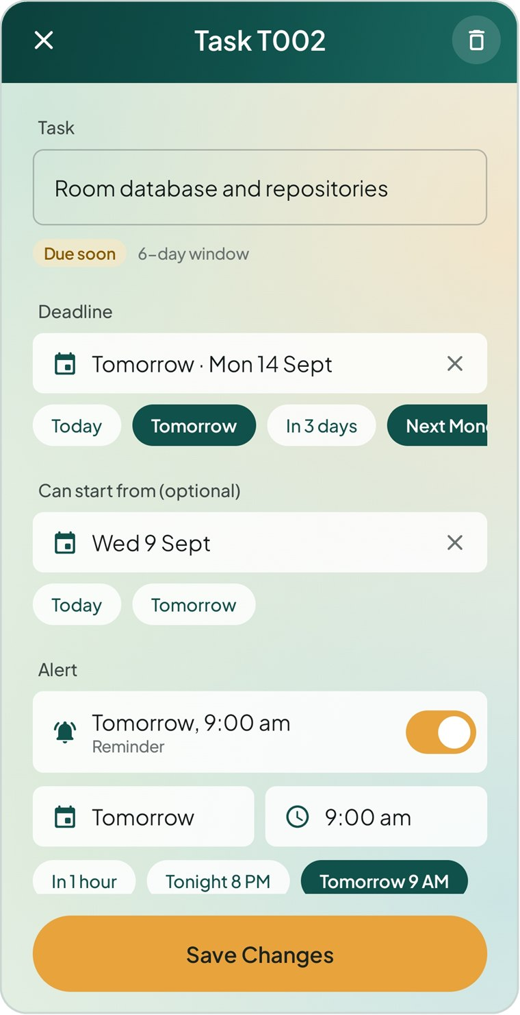  Figure 6.10 Editing task T002 | Tap any task to open it. The title bar shows its reference code, for example Task T002. Change anything, then tap Save Changes.  To finish a task, either tap its circle in any list or set its status to Done.  To delete a task  - Open the task.  - Tap the bin icon in the top-right corner.  - Tap Delete to confirm.  The dialog suggests setting the status to Dropped instead if you want to keep a record of the task without counting it as a failure.

6.8 Projects
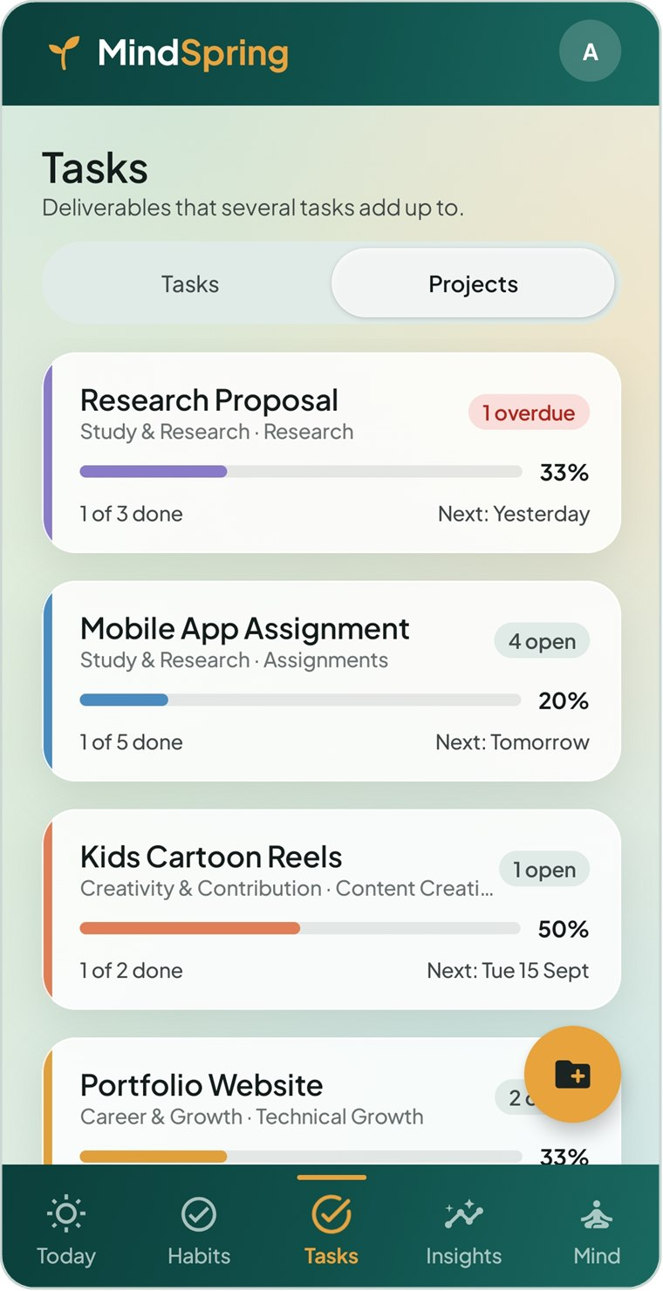  Figure 6.11 The Projects view | Switch to Projects on the Tasks tab to see each project as a card. Unfinished projects come first, ordered by their next deadline.  Each card shows:  - A colour strip on the left and the project name.  - Its life area and sub-area.  - A status pill: N open, N overdue (red), Complete or No tasks.  - A progress bar and percentage — done tasks out of all tasks that were not dropped.  - x of y done and the next deadline.  Archived projects are hidden under Show N archived at the bottom of the list.

6.9 Creating a project
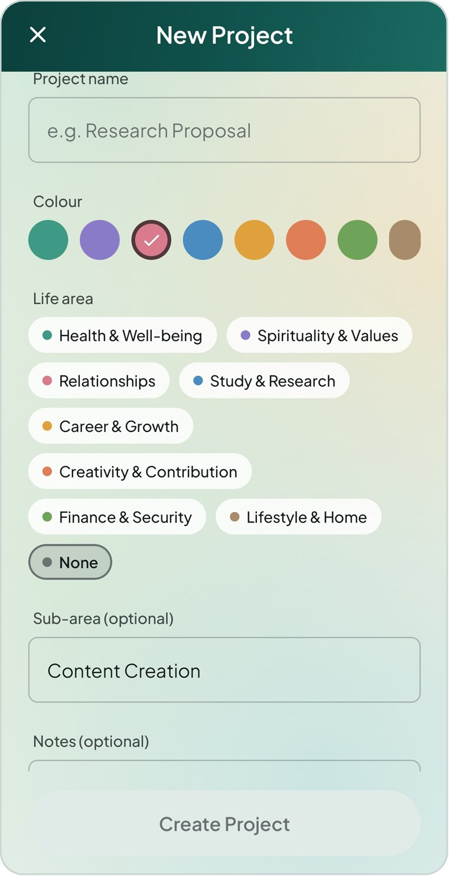  Figure 6.12 The New Project screen | - On the Projects view, tap the amber folder button.  - Enter a Project name, for example “Research Proposal”.  - Pick a Colour. Each new project suggests the next colour so that neighbouring cards differ.  - Choose a Life area and optional Sub-area.  - Optionally describe what “done” looks like in Notes.  - Tap Create Project.  The project’s area and sub-area are copied to any task you add from inside the project.

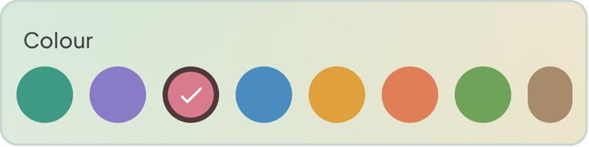
Figure 6.13 The project colour choices

6.10 Project detail
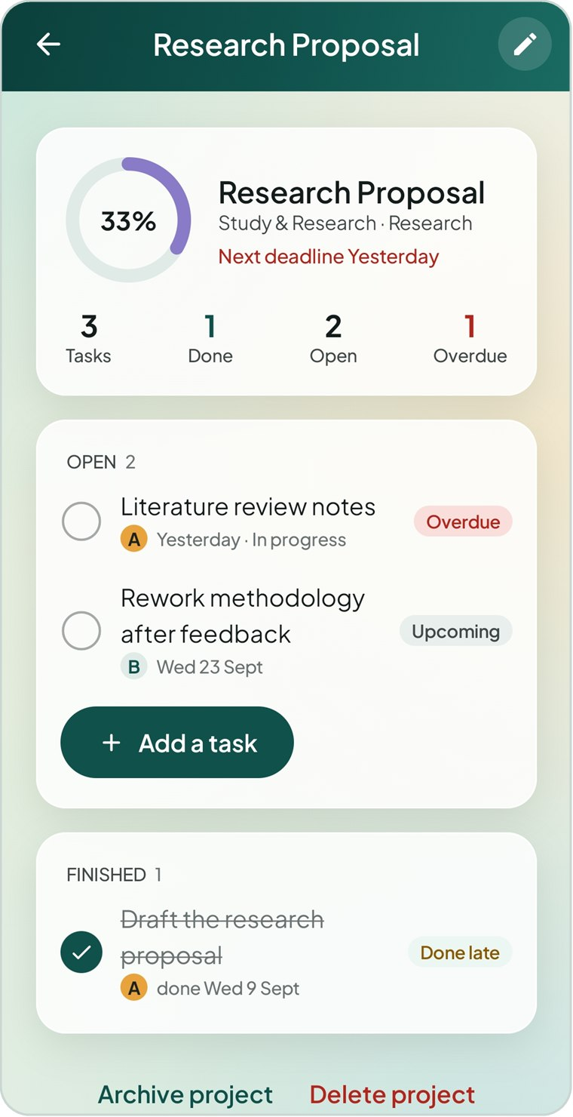  Figure 6.14 A project with an overdue task | 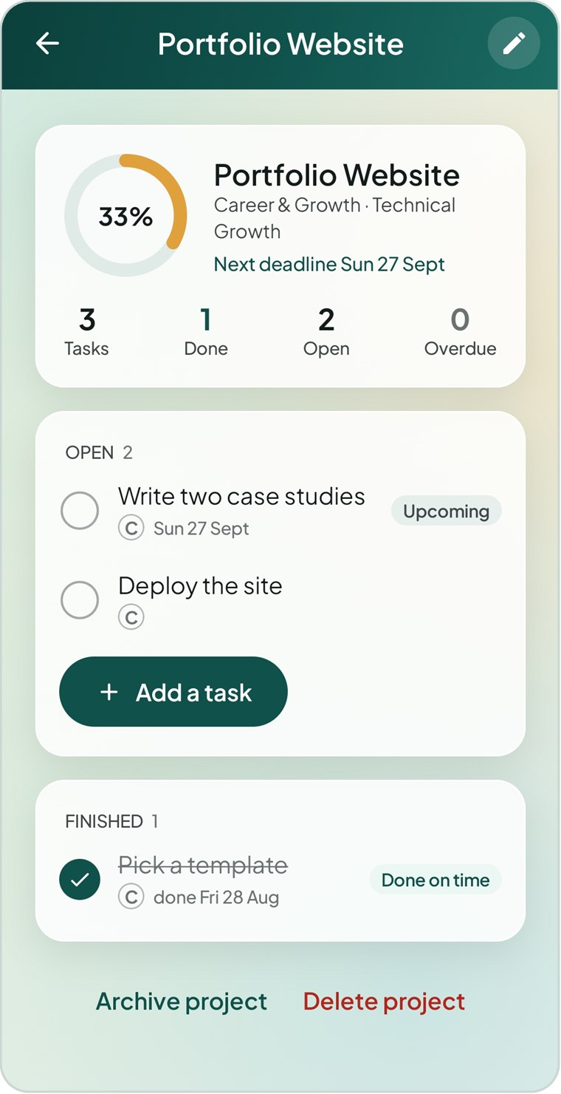  Figure 6.15 A project with a finished task

- The top card shows a progress ring, the life area, the next deadline (red if something is overdue), and counts of Tasks, Done, Open and Overdue. Project notes appear below them.
- The Open card lists the remaining tasks. Tap Add a task to create one already linked to this project.
- The Finished card lists completed and dropped tasks with Done on time or Done late flags.
- Tap the pencil in the top bar to edit the project.
- Tap Archive project to hide it from the list while keeping everything. Tap Unarchive to bring it back.
- Tap Delete project to remove the project. Its tasks are kept as standalone tasks.

7 Mood Tracking
A mood check-in takes about ten seconds: one tap for how you feel, optional feeling tags and an optional note. Over time your check-ins power the mood trend and the key insight.

7.1 Checking in
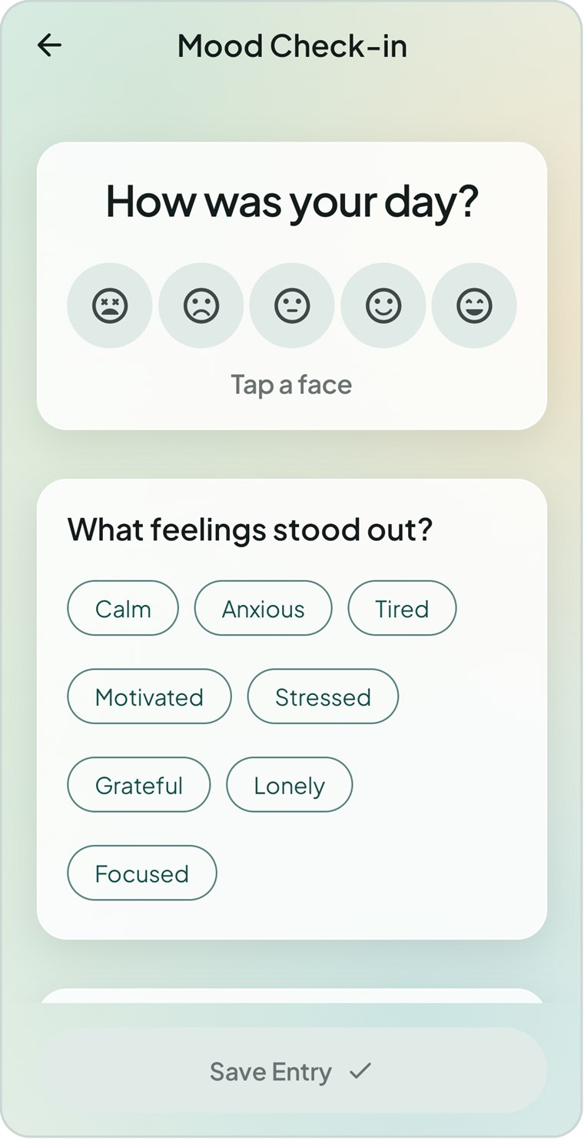  Figure 7.1 Step 1 — tap a face | 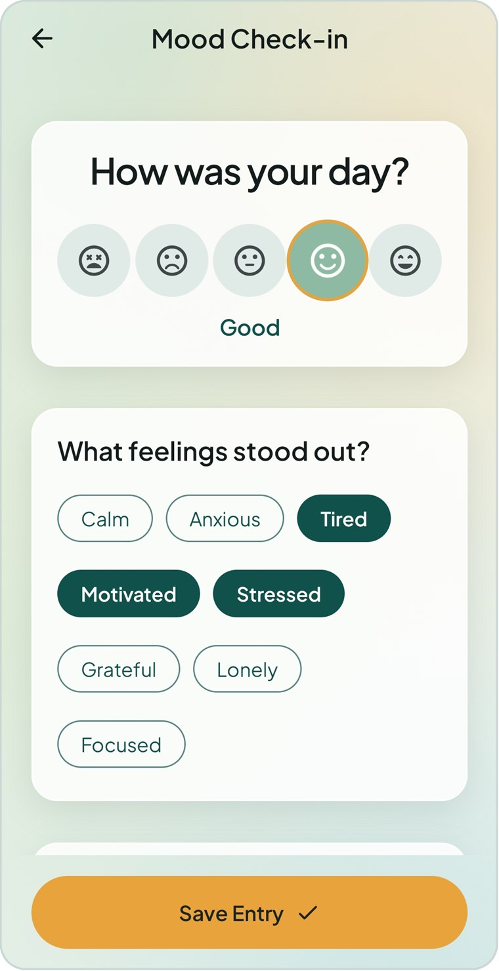  Figure 7.2 Step 2 — pick feelings | 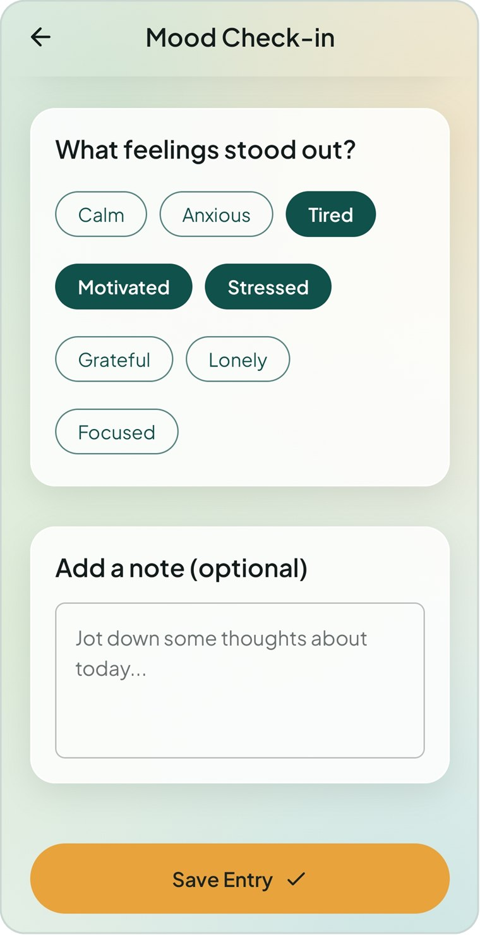  Figure 7.3 Step 3 — add a note

- On the Today screen, tap a face or Check in.
- Under How was your day? tap one of the five faces. Its name appears underneath, for example Good.
- Under What feelings stood out? tap any tags that apply. You can choose several; tap again to deselect.
- Optionally write a few words under Add a note (optional).
- Tap Save Entry. It stays greyed out until you have chosen a face.
The five-point scale and the eight feeling tags are:
Mood | Rating | Colour used in charts and history
Awful | 1 | Red
Bad | 2 | Orange
Okay | 3 | Yellow
Good | 4 | Sage green
Great | 5 | Deep green

Feeling tags: Calm, Anxious, Tired, Motivated, Stressed, Grateful, Lonely and Focused.

7.2 Changing today’s check-in
Once you have checked in, the mood card on Today shows your mood and tags. Tap Update check-in to reopen the entry in Edit Check-in, change anything and tap Save Entry.

7.3 Mood history
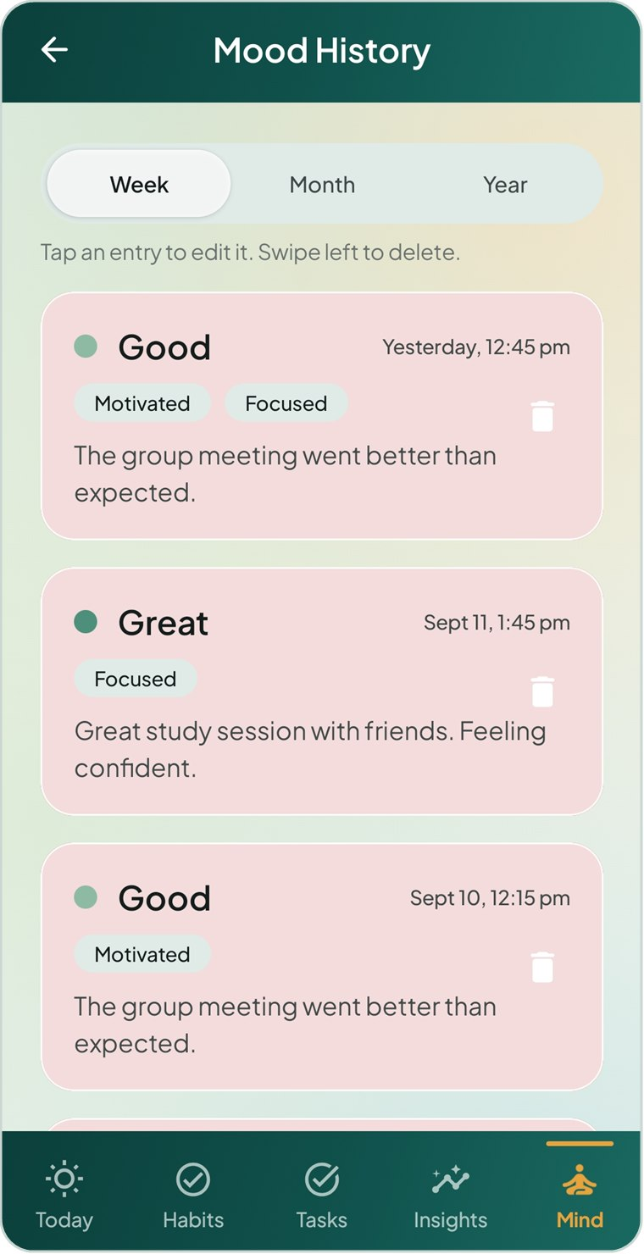  Figure 7.4 Mood History, newest first | Open Mind → Mood History (or Insights → Mind → Mood history) to review every check-in.  - Choose Week, Month or Year at the top to set how far back to look.  - Each card shows a coloured mood dot and label, when you logged it (for example Yesterday, 12:45 pm), your feeling tags and the first two lines of your note.  - Tap a card to edit that check-in.  To delete a check-in  - Swipe the card to the left. A red background with a bin appears and the entry is removed.  - To change your mind, tap Undo on the message bar that appears at the bottom.

8 The Mind Tab
Mind gathers the quieter tools: guided breathing to slow down, a daily reflection journal to process the day, a gratitude journal, and your mood history.

8.1 The Mind screen
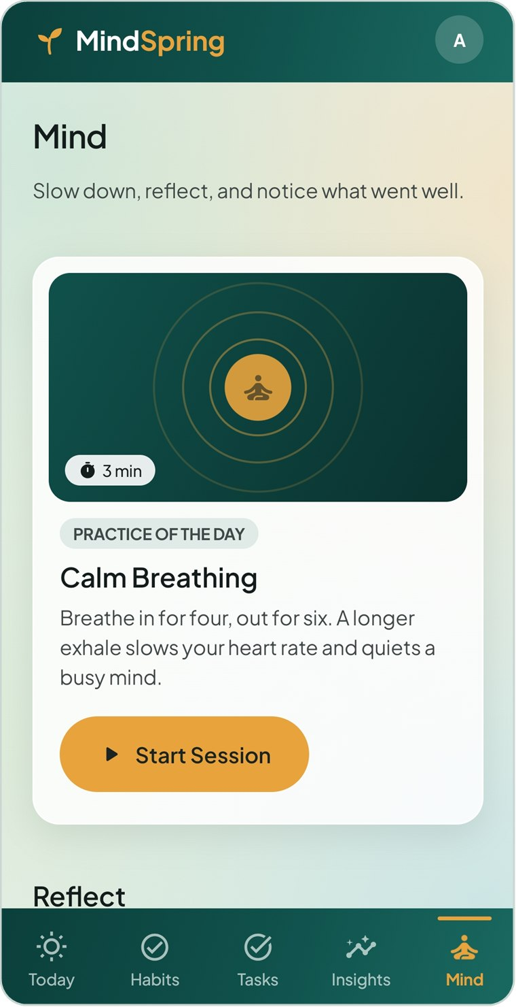  Figure 8.1 Practice of the day | 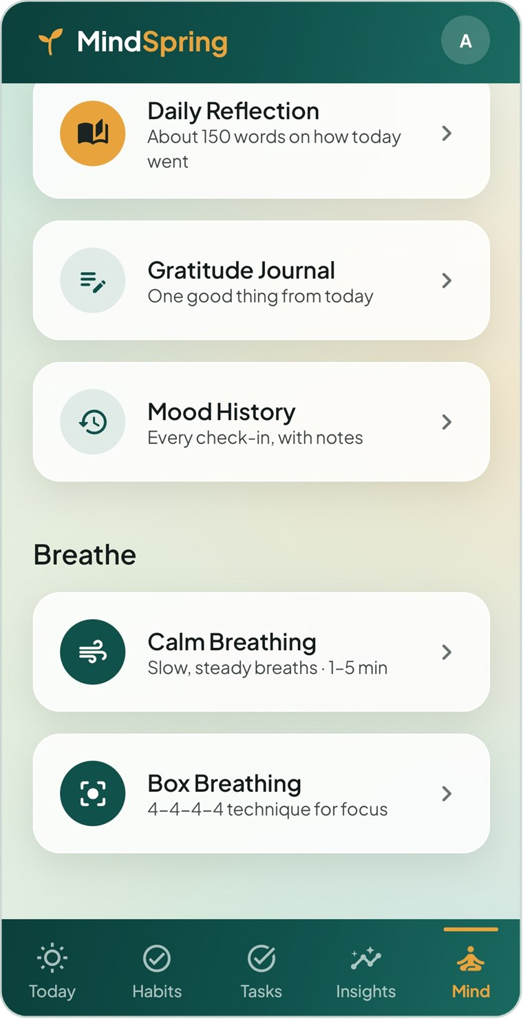  Figure 8.2 Reflect and Breathe sections

Item | What it opens
Practice of the day · Start Session | A three-minute Calm Breathing session.
Daily Reflection | Your journal — about 150 words on how today went.
Gratitude Journal | One good thing from today, and all past entries.
Mood History | Every check-in, with notes (Chapter 7).
Calm Breathing | Slow, steady breathing for one to five minutes.
Box Breathing | The 4-4-4-4 technique for focus.

8.2 Breathing exercises
Breathing sessions fill the screen and hide the navigation bar. The session starts straight away; follow the circle and the words in the middle.
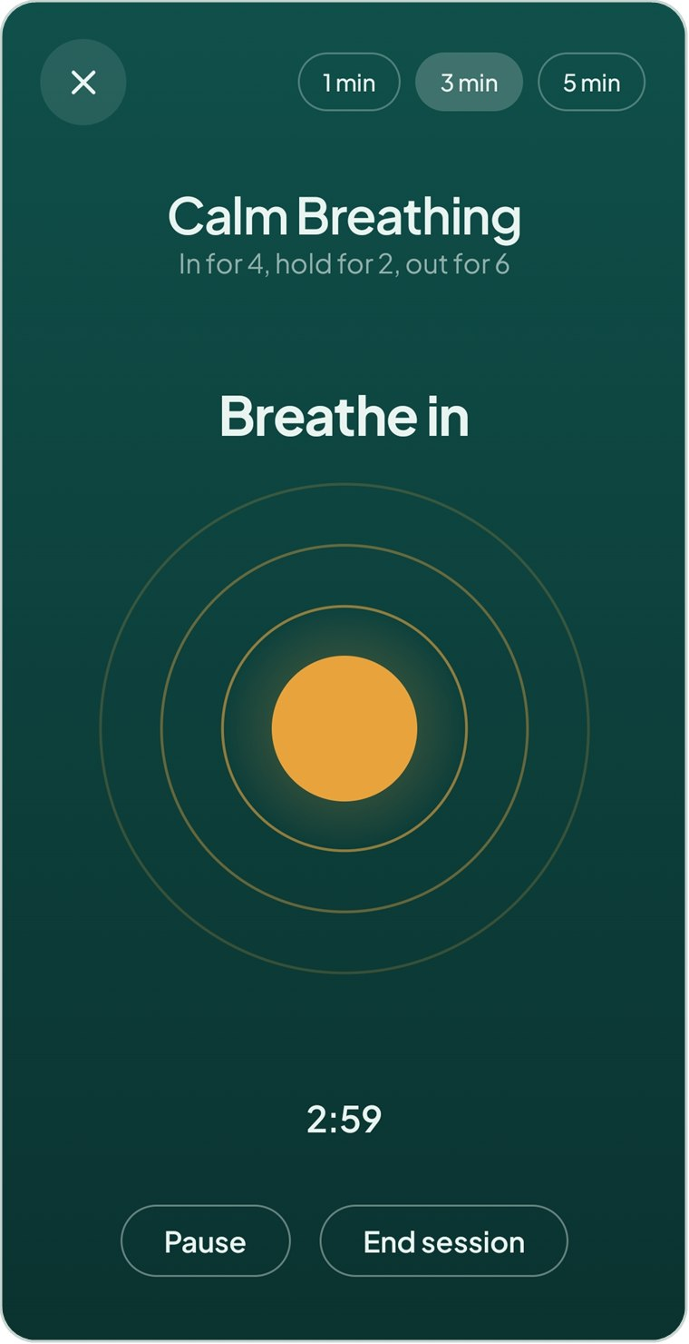  Figure 8.3 Calm Breathing — breathe in | 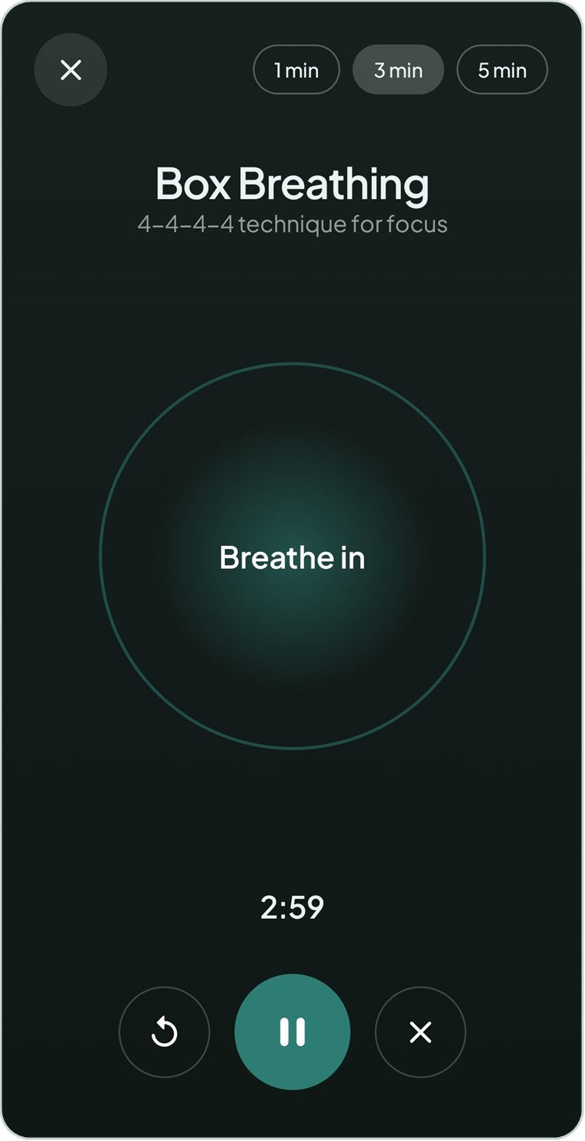  Figure 8.4 Box Breathing

Technique | Pattern | What you see
Calm Breathing | Breathe in for 4 seconds, hold for 2, breathe out for 6. A longer exhale slows your heart rate. | A teal screen with a glowing amber orb that grows as you breathe in and shrinks as you breathe out.
Box Breathing | Breathe in 4, hold 4, breathe out 4, hold 4 — the four sides of a box. | A dark screen with a teal circle that expands and settles, with the phase written inside.

Session controls
- Choose 1 min, 3 min (the default) or 5 min at the top. Changing the length restarts the session.
- The countdown under the circle shows the time left.
- Calm Breathing: tap Pause / Resume, or End session to leave.
- Box Breathing: use the round buttons to restart (↻), pause / resume, or end (×).
- Tap × in the top-left corner to leave at any time.
When the time is up you see Session complete — Well done. Take that calm with you. Tap Done to return.

8.3 Daily reflection
The daily reflection is a short end-of-day journal — one entry per date. It is designed around writing about 150 words, honest rather than polished.
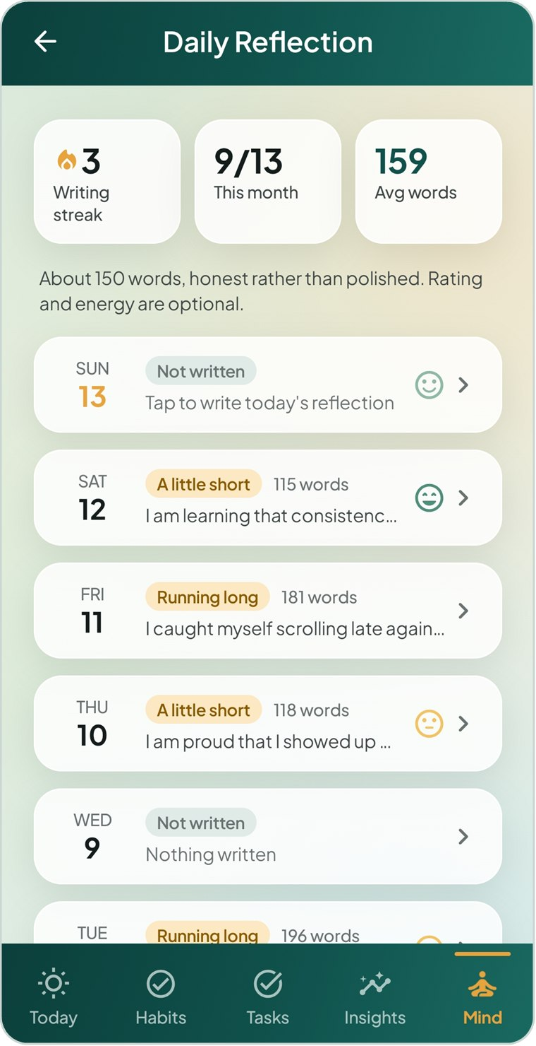  Figure 8.5 The Daily Reflection list | Open Mind → Daily Reflection. Three tiles at the top show your Writing streak (days in a row), how many days you have written This month, and your Avg words.  The last two weeks are always listed, even the days you skipped, so gaps are easy to spot. Older entries appear under EARLIER.  Each row shows the weekday and date (today in amber), a length status, the word count, the start of your text and the face for your day rating.  Tap any day to open or write its entry.
  Status | Word count
  Not written | 0 words
  A little short | 1–119 words
  Good length | 120–180 words
  Running long | More than 180 words

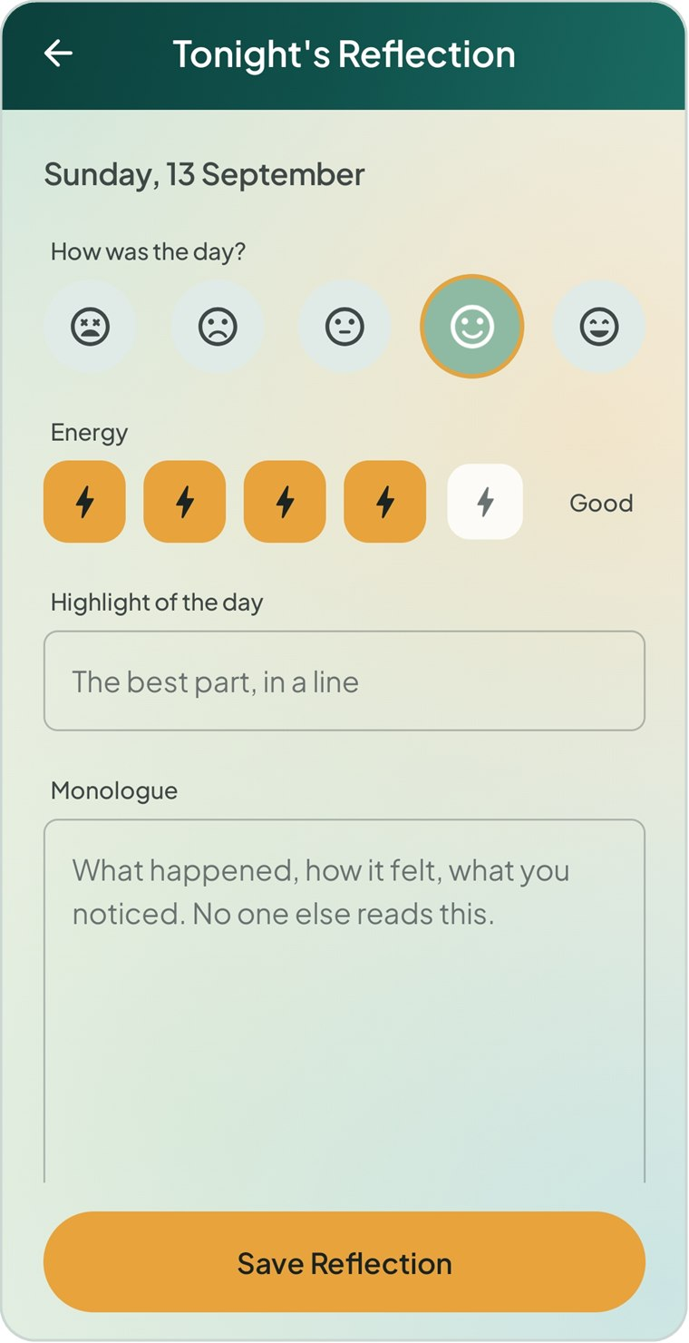  Figure 8.6 Tonight’s Reflection, blank | 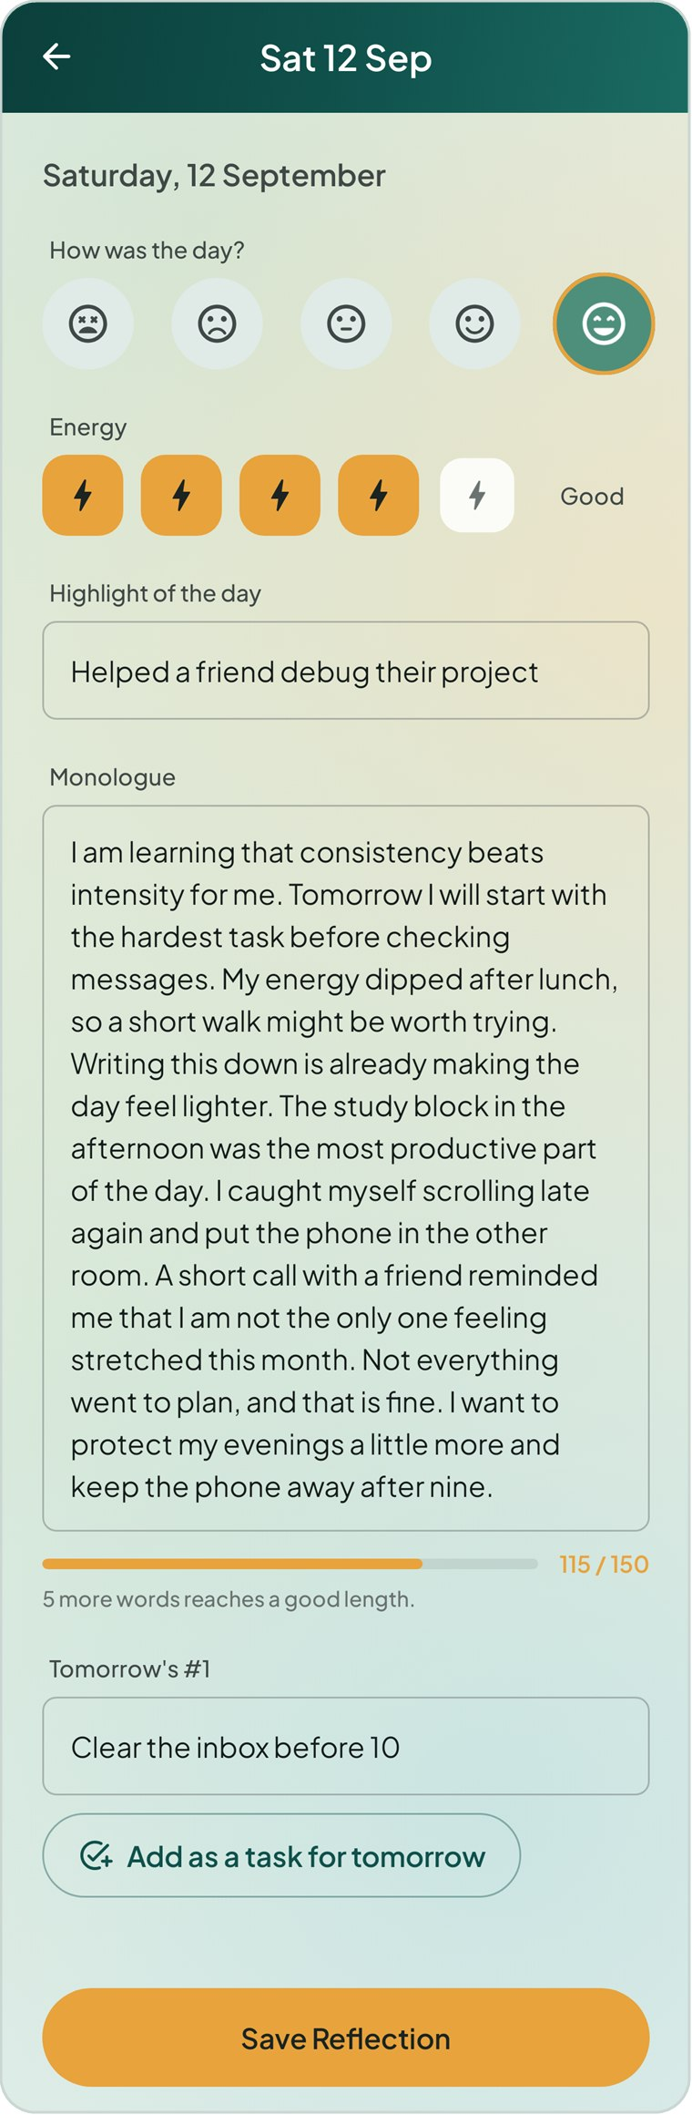  Figure 8.7 A completed reflection

To write a reflection
- Tap Tonight’s reflection on Today, or a day in the Daily Reflection list.
- Under How was the day?, tap a face (optional).
- Under Energy, tap one of five bolts (optional): Drained, Low, Steady, Good or Full. Tap the same bolt again to clear it.
- Write the Highlight of the day in one line.
- Write your Monologue — what happened, how it felt, what you noticed. The meter underneath counts words towards 150 and tells you, for example, “5 more words reaches a good length”.
- Under Tomorrow’s #1, write the one thing that would make tomorrow a win. Tap Add as a task for tomorrow to turn it into a task due tomorrow; the button changes to Added to tomorrow’s tasks.
- Tap Save Reflection.
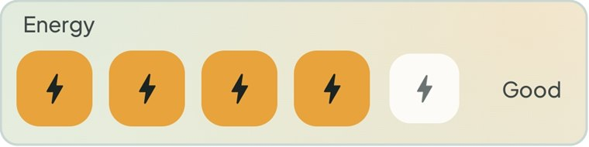
Figure 8.8 Day rating and energy level
PRIVACY Your monologue is private. The placeholder text says it plainly: “No one else reads this.”

8.4 Gratitude journal
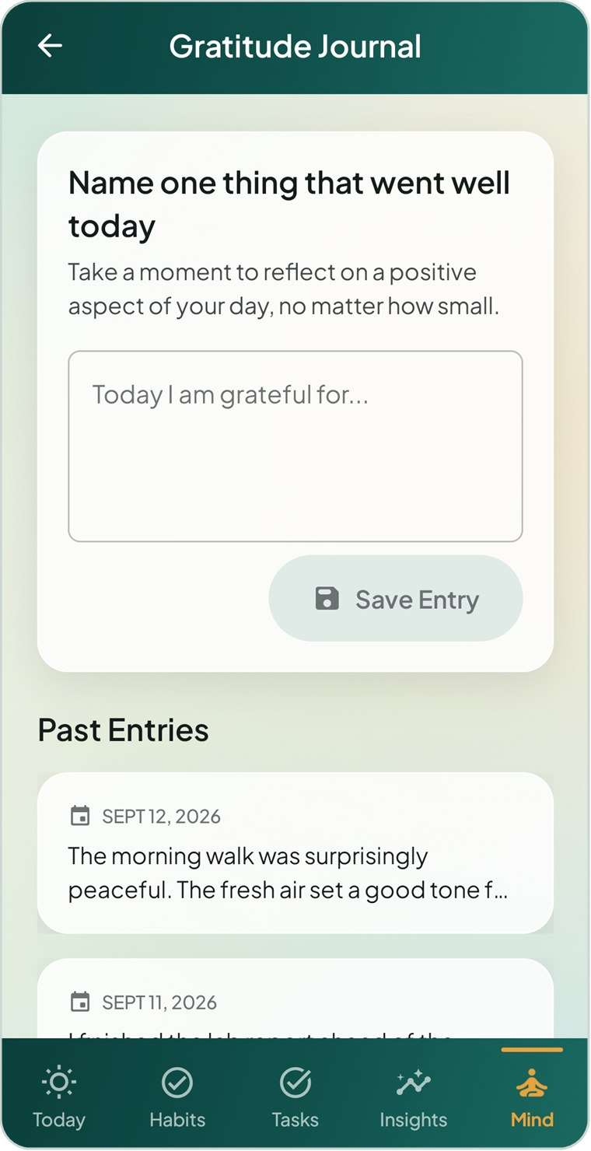  Figure 8.9 The Gratitude Journal | The gratitude journal replaces a blank page with a single prompt: Name one thing that went well today, no matter how small.  To add an entry  - Open Mind → Gratitude Journal.  - Type in the box that starts “Today I am grateful for…” (up to 500 characters).  - Tap Save Entry. The message Entry saved confirms it.  You can also add an entry from the Gratitude card on Today.  Past entries  Entries are listed under Past Entries, newest first, with their dates. Tap an entry to read it in full; while it is open, tap Delete entry to remove it.

9 Insights
Insights turns what you log into plain numbers and simple charts, one month at a time, and highlights the routines that go with your better days.

9.1 Choosing a month and a section
Figure 9.1 The Insights Overview | Open the Insights tab. Two controls sit at the top:  - The month switcher — tap ‹ and › to move between months. You cannot move past the current month.  - The section switcher — Overview, Habits, Tasks and Mind.  Every figure on the screen refers to the month shown. Where a value cannot be worked out yet — for example the average mood before any check-ins — a dash (–) is shown.

9.2 Overview
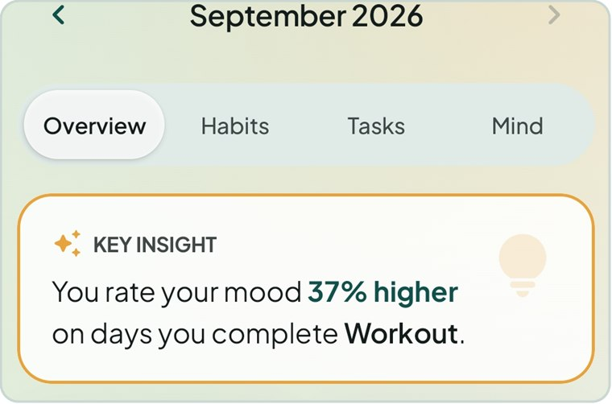  Figure 9.2 The key insight | Key insight  The amber-outlined card opens with a sentence rather than a chart, for example: You rate your mood 37% higher on days you complete Workout.  MindSpring compares your average mood on days you completed each habit with days you did not, and reports the habit with the strongest positive link. It needs at least two days of each kind and a difference of 5% or more.  Until there is enough data, the card says: “Keep logging your mood and habits. After a few days we’ll show you which routines go with your better days.”

NOTE The key insight shows that two things tend to happen together. It does not prove that one causes the other.

Tile | What it shows
Habits | Overall habit completion for the month.
On time | The share of tasks with a deadline that were finished on or before it.
Mood | Your average mood for the month, as a word (Awful to Great) in its colour.
Journal | Days with a written reflection out of the days so far, for example 9/13.

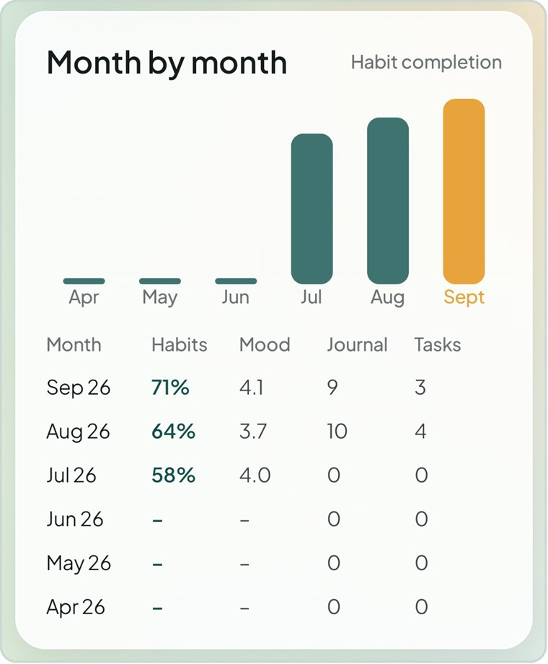  Figure 9.3 Month by month | Month by month  A bar chart of habit completion for the last six months, with the current month in amber.  Beneath it, a table lists each month’s Habits rate, average Mood (out of 5), days Journalled and Tasks completed — a quick way to compare months.  Life areas  The last card, Life areas, opens the Life Areas screen described at the end of this chapter.

9.3 Habits section
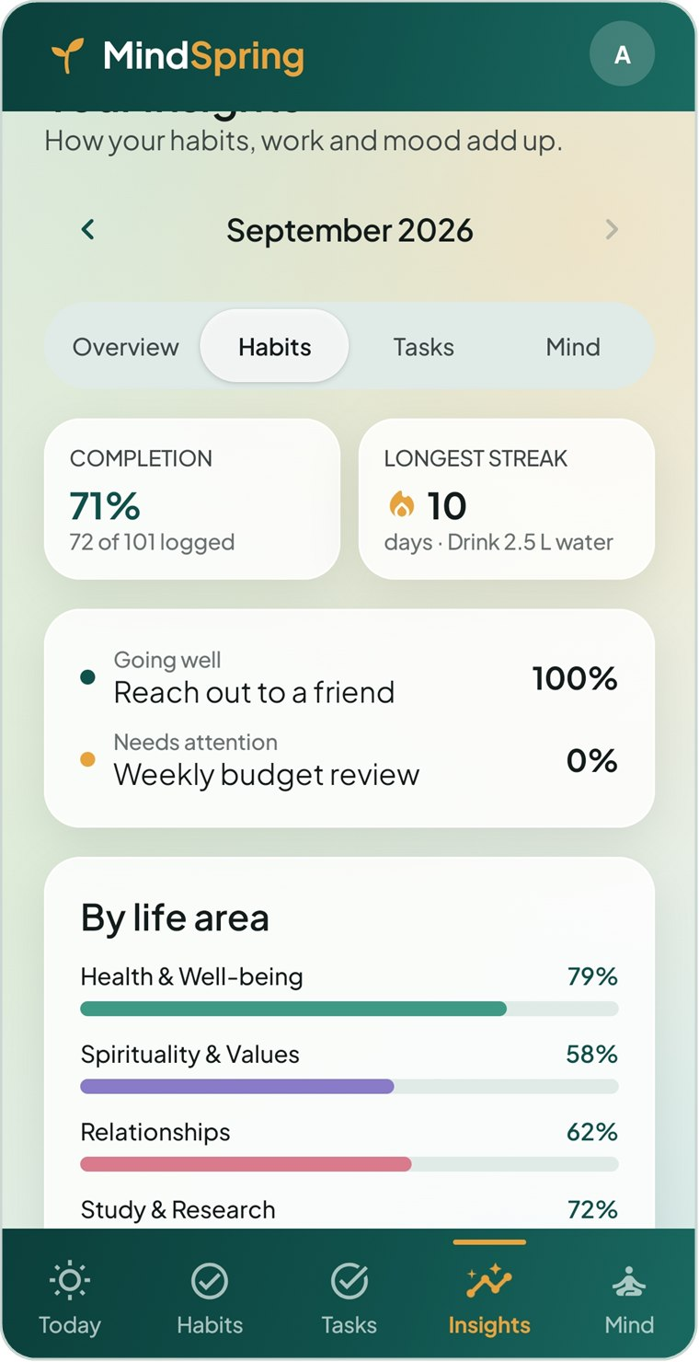  Figure 9.4 Insights — Habits | - Completion — the month’s rate, with the count behind it (for example 72 of 101 logged).  - Longest streak — the habit with the longest running streak and its length.  - Going well / Needs attention — your best and weakest habit this month.  - By life area — a coloured bar for each area’s completion rate.  - Day score — a bar for each day showing the share of that day’s habits you completed; today is highlighted.  - Each habit — every habit’s rate with done/due counts. The first eight are shown; tap Show all for the rest.

9.4 Tasks section
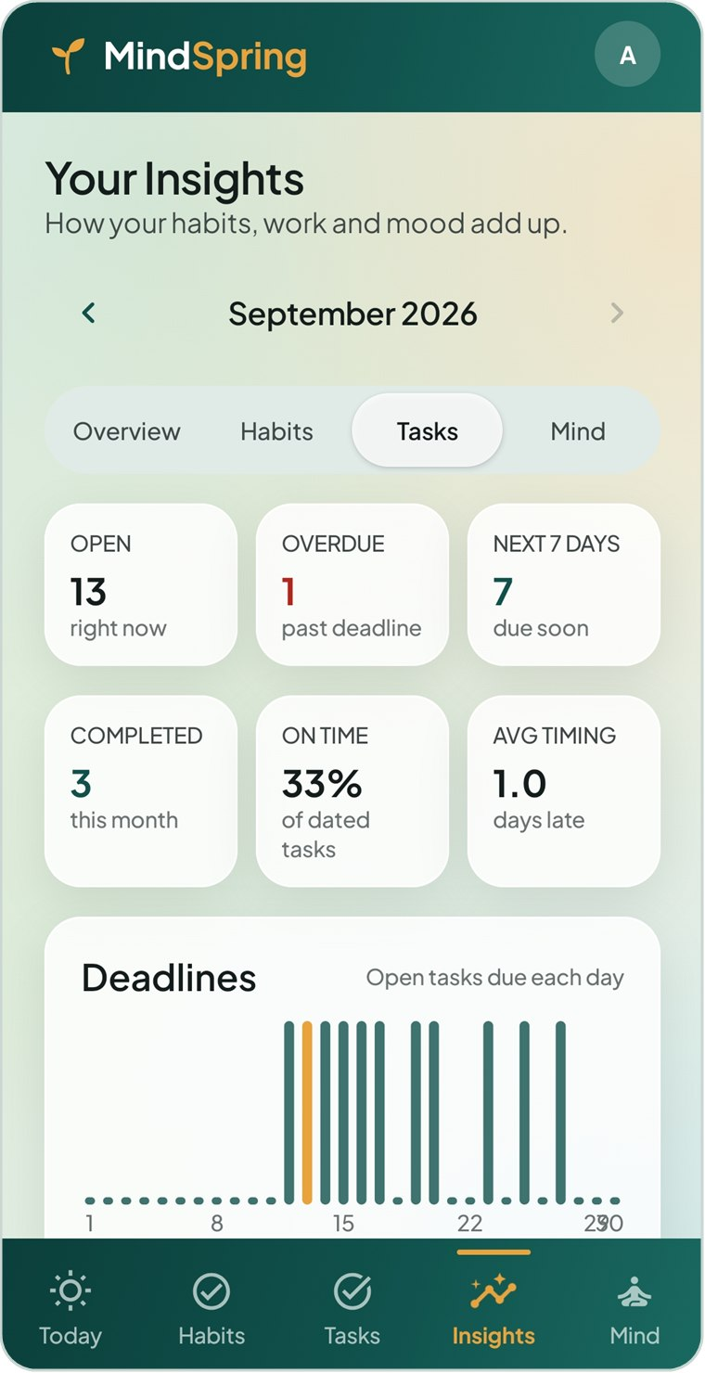  Figure 9.5 Insights — Tasks | - Open, Overdue and Next 7 days — where your tasks stand right now.  - Completed — tasks finished this month.  - On time — the share of dated tasks finished by their deadline.  - Avg timing — how many days early (or late) you finish, on average.  - Deadlines — a bar for each day of the month showing how many open tasks fall due. “Tall bars are crunch days. Spread the work before them.”  - Projects — each project’s progress, with overdue counts in red.

9.5 Mind section
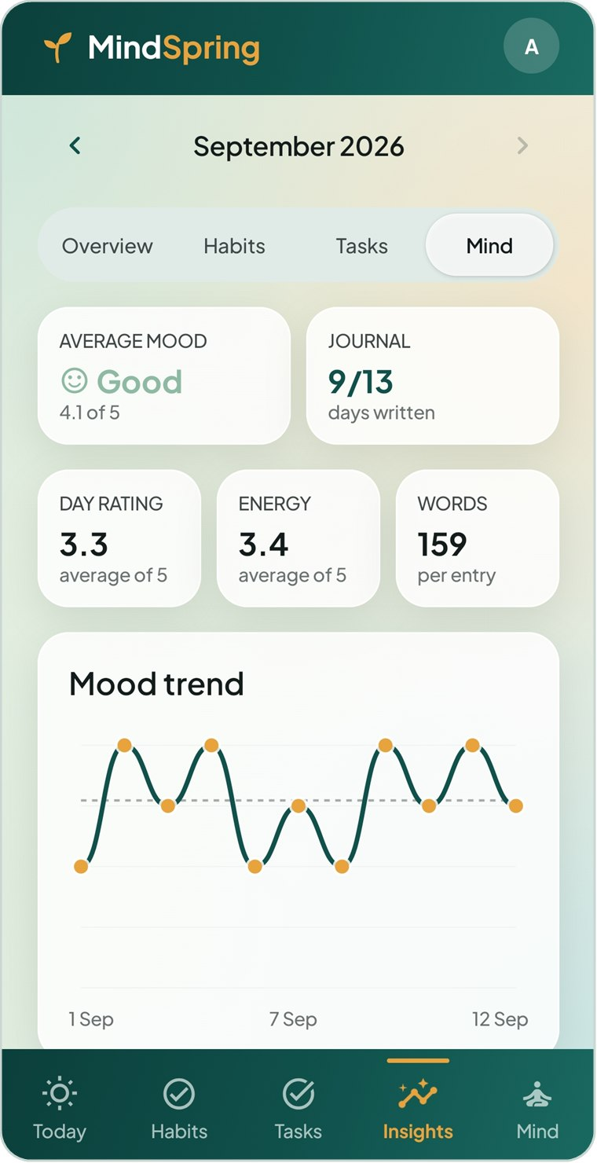  Figure 9.6 Insights — Mind | - Average mood — as a word and a number, for example Good · 4.1 of 5.  - Journal — days written out of days so far.  - Day rating and Energy — averages from your reflections, out of 5.  - Words — average words per reflection.  - Mood trend — a line chart of your daily average mood across the month, with a dashed line for your overall average.  - Links to Mood history and Daily reflection.  The trend needs check-ins on at least two days before it can draw a line.

9.6 Life areas
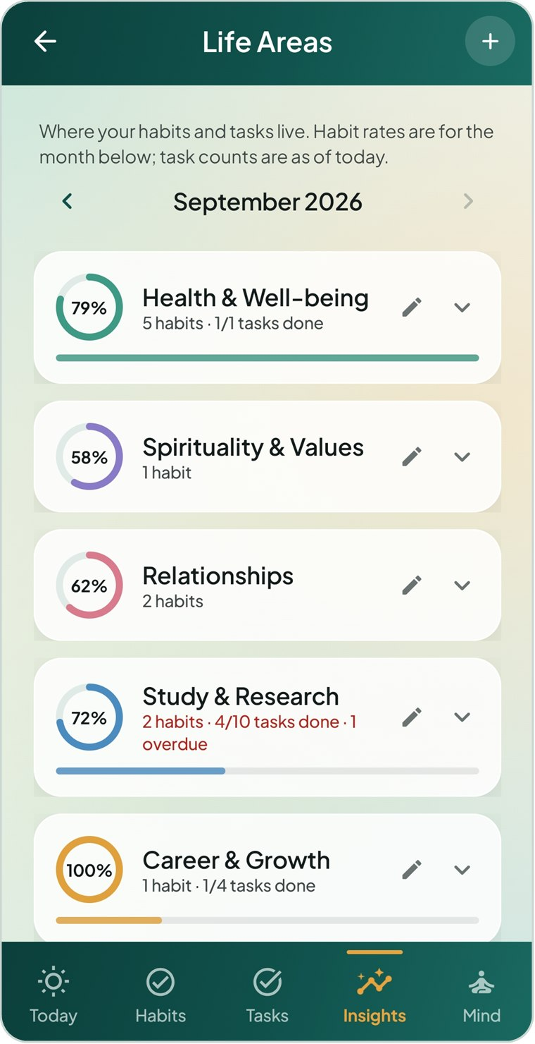  Figure 9.7 The Life Areas screen | Life Areas shows how each part of your life is doing. Open it from Insights → Overview → Life areas or Profile & Settings → Life areas.  - Each card shows a ring with the area’s habit completion for the month chosen at the top.  - Underneath: the number of habits, tasks done out of total, and any overdue tasks (in red), with a progress bar for tasks.  - Tap a card to expand it and see each sub-area with its own habit rate, task count, next deadline and status.  Habits and tasks that are not filed under any area are collected in a Not filed under an area card.

To add, rename, recolour or remove a life area
- To add an area, tap + in the top bar. To change an existing one, tap the pencil on its card.
- Type a Name and tap one of ten colours.
- Tap Save.
- To remove an area, open it with the pencil, tap Remove this area, then tap it again to confirm. Its habits and tasks are kept, just unfiled.
New accounts start with eight life areas, which you can change at any time:
Default life areas
Health & Well-being | Career & Growth
Spirituality & Values | Creativity & Contribution
Relationships | Finance & Security
Study & Research | Lifestyle & Home

10 Profile and Settings
Profile & Settings holds your name, reminder times, alert sounds, appearance, backups and account controls.

10.1 Opening Profile & Settings
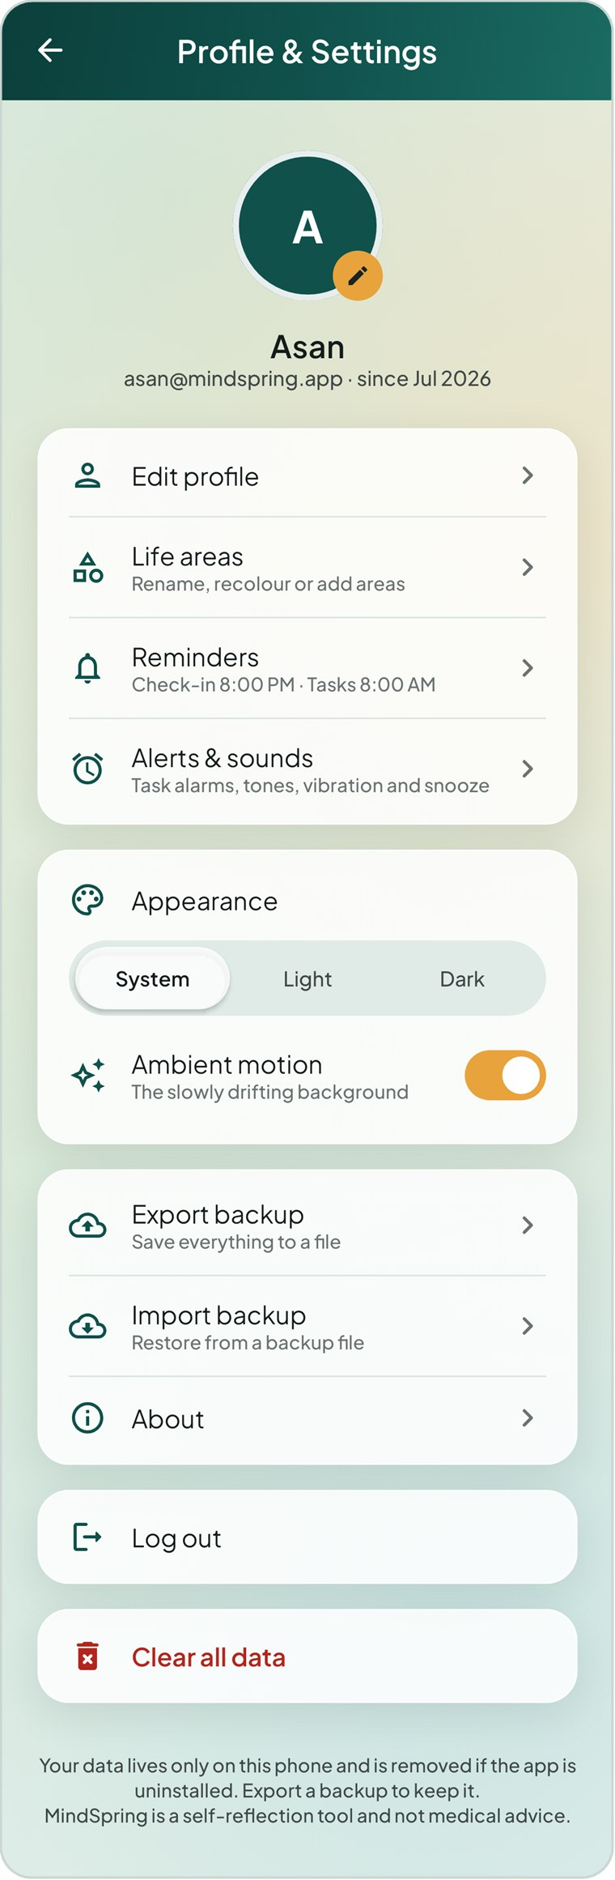  Figure 10.1 Profile & Settings | Tap your avatar in the top-right corner of any main screen. The page shows your initial, name, email and the month you joined, followed by these rows:  The note at the bottom reminds you that your data lives only on this phone and that MindSpring is not medical advice.
  Row | What it does
  Edit profile | Change the name shown in greetings.
  Life areas | Rename, recolour or add areas (Chapter 9).
  Reminders | Evening check-in and morning summary times.
  Alerts & sounds | Tones, vibration, snooze and permissions.
  Appearance | System, Light or Dark theme; ambient motion.
  Export backup | Save everything to a file.
  Import backup | Restore from a backup file.
  About | Version and a short description.
  Log out | Sign out; your data stays on the phone.
  Clear all data | Permanently delete your entries.

10.2 Editing your profile
- Tap Edit profile, or the small amber pencil on your avatar.
- Type your name (up to 40 characters).
- Tap Save.

10.3 Daily reminders
Besides the reminders you set on individual habits and tasks, MindSpring can send two daily nudges. Tap Reminders to set them.
Reminder | Default | What it says — and when it stays quiet
Evening check-in | On, 8:00 PM | “How was your day?” — prompts you to check in, or to write tonight’s reflection. It is not sent if you have already done both.
Morning summary | On, 8:00 AM | “Your day ahead” — for example “1 due today · 1 overdue · 10 habits planned”. It is not sent when there is nothing to report.

- Tap Reminders.
- Use each switch to turn a reminder on or off.
- Tap the time under a reminder to change it.
- Tap Save.
TIP Habit reminders are set on each habit, and task alerts on each task. The Reminders dialog only controls the two daily nudges.

10.4 Alerts and sounds
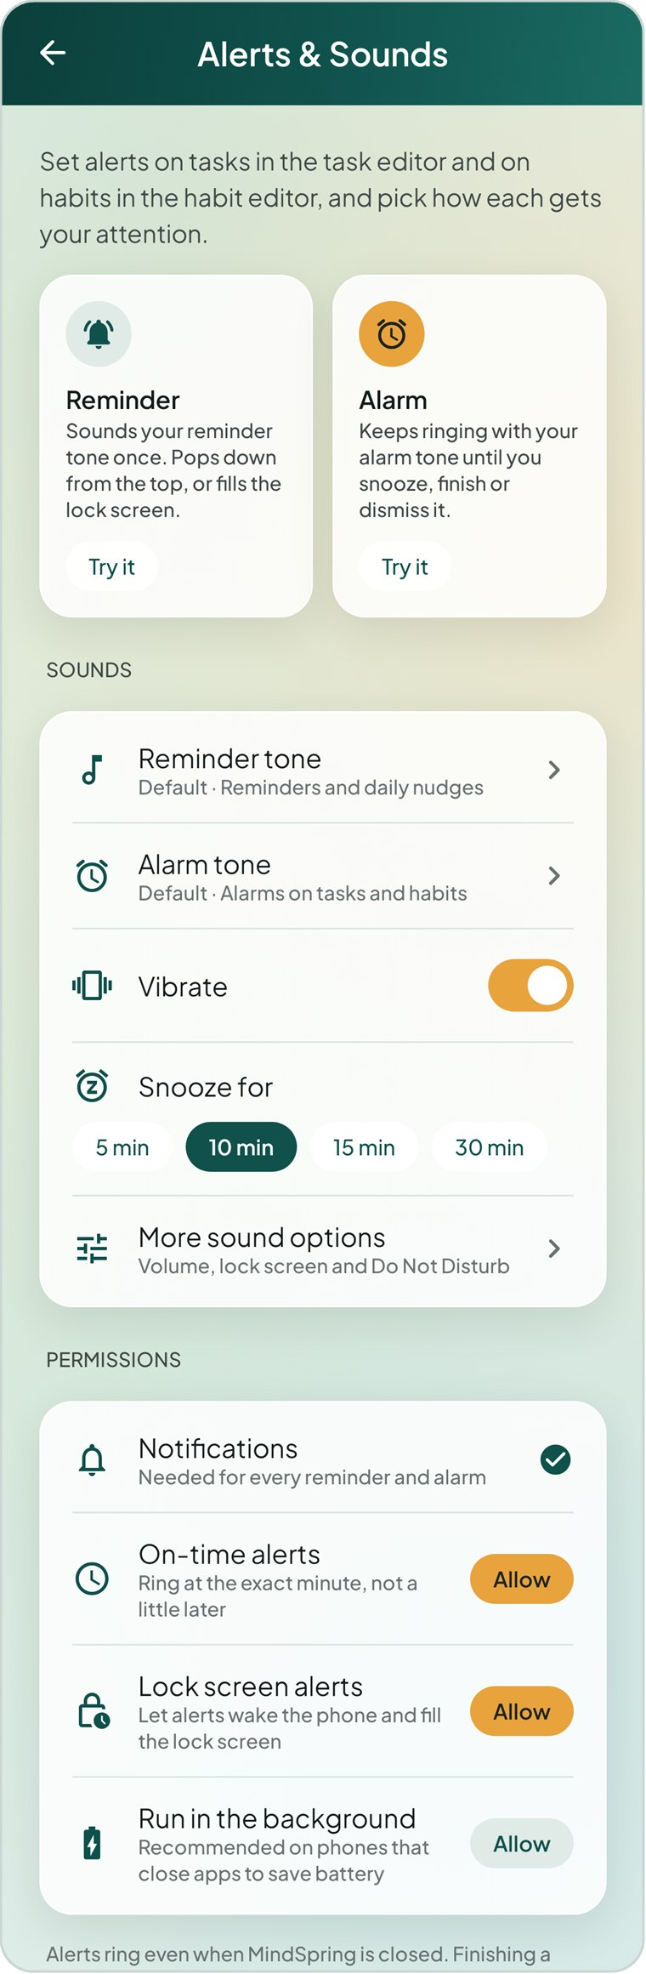  Figure 10.2 Alerts & Sounds | Tap Alerts & sounds to choose how alerts sound and to check that the phone allows them.  Reminder and Alarm  Two tiles explain the styles. Tap Try it on either to receive a test in 10 seconds — lock the phone to see how it fills the screen.  Sounds  - Reminder tone — used for reminders and the daily nudges. Tap to pick from the phone’s sounds, or Silent.  - Alarm tone — used for alarms on tasks and habits.  - Vibrate — on or off.  - Snooze for — 5, 10, 15 or 30 minutes.  - More sound options — opens Android’s own settings for volume, lock screen and Do Not Disturb.  Permissions  Each row shows a teal tick when allowed, or an Allow button that takes you to the right setting:  - Notifications — needed for every reminder and alarm.  - On-time alerts — ring at the exact minute.  - Lock screen alerts — let alerts wake the phone and fill the lock screen.  - Run in the background — optional; recommended on phones that close apps to save battery.

10.5 Appearance
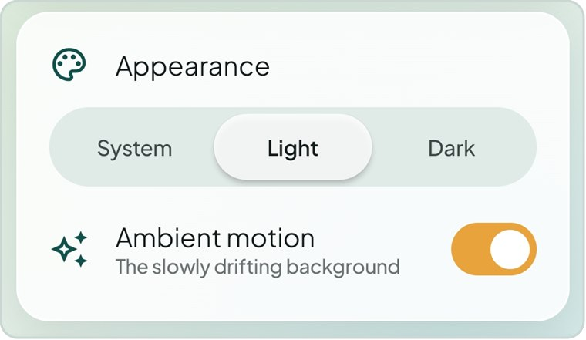  Figure 10.3 Appearance settings | - System — follow the phone’s light or dark setting (the default).  - Light — always use the light theme: an off-white canvas with teal and amber.  - Dark — always use the dark theme: a near-black canvas that is easier on the eyes at night.  Ambient motion controls the soft coloured glow that slowly drifts behind every screen. Turn it off if you prefer a completely still background.

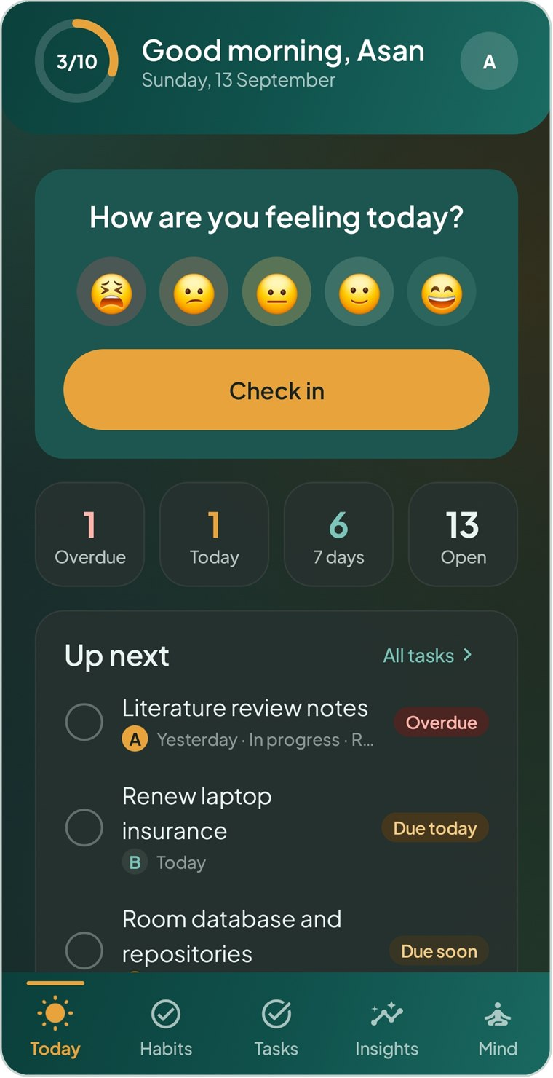  Figure 10.4 Today in the dark theme | 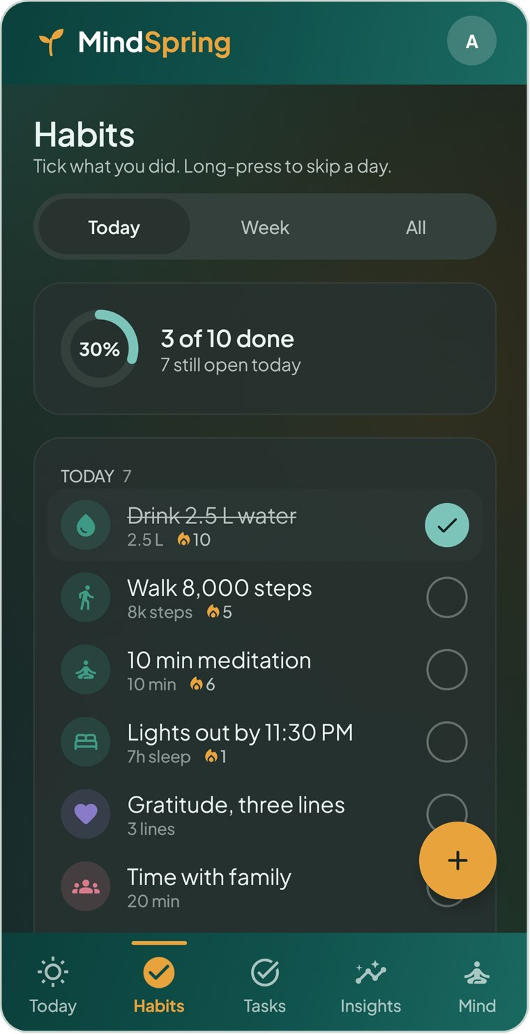  Figure 10.5 Habits in the dark theme | 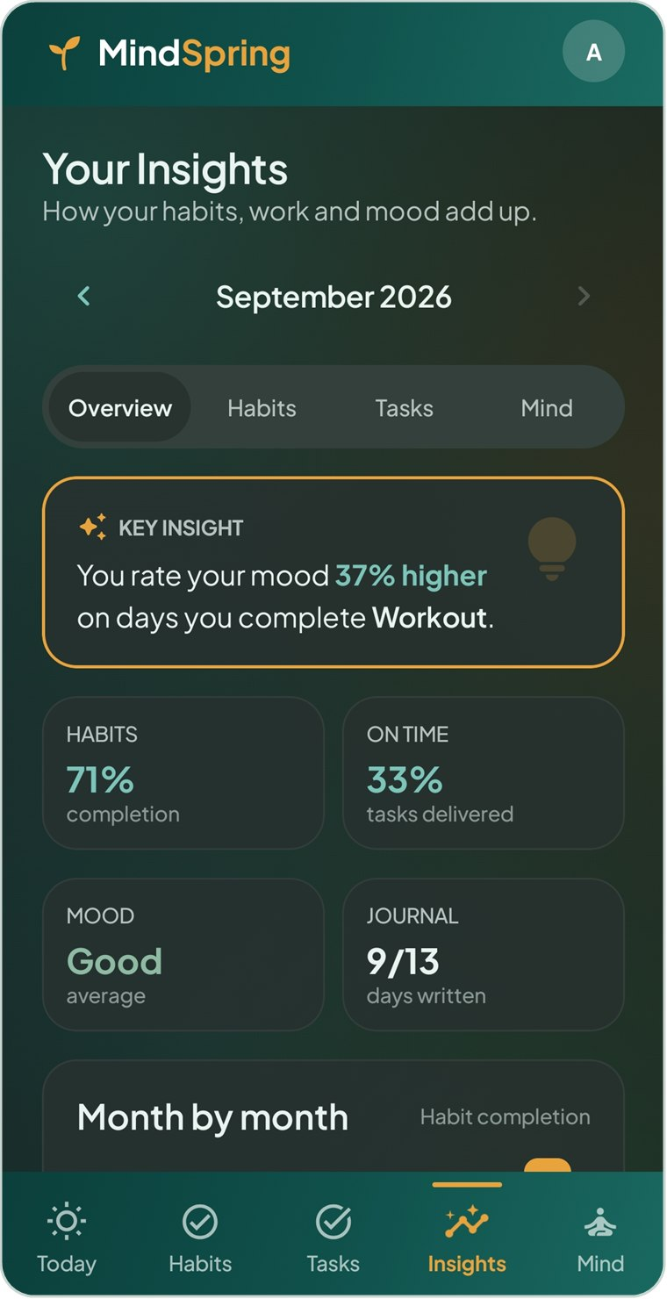  Figure 10.6 Insights in the dark theme

10.6 Backing up and restoring
Because your data is stored only on this phone, a backup file is the way to keep a copy or move to a new phone.

To export a backup
- Tap Export backup.
- Android’s file picker opens with a suggested name such as mindspring-backup-2026-09-13.json. Choose a folder — for example Downloads or a cloud drive folder — and tap Save.
- The message Backup saved confirms it.

To restore a backup
- Tap Import backup and choose a MindSpring backup file.
- Read the warning and tap Restore.
- A message confirms what was restored, for example “Restored 12 habits, 30 tasks and 40 journal entries”.
IMPORTANT Restoring replaces everything currently in your account with the contents of the backup. Export a fresh backup first if you might want your current data.

10.7 Logging out, clearing data and About
Action | What happens
Log out | After confirming, you return to the sign-in screen. All your data stays on the phone and reappears when you sign back in. Alerts for this account stop while you are signed out.
Clear all data | After confirming, every habit, task, project, mood check-in and journal entry on this account is permanently deleted. Your account and life areas are kept.
About | Shows the version (2.1) and a short description, including the reminder that MindSpring is not a medical product.

IMPORTANT Clear all data cannot be undone. It is shown in red, in its own card, so that it is never tapped by accident.

11 Alerts and Alarms
When a task alert or habit reminder is due, MindSpring rings even if the app is closed. This chapter explains what you see and how to respond.

11.1 Reminder or alarm?
 | Reminder | Alarm
Sound | Plays your reminder tone once. | Keeps ringing with your alarm tone until you respond, for up to 10 minutes.
Phone in use | Drops down as a banner at the top of the screen. | Drops down as a banner at the top of the screen.
Phone locked or asleep | Fills the lock screen. | Fills the lock screen.
Good for | Gentle nudges: “Read one paper”. | Things you must not miss: “Submit the final APK”.

11.2 The full-screen alert
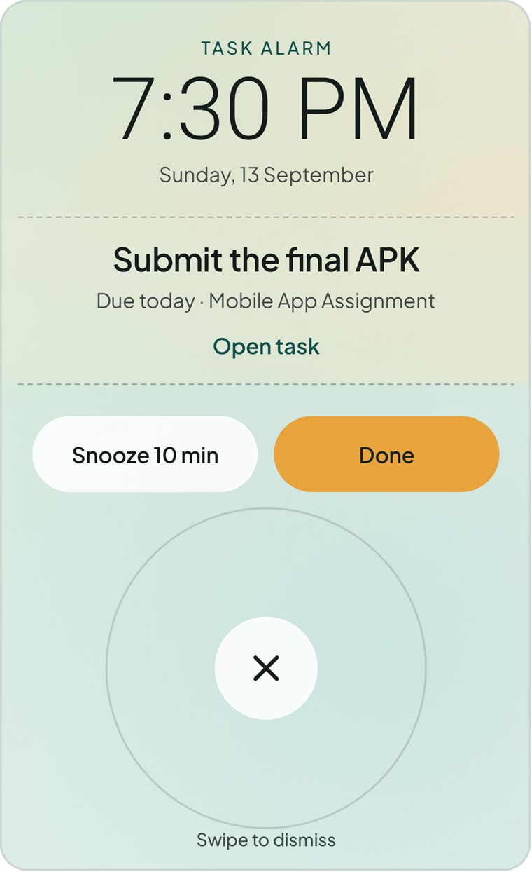  Figure 11.1 A task alarm on the lock screen | 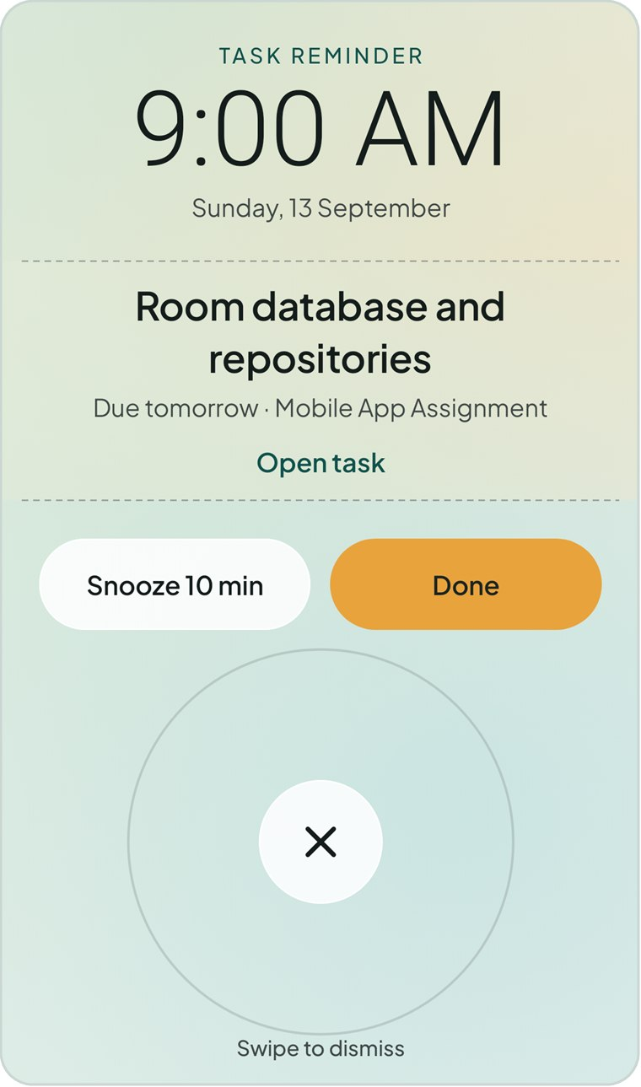  Figure 11.2 A task reminder on the lock screen

The full-screen alert shows whether it is a task or habit and a reminder or alarm, the current time and date, the task or habit name, and a detail line such as Due today · Mobile App Assignment.
To… | Do this
Finish it | Tap Done. The task is marked done, or the habit is ticked for today, and the alert stops.
Be reminded later | Tap Snooze 10 min. The length follows your Snooze setting in Alerts & Sounds.
Silence it without finishing | Drag the round × handle outwards until the circle fills, then let go. A simple tap does not dismiss it, so it cannot be silenced by accident in a pocket.
See the details | Tap Open task or Open habit to go straight to it in the app.

11.3 How alerts behave
- Alerts ring at the exact minute even when MindSpring is closed.
- Finishing a task, or ticking or skipping a habit for the day, silences its alert automatically.
- A habit reminder moves on to the next day the habit is due each time it goes off.
- Alerts are put back automatically after the phone restarts, the app is updated or the time zone changes.
- Signing out cancels your alerts; signing back in restores them.
TIP If alerts arrive late or not at all, open Profile & Settings → Alerts & sounds and make sure every permission row shows a tick. On some phones you should also allow Run in the background.

12 Troubleshooting and FAQ
Answers to the questions people ask most often.
Question or problem | Answer
I forgot my password. | There is no online reset because your account exists only on this phone. Create a new account. If you exported a backup from the old account, you can import it into the new one.
My reminders or alarms don’t appear. | Open Profile & Settings → Alerts & sounds. Allow Notifications, On-time alerts and Lock screen alerts, and consider allowing Run in the background. Use Try it to test.
An alert only shows as a small banner when the phone is locked. | Lock screen alerts are off. Tap Allow beside Lock screen alerts, or Turn on in the warning in the editor.
The Save button is grey. | A required field is missing — a habit or task needs a name, a custom habit needs at least one day, and a mood check-in needs a face.
I can’t tick a habit on an earlier or later day in the Week view. | Future days, days before the habit was created and days the habit is not due cannot be marked.
My streak disappeared. | A streak ends when a due day (or week, or month) passes without the habit being done or skipped. If you were genuinely unable to do it, go to the Week view and mark that day as skipped — skips never break a streak.
Skipping a habit lowered my percentage. | It does not: skipped days are removed from the total. If the rate changed, another due day was probably missed.
A task I finished came back. | It repeats. Finishing a repeating task creates the next occurrence. Set Repeat to Does not repeat to stop it.
The key insight still says “Keep logging”. | It needs mood check-ins on at least two days with and two days without a habit, and a difference of 5% or more.
I deleted a mood check-in by mistake. | Tap Undo on the message bar straight away. After it disappears the entry cannot be recovered.
I want to stop tracking a habit but keep its history. | Retire it from the habit’s detail screen, or switch off Active in the editor.
I’m getting a new phone. | Export a backup, move the file to the new phone, install MindSpring, create an account and use Import backup.
The background keeps moving. | Turn off Ambient motion in Profile & Settings → Appearance.
Will uninstalling delete my data? | Yes. Export a backup first if you want to keep it.

13 Quick Reference
The fastest way to do the things you will do most often.
I want to… | Do this
Log how I feel | Today → tap a face → Save Entry
Tick off a habit | Today or Habits → tap the circle beside the habit
Skip a habit for today | Long-press the habit
Fix an earlier day | Habits → Week → tap the day (done → skipped → clear)
Add a habit | Habits → + → name, frequency → Save Habit
Get reminded about a habit | Open the habit → Edit → Reminder switch → time
See a habit’s streak and history | Tap the habit
Stop a habit but keep its history | Open the habit → Retire this habit
Add a task | Tasks → + → name, deadline → Add Task
Get an alarm for a task | Open the task → Alert switch → choose Alarm
Finish a task | Tap the circle beside it, or Done on its alert
See what is overdue | Today → Overdue tile, or Tasks → Overdue filter
Start a project | Tasks → Projects → folder button → Create Project
Add a task to a project | Open the project → Add a task
Calm down quickly | Mind → Start Session
Write tonight’s reflection | Today → Tonight’s reflection → Save Reflection
Note something I’m grateful for | Today → Gratitude card → Save
Review or delete past moods | Mind → Mood History (swipe left to delete)
See how this month went | Insights → Overview
Compare parts of my life | Insights → Overview → Life areas
Switch to dark mode | Avatar → Appearance → Dark
Change reminder times | Avatar → Reminders
Back up my data | Avatar → Export backup
Sign out | Avatar → Log out

MindSpring is a self-reflection tool, not medical advice.

