**The Orb: 2D Puzzle Platformer**

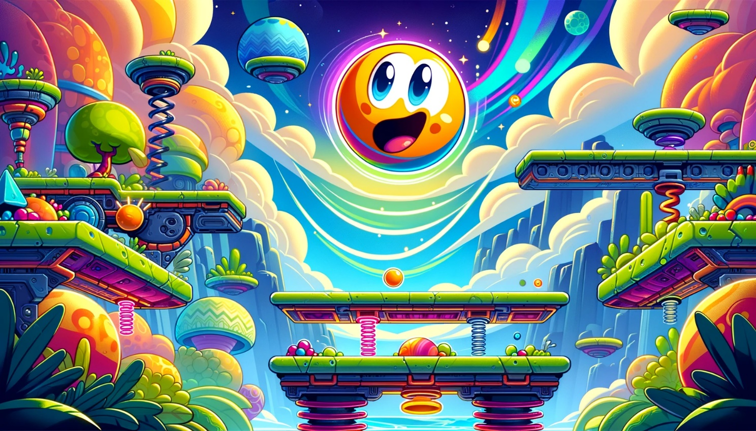

•Game Title: The Orb

•Version Number: 1.0

•Date: March 25, 2024

•Development Team: Gromov Alexander(20218463)

# Table of Contents

1. Introduction

2. Overview

3. Game Concept

4. Gameplay and Controls

5. Story and Narrative

6. Characters

7. Art and Assets

8. Game World, Levels, and Environments

9. User Interface (UI) and User Experience (UX)

10. Audio Design

11. Game Mechanics

12. Progression and Rewards

# 1. Introduction

Modern reinterpretation of the classic game Bounce, except now with new mechanics that change the gameplay, completely new levels, modernized visuals and designed for contemporary platforms.

# 2. Overview

## Game Concept

a 2D puzzle platformer with physics elements.

## Target audience

Casual players, fans of platformers like Bounce.

## Genres

2D platformer, puzzle.

## Game flow summary

Player selects a level that will be loaded and tries to complete it by moving an orb, dodging spikes, overcoming obstacles and using physics to help them while collecting bonuses on the way, which combined with remaining lives will determine the amount of stars player gets on the score screen.

## Visual style

2D pixel-art. Simple yet cohesive and enjoyable.

## Hardware requirement

As low as possible, it’s a simple game.

## Development hardware

Laptop and Wacom.

## Development Software

Unity 2021, Visual Studio 2022 and Paint.

## Network requirements

None, it’s an offline single player game.

# 3. Game Concept

## Core Gameplay Mechanics

Navigating through levels by bouncing, avoiding obstacles, and solving puzzles.

## Unique Features

Transformations that change the way the obstacles work on a character and an adaptive physics system.

## Inspiration

The original Nokia Bounce game, with influences from modern platformers and physics-based games.

# 4. Gameplay and Controls Overview

## Progression

In the original Bounce game, the player controls a red ball using the four arrow keys on the Nokia mobile phone through many levels in a 2D side-scrolling game world. It came pre-loaded on many Nokia mobile phones and is considered one of the most well-known Nokia mobile games along with Snake.

To pass each level the red ball must go through all hoops in that level thus opening the grey door to the next level, having three lives initially as indicated by the three red balls at the bottom of the screen above the remaining number of hoops required to go through in that level (one removed each time one is passed through) and the 8-digit score on the right. Enemies come in the form of static yellow-colored spikes (called "candles") as well as spiky blue moving objects (commonly referred to as "spiders" by the game fanbase) which move along a designated path either left-right, top-bottom or diagonally at various speeds. Touching an enemy will burst the red ball and a life will be lost, these can be regained or increased by collecting light blue balls with the same color as the background up to a maximum of five. Game progress is temporarily stored via the various yellow rhombus checkpoints in each level which allows the ball to respawn at the location of the last collected rhombus (turning into a red downwards arrow once collected and disappearing after the next one is collected) once it loses a life, until all lives are lost which ends the game.

Starting from level 3 onwards water areas are introduced into the game where the original (and smaller) red ball will rapidly sink to the bottom once entering. Hitting the enlarge spike (green with an inverted yellow dome on top) will make the ball bigger (which is now colored blue) thus allowing it to float above water, while a large ball underwater will immediately stick to the uppermost blocks and rise upwards rapidly until it floats above water. To recover the large ball back into the original red ball the shrink spikes (row of four thin red each with an inverted red dome on top) can be used. Some taller height differences require the large ball to be reached while some narrow passageways can only be accessed by the original red ball.

Speed blocks (blue instead of red) are also first introduced in level 3 were bouncing the ball repeatedly on these blocks will increase the bounce height of the ball per bounce until the ball hits the uppermost blocks thus reaching its maximum bounce speed (this will reset once the continuous bouncing action is broken once), which can be used in combination with slanting blocks to reach further heights. Hitting the speed box (yellow with a + symbol and a red dot in the middle) will temporarily increase the moving speed of the ball rapidly with a timer at the bottom of the screen, while hitting the anti-gravity spike (thick blue/grey with yellow panels on top) will cause the ball to fly and temporarily attach to the uppermost blocks also with a timer at the bottom of the screen.

In level 11 there is one particular area which can cause the original red ball to be permanently trapped: a checkpoint completely surrounded by four rows of shrink spikes in one of the lower right areas under but without water. To collect it the regular red ball should be positioned between the uppermost blocks and the top row of shrink spikes, then the ball should move to the right and drop down (try a few times for it to work). However, if the red ball, then gets hit and bursts before another checkpoint is collected it will respawn at the checkpoint within the four rows of shrink spikes, with no way out the only solution is to start a new game.

## Objectives

Complete all levels with perfect score.

## Play flow

Player starts a game, selects a level and then tries to complete it. After that they return on level selector and can select another level to play.

## Controls

Player moves the orb sideways and upwards with jumps.

## Difficulty

First few levels will introduce the mechanics one by one. This will also introduce health points, which adds together with bonus points on the level to give the stars in the end of the level.

## Replaying

Each level has infinite amount of tries and can be replayed anytime.

## Character

A small orb colored by player’s choosing.

## Mechanics and Dynamics

•Bouncing and Control: Ensure the bouncing mechanics are tight and responsive. Since the core gameplay revolves around bouncing, having precise and predictable controls is crucial for player satisfaction.

•Enemies and Obstacles: The introduction of "candles" and "spiders" as static and moving obstacles is a great way to add challenge. Varying their patterns and velocity can help to keep gameplay interesting.

•Power-Ups and Collectibles: Balls of negative color will replenish lives lost, arrow up and arrow down will change the size of the ball, allowing player to access areas that weren’t possible to get before. Adding collectible hoops will give more challenge as the player tries to collect them all to get a perfects core.

•Checkpoint System: The yellow rhombus checkpoints are essential for player progress and reducing frustration. Ensuring they're well-placed is a key to a fair challenge.

# 5. Story and Narrative

## Background Story

In a fantastical realm, the player guides a sentient ball on a quest to restore vibrancy and music, disrupted by discordant forces.

## Characters

The protagonist (the ball), allies providing power-ups, and various enemies representing discord and chaos.

## Main Plot

In a realm where magic intertwines with the fabric of reality, the Kingdom of Lumina was a beacon of peace and prosperity, shielded by the benevolent power of Princess Elara. Her connection to the Luminary Crystals, the source of the kingdom's light and life, kept darkness at bay. However, on a fateful night, a mysterious sorcerer, cloaked in shadows, kidnapped Princess Elara, plunging Lumina into darkness and despair.

The kingdom's bravest knights failed to traverse the perilous lands beyond Lumina, lands now corrupted by the sorcerer's dark magic, leaving the kingdom's fate in the hands of an unlikely hero: a young adventurer named Finn. With a heart full of courage and a spirit unbroken, Finn embarks on a quest not just to rescue the princess but to restore the very essence of hope to Lumina.

Armed with ancient artifacts and guided by cryptic puzzles left by the guardians of Lumina, Finn must navigate through enchanted forests, treacherous caverns, and haunted ruins. Each step forward is a challenge, with puzzles that bend the mind and enemies that test one's resolve. But the promise of bringing light back to Lumina, the dream of seeing the princess's benevolent smile once more, fuels Finn's journey through the darkness.

As Finn ventures deeper into the unknown, the bond between the hero and the princess, though distant, grows stronger, illuminating the path to salvation. The adventure that lies ahead is fraught with perils, but it's a journey of valor, wit, and the unyielding belief that even in the darkest times, a single spark of bravery can illuminate the world.

# 6. Characters

## Main Character

The sentient ball, an emblem of harmony, adaptable and resilient.

## Allies

Mystical entities offering guidance, power-ups, and lore.

## Enemies

"Candles" and "Spiders," along with new adversaries embodying different aspects of discord.

## Player Actions

Simple, movement (right and left arrow keys/A and D) and bounce control (up arrow key/W, the longer held – the higher jump

Menus are navigated by the Mouse.

# 7. Game Mechanics and Dynamics

## Specific Mechanics

Detailed workings of power-ups, enemy behaviors, and environmental interactions.

Rings are the most basic power-up, it adds score anytime the player collides with ring and then the ring disappears. Size up or down are other power-ups except upon collision they change the size of an orb and remain on the same place interactable even after activation.

Other mechanics worth mentioning are “spiders” and “candles”. The “candles” are stationary however the “spiders” move and have a certain loop that they follow, each “spider” can move with different speed than another one, adding additional challenge.

The environment also changes the gameplay, the wind tunnel pushes the orbs of certain sizes in a direction, and sometimes the player needs to go against the direction the wind is blowing. Another present environment mechanic is a pool of water. Having a certain size allows the orb to either sink or float on the very top of the water surface, this makes size-changing power-up more important.

## Rules and Interactions

Bouncing can be charged, the longer player holds the jump – the stronger the jump will be. Colliding with the wall will make the orb bounce off it, colliding with enemy (“spider” or “candle”) will cause the player to lose a life and teleport them to the last activated checkpoint. If there are no more lives, the player gets a small menu suggesting either to go back to Level Selector or try this level again.

## Balance Considerations

Ensuring fair challenge levels, power-up availability, and enemy difficulty scaling.

Levels should be designed in a way to avoid players frustration, especially early on. Later on, levels might require a more creative approach, as more and more mechanics are intertwined in a single level.

Power-ups will be distributed on a level according to their type, size-changers won’t be present on all levels, as do the checkpoints as long as the player has no risk of losing lives or getting stuck. One power-up will be present at all levels, as they are directly influencing each level’s score. Lives should be distributed on the levels where the player is most likely to lose one or many of them.

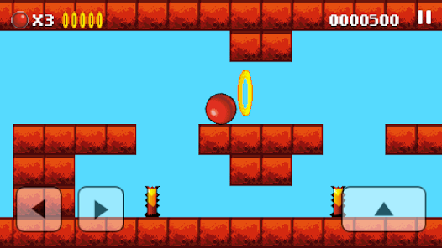

Here the player has to jump carefully, the “candles” are located just between the ledges, however this level is forgiving and allows to come back if the ball has fallen down, as long as player didn’t touch the “candles”.

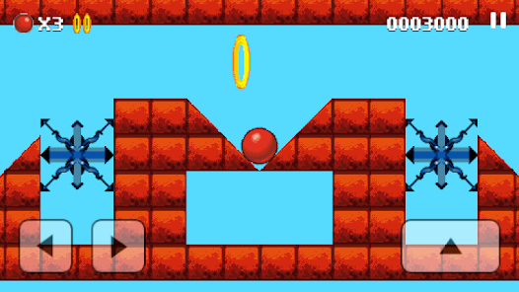

Here the player has to time the jump not to hit the “spider” and get across to progress. After that, player needs to precisely jump on the ledge and repeat this jump, now with another spider with different velocity and pattern.

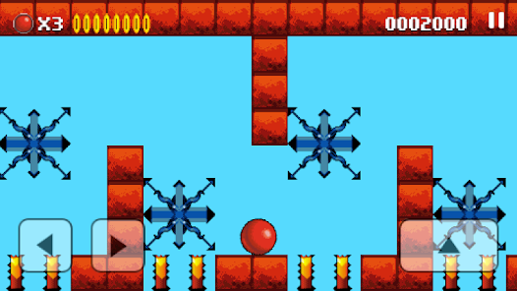

Here, on top of spiders, the player has very limited save space and has to make more jumps because the lower level partially consists of “candles”. Adding all the moving spiders, and if they move with different speed, provides and additional challenge for player as everything needs to be timed correct to proceed further.

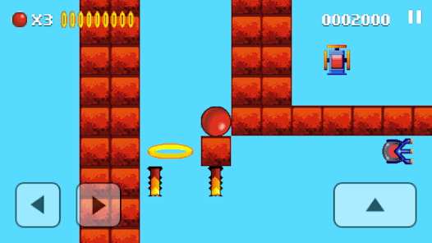

Here player needs a very precise jump to continue. Either you power-up the jump as much as possible and try to bounce off the wall to get the ring but not touch any “candle”, or try to roll over very slowly to achieve the same goal.

# 8. Game World, Levels, and Environments

## Levels Overview

From serene plains to chaotic realms, each level introduces new mechanics and challenges. First one will show the basic controls: jump and roll sideways. The second will explain water, shows that medium and big sized orb floats on the top while small drowns. The third level introduces wind and that only big orb can fly catching the wind. The fourth will introduce spikes, they are either small (then the big and medium orb can roll on them safely), medium (the small orb can get under them unharmed with certain precision while the big orb simply rolls over) and big (both small and medium orb can get between spikes). After those levels will combine elements introduced in tutorials (spikes, wind tunnels, water, obstacles) gradually increasing in difficulty. Final level before the secret level will be testing the player and skills acquired after playing all other levels. The secret level will be revealed after completing all levels and getting maximum stars. The level itself will be just a thank you for playing and maybe show early stages of the game’s development.

## Environmental Details

Interactive elements, such as water bodies, speed blocks, gravity zones and wind tunnels.

## Key Locations

Starting zone, checkpoints.

## Level Design

•Water Areas and Ball Dynamics: The interaction between the ball's size and water introduces an interesting physics-based puzzle element. Design levels to leverage this mechanic, encouraging players to think about when and where to change ball size.

•Speed and Anti-Gravity Mechanics: These can be used to create thrilling sections where timing and precision are key. Consider sections that require the player to quickly adapt to changing speeds or gravity.

•Tricky Sections and Cheat Codes: Be mindful of designing areas that can trap players, as mentioned with the shrink spike trap in level 11. While cheat codes can provide a way out, ensuring fair level design should be a priority to keep players engaged without resorting to cheats.

## Level Editor

You can select which of the eleven levels The Orb allows you to have from the pull-down list, then you will see the option buttons on the right light up. If 'Custom Level' is greyed out, this means you have not yet saved a custom map at the selected level - you should select the original level and click 'Load Level'.

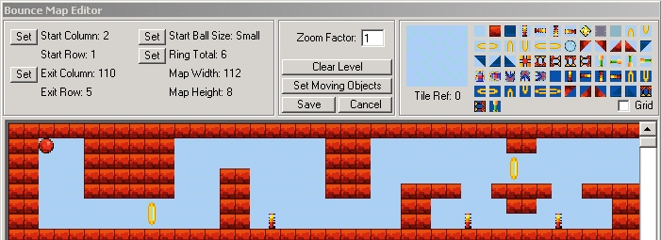

When the level is loaded you will see it appear in a window similar to that shown above. You can use the scroll bars to navigate around the map.

Clicking a tile from the selection on the top right makes it 'active' (you will see a large version appear in the box that says 'Tile Ref' underneath it). Clicking on the main map will then lay this tile. Laying a tile of a particular type also associated its action (laying an inflator will make the ball inflate when it touches it, for example).

Rings should be created in pairs - if you only lay 'half rings' I have no idea what will happen.

The exit (where you go to complete the level) should be a set of four tiles in a square. Take a look at some of the existing maps if you don't understand. The tile for the exit is the 9th along from the left on the top row of icons (a grey square).

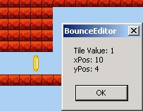

Right clicking on any square of the map brings up a window indicating the Tile Reference (tile value), and the x and y co-ordinates. This is useful when you want to set the start location for your ball, or set moving objects.

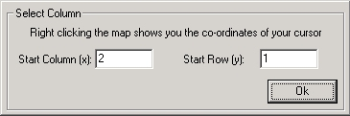

Moving objects are complicated. To begin you need to add 'moving object' tiles to your map for the area in which the object will move. This is the tile next to the exit tile.

You then need to select the top left co-ordinate of your object and decide which direction it will move. One of the bottom right co-ordinates will then automatically be filled in for you, you just need to add the other co-ordinate indicating how far it will move to the right, or to the bottom.

The offset value tells the application at what stage in the travels the object should begin when you first encounter it. If you are confused, the best thing you can do is to look at some of the existing maps you are familiar with and see how their moving objects are coded.

Using the same window, you are also able to edit moving objects, and delete them. Be sure to delete your moving object tiles on the map if you delete an object definition from this window.

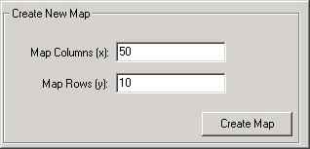

The Create Map window (accessed by clicking 'Clear Level') allows you to create a totally empty map for your designs.

You should also take care when designing your levels as the screen can only scroll one full screen up or down at once. If you look at all the pre-existing levels, you will find they are all based on an eight-high design. This can be seen in the picture below.

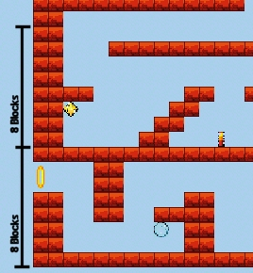

Once you are happy with your level, you are free to test it with either a real phone, or the simulator. Clicking 'Build Game' on the main menu will display a window similar to that shown above. For all levels where you have a custom level, you will have the option to include the original Bounce level, or one of your own creation.

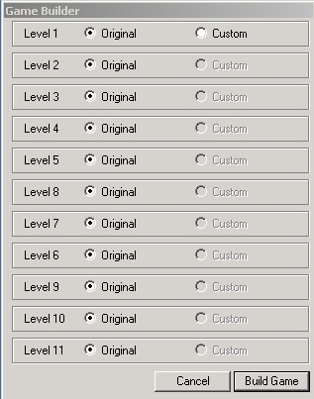

## Progression and Level Design

Gradual introduction of new mechanics, increasing complexity, and thematic level designs.

### Level 1



(Description for each level)

### Level 2

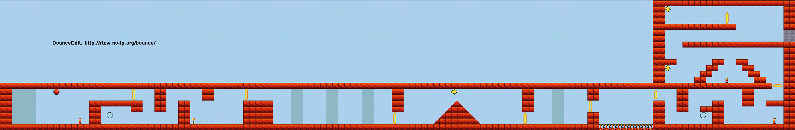

(Description for each level)

### Level 3

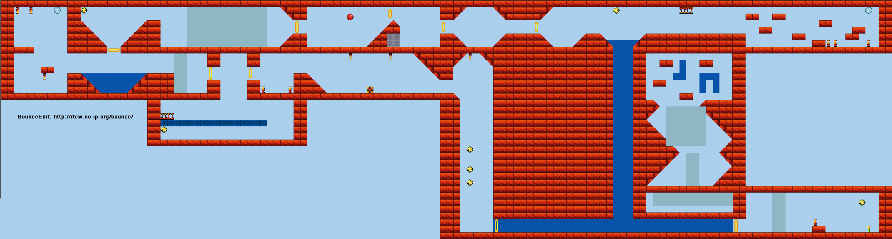

(Description for each level)

### Level 4

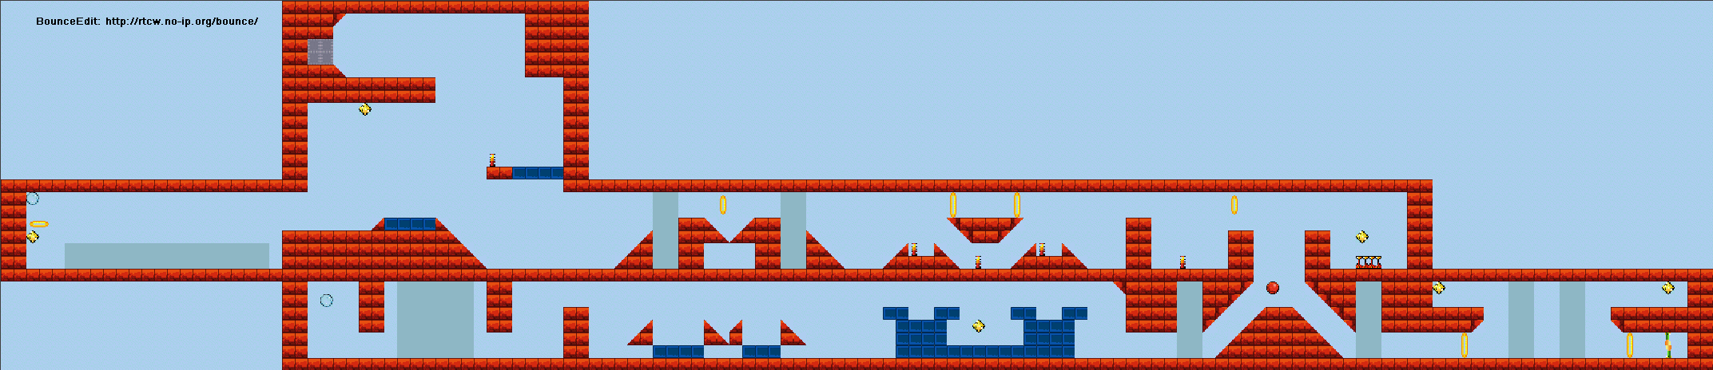

(Description for each level)

### Level 5

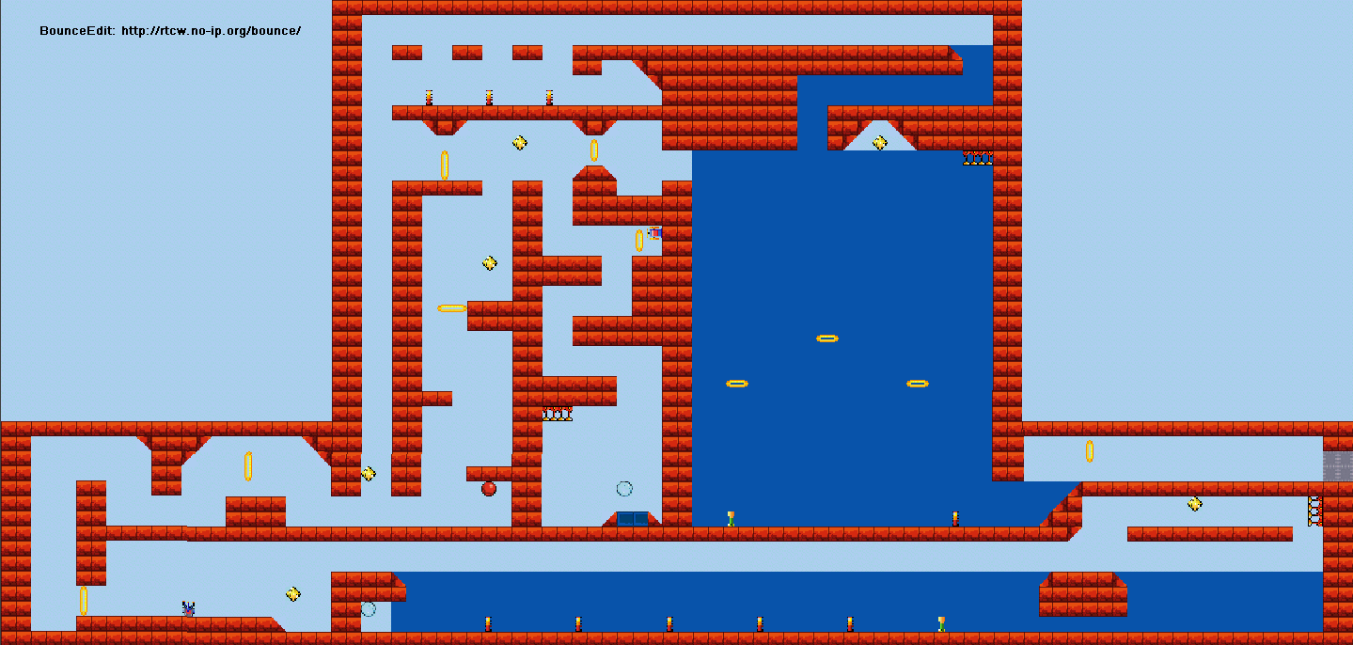

(Description for each level)

### Level 6

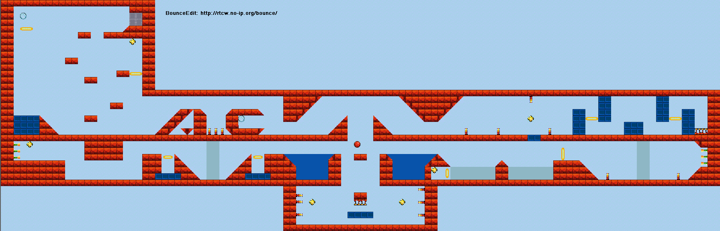

(Description for each level)

### Level 7

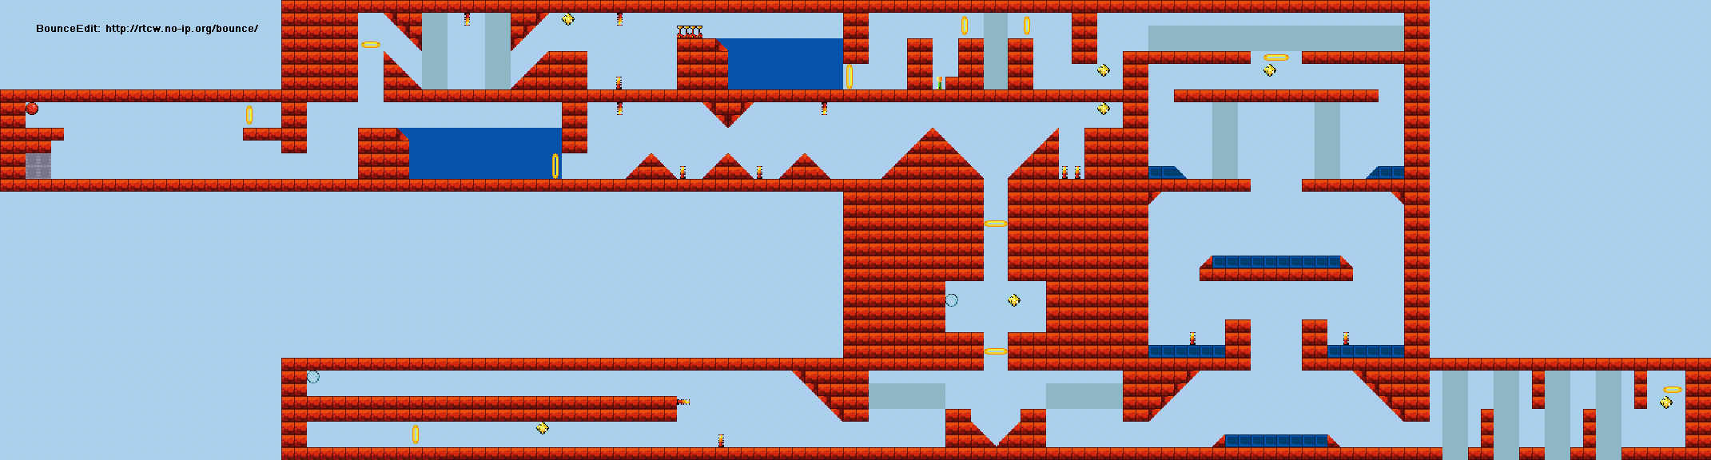

(Description for each level)

### Level 8

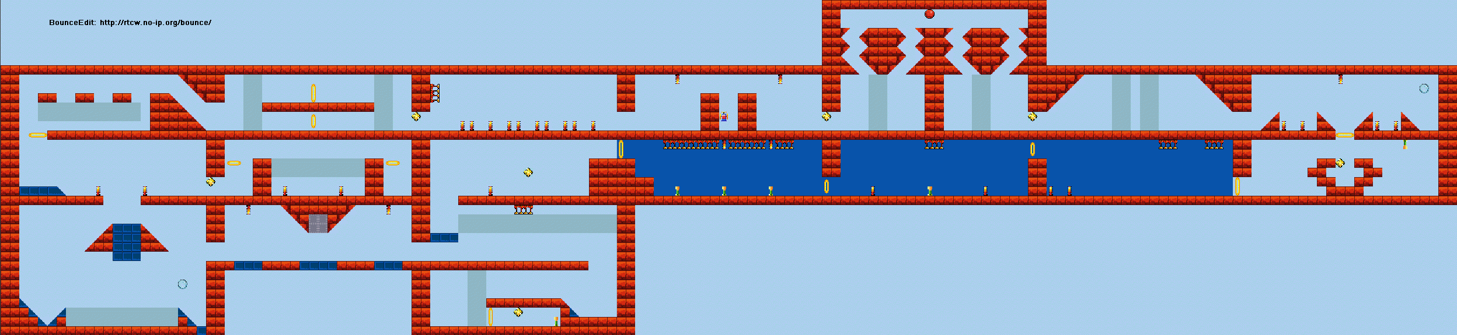

(Description for each level)

### Level 9

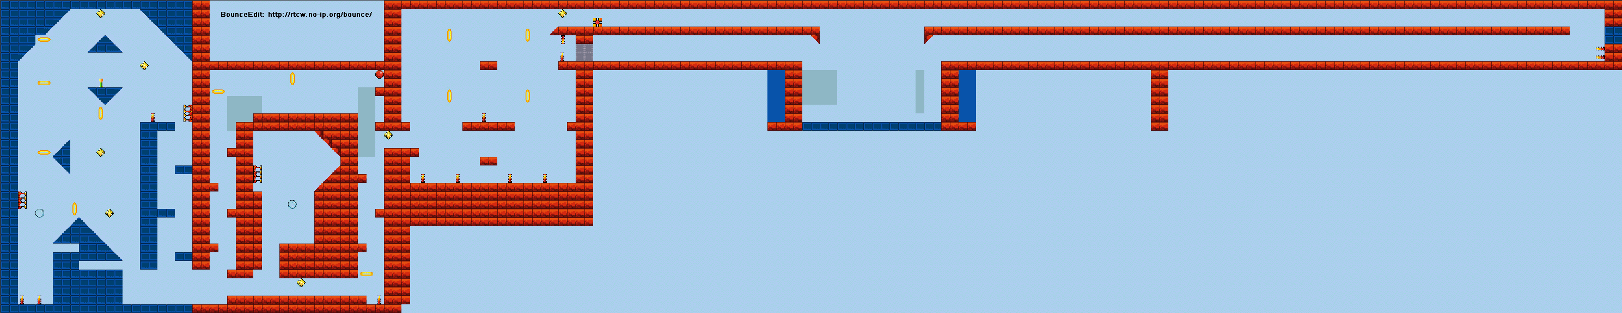

(Description for each level)

### Level 10

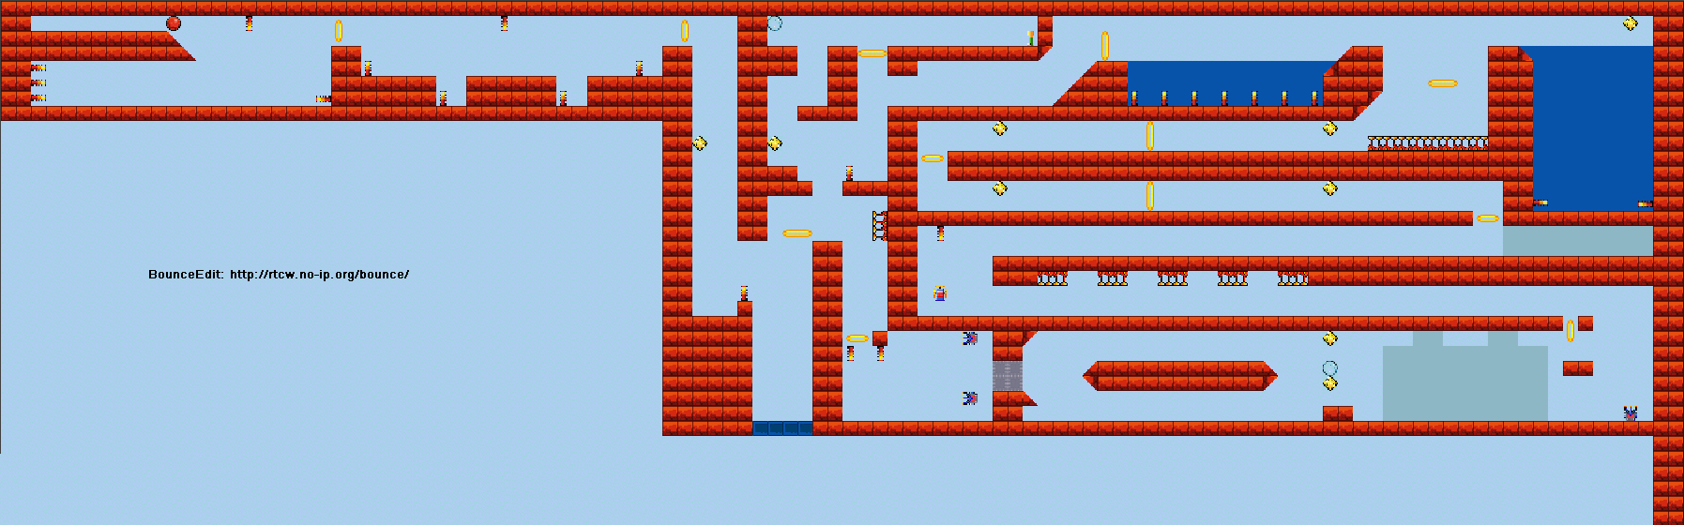

(Description for each level)

### Level 11

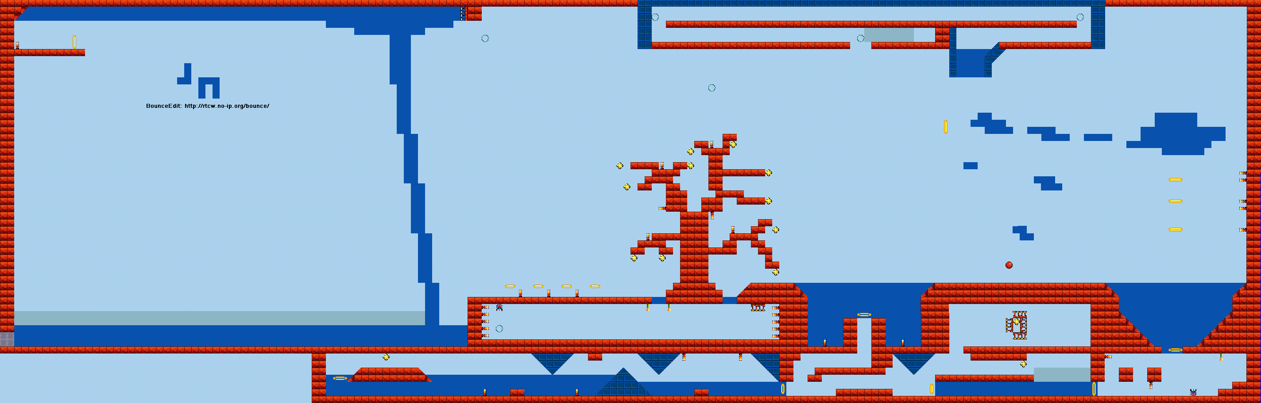

(Description for each level)

# 9. User Interface (UI) and User Experience (UX)

## Man Menu

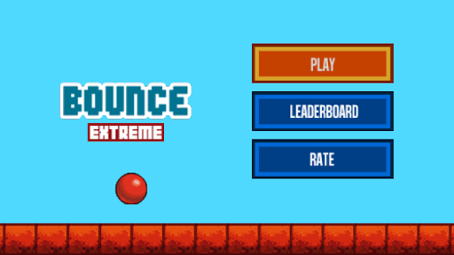

(Explain Main Menu)

## In-Game Menus

Start menu, pause menu, level selection.

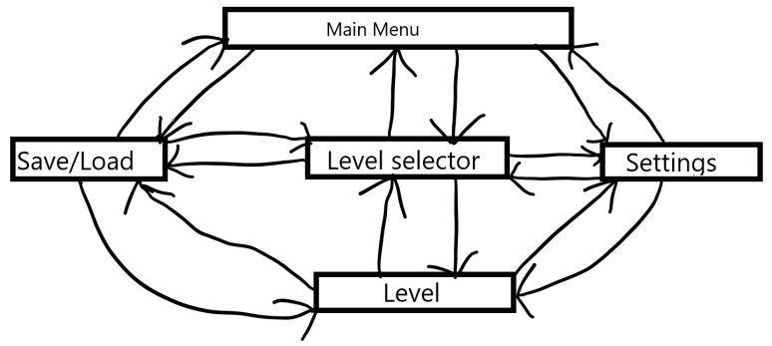



## HUD Elements

Lives, score.

## User Interactions

Intuitive click controls, responsive feedback for actions.

## Cutscenes

Brief animations at key story points, primarily at the beginning (to showcase features as a tutorial) and end of the game (as credits).

## Visual system

* There will be a main menu, which has buttons like Play, Settings, Save/Load and Exit, but mostly is just a splash screen.
* Once Play is pressed, there will be a level selector, showing different levels.
* Besides that, an options menu is always accessible from any part of the game, allowing to adjust graphics and other parameters.
* Save/load menu can be accessed on the main menu, level selector or inside a level.
* Pause menu inside each level also should be implemented, allowing access to options and save/load menu.

## Control system

Simple, movement (right and left arrow keys/A and D) and bounce control (up arrow key/W, the longer held – the higher jump

Menus are navigated by the Mouse.

# 10. Art and Assets

## Visual Style

A blend of the original game's simplicity with modern, vibrant graphics and smooth animations.

## Concept Art

Initial sketches of characters, environments, and key objects.

## Asset List

Characters, environmental elements, power-ups, UI components.

# 11. Audio Design

## Sound Effects

Something simple, ball rolling sound, impact sound when touching the walls, balloon pop when impaled by spikes, some sfx when enter water or wind.

## Music

A dynamic soundtrack that adapts to game states and environments. mostly relaxing and maybe a bit energetic, maybe a couple of my own songs.

## Voiceovers?

Minimal, used primarily for tutorial and key story moments.

# 12. Progression and Rewards

## Advancement System

Levels unlock as players progress, with optional challenges for replayability.

## Rewards

Scores.

## Unlockable Content

Hidden levels, bonus challenges.

# 13. Testing and Marketing

## Testing

Regular playtesting is crucial. Gather feedback from a variety of players to refine controls, level design, and difficulty balancing.

## Selling points

The game has no violence and can be used to educate children the basic concepts of physics and help familiarize with them. Game can also be competitive since players get stars when finishing level and that can be shared among friends.

# Work Plans

### March 2024

Finish GDD, finalize idea, art direction and begin work on the prototype.

### April 2024

Begin rapid prototyping, implement basic elements like rolling, gravity, collision.

### May 2024

Add in sfx, music, design menus, add more elements like spikes, wind tunnels, collectables, lives.

### June 2024

Polishing stage, finish whatever still in progress and cut the parts that won’t be done in time before deadline.