ESP32 Control Panel User Manual

# Introduction

The ESP32 Control Panel is a desktop application designed to interact with an ESP32 device via a serial connection. It provides various controls for motors, outputs, and NFC functionality, as well as a serial monitor to display communication logs.

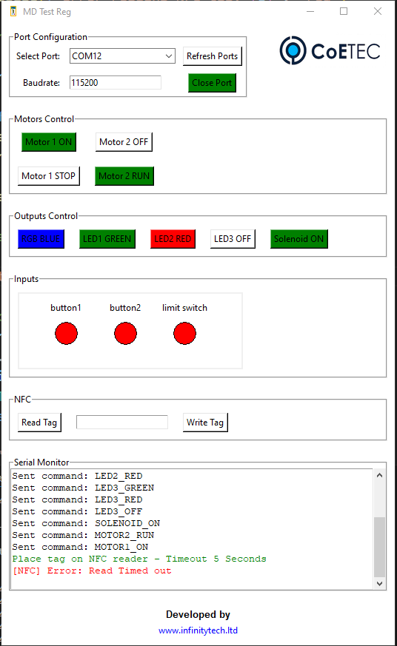

# Port Configuration

- Select Port: Dropdown to select the available serial port.  
- Refresh Ports: Button to refresh the list of available serial ports.  
- Baudrate: Text field to enter the baud rate for the serial connection.  
- Open Port/Close Port: Button to open or close the selected serial port.

# Motors Control

- Motor 1 ON/OFF: Toggle button to turn Motor 1 on or off.  
- Motor 2 ON/OFF: Toggle button to turn Motor 2 on or off.  
- Motor 1 RUN/STOP: Toggle button to run or stop Motor 1.  
- Motor 2 RUN/STOP: Toggle button to run or stop Motor 2.

# Outputs Control

- RGB: Multi-state button to cycle through "RGB OFF", "RGB RED", "RGB GREEN", and "RGB BLUE".  
- LED1: Multi-state button to cycle through "LED1 OFF", "LED1 GREEN", and "LED1 RED".  
- LED2: Multi-state button to cycle through "LED2 OFF", "LED2 GREEN", and "LED2 RED".  
- LED3: Multi-state button to cycle through "LED3 OFF", "LED3 GREEN", and "LED3 RED".  
- Solenoid: Toggle button to turn the solenoid on or off.

# Inputs Section

Displays the status of three inputs using colored circles:  
- button1  
- button2  
- limit switch  
Green indicates the input is active, red indicates it is inactive.

# NFC Section

- Read Tag: Button to initiate reading an NFC tag. Displays instructions and waits for tag data.  
- Write Tag: Text field to enter data to be written to an NFC tag. Button to send the write command.

# Serial Monitor

Displays logs of all communications between the application and the ESP32 device.

# Serial Commands Table

|  |  |
| --- | --- |
| **Command** | **Description** |
| MOTOR1_ON | Turns Motor 1 on |
| MOTOR1_OFF | Turns Motor 1 off |
| MOTOR1_RUN | Runs Motor 1 |
| MOTOR1_STOP | Stops Motor 1 |
| MOTOR2_ON | Turns Motor 2 on |
| MOTOR2_OFF | Turns Motor 2 off |
| MOTOR2_RUN | Runs Motor 2 |
| MOTOR2_STOP | Stops Motor 2 |
| SOLENOID_ON | Turns the solenoid on |
| SOLENOID_OFF | Turns the solenoid off |
| RGB_OFF | Turns the RGB off |
| RGB_RED | Sets the RGB to red |
| RGB_GREEN | Sets the RGB to green |
| RGB_BLUE | Sets the RGB to blue |
| LED1_OFF | Turns LED1 off |
| LED1_GREEN | Sets LED1 to green |
| LED1_RED | Sets LED1 to red |
| LED2_OFF | Turns LED2 off |
| LED2_GREEN | Sets LED2 to green |
| LED2_RED | Sets LED2 to red |
| LED3_OFF | Turns LED3 off |
| LED3_GREEN | Sets LED3 to green |
| LED3_RED | Sets LED3 to red |
| NFC_WRITE, DATA | Writes DATA to an NFC tag |