Check In MVP — Trip Personalization Engine
From a 9-question onboarding to a grounded, day-by-day personalized itinerary · design + working Python reference · July 2026

What the MVP Is
The MVP is the personalization loop: learn who the traveler is once, keep learning from what they actually do, and turn that understanding into a day-by-day trip plan that feels made for them — where every item is real, available on their dates, and within their budget.
The mental model is a dating app, adapted: a short, fun questionnaire seeds the profile (the ‘bio’), and real behavior — what they add, book, swap out, and rate — continuously refines it (the ‘swipes’). The questionnaire gets the first trip roughly right; behavior makes every trip after it sharper.

Design Rules (carried over from the TravelBuddy review)
- Constraints gate, preferences weight. Availability, budget ceilings, and dealbreakers are hard filters applied BEFORE scoring. An unavailable item or a declared no-go can never be outvoted by good ambience — it never reaches the scorer.
- Score structure, never free text. Every scoring signal is a verified, structured attribute (controlled vibe tags, verified price, ratings from an authoritative source). Nothing in the pipeline scores prose an LLM wrote.
- The profile is behavioral, not aspirational. The questionnaire is a prior; bookings, swaps, and post-trip ratings are the truth, and they win over time.
- Learning is gentle. Single events apply small nudges. Profiles drift with evidence; they don't lurch on one tap.

Part 1 — The Onboarding Questionnaire
Nine questions, under two minutes, phrased like a personality quiz rather than a form. Every answer maps to a controlled field — no free-text parsing anywhere in the core path.
# | Question (as the user sees it) | Answer format | What it teaches the engine
Q1 | “Your ideal trip day: every hour planned, or see where the day takes you?” | Slider: Planned ↔ Spontaneous (stored 0–1) | pace_score — drives how many activities per day the planner schedules
Q2 | “Pick your top 3 — what makes a trip unforgettable?” | Pick exactly 3 of 10 vibe chips (adventure, culture, food, nightlife, relaxation, nature, shopping, history, romance, wellness) | Seeds the vibe weight vector — capping at 3 forces real prioritization instead of ‘everything’
Q3 | “You'd happily splurge on ___ but save on ___” | Two picks from: stay · experiences · food · shopping · transport (must differ) | splurge/save categories — lets the ranker treat a pricey dinner as GOOD for a food-splurger instead of always preferring cheap
Q4 | “On holiday you're up and out by…” | 8 AM / 9:30ish / whenever we wake up | chronotype — sets when each itinerary day starts; a late riser never gets a 7 AM temple visit
Q5 | “Which traveler is most you?” | One of 6 archetype cards (Foodie Explorer, Culture Seeker, Adrenaline Chaser, Slow Traveler, Luxury Unwinder, Social Butterfly) | Archetype prior — fills in the rest of the vibe vector beyond the explicit top-3, dating-app style
Q6 | “Who do you usually travel with?” | Solo / partner / friends / family with young kids / multi-generation | Default party shape — pre-fills trip intake and filters kid-unfriendly or group-unfriendly items
Q7 | “Food on trips: stick to what you know, or eat like a local dares you to?” | Slider: Familiar ↔ Anything (0–1) | food_adventurousness — widens or narrows restaurant retrieval beyond safe picks
Q8 | “Any absolute no-gos?” | Multi-select chips: early flights, theme parks, long bus rides, crowded spots, heights, boats… + dietary needs | dealbreakers + dietary — these become HARD FILTERS, never scoring penalties. A no-go never appears, full stop
Q9 | “In one line — describe your perfect travel moment.” (optional) | Free text, one line | Embedded into pgvector for retrieval flavour only — deliberately never scored (see Design Rules)
Why Q9 is quarantined: the one free-text answer is embedded and used only to flavour retrieval (finding candidates similar in spirit). It is never an input to scoring — that keeps the circular-scoring failure mode structurally impossible rather than merely discouraged.

Part 2 — How the Profile Is Stored
The questionnaire compiles into a single UserProfile row: a normalized 10-dimensional vibe weight vector (sums to 1.0) plus controlled scalar fields. Example output from the reference code, for a slow-traveler who picked nature / relaxation / romance:
Vibe weights: relaxation 0.413 · nature 0.293 · wellness 0.160 · romance 0.133
pace_score 0.3 · chronotype mid · splurge: experiences · save: shopping
dealbreakers: [no_early_flights] · dietary: [vegetarian]
Note the wellness weight: the user never picked it — it came from the Slow Traveler archetype prior. That's the dating-app trick: the archetype fills in plausible defaults, and behavior corrects them from the first real signal.

Part 3 — The Learning Loop
Five event types feed the learner, each carrying the vibe tags of the item it touched:
- View dwell (small +) · cart add (+) · cart remove (−) · booking complete (strong +) · itinerary swap in/out (±)
- Post-trip rating: scaled around neutral — a 5/5 nudges those tags up, a 2/5 nudges down, a 3/5 changes nothing.
Demonstrated with the reference code — same slow-traveler profile after a trip where they kept booking food experiences and skipped every relaxation suggestion:
Before: relaxation 0.413 · nature 0.293 · wellness 0.160 · romance 0.133
After: relaxation 0.366 · nature 0.275 · food 0.051 · culture 0.033 · ...
Food appeared from nothing; relaxation eased down. Small, evidence-proportional movement — exactly the behavior you want from a profile that millions of taps will eventually shape.

Part 4 — Query Flow at Trip Time
When the user starts planning a trip, the stored profile is queried and blended with trip-specific context in this order:
- Trip intake: destination, dates, party, budget, and optional trip-level vibe overrides (‘this one's a party trip, not my usual style’) with a blend ratio — so one atypical trip never pollutes the persistent profile.
- Context blend: persistent vibe vector × trip overrides → a per-trip preference vector; budget ceilings per category; dealbreakers carried through as constraints.
- Candidate retrieval: supplier inventory + Places data, plus vector-similarity retrieval seeded by the Q9 embedding for flavour.
- Grounding & verification: every candidate is confirmed to exist, be available inside the trip dates, and carry a verified price — producing grounded_items rows with availability_checked_at timestamps.
- Hard filter: drop anything unavailable, over the category budget ceiling, or carrying a dealbreaker tag.
- Scoring (survivors only): 0.45 × preference-match (cosine of trip vector vs. item's controlled tags) + 0.35 × damped verified rating + 0.20 × spend-fit — where a high price in the user's splurge category scores WELL. A food-splurger sees the tasting menu, not the cheapest cafe.
- Day planning: ranked survivors are clustered by proximity so each day stays in one part of the city, slot count follows pace_score, the day starts at the user's chronotype, dinners are assigned, and each day gets a theme from its dominant vibe.
- The day-by-day map renders; every swap the user makes feeds back into the learning loop; selected items flow into the multi-vendor checkout (covered by its own design doc) already pre-verified.

Part 5 — Data Flow Diagram
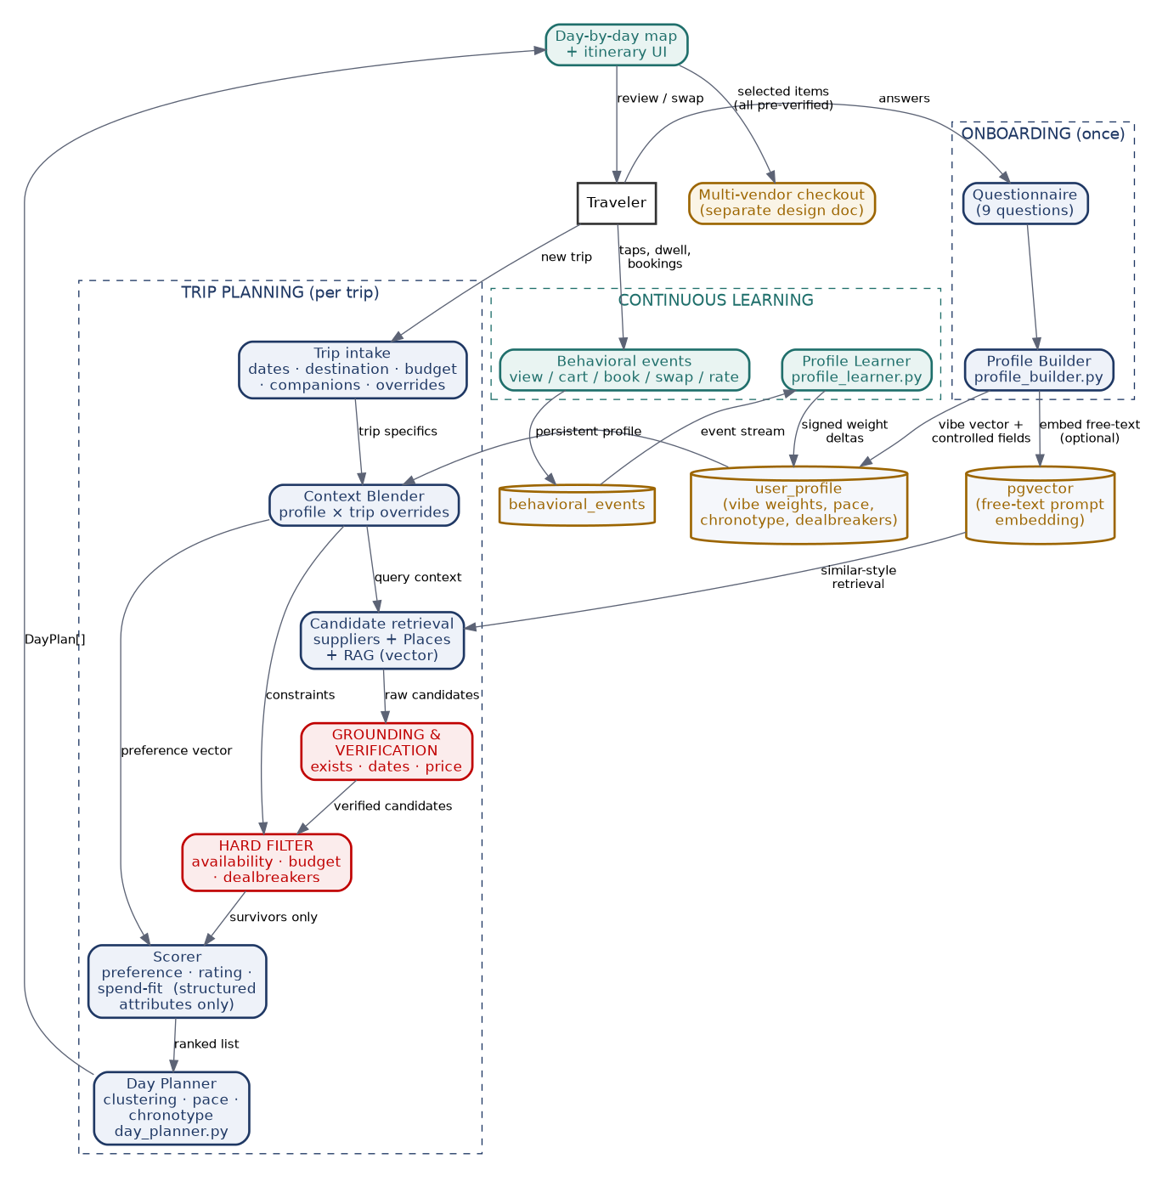
Onboarding (once) → continuous learning → per-trip planning. Red boxes are the reality gates — the parts that make this a travel product rather than a plausible-text generator.

Part 6 — ER Diagram
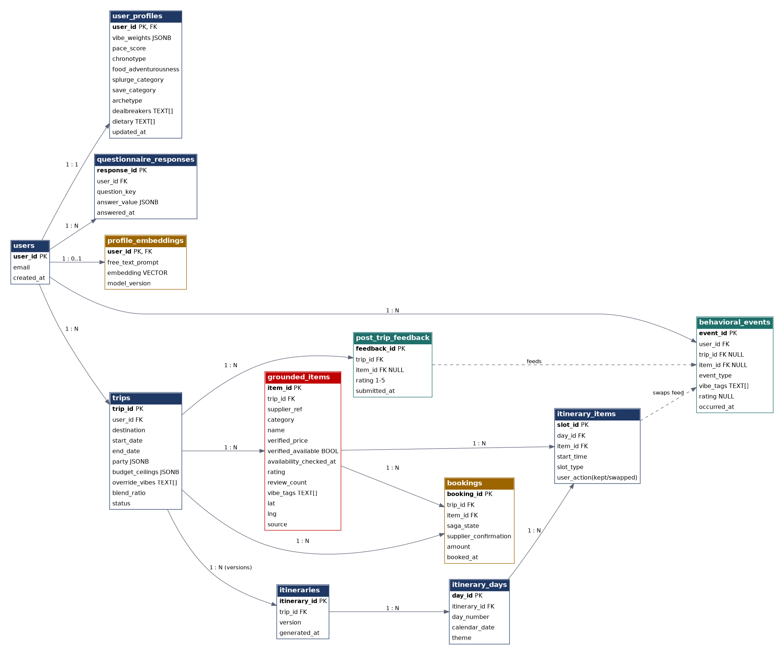
PostgreSQL + pgvector. Red = grounded/verified data · teal = behavioral signal · gold = embeddings and money. itinerary_items.user_action is the swap signal that feeds the learner.
Two schema decisions worth noting: itineraries are versioned per trip (every regeneration is a new version, so ‘what did we show vs. what did they keep’ is always answerable), and grounded_items carries availability_checked_at — staleness is measurable, which the checkout's revalidation step depends on.

Part 7 — The Reference Implementation (Python)
Four small, tested modules — attached alongside this document. They are the working specification: runnable end-to-end today with mock candidates, and structured so the real supplier/Places integrations slot in behind the Candidate dataclass without touching the logic.
Script | Responsibility | Key design choice
profile_builder.py | Questionnaire answers → structured UserProfile (normalized vibe vector + controlled fields) | Explicit top-3 picks outweigh the archetype stereotype; every field is enum/number/capped list
profile_learner.py | Behavioral events (view / cart / book / swap / post-trip rating) → signed nudges to the vibe vector | Small conservative deltas; one bad recommendation can't wreck a profile; 3/5 rating = no update
trip_ranker.py | Blend profile × trip overrides → hard filter → score → rank per category | Constraints GATE (availability, budget ceiling, dealbreakers) before any scoring; score uses only verified structured attributes
day_planner.py | Ranked survivors → day-by-day map: geographic clustering, pace-based slot count, chronotype start times, themed days | Greedy proximity clustering keeps each day in one part of the city — swappable for k-means/TSP later without interface change
End-to-end output of the four modules chained together (real run):
Day 1 — Relaxation (2026-07-13)
11:00 Hamarikyu Gardens Walk
13:30 Onsen Spa Afternoon
19:00 MAISON OLINA [dinner]

Day 2 — Nature (2026-07-14)
11:00 Shinjuku Gyoen Stroll
13:30 Meiji Shrine Morning
19:00 Narisawa [dinner]
Notice what the personalization did: the late-riser chronotype starts both days at 11:00, the low pace_score caps each day at two activities, the two garden walks landed on different days in different neighbourhoods (proximity clustering), and the unavailable firefly event plus the theme-park dealbreaker item from the candidate pool are simply absent — gated before scoring, exactly as designed.

Deliberately Out of MVP Scope
- Collaborative filtering across users (‘travelers like you loved…’) — needs a user base first; the schema already captures the events it will train on.
- Group-trip preference reconciliation — the roadmap differentiator, built on top of this once single-user personalization is proven.
- In-trip real-time replanning (rain, closures) — post-MVP; the versioned-itinerary schema is already shaped for it.
- A/B testing of scoring weights — the 0.45/0.35/0.20 split is a reasoned starting point, to be tuned against the eval harness, not a constant to defend.

Build Order Within the Roadmap
This slots into Phase 1–2 of the Team Execution Roadmap: the questionnaire UI and profile builder are Phase 1 work alongside the design system; the learner, ranker, and day planner are the Phase 2 ‘AI layer’ deliverables; and the grounded_items table is the contract between the grounding/verification workstream and this engine. The eval rubric from Phase 1 tests exactly one question: given a profile and a candidate pool, does the produced day map respect every constraint and read as ‘made for this person’?

