Multi-Vendor Checkout — Design Doc
Failure-safe booking orchestration for Check In · companion to the Team Execution Roadmap (Phase 3) · July 2026

The Problem, Stated Plainly
A Check In checkout books one trip across several independent suppliers — a flight, a hotel, activities, a transfer — as a single purchase. Any supplier can fail at any moment, and a booked flight cannot be rolled back like a database row. No protocol can make four independent suppliers commit atomically — this is one of the genuinely hard problems in travel tech, and teams at much larger companies get it wrong. What makes it tractable is designing for graceful failure from the start.
So the design goal is not “prevent failures.” It is: every checkout ends in one of a small set of known-good states — never in limbo, and never with the traveler's money taken for something unconfirmed.

Design Principles
- Reality gates money. No debit happens before the corresponding booking is confirmed. Ever.
- Failures are classified, not improvised. Every failure mode below has a pre-decided response, so no one has to make judgment calls under pressure.
- A timeout is not a failure. It is an unknown, and unknowns get reconciled before anything retries.
- Nothing is substituted silently. A different hotel is a different product; the traveler chooses.
- Every saga terminates. CONFIRMED, COMPENSATED, or a human ops queue with an SLA — there is no fourth outcome.

Step 0 — Classify Inventory by Reversibility
This table drives everything else: booking order, hold strategy, and compensation policy. It must be validated against each supplier's real contract terms during Phase 2 sandbox work — the values below are the industry-typical starting point, not gospel.
Inventory type | Typical reversibility | Hold mechanism | Policy to confirm with supplier
Flight (GDS) | Void window after ticketing (often ~24h, varies by carrier/market); penalties after | PNR held before ticketing — commit = issue ticket | Void window length; refund class per fare; TBO vs direct GDS behaviour
Hotel | Free-cancellation rates → freely reversible until cutoff; non-refundable rates → penalty or full loss | Book a free-cancel rate as the hold itself | Cancellation cutoff per rate plan (Hotelbeds/TBO expose this per rate)
Activity / event ticket | Often irreversible once issued | Rarely available — treat as commit-only | Which products allow cancellation at all; cutoff times
Transfer / transport | Usually cancellable until close to pickup | Book + cancel-if-needed | Cutoff window; no-show fees
The ordering rule that falls out of it: commit the hardest-to-reverse item LAST, when everything else is already confirmed. If the irreversible item fails, everything before it can still be unwound cheaply.

The Checkout Sequence
- Revalidate everything — price and availability on every cart item, seconds before money moves. Any change: stop, show the delta, get explicit re-consent. Fail while failing is still free.
- Block funds, don't take them. UPI Reserve Pay's single-block-multiple-debit: block the full amount once, then debit per supplier only as each booking confirms. Failures release the un-debited remainder automatically. On cards, authorize-then-capture-per-item approximates the same shape.
- Acquire holds in parallel wherever the supplier supports them (GDS PNR before ticketing; a free-cancellation hotel rate booked as the hold). Holds are the cheap ‘prepare’ phase: if any hold fails, cancel the rest at zero cost — nothing has been charged.
- Commit in reverse-reversibility order, debiting per item as each commit confirms.
- Terminate: all items CONFIRMED → trip confirmed; anything else → the failure playbook below.

Per-Item State Machine
Every line item is in exactly one of these states at all times. Temporal provides the durable state, retries and timers; the compensation policies are business decisions defined in this document, not in code review.
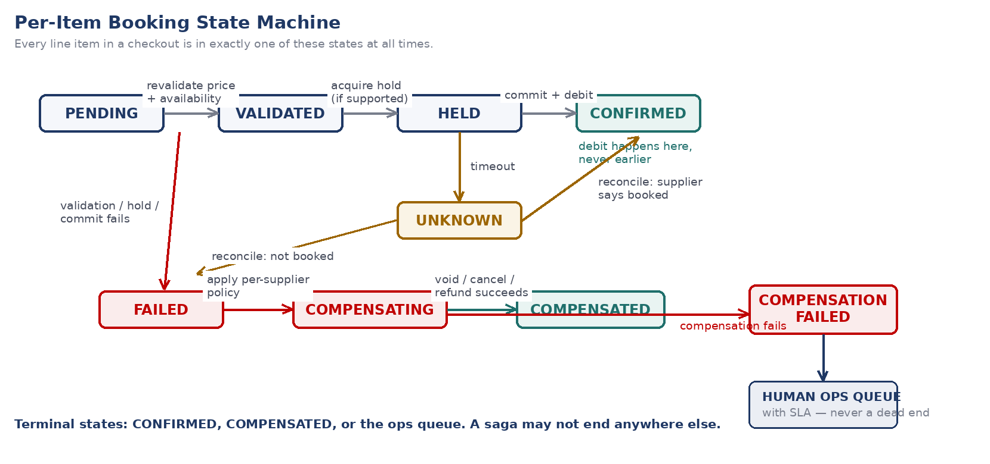

Failure Matrix
Each row is a pre-decided response. The left half of this table is engineering; the right half is policy — and the policy rows marked in red need founder sign-off before Phase 3 build starts.
Stage | Failure | System response | Cost of failure
Revalidation | Price or availability changed on any item | Stop. Show the delta. Require explicit re-consent before continuing. | Zero — nothing held, nothing charged
Fund blocking | Block/authorization declined | Abort checkout, keep cart intact, prompt for another payment method. | Zero
Hold acquisition | Any hold fails | Cancel all other holds (free), release the block, offer alternatives for the failed item. | Zero — holds are the cheap prepare phase
Commit — reversible item | Booking call returns a definitive failure | Retry with the same idempotency key (bounded, jittered). If exhausted: compensate any committed items per policy, release un-debited funds. | Low — voids/free cancels
Commit — irreversible item | Fails after other items already committed | Pause the saga. Offer the traveler an explicit choice: substitute / keep partial trip / full refund. Timer on the choice with a safe default. Never substitute silently. | Real money is now at stake — policy decides who absorbs it
Any commit call | Timeout / no response | Mark UNKNOWN — do NOT retry blind. Reconcile by querying the supplier with our reference, then classify as CONFIRMED or FAILED and proceed accordingly. | Zero if reconciled correctly; double-booking if not
Compensation | Void/cancel/refund call itself fails | Bounded retries, then land the item in the human ops queue with an SLA. The saga still reaches a terminal state. | Contained — human resolves within SLA
Debit | Debit fails after booking confirmed | Booking exists but money not taken: retry debit; if exhausted, ops queue — we are exposed, traveler is not. | Company-side exposure only

Idempotency & Reconciliation — The Two Rules That Prevent Disasters
Idempotency
Every booking and every debit carries an idempotency key derived from (saga_id, item_id, attempt-class). Retries reuse the key. The supplier-facing wrapper must treat “already booked with this key” as success, not as an error. This is the mechanism that makes retrying safe at all — it guarantees an innocent-looking retry can never create a second booking or a second charge.
Timeout reconciliation
A timed-out booking call is ambiguous: the supplier may have succeeded and the response was lost. The correct sequence is always — mark UNKNOWN → query the supplier using our reference/key → classify as CONFIRMED or FAILED → then proceed. This distinction between ‘failed’ and ‘unknown’ is subtle and easy to miss — it's the single most common cause of double-bookings across the industry, which is why we reconcile before we ever retry.

Payments — India-Specific Notes
- UPI Reserve Pay (single-block-multiple-debit) is the primary rail and fits this design natively: one block at checkout, per-supplier debits gated on per-item confirmation, automatic release of the remainder on failure.
- Card fallback uses authorize-then-capture per item. Authorization windows are finite and cannot be assumed to stretch — the saga's maximum wall-clock time (see open decisions) must fit comfortably inside the shortest auth window we rely on.
- If a revalidated price rises above the blocked/authorized amount, that is a stop-and-re-consent event — never an automatic re-block.
- Every money movement writes a ledger entry at the moment it happens. The ledger, the suppliers' records, and the PSP's records are reconciled daily; discrepancies surface to ops, not to chance.

Invariants — What We Test, Not Just Intend
- No debit ever precedes its corresponding booking confirmation.
- Every saga reaches a terminal state (CONFIRMED / COMPENSATED / ops queue) within the bounded wall-clock time.
- Replaying any step with the same idempotency key never creates a second booking or a second charge.
- Every money movement has a ledger entry, and daily three-way reconciliation (ledger / supplier / PSP) passes.

Chaos Test Checklist (Phase 3–4 Exit Requirement)
Run in staging with fault injection. Each test kills or degrades a dependency at a specific state and asserts the invariants hold. The Phase 3 exit criterion in the Team Execution Roadmap (“a deliberately-failed-supplier case that compensates correctly”) is test T2/T3 here — this list is the full set.
- Kill each supplier at VALIDATED — assert: all holds cancelled, block released, cart intact, traveler informed.
- Kill each supplier at HELD — assert: sibling holds cancelled at zero cost, no debit occurred.
- Fail the LAST, least-reversible commit after all others confirmed — assert: saga pauses, traveler choice offered, timer default fires correctly.
- Time out a commit call where the supplier actually succeeded — assert: reconciliation classifies it CONFIRMED, no duplicate booking is created.
- Time out a commit call where the supplier actually failed — assert: reconciliation classifies it FAILED and compensation runs.
- Fire the same commit twice with the same idempotency key — assert: exactly one booking, exactly one debit.
- Fail a compensation call repeatedly — assert: item lands in the ops queue with full context; saga reaches terminal state.
- Confirm a booking, then fail the debit — assert: traveler holds a valid booking, exposure is logged, ops alerted.
- Change a price between cart and revalidation — assert: checkout stops and re-consent is required.
- Crash the orchestrator mid-saga and restart — assert: Temporal resumes from durable state, no step re-executes non-idempotently.
- Run daily reconciliation against a seeded mismatch — assert: ledger vs supplier vs PSP discrepancy is detected and surfaced.

Open Decisions — Policy Blanks to Fill In
These are business decisions the code will encode. They should be settled before Phase 3 build starts, and they belong to the founder unless noted.
Decision | Options | Owner / due
Cancellation penalty on a supplier-caused failure: absorb or pass to traveler? | Absorb below a threshold (e.g. small penalties), pass above / always absorb / always pass | Founder — before Phase 3 build starts
Traveler-choice timer on a paused saga (substitute / partial / refund) | Duration (e.g. 30–60 min) and the safe default when it expires (refund is the safest default) | Founder + Founding Engineer
Ops-queue SLA for COMPENSATION_FAILED and debit-failure cases | e.g. 4h business hours / 12h otherwise | Founder — before launch
Booking commit order | Default: most-reversible first, irreversible last. Confirm per real supplier behaviour once sandbox access exists | Founding Engineer — Phase 2
Maximum saga wall-clock time before forced terminal state | e.g. 15 min to CONFIRMED-or-compensating; hard ceiling with escalation | Founding Engineer — Phase 3

What This Doc Does Not Cover
Fraud screening, chargeback handling, multi-currency settlement, and GST/invoicing on partial refunds are real and adjacent, but out of scope here — they get their own passes once the core saga design is agreed.

The Honest Trade-Off
With irreversible inventory in the cart, a perfect outcome is not always achievable — sometimes the end state is ‘absorb a cancellation penalty’ or ‘disappoint the traveler with a refund.’ This design does not eliminate that. It guarantees the failure is a decided policy executed calmly, with the traveler's money protected throughout, instead of an improvised incident.

