ConstraintGeometry contains a set of components to define and apply constraints in sofa based on the dection provided by an arbitraty detection method (usually from CollisionAlgorithm).

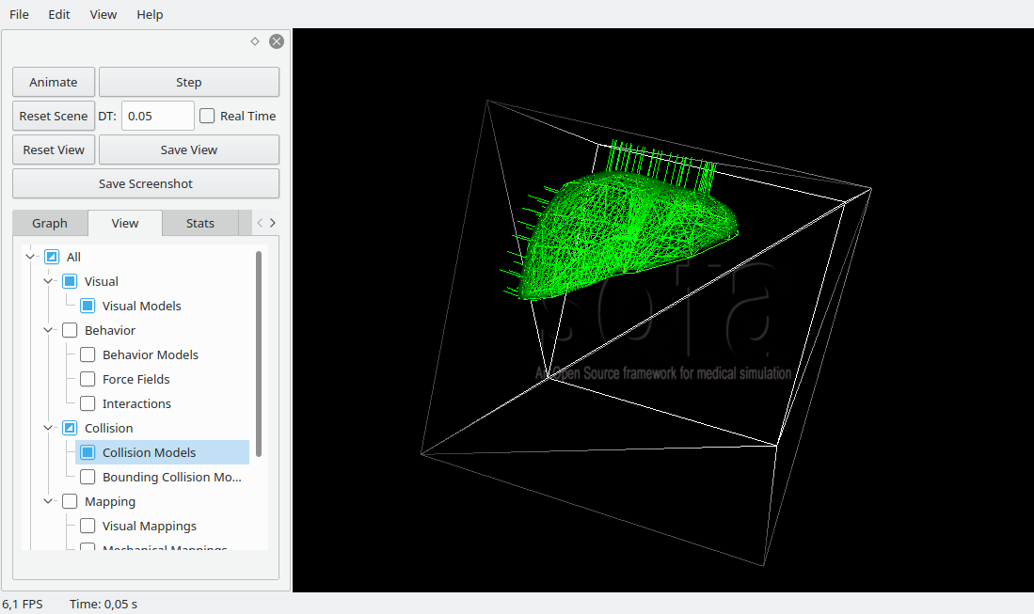

You can find an example of scene here:

<?xml version="1.0" encoding="UTF-8"?>
<Node name="Root" gravity="0 -15 0" dt="0.05">
<RequiredPlugin pluginName="CollisionAlgorithm"/>
<RequiredPlugin pluginName="ConstraintGeometry"/>
<RequiredPlugin pluginName="SofaCUDASolvers"/>
<RequiredPlugin pluginName="SofaAsyncSolvers"/>
<RequiredPlugin pluginName='SofaExporter'/>
<RequiredPlugin pluginName='SofaPreconditioner'/>
<RequiredPlugin pluginName='SofaSparseSolver'/>

<VisualStyle displayFlags="showVisualModels hideBehaviorModels showCollisionModels hideMappings hideForceFields showWireframe showInteractionForceFields" />
<FreeMotionAnimationLoop name="CollisionAnimationLoop"/>
<GenericConstraintSolver maxIterations="200" tolerance="0.0001" />

<FindClosestProximityAlgorithm name="algo" from="@Liver/Collision/Geometry" dest="@Plane/Geometry" />
<NormalFilter name="normal" algo="@algo" angle="-1 0.5" />
<DistanceFilter name="distance" algo="@algo" distance="0.1" />
<AABBSearchMethod algo="@algo" />

<Node name="Liver">
<EulerImplicit name="EulerImplicit" rayleighMass="0.1" rayleighStiffness="0.1" />
<CudaSparseLDLSolver name="precond" template="CompressedRowSparseMatrix3f" />

<MeshGmshLoader name="loader" filename="mesh/liver.msh"/>
<MeshTopology name="Topology" tetrahedra="@loader.tetrahedra" />
<MechanicalObject name="State3D" position="@loader.position" rest_position="@loader.position"/>

<TetrahedronFEMForceField name="TetrahedronFEMForceField" poissonRatio="0.4" youngModulus="50" />

<UniformMass name="UniformMass" totalMass="1"/>

<Node name="Collision">
<TriangleSetTopologyContainer name="Container" position="@../loader.position" />
<TriangleSetTopologyModifier name="Modifier"/>
<Tetra2TriangleTopologicalMapping input="@../Topology" output="@Container" flipNormals="false"/>
<MechanicalObject name="state" />

<TriangleGeometry name="Geometry" color="0 1 0 1" />
<PhongTriangleNormalHandler geometry="@Geometry" />

<AABBBroadPhase geometry="@Geometry" nbox="8 8 8" />

<BarycentricMapping name="BarycentricMapping"/>
</Node>

<Node name="Surface">
<MeshObjLoader name="loader" filename="mesh/liver-smooth.obj"/>
<MeshTopology name="Topology1" triangles="@loader.triangles" />
<OglModel name="OglModel" color="0 1 0" src='@loader'/>
<BarycentricMapping name="BarycentricMapping"/>
</Node>

<LinearSolverConstraintCorrection solverName="precond" />
</Node>

<Node name="Plane">
<MeshObjLoader name="loader" filename="mesh/box_inside.obj"/>
<MeshTopology name="Topology1" triangles="@loader.triangles" />
<MechanicalObject name="State3D1" dy="1" position="@loader.position" />
<OglModel name="OglModel" color="1 1 1 0.8"/>
<TriangleGeometry name="Geometry" color="1 1 1 0.6" />
<AABBBroadPhase geometry="@Geometry" nbox="8 8 8" color="1 0 0 0.3" />
</Node>

<ConstraintUnilateral input="@algo.output" mu="0.6" />
</Node>

