AN ADAPTIVE MARKOV RANDOM FIELD BASED ERROR CONCEALMENT METHOD FOR VIDEO COMMUNICATION IN AN ERROR PRONE ENVIRON fENT

*Shahram ShiraniFaouzi Kossentiniand Rabab Ward*

Department of Electrical and Computer Engineering

University of British Columbia

V ncouver BC V6T lZ4 Canada

ABSTRACT

Loss of coded data during its transmission can affect a coded video sequence to a large extenmt aking concealment of errors caused by data loss a serious issue. Previous work in spa­ tial error concealment exploiting MRF models used a single pixel wide region around the eπoneous area to achieve a reconstruc­

tion based on an optimality measure. This practicaJly restric e amount of available inforrnation that is used in a concealment pro­ cedure t'O a smaJl regi'On ar'Ound the missing area. Incorp'Orating

m'Ore pixels usuaJly means a higher 'Order m'Odel and this is expen­

sive ase complexity grows eXP 'OnentiaJly with the order of E MRF m'Odel.Using previ'Ously proP'Osed approachesthe damaged area is rec'Onstructed fairly weJl in very I'OW frequency p 'Ons of the image. Howevetrhe reconstruction process yields blurry re­ sults with a significant I'OSS of details in high frequencyor edge

P'Ortions ofe image. In our proposed approacha MRF is used

e image a priori model. More available inf'Orrnati'On is in­ c'Orp'Orated in the reconstruction procedure n'Ot by increasing the order of the model but instead by adaptively adjusting the model

parameters. Adaptati'On is done based 'On the image characteris­

tics determined in a large regi'On around the damaged area. Thus

the rec'Onstructi'On procedure can make use 'Of inf'Orrnati'On embed­ ded in n'Ot 'Only immediate neighborh d pixels but als'O in a wider neighb'Orh'O'Od with'Out a dramatic increase in c'Omputati'Onal com­

plexity. The proposed meth'Od outperf'Orrns the previ'Ous methods in the reconstruction 'Of missing edges.

1. INTRODUCTION

"he fast gro th ofdigtiransmissi 'On services has created a great

which may cause loss 'Of blocks 'Of data 'Or total I'OSS 'Of synchro­ nization. The ímpact 'Of bit sE nc'Oπupti'On or I'OSS inepícωre quality while usuaJly substantiaIstiJl depends 'On e actual trans­

míssion meth'Od and the c'Ompressi'On alg'Ormi .

Several methods t'O c'Ombat the channel e 'Ors have been prc P'Osed. Aut'Omatíc Retransmissí 'On Request (ARQ) 'Or interleav­ ing techníques are 'Often ineffectivebecause ARQ may aggravate channel c'Ongesti'On and cause the systemω p m'Ore da and interleaving may require c'Onsiderable delay. An'Other method is t'O

empl'Oy f'Orward eπ'Or c'Ontrol coding techníques. There are sev­

eral pr'Oblems associated wíth these techniques. First ey usu­ aJly requíre t'OO many additi'Onal preci'Ous bits f'Or error detecti'On andJ'Or c'Orrecti'On. Sec'Ondey may introduce I 'Ong delays atare n'Ot acceptable in s'Ome applicati'Ons. An alternative method is t 'O

perf'Orrn e ur c'OnceaImenwt hich intends t 'O c'Onceal the bit eπ'Or

effects at the receíver by expl'Oiting redundancíes in the vide'O sig­ nal and limitations 'Of the human visual systemwith 'Out requíring additional inf'Orrnati'On at the coder [34]. Error c 'Oncealment 'Of images and vide'O airns at rem'Oving the visuaJly ann'Oying tifacts at degrade significantly the 'OveraJl picture quality.

Error c'Oncealment techniques mainly make use 'Of temporal andJ'Or spatial correlati 'On in the vide'O signaI and rec'Onstruct the missing region 'Of víde'O ame from adjacent regi'Ons 'Orames

A simple and yet quite effective temporal rec'Onstructi'On meth'Od is t'O replace the c'Oπuptedlmissing regi'On with its c'OrresP'Onding part in the previ'Ous frame. Alth 'Oughis meth 'Od generaJly w'Orks well in still parts 'Of the picturesuch as e backgroundit can­ n'Ot produce satisfact'Ory results when the vide'O sequence exhíbits

fast m'Oving 'Objectslighting changes 'Or sudden scene changes

Spatial rec'Onstructi'On techniques incJude averaging 'Or linear inter­

interest in digital transmission of image and video signals. Sinc

P'Olati'On [6c]

'Onstrained Iinear inte lati'On [6m] ulti-directi 'Onal

digital image and video signals require very high bit ratesthe m­ press lO of such signals bec'Omes necessary. Three standards have emerged to facilitate the gro th 'Ofn w image c'Ommunicati'On ap­ plicati'Ons. These are: 1) the J'Oint Ph'Ot'Ographic Experts Group (JPEG) standard f'Or still image mpressi'On [122] ) the Inter­ national Telec'Ommunicati'On Uni'O ( U)re mmendation H.261

f'Or video teleph'Ony and nferencing [1] and its subsequent revi­

si'Onse.gH. .263 and H.263+and 3) the M 'Oving Pictures Expert

Group (MPEG) f'Or fuJl m'Otion vide'O co pressi'On and ding in digital storage media and digital c'Ommunicati'On applicati'Ons [1]

The c'Omm'On features 'Of these c'Ompαssi'O standards is that ey

are aIl bl'Ock based and usediscrete c 'Osine transforrn (DCT) C'Ommunicati'On channels 'e n'Ot err'Or free and c'Onsequ ntly

t:he enc'Oded bit strearns are vulnerable t'O transmissi'On impnen

is work was pponed by MDSJBC ASJ and NSERC.

edge-based interpolation [784a]nd Bayesian interpolati 'On [9].

Intuitivelythe m 'Ost effective rec'Onstructi'On meth'Od is the 'One that uses the image a pri'Ori model t'Og er with e available data f'Or estimating the missing data. RecentIyMark 'Ov Rand'Om Fields

(MRF) have been extensively used t'O model images. The attractive features 'Of an MRF m'Odel "Cthe c'Omputational tractability and the ability 'Of e m'Odel t'O capωre n'On-Gaussian aspects 'Of the image such as edges.

Image distributi'On models (e.gM. RF) have been used f 'Or er­

ror c'Oncealment. In facet Bayesian approach provides ane

w'Ork f'Or inc'O oratinge a pri 'Ori inf'Orrnati'On through the ch'Oice

'Of the distributi'On 'Of e image. Maximum a pri'Ori (MAP) estíma­

ti'Ona paradigm used very '0.en in image processingyields the

m'Ost likely image given e observed data. A criticaI c'Omp'Onent

in MAP estimati'On ise prior distributi 'On of the image model.

Previ'Ous w'Ork in spatial eπ'Or concealment expl'Oiting IRF

models used a single pixel wide region around the eπoneous area to achieve a reconstruction based on an optimality measure. In er wordsamount of available informationat is used in

estimating damaged datahas been restricted. Incorporating more pixels usually means a higher order MRF model and is is expen­ sive as the complexity grows exponentially with the order of the MRF model.Using previously proposed approachesthe damaged

minimum. Commonlythe potential functions are selected to be in the form of

*LVc(x)* = p(d x) (2)

cEC *cEC*

where d c is a coecient vector for a c1ique c. These coeclents

are selected based on the a priori assumptions about the image.

area is reconstructed fairly well in very low -equency portions

ofe image. Howevetrhe reconstruction process yields blurry

Usually they are selected so at dc

provides an approximation of

blocks with a signci ant loss of details in high frequency or edge p ons of the image.

In our approacha MRF is used as the image a priori model.

We incorporate more available information in our suggested re­

construction method not by increasing the order of the model but instead by adapüvely adjusting the model parameters. Adaptation is done basedon the image characteristics deterrnned using a large region around the damaged area. lUSe reconstruction proce­ dure can make use of information embedded in not only immedi­ ate neighborhood pixels but also in a wider neighborhood without

a drarnatic increase in computational complexity. The proposed method achieves better performance in reconstructing the edges.

AoI ugh the method is general and can be applied to any of block­

based compression meod (for images or image sequences) we use H.263 video coding method

It is assumedroughoutat the decoder knows the locations

of the missing macroblocks (MB). ls can be achievedfor ex n­

pleby transmitting the MBs of the image sequence in a predeter­

first or second derivative of the image at each pixel. We will con­

sider only potential functions which act on pairs of pixels. For the special case of *p(x)* = the model is called a Gauss-Markov

random field (G This image model may result in blurred estimate of e image particularly along edges. To reducee smoothing effect of the GMRF other forrns of cost functions have been introduced. One of the proposed cost functions ise Huber function

(3)

where "1 ise tbreshold. The image model exploiting this cost function is called a Huber Markov Random Field (HMRF).

Inis workwe will consider an eight pixel c1ique around

each pixel as shown in Figure 1. There 'e eight directions cob

sponding to e line segment connecting the pixel and one of the pixels in its c1ique. The potential function can be written as

mined order and assigning sequence numbers to packets in packet

AY

z *x)* =

*L*(

=

*LP(*

'*Dm(x* .. )) *(4)*

based transmission

The structure of this paper is as follows. In Se on2MRF

)*(*

*cEC* • J m=l

and MAP estimation of missing data is discussed. Section 3 details

where *Dm(Xi*

1IJ

is the difference between the value of the pixel

the proposed method. Sections 4 and 5 present e experimental

results and the conclusionrsespectively.

2. MRF AND MAP ESTIMATION OF THE MISSING DATA

Over the last few yearsMRFs have been extensively used for im­ age modeling [10]. The at active features of an MRF model are computational tractability and the ability of the model to capture

non-Gaussian pects of the image such as edges. To enable the

model to accurately characterize the image da usually adjustable parameters are considered in the model. A MRF with a Gibbs dis­ tribution is

*Pr( exp{- L (x)}* (1)

*J)* z~

in position (ji) and thze4 4 p+ixels in its clique corresponding to m-th

direction and *w;:'J* is thea w=eight assigned to this difference. The reason for selecting an eig~ h(t pixel c1ique in the way shown will

?"

become c1ear in the following9"-Ps-ection.

+

3. PROPOSE ''~A- Msa ) ETHOD

D n

Basicallythe performance of the MAP estimator based on a HMRF

can be described in this way: when the valuzez s of the neighboring

pixels are c10se to each othetrhe missing pixel i<s>set to the aver­

age of those pixels. When the pixel values are not ~similaar voting

procedure is performed and the estimated value is selected that is c10se to the value of the mjority of the neighboring pixels (a me­ dian like performance). This behavior preventse appearance of

pixel values different from their neighborswhich in tum limits

cEC

where Z is a normalizing const *V c* (.) is called potential func­

tion and is a function of a local group of pixels c called cliqueand

C denotes the set of all cliques tbroughout the image. Depend­ ingone choice of the potential function and the c1iquedifferent models are obtained. Each potential function characterizes the re­

lationship between a group of pixels by assigning a larger cost to configurations of pixels which are less likely to occur.

Having selected the image modeel stimation of image missing data using the MAP estimation technique eventuates into a func­ tional minimization problem11]. The choice of the potential function is crucial to the quality ofe estimated image. The poten­

tial function should be convex to have an easily obtainable global

E

performance ofe estimator in recons ucting edges. A very sim­ ple situation is depicted in Figure 2. The value of the center pixel *Xi J* is missing. Assuming the pixel values are p and q as shown

in the figure and *p* << *q*there will be a vertical edge in the image

Using the GMRF modetlhe value ofthe missing pixel is

'*J* = *Xi J/(Oc* + oc')'

(ij)EcUc'

where c is the c1ique and c' is its complement shown in Figure

1 Oc and *Oc'* are the number of pixels in the c1ique and com­

plement respec vely (each 8 for the shown c1ique) [11] For the

shown valuesthe estimation will be

(6)

3118

Exploiting the 1 { Fmodel we will get

j = ( *Xij -* /

*(iJ)EI*

wherecm is e counter in the m-th direction and *a* is a constant.

It can be shown along the pr' f given in [11] at under these

(7) conditions

*;;i J* = *L W* '0*X i J/( w::'* ) (14)

where *1* = c Uc' -{(i *-1 j)* (i + *l j)}* andnI isthenumber

of pixels in *1.* For the specific examplewe will have

14q *- 2ì*

Therefore an iterative procedure can be exploited to estimate the

x" *= --14-­*

(8)

missing pixel values. Finallythe whole reconstruction procedure can be described as follows:

Obviouslythe estimated value is c10se to the majority of the neighboring pixels. Thuns one of the above mentioned models is able to detecte presence of the vertical edge and reconstruct the missing pixel value based on that edge. Usuallyrelying only

one local image characteristics (e.g. using a window) in the '

construction procedure causes some of the image attributes to be ignored or misinterpreted.

In this workinstead of using the HMRF which seems to be

ineffectivewe exploit the GMRF model wi an eight pixel neigh­ borhoodase c1ique. The weight coπesponding to e differences between a pixel and each of the pixels in its clique is selected adap­ tivelybased on the likelihood of an edge in the direction of at

pair of pixels. The rationale behind this selection is to weigh more

e difference betw en the pixelsat direction. This will cause

the values of e pixels in at direction to get closer to each other.

The likelihood of edges in each of the eight directions is calculated using a -ge ea around the missing MB. In this waythe avai1-

able information is exploited on a larger area without increasing the order of G F model which consequently increases compu­ tational complexity. As the weights are selected according to the edges in the corresponding directionwhen several edge directions existthe reconstruction procedure combines them.

The rst step in the proposed method is to detennine those

edges in the MBs surrounding the missing MBs at pass rough

the missing MBs. Edges in the MBs to the lerighut p and down

of the missing MB are determined using the gradient measure in the spatial domain [784]. The edge for pixel x(ji) ine sur­

rounding MBs is computed by

*gr* = *X.+1J* - *Xi-1J-1* + *XI J (9)*

*X'-IJ-l* + *Xi+1J* - *X l j-l*

gν *=XIJ* - *Xi-1J-1* +*XIJ* (1*0)*

*-Xi-l.J-l* + *Xt+l* ) - *Xi-l j-l*

which is the Sobel mask. The magnitude and angular direction of e gradient at (ij) are:

1. Determine the edges in the neighbor MBs and assign them to eight equally spaced directions. Count the number of edges in each direction

2. Assign a value proportional to each edge counter toe corresponding weight in the GMRF model

3. Use (14) to find an estimation of each missing pixel based

on its adjacent pixels and the weight obtained ine previous steps and

4. Iteratively estimate the missing pixels using (14) until the procedure converges.

In the case where adjacent MBs are lostthe reconstruction algorithm is applied recursively starting with the MBs with maxi­ mum number of correctly decoded neighbors

4. EXPERIMENTAL RESULTS

The proposed error conce Iment method has been tested using a H.263 video coder. Figure 3 shows aneofe image sequence FOREMAN coded and decoded using H.263. Figure 4 shows the

same ame missing a number of MBs. Figur 5 shows the image reconstructed usinge non-adaptive GMRF model. Obviously

this method performs poorly in reconstruction of edges. Figure 6 shows the image of Figure 4 after applying the proposed error con­ cealment algorithm. Clearlythe proposed method is performing bener in retrieving the edges. The PSNR for reconstructed ames

using non-adaptive GMRF and adaptive G'F" are 28.1 and 31.8 respectively. The results shown heraes well as results obtained

for other test imageds emonstrate at the proposed algori mper­

form well.

5. CONCLUSIONS

In this paper we presented a new approach for reconstruction of missing coded data. Ine suggested methoda MRF is used as the image a priori model and the model par neters are adaptively and

locally adjusted based on the image chru cteristics determined us­

In this way e recon­

G= Jgf

0= *arctan(* )

*u:*

(11)

(12)

ing a large region around the damaged area.

struction procedure exploits the info nation embedded in a 1-ge

neighborhood around the area with missing data without a substan­

tial increase in computational complexity. le missing data is es­

The angular value of the gradient is rounded to one of the eight di­ rections equally spaced in the zero to 1800 • There is a counter cor­ responding to each ofe eight directions. If a line drawn through

the pixel (ji) passes thought the missing blockthe corresponding counter is incremented by the amount of the gradient.The weigh

in the potential function coπesponding to each pair of pixels is se­ lected proportional to the counter in e direction coπ'esponding to them. That is

m

timated using a MAP estimator ld the adaptive MRF model.The proposedme od outperforrns previous methods in reconstructing the edges ld the quality of the reconstructed images is a1so rela­ tively good.

6. REFERENCES

[1] K. R. Rao and J. J. Hwang*Techniques and Standnrdsfor*

*Image* V*deo and Audio Coding.* Englewood CIiSNJ

U.J = O'Cm

(13)

Prentice-Hal1l 996.

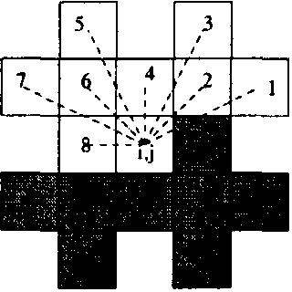

Figure 1: A pixel. its clique c and the eight directions. c' is the dark ea.

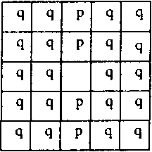

Figure 2: A missing pixel in a vertical edge.

[2] ISOIIEC *Digital compression and coding of continuous* ω*ne still images: requirements and guidlines.* Intemational Stan­

dard Organization1994

[3] Y. Wang and Q. F.Zhu"Error control and concealment for video communication: A review "*Proceedings oftlze IEEE*

pp. 974-997May 1998.

[4] Q. F.ZhuY. Wangand L.Shaw"lmage reconstruction for

hybrid video coding systems "in *Proc. IEEE Data Compres­*

*sion Conj*(SnowbirdUTp) p. 229-238Mar. 1992

[5] M. Ghanbari and V. Sef'ledris

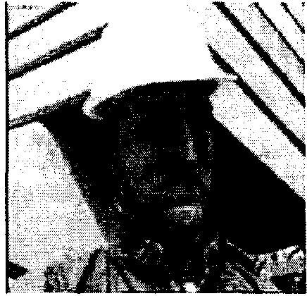

Figure 3: Original frame of the image sequence Forem1

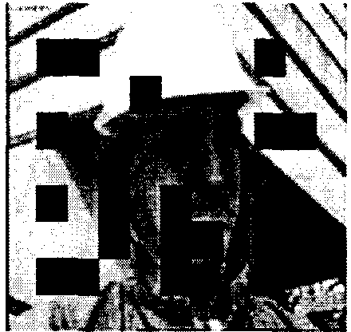

Figure 4: Frame missing MBs

Aτ'M videωocoesdc

"*IEEE Transactìons on Circuit and s*

*tem ìn video teclznology*vol.3pp. 238-247June 1993

[6] P. SalamaN. B.ShrofEf . J. Coyleand E. J. Delp"Eπor concealment techniques for encoded video streams "in *Pro­ ceedings of Intemational Conference on Image Processing* pp.9-121995

[7]η] H. Sun and W.Kwok

forrn coded imgae

gsnpuqirsli

0ec onontωoconvεxse*ts"IEEE*

*Transactìons image processing*vol. 4pp. 470--477April

1995

[8] W.Kwok and H. Sun"Multi-directional inteolation for spatialeπor concealment "*IEEE Transactions on consumer electronics*vol.39pp. 455-460August 1993.

[9] P. SalamaN. B. Shroffand E. J. Delp"A baysian ap­

proach to error concealment in encoded video streams "in *Proceedings of Internatìonal Conference on Image Process­ ing*pp. 49-521996.

[10] S. Geman and D. Geman"Stochastic relaxationGibbs dis­ butionand the Bayesian restoration of images" *IEEE Trans. Pattem Ana*l. *and Maclz. Int.*vol. 11no. 6pp. 689-

691.1984

[11] P. SalamaN. B. Shroffand E. J. Delp"A fast suboptimal approach to eπor concealment in encoded video streams "in *Proceedings of International C0è1rence on Image Process­ ing1997.*

Figure 5: Frame after reconstruction using a GMRF model

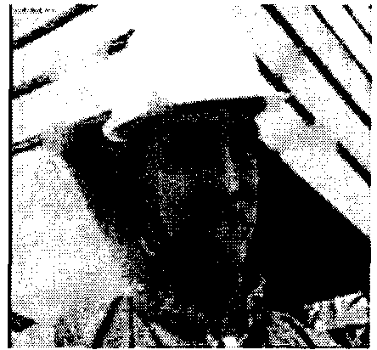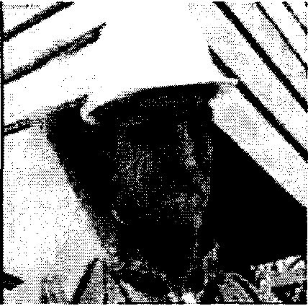

Figure 6: Frame after reconstruction using our adaptive G ffiF

model

3120