470 IEEE TRANSACTlONS ON IMAGE PROCESSING. VOL. 4. NO. 4 APRIL 1995

Concealment of Damaged Block Transform Coded

Images Using Projections onto Convex Sets

Huifang Sun*Senior MemberIEEE*and Wilson Kwok*MemberIEEE*

*Abstract-*An algorithm for lost signal restoration in block­ based stiIl image and video sequence coding is presented. Prob­ lems arising from imperfect transmission of block-coded images

resuIt in lost blocks. The resulting image is tlawed by the absence

of square pixel regions that are notably perceived by human visioenven in real-time video sequences. Error concealment is aimed at masking the effect of missing blocks by use of tem­ poral or spatial interpolation to create a subjectively acceptable

approximation to the true error-free image. This paper presents a spatial interpolation algorithm that addresses concealment of lost image blocks using only intra-frame information. It attempts

to utilize spatially correlated edge information from a large local neighborhood of surrounding pixels to restore missing blocks. The algorithm is a Gerchberg-type spatial domain/spectral domain constraint-satisfying iterative procesasnd may be viewed as an alternating projections onto convex sets method.

l. INTRODUCTION INbwmhmcodlng spatial dancies within

blocks are removedand the energy is compacted into a small number of coefficients after the transformation. Com­ pression is achieved by assigning more bits to code th high energy coefficients and less bits to the low-energy coefficients. The compressed data can be stored or be transmitted through

a communication channel. Practical communication channels

are not eπor free although the loss mechanism may vary widely from media to media. Data coπuption may be caused by network congestionthermal noiseswitch noisesignal

fad etc. Since the signals transmitted on real-world channels

are highly compressedindependent of causethe quality of images reconstructed from any coπupted data can be very unsatisfactory.

Error concealment is intended to ameliorate the impact of channel impairments (i.eb. it-errors in noisy channels or

loss in packet networks) by utilizing *a priori* information

about typical images in cuonction with available picture redundancy to provide subjectively acceptable renditions of affected picture regions. The concealment process must be supported by an appropriate transport format that helps to identify image pixel regions that correspond to lost or damaged data [81. Once the image regioTls to be concealed are identifìed

a combination of spatial and temporal replacement techniques

may be applied to fill in lost picture elements.

Manuscript received April 301993; revised April 221994. The associate editor coordinating the review of this paper and approving it for publication was Dr. Hsueh-Ming Hang

The authors are with David Samoff Research Center Princeton NJ 08543

53 USA

IEEE Lo.g Number 9409277

In this papewr e introduce a proposed method of eπor concealment based on projections onto convex sets (POCS) [7]. The POCS method of image restoration attempts to satisfy *a priori* characteristics typical of most natural video images.

The algorithmterates betw en satisfying spatial domain and spectral domain constraintms uch like Gerchberg's method

[91. We investigate th proposed algorithm by perforrning simulation on typical video images. The algorithm is judged 00

how well it perforrns with varying degrees of e or localization (i.e. how large the damaged region is). Typical rates of algo­ rithm convergence are deterrnined. An objective figure of merit using peak-signal-to-noise ratio will assess the improvement

gains over simpler methods of concealment. Pictorial results

wiII demonstrate the subjective quality of the restoration.

II. BACKGROUND

*A. The Source ( l Errors*

A typical block-based video source codesruch as MPEG [10]consists of the cascade of a linear transforrn Op ration quantizationand entropy coding. Specifically in the MPEG standardan image is segmented into nonoverlapping blocks; then each block or prediction residual block is transforrned via

DCT to remove spatial correlation and subsequently the DCT coefficients ar quantized and entropy coded using variable length cod words. When bit errors occur in such a highly compressed bitstream all subsequent inforrnation becomes useless until bitstream synchronization can be reestablished. Pack tization is the most common way to localize eπors in a bitstreamand provides for resynchronization in the case of bit

E ors. Packetized bitstreams are suitable for transmission via a broadcast RF channel or packet switched network. In either scenariobit e ors that occur may lead to lost packets. In the packet network contexnt etwork congestion may cause some

packets to be discarded and simply not sent to the receiver. In

the broadcast RF contexdt amaged packets may be received with uncorrectable bit errors and there is no way to ascertain how much of the data within the packet is usable. So for practical puosedsamaged packets are treated as lost packets.

Packets contain a known number of image data segments

For our puos a basic unit of image data wiII be taken as a 16 x 16 pixel block of image samples. A packet will contain one or more of these blocks. Loss of a packet therefore results in loss of a known quantity of blocks in the image. ln the followingwe first consider the restoration of a lost block surrounded by good blocks. Latewr e address situations where

adjacent blocks are also lost.

I( 7-7149/95$04.00 1995 IEEE

SliN AND KWOK: CONCEALMENT OF DAMAGED BLOCK TRANSFORVI CODED IMAGES

P(BIG)

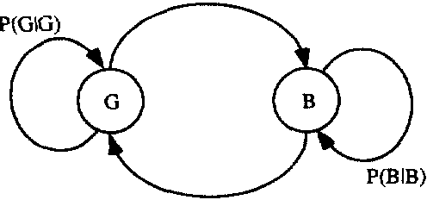

)( r.lsignalwEi

Signal with TOrs

471

P(GIB)

Fig. 1. Markov discre\e channel model

B. Discrete Channel Model

A discrete channel model is u ed because our studies involve only discrete packet quantities. The model will char acterize the channel at the packet 1 vel and not at the physical waveform level. A simple channel model often employed for the simulation of bursty eπor sequences is a two-state Markov chainas shown in Fig. 1. Th two states correspond to reception of a (G)ood packet or a (B)ad packet. This model can describ the types of eηor dependence in real channels and is suggest d by experimental data [51. Two parameters for this model have to be specitìed: the probability of receiving

a bad packet given the pr vious received packet was good *(P(B* 1 G)) and the probability of receiving a bad packet given the previous packet was bad *(P(B* 1 *B)).* Altematively we may specify an average packet e or probability and a mean

burst length of con cutiv lost packets. The average packet

Fig. 2. Example 01' packet-Ioss degradation

pseudo-inverse estimate f+ H+g Hg = g. Therefore in order to restore a useful estimate of fwe must rely solely

on *a priori* constraints about the class of images to which f

belongs.

D. Previous Related Work

The problem of lost data in block-coded images due to imperfect communication channels needs to be solved. In particulaar good spatial intoelation method is necessary

for hiding the effect of missing blocks in still images and video frames. Temporal inteolationor replenishme by itself is not always adequate for concealment of e ors in video sequences. This is specially true for stressful image scquences with irregular motion. abrupt scene changeasnd intra-coded image frames that are treated as still images. To the viewepr oor temporal replacement of em regions appear

as portio| ns of the image being broken up into displaced pieces.

M-mEEaBEBEE--hnu

error probability is given by 12

13

*P(B)* = P(β1 *G)/[1* - *P(B*I *B)* + *P(B* I *G)]*

and the mean burst length is given by

*Ln* = *1/[1* - *P(*β *IB)]*

*C* lma e DeKradatíon Model

Earlier consideration of a spatial interpolation altemative was

addressed in Wang and Zhu 11]. In that workthe spatial

(1) or concealmeX+4nt used an approach of interpolating a single­

pixel wid boundxa-5 ry around th missìng block tωo achieve

a restoration based voh@6 n an optimal measure 0f smooωthness. (2) The damaged blocks wX4e7 re restοr d f awirell in verηY low­

[

frequency portions of the image. However. the smoothing

l

process restores blurry blocks with a signitìcant loss of detail

|-

Packct losses manifest themselves as an erasure of pixel regions in video images. An illustration in one dimension is shown in Fig. 2. Signal f is the ideal image without eπor and g is the corrupted image. The degradation can be expressed as

in hìgher frequency po ions of nE the image.

In this paper. we seek to utiliz l1 lspatially correlated infor­

e

mation more thoroughly by performinng interpolation based on a large local neighborhood of surrounding pels and to

restore edges that are continuous with those present in the

g= Hf

o ()

()

g=

o

()

(3) neighborhood. Ramamurthi and Gersho 12J have demonstrated that dges play an important role in the subjective quality

of imagesand have developed a post-proccssìng algorithm

fo to reduc blocky artifacts caused by low bit-rate VQ. It

performs nonlinear space-variant tìltering that adapts to the

i shape of the local ignal spectrum and effectively smooths

out the "staircase" nois with tìlt rs aligned parallel to dges

14 Some of the concepts in [21 used to estÎmate the local edge

t characteristics in imageasnd their use of directional tìlters

fó can be applied to our application of restoring lost image blocks.

f III. PROPOSED METHOD

f9

Space variant restoratÎon is a method of adaptively tìltering

a degraded image to suit the local image characteristics. To proceed with this objectivewe need to estimate from the

The degradation operator H acts to admit some values of f unchanged and nulls out the others. The degradation caused by

H is abrupt. H is rank detìcient. and so it cannot be directly

inverted to estimate f. The pseudo-inversc H+ does not serve to give a useful estimat of f because H =H and so the

decoded image whether the missing block to be restored belongs to a monotone or edge area of the image. If the block

belongs to an edge portion of the imagewe must further estimate the orientation of the edge. Information obtained from the surrounding valid decoded blocks are used as an aid in

472

IEEE TRANSACTIONS ON IMAGE PROCESSING. VOL. 4. NO. 4 APRIL 199

T

LH

I

F3

03CU

EJ

MmI=

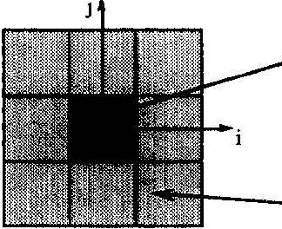

Ilal--Eta-L

V

'm-

n12I t

t

M: MissingBl k n

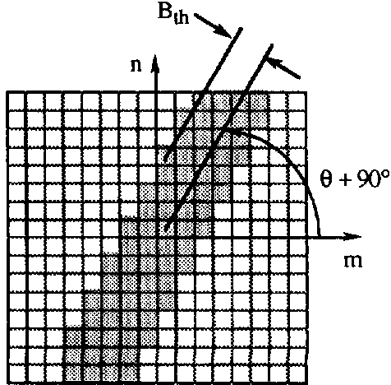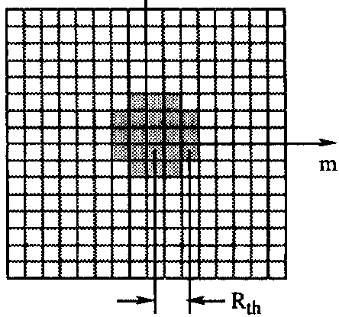

*N:* 5uπ'Ounding Neighborhood

Fig. 3. Missing block :((o(hp)})fa pixels with πounding neighborhood 01" good

pixels

mwl21

hd-----

--n

OE

-S

112.so (D5)

9Q"1(I"D4) 67.5'(D3)

135 ρ4 I *r*-guv i

.;45('D2)

(a)

157.5 7)_ \ 11 / .."X.....---2LL2.5' (D1)

3

E:...----u31i"110o'(00)

Fig.5 (a) Lowpass filtc (b) bandpass directional filter

Fig. 4. Eight directional edge categories

KU

d;(- m!)2

9u

thus corresponds to one of eight directional categories equally spaced around 1800 as depicted in Fig. 4. There ar counters

determining edge angle. Once the missing block are](a- has been

L)

li

classifi d to b monotone or an edge of particular orie1liltP-llAntation

iw

a filter specific to the class identified is then applied to reIsqutore

for each of the eight directions *Do* through *D7.* A voting

mechanism is used that involves incrementing the selected category counter by the magnitude of the gradient if a line

the missing block.

A. Block Class(fier and Edge OrientatÎon Detector

tv

JVEEF

F3

drawn through the pixel at ('i. *j)* with orientation *ß* passes through the missing block. This is described by the following

pseudo-code

*Lost image blocks are restored by extending edges present in the surrounding neighborhood so that they pass through*

*the missing block.* If *no edges are present in the su ounding*

DO [over all *(i j)* pixel coordinates in neighborhood N] {

Compute G and *ß* from equation (7)

*0*

*neighborhood the lost block is restored by a smoothing*

J.:*[round(ßj22.5*

*)* + mod 8

*process. To accomplish this the presence or absence of edges must be detelmined; if edg s are presentthe most likely edge orintation should be coηectly chosen based on some knowl­ edge of the edge characteristics around the missing block. A reasonably simple and effective method of performing this*

cJ*assification is through the use of gradient measures in the*

*spatial domain. The local edge gradient components for the*

if[line drawn through *(ij)* with a le *ß*

intersects M] {

*D.=Dk+G*

(8)

*pixel* :z:( i. j) *is computed by*

r :/:;+l).-1 -.1:;-1 ) 1 +2./+1.*j* - 2 :/:;-I..i

After all the pels in the surrounding neighborhood have

"voted" the counter containing the largest value determines which direction to use in the interpolation

+ +1.1 - :r:;--l..i*+l (4)*

_q*y* :/:;-1*J+1* - :1:;-1.1) + 2:1:; .i 1 - *2:*1:;*j_l*

k:max = ari!;lll *x(D*k)

A )

(9)

*+ :C*1*;* .*)+1* -:r*l*:*j*;*-l'*

(5) If the largest counter value is below a certain threshold value *T.* then th re is no discernible edge orientation and the block is classified to belong to a monotone portion 01' the image(l

The magnitude and angular direction of the gradient at coor­

dinate *(i*ρare

V

)

*Dkm"x* < *T]* {

*ME* MONOTONE AREA

*} els* {

*M* EDGE AREA with orientaloll gi\'en

G= j hbLIII(fhMr)

(7)

*by index* I.-*max*

The Sobel operator is select d for gradient estimation due to its circularity property [6]which gives more accurate angle estimates over the standard gradient operator. Fig. 3 illustrates the missing block of pixels denoted by1 surrounded by a neighborhood of correctly received pixels denoted by N. The

gradient measure is computed for every *(i.* .f) coordinate in the neighborhood surrounding the missing macroblock. The

value of the gradient angle is rounded to the nearest 22.5 0 and

Now the missing block has been classified as being a monotone block or an edge block with a particular orientation.

B. Projections onto COf1vex Sets

*An it rative technique for restoring the damaged image blocks can be developed based on the method of projections onto convex sets (POCS). POCS has becn applied to various*

SUN AND KWOK: CONCEALMENT OF DAMAGED BLOCK TRANSFORM CODED IMAGES

47_l

image restoration problems where *a priori* information can be used to constrain the size of the feasib1e solution set

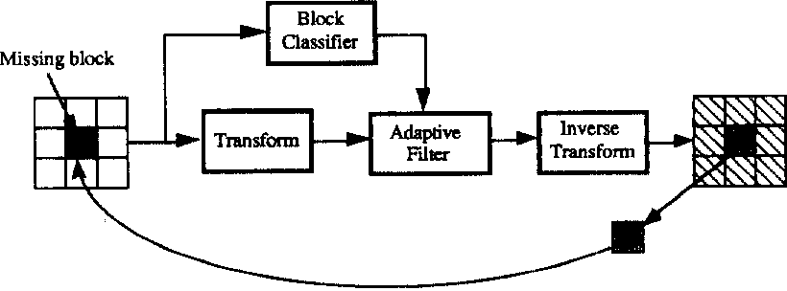

[31. [4J. These constraints can be used at the receiv r to

implement a1gorithms that generate an estimate of the imag to be restored. There are *a priori* properties about typical video

images we wou1Td 1ike to use; these inc1ude:

*1) Smoothness*P*-*P*requires reconstructed samples to b*

*smoothly conn*q*e*4x*cted with adjacent samp1es Fig. 6. Adaptive POCS iterative restoration proce*

*2) Edge Continuity-requires that edges of objects in the*

-

*scene be continuous*

ErzErt

*3) Consistency with know* nzyd *values-requires that corr ctly*

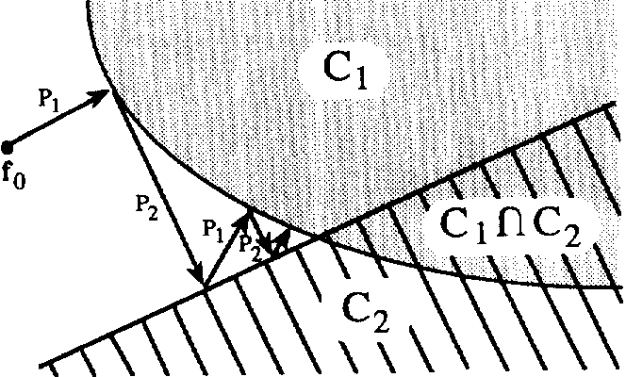

*received samp1e values not*x*be altered by the restoration*

*processand that restored va1ues lie in a known range*

*(e.g.* [*255]).* tO

*The goa1 is to formulate these desir' d pr*I*operties as convex*

*constramts.* w

e

pd

*Common constraints such as space-limitingband-limiting*

*nonnegativityand bounded energy are known to be convex sets [71. To characterize the desired image properties enumer­*

*ated ahove we make use of th following conv x constraints*

(

l

Fig.7 Signal space illustration ()f pr eclIons onto convex sets

*and projection operators:*

i ) Projection operator P1 can be used to impose the constraint

*1)* The class of signals that takes 011 a prescrihed set (d' knowl1 values: *This set C 1 containing a*l1 *signal vectors x in n-dimensiona1 real spac Rn with some components*

*equa1 to known valucs can be expressed as*

of consistency with known values. Any signal vector x rep­

resenting an image over this region shown in Fig. 3 can be forcedPto satisfy consistency with the fol1owing projection

''AX

C1={xεRn: =I.:*j.;* εI}

where .D *j* is the *ith* component of vector xand 1 ;; are known constants in a given index set 1. The projection

J

BFEBEBEEE-Et-

ko2I

h FJh

JFJj

indiceand :a;;re the correct1y

(15)

operator P1 onto conv x set C1 is given by

where *(ij)* are the pixel

((([

'' +M

1εI

otherwise.

received neighborhood pixe-eLlH e--1-1cva1ues.

Projection operator P2 canJtp/l be. used to impose smoothness

(12) and edge continuity constraints. PNMMM 2 is adaptive to the 10ca1

image charact ristics. 1n monotone aaanrneas of the imagethe spectrum is nearly isotropic and has veJrUAUy low bandwidth. So.

*This per ction operates as fo*l1*ows: if the value of the component is known then this value is assigned to the projection; otherwise it is 1eft unchang d*

2) The cl*α*SS of signals that takes on a prescrihed set *(!f*

tral1sform coeffìcients: *This set C 2 containing all signal vectors x in n-dimensional complex space Cn with some transform coeftìcients equal to known values can*

*be expressed as*

(13)

for missing blocks classitìed to belong to monotone ar aws e can impose the constraint that any feasible r<e>storation must

have a lowpass bandlimited spectrum (i.em. ust beO2 smooth)

d'dJ

J

Specitìcal1y in this caseconvex set Cbecomes rd

C2 S*OTH* = n ; [Tx]m 1) Jτ ; Rtlt}

{xεC

(16)

where T is the 2-D *N* x *N* discrete Fourier transform operator

*(rn n)* specify indices to a Fouri r coeftìcient with*T /2*

T *nN* /2- 1and Rtlt is a threshold radius that specitìes

C 2 = {xεCn : [Tx]; = *.Zj* i εI}

where T is a linear transform operator [Tx]; is the

the lowpass cutoff frequcncy. Projection operator P2 then

becomes

I JO JF> Rth

ith transform coeftìcient and ;::are known constants

in a given index set 1. The projection operator P2 onto

*TP2SMOOTHX]m.n* = 1[T *X]*

" 1I'

othcrwise

(17)

convex set C2 is given by

ft h trans;foωrm

So *P2.SMO* ο*TH* acts as a lowpass fìlter that sets high fre­

quency coeftìcients located outside the handwidth radius spec­ (14) ifìed by Rth to zero and leaves low-frequency coeftìcients

unchanged. Fig. 5(a) il1ustrates the fìlter corresponding this

projection. The shaded regions denote the passband of the tìlt r with unity gain and th unshaded regions denote the stopband

assignedhta t coeftìcient ohte rwise it is left unchanged.

of the tìlter with zero gain. ln edge arcas of the image.

474

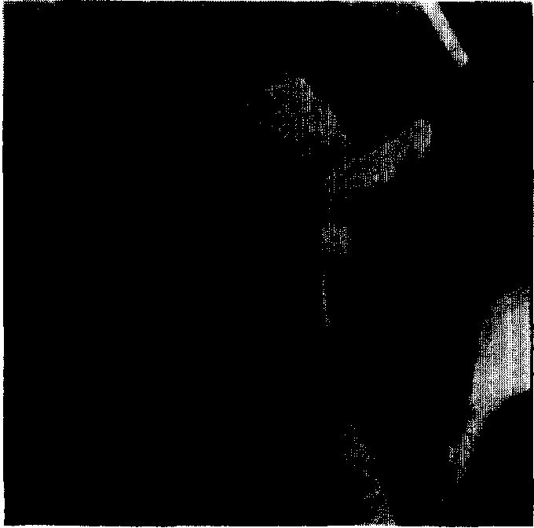

(a)

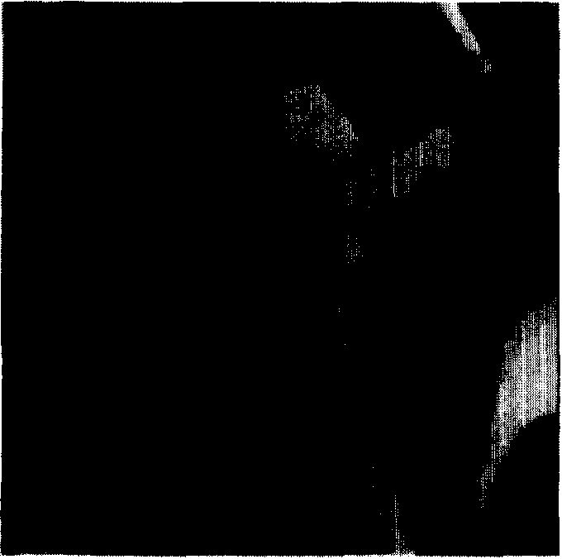

(c)

IEEE TRANSACTIONS ON IMAGE PROCESSING. VOL 4. NO. 4. APRIL 199

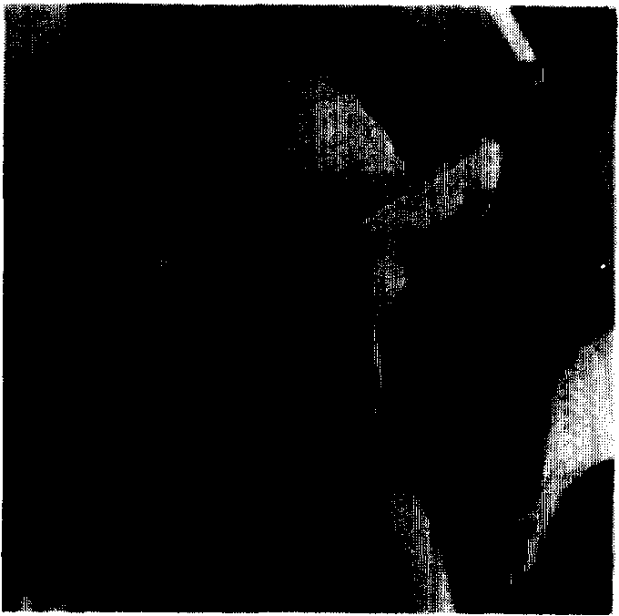

(b)

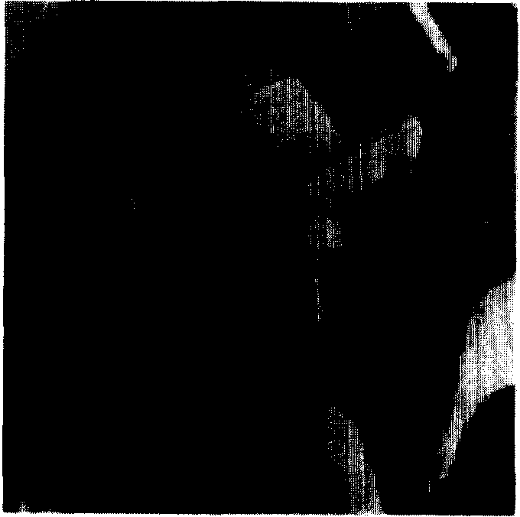

(d)

Fig. 8. Isolated lost block experiment. (a) Original "Lena" image512 x 12; (b) damaged image with lost blocks concealed with neighborhood mean value

(20.26 dB); (c) smooth POCS restoration (2 1.33 dB); (d) adaptive smooth/edge POCS restoration (23.93 dB)

the spectrum has a bandpass characteristic in which energy is localized in transform coefficients that lie in a direction orthogonal to the edge; the other remaining coefficients are

very small. So for missing blocks classified to belong to

edge areaswe can impose the constraint that any feasible restoration must have a bandpass spectrum oriented orthogonal to the classified edge. Specitìcally in this case convex set C2 becomes

*C2.EDGE* = n : [Tx]rn.n = ()

{xεc

These two convex projections can be used in the proposed H rative restoration algorithm shown in Fig. 6. Here the damaged block with surrounding good blocks is used to form a large block. The laer block is classitìed to be monotone or one of the edge directions and at the same time undergoes a Fourier transformation. The transform coeffìcients are fìltered by the adaptive fìlter according the type of the large block

specifìed by the c1assifier. The filtered coefficients are used to

reconstruct the image using inverse transform. The portion of the reconstructed image at the location of the damaged part of

| *n* * tan(B + 9(0 )1 > *Bth}*

(18) the image is sent back to the input for the next iteration.

Thusthe signal to be restored is forced to satisfy the

where T is the *2-D N* x *N* discrete Fourier transform operator

*n)* specify indices to a Fourier coefficient with -*N /2*

*m .nN 12-* 1 *ø* is the angle of the classified edgeand *B th*

is a threshold bandwidth. Projection operator Pz then becomes

[TP2*EDGEX]*

two convex constraints by alternatively projecting onto each convex set. The signal to be restoredf can be founcl through the following iteration

f;+l = P 1P2f; (20)

_ ;J 0 l

"

1'm-_ 11 * t'<'1'-.-9\0''

0 )11 >-

Bth

-u

(19)

where we have identified the following operators P 1 and Pz as

1[T X]rn ll' otherwise

SoP 2 *EDGE* acts to set frequency co ffìcients located outside the bandpass bandwidth specified by Bth to zero and leaves th other frequency coefficients unchanged. Fig. 5(b) illustrates

the filter corresponding to this projection operator.

P2 is the projection operator coηesponding to the aclaptive filtewr hich imposes the convex constraint that cealll transform coefficients are known *a pri*ο*ri* to be zero.

P 1 is the projection operator coηesponding to copying the restored image block back into the center of the large

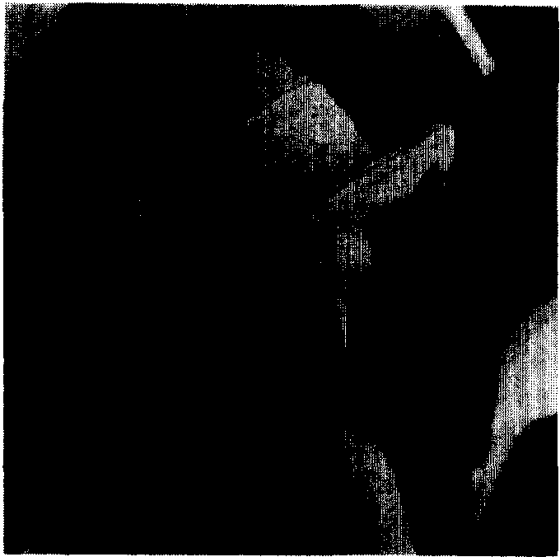

(a)

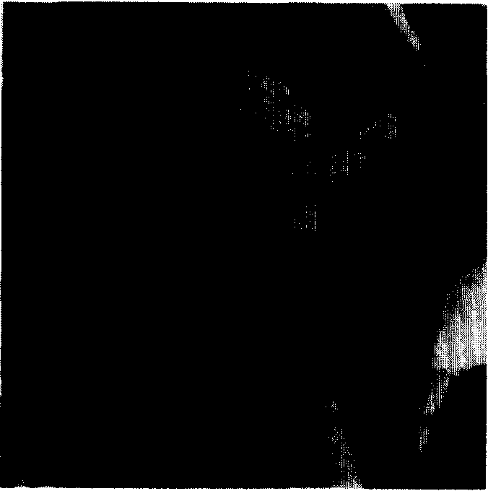

(c)

(b)

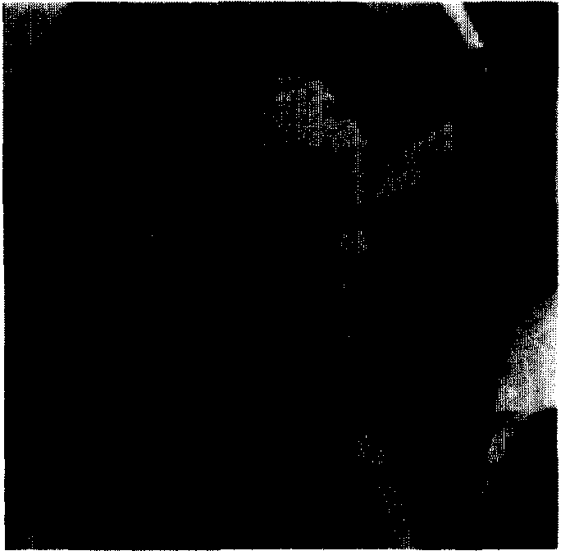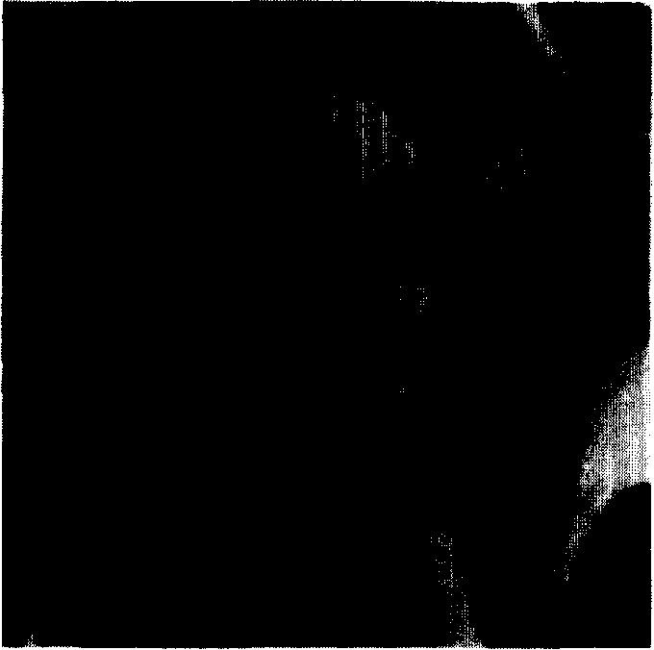

(d)

Fig. 9. Contiguous lost block experiment. (a) Original "Lena" imagc 512 x 512; (b) damaged image with 105t blocks concealed with neighborhood mean value (15.97 dB); (c) smooth POCS restoration (16.71 dB); (d) adaptive smooth/edg POCS restoration (18.08 dB)

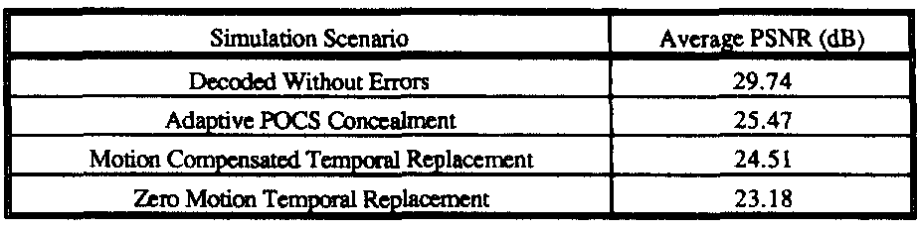

Fig Average PSNR for the video sequence

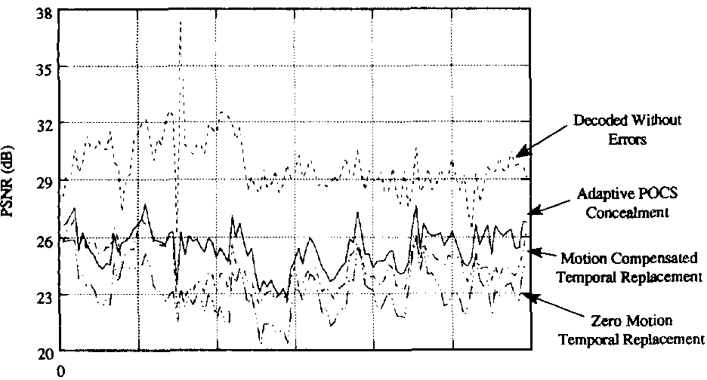

20 40 80 1 120

*F*

Fig. 10. Video experiment on sequence "Basketbal1."

block which imposes the convex constraint that forces known correctly received neighboring pixel values to remain unchang d.

If the two convex sets intersect one anothetrhen convergence

to a point of intersection is guaranteed [7]. If the two convex sets do not intersectthe algorithm will oscil1ate between two projection points that are in some sense "c1ose" to both ts.

Depending on where the algorithm stopsthe solution will either be in one set or the other. Fig. 7 illustrates this projection

proccss.

According to the c1assification an adaptive filter is formed that either passes transform coeffìcients of low­ frequency or transform coeffìcients aligned with the classifìed

edge unchanged and zeroes out the rest. Although the

adaptive fìlters impose constraints that are not exact *a priori* knowledge these heuristically developed constraints form good estimates of the likely solution space. If th classifìed block belongs to a monotone area. we see that the algorithm acts to create a r constructecl block that is a smooth extension of neighborhood blocks. If the classified block belongs to an edge areathe algorithm acts to create

a reconstructed block with an edge extended from th neighborhood pixel region. We note that this algorithm produces a restored image that is consistent with all correctly received data; good image blocks are not altered by this process



(a)



(c)

(b)



(d)

Fig. 12. Snapshot of a P-picture from the video experimenl. (a) Decoded without eπors (29.46 dB); (b) zero motion temporal replacement (23.8l dB); (c)

motion compensated temporal replacement (24 44dB); (d) adaptive POCS spatial concealment (25.60 dB)

IV. SIMULATION RESULTS

The algorithm is tested on several still images and image sequences. le size of the test image is 512 x 512 pixels and lost blocks are 16 x 16 pixels. Monotone/edge gradient decision threshold *T* 5000. lowpass fìlter radius R th

3and bandpass width *B th* 3 were found to be suitable

threshold parameters for typical images of those dimensions.

Simulation results show that good restored images can be obtained after approximately fìve to ten iterations when the initial starting valuefo from (20i)s set to the mean value of pixels from the neighboring blocks.

Fig. g shows pictorial results of a still image experiment in which lost blocks are isolatedwhereby each lost block

has all eight of its neighboring blocks received correctly.

Fig. 8(a) is the original "Lena" picture. Fig. 8(b) shows the damaged blocks simply concealed by a constant neighborhood averaging of pixels. The blockiness present makes this simple method unacceptable in most images. Fig. 8(c) shows the results of the POCS method using only a space-invariant

smoothing constraint. lt is seen that blurred blocks result in

the reconstructed image. FinallyFig. 8(d) shows the results

of the POCS method using adaptive classifìed edge constraints in addition to the smoothness constraint. The quality of the restored edges of the background vertical columnthe hat rim

and Lena's lip is noteworthy. The peak signal-to-noise ratio

(PSNR) serves as an objective measure of image qualityand is given by

( 2552 \ PSNR = 10 Ioe: I ..... . _ I n 7 2:::; |r($11)-k(iJ)|2/

212:1=

(21 )

where 5: is the restored image :J.: is the original imageand the dimensions are N x f pixels. The PSNR's for Figs. 8(b)-(d) arl 20.2621.33and 23.93 dBrespectively.

Fig. 9 shows pictorial results of another still image exper­ iment in which lost blocks occur consecutively in a row so that horizontal adjacent blocks are also lost. This scenario represents a severe case of errors when image blocks are

packetized and transmitted in raster-scan order. Missing block classifìcation is limited to an estimate based on neighboring top

and bottom good blocks only. Fig. 9(a()d) shows the original imagemean value restorationsmooth POCS restorationand adaptive smooth/edge POCS restorationrespectively. The PSNR's for Figs. 9(b()d) are 15.9716.71and 18.08 dB respectively.

The results have shown that if an edge direction is chosen correctlythe edge wilJ be extended from the surrounding blocks to the recovered lost blocks. When strong edges are presentthe classifìer works well in determining which di­ rection to use in the directional fìltering. In Fig. 9(de) dges oriented close to horizontal cannot be expected to be restored as well as those oriented vertically because of the lack of valid decoded blocks on either side. Overaltlhe scutive quality

of the image is good considering the severe damage caused by so many lost blocks.

In the video sequence simulationqs uantitative results are obtained by calculating PSNR as a function of frame number. The video sequence source tested is "Basketball which

contains moderately irregular motion throughout; it consists of 720 x 512 pixel image frames and is encoded with an MPEG encoder at 6.0 Mbps. MPEG coding parameters [10] J'\;! 3 and *N* 15 wer usedwhich effectively limits

the extent of temporal error propagation to be less than 15

SUN AND KWOK: CONCEALMENT OF DAMAGED BLOCK TRANSFORM CODED IMAGES

477

frames. The r sulting bitstrearn is then pack tized into 47- byte ATM-style data packets and e ors were introduced with a ceJl loss probability of 10- 2 and rnean burst length of 2. ln the MPEG contexat *slice* consìsts of an integral number

of *macroblocks* grouped together in raster-scan row order Each MPEG macroblock consists of the combination of 16 x 16 pixel lumìnance blocks and corresponding chrominance blocks. Upon occu nce of a lost packertesynchronization into the bitstream begins at the start of the next slice. A slice size consisting of nine macroblocks was chosen to localize the eη rs. We compare the perforrnance for four different simulation cases: 1) decoded sequence without eηors; 2) de­ coded sequence with e ors and adaptive POCS concealment;

3) decoded sequence with rrors and rnotion cornpensated

temporal replacement; and 4) decoded sequence with eπors and zero motion temporal replacement. The zero motion temporal replacement scenario simply does a macroblock-copy

of co esponding pixels from the previous reference frame whereas the motion compensat d ternporal replacernent sce­ nario does a motion cornpensated macroblock-copy using the motion vector from the top aacent macroblockif available.

Fig. 10 shows the results of cases 12) ). 3a)nd 4) plotted

on the same set ofaxes. Fig. 11 shows the average PSNR

for all four cases. he PSNR's are cornputed relative to the original uncoded source irnages. It is observed that the adaptive POCS concealment algorithrn performs b tter than motion compensated block-copying by 1.0 dB and better than zero motion block-copying by 2.3 dB; the adaptive POCS concealed irnages are within 5 dB of perfectly decoded images.

In Fig.a typical P-picture located in the middle of a group

of pictures (GOP) is taken frorn the set of four simulation scenarios and displayed for cornparison. These r sults are not intended to suggest that our spatial concealment algorithrn perforrns better than temporal replacem nt in general but only in certain kinds of video sequences. When errors strike portions of video that hav highly irregular rnotion and scene­ cutspatial concealrnent will generally perform better than temporal replacement; when eηors strike portions of video that have uniforrn srnall or no motion temporal replacement

will generally perform better. Spatial concealment can be

combined with temporal replacement to obtain even better error concealment than either rnethod alone [11].

V. CONCLUSION

Compared with the existing spatial error concealment al­ gorithm 11t]he technique proposed here has two important features. Th first is th us of spatially correlated inforrnation on a large local neighborhood pels instead of a one-pixel wide boundary. In such a wthe edge information can be better estimated. Seconddirectional filtering is used for recovery of

the missing block. In this methoda directional constraint instead of only a smoothness constrainits applied to the method of projections onto convex sets. Th reconstruction of the lost block converges to the set with edge information

specified by the directional filter. This spatial concealment

technique can be used to recover the lost blocks in still images or video sequences. It can also be combined with temporal

replac m nt algorithms to provide improved error concealment for block-based video sequence coding.

REFERENCES

[1] Y. Wang and Q. Zhu. "Signal loss recovery in DCT-based image and video codecs." in *SP/E Proc. Visual Commlln. /mage Processing '91.* Boston MA.Nov. 11-13. 1991 pp. 667 678.

[2] B. Ramamurthi and A. Gersho. "Nonlinear space-variant postprocessing

of block coded images." *IEEE Trans. Ac(}u; .Spee( h Si*f?*nal Processin*

vol. ASSP-34. no. 5. pp 1258-1267 Oct. 1986

[3] M. 1. Sezan and H. Stark "Tomographic image reconstruction from in

complete view data by convex projections ancl direct Fourier inversion "

*IEEE Trans. Med. /ma*f?.vol. MI-3pp. 91June 1984.

[41 M. 1. Sezan ancl M. Tekalp. ' Adaptive image restoration with artifact

suppression using th theory of convex projections" *JEEE Trans*

*Ac(}usr.Spe 'h* Si *nal Processin*ιvol. 38. no. 1. pp. 181-185 Jan

1990.

[5] M. C. Jeruchim et al..*Simulation of* Cρ*mmunlcatl* 1 *Systems.* New

York: Plenum 1992

[6] E. R. Davies*Machine Visioll.* New York: Academic. 1990

[7] D. C.Youla and H. Webb. "Image restoration by the methocl of convex

projections: Part I-Theory " *IEEE Trans. Med. lmag..* vol. MI-Ipp

81-94 Oct. 1982.

18] D Raychaudhuri H. Sun. and R. S. Girons. . ATM transpo ancl cell­

los5 concealment tcchniques for MPEG video." in *p* υ*c. ICASSP '93.*

pp. 117 120 vol. 1

[9] R. W. Gerchberg "Super-resolution through error energy reduction."

*Opt. Acta.* vol. 21. pp. 709-720 1974

1101 Moving Pictures Experts Group.

associated auclio for digital storage media at up to about 1.5 Mbps. Part 2: Video"*/SO-IECIJTC I SC29*4f*G* /l Nov. 23 1991.

111] H. Sun ancl J. Zdepski "Adaptivc e or concealment algorithm for

MPEG compressecl video." in *Proc. SP/E Visual C*υ*mmun. Signal Pr* υ­

*cessl* '92 pp. 81 4-824 1. 2

Huifang Sun '86-M'XιSM'93) received the B.S. degree in electrical engineering from Harbin Engineering Institute Harbin China in 1967 and the Ph.D. degree in electrical engineering from University of Ottawa Ottawa Canada in 1986

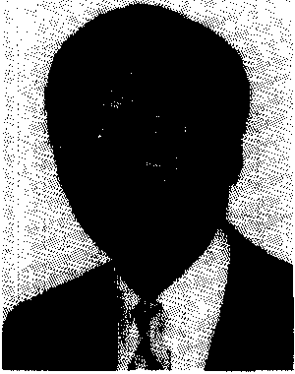

Beginning in 1970 he wa an engmeer at

the Shanghai Aeronautical Radio and Electronic

Research Institute Shanghai China. In 1981. he was a visiting scholar at Laval University Quebec. Canada. From 1982 to 1986 he was with thc

digital image processing laboratory in electrical engineering at University of Ottawa. where he s rved as a Teaching Assistant Research Assistant and post-doctoral Fellow. In 1986. he jointecl Fairleigh Dickinson University Teaneck NJ. as an assistant professor and later as an associate professor in electrical engineering. Since 1990. he has been with the David Sarnoff Research Center (formerly RCA Laboratorie Princeton NJ. as a Member of thc Technical Staff. His current interests include digital image processing vid o data compression and e ür concealment. visual communications. and HDTV d ign.

1filson Kwok (M'93) was born in Brooklyn. NY in 1970. He received the B.S. ancl M.S. degrees in electrical engineering. summa cum laude from The Cooper Union. New York. NY in 1991 and 1992 respectively

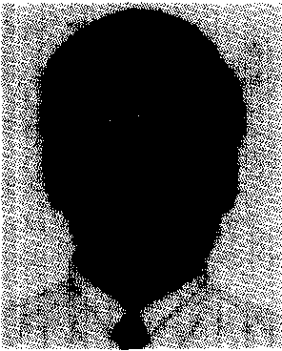

In 1992 he joined the David Sarnoff Research Cent where he is now a Mernber 01' the Tech­ nical Staff. He currently works on MPEG IDTV development. His research interests includc imaging systems image/video processing and communica tion network systems.

Mr. Kwok was the recipient of the lEEE Region 1 studcnt paper award in

1991 for his work on synthetic aperture radar imaging systems