ITU - Telecommunications Standardization Sector  STUDY GROUP 16 Question 6  Video Coding Experts Group (VCEG)  _________________  14th Meeting: Santa Barbara, CA, USA, 21-24 September, 2001 | Document VCEG-N62  Filename: VCEG-N62.doc  Generated: 18 Sep ’01

Question: | Q.6/SG16 (VCEG)
Source: | Viktor Varsa  Nokia Research Center  6000 Connection Drive  Irving, TX, 75039 – USA  Miska M. Hannuksela,  Ari Hourunranta  Nokia Mobile Phones  P.O. Box 68  33721 Tampere  Finland  Ye-Kui Wang  TICSP  Tampere Univ. of Technology  P.O. Box 553  FIN-33101 Tampere  Finland | Tel:  Fax:  Email:  Tel:  Tel:  Email:  Tel:  Email: | +1 972 374 1861  +1 972 894 4589  viktor.varsa@nokia.com  +358 40 5212845  +358 40 5276441  miska.hannuksela@nokia.com  ari.hourunranta@nokia.com  +358 3 365 4368  wangy@cs.tut.fi
Title: | Non-normative error concealment algorithms
Purpose: | Proposal

Summary
In order to have a realistic view of H.26L’s operation in error-prone systems, basic error resilience tools have to be implemented in the TML reference software. One of these basic tools is decoder-side error concealment. As error concealment is out of the scope of the standard itself, this contribution proposes non-normative error concealment algorithms for TML software. The description of the algorithms can be included in an informative part of the test model description.
Results comparing the proposed error concealment algorithms with the current TML-8.4 software in H.323/Internet conditions can be seen in VCEG-N63. The results show that the proposed algorithms outperform TML-8.4.

General
The proposal assumes that no erroneous or incomplete slices are decoded. After all received slices of a picture are decoded, skipped slices are concealed according to the proposed algorithms. In practice, record is kept in a Macroblock (MB) based status map of the frame. The status of an MB in the status map is "Correctly received" whenever the slice that the MB is included in was available for decoding, "Lost" otherwise. After the frame is decoded if the status map contains "Lost" MBs, concealment is started.
Given the slice structure and MB-based status map of a frame, the concealment algorithms were designed to work MB-based. The missing frame area (pixels) covered by MBs marked as "Lost" in the status map are concealed MB-by-MB (16x16 Y pixels, 8x8 U,V pixels). After an MB has been concealed it is marked in the status map as "Concealed". The order in which "Lost" MBs are concealed is important as also the "Concealed", and not only the "Correctly received" MBs are treated as reliable neighbors in the concealment process whenever no "Correctly received" immediate neighbor of a "Lost" MB exists. In such cases a wrong concealment can result in propagation of this concealment mistake to several neighbor concealed MBs. The processing order chosen is to take the MB columns at the edge of the frame first and then move inwards column-by-column so to avoid a concealment mistake made in the usually "difficult" (discontinuous motion areas, large coded prediction error) center part of the frame propagate to the "easy" (continuous motion area, similar motion over several frames) side parts of the frame.
Figure 1 shows a snapshot of the status map during the concealment phase where already concealed MBs have the status of "Concealed", and the currently processed (concealed) MB is marked as "Current MB".
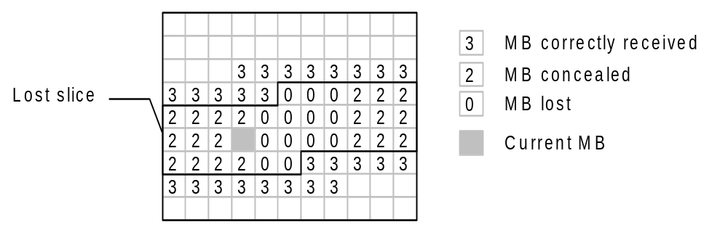
Figure 1: MB status map at the decoder

INTRA Frame Concealment
Lost areas in INTRA frames have to be concealed spatially as no prior frame may resemble the INTRA frame. The proposed spatial concealment algorithm is based on weighted pixel averaging as is illustrated in Figure 2. The weight used for averaging is simply the inverse distance between the source and destination pixels.
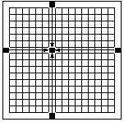
Figure 2. Spatial concealment based on weighted pixel averaging
In the proposed spatial concealment algorithm, only "Correctly received" neighboring MBs are used for concealment if at least two such MBs are available. Otherwise, neighboring "Concealed" MBs are also used in the averaging operation.

INTER Frame Concealment

General
Instead of directly operating in the pixel domain a more efficient approach is to try to "guess" the motion in the missing pixel area (MB) by some kind of prediction from available motion information of spatial or temporal neighbors. This "guessed" motion vector is then used for motion compensation using the reference frame. In the proposed algorithm these copied pixel values give the final reconstructed pixel values for concealment, and no additional pixel domain operations are used. This is a simple form of temporal concealment.

Concealment using motion vector prediction
In the proposed temporal concealment algorithm, the motion activity of the correctly received slices of the current picture is investigated first. If the average motion vector is smaller than a pre-defined threshold (currently ¼ pixels for each motion vector component), all the lost slices are concealed by copying from co-located positions in the reference frame. Otherwise, motion-compensated error concealment is used, and the motion vectors of the lost macroblocks are predicted as described in the following paragraphs.
The motion of a "Lost" MB is predicted from a spatial neighbor MB's motion relying on the statistical observation, that the motion of spatially neighbor frame areas is highly correlated. For example, in a frame area covered by a moving foreground scene object the motion vector field is continuous, which means that it is easy to predict.
The motion vector of the "Lost" MB is predicted from one of the neighbor MBs (or blocks). This approach assumes, that the motion vector of one of the neighbor MBs (or blocks) models the motion in the current MB well. It was found in previous experiments, that median or averaging over all neighbors' motion vectors does not give better results. For simplicity, in the current implementation the smallest neighbor block size that is considered separately as predictor is set to 8x8 Y pixels. The motion of any 8x8 block is calculated as the average of the motion of the spatially corresponding 4x4 or other shaped (e.g. 4x8) blocks.
The decision of which neighbor's motion vectors to use as prediction for the current MB is made based on the smoothness of the concealed (reconstructed) image. During this trial procedure the concealment pixel values are calculated using the motion vector of each candidate (motion compensated pixel values). The motion vector, which results in the smallest luminance change across block boundaries when the block is inserted into its place in the frame is selected. (see Figure 3). The zero motion vector case is always considered and this copy concealment (copy pixel values from the co-located MB in the reference frame) is evaluated similarly as the other motion vector candidates.
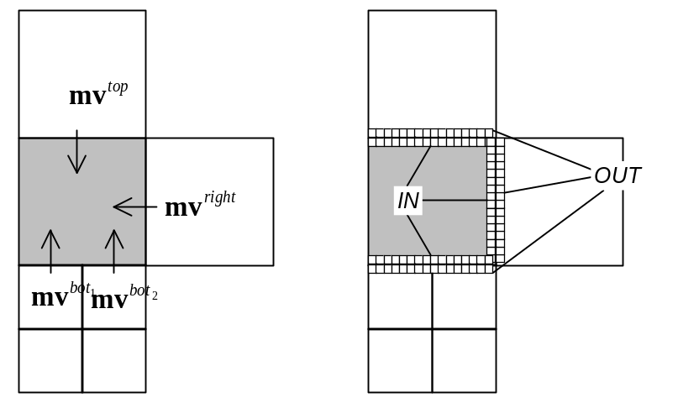
Figure 3: Selecting the motion vector for prediction
The winning predictor motion vector is the one which minimizes the side match distortion 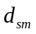, which is the sum of absolute Y pixel value difference of the IN-block and neighboring OUT-block pixels at the boundaries of the current block:
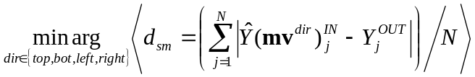 | (1.)

When "Correctly received" neighbor MBs exist the side match distortion is calculated only for them. Otherwise all the "Concealed" neighbor MBs are included in the calculation.

Recommendation
It is recommended, that the proposed non-normative error concealment algorithm is adopted to be implemented in the TML reference software. The authors offer to donate and integrate into TML the software that implements the above-described algorithm.

IPR Statement
The contributor(s) are not aware of any issued, pending, or planned patents associated with the technical content of this proposal.

