

**SpiraTeam® | Build Server Integration Guide**

Inflectra Corporation

Contents

1. Introduction 1

2. Jenkins / Hudson 2

3. JetBrains TeamCity 9

4. Atlassian Bamboo 16

5. Microsoft Azure DevOps Pipelines 23

# 1. Introduction

SpiraTeam® is an integrated **Application Lifecycle Management** (ALM) system that manages your project's requirements, releases, test cases, issues and tasks in one unified environment:

SpiraTeam® contains all of the features provided by SpiraTest® - our highly acclaimed **test management system** and SpiraPlan® - our **agile project management** solution. With integrated customizable dashboards of key project information, SpiraTeam® allows you to take control of your entire project lifecycle and synchronize the hitherto separate worlds of development and testing.

SpiraTeam® includes the ability to integrate with a variety of continuous integration / automated build servers so that the results of automated builds can be displayed in SpiraTeam linked to the associated release or iteration. In addition, the results of automated tests and source code operations can be linked to the build events, providing traceability from a specific build to the bugs that were fixed, tests that were run and source code files that were modified.

This guide outlines how to integrate and use SpiraTest, SpiraPlan and SpiraTeam in conjunction with various build servers commonly used by software development teams. This guide assumes that the reader is familiar with both SpiraTeam and the appropriate build server being discussed. For information regarding how to use SpiraTeam, please refer to the *SpiraTeam User Manual*.

# 2. Jenkins / Hudson

This section outlines how to use SpiraTest, SpiraPlan or SpiraTeam (hereafter referred to as SpiraTeam) in conjunction with either the Jenkins or Hudson (hereafter referred to as Jenkins) continuous integration build servers. It assumes that you already have a working installation of SpiraTest, SpiraPlan or SpiraTeam v3.2 or later and a working installation of Jenkins/Hudson v1.405 or later. If you have an earlier version of SpiraTeam, you will need to upgrade to at least v3.2.

## 2.1. Overview

Jenkins provides continuous integration services for software development, primarily in the Java programming language. It is a server-based system running in a servlet container such as Apache Tomcat. It supports SCM tools including CVS, Subversion, Git, Mercurial, Perforce and Clearcase, and can execute Apache Ant and Apache Maven based projects as well as arbitrary shell scripts and Windows batch commands.

When you use the SpiraTeam plugin for Jenkins, it will allow you to associate each Jenkins project with a corresponding project and release in SpiraTeam. Then, each time Jenkins creates a new build, a new build artifact will be created in SpiraTeam. Each build in SpiraTeam will be automatically linked to the incidents fixed, source code revisions committed, and any SpiraTeam tokens in the Jenkins changelog will be parsed and turned into SpiraTeam artifact hyperlinks.

## 2.2. Installing the SpiraTeam Plug-in for Jenkins

Go to the Inflectra website and open up the page that lists the various downloads available for SpiraTeam (<http://www.inflectra.com/SpiraTeam/Downloads.aspx>). Listed on this page will be the SpiraTeam Plug-In for Jenkins. Right-click on this link and save the Zip compressed folder to a temporary location. Open up the compressed folder and extract the spira-plugin.hpi file contained inside.

Now open up a web browser and connect to your Jenkins server:

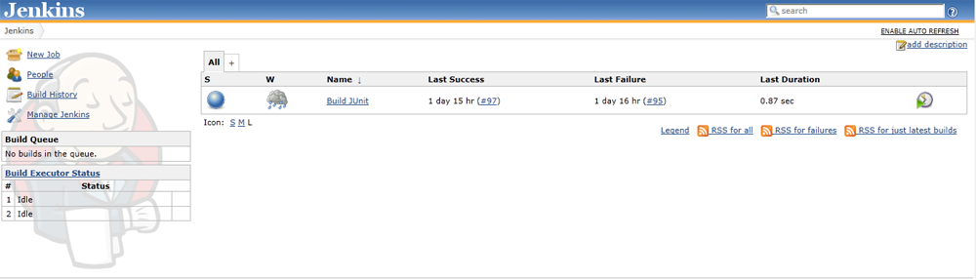

Click on the “Manage Jenkins” hyperlink, following by the “Manage Plugins” hyperlink. That will bring up the page that displays all the currently loaded plugins. Click on the “Advanced” tab:

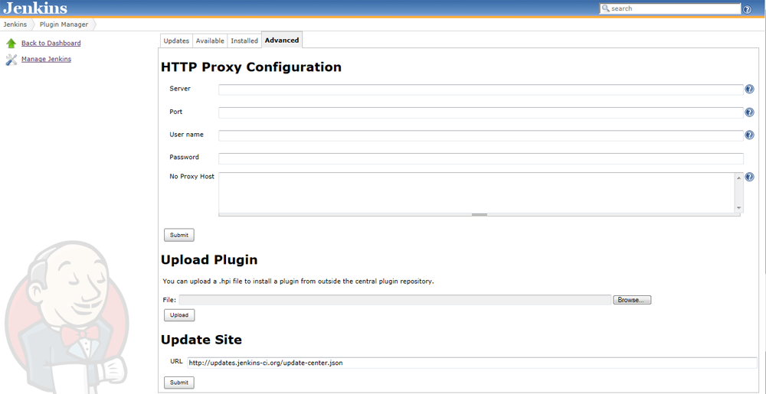

Now you can click on the [Browse] button next to the section that lets you upload a new plugin to the server. Navigate to where you saved the spira-plugin.hpi plugin file and upload the SpiraTeam plugin into Jenkins. Once that has completed, click on the “Installed” tab to display the list of installed plugins:

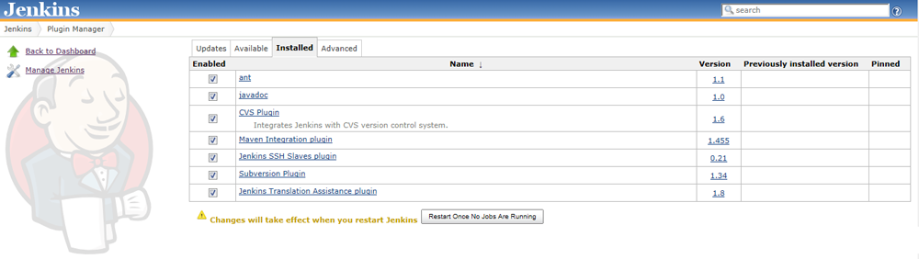

You will see an option to Restart Jenkins and load any recently added plugins. Click on this button and Jenkins will automatically restart once all pending jobs have been completed. Once Jenkins has restarted, you will now see the SpiraTeam plugin listed as one of the installed plugins:

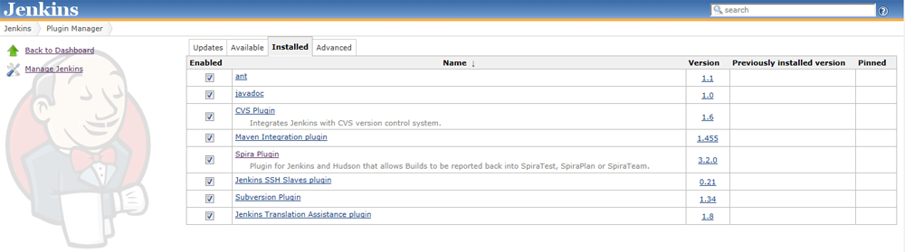

## 2.3. Setting-Up the SpiraTeam Jenkins Plug-in

Now that the plugin has been installed, you need to go back to the Jenkins homepage and click on the “Manage Jenkins” hyperlink followed by the “Configure System” hyperlink. This will bring up the main Jenkins configuration page. Scroll down to find the “**Spira Integeration**” section:

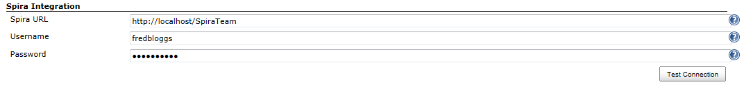

Enter in the **URL** you use to access your instance of SpiraTeam, together with a valid **username** and **password**. Once you have entered the values, click on the [Test Connection] button to verify that Jenkins can connect to SpiraTeam successfully.

Once it has connected successfully, click the [Save] button at the bottom of the screen to save your connection settings.

## 2.4. Configuring a Jenkins Job

Now that you have setup the global SpiraTeam settings in Jenkins, next you need to associate each of your Jenkins Jobs with their corresponding SpiraTeam Project and Release/Iteration. To do this, click on the name of the Jenkins Job and then click on the “Configure” hyperlink for that Job:

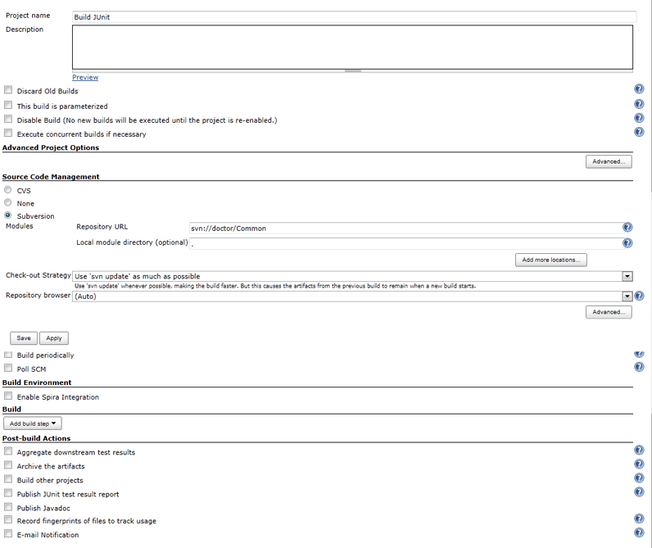

Under the section “**Build Environment**” select the checkbox marked “**Enable Spira Integration**”. That will display the SpiraTeam configuration panel for this Job:

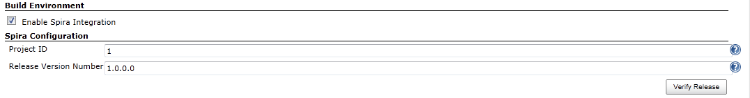

Now you need to enter the following values:

* **Project ID** – The numeric ID of the SpiraTeam Project that the Build belongs to. (e.g. for Project PR00001 just enter 1)
* **Release Version Number** – The version number of the SpiraTeam Release/Iteration that the Build belongs to. (e.g. for Release RL0004 with version number 1.0.0.0 you'd enter just 1.0.0.0)

Once you have entered in the Project ID and Release version number, click the [Verify Release] button and the plugin will connect to SpiraTeam and verify that the project exists, that the current user can connect to that project, and that the specified release/iteration exists in the project.

Once it has verified successfully, click the [Save] button at the bottom of the screen to save your Job configuration settings. You are now ready to use Jenkins with SpiraTeam.

## 2.5. Viewing the Build Results in SpiraTeam

Now that you have associated your Jenkins job with a specific SpiraTeam project and release/iteration, you can now use Jenkins to manage your software builds and have the results of the build be reported back into SpiraTeam. For example when the ‘Build JUnit’ job illustrated in the previous section is executed, it will report back the following result in Jenkins:

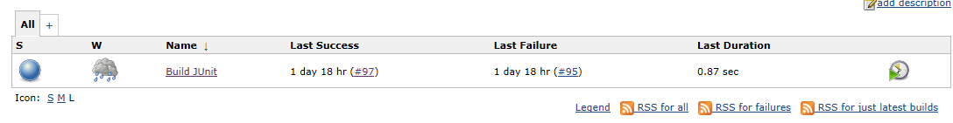

The corresponding build entry will also be created in SpiraTeam under the specified project and release/iteration:

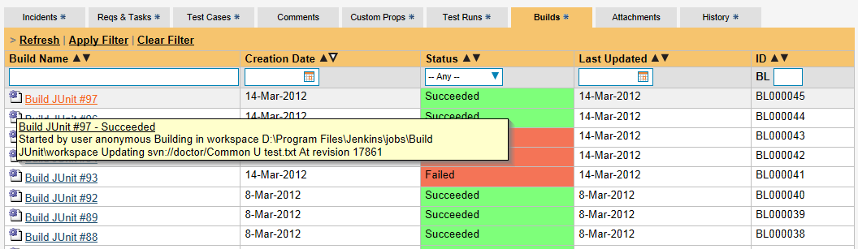

If you have configured your Project Home to include the list of recent builds, the build information will also be displayed on the Project Home dashboard:

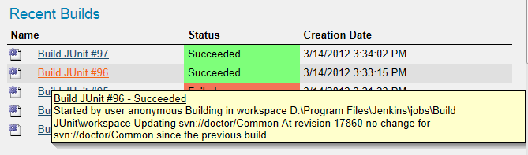  
Clicking on either of the hyperlinks will allow you to navigate to the Build details page inside SpiraTeam:

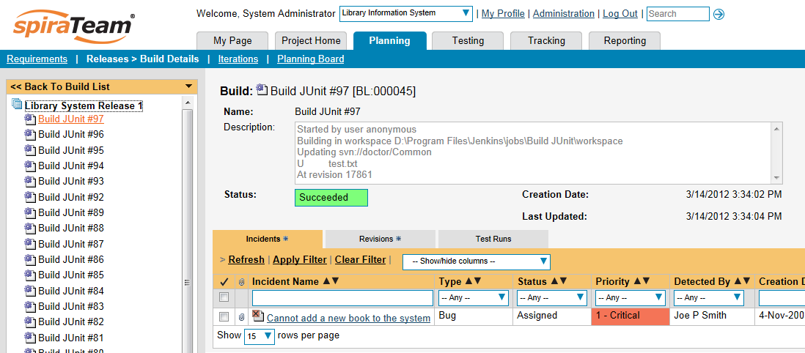

This page will display the status (success / failure) and details of the build (from the Jenkins Console Output) together with a list of the associated incidents, test runs and source code revisions. The following section will explain how to use your Source Code Management (SCM) system to take advantage of the SpiraTeam plugin and automatically link incidents and source code revisions to the build information.

## 2.6. Working with Source Code Changesets

When your developers commit changes to your application’s source into the SCM repository, they should make sure to link the commit to the appropriate artifacts in SpiraTeam. For example they may want to record that the revision fixes a specific incident or implements a specific feature (requirement).

Linking an artifact is very simple. All the developer needs to do is enter the artifact token in the following format:

**[PREFIX:ID]**

The first half, the Artifact Identifier, is a two-letter code that is used throughout SpiraTeam, and is visible on almost every page in the application. For example, a requirement’s identifier is “**RQ**”. Incidents are “**IN**”, and tasks are “**TK**”. The artifact ID is the number of the artifact. So by creating a commit message that reads:

Due to requirement [RQ:12], the code for .toString in class XMLparser was modified. This also fixed Incident [IN:1034].

SpiraTeam will automatically detect the tokens and will include links to them under the Associations tab for each revision detail in SpiraTeam.

In addition, when Jenkins creates the next build (that includes this revision), the plugin will automatically parse the revision message and convert the tokens into hyperlinks to the corresponding SpiraTeam artifact. That way, when developers view the build changelog in Jenkins, it will automatically include links to the SpiraTeam items:

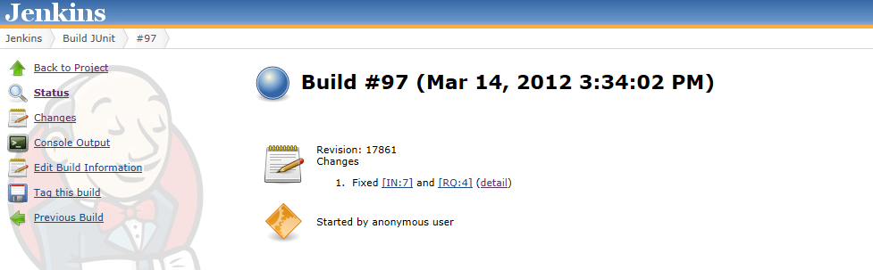

Meanwhile, inside SpiraTeam, the system will use the same information to automatically link the list of associated revisions to the build record:

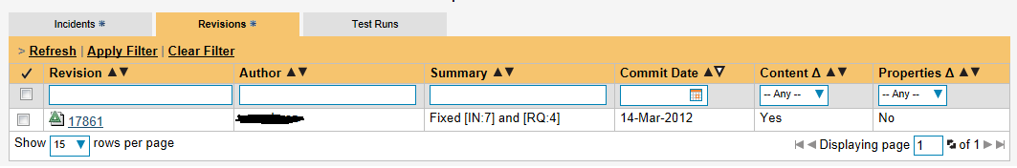

If the commit message contains Incident tokens, the plugin will also automatically link those incidents to the appropriate build:

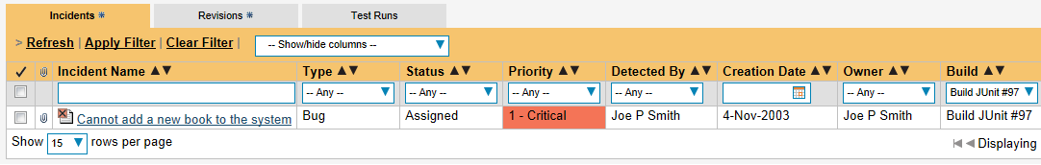

Similarly when you view the list of incidents inside SpiraTeam you will now be able to sort and filter the list by the associated build:

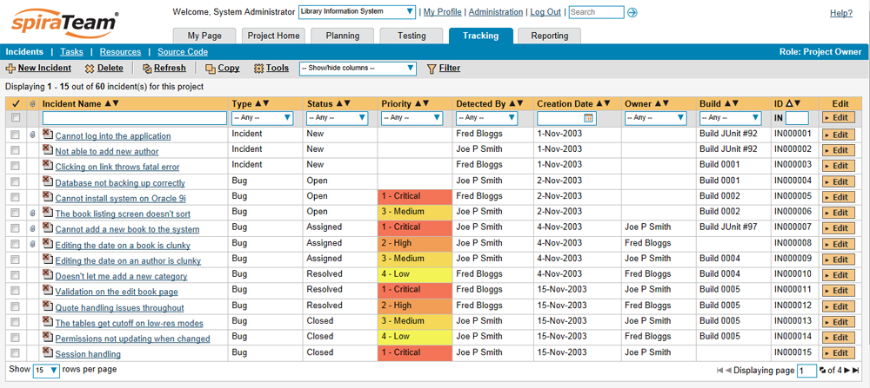

Congratulations! You are now able to use SpiraTeam and Jenkins to be able to manage your builds and have the build status integrated into your SpiraTeam project dashboard.

## 2.7. Scheduling Test Sets Upon Successful Builds

One additional feature of the integration with SpiraTest and SpiraTeam (hereafter just SpiraTest) is the ability to have SpiraTest automatically schedule the execution of a test set whenever a build passes.

To do that, make sure the Test Set is associated with the SpiraTest release or iteration that is being built and then set the **Schedule on Build** field to “Yes” and optionally enter in the delay (after the build succeeds) that you want the test set to be scheduled for:

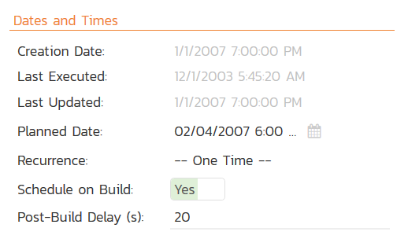

This means that you don’t need to separately manage your build schedule in Jenkins and your test automation schedule in SpiraTest.

# 3. JetBrains TeamCity

This section outlines how to use SpiraTest, SpiraPlan or SpiraTeam (hereafter referred to as SpiraTeam) in conjunction with the JetBrains’ TeamCity continuous integration build servers. It assumes that you already have a working installation of SpiraTest, SpiraPlan or SpiraTeam v4.0 or later and a working installation of TeamCity v9.0.4 or later. If you have an earlier version of SpiraTeam, you will need to upgrade to at least v4.0.

## 3.1. Overview

TeamCity provides continuous integration services for software development, primarily in the Java programming language. It is a server-based system running that supports a variety of different version control systems and build runners. It supports SCM tools including CVS, Subversion, Git, Mercurial, Perforce and Borland StarTeam, and can execute Apache Ant and Apache Maven based projects as well as arbitrary shell scripts and Windows batch commands.

## When you use the SpiraTeam Plug-In for TeamCity, it will allow you to associate each TeamCity project with a corresponding project and release in SpiraTeam. Then, each time TeamCity creates a new build, a new build artifact will be created in SpiraTeam. Each build in SpiraTeam will be automatically linked to the incidents fixed, tasks implemented, requirements developed and source code revisions committed.

## 3.2. Installing the SpiraTeam Plug-in for TeamCity

Go to the Inflectra website and open up the page that lists the various downloads available for SpiraTeam (<http://www.inflectra.com/SpiraTeam/Downloads.aspx>). Listed on this page will be the SpiraTeam Plug-In for TeamCity. Right-click on this link and save the Zip compressed folder to the TeamCity’s Plug-In directory (*$TEAMCITY_USER_HOME/plugins*). After that, restart TeamCity for the plugin to take effect. It’s also possible to install the Plug-In through the user interface of TeamCity via Administration > Plugins List > Upload Plugin Zip, choosing the zip-file from your file-system:

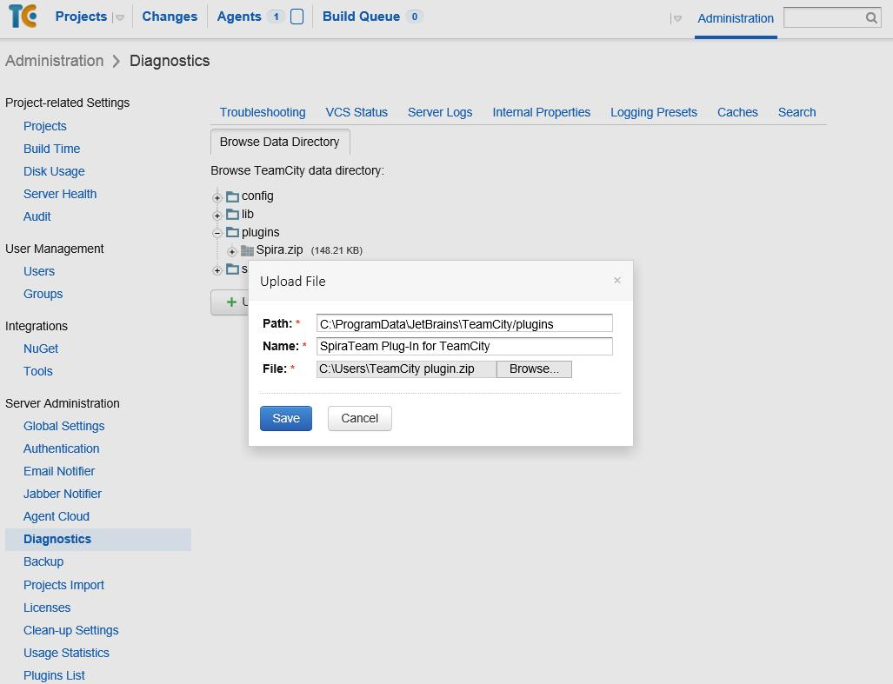

Do not forget to restart TeamCity for the plugin to take effect.

Once TeamCity has restarted, you can see the SpiraTeam Plug-In listed as one of the installed plugins:

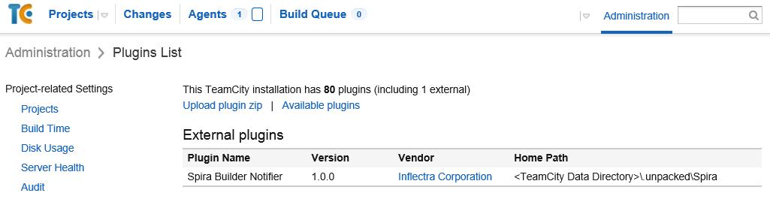

## 3.3. Setting-Up the SpiraTeam TeamCity Plug-in

Now that the plugin has been installed, you need to configure the Global Settings for integration with SpiraTeam. To do this, go to Administration > Spira Global Settings:

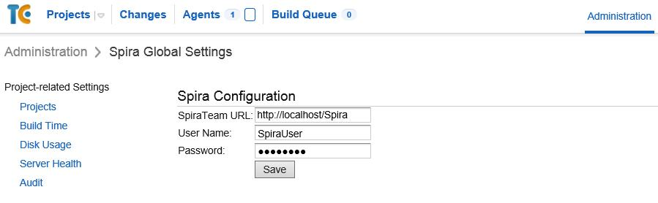

You will need TeamCity administrator privileges to access this configuration page. Once in the *Spira Global Settings* page, enter in the **URL** you use to access your instance of SpiraTeam, together with a valid **username** and **password**. Once you have entered the values, click on the [Save] button. TeamCity will then verify if it can connect to SpiraTeam successfully.

Once it has connected successfully, your connection settings will be saved. In case of error, follow the instructions on-screen and try again.

After setting the global configurations appropriately, you will need to enable the notifications in TeamCity. To do this, go to *My Settings & Tools,* that can be accessed through clicking your TeamCity username (top right). Once there, in the *General* tab, inside the *Watched Builds and Notifications* box, find the *Spira Notifier for TeamCity* section, and click in *Edit*:

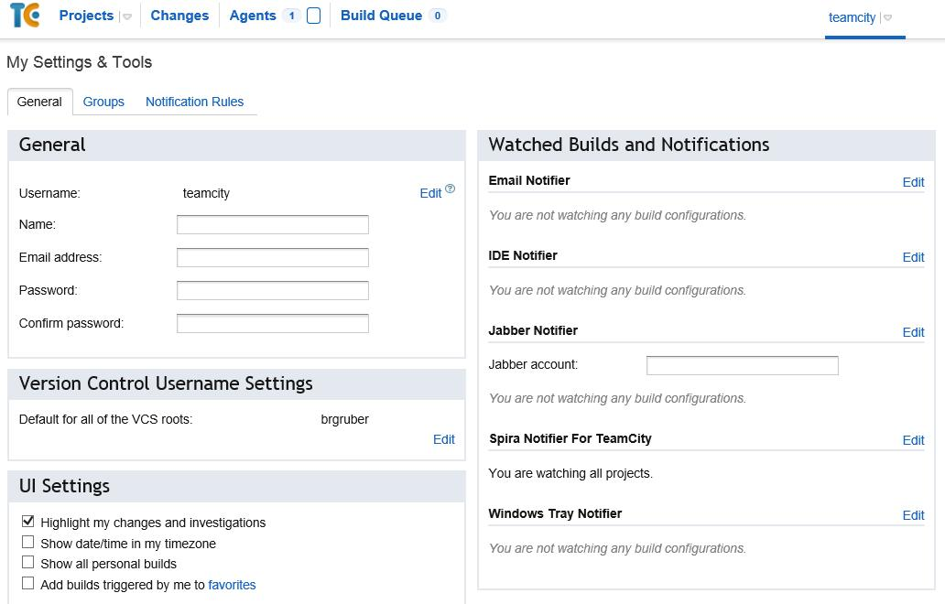

Once in the page, click in *Add new Rule*. Then, inside the *Send notification when* section, select the events you want TeamCity notify SpiraTeam:

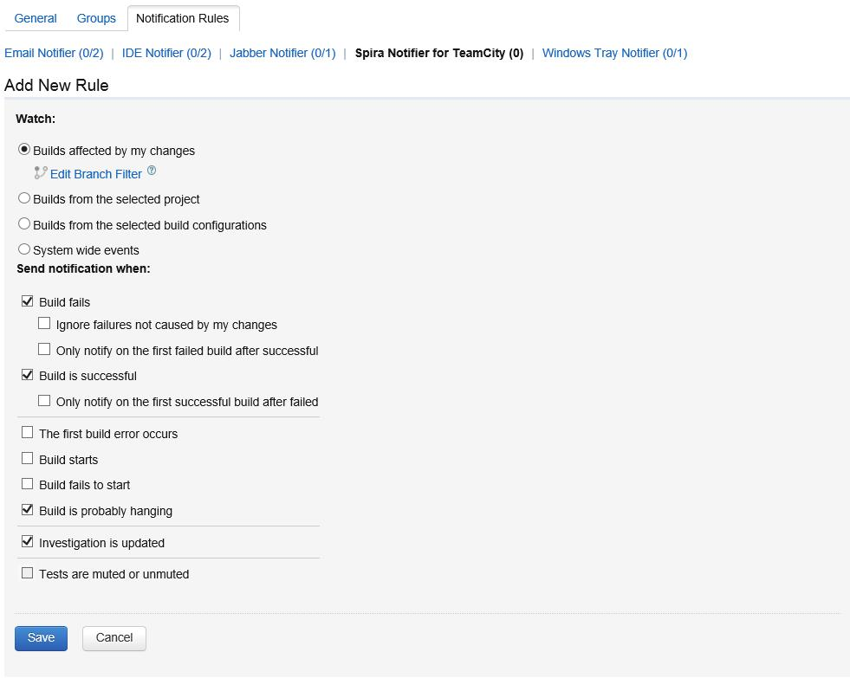

After selecting your preferences, click in the Save button.

## 3.4. Configuring a TeamCity Project

Now that you have setup the Global SpiraTeam and Notifications settings in TeamCity, next you need to associate each of your TeamCity Projects with their corresponding SpiraTeam Project and Release/Iteration. To do this, click on the name of a project and then click on the “Spira Project Configuration” tab for that Project:

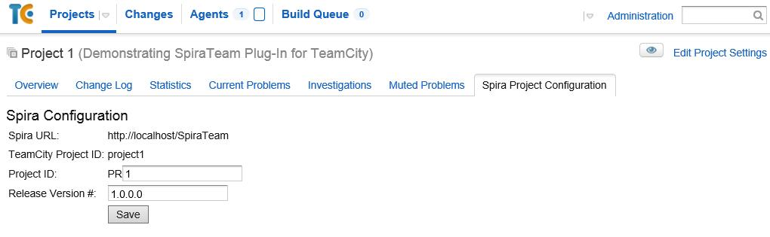

In this page you can check the URL of the SpiraTeam Server. If it is wrong, you can change it in the Spira Global Settings menu (see section 3.3 again). It is also possible to check the Project ID associated with the project in TeamCity. This information can be useful for debugging/checking reasons.

To associate a TeamCity Project with a SpiraTeam Project, enter the following values:

* **Project ID** – The numeric ID of the SpiraTeam Project that the Build belongs to. (e.g. for Project PR00001 just enter 1)
* **Release Version Number** – The version number of the SpiraTeam Release/Iteration that the Build belongs to. (e.g. for Release RL0004 with version number 1.0.0.0 you'd enter just 1.0.0.0)

Once you have entered in the Project ID and Release version number, click the [Save] button and the plugin will connect to SpiraTeam and verify that the project exists, that the current user can connect to that project, and that the specified release/iteration exists in the project. Once it has verified successfully, it will save your Project configuration settings. In case of error, follow the instructions on-screen and try again. You are now ready to use TeamCity with SpiraTeam.

## 3.5. Viewing the Build Results in SpiraTeam

Now that you have associated your TeamCity Project with a specific SpiraTeam project and release/ iteration, you can now use TeamCity to manage your software builds and have the results of the build be reported back into SpiraTeam. For example when the ‘BuildConfigTest’ build of Project 1 illustrated in the figure bellow is executed, it will report in TeamCity:

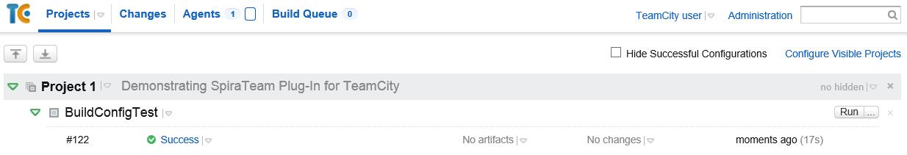

The corresponding build entry will also be created in SpiraTeam under the specified project and release/iteration:

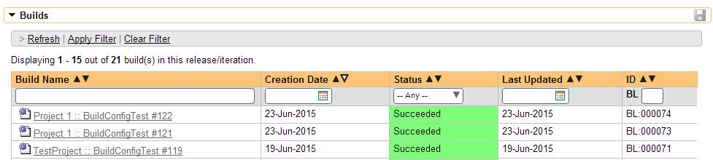

If you have configured your Project Home to include the list of recent builds, the build information will also be displayed on the Project Home dashboard:

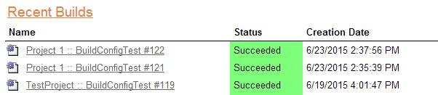  
Clicking on either of the hyperlinks will allow you to navigate to the Build details page inside SpiraTeam:

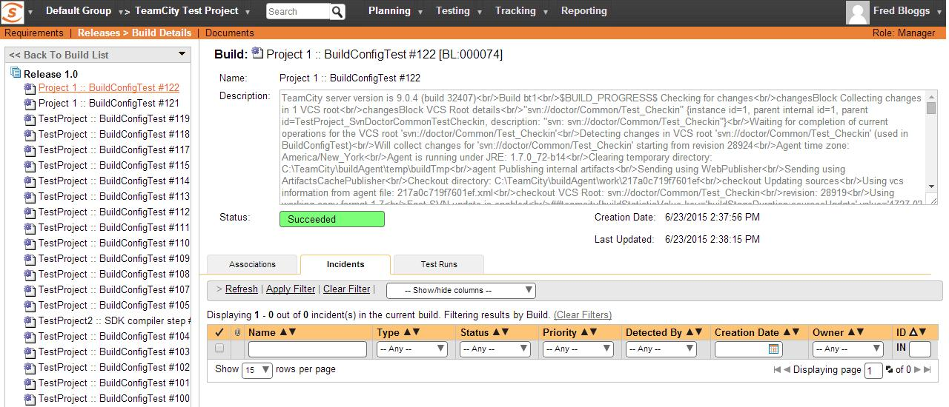

This page will display the status (success / failure) and details of the build (imported from the TeamCity Console Output) together with a list of the associated incidents, test runs and source code revisions. The following section will explain how to use your Source Code Management (SCM) system to take advantage of the SpiraTeam plugin and automatically link incidents and source code revisions to the build information.

## 3.6. Working with Source Code Changesets

When your developers commit changes to your application’s source into the SCM repository, they should make sure to link the commit to the appropriate artifacts in SpiraTeam. For example they may want to record that the revision fixes a specific incident or implements a specific feature (requirement).

Linking an artifact is very simple. All the developer needs to do is enter the artifact token in the following format:

**[PREFIX:ID]**

The first half, the Artifact Identifier, is a two-letter code that is used throughout SpiraTeam, and is visible on almost every page in the application. For example, a requirement’s identifier is “**RQ**”. Incidents are “**IN**”, and tasks are “**TK**”. The artifact ID is the number of the artifact. So by creating a commit message that reads:

Due to requirement [RQ:12], the code for .toString in class XMLparser was modified. This also fixed Incident [IN:1034].

SpiraTeam will automatically detect the tokens and will include links to them under the Associations tab for each revision detail in SpiraTeam.

Inside SpiraTeam, the system will use the same information to automatically link the list of associated revisions to the build record:

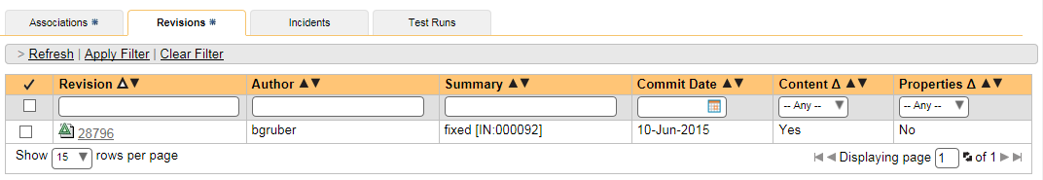

If the commit message contains Incident tokens, the plugin will also automatically link those incidents to the appropriate build:



Similarly when you view the list of incidents inside SpiraTeam you will now be able to sort and filter the list by the associated build:

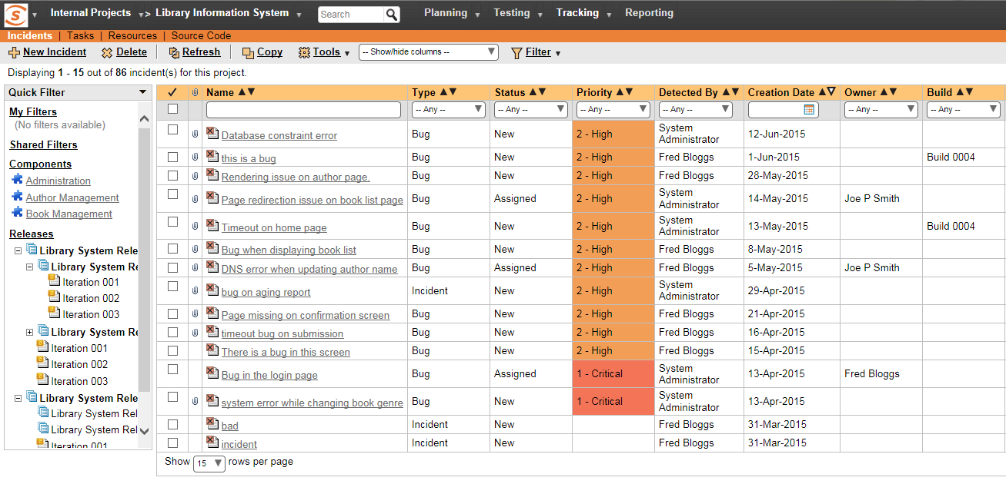

Congratulations! You are now able to use SpiraTeam and TeamCity to be able to manage your builds and have the build status integrated into your SpiraTeam project dashboard.

## 3.7. Scheduling Test Sets Upon Successful Builds

One additional feature of the integration with SpiraTest and SpiraTeam (hereafter just SpiraTest) is the ability to have SpiraTest automatically schedule the execution of a test set whenever a build passes.

To do that, make sure the Test Set is associated with the SpiraTest release or iteration that is being built and then set the **Schedule on Build** field to “Yes” and optionally enter in the delay (after the build succeeds) that you want the test set to be scheduled for:



This means that you don’t need to separately manage your build schedule in Jenkins and your test automation schedule in TeamCity.

# 4. Atlassian Bamboo

This section outlines how to use SpiraTest, SpiraPlan or SpiraTeam (hereafter referred to as SpiraTeam) in conjunction with the Atlassian’s Bamboo continuous integration build servers. It assumes that you already have a working installation of SpiraTest, SpiraPlan or SpiraTeam v4.0 or later and a working installation of Bamboo v 5.0 or later. If you have an earlier version of SpiraTeam, you will need to upgrade to at least v4.0.

## 4.1. Overview

Bamboo provides continuous integration services for software development, in any programming language using any build tool. It is a server-based system running that supports a variety of different version control systems. It supports SCM tools including CVS, Subversion, and Git, and can execute Apache Ant and Apache Maven based projects as well as arbitrary shell scripts and Tomcat.

## When you use the SpiraTeam Add-on for Bamboo, it will allow you to associate each Bamboo project and plan with a corresponding project/release in SpiraTeam. Then, each time Bamboo creates a new build, a new build artifact will be created in SpiraTeam. Each build in SpiraTeam will be automatically linked to the incidents fixed, tasks implemented, requirements developed and source code revisions committed.

## 4.2. Installing the SpiraTeam Add-on for Bamboo

Go to the Inflectra website and open up the page that lists the various downloads available for SpiraTeam (<http://www.inflectra.com/SpiraTeam/Downloads.aspx>). Listed on this page will be the SpiraTeam *Add-on* for Bamboo. Right-click on this link and save the .zip file to your local computer.

Inside this .zip file will be a .jar file, extract the .jar file and save to a local folder on your system. After that, go to Bamboo Administration. You will need Bamboo administrator privileges to access this configuration page. Under Add-ons, click on the *Manage Add-ons* link and then on *Upload Add-on* on the left:

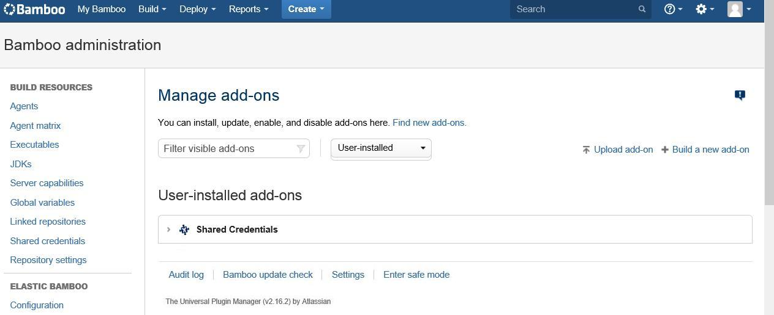

After that, click on *Browse* and select the .jar file extracted from the .zip archive downloaded from the Inflectra website. Then, click on *Update*.

After the installation of the SpiraTeam Add-on, you should see a welcome screen:

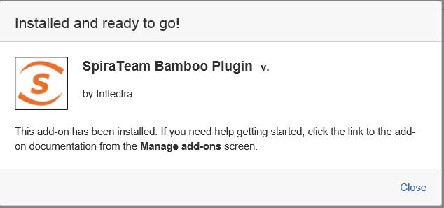

## You will then be able to see the SpiraTeam Add-on in the User Installed Add-ons list :

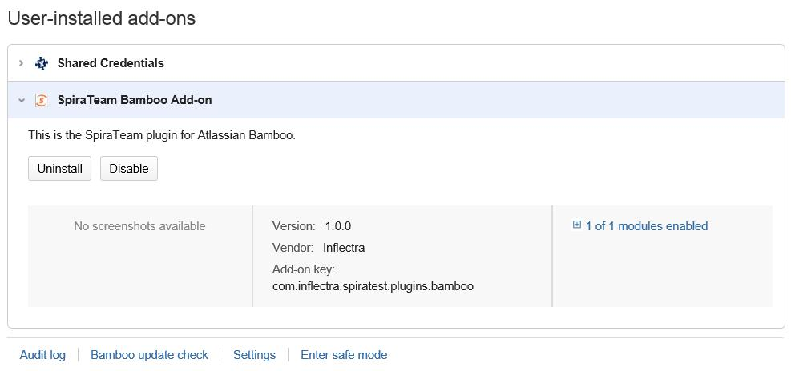

## 4.3. Setting-Up the SpiraTeam Bamboo Add-on

Now that the add-on has been installed, you need to configure the settings for integration with SpiraTeam. To do this, go to the Project you want to communicate with SpiraTeam, and under the plan you want to receive notifications, click on Edit ( icon). In the Plan Configuration screen, go to the *Notifications* tab and click on Add Notification:

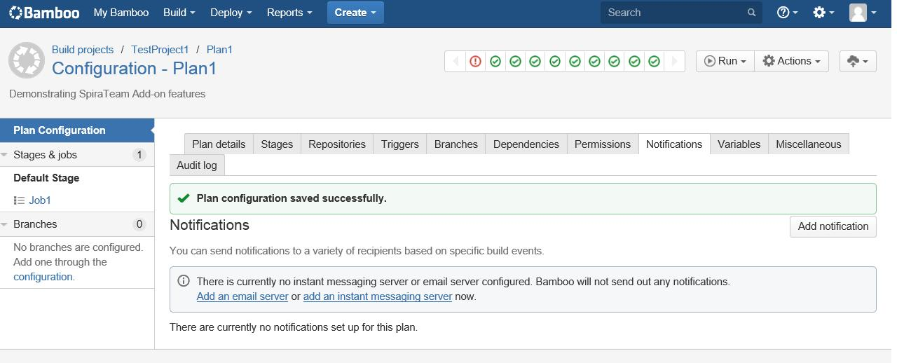

In the Add a new notification pop-up, select the appropriate event you want to receive notifications, and in the Recipient type box, select *SpiraTeam*:

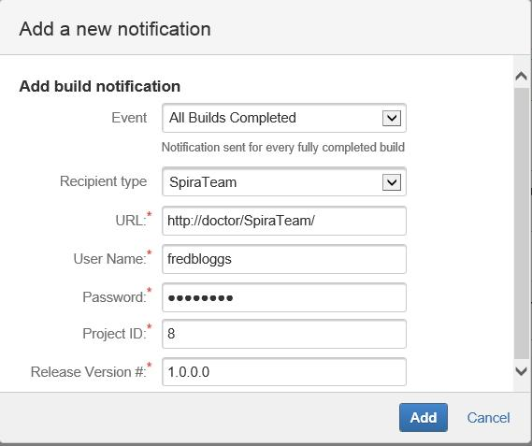

After that, you will see some new fields to fill, they are:

* **URL** - It is the URL you use to access your instance of SpiraTeam;
* **User Name**: Your SpiraTeam user name;
* **Password**: Your SpiraTeam password;
* **Project ID** – The numeric ID of the SpiraTeam Project that the Build belongs to. (e.g. for Project PR00001 just enter 1)
* **Release Version Number** – The version number of the SpiraTeam Release/Iteration that the Build belongs to. (e.g. for Release RL0004 with version number 1.0.0.0 you'd enter just 1.0.0.0)

After filling this boxes with appropriate information, click on *Add* button. Bamboo will then try to connect to the SpiraTeam Server, and check the Project/Release provided info. Once it validates your information, the connection settings will be saved. In case of error, follow the instructions on-screen and try again.

## 4.4. Viewing the Build Results in SpiraTeam

Now that you have associated your Bamboo Project and Plan with a specific SpiraTeam project and release/iteration, you can use Bamboo to manage your software builds and have the results of the build be reported back into SpiraTeam. For example when the ‘Plan1’ build of TestProject 1 illustrated in the figure bellow is executed, it will report in Bamboo:

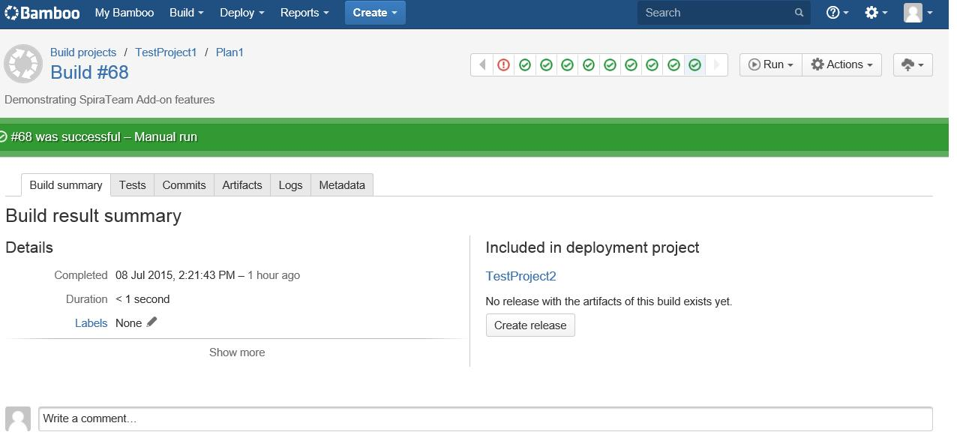

The corresponding build entry will also be created in SpiraTeam under the specified project and release/iteration:

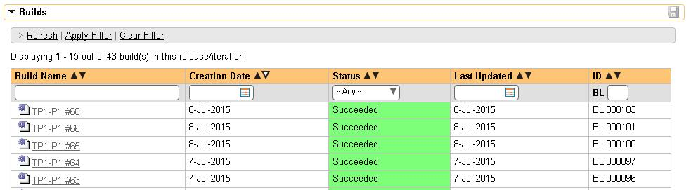

If you have configured your Project Home to include the list of recent builds, the build information will also be displayed on the Project Home dashboard:

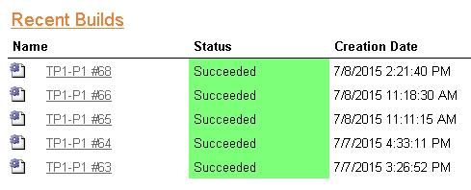

Clicking on either of the hyperlinks will allow you to navigate to the Build details page inside SpiraTeam:

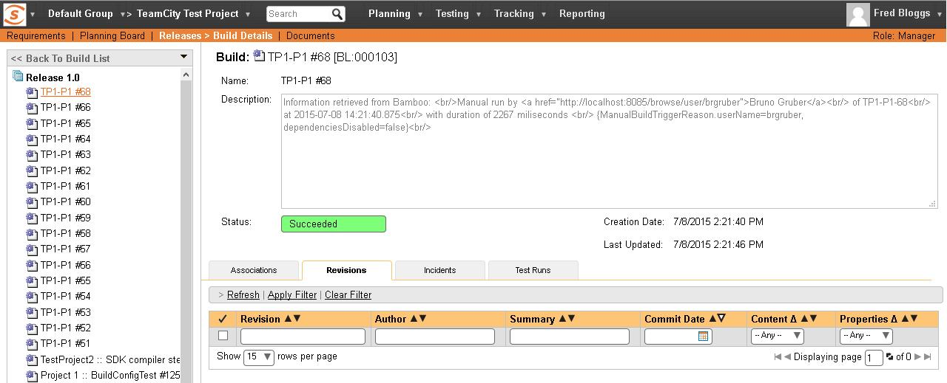

This page will display the status (success / failure) and details of the build (imported from the Bamboo Console Output) together with a list of the associated incidents, test runs and source code revisions. The following section will explain how to use your Source Code Management (SCM) system to take advantage of the SpiraTeam add-on and automatically link incidents and source code revisions to the build information.

## 4.5. Working with Source Code Changesets

When your developers commit changes to your application’s source into the SCM repository, they should make sure to link the commit to the appropriate artifacts in SpiraTeam. For example they may want to record that the revision fixes a specific incident or implements a specific feature (requirement).

Linking an artifact is very simple. All the developer needs to do is enter the artifact token in the following format:

**[PREFIX:ID]**

The first half, the Artifact Identifier, is a two-letter code that is used throughout SpiraTeam, and is visible on almost every page in the application. For example, a requirement’s identifier is “**RQ**”. Incidents are “**IN**”, and tasks are “**TK**”. The artifact ID is the number of the artifact. So by creating a commit message that reads:

Due to requirement [RQ:12], the code for .toString in class XMLparser was modified. This also fixed Incident [IN:1034].

SpiraTeam will automatically detect the tokens and will include links to them under the Associations tab for each revision detail in SpiraTeam.

Inside SpiraTeam, the system will use the same information to automatically link the list of associated revisions to the build record:



If the commit message contains Incident tokens, the add-on will also automatically link those incidents to the appropriate build:



Similarly when you view the list of incidents inside SpiraTeam you will now be able to sort and filter the list by the associated build:



Congratulations! You are now able to use SpiraTeam and Bamboo to be able to manage your builds and have the build status integrated into your SpiraTeam project dashboard.

## 4.6. Scheduling Test Sets Upon Successful Builds

One additional feature of the integration with SpiraTest and SpiraTeam (hereafter just SpiraTest) is the ability to have SpiraTest automatically schedule the execution of a test set whenever a build passes.

To do that, make sure the Test Set is associated with the SpiraTest release or iteration that is being built and then set the **Schedule on Build** field to “Yes” and optionally enter in the delay (after the build succeeds) that you want the test set to be scheduled for:



This means that you don’t need to separately manage your build schedule in Bamboo and your test automation schedule in SpiraTest.

# 5. Microsoft Azure DevOps Pipelines

This section outlines how to use SpiraTest, SpiraPlan or SpiraTeam (hereafter referred to as SpiraPlan) in conjunction with Microsoft’s Azure DevOps continuous integration platform called **Azure DevOps Pipelines**. It assumes that you already have a working installation of SpiraPlan v5.0 or later and have already setup Microsoft Azure DevOps Pipelines. If you have an earlier version of SpiraTeam, you will need to upgrade to at least v5.0.

## 5.1. Overview

Microsoft Azure DevOps provides tools for managing the entire application lifecycle, including source code management, reporting, automated builds, testing and release capabilities, for example. It supports version control using either its native TFS source code management system or Git. SpiraTeam has version control plugins for both TFS native and TFS with Git source code management options.

## When you use the Spira Build Server Extension for Azure DevOps, it will allow you to associate different Azure DevOps projects with a corresponding project and release in SpiraPlan. Then, each time a DevOps pipeline creates a new build, a new build artifact will be created in SpiraPlan. Each build in SpiraTeam will be automatically linked to the incidents fixed, tasks implemented, requirements developed and source code revisions committed.

## 5.2. Installing the SpiraTeam Build Plug-in for Azure DevOps

Go to the Inflectra website and open up the page that lists the various downloads available for SpiraTeam (<http://www.inflectra.com/SpiraTeam/Downloads.aspx>). Listed on this page will be the Azure DevOps Pipeline Plug-In. When you click on the link on this page, it will take you to the Azure DevOps Marketplace, where you can install the Spira extension into your DevOps instance:

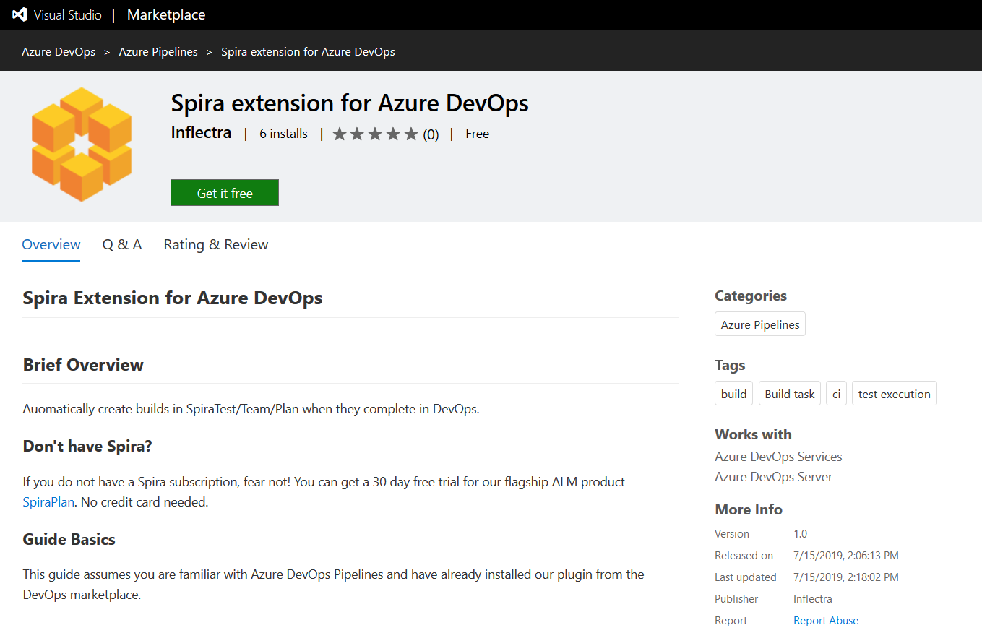

After that, the plugin will be available in your instance of Azure DevOps.

## 5.2. Authenticating with Spira

In DevOps, open the project you would like to have builds sync with Spira. Go to Project Settings > Pipelines > Service Connections

Under Service connections, click the "New service connection" button and click "SpiraPlan Configuration." Under connection name, put something helpful like SpiraPlan Fred Bloggs

For SpiraPlan URL put the 'root' directory of your Spira instance, not including the end slash. For username, put the username you use to sign-in to Spira. For RSS Token, go to your user profile page in Spira, enable RSS Feeds and copy the token into DevOps. Now verify the connection by clicking "Verify connection," if you entered everything correctly, you're good to go!

## 5.3. Adding the Spira Build Task

Now in the pipeline you would like to add Spira support to, open the pipeline's YAML file and in the assistant to the right, search "Spira" and select "Export data to Spira" Select the service connection name you put in earlier, enter the ID of the project in Spira you would like your results sent to, the ID of the release you would like the builds to be associated with, and the base url of your DevOps instance (like <https://dev.azure.com/fabrikam> or [https://fabrikam.visualstudio.com](https://fabrikam.visualstudio.com/))

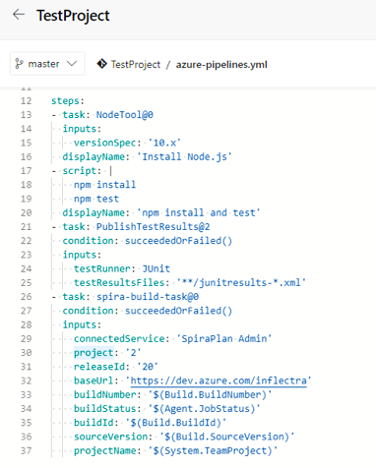

The other fields are used internally by the plugin and should be left as-is - DO NOT CHANGE THEM. Click "Add" and add the condition: succeededOrFailed() above inputs in the YAML snippet. This makes sure that the Spira task can access the current build status.

Now move the spira-build-task YAML Snippet to the end of the file so that it's executed last. This will make sure that the final result of the build gets recorded in Spira.

Here is an example YAML file:

trigger:

- master

pool:

vmImage: 'ubuntu-latest'

steps:

- task: NodeTool@0

inputs:

versionSpec: '10.x'

displayName: 'Install Node.js'

- script: |

npm install

npm test

displayName: 'npm install and test'

- task: PublishTestResults@2

condition: succeededOrFailed()

inputs:

testRunner: JUnit

testResultsFiles: '**/junitresults-*.xml'

- task: spira-build-task@0

condition: succeededOrFailed()

inputs:

connectedService: 'SpiraPlan Fred Bloggs'

project: '2'

releaseId: '20'

baseUrl: 'https://dev.azure.com/inflectra'

buildNumber: '$(Build.BuildNumber)'

buildStatus: '$(Agent.JobStatus)'

buildId: '$(Build.BuildId)'

sourceVersion: '$(Build.SourceVersion)'

projectName: '$(System.TeamProject)'

If everything had been configured correctly a new build in DevOps will create a new build in Spira!

## 5.4. Viewing the Build Results in SpiraTeam

Now that you have associated your Azure DevOps pipeline with a specific SpiraTeam project and release/ iteration, you can now use Azure DevOps to manage your software builds and have the results of the build be reported back into SpiraPlan. For example, when a DevOps Pipeline runs, it will report in Azure DevOps something like the following:

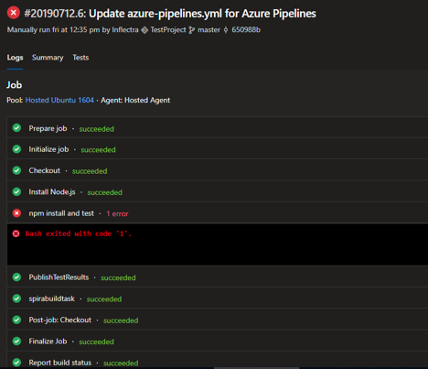

The corresponding build entry will also be created in SpiraPlan under the specified project and release/iteration:

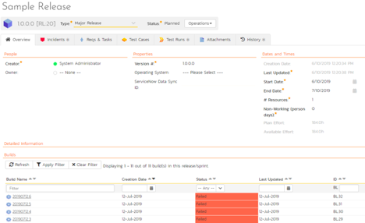

If you have configured your Project Home to include the list of recent builds, the build information will also be displayed on the Project Home dashboard:

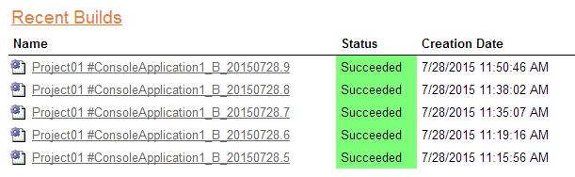

Clicking on either of the hyperlinks will allow you to navigate to the Build details page inside SpiraTeam:

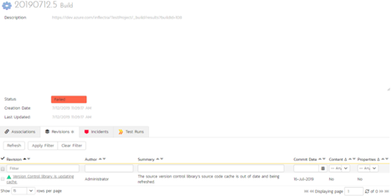

This page will display the status (success / failure) and details of the build.

Congratulations! You are now able to use SpiraPlan and Azure DevOps to be able to manage your builds and have the build status integrated into your SpiraPlan project dashboard.

## 5.7. Scheduling Test Sets Upon Successful Builds

One additional feature of the integration with SpiraPlan is the ability to have SpiraPlan automatically schedule the execution of a test set whenever a build passes.

To do that, make sure the Test Set is associated with the SpiraPlan release or iteration that is being built and then set the **Schedule on Build** field to “Yes” and optionally enter in the delay (after the build succeeds) that you want the test set to be scheduled for:



This means that you don’t need to separately manage your build schedule in Azure DevOps and your test automation schedule in SpiraPlan.

#### Legal Notices

This publication is provided as is without warranty of any kind, either express or implied, including, but not limited to, the implied warranties of merchantability, fitness for a particular purpose, or non-infringement.

This publication could include technical inaccuracies or typographical errors. Changes are periodically added to the information contained herein; these changes will be incorporated in new editions of the publication. Inflectra Corporation may make improvements and/or changes in the product(s) and/or program(s) and/or service(s) described in this publication at any time.

The sections in this guide that discuss internet web security are provided as suggestions and guidelines. Internet security is constantly evolving field, and our suggestions are no substitute for an up-to-date understanding of the vulnerabilities inherent in deploying internet or web applications, and Inflectra cannot be held liable for any losses due to breaches of security, compromise of data or other cyber-attacks that may result from following our recommendations.

SpiraTest®, SpiraPlan®, SpiraTeam® and Inflectra® are registered trademarks of Inflectra Corporation in the United States of America and other countries. Microsoft®, Windows®, Explorer® and Microsoft Project® are registered trademarks of Microsoft Corporation. All other trademarks and product names are property of their respective holders.

Please send comments and questions to:

Technical Publications

Inflectra Corporation

8121 Georgia Ave, Suite 504

Silver Spring, MD 20910-4957

U.S.A.

[*support@inflectra.com*](mailto:support@inflectra.com)