A REVIEW OF DEVELOPMENT OF CHEMICAL SENSORS

Indrapati Mamatha 1*, Gajula Malathi2, C. Dharani3, D. Nandini4, K. Shiva Prasad5

1. Assistant Professor at Joginpally B.R. Pharmacy College, JNTU Hyderabad. Mail. [Mamatha6101@gmail.com](mailto:Mamatha6101@gmail.com), contact no: 7702892508
2. Student of Joginpally B.R. Pharmacy College, JNTU Hyderabad.
3. Student of Joginpally B.R. Pharmacy College, JNTU Hyderabad.
4. Student of Joginpally B.R. Pharmacy College, JNTU Hyderabad.
5. Student of Joginpally B.R. Pharmacy College, JNTU Hyderabad.

ABSTRACT

A comprehensive summary of the most recent research concentrating on chemical sensors utilizing nanotubes, Nano rods, Nano belts, and nanowires is given in this article. The experimental principle, sensor device design, sensor mechanism, and multiple significant conclusions receive the vast majority of our attention. The following four sections provide additional information on the creation of chemical sensors based on nanostructured materials: nanotube sensors, Nano rod sensors, Nano belt sensors and Nano wire sensors.

We conclude this review with personal perspectives on the directions towards which future research on nanostructured sensors might be directed.

At ambient temperature, the nanotube sensors show a far faster response time and a significantly higher sensitivity than the current solid-state sensors. Reversibility of the sensor can be obtained by heating it to a high temperature or by slowly recovering under ambient conditions. Over the past decade, synthesized nanomaterial’s, such as carbon nanotube, nanoparticle, quantum dot, and nanowire, have already made breakthroughs in various fields, including biomedical sensors. Enormous surface area-to-volume ratio of the Nano materials increases sensitivity dramatically compared with macro-sized material. Herein we present a comprehensive review about the working principle and fabrication process of nanowire sensors. The nanotube sensors exhibit a fast response and a substantially higher sensitivity than that of existing solid-state sensors at room temperature. Sensor reversibility is achieved by slow recovery under ambient conditions or by heating to high temperatures.

Synthesized Nano materials, including carbon nanotubes, nanoparticles, quantum dots, and nanowires, have already achieved significant advances in a number of sectors, including biological sensors, during the last ten years. When compared to macro-sized material, the nanoparticles' enormous surface area-to-volume ratio significantly boosts sensitivity. We provide a thorough overview of the fabrication process and operating principle of the nanowire sensor here. Recent advances including self-powering, reusability, sensitivity in high ionic strength solvent, and long-term stability are surveyed and highlighted as well. Nanowire is expected to lead significant improvement of biomedical sensor in the near future.

Advantages and disadvantages of the sensors are provided along with brief descriptions. An electrical device that monitors changes in a quantity, such as voltage, temperature, pressure, or humidity, is called a sensor. As a result, classification is done according to the attribute that a sensor measures. A temperature sensor detects even the smallest variations in its environment or shifts in temperature, such as hot or cold weather.

Microelectronic manufacturing techniques have been used to manufacture chemical and electrochemical sensors. The development of chemical sensors has been spurred forward by the recent advances in micromaching technology. Chemical sensor research has advanced thanks to micromachining methods like sacrificial layers, plasma etching, and chemical anisotropic etching. These methods enable the creation of low mass, low power driven devices as well as controlled working conditions and temperature.

Researchers became interested in these carefully chosen in vitro nanostructures when they were combined with nanomaterials because the improved properties of these nanostructures led to advances in the analytical performance of chemical and biosensors. This study covers the latest advancements in recognition elements that are integrated into chemical sensors and biosensors used in the food, medical, and environmental domains. These elements include both traditional ones like enzymes and antibodies as well as more modern ones like aptomers and phages.

Cyclic voltammetry and electron microscopy are frequently used in the characterization of chemically modified sensors and biosensors because they enable the confirmation of electrode mechanisms and surface morphologies. X-ray photoelectron spectroscopy (XPS), among other methods, is a special tool for obtaining information on the sensor surface that is qualitative, quantitative/semi-quantitative, and speciation-related. However, XPS is still not widely applied in this industry. The purpose of this work is to review a few selected studies that demonstrate how well XPS performs when characterizing the top surface layers of biosensors and chemically

Modified sensors. The reader is provided with the necessary background information in a brief introduction to X-ray photoelectron spectroscopy. The use of XPS to characterize sensors appropriate for environmental and food analysis is highlighted.

# KEYPOINTS

Nanotubes, nanowires, Nano rods, Nano belts, optical sensors, nanoparticles, chemical stimulus, chemical signals, sensitivity, nanostructured particles, micro hotplate, biosensors, wearable chemical sensors. Micro fibrication technique, micro electronic sensors

# INTRODUCTION

The three "S" sensitivity, selectivity, and stability are the most crucial factors to consider when examining different types of sensors. Such as investigating new sensing materials. Control of sensor structures (arrays), surface modification techniques, measurement methods (static and dynamic), sensor manufacture methods, and research data analytical methods. An enormous amount of literature on one-dimensional nanostructured materials, such as tubes, rods, belts, and wires in this field, has been written annually due to the advancement of Nano science and technology [1]

Microelectronic manufacturing techniques have been used to manufacture chemical and electrochemical sensors. The development of chemical sensors has been spurred forward by the recent advances in micromaching technology. Chemical sensor research has advanced thanks to micromachining methods like sacrificial layers, plasma etching, and chemical anisotropic etching [2].

A sensing film's temperature can influence a number of variables, such as the base conductance of the film, the amount of gases it will adsorb, and the speeds at which adsorbents react with one another on its surface. Temperature-controlled platforms have been used in the development of gas sensors since these effects can be significant in generating reaction signals. In an effort to use temperature management to achieve low power consumption, smaller device platforms have been manufactured more frequently lately. Micro hotplate fabrication methods for producing array configurations with functionalities that facilitate investigations of sensing materials, detection principles and mechanisms [3].

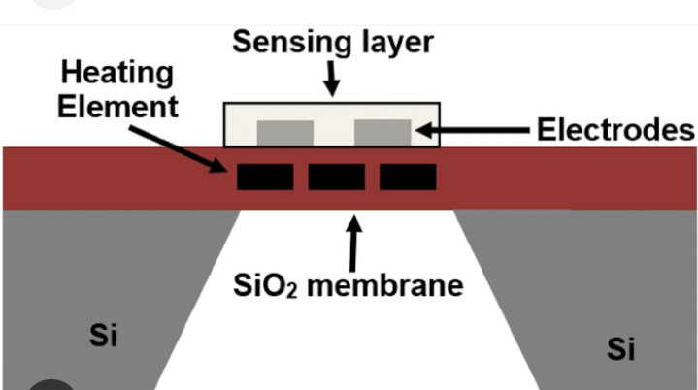

The physicochemical interfacial characteristics of silicon and germanium, the two primary semiconductors, served as the foundation for the first semiconductor-based transistors. The real area and thickness of the active layer, as well as the ultimate dimensions and form of the entire device, were the key physical characteristics of the transistors. Most crucially, it has long been understood that the behavior and performance of the finished device are largely determined by the chemical properties of the semiconductor's active region [4].

Nanotube sensors: Metal oxide tubes like CO3O4, Fe2O3, SnO2 and TiO2 as well as metal

tubes like Pt. Nano sensor

Are examples of nanotube-based sensors? When it came to H2, nanotubes showed better gas sensing skills. The sensor was created by pouring the ethanol and nanotube combination into ceramic tubes and connecting them with four platinum wires connecting gold electrodes. They proposed that the adsorption was primarily responsible for the change in resistance.

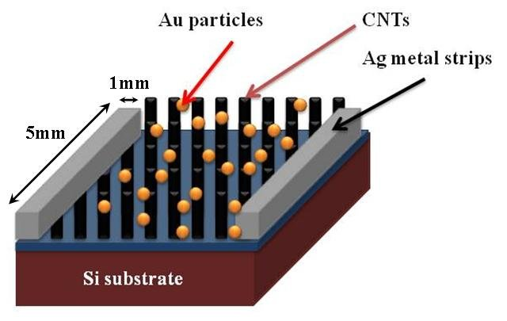

# NANOROD SENSORS:

Metal oxide Nano rods (ZnO, MoO3, and tungsten oxide Nano sensors), polymer Nano rods (poly (3, 4

-Ethylene-dioxythiophene) Nano sensor), and metal Nano rods (Au Nano sensor) typically involve a significant number of repetitive steps of Nano rod-based sensors. The majority of these studies have been on ZnO Nano rod sensors.

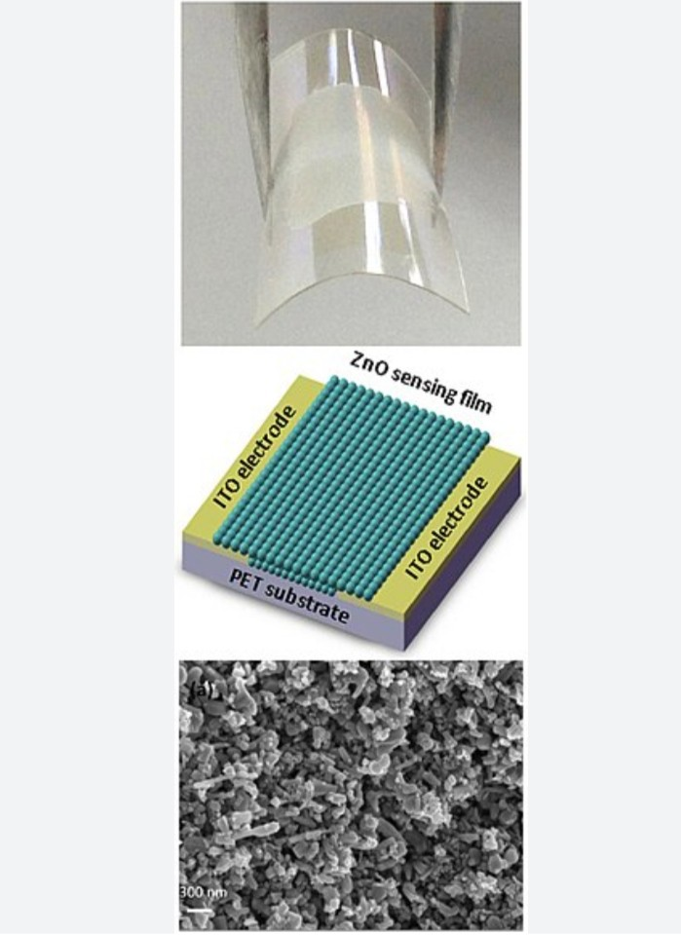

# NANOBELT SENSORS:

Nano belt-based sensors, metal oxides like ZnO, SnO2, and V2O5 Nano sensors particularly ZnO Nano belt sensors are received the most interest. Wang et al. demonstrate the oxygen-sensing capabilities of SnO2 field-effect transistors. Additionally, they have put together tin dioxide Nano belts with low-power micro heaters to detect the nerve agent stimulant dimethyl methylphosphonate .

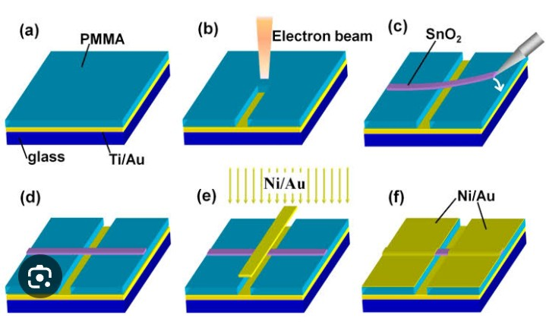

# NANOWIRE SENSORS:

Hydrogen sensors and switches based on electrodeposited palladium mesowire arrays (PMAs) were disclosed by Penner and colleagues.These sensors were made of up to 100 Pd mesoscopic wires, also referred to as "mesowires," arranged in parallel and made contact with silver epoxy. The mesowire-based sensors showed a rise-time (baseline to 90% signal saturation) of less than 80ms in response to 5% H2 [5].

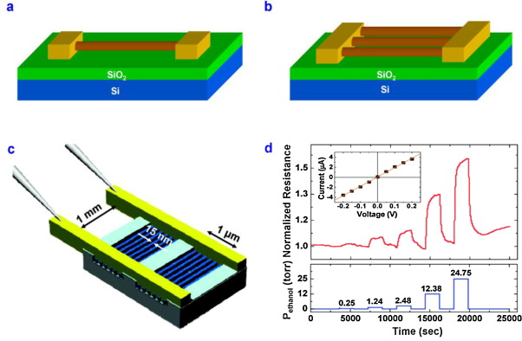

To gather (bio) chemical data from their immediate surroundings, process it, and send the chemical analysis data to one or more distant devices .

A growing number of economically robust business sectors, including healthcare, security, the food chain, and sports, have expressed a need for distributed (bio) chemical sensing. This demand has been fueled by significant advancements in mobile communications and miniaturization techniques .

Therefore, the target application plays a major role in determining how a chemical sensing component and a wireless link are combined to create a single hybrid device. The analytical application's connectivity needs play a major role in the selection of a wireless technology. The characteristics and constraints of the chemical sensor's signal transduction process [6].

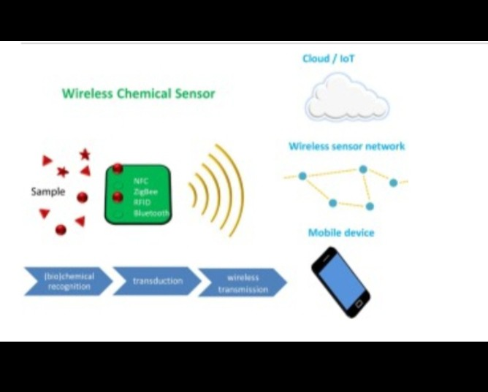

# MAY ALSO HAVE AN IMPACT ON:

Chemical and biosensors depend heavily on their recognition mechanisms, and by improving these mechanisms or instance, by adding nanomaterials chemical and biosensors can perform much better analytically, especially in terms of selectivity .

Chemical sensor is a device that transforms chemical information, ranging from the concentration of a specific sample component to total composition analysis, into an analytically useful signal. Recognition element entirely depends on the target analyte and the recognition element should have a high binding affinity for the target as well as stability. Chemical sensors and biosensors [7].

Since 1948, when the transistor was invented, semiconductor technology has grown dramatically. The physicochemical interfacial characteristics of silicon and germanium, the two primary semiconductors, served as the foundation for the first semiconductor-based transistors. The real area and thickness of the active layer, as well as the ultimate dimensions and form of the entire device, were the key physical characteristics of the transistors. Most crucially, it has long been understood that the behavior and performance of the finished device are largely determined by the chemical properties of the semiconductor's active region. This is accurate, as a detailed examination of the interfacial processes entailed in transistor operation demonstrates that it is unquestionably a chemical process [8].

# PRESENT CHALLENGES AND FUTURE PROSPECTS:

The development of wearable chemical sensors that provide more thorough information on a wearer's well-being has received little attention. The creation of wearable chemical sensors is confronted with numerous obstacles on several fronts. This viewpoint examines the main technological obstacles and constraints in the areas of materials, power, analytical technique, communication data collecting, processing, and security that prevent the successful development of wearable chemical sensor systems .

Current chemical sensors are too big, too rigid, or too complicated to use with wearable technology. Key analytical issues include on-body sensor surface regeneration and sensor

Stability. Similarly, because of their low energy density and delayed recharging, current wearable power sources cannot match the demands of wearable electronics. There are inherent problems with a number of energy-harvesting techniques, such as unstable power supplies and low stability [9].

# USE OF SENSORS IN INDUSTRY:

Modern process and environmental analytical applications that have already been accomplished offer a potential approach for the effective use of chemical sensors in industry. We come to the conclusion that, in order to address process analytical issues, chemical sensors currently need to be designed in conjunction with an appropriate metrology and incorporated into total analysis systems [10].

# TYPES OF CHEMICAL SENSORS

Temperature Sensor, Proximity Sensor, Accelerometer, IR Sensor (Infrared Sensor), Pressure Sensor, Light Sensor, Ultrasonic Sensor, Smoke, Gas and Alcohol Sensor, Touch Sensor, Color Sensor, Humidity Sensor, Position Sensor, Magnetic Sensor (Hall Effect Sensor), Micro phone (Sound Sensor), Tilt Sensor, Flow and Level Sensor, PIR Sensor, Touch Sensor.

# CLASSIFICATION OF CHEMICAL SENSORS

Chemical sensors can be categorized based on the transducer's operating mechanism.

1. Changes in optical phenomena brought about by the interaction of the analyte with the receptor component are transformed by optical devices.
2. Measured in a transparent medium, absorbance can be attributed to either the analyte's inherent absorptivity or an interaction with an appropriate indicator.
3. In non-transparent material, reflectance is measured, typically using an immobilized indicator.
4. Luminescence, which is determined by measuring the amount of light released by the receptor system's chemical response.
5. Electrochemical devices convert the electrochemical interaction between the analyte and electrode into a signal that is useful. The subsequent subcategories can be identified
   1. Voltammetric sensors, which measure current they include amperometric instruments. Chemically active electrodes, chemically inert electrodes, and modified electrodes may be the basis for sensors in this class. This category includes sensors that have an external current source or not galvanic sensors.
   2. The potential of the indicator electrode (ion-selective electrode, redox electrode, is measured against a reference electrode using potentiometric electrode
6. Electrical devices based on measurements, where no electrochemical processes take place, but the signal arises from the change of electrical properties caused by the interaction of the analyte.
   1. Metal oxide semiconductor sensors used principally as gas phase detectors, based on reversible redox processes of analyte gas components.
   2. Organic semiconductor sensors, based on the formation of charge transfer complexes, which modify the charge carrier density.
   3. Electrolytic conductivity sensors.
   4. Electric permittivity sensors.
7. Mass sensitive devices transform the mass change at a specially modified surface into a change of a property of the support material. The mass change is caused by accumulation of the analyte.
8. Magnetic devices based on the change of paramagnetic properties of a gas being analyzed. These are represented by certain types of oxygen monitors.
9. If other physical characteristics are utilized to determine chemical composition, such as X-, p-, or r-radiation, they could serve as the foundation for a chemical sensor [11].

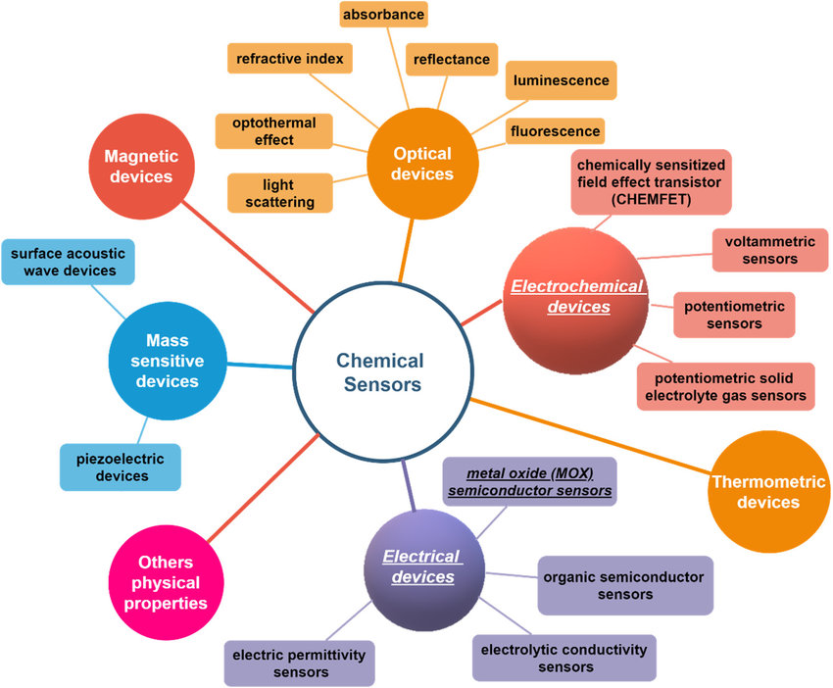

# ADVANTAGES

High surface-to-volume ratios, Debye lengths comparable to the target molecule, minimum power consumption, and they can be relatively easily incorporated into microelectronic devices.

For many important chemicals, optical measurements can offer a quick, accurate, and nondestructive investigation. With fiber-optic chemical sensors, the analyte in the sample can be detected remotely thanks to the use of optical fibers to transfer the optical signal to the measuring device.

Chemical stimulus.

Sensors may be used to screen and manipulate structures remotely, permitting faraway operation and maintenance.

Sensors can automate responsibilities and methods, growing performance and accuracy. Sensors might also have restrained ranges, which mean they'll no longer be capable of degree very excessive or very low values.

Sensors may not be appropriate for all environments, as a few sensors may not be capable of facing up to excessive ranges of moisture or dust.

Does not get poisoned by other gases. The presence of other ambient vapors will not shorten or curtail the life of the sensor .

# DISADVANTAGES

# Sensors might also have restrained ranges, which mean they'll no longer be capable of degree very

# excessive or very low values.

Sensors may not be appropriate for all environments, as a few sensors may not be capable of facing up to excessive ranges of moisture or dust.

Sensors may be expensive, in particular, if they're excessive-precision or specialized.

Sensors may be tormented by interference from different sources, electromagnetic fields. Limited or confined temperature range.

Short or limited shelf life.

Cross-affectability of different gases.

Shorter the life span due to greater exposure to the target gas.

Sensors may be expensive, in particular, if they're excessive-precision or specialized. Sensors may be fragile and can want to be covered from bodily harm or severe temperatures. Sensors may be tormented by interference from different sources, electromagnetic fields, or sensors. [12].

# APPLICATIONS

Biotechnology, chemical and environmental engineering, and other industries are currently being revolutionized by ever-increasing automation.

Here, system theory or safety considerations necessitate a high degree of automation in order to maximize efficiency.

To provide an accurate image of the system's state, a wide range of sensors and recording devices are used. This makes it clear that the sensors play a crucial role in the control system's functionality.

In dynamic systems, errors in the measured quantities might result in unfavorable operating conditions or be magnified in the control variables.

Significant advancements in microelectronics mean that self-calibrating and self-regulating "intelligent sensors" will be a major technological focus in the 1990s.

Instrumental methods of molecular analysis in particular, owing to their very favorable cost- performance relationship. .

Chemical sensors, which are based on low-dimensional nanostructured materials, exhibit high sensitivity and quick response times to a wide range of vapors and gases. These sensors find the most in bioengineering, environmental monitoring, food industry, medical detection, mining, and defense safety [13].

Chemical sensor based on resonance-frequency oscillating Nano cantilevers. A determining signal is produced when the chemical connects to the cantilever and stops the pattern of oscillation can be applied to the detection of biological viruses.

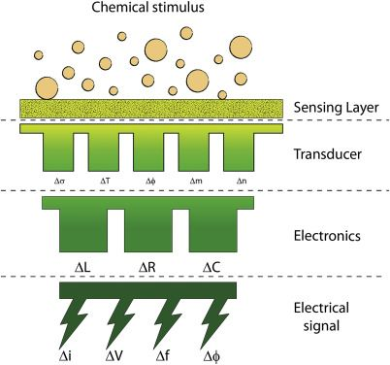

# FEATURES:

Two of the most important features of any chemical sensors include selectivity and sensitivity. Analyte can be present in liquid, gas, solid

Phases and May only is transient present in the sample. Analyte may also be present over a range of dimensional scales from liters to picoliters.

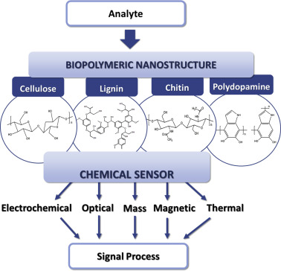

# SCOPE of Chemical Sensors.

These days, new recognition components and their combinations have been researched to improve recognition in chemical sensing and bio sensing. This is because of the requirement for quick diagnosis as well as improvements in sensing properties including selectivity, stability, and cost-effectiveness. The development of sophisticated Nano sensors has been aided by the identification of novel recognition components for chemical and biosensors as well as the use of nanotechnology. This combination has increased the sensitivity, selectivity, limit of detection (LOD), and signal-to-noise ratio of Nano sensors in terms of analytical performance. These Nano sensors have been applied in biomedical fields, including illness biomarker detection, virus identification, and pathogenic bacteria monitoring.

The difficulty lies in creating devices that adhere to the same exacting standards of accuracy and precision as those attained by laboratory analysis. However, in situ instrumentation must carry out this work in an actual environment that varies in temperature, salinity, pH, and the concentrations of interfering chemicals (which are frequently higher than the concentration of the analyte) as well as high ambient pressures. Therefore, in situ calibrations are required in order to assess the efficacy of remote sensors.

# CONCLUSION

Growth during the previous ten years as a result of the growing commercial availability of several types of specialty optical fibers. The detection of numerous useful sensing parameters, such as pH, humidity, ions, DNA, glucose, hazardous gases and organic materials, and explosive gases, has been successfully demonstrated using FOCS and FOBS due to their unique characteristics of

Small size, long distance transmission with low loss and no electromagnetic interference.

An overview of the state of research on chemical sensors based on novel forms of nanostructured materials, including nanotubes, Nano rods, Nano belts, and nanowires, is given in this article. For a wide variety of sensors, including as biological, electrochemical, gas, optical, pH, orientation, and more, these nanostructure-based sensors offer a potent detecting platform. Both single and multiple nanostructured sensors are part of the sensing apparatus.

# REFERENCE

1. Xing-Jiu Huang, Yang-Kyu Choi, Chemical sensors based on nanostructured materials, Sensors and Actuators B: Chemical, Volume 122, Issue 2, 26 March 2007, Pages 659-671
2. Qinghai Wu, kwang-Man Lee 1, Chung-Chiun Liu,Development of chemical sensors using microfabrication and micromachining techniques Sensors and Actuators B: Chemical, Volume 13, Issues 1–3, May 1993, Pages 1-6
3. S. Semancik a, R.E. Cavicchi a, M.C. Wheeler a, J.E. Tiffany a, G.E. Poirier a, R.M. Walton 1 a, J.S. Suehle a, B. Panchapakesan b, D.L. DeVoe b Microhotplate platforms for chemical sensor research Sensors and Actuators B: Chemical, Volume 77, Issues 1–2, 15 June 2001, Pages 579-591
4. Petar Kassal a, Matthew D. Steinberg b, Ivana Murković Steinberg,Wireless chemical sensors and biosensors,Sensors and Actuators B: Chemical,

Volume 266, 1 August 2018, Pages 228-245.

1. Celine I.L. Justino a b, Ana C. Freitas a b, Ruth Pereira c d, Armando C. Duarte a, Teresa A.P. Rocha Santos.Recent developments in recognition elements for chemical sensors and biosensors,TrAC Trends in Analytical Chemistry,Volume 68, May 2015, Pages 2-17.
2. Nikos Chaniotakis, Nikoletta Sofikiti,Novel semiconductor materials for the development of chemical sensors and biosensors,Analytica Chimica Acta,Volume 615, Issue 1, 12 May 2008, pages 1-9
3. Wolfgang Gopel,New materials and transducers for chemical sensors,Sensors and Actuators B: Chemical,Volume 18, Issues 1–3, March 1994, Pages 1-21
4. N. Graber, H. Lüdi, H.M. Widmer,The use of chemical sensors in industry,Sensors and Actuators B: Chemical,Volume 1, Issues 1–6, January 1990, Pages 239-243.
5. A. Hulanicki , S. Glab and F. Ingman, Chemical sensors: definitions and

classification,Pure&App/. Chern., Vol. 63, No. 9, pp. 1247-1250, 1991.

1. manish pandey,gourav mishra,Types of chemical sensors applications,advantages and disadvantages Advances in intelligent systems and computing book Volume 814,pages 791-804.
2. Prof. Dr. Karl Cammann, Dipl.-Chem. Udo Lemke, Dipl.-Chem. Anja Rohen, Dipl.-Chem. Jürgen Sander, Dipl.-Chem. Hildegard Wilken, Dipl.-Chem. Babette Winter,Chemical Sensors and Biosensors—Principles and Applications,Angewandte Chemie International Edition in EnglishVolume 30, Issue 5 p. 516-539.
3. Susana Cardoso, Armando C. Duarte, Strategies for enhancing the analytical performance of nanomaterial-based sensors, TrAC Trends in Analytical Chemistry

Volume 47, June 2013, Pages 27-36.

1. Segyeong Joo and Richard B. Brown, Chemical Sensors with Integrated Electronics, Chemical, volume 108, 2, 2008, pages 638–651.



