**LICENSE PLATE DETECTION BASED ON OPENCV**

1Prof. S. Ramya, 2Hemasree M, 3Moonisha M and 4Krithika S

1Assistant Professor, Department of Information Technology

2,3,4 Department of Information Technology,

Er. Perumal Manimekalai College of Engineering, Hosur, India

***Abstract*:**

In this project a new approach of automatic vehicle number plate recognition in National Highways and this approach enables the vehicle to automatically pass the NH roads by using object detection, 3D environment construction, virtual line generation, path planning. The system is to monitor the vehicles that are entering and going out of the NH roads. All vehicles have their own unique license plate number, so the abstraction of plate number plays a major role in this system. The vehicle number plate is taken by the tool like machine learning based camera which is placed at the road junctions. The captured image will be processed by the automatic number plate recognition using OCR (optical character recognition) algorithm, here we using Gaussians filters for remove the blueness of the image using a Gaussian kernel suppresses only high-frequency spatial information. Then the entry and exit vehicle number should be recorded. A database is created with the vehicle number. This method is an efficient way of recognizing the vehicle number plate and strengthen the security system. In case of centralized receiver all the entrance records are kept in storage and it will check the presence of theft vehicle entering into the NH roads, it will be noticed and capture the vehicle image and vehicle information’s will be send to authorized person using IMAP (Internet Message Access Protocol). The OCR technique is used to identify the number. This system has many advantages like theft detection, less man power, user friendly, vehicle logging and less processing time.

***Keywords****: Faster R-CNN; Number Plate Detection, Vehicle Detection, Optical Character Recognition, Number Recognition, Image Segmentation, Image Interpolation.*

1. **INTRODUCTION**

The project introduces an innovative approach to automate vehicle number plate recognition on National Highways (NH), enhancing security and efficiency in monitoring vehicle movement. By leveraging advanced technologies such as object detection, 3D environment construction, virtual line generation, and path planning, the system enables vehicles to seamlessly traverse NH roads. The primary objective is to monitor the entry and exit of vehicles on NHs, crucial for ensuring safety and security while facilitating smooth traffic flow. At the core of the system lies automatic number plate recognition (ANPR) using optical character recognition (OCR) algorithms. Machine learning-based cameras strategically placed at road junctions capture vehicle number plates, and the images undergo processing to extract plate numbers accurately. Gaussian filters are employed to eliminate image noise and enhance plate clarity, ensuring reliable identification. The recorded entry and exit details are stored in a centralized database, enabling efficient monitoring and analysis of vehicle movement patterns. One of the key features of this system is its ability to detect theft vehicles attempting to enter NH roads. By cross-referencing captured plate numbers with a centralized database, any unauthorized or stolen vehicles trigger immediate alerts. In such instances, vehicle images and relevant information are swiftly relayed to authorized personnel via Internet Message Access Protocol (IMAP), facilitating prompt action. With its focus on theft detection, reduced manpower requirements, user-friendly interface, comprehensive vehicle logging, and minimal processing time, this system presents a robust solution for enhancing NH security and management.

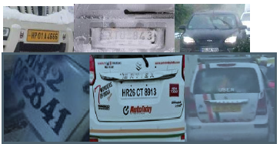

Figure 1 Various Conditions of number pates

1. **LITERATURE SYRVEY**

**[1] A.S. Reddy, U. Rani, M. Sudhakar, and R. Associate** “An Effective Thresholding Technique for Otsu’s Method using Contrast Enhancement,”2020 A common method in extracting the plate is by using Weiner deconvolution method to minimize the blurring effect. The above described method is operated in a loop. The loop repetitions are kept equal to the range of the parameter which is present in the blurred image. An image with maximum blur removal is considered from all the images in the loop iterations to which image processing techniques are applied. Noise can’t be removed completely if it is added to the image. In this case, images processing techniques are applied to this noisy image.

**[2] Goh, Ta Yang, Shafriza Nish Basah, Haniza Yazid, Muhammad Juhairi Aziz Safar, and Fathinul Syahir Ahmad Saad.** "Performance analysis of image thresholding: Otsu technique."2021 Another process that is necessary for ANPR is binarization of the grayscale image. The processing of black and white images takes lesser time compared to the processing of the grayscale image. With a wide range of techniques used for binarization, the common one is Otsu’s method. With certain conditions ensured while acquiring images, Otsu’s method gives out the best results.

**[3] Kumar, T. Senthil.** "A Novel Method for HDR Video Encoding, Compression and Quality Evaluation." Of all the imaging techniques, High Dynamic Ranging is becoming popular and important. Significant improvements are made to the system to improve this technique For reducing the distortion in High Dynamic Ranging video data, quantization with the help of luminous masking helps a lot.

**[4] H. Modi and M. C.,** “A Review on Optical Character Recognition Techniques,” Int. J. Comput. Appl., vol. 160, no. 6, pp. 20–24, 2017. IoT Based Automatic Vehicle License Plate Recognition System Prof.R.M.Sahu, Professor, Electronics Engineering, PDEACOEM, Maharashtra, India. IJARIIE- ISSN(O)-2395-4396. Vol-3 Issue-2 2022.OCR is done by comparing the pixel intensities from each bounding box to the stored set of alpha numeric intensities by a correlation factor. Whenever a bounding box pixel intensity matches with any of alpha numeric intensities correlation factor will be high and the desired character is detected.

**[5] MATLAB Based Vehicle Number Plate Recognition. Ms. Shilpi Chauhan and Vishal Srivastava. International Journal of Computational Intelligence Research ISSN 0973-1873 Volume 13, Number 9 (2020), pp. 2283-2288 © Research India Publications.** A traditional number plate detection system developed using MATLAB involves capturing an image from camera and is converted to Grayscale image. Then image processing techniques like Dilation, Edge detections and Low pass filtrations are applied. Binarization of the processed image is initiated to detect alphanumeric characters from the plate and these characters in optical form are converted into electrical form using Optical Character Recognition (OCR) scheme where characters are matched to the predefined customized templates for extraction. However morphological processing can also be done using Sobel operators.

**[6] Goh, Ta Yang, Shafriza Nisha Basah, Haniza Yazid, Muhammad Juhairi Aziz Safar, and Fathinul Syahir Ahmad Saad.** "Performance analysis of image thresholding: Otsu technique." Measurement 114 (2020): 298-307.When the number plate has been successfully localized, the next important step would be to segment the characters in it. For segmentation, there are some well-known techniques namely Hough transform, edge detection, etc., that give out good results.

1. **METHODOLOGY**

Optical character recognition (OCR) algorithms allow computers to analyze printed or handwritten documents automatically and prepare text data into editable formats for computers to efficiently process them. Human eyes naturally recognize various patterns, fonts or styles. For computers, it is hard work to do. Any scanned document is a graphics file, i.e., a pattern of pixels. Then, it becomes possible to extract meaningful information. Texts in a machine-readable form can then be used for different purposes.

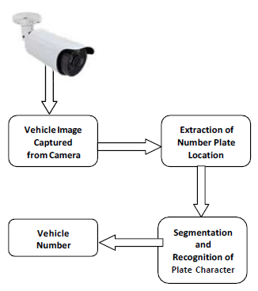

Figure 2. Steps before OCR

Optical character Recognition (OCR) serves as a tool to detect information from natural images and transfer them into machine-coded texts, such as words, symbols and numbers. It is still a hot ongoing search area and some novel algorithms are publishing from time to time. It is pretty interesting and essential to recognize the characters in the image because it could help greatly in some certain area: auto plate number recognition, books and documents scanning, assistive technology for blind and visually impaired users , zip-code recognition needed for post offices and much more.

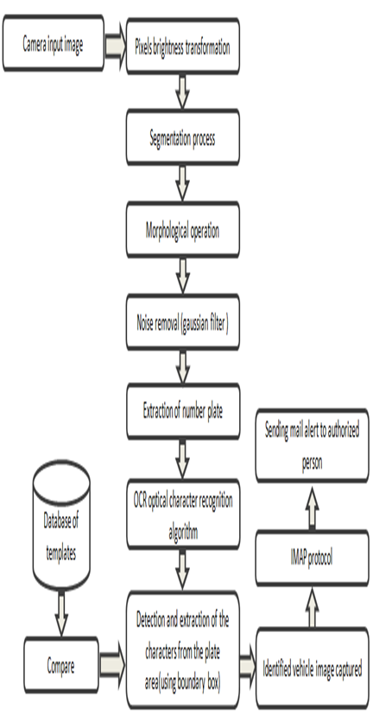

Figure 2 Architecture Design

1. **RESULT**

The captured image, the system accurately identifies and extracts the vehicle's number plate. Utilizing advanced object detection and image processing techniques, the system localizes the number plate within the image and precisely delineates its boundaries. This extracted plate is then subjected to optical character recognition (OCR) algorithms, enabling the system to decipher the alphanumeric characters comprising the plate number. The result is a highly reliable and efficient method for automatically recognizing and recording vehicle identification information. This streamlined process enhances security measures, facilitates traffic management, and enables seamless toll collection on National Highways. Overall, the successful extraction of the number plate represents a pivotal advancement in transportation technology, promising improved efficiency and effectiveness in monitoring and managing road networks.

1. **PROJECT MODULE**

There are six modules in this project

* Camera module
* Preprocessing and segmentation module
* Dataset comparing module
* Number plate recognition module
* Boundary box marking module
* Notification module

1. ***Camera Module:*** In this module the input number plate images can be captured by using the camera.
2. ***Preprocessing and Segmentation Module:*** In this module the features can be extracted from input number plate images. The segmentation process is used for separate the input images and binary image can be separated into background and original image.
3. ***Dataset Comparing Module:*** In database module, the images will be pre trained the number plate templates images and stored in the database for comparing with real time captured vehicle number plate images.
4. ***Number Plate Recognition Module:*** This module will recognize the vehicle number plate by using optical character recognize algorithm. The OCR algorithm will compare the input images with database trained template images, then this algorithm will detect the vehicle number plate and information.
5. ***Boundary Box Marking Module:*** After the detection of vehicle number plate, the Bounding Box is applied to this region to detect the characters in the plate.
6. ***Notification* *Module:*** If the vehicle number plate is detected means the vehicle image will be captured and the vehicle information mail alert will be sent to authorize person by using IMAP protocol.
7. **EXISTING SYSTEM**

The existing system proposes the use of the Faster R-CNN (Region-Based Convolutional Neural Network) to detect the number plate in the vehicle from the surveillance camera which is placed on the traffic areas etc. The created system is used to capture the video of the vehicle and then detect the number plate from the video using frame segmentation and image interpolation for better results. From the resulted image using the technique called optical character recognition is applied on that image for number recognition. These number are given as input to the database to retrieve data of vehicles.

**Disadvantages:**

* In this existing only detect the vehicle number plate and retrieve the data of vehicle.
* There is no any notification send to authorized person about the vehicle infor

1. **PROPOSED SYSTEM**

The proposed system first would capture the image of the vehicle, captured images are then extracted by using the segmentation process. Unwanted regions in the image are filtered by using gaussian filter and image is segmented and resized to obtain Number Plate Region. The Optical Character Recognition (OCR) algorithm to identify the characters, obtained data is then compared with the data stored in their database. Template matching is demonstrated using the stored set of number plates for OCR and the output is compared with the valid plates to allow access in real time. Bounding Box is applied to this region to detect the characters in the plate. In case of centralized receiver all the entrance records are kept in storage and it will check the presence of theft vehicle entering into the NH roads, it will be noticed and capture the vehicle image and vehicle information’s will be send to authorized person using IMAP (Internet Message Access Protocol).

**Advantages:**

* In our proposed system the vehicle number plate is detected by using OCR algorithm.
* The identified vehicle number plate and then vehicle images can be captured and send to Mail Alertto authorized person by using IMAP protocol.

1. **CONCLUSION**

In this project, the automatic number plate recognition systemusing vehicle license plate is introduced. The system utilizes machine learning techniques for recognizing the vehicle from the database stored in the computer by user. The system works agreeably for wide variation of conditions and distinctive sorts of number plates. In proposed work a novel system has been proposed for denoising and for the better character reorganization using standard classifiers and give better number plate detection. Then the identified vehicle image and information send Mail Alertto authorized person by using IMAP protocol. The improvement in the accuracy rate can be ensured if the OCR algorithm.

**References:**

1. C. Gou, K. Wang, Y. Yao, Z. Li, "Vehicle license plate recognition based on extremal regions and restricted Boltzmann machines", IEEE Trans. Intell. Transp. Syst., vol. 17, no. 4, pp. 1096-1107, Apr. 2016.
2. S. G. Kim, H. G. Jeon, H. I. Koo, "Deep-learning-based license plate detection method using vehicle region extraction", Electron. Lett., vol. 53, no. 15, pp. 1034- 1036, 2017.
3. Y. Yuan, W. Zou, Y. Zhao, X. Wang, X. Hu, N. Komodakis, "A robust and efficient approach to license plate detection", IEEE Trans. Image Process., vol. 26, no. 3, pp. 1102-1114, Mar. 2017.
4. İ.Türkyılmaz, K. Kaçan, "License plate recognition system using artificial neural networks", ETRI J., vol. 39, no. 2, pp. 163-172, 2017.
5. J. Xing, J. Li, Z. Xie et al., "Research and implementation of an improved radon transform for license plate recognition", IEEE Int. Conf. on Intelligent Human Machine Systems and Cybernetics,pp. 45-48, 2016.
6. S. Ren, K. He, R. Girshick et al., "Faster R-CNN: towards real-time object detection with region proposal networks", Int. Conf. on Neural Information Processing Systems, pp. 91-99, 2015.
7. J. Redmon, A. Farhadi, "YOLO9000: better faster stronger", IEEE Conf. Computer Vision and Pattern Recognition, pp. 6517-6525, 2017.