**AI BASED COLLEGE SURVEILLANCE SYSTEM**

**FOR CLASS SKIPPER**

1Prof. A. Richard William, 2Kanagaraj D, 3Vinoth Kumar P and 4Dhanush L

1Assistant Professor, Department of Information Technology

2,3,4 Department of Information Technology,

Er. Perumal Manimekalai College of Engineering, Hosur, India

***Abstract*:**

Traditional methods of taking attendance are often time-consuming and prone to errors, leading to inefficiencies in academic administration. The Classroom Skipper Recognition System (this project) is an innovative solution designed to streamline attendance management in educational institutions. This project addresses these challenges by harnessing the power of facial recognition technology coupled with advanced algorithms. Initially, this project builds a comprehensive database of students' facial data, where each student's face is captured and stored. This data is then used to train a robust face recognition model, ensuring high accuracy in identifying individuals. During class sessions, instructors input the current time, triggering the system to initiate attendance tracking. Using real-time facial detection, this project analyzes the faces present in the classroom and matches them against the stored database. Students who are recognized as present are marked as such in the attendance records. Moreover, the system periodically reassesses attendance by comparing the current session's detected students with historical data. A key feature of this project is its ability to detect class skippers—students who were present in previous sessions but are absent without valid reasons in the current session.

***Keywords****: Computer Vision, Predictive Analysis, Object Detection, Behavioral Analysis, Facial Recognition, Attendance Data Analysis.*

**1. INTRODUCTION**

In educational institutions, monitoring student attendance is a fundamental administrative task essential for maintaining academic integrity and student accountability. Traditional methods of attendance taking, such as roll call or manual checklists, are labor-intensive, prone to errors, and lack real-time insights. To address these challenges, there is a growing demand for automated attendance management systems that offer efficiency, accuracy, and convenience.

The traditional approach of calling out students' names, passing the attendance sheet is not only limited to being time - consuming but also gives rise to malpractices like manipulation in the attendance, proxy, etc. There are a few attendance systems which use technology like sensors and biometrics like fingerprint, iris scanning (which at times can be unreliable). However, the system proposed in this conference stands out as it is a one-stop system to manage and record the class attendance. The Classroom Skipper Recognition Project introduces an innovative solution to automate attendance tracking using facial recognition technology and advanced algorithms. This project aims to revolutionize the way attendance is managed in classrooms by leveraging the power of modern computer vision techniques. By capturing and storing facial data of students in a centralized database, this system eliminates the need for manual attendance recording. Instead, it employs real-time facial detection during class sessions to accurately identify and track students' presence Furthermore, the system periodically evaluates attendance records, identifying students who were present in previous sessions but are absent without valid reasons in the current session—a phenomenon commonly referred to as class skipping

Few of the terms used in the paper are explained in brief:

1. **Local Binary Patterns Histogram (LBPH)**

The local Binary Patterns Histogramor simply, LBPH is used widely for face recognition because of the computational simplicity offered by this algorithm. This algorithm is OpenCV’s part and it follows a few steps to recognize the face. It first creates the database, performs face acquisition, extracts the features from the face, and classifies the database to check if it matches with the input or not.

1. **Haar Cascade Algorithm**

Haar Cascade is a face detection algorithm. To train the classifier, this algorithm needs a few images, it extracts the features from the image and calculates it. The irrelevant features calculated are removed by the Adaboost - a training process where the facial and non-facial features are classified. Since the non-facial regions are more in the image, the cascade classifier removes it in a singles hot and hence the algorithm gets facial regions for detection. The OpenCV has both - the trainer as well as the detector and it also contains a lot of pre-trained classifiers which are available in the form of XML file.

2. **LITERATURE SURVE**Y

There have been many people who understood the need for the automated attendance management system in education technology. There are many projects and researches made regarding automated attendance systems. A few of the systems are closely related to the system is proposed in this paper. Here is a literature survey for getting a clear idea about the related work done in the past and for analysing these systems.

Shubhobrata Bhattacharya et al [1] designed a system which needs a video sequence as an input, the face is detected using the Viola-Jones algorithm and the facial features are extracted. The facial features are then normalized for which they used parameters like pose detection, sharpness, image size or resolution, and brightness. Lastly, a final quality score is displayed. Whereas, the authors in [2] proposed a system which captures the face, carries out a face detection process in which the skin colour and face motion is detected and tracked. It also localizes the position of eyes, lips, and face borders. Further, the face is aligned, normalized and then the features are extracted to be used in the matching process.

In [3] the authors made a system which captures a video and converts it into frames. The face is detected using the CNN algorithm. These detected faces in the database are then matched with the input to recognise the face. On completion of this process, the name of students is updated in the CSV file - on a weekly or monthly basis.

On a similar lines, in the paper [4] developed a system which captures video, convert it into frames which are further used as the student image, detects the face using Viola-Jones algorithm, recognises the face using LBPH algorithm, and lastly, once the face is matched with the database, the student attendance is marked in the CSV file.

Mayank Srivastava et al [5] developed a system which consists of three steps - Firstly, the face image is detected, extracted, and stored in an YML file such that it can be used in the future. In the second step, the image is trained and thus the Eigen vector and Eigen value of the image is computed. Finally, the images stored in the YML format are used to compare and recognize the face.

In the paper [6], the authors used two-dimensional face recognition by implementing LBP. This system also controls the door for allowing the students in the class, It is an online web server and hence is accessible to any individual who is an authenticated web client.

KennedyOkokpujieetal [7] served the camera as an input device. The camera acquires the detected face for which the Viola-Jones algorithm is used. To create the templates of the captured images, Fisher faces algorithm is used. The verified face images form the basis for the attendance. The attendance recorded is relayed to the authorized handheld devices via cellular network. The database capacity is up to twenty persons with twenty to fifty image databases per person. There are a lot of insightful papers regarding attendance using face recognition. These systems have recorded some or other drawbacks which the proposed system tries to overcome. A few of the observed drawbacks are - limited database capacity, expensive systems, lack of accuracy, in the process, attendance on a weekly or monthly basis.

Mentioned below are a few attendance systems other than face recognition and also a few existing face recognition algorithms are discussed:

**A. Attendance using pen and paper**

In this method, there are two types. One in which the teacher calls out the name of the students to mark their attendance. And the other in which the sheet is passed in the class and the students mark their attendance by entering the required details. This approach not only takes up time and disturbs the class but also leads to malpractices like manipulation in attendance and proxy and hence is not a reliable option.

**B. Attendance using physiological biometrics**

To automate the attendance system, there are several fingerprint and hand sensing attendance systems. For example, Mohamed Basheer K P and Raghu CV [8] proposed a system in which a handheld device (LCD Display) can be used in the classroom to mark the attendance using the fingerprint sensor. This device is managed by the faculty using a host computer. The student data can be added, and attendance data can be imported or exported.

Considering the current Covid-19 pandemic situation, using a finger print or hand scanner is indeed not are liable system since it contains contact of every student with the device and hence can be dangerous.

The attendance can also be recorded automatically using iris recognition. Amena Khatun et al [9] proposed a system in which an image of a person is taken through a web-cam and sent to a computer for further processing. The transfer of data is through a USB connection between the webcam and computer. In the image acquisition process, there is localized, the image is adjusted, and the iris is checked. If the required conditions are matched, the iris is extracted and is saved as an iris template database. This iris when matched with the person, is then authenticated else the above steps are repeated. This system can be reliable but there is a probability of lack of accuracy.

**C. Attendance using physiological biometrics**

Biometrics like voice can be used for attendance management. Benfano Soewito et al [10] made research in which they used a smartphone for fingerprint and voice recognition. For voice recognition, the recorded electronics signal is converted into a spectrogram or voiceprint. The next voiceprint is stored in the form of a sequence of numbers and each dominant frequency in each segment is expressed as a binary number. Thus, they get a sound template which can be used to match for the authentication process.

**D. Existing face recognition algorithms**

There are several types of face recognition algorithms. The Eigenfaces, LBPH, Fisherfaces, SIFT, and SURF are few of the most known face recognition algorithms. These algorithms are compared in Table No. 1 based on the approximate standard maximum accuracy which each algorithm offers.

Table 1 Face Recognition Algorithms

|  |  |
| --- | --- |
| **Face Recognition Algorithm** | **Accuracy** |
| Eigen faces | ≈ 93% |
| Local Binary Patterns Histograms(LBPH) | ≈ 94% |
| Fisherfaces | ≈ 92% |
| Scale Invariant Feature Transform(SIFT) | ≈ 96.44% |
| SpeedUp Robust Features(SURF) | ≈ 90.2% |

**3. METHODOLOGY**

The system proposed in the basis of face recognition. When a student come across the camera module, then his/her image/photo will be captured and recognize with validation. When recognition and validation is succeeded, then his/her attendance will mark automatically. In this system, user gets a login interface to interact with the system. The proposed block diagram of the automatic attendance system is shown in the Fig. 1. The system block diagram and explained as follows.

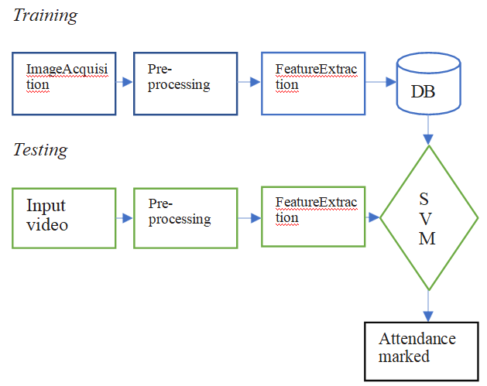

Fig.1. Architecture of ELBAS

1. **Capturing the Video**

The camera is used to take the video of students present in the class which will then be divided into frames to get the images.

1. **Face Detection**

In this part, implements face detection, which helps to determines captured image with location and sizes of student faces. The image will be captured from detected faces using HAAR cascade classifier.

1. **Image Pre-processing**

There is a pre-processing requirement for enhance the input image for improve the quality of image and convert input image to grey scale image using colour to grey image conversion technique.

1. **Training Set**

Comparing the faces which to be recognized with some other similar faces to did recognition process. Supply algorithm faces in training set for tell which person who belongs. When recognize face by algorithm, it uses the training set to make recognition.

1. **Face Recognition**

The important part of this system is face recognition. Face recognition of an automatic method of identifying and verifying a person from images and videos from camera.

1. **Attendance marker**

The particular student will be marked as present in attendance when if a face from the particular date folder is matched. That is, collect the list of all students who were present in the class, and rest of the students belongs the class will be marked as absent. This is the following procedure. Face Detection using HAAR cascade classifier Paul Viola and Michael Jones are proposed the effective object detection method HAAR cascade classifier. This is machine learning based approach. From this, a cascade method analyses from the positive and negative images.

**4. RESULT**

The developed project is a college-based class attendance system For College Skipper which is expected to take the student details and images as input. The image is trained using Haar Cascade algorithm and a YML file is created out of these trained images. The trained image data is compared with the tracked image using SVM classifier which works better when compared KNN as shown in the below chart then the attendance is marked for the student whose face matches with the existing database.

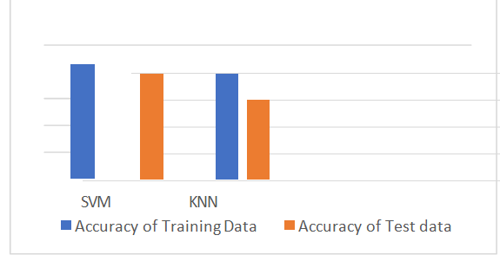

Figure 3 Comparison of SVM & KNN

1. **Add Details**

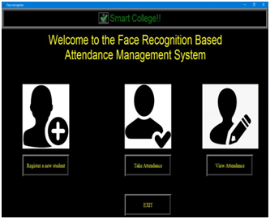

Figure 4 Student Detail Input

The details of the student - Roll number and Name are added in the table created namely “student.”The roll number is a primary key and the name is a text. Fig.2 shows the GUI of Add Details page.

**B. Take Image**

On clicking “Take Image,” the webcam opens up and records a real-time video and converts it in frames to be used as an image of the student. On images being taken, the status will be updated as “Images taken for ID: roll no

Name: name.”

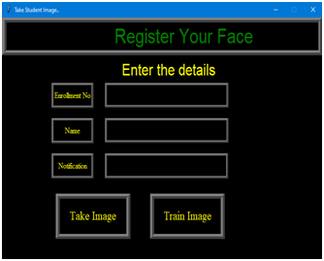

Figure 5 student details

**C. Train Image**

The image is trained using the Haar cascade algorithm. The label to the image is assigned as the name and roll number of the student. This trained data set is saved as “trainer.” The status is updated to “Image trained”

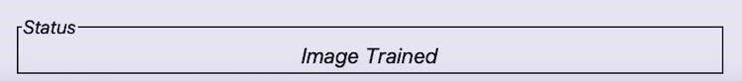

Figure 6 Status Update

**D. Attendance Record**

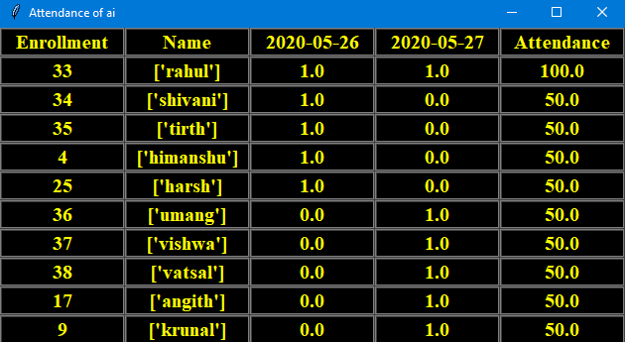

Figure 7 Attendance marked

The attendance is marked in the CSV file for the students whose face matches with the existing database. shows how the attendance is marked in the sheet in “Attendance, date” format.

**G. View List**

On clicking the “View List,” the list of students in the class whose database has been recorded can be viewed. In case a student is not recognised by the system, the faculty can view the list and make sure if the database of the student has been added or not.

**5. CONCLUSION**

The Classroom Skipper Recognition System revolutionizes attendance management in educational institutions through its innovative integration of facial recognition technology and advanced algorithms. By efficiently capturing and storing students' facial data, the system ensures accurate identification during class sessions, reducing administrative burdens and errors associated with traditional attendance methods. Its real-time monitoring capabilities enable proactive intervention by identifying class skippers and flagging attendance discrepancies, promoting student engagement and accountability. With its user-friendly interface and robust face recognition model, this project offers a reliable and efficient solution for academic institutions seeking to streamline attendance monitoring and enhance student engagement.

**6. FUTURE SCOPE**

* The newer version of the system can be updated where this system will not only be limited to a classroom. This system can be made available for any place where attendance is a need. For example - in an office, in the hospital.
* This system can be developed as a product. It can be made available on the webserver so that it can be accessible to anyone, anywhere across the globe

**References:**

1. S.Bhattacharya, G.S.Nainala, P.Dasand A. Routray, "Smart Attendance Monitoring System (SAMS): A Face Recognition Based Attendance System for Classroom Environment," 2018 IEEE 18thInternational Conference on Advanced Learning Technologies (ICALT), Mumbai, 2018, pp.358-360, doi:10.1109/ICALT.2018.00090.
2. R.Hartantoand M.N.Adji, "Face Recognition for Attendance System Detection," 2018 10th International Conference on Information Technology and Electrical Engineering (ICITEE), Kuta, 2018, pp.376-381, doi: 10.1109/ICITEED.2018.8534942.
3. Nandhini R, Duraimurugan N, S.P.Chokkalingam, “Face Recognition Based Attendance System,” International Journal of Engineering and Advanced Technology (IJEAT) ISSN: 2249 – 8958, Volume-8, Issue-3S, February 2019
4. Smitha, & Hegde, Pavithra & Afshin, (2020). Face Recognition based Attendance Management System. International Journal of Engineering Research and. V9. 10.17577/IJERTV9IS050861.
5. M. Srivastava, A. Kumar, A. Dixit and A. Kumar, "Real Time Attendance System Using Face Recognition Technique," 2020International Conference on Power Electronics & IoT Applications in Renewable Energy and its Control(PARC), Mathura, Uttar Pradesh, India, 2020, pp. 370-373, doi: 10.1109/PARC49193.2020.236628.
6. A. R. Salim, R. F. Olanrewaju and W. A. Balogun, "Class Attendance Management System Using Face Recognition," 2018 7th International Conference on Computer and Communication Engineering (ICCCE), Kuala Lumpur, 2018, pp. 93-98, doi:10.1109/ICCCE.2018.8539274.
7. K. Okokpujie, E. Noma-Osaghae, S. John, K. Grace and I. Okokpujie,"A face recognition attendance system with GSM notification," 2017 IEEE 3rd International Conference on Electro-Technology for National Development (NIGERCON), Owerri, 2017, pp. 239-244, doi:10.1109/NIGERCON.2017.8281895.
8. Basheer, Mohamed & Raghu, C.V..(2012). Finger print attendance system for classroom needs. 433-438.10.1109/INDCON.2012.6420657.
9. B.Soewito, F. L. Gaol, E.Simanjuntakand F. E.Gunawan, "Smart mobile attendance system using voice recognition and fingerprint onsmartphone,"2016InternationalSeminaronIntelligentTechnologyandIts Applications (ISITIA), Lombok, 2016, pp. 175-180, doi:10.1109/ISITIA.2016.7828654.
10. A.Khatun, A. K. M. Fazlu lHaque, S. Ahmedand M. M. Rahman, "Design and implementation of iris recognition based attendance management system," 2015 International Conference on Electrical Engineering and Information Communication Technology (ICEEICT), Dhaka, 2015, pp. 1-6.