**AMBULANCE BLOCKING VEHICLES IDENTIFICATION BY ARTIFICIAL INTELLIGENCE**

1Prof. G. Venkateshwari, 2S. Gopi Krishna, 3CP. Gurudeep,

4N. Syed Zain N and 5J. Vignesh

1Assistant Professor, Department of Information Technology

2,3,4,5 Department of Information Technology,

Er. Perumal Manimekalai College of Engineering, Hosur, India

***Abstract*:**

In the new evolving world, traffic rule violations have become a central issue for majority of the developing countries. The number of vehicles is increasing rapidly as well as the number of traffic rule violations are increasing exponentially. Managing traffic rule violations has always been a tedious and compromising task. Even though the process of traffic management has become automated, it’s a very challenging problem, due to the diversity of plate formats, different scales, rotations and non-uniform illumination conditions during image acquisition. The increased vehicular traffic has also increased the traffic and the road accidents to take place frequently which causes loss of life and property because of the poor emergency facilities. Due to huge traffic, emergency vehicles like ambulances are not able to reach their destinations in time, resulting into loss of human lives. This project will provide an optimum solution to this draw back. If any other vehicles are blocking ambulance, the vehicle is first identified for its type, using yolo v4 algorithm whether it is a car or a truck or any other vehicle. Then the number plate of the blocking vehicle is detected using OCR algorithm. After recognizing the vehicle’s number from number plate, it is then saved so that the driver could be given penalty.

*Keywords:* *Ambulance, Yolo v4 architecture, segmentation, OCR algorithm.*

**1. INTRODUCTION**

Emergency vehicles play an important role in every life-threatening situations. Traffic jam takes more than 20% patient’s lives in an ambulance but when the patient’s condition is very serious the percentage of patient death is increased. These are situations when an emergency patient needs to go to the hospital immediately and the ambulance got stuck in the traffic jam. This scenario is dangerous in case of heart patients who needed to be rushed to hospital in time. In traffic jams, many people do not bother to give pass-way for the emergency vehicle and also traffic police can’t see which lane they should clear for the ambulance. We can reduce these problems by introducing a OCR algorithm, that will detect the violating vehicle number plate to give penalty to the drivers thus reducing the violations. So this proposed is to reduce the traffic violence. In this study, a multimodal feature fusion approach was adopted to complete vehicle detection through the multimodal feature fusion of camera and millimeter-wave radar. The sensors were jointly calibrated to achieve spatial and temporal alignment and reduce sampling errors, and a statistical filtering algorithm was added to remove point cloud outliers and interference. After preprocessing, the fused features were transmitted to the vehicle-detection module. Then the collected features were fused and extracted by the multimodal feature fusion module combined with the feature pyramid to improve the multiscale vehicle-detection accuracy.

**2. OBJECTIVE**

* The main objective of this project is to detect the ambulance blocking vehicles easily without the need of any traffic police.
* The number plates of violating vehicles are easily saved to assign penalty to the violators.
* This helps in reducing the violation of traffic rules.
* Thus ambulance blocking would be reduced resulting in the saving of many critical patient’s life.

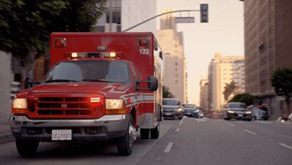

Figure 1 Existing System

**3. EXISTING SYSTEM**

An ambulance is rushed to the accident spot which carries the patient to the hospital and simultaneously monitors the vital parameters like temperature and pulse rate and conveys them to the concerned hospital. Along with this there would be control of traffic light signals in the path of the ambulance via RF communication to provide a clear path for the ambulance. This will minimize the time required by the ambulance to reach the hospital. But the traffic system is not good enough to leave way to ambulance. There is no proposed system to detect the number plate identification of ambulance blocking vehicles.

Disadvantages:

* This system doesn’t identifies the blocking vehicles
* Though the ambulance is fast it couldn’t reach destination on time making patient’s life riskier.

**4. PROPOSED SYSTEM**

In our work, the only piece of hardware we propose to use is the surveillance camera itself. The system will detect vehicle through images instead of using electronic sensors. The input video will converted into single frame which is used to image preprocessing and segmentation will separate the wanted part and unwanted part that is image of vehicle and background. The RGB color image converted into gray scale image for extracting the wanted part of the image, the gaussian filter is used for removing the noise present that image and canny edge detection is used for marking the outline of the number plate. A camera will be installed in front of the ambulance which will capture the footage of the vehicle’s number plate. The captured footage is then converted to frames and YOLO algorithm is used to extract the vehicles. The extracted images is then processed by OCR algorithm to detect and store the details about the vehicle.

Advantages

* It will avoids unwanted vehicles blocking the ambulance in emergency situations.
* It save human life and time also.
* Less Equipments needed
* Fully automated system
* Highly scalable

**Block Diagram**

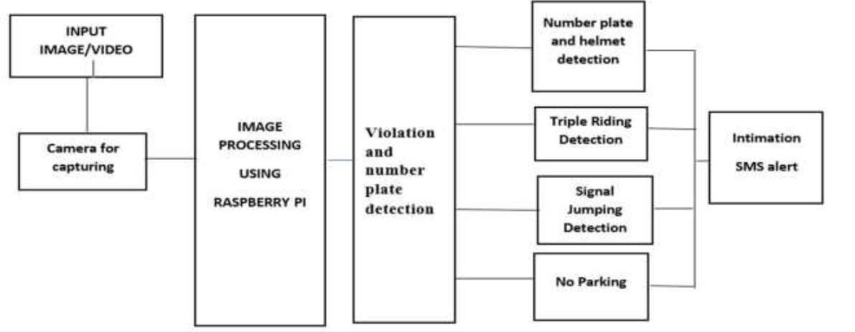

Figure 2 System Architecture

License Plate Recognition (LPR) is one form of ITS (Intelligent Transport System) technology that not only recognizes and counts the number of vehicles but also differentiates them. For some applications, such as electronic toll collection and red-light violation enforcement, LPR records license plates alphanumerically so the vehicle owner can be assessed the appropriate amount of fine. In others cases, like commercial vehicle operations or secure-access control, a vehicle's license plate is compared against a database of acceptable ones to determine whether a truck can bypass a weigh station or a car can enter a gated community or parking lot. A license plate is the unique identification of a vehicle. The basic issues in real-time license plate recognition are the accuracy and the recognition speed. License Plate Recognition (LPR) has been applied in numerous applications such as automatically identifying vehicles in parking lots, access control in a restricted area and detecting and verifying stolen vehicles.

Quality of algorithms used in a license plate detector determines the speed and accuracy of the license plate detection. In the past, a number of techniques have been proposed for locating the plate through visual image processing. A video is taken from a camera, and then each frame of the video is processed as the image. In this stage the license plate region from the given image is located and isolated. Quality of the image plays an important part hence prior to this stage pre- processing of the image is necessary. So first each frame pre-processed by binarization, noise reduction and edge detection. Then, the license plate is located by different image processing technique.

**5. MODULE DESCRIPTION**

1. Video Processing module
2. Image conversion module
3. Vehicle detection module
   1. **Number plate recognition using OCR module**

**Number plate recognition OCR module:**

* The number plate of the vehicle blocking the ambulance is segmented using OCR algorithm. In this module, is used to detect the vehicle and it is used OCR algorithm to recognition the number plate, it will be store in database.

**Database module**

* A database is an organized collection of image and train dataset information, or data, typically stored computer system. A database is usually controlled by a database management system (DBMS).

**Video Processing module:**

* The camera installed in the front of ambulance captures all the vehicles which blocks its way. The video processor module receives and processes image data provided by the cameras. The plurality of interfaces include interfaces for wired connection to the cameras and for receiving image data from the cameras

**Image conversion module.**

* Image conversion is the converts the true color image RGB to the grayscale image. The RGB images to grayscale by eliminating the background images and saturation information while and black color conversion. Gaussian filter is used to remove the unwanted noise in the image; blurred edge detection is used to mark the outline of the license plate.

**Vehicle detection module:**

* The module is used to detect the vehicle; it’s to identify the car or truck and recognition number plate. A vehicle detection operation is applied on the profile of the unprocessed image. The method used here is based on applying edge detector operators to a profile of the image edges are less sensitive to the variation of ambient lighting and are used in full frame applications (detection). The first step to measure the TMJ parameters using the key region method is to cover the boundary of the junction by a polygon in such a way that all the entry and exit paths of the junction cross the polygon. However, the polygon should not cover the pedestrian marked lines. This step is shown in the figure given below. The second step of the algorithm is to define a minimum number of key regions inside the boundary of the polygon, covering the junction.

**6. RESULT**

Through this paper Number Plate of the vehicle is authenticated and data is taken. Since this model is capable of detecting vehicles in every frame it is having been enhanced to detect the speed of the vehicle in a video. Detection of vehicle crossing during a red light in the image and locate the exact location. Data of the vehicle is taken when the people riding on two-wheeler is more than two. Vehicle parked in the no parking area is given five minutes time to change the vehicle from the spot if not changed violation is detected and fine is sent through SMS. The speed is calculated using all the three principles, the rate of change of the object is the video frame by frame gives us the speed but it is not the true speed. This because the object in the video doesn’t move linearly hence the area of the boundary frame by frame gives us the actual distance travelled by the vehicle in the video. The anchor points add more perception to the parameters. With this parameter, the speed of the vehicle is determined.

**7. CONCLUSION**

Ambulance acts as one of the lifesaving factors in which there is a requirement of quick response. Delayed ambulance arrival can cause serious issues like death, more loss of blood. In this project the capture vehicle is an ambulance blocking vehicle, we successfully detecting the vehicle. And capture the vehicle number plate it will be store in excel and fine will be collected from vehicle owner. This can be enhanced to capture an image from a live video and detect the vehicle and clearing the root to save the life of the patients. Results show that the detection of multiple traffic violations from a single input source is achievable. It should be noted that robust motion detection is a critical task and its performance is affected by the presence of varying illumination, background motion, camouflage, shadow, and etc.

**References:**

1. Becker, L. R., Zaloshnja, E., Levick, N., Li, G., & Miller, T. R. (2020). The relative risk of injury and death in ambulances and other emergency vehicles. Accident Analysis & Prevention.
2. Liaw, J. J., Wang, W. S., Chu, H. C., Huang, M. S., & Lu, C. P. (2021, October). Recognition of the ambulance siren sound in Taiwan by the longest common subsequence.
3. Fatimah, B., Preethi, A., Hrushikesh, V., Singh, A., & Kotion, H. R. (2020, July). An automatic siren detection algorithm using Fourier Decomposition Method and MFCC 2020,IEEE.
4. Ergonomics-Danger Signals are Further Subdivided and Work AreasAuditory Danger Signals, Standard 7731, International Organization for Standardization, 2019.
5. F. Beritelli, S. Casale, A. Russo, and S. Serrano, ‘‘An automatic emergency signal recognition system for the hearing impaired,’’ in Proc. IEEE 12th Digit. Signal Process. Workshop, 4th IEEE Signal Process. Educ. Workshop, Sep. 2020.
6. G. Suciu, A. Vintea, S. C. Arseni, C. Butca, andV. Suciu, “Challenges and Solutions for Advanced Sensing of Water Infrastructures in Urban Environments,” pp. 349–352, 2021.
7. NiteenMohod, “Usability of Internet of Things [IoT] For Dam Safety and Water Management”, International Journal of Research in Advent Technology, Vo.5, No.1, January 2020.
8. A.C. Khetre, S.G. Hate, “Automatic monitoring & Reporting of water quality by using WSN Technology and different routing methods”, IJARCET Vol 2, Issue 12, Dec 2018, pp 3255- 3260.