**AGRODEFEND: SMART FIRE PREVENTION SOLUTIONS**

By

D.C. Reddy* P.Tiwari* B.Bhuarya * Prof.V.Sharma*

* Department of Electronics and Telecommunications, Bhilai Institute of Technology, Durg, India.

# **ABSTRACT**

The "IoT-based Fire Detection and Prevention System in Farmland" project seeks to develop an innovative and robust solution to minimize the risks of fire outbreaks in agricultural areas. Leveraging the capabilities of the Internet of Things (IoT), this system provides continuous, real-time monitoring of farmland conditions to enable early detection of fire hazards. A network of interconnected sensors is strategically deployed across the farmland to measure environmental parameters such as temperature, and smoke levels. These sensors transmit the collected data to a central control unit, which is processed by an advanced algorithm designed to detect potential fire threats. Upon detection, the system triggers an automatic response using relays that activate fire suppression mechanisms such as sprinkler systems or water pumps using motors, effectively containing and preventing the spread of fire. Additionally, the system includes a display module that provides real-time alerts and updates to farmers and relevant authorities, ensuring they can take immediate action when necessary. This solution not only enhances safety but also reduces crop damage and financial losses by addressing fire threats before they escalate.

Keywords: IoT-based Fire Detection, Fire Prevention System, Real-Time Monitoring, Environmental Sensors, Automatic Fire Suppression, Agricultural Technology.

# **INTRODUCTION**

This project focuses on developing a comprehensive, IoT-based solution for mitigating fire risks in agricultural farmlands, offering an innovative approach to enhance safety and reduce potential losses due to fire outbreaks. Fire hazards in farmland pose a significant threat, not only to crops and livestock but also to surrounding ecosystems and local communities. Current firefighting methods in rural areas are often reactive, and by the time fires are detected and reported, they may have already caused irreversible damage. To address these challenges, our project leverages the power of Internet of Things (IoT) technology, providing a proactive, real-time monitoring system designed to detect early signs of fire and respond immediately, preventing its spread and minimizing the damage.

The system's core functionality is built around a network of interconnected sensors that are strategically placed throughout the farmland. These sensors monitor various environmental conditions, including temperature, and the presence of smoke, which are critical indicators of a fire. The choice and placement of sensors are tailored to the specific requirements of each agricultural area, ensuring optimal coverage and accuracy. The sensors continuously gather data and transmit it to a central control unit, where the information is processed using advanced algorithms designed to detect anomalies that could indicate the onset of a fire. By analyzing

temperature spikes, abnormal smoke levels, and other environmental changes, the system can identify potential fire hazards at an early stage, providing a crucial window of opportunity to take preventive measures.

Upon detecting any sign of fire, the system immediately triggers alerts. These alerts are sent in real-time to farmers, enabling swift action to be taken. Also, the notification is sent via email, ensuring all relevant information is sent promptly. This early warning system helps to significantly reduce the time between the detection of a fire and the initiation of firefighting efforts, which is essential for minimizing the spread of the fire and reducing damage.

In addition to real-time alerts, the system also employs relays that are directly integrated with fire suppression mechanisms. Once a fire is detected, these relays automatically activate sprinkler systems or water pumps, effectively containing and suppressing the fire before it can spread to other parts of the farmland. This automatic response helps to control the fire in its early stages, significantly reducing the reliance on external firefighting services and enabling farmers to protect their crops and property more efficiently.

To provide continuous monitoring and facilitate real-time decision-making, the project includes the development of an LCD Display module. This module serves as a user-friendly interface where farmers and local authorities can access real-time data on the environmental conditions of the farmland.

By integrating IoT technology, real-time monitoring, automatic fire suppression, and a comprehensive display module, this project provides a robust solution to the challenges posed by fire outbreaks in agricultural farmlands. The proactive nature of the system not only helps to mitigate the risk of fires but also ensures that resources are used efficiently, reducing water consumption and the need for external firefighting services. Overall, this project enhances the safety of agricultural operations, safeguarding crops, livestock, and property from fire-related damage while providing farmers with an effective tool to manage and monitor their farmland.

**1. Literature Review**

Fire prevention and suppression technologies have evolved significantly with advancements in IoT, AI, and remote sensing. Recent studies have explored various methodologies that enhance early fire detection, predictive analytics, and rapid response mechanisms, leading to more effective fire management strategies.

A foundational study by Srikanth & K.H. (2019) [1] introduced an automated Smart Crop Protection System utilizing Arduino technology to safeguard crops from fire and animal threats. The system integrates motion sensors to detect animal movement and environmental sensors to identify fire risks. Upon detection, it activates alarms and fire suppression mechanisms, providing a cost-effective and efficient method for preventing crop damage in rural agricultural areas. This research highlights the importance of integrating low-cost embedded systems for real-time fire prevention.

A complementary study by Harjinder Singh (2016) [2] explored wireless sensor networks for forest fire detection. The system employs a network of sensors distributed across forested areas to monitor temperature and smoke levels in real-time. When fire conditions are detected, alerts are transmitted via GSM to concerned authorities, enabling a rapid and accurate response. The study emphasizes the role of wireless communication in enhancing fire detection in remote areas, where traditional methods are less effective.

GB Harsha & SJ (2024) [3] expanded on fire suppression technologies by developing an IoT-enabled drone equipped with flame sensors and water pumps. This drone autonomously detects fire sources and releases water for suppression. The system improves the efficiency of firefighting efforts by reaching areas that are difficult for ground-based responders to access. The study highlights how automated aerial vehicles can significantly enhance fire suppression in challenging environments.

Building on AI-driven wildfire prevention, Patel et al. (2023) [4] proposed an AI-integrated wildfire prevention system that utilizes IoT sensors and predictive analytics. Their system assesses fire risk using machine learning models that analyze weather patterns, vegetation dryness, and wind conditions. Equipped with temperature, humidity, and smoke sensors, the system transmits alerts via LoRaWAN and GSM. Additionally, AI-powered drones conduct aerial surveillance of fire-prone areas, enhancing real-time monitoring. This study underscores how AI-driven fire prediction can improve fire prevention strategies.

Further extending remote monitoring approaches, Zhang & Li (2023) [5] investigated the role of remote sensing and satellite imaging in fire monitoring. They utilized thermal imaging, vegetation indices, and AI-based anomaly detection to identify fire outbreaks. Their study emphasizes how satellite imaging technologies (e.g., Sentinel-2, MODIS) provide high-resolution thermal data for fire-prone regions. However, limitations such as cloud cover interference and delayed response times suggest the need for hybrid detection approaches, integrating IoT sensors, AI, and satellite data.

A significant contribution to AI-based fire management was made by Kumar & Verma (2019) [6], who developed a Smart Fire Management System integrating AI and IoT. Their study focused on machine learning algorithms trained on historical fire data to improve fire risk prediction. The system employs fixed and mobile sensors to monitor environmental parameters, automatically triggering alerts to local authorities when a fire is detected. Additionally, they highlight the role of Geographical Information Systems (GIS) in mapping fire-prone areas and improving response coordination. This research is particularly relevant to the AgroDefend system, as it demonstrates how AI can enhance fire detection accuracy and improve system responsiveness.

Collectively, these studies illustrate how emerging technologies, particularly IoT, AI, and remote sensing, are transforming fire detection and suppression strategies. By integrating predictive analytics, real-time monitoring, and automated response mechanisms, fire management systems can become more efficient, proactive, and adaptive, reducing the risk of large-scale fire outbreaks.

**Table 1: Comparative Analysis of Fire Prevention Technologies**

|  |  |  |  |  |
| --- | --- | --- | --- | --- |
| **Author &Year** | **Aim** | **Technology Used** | **Key Features** | **Advantages** |
| Srikant & K.H(2019) | Smart Crop Protection System | Arduino, Motion & Fire Sensors | Fire suppression & alarm activation | Cost-effective, real-time response |
| Harjinder Singh (2016) | Forest Fire Detection | Wireless Sensors, GSM | Remote monitoring & fire alerts | Accurate detection in remote areas |
| GB Harsha & SJ (2024) | IoT-Enabled Fire Suppression Drone | Flame Sensors, Water Pumps | Autonomous fire suppression | Rapid response in inaccessible areas |
| **Patel et al. (2023)** | AI-Driven Wildfire Prevention | IoT, AI, LoRaWAN, GSM | Predictive analytics, Drone surveillance | Early fire risk assessment |
| Kumar & Verma (2019) | Smart Fire Management | AI, IoT, GIS | Fire risk prediction | Improved detection accuracy |

|  |  |  |
| --- | --- | --- |
| **Method** | **Advantages** | **Limitations** |
| Wireless Sensor Networks | Real-time monitoring, low power consumption | Limited range, network maintenance required |
| Satellite Imaging | Large-area coverage, high-resolution thermal imaging | Affected by clouds, delayed data processing |
| AI-Driven Predictive Models | Accurate risk prediction, automated decision-making | Requires large datasets, computationally expensive |
| IoT-Based Fire Suppression | Immediate response, autonomous operation | Dependent on communication networks, power limitations |
| Drone Surveillance | Fast response in inaccessible areas | Limited flight time, high operational cost |

**Table 2: Advantages and Limitations of Fire Prevention Methods**

# **1.1 HISTORICAL EVOLUTION**

Smart Fire Prevention Solutions is rooted in the growing need for innovative technologies to address fire hazards in agricultural farmlands. Historically, agricultural fire prevention methods were limited to traditional firebreaks, manual monitoring, and firefighting responses, which were reactive. However, with the rapid advancements in technology, especially in the field of IoT (Internet of Things), a shift toward more proactive, automated, and real-time fire detection and prevention systems became possible. The journey of fire detection and prevention systems in agriculture has seen considerable technological growth over the last two decades, marked by the integration of modern electronics, sensors, and communication networks**.**

In the early 2000s, agricultural fire detection relied heavily on manual processes such as physical patrols and lookout towers. Firebreaks—gaps or strips of land cleared to prevent fires from spreading—were a primary preventive measure. While these strategies had some effectiveness, they were labour-intensive and subject to human error. With the onset of more frequent and intense wildfires due to climate change, it became increasingly evident that traditional methods were insufficient for protecting large farmlands, as they lacked real-time monitoring and immediate response capabilities. There was a need to develop technologies that could offer enhanced detection, rapid alerts, and swift suppression to mitigate fire damage.

The early 2010s saw the emergence of basic sensor-based systems in agriculture. During this period, wireless sensor networks (WSNs) became a crucial component in environmental monitoring. For example, the study by Harjinder Singh (2016) demonstrated the use of wireless sensors, combined with Arduino and GSM, for detecting forest fires. This laid the groundwork for agricultural applications, as fire detection in forests shares many similarities with farmland. WSN-based systems allowed for temperature and smoke detection but had certain limitations, such as limited range and delayed response times. This highlighted the need for more advanced and integrated systems.

The integration of IoT in agricultural fire prevention started gaining traction around the late 2010s. IoT devices, which connect sensors to centralized systems via the internet, offer real-time data monitoring and analysis. In 2019, Srikanth N and colleagues developed an automated system using Arduino to detect threats like fire and animals in farmland, making use of motion and environmental sensors. This marked a significant step forward in smart agriculture, as it allowed for automated detection and response to multiple threats, not just fire. With IoT, the system could remotely notify farmers of hazards via mobile applications, improving both detection time and communication efficiency.

In recent years, more sophisticated systems have been developed, integrating multiple components such as IoT sensors, actuators, and web-based platforms. The work by G. B. Harsha and his team (2024) introduced the use of smart drones equipped with flame sensors and water pumps for fire suppression, emphasizing the role of IoT-enabled automation in improving firefighting efficiency. The drone technology represented a new level of precision and accessibility, capable of reaching remote or hazardous areas that conventional methods could not.

Inspired by these developments, the AgroDefend project takes the evolution of IoT-based fire prevention systems a step further by combining real-time monitoring, automated fire suppression, and LCD Display Module in a comprehensive solution. The system uses strategically placed sensors to continuously monitor environmental conditions like temperature and smoke. These sensors communicate with a central control unit, where data is analyzed to detect potential fire risks. Upon detection, alerts are immediately sent to farmers via Wi-Fi, triggering a rapid response.

The addition of relays that activate sprinkler systems represents a major leap in automated fire suppression. Unlike earlier systems that relied solely on human intervention, the AgroDefend system minimizes the response time by automatically deploying water to control and contain fires. The inclusion of a web-based dashboard further enhances this system, offering farmers a real-time view of their land’s fire risk status, historical data analysis, and remote control over the suppression systems.

The historical evolution of fire prevention in agriculture reflects a growing reliance on advanced technologies to address increasing fire risks due to climate change. The AgroDefend project encapsulates this progress, offering a highly efficient and user-friendly system designed to meet the needs of modern agriculture. By drawing on earlier innovations in wireless sensors, IoT, and sprinkler systems, this project represents the next phase of technological advancement in safeguarding agricultural farmlands from fire. The continual improvement of these systems ensures that agricultural communities are better equipped to handle the challenges posed by fire hazards, protecting both crops and livelihoods.

**1.2 APPLICATIONS OF AGRODEFEND IN ELECTRONICS AND TELECOMMUNICATIONS:**

AgroDefend, an IoT-based fire prevention system, exemplifies the practical use of electronics and telecommunication in mitigating fire risks in agricultural farmlands. The system relies on a network of sensors, such as temperature and smoke detectors, to continuously monitor environmental conditions. These sensors communicate wirelessly with a central control unit using Wi-Fi, enabling real-time data collection and analysis. When a potential fire is detected, the system automatically sends email notifications to farmers, allowing for timely intervention and reducing potential damage.

In the electronics aspect, components like microcontroller in this project ESP32 plays a crucial role in processing sensor data and activation of relays to automatic sprinkler systems, to suppress fires. The integration of wireless communication and automated control systems provides an effective solution for farmland fire safety. By leveraging IoT technology, AgroDefend ensures real-time monitoring and rapid response, making it an essential tool for modern agricultural practices.

**2. PROPOSED METHODOLOGY:**

**2.1 ESP8232:**

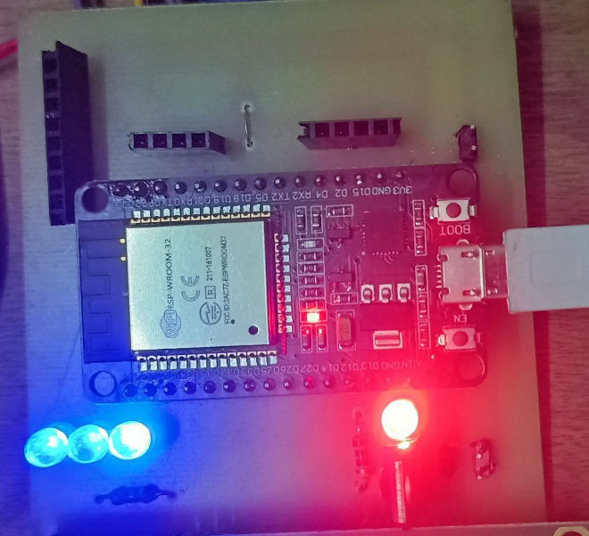

**Figure 1**

In this project, the primary component used for communication and control is the ESP8232 microcontroller. The ESP8232 is a Wi-Fi- enabled microcontroller that facilitates the connection of the project to a network, allowing for remote monitoring and control. It is responsible for receiving data from the temperature sensors (LM35) placed in the farmland plots, processing this data, and then activating various output devices such as the relay, buzzer, and motor. The key output of the ESP8232 is that it provides real-time data monitoring and control over the fire detection system, allowing the system to trigger actions when the temperature crosses a predefined threshold. It also sends email alerts to notify the farmer in case of fire.

**2.2 LM35:**

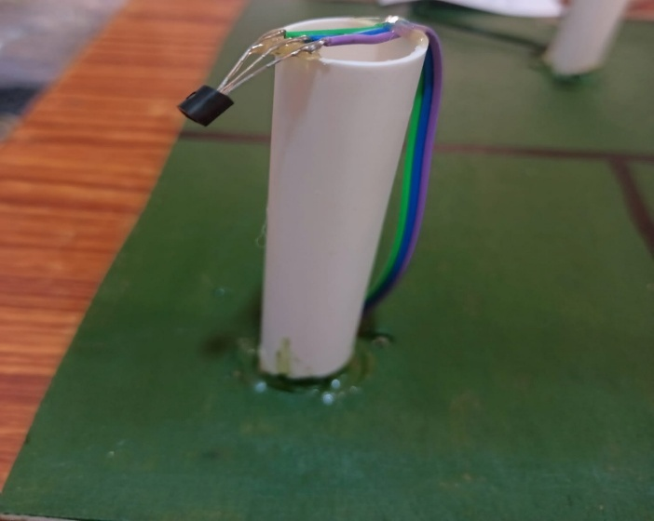

**Figure 2**

The LM35 temperature sensors are placed in three separate plots of the field to monitor temperature changes in each section. These sensors are connected to the ESP8232, which continuously reads temperature data from each sensor. Under normal conditions, the temperature values are stable and within a safe range, displayed on the LCD screen. If the temperature rises above 50-55°C due to a fire hazard, the sensors send this data to the ESP8232, which processes it to trigger alerts.The output from the LM35 sensors serves as the critical input to the ESP8232, enabling it to detect fire hazards based on rising temperatures.

**2.3 Relay:**

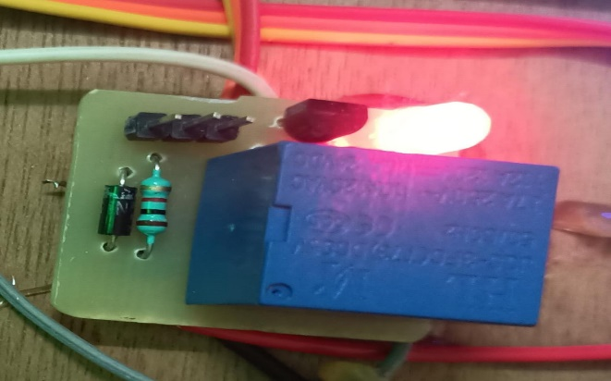

**Figure 3**

Next, the relay serves as the intermediary between the ESP8232 and the motor that controls the sprinkler system. The relay is essentially an electrically operated switch that receives signals from the ESP8232 based on the data from the LM35 sensors. When the ESP8232 detects that the temperature has crossed the threshold, it sends a signal to the relay, which then switches on the motor to activate the sprinkler system. The relay’s role is crucial because it controls the higher-powered motor circuit, ensuring that the motor can be safely turned on or off. The output of the relay directly controls the sprinkler system’s activation.

**2.4 Motor:**



**Figure 4**

The motor connected to the sprinkler system is activated by the relay. Once the relay is triggered, the motor turns on, enabling water to be sprayed over the affected area to suppress the fire. The motor’s output is to effectively manage fire suppression by distributing water in the direction of the fire hazard. The motor remains operational for a preset duration of 20 seconds, providing enough time to control the fire in its early stages. During this time, the system continues to monitor the temperature to ensure the fire is under control.

**2.5 LCD Display:**

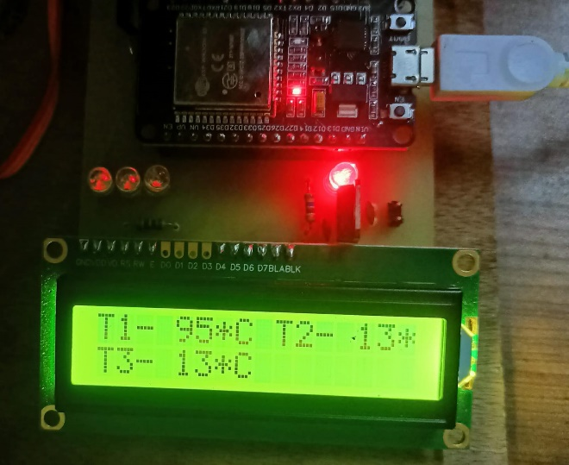

**Figure 5**

The LCD display is used to provide real-time updates to the user, showing the current temperature in the field and system status messages such as when the relay is activated, or when an email has been sent. The data from the ESP8232 is displayed on the LCD screen, allowing the farmer to monitor the system locally. The display acts as a user interface for the system, giving live feedback on temperature changes, alerts, and the status of the sprinkler system.

**2.6 E-mail Alert:**

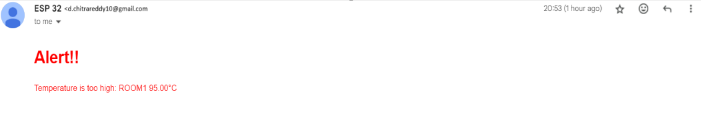

**Figure 6**

Finally, the system sends an email alert to the farmer once the fire has been detected and the sprinkler has been activated. This alert includes the current temperature and a message notifying the farmer about the fire hazard. The ESP8232, after receiving temperature data from the LM35 sensors and controlling the motor via the relay, sends the email through Wi-Fi. This automated email notification ensures that the farmer is aware of the fire risk and the system’s response even if they are not present at the field.

**Figure 7: Workflow of AgroDefend: Smart Fire Prevention Solutions**

IoT

Location Estimator

NODE

MCU

ESP8232

Water Pump

Water Pump Driver

Temperature Sensor

Alarm Circuit

Power Supply

**3. RESULT:**

**3.1 Normal Field Conditions:**

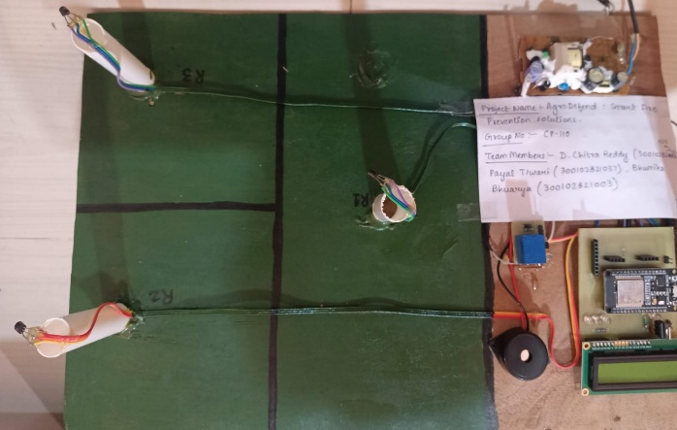

**Figure 8**

In this initial state, the LM35 temperature sensors placed across the three plots of farmland continuously monitor ambient temperature. The ESP8232 microcontroller receives real-time data from these sensors and displays the temperature on the LCD screen. As the temperature remains within the normal range (below 50°C), no further action is triggered. The display shows stable temperature readings, indicating normal environmental conditions. This setup ensures that the system is actively monitoring without activating the sprinkler system, providing a steady-state baseline for the fire detection mechanism.

**3.2 Fire Ignition Near LM35:**

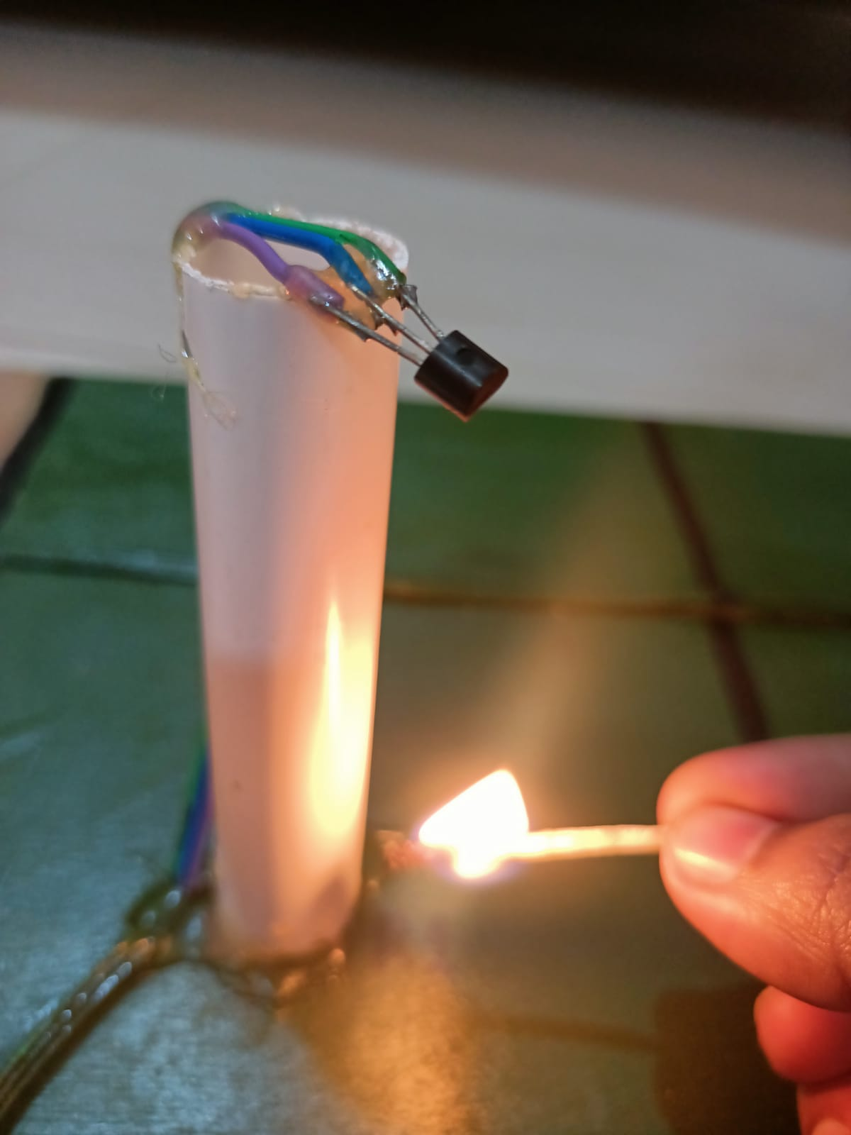

**Figure 9**

In this scenario, a fire is deliberately ignited using a candle or matchstick near the LM35 sensors placed in the field. The sensor immediately detects a rapid increase in temperature, with readings rising sharply from normal ambient levels to above 50°C. This stage demonstrates the system's ability to react quickly to a fire in close proximity to the sensor. The rapid temperature data captured by the LM35 plays a critical role in triggering timely action, preventing the fire from escalating further.

**3.3 Temperature Rise Detected:**

When a fire is introduced using a candle or matchstick within the LM35 within a specific detection range, the temperature starts rising gradually. The ESP8232 processes this data and sends updated temperature readings to the LCD display. As the temperature reaches 50°C, the system's pre-alert mode is triggered. The display now shows the elevated temperature values, and the farmer is made aware of the situation through visual and audible alerts, such as an LED light turning on. This stage ensures early detection before the fire spreads significantly.

**3.4 Alarm Activation and Sprinkler Trigger:**

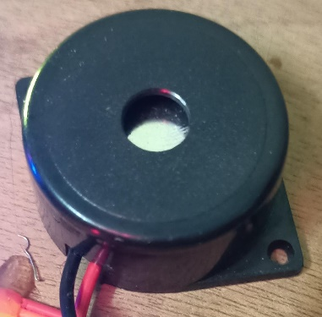

**Figure 10**

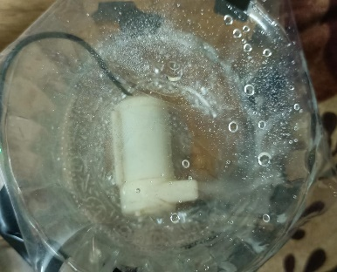

**Figure 11**

Once the temperature surpasses 55°C, the system enters the alarm stage. The ESP8232 microcontroller sends a signal to activate the relay, which switches on the motor to start the sprinkler system. The relay acts as the bridge between the low-voltage control circuit and the high-voltage motor circuit. During this phase, the buzzer sounds an alarm, and the LCD display indicates the fire suppression mode, showing that the sprinkler system has been activated. This automated process helps control the fire early on, significantly reducing potential damage to crops and farmland.

**3.5 Email Sending:**

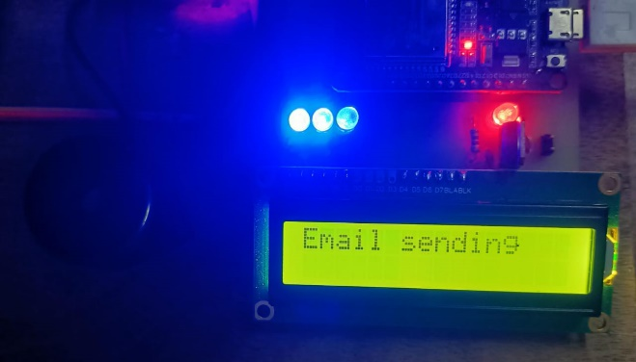

**Figure 12**

As the fire hazard escalates and the temperature crosses the critical threshold of 55°C, the system triggers the Email Sending process. Once this threshold is reached, the ESP8232 sends a command to notify the farmer via email. The LCD display immediately switches to show the message “Email Sending”, indicating that the system is working on dispatching the alert. This real-time update assures the user that communication is in progress. The email contains crucial information such as the current temperature of the field and an alert message, warning of the detected fire. This feature is vital for farmers who are not present on-site, enabling them to act remotely.

**3.6 AgroDefender:**

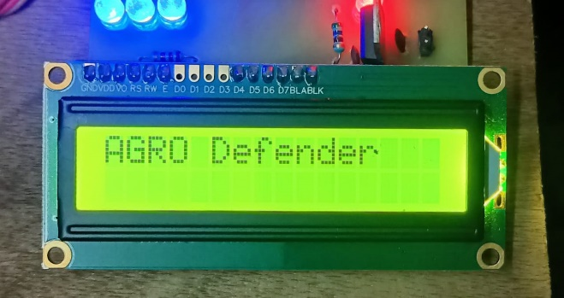

**Figure 13**

During the email-sending process, while the sprinkler system is actively working to suppress the fire, the display temporarily switches to show the name of the system, “AgroDefender”. This message indicates that the system is in full operation mode, protecting the field from the fire threat. The AgroDefender message serves as a branding signal to the user, highlighting that the custom-built system is currently engaged in managing the fire risk. This occurs after the sprinkler system stops, offering a clear indication that the AgroDefender system is fully functional and responding appropriately to the fire threat.

**3.7 Display after email has been sent:**

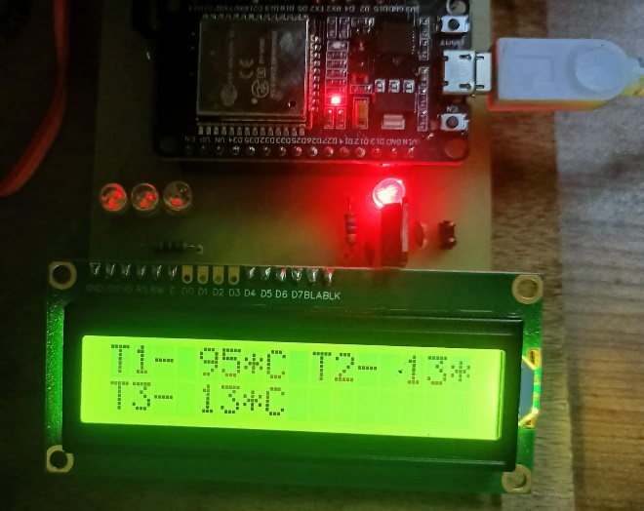

**Figure 14**

After the sprinkler system completes its operation and extinguished, the the fire system is successfully automatically transitions back to its normal monitoring mode. The temperature starts to drop below the critical threshold, and the ESP8232 deactivates the relay, stopping the motor and sprinkler system. The LCD display reverts to showing normal temperature readings, resuming its role as a real time monitoring device. This scenario highlights how the system not only handles fire suppression efficiently but also returns to a ready state for continuous monitoring after completing the email notification and fire control process.

**Table 3: AgroDefend System Response to Fire Detection**

|  |  |  |  |  |
| --- | --- | --- | --- | --- |
| **STAGE** | **TEMPERATURE CONDITION** | **SYSTEM RESPONSE** | **DISPLAY MESSAGE** | **ACTIONS TAKEN** |
| 3.1 Normal Field Condition | Below 50°C | Monitoring Mode | Normal Temperature | No action triggered |
| 3.2 Fire ignition near LM35 | Rapid increase above 50°C | Detects fire ignition | High Temperature Detected | System prepares for alert |
| 3.3 Temperature Rise Detected | Reaches 50°C | Pre-alert mode | Alert: Temperature Rising | LED light turns on |
| 3.4 Alarm Activation & Sprinkler Trigger | Surpasses 55°C | Fire suppression mode | Fire Detected - Sprinkler ON | Relay activates sprinkler & buzzer sounds alarm |
| 3.5 Email Notification | Above 55°C | Sends alert email | Email Sending | Email sent to farmer with fire details |
| 3.6 AgroDefender System Activation | Fire suppression in progress | System fully operational | AgroDefender Activated | System actively handling fire threat |
| 3.7 Post-Fire Monitoring | Temperature drops below | System returns to normal | Normal Temperature | Relay de-activates, sprinkler stops |

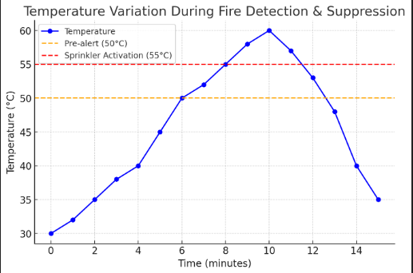**Figure 15: Graph of Temperature Response of AgroDefend System**

The plotted graph shows that the project successfully detects temperature variations in real time, triggering appropriate responses such as alert activation, sprinkler operation, and email notifications. It highlights the system's ability to detect fire hazards, respond efficiently, and return to normal monitoring after fire suppression, ensuring continuous field protection.

**4. DISCUSSION**

The AgroDefend system developed in this study offers an innovative approach to fire prevention in farmlands using IoT technology. The system leverages real-time monitoring to detect potential fire risks and initiate fire suppression mechanisms automatically. Sensors such as temperature, humidity, and smoke detectors were integrated to monitor the environment, and the system utilized the NodeMCU ESP8266 for processing and communication. By connecting to a cloud-based platform, it allowed farmers to monitor their land remotely, receiving real-time alerts in case of potential fire hazards.

The model's performance during testing demonstrated its ability to detect fire risks effectively. Over the course of the trials, the system showed accurate detection of temperature fluctuations and smoke patterns indicative of fire, triggering immediate alarms and initiating fire suppression protocols. The integration of IoT enabled the system to provide real-time data updates to farmers' mobile devices, thus ensuring timely responses.

However, despite the successful detection of fire risks, the system's sensitivity to environmental conditions posed a challenge. The variability in weather, such as changes in humidity or high winds, sometimes affected the sensors' ability to differentiate between fire hazards and normal environmental changes. Calibration and optimization of the sensors for various conditions will be critical in enhancing detection accuracy. Additionally, while the system performed well under controlled tests, further validation is required in different geographical locations with diverse environmental factors to refine its reliability.

The overall effectiveness of the fire prevention system highlights its potential for large-scale implementation in agriculture, offering a preventive solution to the growing issue of wildfires and fire hazards in farmlands. The system's IoT-based design not only aids in preventing fire damage but also provides farmers with a means of early detection and rapid intervention, potentially saving crops and livestock.

The computational efficiency of the system is suitable for real-time applications, with low latency between detection and action. This makes the AgroDefend solution a valuable tool for farmers looking to enhance their land's safety. Future iterations of the system could include machine learning algorithms for improved pattern recognition and predictive analysis of fire risks, further optimizing its fire detection capabilities.

In conclusion, the AgroDefend system demonstrates significant promise in revolutionizing fire prevention in agriculture. With further refinement and real-world validation, the system has the potential to become an essential tool in safeguarding farmlands from the devastating effects of fires.

**5. CONCLUSION:**

The “AgroDefend: Smart Fire Prevention Solutions” project aims to address the critical issue of fire hazards in agricultural farmlands by utilizing IoT technology to offer a comprehensive and efficient solution. Through real-time monitoring of environmental conditions, early fire detection is achieved by deploying strategically placed IoT sensors that continuously measure temperature, smoke levels, and other relevant factors. This allows the system to trigger alerts at the earliest signs of a fire, notifying farmers immediately for swift action. The integration of automatic sprinkler systems ensures that fires can be suppressed rapidly, preventing further spread and mitigating potential damage to crops, livestock, and property.

The research highlighted the inefficiencies in current methods, including limited detection capabilities, delayed responses, and less effective fire suppression techniques. By adopting IoT-enabled technology, AgroDefend overcomes these limitations, providing a solution that is proactive, responsive, and capable of functioning autonomously. The use of a Display Modules allows farmers and authorities to access real-time data and receive alerts through multiple communication channels, further enhancing the system’s effectiveness. This continuous flow of information enables better decision-making and improves resource management, particularly in preventing fire outbreaks.

The outcome of this project ensures improved fire safety, enhanced risk management, and better protection for agricultural assets. By focusing on early detection, rapid alerts, and automatic suppression, the system not only protects farmlands but also contributes to environmental sustainability by minimizing the waste of water and other resources. In conclusion, the AgroDefend project provides an essential tool for farmers, combining innovation and practicality to safeguard agricultural operations against the increasing risks posed by fires, particularly in an era of climate change and extreme weather events.

**6. FUTURE SCOPE:**

The "AgroDefend: Smart Fire Prevention Solutions" project offers significant potential for future development and scalability. As the system focuses on IoT-based real-time monitoring and fire suppression, several advancements can enhance its performance, adaptability, and utility across broader applications. In future iterations, the system can integrate advanced machine learning algorithms to predict fire outbreaks more accurately based on historical data and patterns. By incorporating predictive analytics, the system could assess fire risk levels and provide early warnings even before fires start, offering proactive rather than reactive fire prevention.

To enhance the precision and efficiency of fire suppression, the sprinkler systems in the proposed project are optimized based on real-time conditions. By using sensors that detect the exact location and intensity of a fire, the system can adjust the water flow and target affected areas more accurately. This optimization minimizes water wastage while maximizing the effectiveness of fire control in the farmland, ensuring resources are used efficiently.

In order to ensure continuous monitoring during network outages, the system includes offline functionality. When connectivity is lost, sensor data is stored locally, allowing the system to continue monitoring environmental conditions such as temperature and smoke levels. Once the network is restored, the stored data is automatically transmitted to the web-based dashboard. This ensures that fire risks are detected and managed, even in areas with unreliable internet access.

A proactive approach to fire risk management is enabled by integrating real-time weather data into the system. Key factors such as temperature, humidity, and wind speed are continuously analyzed to assess potential fire risks. If hazardous conditions are detected, the system can send alerts to farmers and other stakeholders in advance, allowing them to take preventive measures. This early warning system helps reduce the likelihood of fire outbreaks and enhances preparedness in agricultural areas.

To further streamline operation and improve real-time control, the system incorporates voice command functionality. This feature allows users to control and monitor the system hands-free, using voice assistants to receive updates, activate sprinklers, or respond to alerts. The voice command interface is particularly useful in emergency situations, enabling quick and efficient responses to fire threats without the need for manual interaction with the system.

Another area of future exploration involves expanding the sensor network to include additional environmental factors, such as humidity, wind speed, and soil moisture, which may impact fire risk. The integration of drones equipped with advanced thermal imaging cameras could further enhance the system by providing aerial surveillance over large areas, enabling real-time detection in remote or difficult-to-reach farmland regions. This would improve detection accuracy and coverage, ensuring no fire threats go unnoticed.

Additionally, expanding the communication capabilities of the system through satellite or long-range wireless networks would be beneficial for areas with limited internet connectivity. This would ensure that the system can function effectively in rural and remote agricultural areas, where traditional communication infrastructure is weak. Furthermore, the system can be designed to integrate with existing smart farm management systems, allowing for a more comprehensive approach to farm safety and operations.

**7. REFERENCES:**

[1] Ms. Aditi A Kulkarni, Ms. Sweety (2021), Design & Implementation of

IOT Based Firefighting System to Protecting Farm.

[2] Harjinder Singh (2016), Forest Fire Detection using Wireless Sensor.

[3] Hari Varshini S, Bhoomika S. (2022), IOT based Fire Alarm Security System.

[4] Dr. R Manjunatha, Amrutha K. (2023), IOT Based Fire Detection and Prevention System in Farmland

[5] Srinath N, Aishwarya (2019), Smart Crop Protection System from Animals and Fire using Arduino.

[6] G B Harsha (2024), IOT Enabled Smart Fire Suppression Drone for Enhanced Efficiency and Effectiveness.

[7] Snehal A, Jadhav (2015), Wireless Sensor Network Based Monitoring System for Forest.

[8] Rupali Mahajan (2023), Wireless Sensor Network Based Early Fire Detection System

[9] Kumar & Verma (2019), Smart Fire Management Systems Using AI and IoT.

[10] Zhang & Li (2023), Remote Sensing and Satellite-Based Fire Monitoring.

[11] Patel et al. (2023), Smart Wildfire Prevention System Using AI and IoT.

[12] Rajesh Kumar, P., & Mehta, S. (2018), IoT-Based Early Fire Detection System for Agricultural Lands.

[13] Priya Sharma, R., & Varun K. (2020), Wireless Sensor Networks for Fire Prevention in Rural Farming Areas.

[14] Arjun Patel, S., & Deepak Verma, R. (2019), AI-Enabled Smart Fire Detection and Prevention System.

[15] Manisha Nair, A., & Karthik Reddy, V. (2021), Drone-Based Fire Surveillance and Prevention for Farmlands.

[16] Sanjay Gupta, T., & Ramesh Iyer, K. (2021), Role of Smart Irrigation in Agricultural Fire Prevention.

[17] Neha Joshi, M., & Vikram Desai, P. (2023), Challenges in Implementing IoT-Based Fire Prevention Systems in India.

[18] Dinesh Choudhary, B., & Anjali Rao, S. (2019), Satellite-Based Fire Monitoring and Risk Assessment in Indian Agriculture.

[19] Rohit Sharma, L., & Sneha Kulkarni, R. (2020), Integration of Thermal Imaging Drones for Fire Detection in Indian Farms.