# PERFORMANCE OF RUBBERIZED CONCRETE BEAMS WITH MICRO-REINFORCEMENT - A NEURAL APPROACH

# R. Karthikeyan*1, a, Pachaivannan partheeban2,b P.N. Raghunath3, c and K. Suguna4,d

# 1Department of Civil Engineering, Chennai Institute of Technology, Chennai, Tamilnadu, India.

# 2Department of Civil Engineering, Chennai Institute of Technology, Chennai, Tamilnadu, India.

# 3Department of Civil and Structural Engineering, Annamalai University, India

# 4Department of Civil and Structural Engineering, Annamalai University, India

The paper presents the results of an analytical investigation conducted for assessing the performance of rubberized concrete beams with micro-reinforcement using ANN tool. Back propagation networkwith Levenberg-Marquardt, Bayesian Regularization and Scaled Conjugate Gradient algorithms have been used in this study for the prediction purpose. The beam cross-sectional dimensions, span, concrete strength. steel strength, area of reinforcing steel and elasticity modulus of concrete were taken as input parameters. First crack load, deflection at first crack load, yield load, deflection at yield load, ultimate load, deflection at ultimate load and ductility were the output parameters.

The statistical indicators such as RMSE, R2 and MAPE have also been obtained and found to be in the acceptable range. The experimental and predicted results were correlated through scatter plots. A good convergence has been observed between the results predicted through ANN modeling and the experimental results.

1. **Introduction**

In the present days, disposal of waste rubber tyres has become a global problem. In several countries, burying the waste rubber tyres has become a common method of disposal. But this practice poses a very serious threat to ecology. Hence recycling and reuse of waste rubber is a sine qua non. Some efforts have been made to use waste rubber tyres for paving purposes, for artificial reef formation, for use as fuel in cement kilns and for producing carbon black [1,2]. Simultaneously researchers have attempted to use waste rubber in concrete as replacement for aggregates with a view to enhance its performance. Replacing mineral aggregates with crumb rubber particles can possibly reduce the mechanical properties of rubberized concrete [3,4,5,6,7,8]. This reduction may be due to weak bonding between the rubber particles and the cement matrix [9]. Several attempts have been made to strengthen the interfacial transition zone by alkali etching [10,11], particle surface coatings [12], using NaOH aqueous solution [13,14], using coupling agents [11], using thin layer of cement paste, using SBR latex and organic sulphur coating [15]. Some methods significantly improved the mechanical properties of rubberized concrete [16].

Incorporation of steel fibres in concrete enhances its post - crack resistance, ductility, toughness and resistance to fatigue and impact [17,18]. Addition of steel fibres imparts ductility to brittle concrete which is highly demanding for structures located in seismic prone regions. Addition of steel fibres along with crumb rubber in concrete led to increase in impact energy [28]. More resilient behaviour was observed for the rubberized concrete compared to plain concrete [30]. Incorporation of two types of fibres such as steel fibre and polypropylene fibres in rubberized concrete increases its compressive strength and splitting tensile strength [31].

The results showed that the ANN model with the MLP/BP algorithm provided a better prediction of shear strength than the ANFIS model [33**]**.

An attempt has hence been made to assess the impact of micro-reinforcement on the structural performance of rubberized concrete beams by using neural computation approach.

**2. Artificial Neural Network (ANN)**

Artificial Neural Network provides an alternative approach to be applied to problems where the algorithmic and symbolic approaches are not well suited. An ANN is comprised of a network of artificial neurons. There are three types of neurons in an ANN, input nodes, hidden nodes, and output nodes. In modeling neural networks of the nervous system, one has to consider many factors. The brain and the neural network should be considered as an integrated and self-contained firmware system that includes hardware, software, memory, database and a complex network of active elements and passive elements that carry information within and in-and-out of the body.

**3. Database**

The mechanical properties of the rubberized concrete with micro-reinforcement such as rubber volume fraction (RVF), fibre volume fraction (FVF), length (L), breadth (B), depth (D), characteristic compressive strength (fck), characteristic strength of steel (fy), area of steel (Ast) and modulus of elasticity (E) were considered as input parameters. The experimental results such as first crack load, deflection at first crack load, yield load, deflection at yield load, ultimate load, deflection at ultimate load and ductility were considered as target parameters. The input and target parameters for ANN modeling are presented through Tables 1 and 2.

**4. Steps in ANN Modeling**

In this stage, the input data are divided into three groups which are train data, validate data and test data.The process of training involves importing the input and target parameters and neural network is adjusted to its error. Validation is used to measure network generalization and to halt training when generalization stops improving. Testing is independent measure of network performance during and after training. The step wise procedure for ANN modeling is presented through Figs.1 to 8.

**4.1 Collection of data**

An extensive literature review has been carried out and thirty-onedatashave been collected for rubberized concrete beams.The input parameters are presented in Table 1 and target parameters are presented in Table 2.

**4.2 Preprocessing Data**

In this stage the input data’s are divided into three groups. They are train data, validate data and test data. The step wise procedures for ANN modeling are represented through Figs. 1 to 3.



**Fig.1.** Neural Network Fitting Tool Set Up

**4.3 Providing Input and Target Data**

Clicking on next button the input and target data will be imported to the matlab.

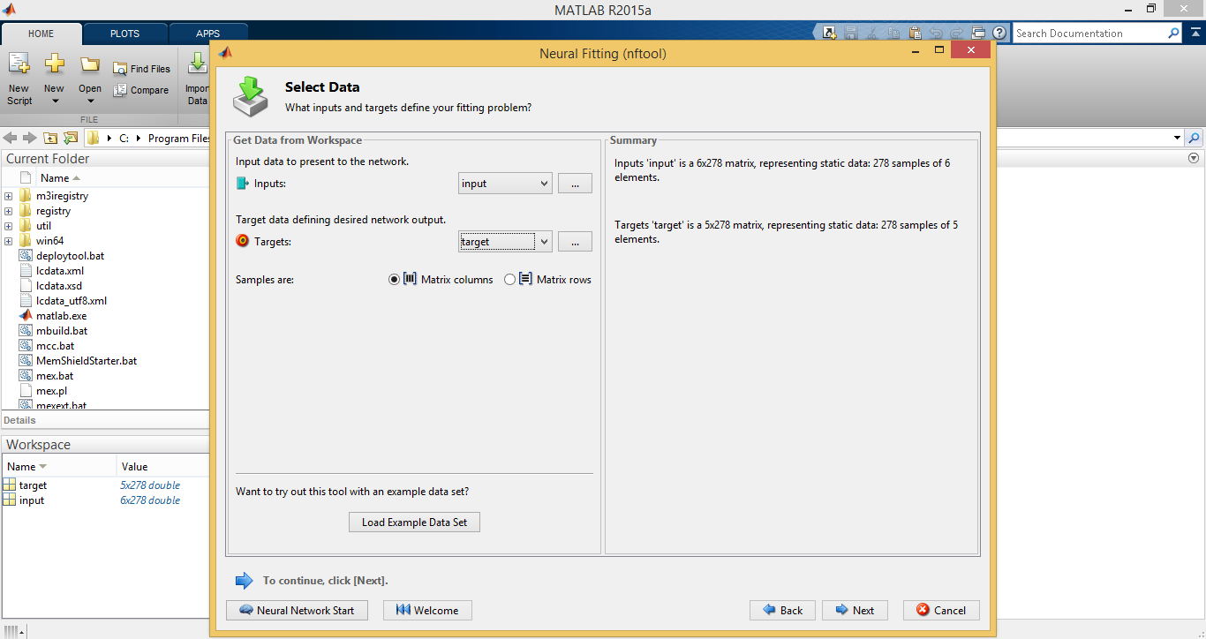

**Fig.2.**Importing the Input and Target Parameters



**Fig.3.**Selection of Training, Validation and Testing Data

**4.4 Building the Network**

The architecture of neural network proposed model is shown in Fig.4.

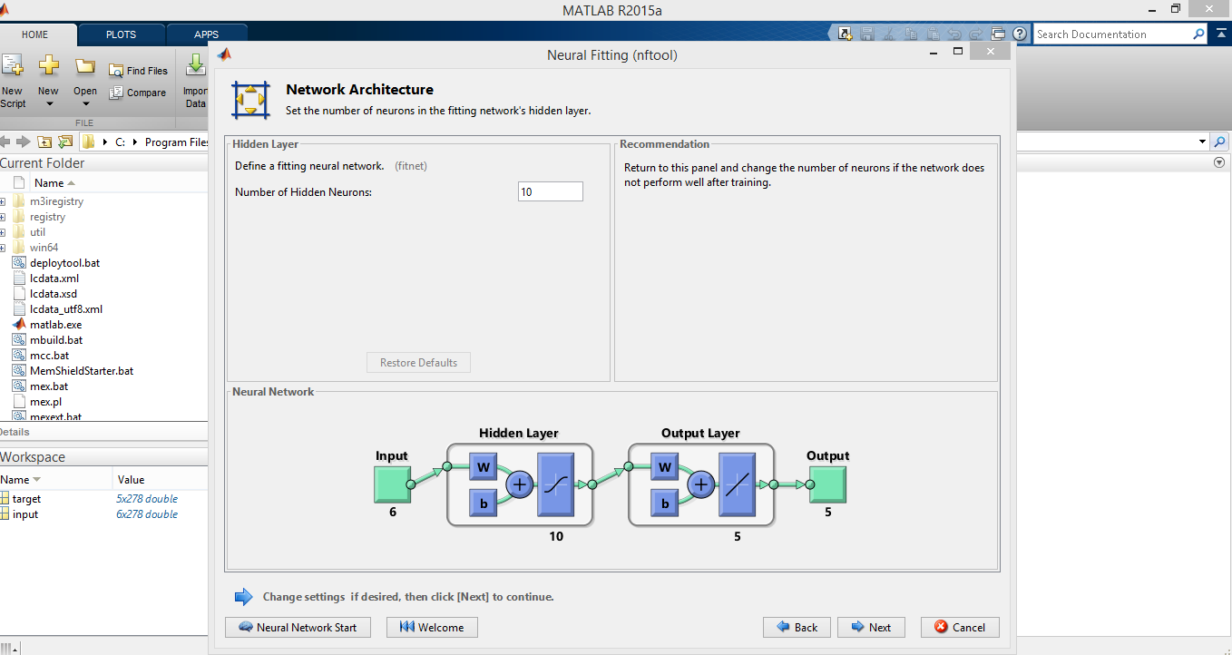

**Fig.4.** Neural Network Architecture

**4.5 Training the network**

Back propagation-Levenberg Marquardt algorithm was used to developing the artificial neural network. The training processes are shown in Fig 5 and Fig 6.

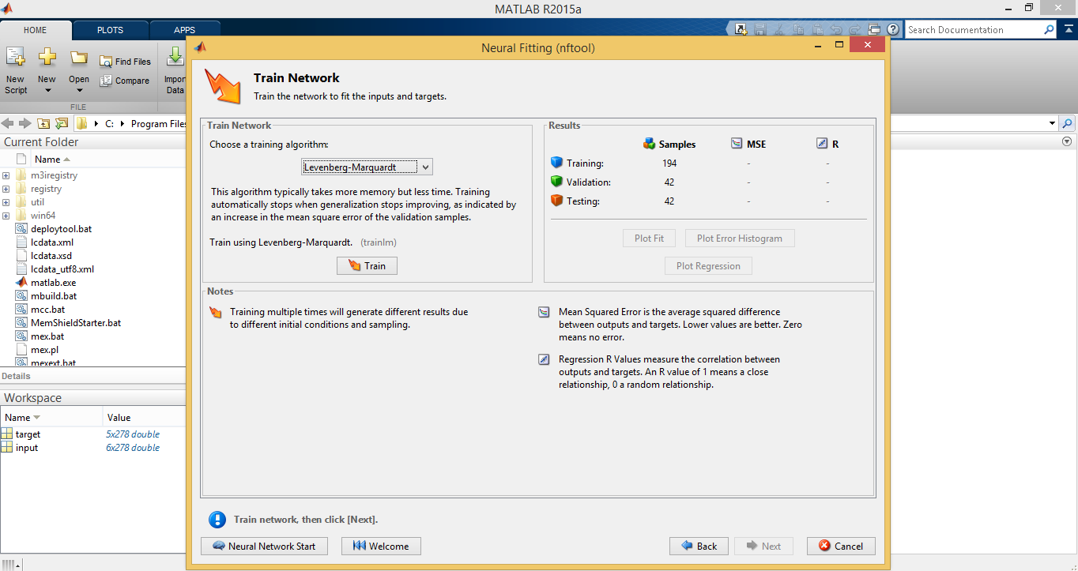

**Fig.5.** Training Network Wizards

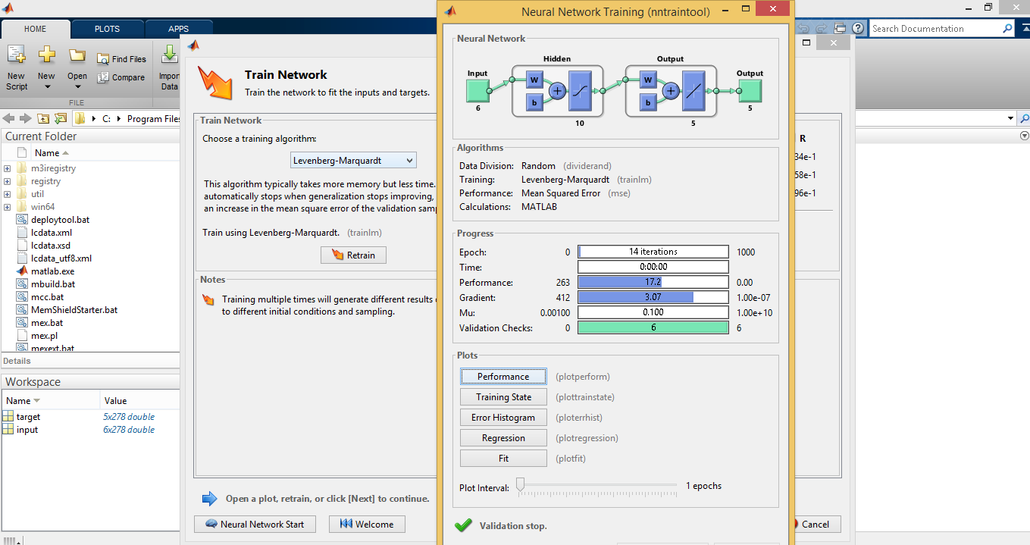

**Fig.6.** Neural Network Training

**4.6 Test performance of the model**

The fitness of the developed model is shown through Figs. 7 to 12.

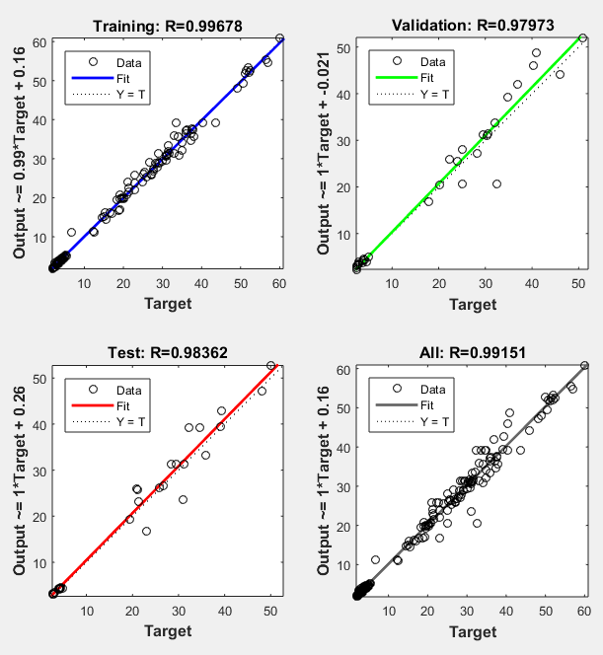

**Fig.7.** Neural Network Regression Plot

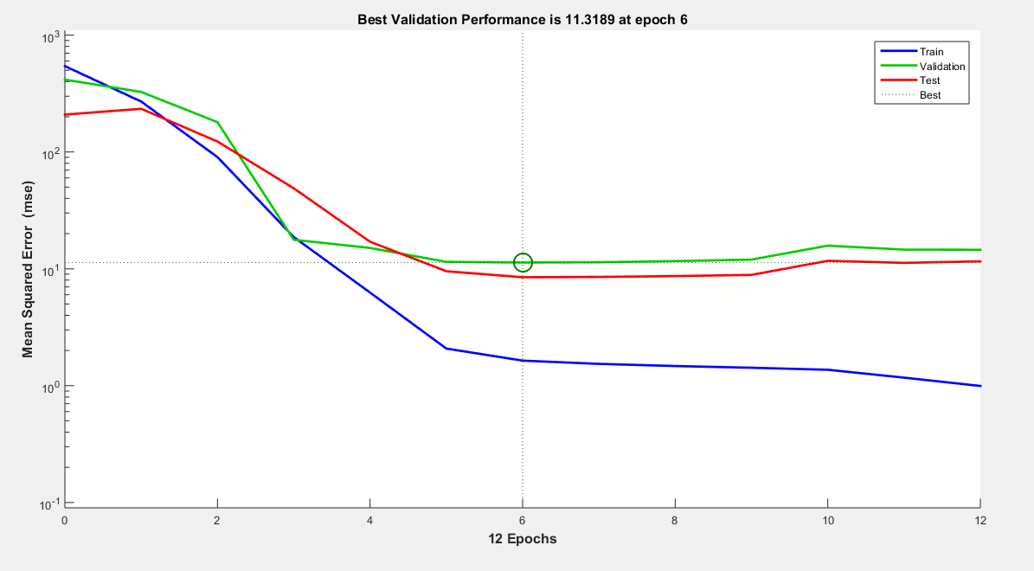

**Fig.8.** Neural Network Training Performance Plot

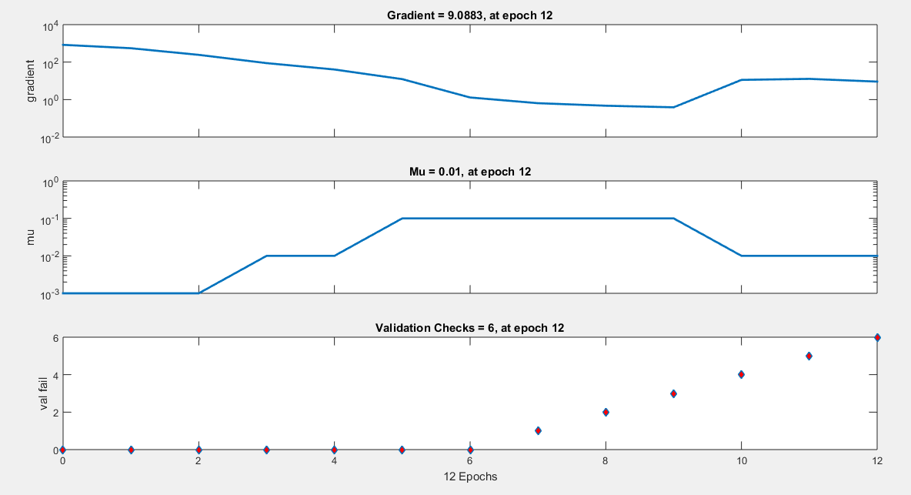

**Fig.9.** Neural Network Training State (Levenberg-Marquardt) Algorithm

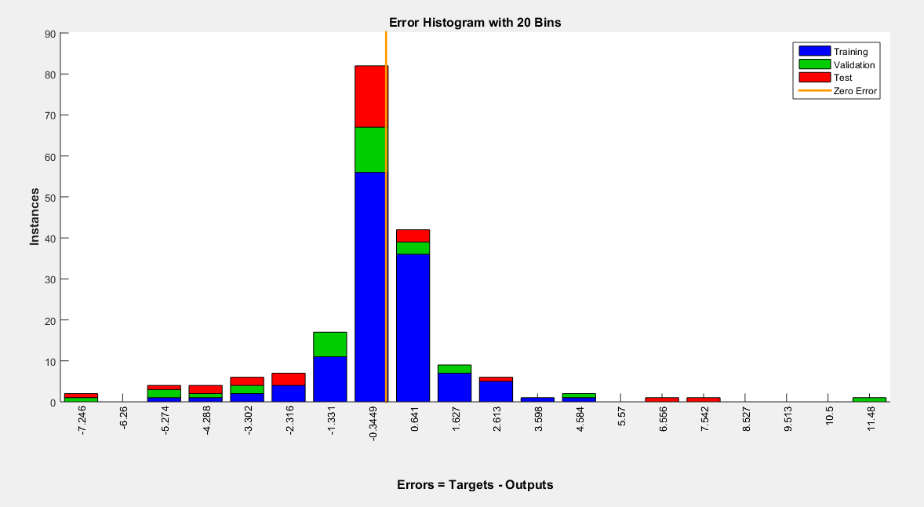

**Fig.10.**Neural Network Error Histogram State

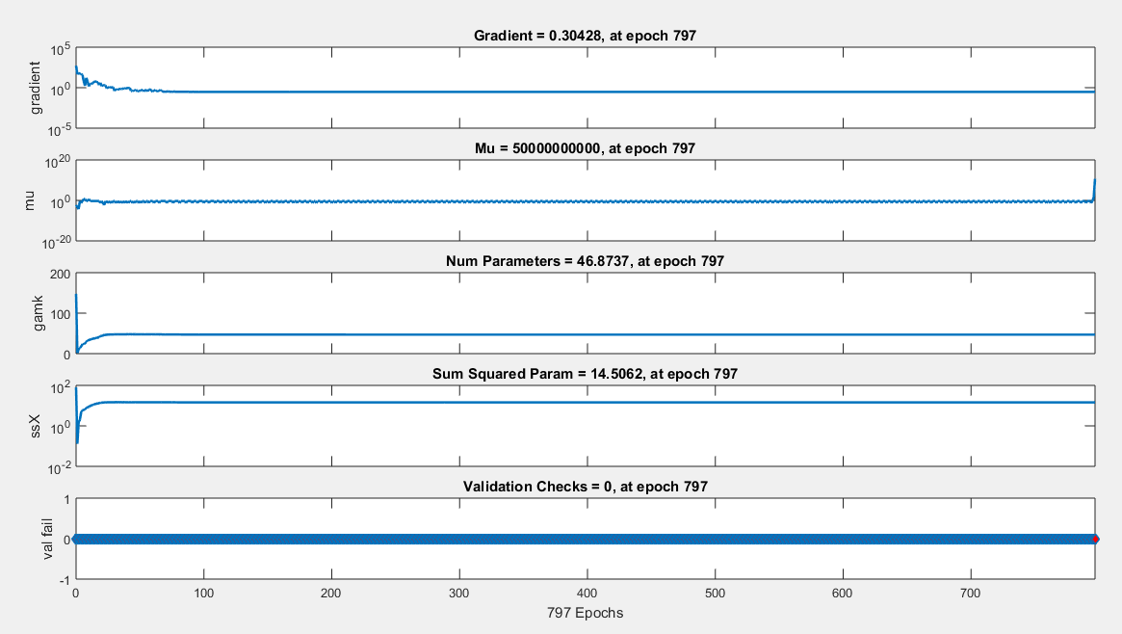

**Fig.11.**Neural Network Training State (Bayesian Regularization) Algorithm

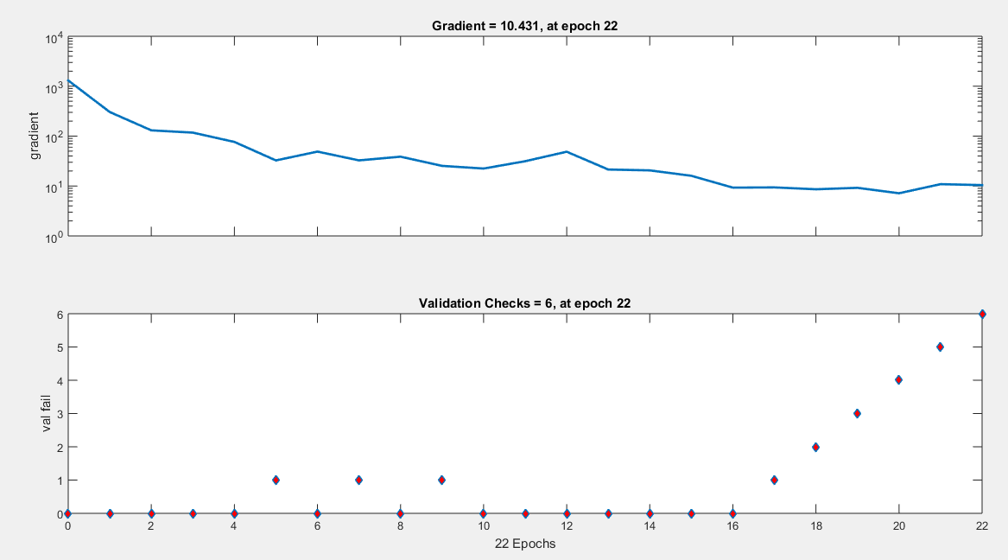

**Fig.12.** Neural Network Training State (Scaled Conjugate Gradient) Algorithm

**5. Rubberized Concrete Beams with Micro-reinforcement**

The input parameters for rubberized concrete beams with micro-reinforcementare presented in Table 1

Table 1 Input Parameters for ANN modeling

|  |  |  |  |  |  |  |  |  |  |  |
| --- | --- | --- | --- | --- | --- | --- | --- | --- | --- | --- |
| **Authors Name** | **Test specimen** | **RVF**  **(%)** | **FVF**  **(%)** | **L**  **(mm)** | **B**  **(mm)** | **D**  **(mm)** | **fck**  **(MPa)** | **fy**  **(MPa)** | **Ast**  **(mm2)** | **E**  **(GPa)** |
| Ismail *et al.*  (2016) | 500C-0CR | 0 | 0 | 2440 | 250 | 250 | 50.20 | 400 | 1138.82 | 35.43 |
| 500C-5CR | 5 | 0 | 2440 | 250 | 250 | 43.00 | 400 | 1138.82 | 32.79 |
| 500C-10CR | 10 | 0 | 2440 | 250 | 250 | 41.80 | 400 | 1138.82 | 32.33 |
| 500C-15CR | 15 | 0 | 2440 | 250 | 250 | 35.30 | 400 | 1138.82 | 29.71 |
| 550C-15CR | 15 | 0 | 2440 | 250 | 250 | 37.60 | 400 | 1138.82 | 30.66 |
| 550C-20CR | 20 | 0 | 2440 | 250 | 250 | 32.80 | 400 | 1138.82 | 28.64 |
| 550C-20CR-MK | 20 | 0 | 2440 | 250 | 250 | 40.80 | 400 | 1138.82 | 31.94 |
| 550C-30CR-MK | 30 | 0 | 2440 | 250 | 250 | 34.80 | 400 | 1138.82 | 29.50 |
| 550C-30CR-MK-MA | 30 | 0 | 2440 | 250 | 250 | 30.20 | 400 | 1138.82 | 27.48 |
| 550C-40CR-MK-MA | 40 | 0 | 2440 | 250 | 250 | 26.40 | 400 | 1138.82 | 25.69 |
| 550C-40CR-MK-VRC | 40 | 0 | 2440 | 250 | 250 | 28.90 | 400 | 1138.82 | 26.88 |
| 550C-50CR-MK-VRC | 50 | 0 | 2440 | 250 | 250 | 22.40 | 400 | 1138.82 | 23.66 |
| Ismail *et al.*  (2017) | B1-0CR | 0 | 0 | 1500 | 250 | 250 | 65.61 | 400 | 1138.82 | 32.96 |
| B2-5CR  B3-15CR | 5  15 | 0  0 | 1500  1500 | 250  250 | 250  250 | 58.44  48.35 | 400  400 | 1138.82  1138.82 | 30.3  27.13 |
| B4-25CR | 25 | 0 | 1500 | 250 | 250 | 38.35 | 400 | 1138.82 | 22.03 |
| B5-5CR-0.35SF | 5 | 0.35 | 1500 | 250 | 250 | 59.15 | 400 | 1138.82 | 30.65 |
| B6-15CR-0.35SF | 15 | 0.35 | 1500 | 250 | 250 | 49.45 | 400 | 1138.82 | 28.28 |
| B7-25CR-VRC | 25 | 0 | 1500 | 250 | 250 | 40.26 | 400 | 1138.82 | 22.88 |
| B8-35CR-VRC | 35 | 0 | 1500 | 250 | 250 | 29.73 | 400 | 1138.82 | 18.23 |
| B9-35CR-0.35SF-VRC | 35 | 0.35 | 1500 | 250 | 250 | 31.10 | 400 | 1138.82 | 18.36 |
| B10-35CR-1SF-VRC | 35 | 1 | 1500 | 250 | 250 | 32.38 | 400 | 1138.82 | 19.19 |
| B11-35CR-0.35LSF-VRC | 35 | 0.35 | 1500 | 250 | 250 | 30.71 | 400 | 1138.82 | 17.88 |
| B12-35CR-1LSF-VRC | 35 | 1 | 1500 | 250 | 250 | 31.51 | 400 | 1138.82 | 18.69 |
| Mr.R. Karthikeyan | SC | 0 | 0 | 3000 | 150 | 250 | 26.60 | 415 | 383.27 | 25.79 |
| S11 | 2.5 | 0.5 | 3000 | 150 | 250 | 30.22 | 415 | 383.27 | 27.49 |
| S12 | 2.5 | 1 | 3000 | 150 | 250 | 40.35 | 415 | 383.27 | 31.76 |
| S21 | 5 | 0.5 | 3000 | 150 | 250 | 41.71 | 415 | 383.27 | 32.29 |
| S22 | 5 | 1 | 3000 | 150 | 250 | 50.60 | 415 | 383.27 | 35.57 |
| S31 | 7.5 | 0.5 | 3000 | 150 | 250 | 29.54 | 415 | 383.27 | 27.18 |
| S32 | 7.5 | 1 | 3000 | 150 | 250 | 31.60 | 415 | 383.27 | 28.11 |
|  | | | | | | | | | | |

The target parameters for rubberized concrete beams with micro-reinforcement are presented in Table 2.

Table 2 Target Parameters for ANN modeling

|  |  |  |  |  |  |  |  |  |
| --- | --- | --- | --- | --- | --- | --- | --- | --- |
| **Authors Name** | **Test specimen** | **First Crack Load**  **(kN)** | **Deflection at First Crack Load**  **(mm)** | **Yield Load**  **(kN)** | **Deflection at Yield Load**  **(mm)** | **Ultimate Load**  **(kN)** | **Deflection at Ultimate Load**  **(mm)** | **Ductility** |
| Ismail *et al.*  (2016) | 500C-0CR | 32.80 | 1.50 | 200.00 | 10.30 | 250.00 | 27.00 | 2.62 |
| 500C-5CR | 25.30 | 1.10 | 170.00 | 9.30 | 251.10 | 28.50 | 3.06 |
| 500C-10CR | 22.80 | 1.00 | 150.00 | 8.80 | 249.20 | 28.20 | 3.20 |
| 500C-15CR | 21.40 | 0.90 | 160.00 | 9.10 | 243.30 | 30.80 | 3.38 |
| 550C-15CR | 22.00 | 2.00 | 140.00 | 8.80 | 246.60 | 25.90 | 2.94 |
| 550C-20CR | 18.20 | 1.00 | 130.00 | 8.90 | 243.20 | 26.80 | 3.01 |
| 550C-20CR-MK | 20.80 | 0.80 | 125.00 | 9.00 | 245.00 | 21.90 | 2.43 |
| 550C-30CR-MK | 17.20 | 0.90 | 150.00 | 9.20 | 228.00 | 21.30 | 2.32 |
| 550C-30CR-MK-MA | 16.50 | 0.70 | 120.00 | 8.10 | 219.00 | 17.90 | 2.21 |
| 550C-40CR-MK-MA | 13.90 | 0.60 | 145.00 | 9.20 | 203.60 | 15.70 | 1.71 |
| 550C-40CR-MK-VRC | 14.80 | 0.50 | 130.00 | 9.00 | 205.70 | 16.20 | 1.80 |
| 550C-50CR-MK-VRC | 14.00 | 0.50 | 155.00 | 9.30 | 197.50 | 15.90 | 1.71 |
| Ismail *et al.*  (2017) | B1-0CR | 132.55 | 0.50 | 180.00 | 0.80 | 250.70 | 1.92 | 2.40 |
| B2-5CR | 123.87 | 0.75 | 170.00 | 0.80 | 230.13 | 2.13 | 2.66 |
| B3-15CR | 111.21 | 0.80 | 140.00 | 0.80 | 195.97 | 1.95 | 2.44 |
| B4-25CR | 102.31 | 0.90 | 120.00 | 0.80 | 174.24 | 2.11 | 2.64 |
| B5-5CR-0.35SF | 136.12 | 1.20 | 280.00 | 2.20 | 283.59 | 2.47 | 1.12 |
| B6-15CR-0.35SF | 126.77 | 0.80 | 200.00 | 1.20 | 244.74 | 2.31 | 1.93 |
| B7-25CR-VRC | 105.87 | 1.00 | 142.00 | 1.00 | 181.25 | 1.81 | 1.81 |
| B8-35CR-VRC | 91.19 | 1.30 | 119.00 | 1.00 | 145.10 | 1.84 | 1.84 |
| B9-35CR-0.35SF-VRC | 117.88 | 1.80 | 225.00 | 2.00 | 233.76 | 2.47 | 1.24 |
| B10-35CR-1SF-VRC | 149.02 | 1.50 | 350.00 | 2.50 | 366.57 | 4.23 | 1.69 |
| B11-35CR-0.35LSF-VRC | 111.21 | 1.70 | 210.00 | 2.00 | 209.32 | 2.07 | 1.04 |
| B12-35CR-1LSF-VRC | 142.34 | 1.60 | 325.00 | 4.00 | 343.65 | 4.04 | 1.01 |
| Mr.R. Karthikeyan | SC | 18.50 | 1.95 | 32.00 | 5.50 | 60.00 | 12.00 | 2.18 |
| S11 | 20.00 | 2.75 | 34.50 | 6.00 | 62.50 | 14.40 | 2.40 |
| S12 | 22.50 | 3.10 | 37.50 | 6.50 | 65.00 | 15.60 | 2.40 |
| S21 | 23.00 | 3.20 | 38.25 | 6.90 | 66.50 | 16.80 | 2.43 |
| S22 | 25.00 | 3.26 | 41.00 | 7.45 | 68.50 | 18.60 | 2.50 |
| S31 | 25.75 | 3.28 | 42.50 | 7.95 | 69.75 | 20.80 | 2.62 |
| S32 | 27.50 | 3.35 | 45.00 | 8.10 | 72.50 | 24.90 | 3.07 |

**5.1 Comparison of Results**

The results predicted through ANN modeling for rubberized concrete beams with micro-reinforcement are presented in Tables3 to 6.

Table 3Experimental and ANN Results for First Crack Load and Deflection at First Crack Load

|  |  |  |  |  |  |  |  |  |  |
| --- | --- | --- | --- | --- | --- | --- | --- | --- | --- |
| **Authors name** | **Test Specimen** | **First Crack Load**  **(kN)** | | | | **Deflection at First Crack Load**  **(mm)** | | | |
|  |  | **Exp** | **Levenberg-**  **Marquardt** | **Bayesian Regularizaton** | **Scaled Conjugate Gradient** | **Exp** | **Levenberg-**  **Marquardt** | **Bayesian Regularizaton** | **Scaled Conjugate Gradient** |
| Ismail *et al.*  (2016) | 500C-0CR | 32.80 | 44.67 | 24.60 | 29.20 | 1.50 | 0.96 | 1.19 | 4.27 |
| 500C-5CR | 25.30 | 34.20 | 25.23 | 26.08 | 1.10 | 1.03 | 1.25 | 3.69 |
| 500C-10CR | 22.80 | 28.69 | 23.12 | 20.68 | 1.00 | 1.01 | 1.14 | 3.26 |
| 500C-15CR | 21.40 | 24.66 | 21.46 | 19.71 | 0.90 | 0.93 | 1.42 | 2.94 |
| 550C-15CR | 22.00 | 24.39 | 21.76 | 17.74 | 2.00 | 0.96 | 1.22 | 2.90 |
| 550C-20CR | 18.20 | 23.74 | 18.25 | 16.39 | 1.00 | 0.81 | 1.43 | 2.64 |
| 550C-20CR-MK | 20.80 | 22.47 | 20.72 | 11.75 | 0.80 | 0.96 | 0.63 | 2.51 |
| 550C-30CR-MK | 17.20 | 20.97 | 17.23 | 7.35 | 0.90 | 0.76 | 0.64 | 1.97 |
| 550C-30CR-MK-MA | 16.50 | 22.26 | 16.49 | 9.61 | 0.70 | 0.63 | 0.90 | 2.09 |
| 550C-40CR-MK-MA | 13.90 | 19.84 | 13.07 | 6.74 | 0.60 | 0.72 | 0.69 | 1.71 |
| 550C-40CR-MK-VRC | 14.80 | 19.74 | 20.30 | 5.68 | 0.50 | 0.65 | 0.67 | 1.64 |
| 550C-50CR-MK-VRC | 14.00 | 24.84 | 14.01 | 6.68 | 0.50 | 1.24 | 0.89 | 1.45 |
| Ismail *et al.*  (2017) | B1-0CR | 132.55 | 139.16 | 132.64 | 136.23 | 0.55 | 0.55 | 0.73 | 4.85 |
| B2-5CR | 123.87 | 131.37 | 123.81 | 122.64 | 0.88 | 0.88 | 0.76 | 4.14 |
| B3-15CR | 111.21 | 126.57 | 111.18 | 107.18 | 0.87 | 0.87 | 0.76 | 3.21 |
| B4-25CR | 102.31 | 120.18 | 102.65 | 101.60 | 0.67 | 0.67 | 1.19 | 2.72 |
| B5-5CR-0.35SF | 136.12 | 142.94 | 136.08 | 133.17 | 0.07 | 0.07 | 1.01 | 4.35 |
| B6-15CR-0.35SF | 126.77 | 128.56 | 126.79 | 115.94 | 0.28 | 0.28 | 1.13 | 3.49 |
| B7-25CR-VRC | 105.87 | 123.03 | 105.89 | 104.27 | 0.60 | 0.60 | 1.01 | 2.71 |
| B8-35CR-VRC | 91.19 | 88.62 | 91.21 | 96.58 | 1.68 | 1.68 | 1.21 | 2.35 |
| B9-35CR-0.35SF-VRC | 117.88 | 117.09 | 117.75 | 110.88 | 1.72 | 1.72 | 1.57 | 2.72 |
| B10-35CR-1SF-VRC | 149.02 | 147.92 | 149.06 | 143.49 | 0.32 | 0.32 | 1.57 | 3.61 |
| B11-35CR-0.35LSF-VRC | 111.21 | 114.65 | 111.32 | 111.48 | 1.85 | 1.85 | 1.59 | 2.75 |
| B12-35CR-1LSF-VRC | 142.34 | 144.17 | 142.30 | 144.07 | 0.46 | 0.46 | 1.62 | 3.66 |
| Mr. R. Karthikeyan | SC | 18.50 | 6.09 | 18.49 | 19.72 | 2.87 | 2.87 | 2.16 | 3.53 |
| S11 | 20.00 | 20.60 | 20.01 | 22.87 | 2.99 | 2.99 | 2.72 | 3.60 |
| S12 | 22.50 | 21.15 | 22.55 | 29.95 | 3.09 | 3.09 | 3.25 | 3.68 |
| S21 | 23.00 | 23.86 | 22.97 | 22.65 | 3.06 | 3.06 | 2.86 | 3.57 |
| S22 | 25.00 | 23.60 | 25.00 | 41.28 | 2.83 | 2.83 | 3.24 | 3.78 |
| S31 | 25.75 | 23.97 | 25.78 | 23.21 | 3.12 | 3.12 | 3.17 | 3.59 |
| S32 | 27.50 | 25.01 | 27.45 | 29.28 | 3.67 | 3.67 | 3.43 | 3.65 |

The scatter plots drawn between the experimental and results those predicted through ANN modeling for first crack load and deflection at first crack load in Bayesian Regularization are shown through Figs. 13-14.

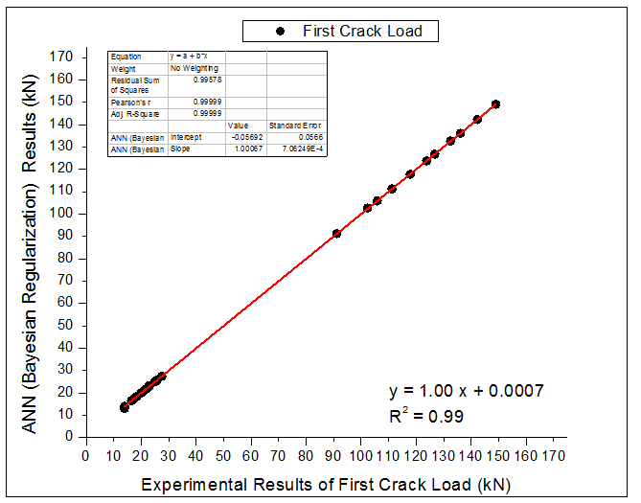

**Fig.13.**First Crack Load

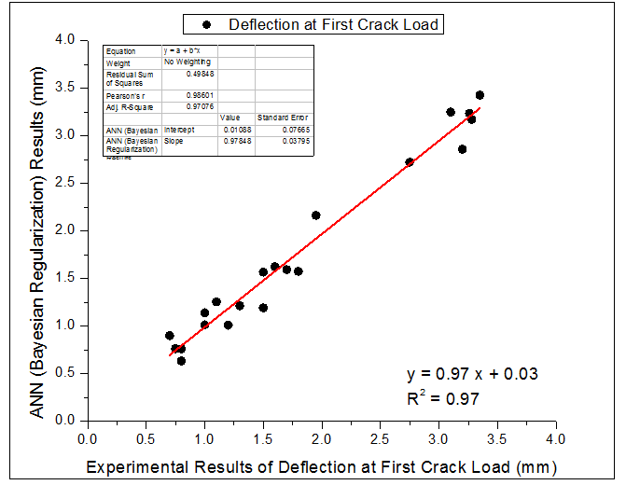

**Fig.14.**Deflection at First Crack Load

Table 4Experimental and ANN Results for Yield Load and Deflection at Yield Load

|  |  |  |  |  |  |  |  |  |  |  |  |  |  |  |  |  |
| --- | --- | --- | --- | --- | --- | --- | --- | --- | --- | --- | --- | --- | --- | --- | --- | --- |
| Authors name | Test Specimen | **Yield Load** | | | | | | | **Deflection at Yield Load** | | | | | | | |
|  |  | **Exp** | | **Levenberg-**  **Marquardt** | | **Bayesian Regularizaton** | | **Scaled Conjugate Gradient** | | | **Exp** | | **Levenberg-**  **Marquardt** | **Bayesian Regularizaton** | | **Scaled Conjugate Gradient** | |
| Ismail *et al.*  (2016) | 500C-0CR | 200 | 176.58 | | 167.28 | | 192.97 | | | 10.30 | | 8.60 | | 9.90 | 11.53 | |
| 500C-5CR | 170 | 166.80 | | 170.04 | | 161.79 | | | 9.30 | | 8.79 | | 9.19 | 11.94 | |
| 500C-10CR | 150 | 163.87 | | 149.82 | | 152.59 | | | 8.80 | | 8.81 | | 9.07 | 11.87 | |
| 500C-15CR | 160 | 150.52 | | 149.53 | | 142.62 | | | 9.10 | | 9.01 | | 8.99 | 11.91 | |
| 550C-15CR | 140 | 155.91 | | 140.21 | | 143.22 | | | 8.80 | | 8.90 | | 8.88 | 11.85 | |
| 550C-20CR | 130 | 142.88 | | 129.91 | | 141.24 | | | 8.90 | | 9.05 | | 8.90 | 11.73 | |
| 550C-20CR-MK | 125 | 162.74 | | 125.01 | | 143.07 | | | 9.00 | | 8.56 | | 8.60 | 11.47 | |
| 550C-30CR-MK | 150 | 152.61 | | 150.00 | | 137.37 | | | 9.20 | | 8.48 | | 9.33 | 11.22 | |
| 550C-30CR-MK-MA | 120 | 140.52 | | 120.01 | | 142.28 | | | 8.10 | | 8.96 | | 8.20 | 11.27 | |
| 550C-40CR-MK-MA | 145 | 153.39 | | 153.03 | | 145.85 | | | 9.20 | | 9.10 | | 8.66 | 10.86 | |
| 550C-40CR-MK-VRC | 130 | 155.32 | | 186.49 | | 140.56 | | | 9.00 | | 8.64 | | 9.71 | 10.90 | |
| 550C-50CR-MK-VRC | 155 | 178.68 | | 155.00 | | 147.64 | | | 9.30 | | 9.56 | | 9.09 | 10.58 | |
| Ismail *et al.*  (2017) | B1-0CR | 180 | 197.21 | | 180.00 | | 189.91 | | | 0.80 | | 0.91 | | 0.89 | 11.71 | |
| B2-5CR | 170 | 182.84 | | 170.00 | | 162.22 | | | 0.80 | | 0.63 | | 0.79 | 11.63 | |
| B3-15CR | 140 | 143.31 | | 139.98 | | 136.86 | | | 0.80 | | 0.47 | | 0.68 | 11.45 | |
| B4-25CR | 120 | 100.03 | | 139.63 | | 129.93 | | | 0.80 | | 0.84 | | 1.27 | 10.96 | |
| B5-5CR-0.35SF | 280 | 228.74 | | 280.00 | | 219.68 | | | 2.20 | | 0.62 | | 1.92 | 11.96 | |
| B6-15CR-0.35SF | 200 | 205.48 | | 199.99 | | 209.90 | | | 1.20 | | 0.41 | | 1.22 | 11.49 | |
| B7-25CR-VRC | 142 | 109.18 | | 142.04 | | 125.97 | | | 1.00 | | 0.76 | | 1.03 | 11.13 | |
| B8-35CR-VRC | 119 | 106.43 | | 118.98 | | 131.78 | | | 1.00 | | 2.30 | | 1.46 | 10.51 | |
| B9-35CR-0.35SF-VRC | 225 | 211.95 | | 225.09 | | 211.83 | | | 2.00 | | 1.80 | | 1.87 | 9.99 | |
| B10-35CR-1SF-VRC | 350 | 342.84 | | 349.95 | | 331.75 | | | 2.50 | | 3.99 | | 3.37 | 9.81 | |
| B11-35CR-0.35LSF-VRC | 210 | 204.27 | | 209.92 | | 213.78 | | | 2.00 | | 1.75 | | 1.78 | 9.88 | |
| B12-35CR-1LSF-VRC | 325 | 330.37 | | 325.03 | | 337.00 | | | 4.00 | | 3.90 | | 3.36 | 9.62 | |
| Mr. R. Karthikeyan | SC | 32 | -16.35 | | 32.00 | | 30.36 | | | 5.50 | | 7.87 | | 5.59 | -5.67 | |
| S11 | 34.5 | 37.12 | | 34.52 | | 41.78 | | | 6.00 | | 7.24 | | 6.19 | -5.73 | |
| S12 | 37.5 | 39.78 | | 37.49 | | 41.94 | | | 6.50 | | 6.35 | | 6.54 | -5.24 | |
| S21 | 38.25 | 35.00 | | 38.24 | | 38.35 | | | 6.90 | | 8.48 | | 7.20 | -5.72 | |
| S22 | 41 | 38.47 | | 41.01 | | 28.41 | | | 7.45 | | 6.50 | | 7.41 | -4.44 | |
| S31 | 42.5 | 45.67 | | 42.47 | | 40.77 | | | 7.95 | | 7.60 | | 7.45 | -5.64 | |
| S32 | 45 | 42.80 | | 45.02 | | 44.42 | | | 8.10 | | 7.34 | | 8.06 | -5.18 | |

The scatter plots drawn between the experimental and results those predicted through ANN modeling for yield load and deflection at yield load in Bayesian Regularization are shown through Figs. 15-16.

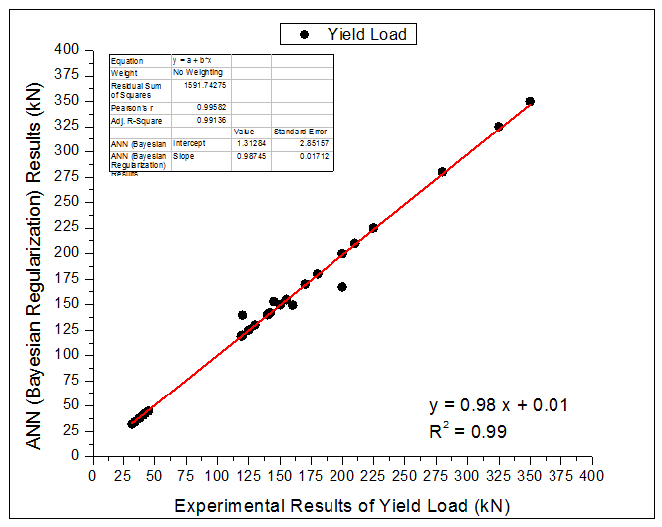

**Fig.15.** Yield Load

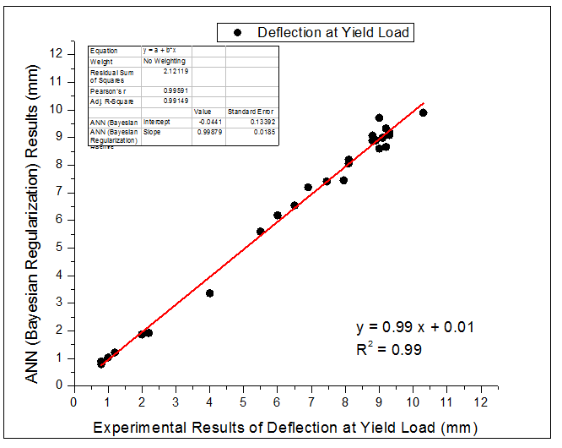

**Fig.16.** Deflection at Yield Load

Table 5Experimental and ANN results for Ultimate load and Deflection at Ultimate Load

|  |  |  |  |  |  |  |  |  |  |
| --- | --- | --- | --- | --- | --- | --- | --- | --- | --- |
| **Authors name** | **Test Specimen** | **Ultimate Load**  **(kN)** | | | | **Deflection at Ultimate Load**  **(mm)** | | | |
|  |  | **Exp** | **Levenberg-**  **Marquardt** | **Bayesian Regularizaton** | **Scaled Conjugate Gradient** | **Exp** | **Levenberg-**  **Marquardt** | **Bayesian Regularizaton** | **Scaled Conjugate Gradient** |
| Ismail *et al.*  (2016) | 500C-0CR | 250 | 263.16 | 265.71 | 259.21 | 27.00 | 27.06 | 31.26 | 12.40 |
| 500C-5CR | 251.1 | 254.17 | 251.08 | 256.95 | 28.50 | 27.31 | 28.72 | 15.62 |
| 500C-10CR | 249.2 | 250.81 | 249.32 | 245.74 | 28.20 | 26.81 | 27.74 | 15.42 |
| 500C-15CR | 243.3 | 242.82 | 245.10 | 246.18 | 30.80 | 26.59 | 27.47 | 16.82 |
| 550C-15CR | 246.6 | 245.10 | 246.40 | 240.97 | 25.90 | 26.37 | 26.61 | 16.11 |
| 550C-20CR | 243.2 | 238.20 | 243.31 | 238.91 | 26.80 | 25.52 | 26.12 | 16.44 |
| 550C-20CR-MK | 245 | 245.41 | 245.00 | 222.41 | 21.90 | 24.42 | 21.94 | 14.24 |
| 550C-30CR-MK | 228 | 234.66 | 228.03 | 211.64 | 21.30 | 20.88 | 20.97 | 14.21 |
| 550C-30CR-MK-MA | 219 | 229.88 | 218.98 | 220.28 | 17.90 | 21.32 | 18.40 | 14.93 |
| 550C-40CR-MK-MA | 203.6 | 222.53 | 174.37 | 207.85 | 15.70 | 16.68 | 15.87 | 13.77 |
| 550C-40CR-MK-VRC | 205.7 | 223.08 | 209.60 | 204.15 | 16.20 | 15.44 | 19.99 | 13.59 |
| 550C-50CR-MK-VRC | 197.5 | 232.14 | 197.49 | 199.59 | 15.90 | 17.06 | 15.95 | 12.91 |
| Ismail *et al.*  (2017) | B1-0CR | 250.7 | 231.03 | 250.66 | 250.92 | 1.92 | 3.12 | 2.13 | 7.22 |
| B2-5CR | 230.13 | 215.92 | 230.17 | 220.82 | 2.13 | 2.72 | 2.07 | 9.73 |
| B3-15CR | 195.97 | 198.56 | 196.00 | 197.21 | 1.95 | 3.28 | 1.78 | 11.36 |
| B4-25CR | 174.24 | 177.99 | 180.35 | 174.95 | 2.11 | 2.85 | 3.48 | 11.36 |
| B5-5CR-0.35SF | 283.59 | 258.07 | 283.59 | 293.08 | 2.47 | -0.26 | 2.46 | 6.14 |
| B6-15CR-0.35SF | 244.74 | 240.94 | 244.74 | 267.47 | 2.31 | 0.54 | 2.29 | 6.80 |
| B7-25CR-VRC | 181.25 | 188.23 | 181.21 | 181.07 | 1.81 | 2.96 | 1.91 | 11.58 |
| B8-35CR-VRC | 145.1 | 140.69 | 145.13 | 167.04 | 1.84 | 1.25 | 1.71 | 10.32 |
| B9-35CR-0.35SF-VRC | 233.76 | 226.60 | 233.67 | 214.64 | 2.47 | 2.07 | 2.55 | 5.80 |
| B10-35CR-1SF-VRC | 366.57 | 360.37 | 366.56 | 355.74 | 4.23 | 4.98 | 3.94 | 3.97 |
| B11-35CR-0.35LSF-VRC | 209.32 | 213.95 | 209.40 | 210.66 | 2.07 | 0.74 | 2.10 | 5.75 |
| B12-35CR-1LSF-VRC | 343.65 | 342.72 | 343.65 | 354.33 | 4.04 | 3.19 | 4.27 | 4.09 |
| Mr. R. Karthikeyan | SC | 60 | 24.27 | 60.00 | 64.72 | 12.00 | 10.43 | 11.94 | 15.64 |
| S11 | 62.5 | 68.33 | 62.48 | 65.75 | 14.40 | 16.17 | 14.35 | 15.32 |
| S12 | 65 | 61.32 | 65.01 | 77.19 | 15.60 | 17.31 | 15.73 | 15.30 |
| S21 | 66.5 | 73.50 | 66.50 | 64.53 | 16.80 | 18.19 | 16.69 | 14.60 |
| S22 | 68.5 | 60.31 | 68.50 | 107.59 | 18.60 | 18.31 | 18.58 | 15.40 |
| S31 | 69.75 | 78.61 | 69.75 | 65.28 | 20.80 | 18.69 | 21.00 | 15.29 |
| S32 | 72.5 | 74.67 | 72.49 | 70.62 | 24.90 | 23.73 | 24.79 | 15.35 |

The scatter plots drawn between the experimental and results those predicted through ANN modeling for ultimate load and deflection at ultimate load in Bayesian Regularization are shown through Figs.17-18.

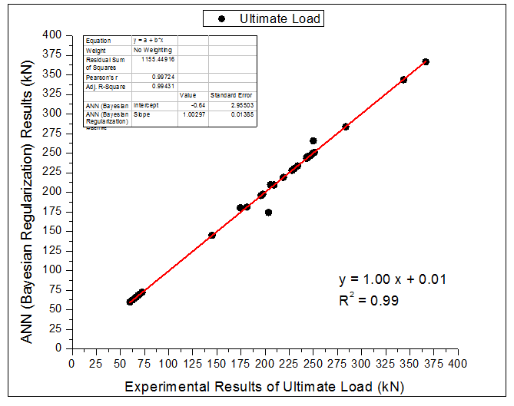

**Fig. 17.** Ultimate Load

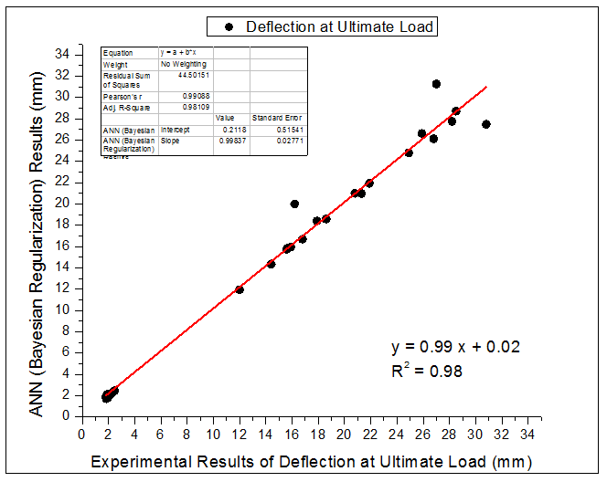

**Fig.18.** Deflection at Ultimate Load

Table 6 Experimental and ANN Results for Ductility

|  |  |  |  |  |  |  |  |  |  |  |  |  |
| --- | --- | --- | --- | --- | --- | --- | --- | --- | --- | --- | --- | --- |
| **Authors**  **name** | **Test Specimen** | | |  | **Ductility** | | | | | | | |
|  |  | | | **Exp** | **Levenberg-Marquardt** | | | **Bayesian Regularization** | | | **Scaled Conjudate Gradient** | |
| Ismail *et al.*  (2016) | 500C-0CR | | | 2.62 | | | 2.79 | | | 3.25 | | 1.09 | |
| 500C-5CR | | | 3.06 | | | 2.83 | | | 3.09 | | 0.71 | | |
| 500C-10CR | | | 3.20 | | | 2.85 | | | 3.11 | | 0.46 | | |
| 500C-15CR | | | 3.38 | | | 2.84 | | | 2.88 | | 0.25 | | |
| 550C-15CR | | | 2.94 | | | 2.85 | | | 2.96 | | 0.23 | | |
| 550C-20CR | | | 3.01 | | | 2.77 | | | 2.74 | | 0.08 | | |
| 550C-20CR-MK | | | 2.43 | | | 2.86 | | | 2.79 | | 0.00 | | |
| 550C-30CR-MK | | | 2.32 | | | 2.60 | | | 2.20 | | -0.33 | | |
| 550C-30CR-MK-MA | | | 2.21 | | | 2.43 | | | 2.22 | | -0.26 | | |
| 550C-40CR-MK-MA | | | 1.71 | | | 1.90 | | | 1.75 | | -0.48 | | |
| 550C-40CR-MK-VRC | | | 1.80 | | | 1.97 | | | 1.79 | | -0.53 | | |
| 550C-50CR-MK-VRC | | | 1.71 | | | 1.86 | | | 1.70 | | -0.63 | | |
| Ismail *et al.*  (2017) | B1-0CR | | | 2.40 | | | 2.13 | | | 2.25 | | 1.55 | | |
| B2-5CR | | | 2.66 | | | 2.23 | | | 2.27 | | 1.28 | | |
| B3-15CR | | | 2.44 | | | 2.56 | | | 2.31 | | 0.83 | | |
| B4-25CR | | | 2.64 | | | 2.70 | | | 1.94 | | 0.74 | | |
| B5-5CR-0.35SF | | | 1.12 | | | 2.28 | | | 1.66 | | 0.46 | | |
| B6-15CR-0.35SF | | | 1.93 | | | 2.32 | | | 1.99 | | 0.01 | | |
| B7-25CR-VRC | | | 1.81 | | | 2.77 | | | 1.91 | | 0.65 | | |
|  | | | B8-35CR-VRC | 1.84 | | | 2.02 | | | 1.69 | | | 0.65 | | |
| B9-35CR-0.35SF-VRC | 1.24 | | | 1.87 | | | 1.34 | | | 0.08 | | |
| B10-35CR-1SF-VRC | 1.69 | | | 1.75 | | | 1.21 | | | -1.22 | | |
| B11-35CR-0.35LSF-VRC | 1.04 | | | 1.85 | | | 1.35 | | | 0.13 | | |
| B12-35CR-1LSF-VRC | 1.01 | | | 1.73 | | | 1.32 | | | -1.16 | | |
| Mr.R. Karthikeyan | | | SC | 2.18 | | | 3.08 | | | 2.32 | | | 3.84 | | |
| S11 | 2.40 | | | 2.43 | | | 2.36 | | | 3.86 | | |
| S12 | 2.40 | | | 2.24 | | | 2.53 | | | 3.79 | | |
| S21 | 2.43 | | | 2.91 | | | 2.44 | | | 3.86 | | |
| S22 | 2.50 | | | 2.22 | | | 2.56 | | | 3.60 | | |
| S31 | 2.62 | | | 2.51 | | | 2.46 | | | 3.85 | | |
| S32 | 3.07 | | | 2.76 | | | 2.88 | | | 3.80 | | |

The scatter plots drawn between the experimental and results those predicted through ANN modeling for ductility in Bayesian Regularization are shown in Fig. 19.

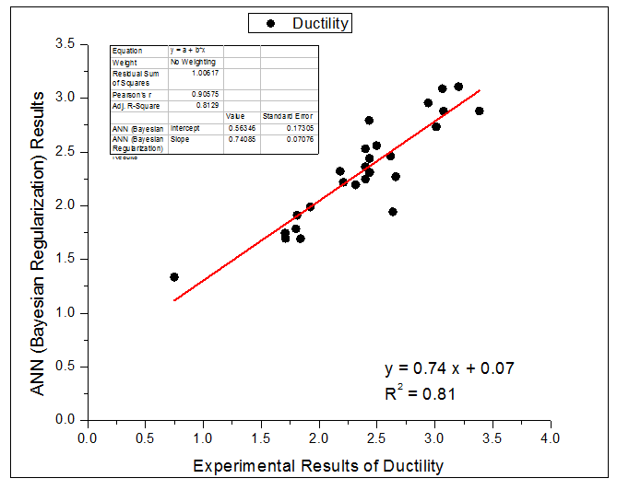

**Fig.19.** Ductility

**5.2 Summary of Parameters used in ANN Model**

The summary of parameters used in ANN model for rubberized concrete beams with micro-reinforcement are presented in Table 7.

Table 7 Rubberized Concrete Beams with micro-reinforcement

|  |  |  |  |
| --- | --- | --- | --- |
| **Training Algorithm** | **Transfer Function** | **Network Architecture** | **Training, Verifying and Testing Data** |
| Levenberg- Marquardt  (Back Propagation) | LOGSIG | 9-15-7 | 21,5,5 |
| Bayesian Regularization  (Back Propagation) | LOGSIG | 9-10-7 | 21,5,5 |
| Scaled Conjugate Gradient  (Back Propagation) | LOGSIG | 9-10-7 | 21,5,5 |

**5.3 Results and Discussion**

Table8 provides the statistical indicators such as the coefficient of determination (R2), RMSE and MAPE for estimating the accuracy of predicted results.

RMSE = (1)

R2 = (2)

MAPE = x100 (3)

Figs.16-22show that experimental and predicted values of performance parameters for rubberized concrete beams correlate well and the representative points in the scatter plots correlate to the line of equality.

The potential of ANN model for predicting the performance parameters for rubberized concrete beams with micro reinforcements has been explored in this study. 31 experimental data values were used for training and testing models for rubberized concrete beams with micro-reinforcement. ANN based prediction has been made with different algorithms such as Levenberg-Marquardt, Bayesian Regularization and Scaled Conjugate Gradient to identify the algorithm which will provide better convergence. Artificial Neural Network performed well for predicting the first crack load, deflection at first crack load, yield load, deflection at yield load, ultimate load, deflection at ultimate load and ductility for rubberized concrete beams with micro-reinforcements. To evaluate the accuracy of the models, scatter plots were drawn between the experimental and predicted results as shown in Figs. 16-22. Table 8 provides the statistical indicators such as the coefficient of determination (R2), RMSE and MAPE for estimating the accuracy of predicted results.

**5.4 Statistical Indicators**

Table 8 Rubberized Concrete Beams with Micro-reinforcement

|  |  |  |  |  |
| --- | --- | --- | --- | --- |
|  | **Rubberized Concrete Beams with Micro-reinforcement** | | | |
|  | **Algorithms in ANN** | | |
| **Output Parameters** | **Performance Parameters** | **Levenberg-Marquardt** | **Bayesian Regularization** | **Scaled Conjugate Gradient** |
| First Crack Load | RMSE | 7.09 | 0.19 | 3.811 |
| R2 | 0.990 | 0.99 | 0.998 |
| MAPE | 6.760 | 0.40 | 5.947 |
| Deflection at First Crack Load | RMSE | 0.60 | 0.16 | 1.41 |
| R2 | 0.900 | 0.99 | 0.75 |
| MAPE | 29.650 | 8.91 | 2.19 |
| Yield Load | RMSE | 15.78 | 7.37 | 10.57 |
| R2 | 0.99 | 0.998 | 0.996 |
| MAPE | 8.22 | 1.52 | 6.71 |
| Deflection at Yield Load | RMSE | 0.86 | 0.29 | 0.97 |
| R2 | 0.99 | 0.998 | 0.988 |
| MAPE | 9.14 | 3.96 | 9.69 |
| Ultimate Load | RMSE  R2 | 11.46  0.997 | 6.11  0.999 | 9.96  0.998 |
|  | MAPE | 4.96 | 0.88 | 4.17 |
| Deflection at Ultimate Load | RMSE | 1.76 | 1.32 | 3.27 |
| R2 | 0.99 | 0.995 | 0.970 |
| MAPE | 10.47 | 3.97 | 14.10 |
| Ductility | RMSE | 0.28 | 0.25 | 0.71 |
| R2 | 0.99 | 0.99 | 0.85 |
| MAPE | 10.00 | 8.79 | 25.91 |

Firstly,the performance of all the proposed ANN models (using various algorithms) for predicting the performance parameters of rubberized concrete beams with micro-reinforcement has been evaluated through statistical indicators (RMSE,R2, MAPE).Also, the effects of various algorithms on the performance of proposed ANN model have been examined.

A RMSE, co-efficient of determination and MAPE of 0.19, 0.999 & 0.40, 0.16, 0.99 & 8.91, 7.37, 0.998 & 1.52, 0.29, 0.998 & 3.96, 6.11, 0.999 & 0.88, 1.32, 0.995 & 3.97, 0.25, 0.99 & 8.79 were observed while predicting the first crack load, deflection at first crack load, yield load, deflection at yield load, ultimate load, deflection at ultimate load and ductility of rubberized concrete beams.

It can be seen from the results (Table8) that the ANN model constituted with Bayesian Regularization algorithm gives reliable results. This is evident from a lower value of RMSE and MAPE and a higher value of coefficient of determination. Thus, the high prediction ability of the ANN model can be realized in a short period of time.

**6.Conclusions**

Concrete beams with micro-reinforcement incorporating pre-treated rubber aggregatesexhibit improved performance in terms of load carrying capacity, deformation capacity and ductility. ANN model has been proposed for predicting the performance parameters of rubberized concrete beams with micro-reinforcement using three different algorithms in MATLAB ANN Tool Box. The results predicted through ANN modeling exhibited better correlation with the experimental results. This is ascertained through the statistical indicators. A comparison between experimental and predicted results was made through scatter plots for all the three algorithms. A correlation co-efficient of 0.81 to 0.99 has been observed for Bayesian Regularization in scatter plots. ANN model constituted with Bayesian-Regularization algorithm gives reliable results compared to the other two algorithms.

**References**

1. Ahmed TareqNoamana, B.H. Abu Bakara, and Hazizan Md. Akil (2015), The Effect of Combination between Crumb Rubber and Steel Fiber on Impact Energy of Concrete Beams, *Procedia Engineering* 125 ,825 – 831.
2. Ahmed TareqNoamana,b, B.H. Abu Bakar a, Hazizan Md. Akil c, A.H. Alani (2017),Fracture Characteristics of Plain and Steel Fibre Reinforced Rubberized Concrete, *Construction and Building Materia*ls 152 ,414–423
3. Bakar BadorulHishamAbu ,Ahmed Tareq ,NoamanHazizan M (2017), Cumulative Effect of Crumb Rubber and Steel Fiber on the Flexural Toughness of Concrete, *Engineering, Technology & Applied Science Research , 1345-1352.*
4. Balendran R.V., Zhou F.P., Nadeem A. and Leung A.Y.T. (2002), Influence of Steel Fibres on Strength and Ductility of Normal and Lightweight High Strength Concrete, *Building and Environment*, 37(12), 1361-1367.
5. Chou L., Lin C., Lu C., Lee C. and Lee M. (2010), Improving Concrete by Waste Organic Sulphur Compounds, *Waste Management*, 28, 29-35.
6. Corinaldesi V. and Moriconi G. (2004), Durable Fibre Reinforced Self-Compacting Concrete, *Cement and Concrete Research*, 34, 249-254.
7. Fattuhi N.I. and Clark L.A. (1996), Cement based Materials containing Shredded Scrap Truck Tyre Rubber, *Construction and Building Materials*, 10(4), 229-236
8. N. Ganesan, J. Bharati Raj 1, A.P. Shashikala(2013), Flexural Fatigue Behavior of Self Compacting Rubberized Concrete, *Construction and Building Materials* 44 ,7–14.
9. Ganjian E., Khorami M. and Maghsoudi A.A. (2009), Scrap - Tyre-Rubber Replacement for Aggregate and Filler in Concrete, *Construction and Building Materials,* 23(5), 1828-1836.
10. GhalyA.and Cahill J. (2005), Correlation of Strength, Rubber Content and Water to Cement Ratio in Rubberized Concrete, *Canadian Journal of Civil Engineering*, 32, 1075-1081
11. Grunewald S. and Walraven J.C. (2001), Parameter - Study on the influence of Steel Fibres and Coarse Aggregate Content on the Fresh Properties of Self-Compacting Concrete, *Cement and Concrete Research*, 31, 1793-1798.
12. Hee S.I., Hosin I., Moon J.S and Hwan W. (1998), Development of Tire - added Latex Concrete, *ACI Materials Journal*, 95(4), 9-17.
13. Khaloo A.R., Dehestani M. and Rahmatabadi P. (2008), Mechanical Properties of Concrete containing a High Volume of Tire Rubber Particles, *Waste Management*, 28(12), 2472-2482.
14. IS 383:1970, Specification for Coarse and Fine Aggregates for Concrete, Bureau of Indian Standards, New Delhi, India
15. Li F., Li Z. and Li J. (1998), Properties of Concrete incorporating Rubber Tyre Particles, *Magazine of Concrete Research*, 50(4), 297-304.
16. Li G., Stubblefield M.A., Garrick G.E., John A.C. and Huang B. (2004), Development of Waste Tire Modified Concrete, *Cement and Concrete Research*, 34(12), 2283-2289.
17. Mohamed K. Ismail ,Assem A.A. Hassan(2017), An Experimental Study on Flexural Behavior of Large-Scale Concrete Beams incorporating Crumb Rubber and Steel Fibres, *Engineering Structures* 145, 97–108.
18. Najim K.B. and Hall M.R. (2010), A Review of Fresh/Hardened Properties and Applications of Plain and Self-Compacting Rubberized Concrete, *Construction and Building Materials*, 24(11), 2043-2051.
19. Najim K.B. and Hall M.R. (2013), Crumb Rubber Aggregate Coatings/Pre-treatments and their Effects on Interfacial Bonding, Air Entrapment and Fracture Toughness in Self-Compacting Rubberized Concrete, *Materials and Structures*, 46(12), 2029-2043.
20. Raghavan D., Huynh H. and Ferraris C. (1998), Workability, Mechanical Properties and Chemical Stability of a Recycled Tyre Rubber Filled Cementitious Composite, *Journal of Material Science*, 33, 1745-1752.
21. Segre N. and Joekes I. (2000), Use of Tire Rubber Particles as addition to Cement Paste, *Cement and Concrete Research*, 30(9), 1421-1425.
22. Segre N., Monteiro P. and Sposito G. (2002), Surface Characterization of Recycled Tyre Rubber to be used in Cement Paste Matrix, *Journal of Colloid Interf Science*, 248, 521-523.
23. Snelson D., Kinuthia J.M., Davies P. and Chang S. (2009), Sustainable Construction: Composite use of Tyres and Ash in Concrete, *Waste Management*, 29, 360-367.
24. Thomas,B.S., Gupta, R.C and Panicker, V.J. (2016), Recyling of Waste Tire Rubber as Aggregate in Concrete - Durability related Performance, *Journal of Cleaner Production*, 112, 504-513.
25. Thomas,B.S. and Gupta, R.C (2016), Properties of High Strength Concrete containing Scrap Tire Rubber, *Journal of Cleaner Production*, 113, 86-92.
26. Valadares F., Bravo, M. and Brito, J. (2012), Concrete with used Tire Rubber Aggregates: Mechanical Performance, *ACI Materials Journal*, 109(3), 283-292
27. Xie Jian-he ,Guo Yong-chang , Liu Li-sha , XieZhi-hong (2015), Compressive and Flexural Behaviours of a New Steel Fibre-Reinforced Recycled Aggregate Concrete with Crumb Rubber ,*Construction and Building Materials* 79,263–272
28. Ahmed TareqNoamana,, B.H. Abu Bakara, and Hazizan Md. Akilb ( 2015 ) The Effect of Combination between Crumb Rubber and Steel Fibre on Impact Energy of Concrete Beams , *Applied Mechanics and Materials* ,802, 961 – 201.
29. Adel A. Al-Azzawi1, Dalia Shakirand NooraSaad(2018),Flexural Behavior of Rubberized Reinforced Concrete Beam , *International Journal of Engineering & Technology, 7 (4.20) 316-320.*
30. Mohamed Elchalakani,Tarek Aly and Emad Abu-Aisheh (2016) ,Mechanical Properties of Rubberized Concrete for Road Side Barriers, *Australian Journal of Civil Engineering.*
31. Farhad Aslani1 and Ronny Gedeon (2019) Experimental Investigation into the properties of Self-compacting Rubberised Concrete incorporating Polypropylene and Steel fibers ,*Structural Concrete*. 20:267–281.

32. O. Youssf, M. A. ElGawady, J. E. Mills and X. Ma ( 2014 ),Prediction of Crumb Rubber Concrete Strengt23rd Australasian Conference on the *Mechanics of Structures and Materials* (ACMSM23), *9-12.*

33.Amani, J., Moeini, **R.,**(2012) , Prediction of shear strength of reinforced concrete beams using adaptive neuro-fuzzy inference system and artificial neural network, *ScientiaIranica*, Vol. 19 pp. 242-248.