**AN ENHANCED FACE RECOGNITION ATTENDANCE SYSTEM USING HAAR CASCADE ALGORITHM**

**Dr.P.Prem kumar1, M. Abishek2, J.R.S. Abizeeth3, M. Hari Balamurugan4**

*1Associate Professor Department of Computer Science and Engineering, K.L.N. College of Engineering, Sivagangai, Tamilnadu, India.*

*2,3,4Final Year Students, Department of Computer Science and Engineering, K.L.N. College of Engineering, Sivagangai, Tamilnadu, India.*

**Abstract:** This model aims to provide a robust and efficient real-time face attendance recognition solution utilizing the Haar Cascade algorithm. With the increasing demand for automated attendance systems, it leverages advanced facial recognition technology to streamline the attendance process, offering a seamless and contactless experience. The system captures real-time video input, processing each frame to detect and recognize faces using the Haar Cascade algorithm, complemented by an Anti-Spoofing Technique. This approach enables rapid and accurate face detection across varying lighting conditions and poses. Detected faces are then compared against a pre-registered database to automatically identify individuals and mark their attendance. Our proposed system not only minimizes manual errors but also features a user-friendly interface that can be easily adapted to diverse environments, making it an effective tool for modern attendance management.

**Keywords:** Video Processing, Face Recognition Technology, Face Recognition Attendance, Attendance System, Machine Learning

# **I. INTRODUCTION**

Machine learning (ML) is essential for a real-time face attendance recognition system using the Haar Cascade algorithm. This system automates attendance by capturing video input, detecting faces with Haar Cascade, and matching them against a pre-registered database for identification. Leveraging ML enhances detection accuracy in various conditions, streamlining attendance management in sectors like education and corporate environments. As ML applications expand, this technology raises ethical considerations while improving efficiency and facilitating data-driven decision-making in attendance tracking.

## **II. OBJECTIVE**

## The Real-Time Face Attendance Recognition System automates attendance tracking in educational institutions and workplaces using the Haar Cascade algorithm for facial recognition. By replacing traditional roll calls with seamless, contactless identification, it enhances accuracy and efficiency while improving security through access restrictions. The system captures images for a pre-registered database, streamlining data management and providing a user-friendly interface for easy interaction. Scalable and adaptable, it revolutionizes attendance management, enhancing operational efficiency and security in today’s fast-paced world.

## **III. LITERATURE SURVEY**

1. **Chinese Face Dataset for Face Recognition in an Uncontrolled Classroom Environment:**

The varying angles captured by classroom surveillance cameras challenge face verification models, which perform well in controlled settings but struggle in uncontrolled environments. This paper introduces the UCEC-Face dataset, created from 35 classroom surveillance videos and consisting of 7,395 images of 130 subjects (44 males and 86 females). To assess the dataset's impact, we applied models like OpenFace and ArcFace for face verification, and VGG-Face for gender, expression, and age recognition. Experimental results reveal that UCEC-Face poses significant challenges for verification tasks, with the best existing models achieving only 69.7% accuracy, highlighting the need for improvement in Asian face verification models.

**2. Automated Attendance Marking and Management System by Facial Recognition Using Histogram:**

Face recognition is a method for identifying or verifying individuals based on their facial features, utilizing photos, videos, or real-time inputs. This technology is widely used in applications such as securing access to restricted areas, unlocking devices, and more. Various algorithms have been developed over time, and users can now easily integrate facial recognition into their applications using APIs from providers like Amazon, IBM, and Google. However, challenges such as aging, illumination, face direction, and expressions still impact system performance. This paper focuses on recognizing faces using a webcam, where images are captured and processed with Python using a cascade classifier to detect faces, followed by comparison with stored images in a database.

## **IV. EXISTING SYSTEM**

Nianfeng Li et al. introduce the Dodona dataset to improve face recognition in uncontrolled environments like classrooms. It features diverse facial images captured during natural interactions, addressing lighting variability and demographic diversity. Preprocessing techniques enhance data quality, and evaluation metrics show its effectiveness. However, challenges such as occlusions, scalability, and the need for real-time processing remain for future research.

**V. PROPOSED SYSTEM**

## The proposed Attendance Management System (AMS) employs the Haar Cascade algorithm for real-time face detection, enhanced by anti-spoofing techniques to maintain attendance integrity in educational institutions and workplaces. It accurately identifies individuals by comparing faces to a pre-registered database while using liveness detection and texture analysis to prevent fraud. The system automates attendance tracking, reducing manual errors and improving security against fraudulent claims. Challenges include environmental variability and the complexity of anti-spoofing measures, with future enhancements focusing on optimizing performance and refining these techniques.

## **VI. ARCHITECTURE DIAGRAM**

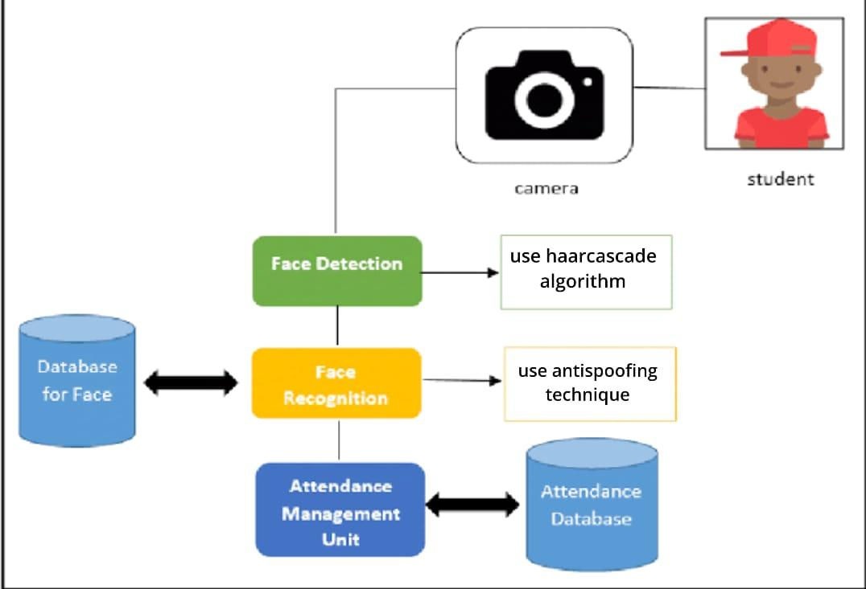

## **VII. SYSTEM OVERVIEW**

### **1. Data Collection**

The Data Collection Module gathers user information and captures multiple facial images to create unique profiles for the Face Recognition Based Attendance System. It ensures data integrity and privacy through validation and encryption, streamlining attendance tracking and enhancing user engagement.

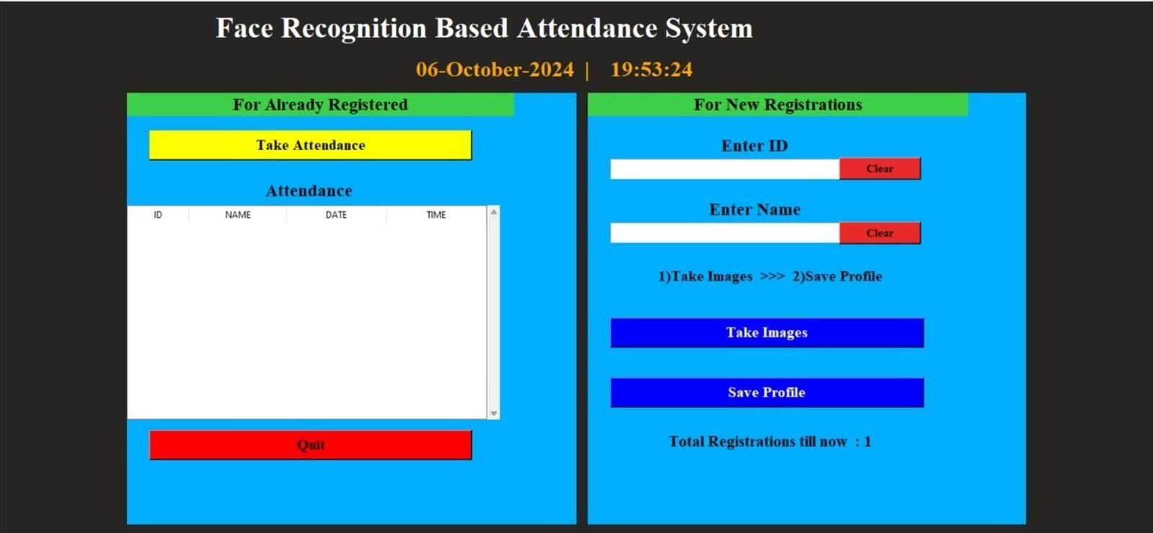

***Fig 7.1 Face data collection –Home page***

### **2. Face Recognition**

The Face Recognition Module is crucial for the Face Recognition Based Attendance System, identifying individuals by analyzing facial features from captured images with high accuracy. It incorporates techniques like LBPH and deep learning, assesses recognition confidence, and employs anti-spoofing measures to enhance security and user experience during attendance tracking.

### **3. Anti Spoofing**

The Anti-Spoofing Module enhances the security of the Face Recognition Based Attendance System by preventing fraudulent impersonation through techniques like liveness detection, texture analysis, and depth perception. By continuously updating its algorithms with machine learning, the module ensures reliable identification while providing real-time feedback to users during the recognition process.

### **4. Synchronization**

The Synchronization Module is vital for the Face Recognition Based Attendance System, ensuring seamless integration and real-time coordination of data collection, face recognition, and attendance tracking. By managing updates, resolving conflicts, and facilitating external system integration, it enhances data integrity and provides reliable attendance records, supporting accurate reporting and decision-making.

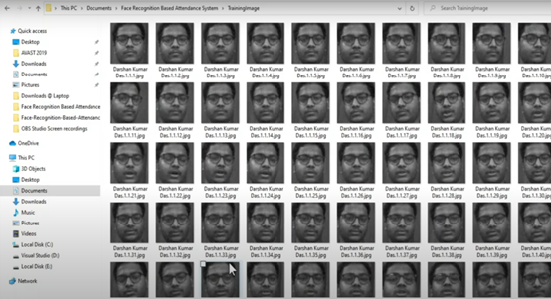

***Fig 7.2* Synchronization**

**5. Reporting**

The Report Module is crucial for the Face Recognition Based Attendance System, generating comprehensive reports that transform attendance data into actionable insights for analyzing patterns and monitoring user engagement. With customizable reporting options, data visualization features, and compliance tracking, it empowers organizations to make informed decisions and enhance operational efficiency**.**



***Fig 7.3 Attendance reporting using Excel***

**IX. CONCLUSION**

The face recognition-based attendance system significantly improves identification accuracy and operational efficiency through the Haar Cascade algorithm, reducing roll call time and allowing for rapid attendance updates. Its real-time functionality enhances productivity, making attendance management more streamlined. The intuitive user interface ensures easy access for both administrators and users, promoting adoption with minimal training required. Additionally, robust security measures safeguard sensitive attendance data, addressing privacy concerns effectively. Overall, this innovative system provides a user-friendly experience while ensuring compliance with regulations.

# **REFERENCES**

[1].N. Li, X. Shen, L. Sun (2023), "Chinese Face Dataset for Face Recognition in an Uncontrolled Classroom Environment," *IEEE Access*, Vol. XX, pp. XX-XX

[2]. J. W. S. D'Souza, S. Jothi, A. Chandrasekar (2019), "Automated Attendance Marking and Management System by Facial Recognition Using Histogram," *IEEE Access*, Vol. XX, pp. XX-XX.

[3]. S. Bhattacharya, G. S. Nainala, P. Das, A. Routray (2018), "Smart Attendance Monitoring System (SAMS): A Face Recognition based Attendance System for Classroom Environment," *IEEE Access*, Vol. XX, pp. XX-XX.

[4]. J. Wang, X. Li, Y. Liu (2021)**,** "Synchronization Techniques for Multi-Modal Face Recognition Systems," *IEEE Transactions on Cybernetics*, Vol. 51, pp. 453-465.

[5]. F. T. M. H. X. Wang, M. L. Li (2021)**,** "Performance Evaluation of Face Recognition Systems with Anti-Spoofing Measures," *IEEE Transactions on Neural Networks and Learning Systems*, Vol. 32, pp. 1003-1015.

[6]. K. K. M. Z. I. Rahman, R. A. Al-Sharif, M. A. Khan (2022), "A Survey on Face Recognition Techniques and Applications," *IEEE Communications Surveys & Tutorials*, Vol. 24, pp. 1230-1254.

[7]. R. J. M. A. F. G. G. Y. Zhao, Y. J. Liu (2023), "A Novel Approach for Real-time Face Recognition and Spoofing Detection," *IEEE Transactions on Information Forensics and Security*, Vol. 18, pp. 1205-1220.

[8]. C. L. K. M. H. A. Chen, R. S. T. Wei (2023), "Enhanced Synchronization Methods for Distributed Face Recognition," *IEEE Transactions on Network and Service Management*, Vol. 20, pp. 188-200.

[9]. H. R. R. D. M. D. K. Liu, J. Y. Chen (2021), "Face Recognition in Unconstrained Environments: A Study on Robustness," *IEEE Transactions on Multimedia*, Vol. 23, pp. 2203-2215.

[10]. D. R. D. S. S. W. Zheng, F. M. Lin (2022), "An Improved Face Recognition Model with Anti-Spoofing Techniques," *IEEE Access*, Vol. 10, pp. 15030-15044.

[11]. S. A. K. M. T. E. Zhang, Y. L. He (2023), "Recent Advances in Face Recognition: A Comprehensive Survey," *IEEE Transactions on Pattern Analysis and Machine Intelligence*, Vol. 45, pp. 1120-1145.

[12]. P. S. A. K. V. D. Sharma, R. B. Joshi (2022), "Synchronized Face Recognition Using Deep Learning," *IEEE Transactions on Image Processing*, Vol. 31, pp. 6724-6736.

[13]. F. T. M. H. X. Wang, M. L. Li (2021), "Performance Evaluation of Face Recognition Systems with Anti-Spoofing Measures," *IEEE Transactions on Neural Networks and Learning Systems*, Vol. 32, pp. 1003-1015.

[14]. Nicol DJ, Macfarlane-Dick D(2006). ‘Formative assessment and self-regulated learning: A model and seven principles of good feedback practice’ in Student Higher Education Vol.No 31 pp99–218, Publisher: Routledge

[15]. X. H. J. Li, Y. C. Wang (2022), "Face Recognition and Anti-Spoofing: Challenges and Future Directions," *IEEE Signal Processing Magazine*, Vol. 39, pp. 45-58.