**AUTOMATED CAR PARKING MANAGEMENT SYSTEM USING IOT**

**Sangamithra.S1, Sornalatha.M 2, Soundharya Sri.P.G3, Subhashini.R4**

*1Assistant Professor Department of Computer Science and Engineering,*

*K.L.N. College of Engineering and Technology, Sivagangai, India*

*2,3,4 Student, Department of Computer Science and Engineering,*

*K.L.N. College of Engineering and Technology, Sivagangai, India*

*Corresponding Author:krishnasangamithra@gmail.com*

| ***Abstract:****A fully automated parking management system utilizing FASTag technology integrated with Orion RFID tags and ultrasonic sensors to streamline vehicle entry, parking duration monitoring, and payment processing. The system captures the FASTag UID from both entry and exit points using Orion RFID tags. Ultrasonic sensors monitor vehicle presence within the parking slot, enabling real-time detection of entry and exit times. A microcontroller stores these timestamps and calculates the duration of parking using a timediff algorithm. Upon exit, the microcontroller verifies the FASTag UID at both entry and exit points and processes the corresponding payment by transmitting the calculated parking fee to the vehicle owner's bank account, which is linked to the FASTag system. The system ensures a seamless and automated transaction, with payment confirmation sent via standard bank notification methods. This project enhances parking efficiency, reduces human intervention, and facilitates secure, automated transactions.*  ***Keywords****:*Automated parking, FASTag, RFID tags, Ultrasonic Sensor, Microcontroller, Vehicle Detection, Parking Duration, Payment process*.* |
| --- |

1. **Introduction**

Automating parking management systems has become essential in modern urban environments to enhance efficiency and reduce manual intervention. Utilizing FASTag technology integrated with Orion RFID tags and ultrasonic sensors, this project presents a streamlined solution for capturing vehicle information, monitoring parking duration, and processing payments. At the entrance of the parking area, Orion RFID tags scan and capture the FASTag UID, storing it in a microcontroller. Once the vehicle reaches the parking slot, ultrasonic sensors detect the vehicle’s presence and trigger a timestamp to capture the entry time. Similarly, when the vehicle exits the slot, the system detects the change, records the exit time with another timestamp, and stores both times in the microcontroller. The parking duration is then calculated using a timediff algorithm. Upon exiting, the FASTag UID is verified at the exit point, and the system processes the payment by sending the calculated amount to the linked bank account. This approach ensures efficient real-time tracking, secure data handling, and seamless automated transactions.

1. **Research And Findings**

The integration of FASTag technology, RFID tags, and ultrasonic sensors in parking management systems is becoming increasingly popular as cities grow and the demand for smarter infrastructure increases. Research into automated parking solutions has shown that manual systems often face challenges such as slow entry and exit processes, incorrect fee calculations, and long queues. FASTag technology, primarily used for toll collection on highways, offers an efficient way to handle vehicle identification and payment transactions in a parking environment. By combining this with RFID and ultrasonic sensors, parking systems can not only automate entry and exit but also provide accurate tracking of the time spent in the parking area.

The use of Orion RFID tags to capture the FASTag UID at both entry and exit points ensures accurate and secure identification of vehicles. RFID systems have been extensively tested in various industries and have proven to be reliable for quick scanning and information processing. With the FASTag UID stored in a microcontroller, the parking system is able to track each vehicle's movements from the moment it enters until it leaves. This seamless process reduces human intervention and errors that typically occur in manual logging systems, making the overall parking experience more efficient for both users and operators.

Ultrasonic sensors add another layer of precision to the system by monitoring vehicle presence in parking slots. These sensors detect when a car arrives or leaves by measuring the distance between the sensor and the vehicle. A key advantage of using ultrasonic sensors is their ability to trigger a timestamp at both the vehicle's entry and exit, recording these events in the microcontroller. This allows for accurate calculation of parking duration, which is essential for determining the correct parking fee. The combination of these technologies ensures that all data is recorded and processed in real-time, improving the overall reliability of the system.

Once the vehicle reaches the exit point, the system verifies the FASTag UID scanned earlier to ensure consistency and security. Research into automated payment systems shows that direct integration with banks through linked FASTag accounts is both secure and efficient, eliminating the need for cash transactions or manual payment systems. By calculating the duration of parking using the stored timestamps, the microcontroller automatically determines the amount to be debited and sends the required information to the bank. This process ensures that payments are handled swiftly and users are notified through standard banking methods, enhancing the user experience.

In conclusion, the research and implementation of this automated parking system demonstrate its ability to improve efficiency, reduce errors, and provide a secure payment solution. The combination of FASTag, RFID tags, and ultrasonic sensors addresses key challenges faced by traditional parking systems and offers a modern, scalable solution. With accurate time tracking, seamless transactions, and minimal human involvement, this system sets a new standard for parking management, making it suitable for adoption in various urban and commercial environments.

**III. System Implementation**

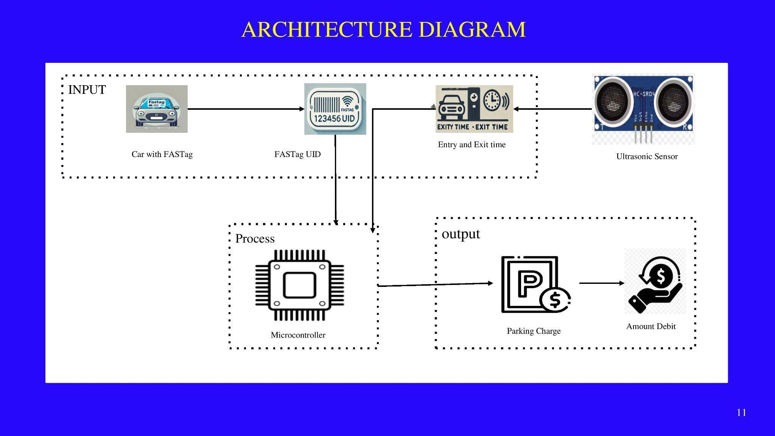

This diagram focuses on an automated parking fee collection system that uses RFID and ultrasonic sensors to track vehicles, calculate parking durations, and debit fees automatically. The architecture relies on capturing vehicle entry and exit times using ultrasonic sensors and FASTag UID through Orion RFID tags. This data is processed by a microcontroller, which calculates the parking duration and initiates the payment process via linked bank accounts.

1) Capturing FASTag UID

The Orion RFID tag scans the FASTag UID attached to the vehicle. This process begins when the car arrives at the parking area. The RFID system captures the unique identification of the car’s FASTag and sends this information to the microcontroller. The microcontroller then stores the FASTag UID, which will be essential for further processing.

2) Detecting Entry Time via Ultrasonic Sensors

Once the vehicle reaches the parking slot, an ultrasonic sensor detects its presence by measuring the distance to the car. A predefined threshold value helps the system identify the car's arrival. When the vehicle crosses this threshold, the microcontroller captures the entry time using a timestamp. This data is stored in the microcontroller, which plays a vital role in tracking the parking duration.

3) Capturing Exit Time and Duration Calculation

When the vehicle leaves the parking slot, the ultrasonic sensor detects the exit by noticing the threshold value change. The microcontroller captures the exit time using another timestamp. To calculate the total time the vehicle was parked, the system uses the Timediff algorithm. The duration of the parking session is stored, allowing the microcontroller to determine the applicable parking fee.

4) FASTag Scanning at Exit

As the car approaches the exit, the Orion RFID tag scans the FASTag UID once again. The microcontroller compares this UID with the one captured during entry. This matching ensures that the correct car is being processed for payment, avoiding errors in billing

5) Fee Calculation and Payment Process

After calculating the parking duration, the microcontroller determines the fee to be debited from the linked FASTag account. It sends the required information, including the FASTag UID and the amount, to the bank. The bank processes the transaction, and the car owner receives a notification regarding the fee deduction, completing the automated parking system.

The automated parking system uses Orion RFID tags and ultrasonic sensors to capture a vehicle's FASTag UID and detect its entry and exit times. The microcontroller stores the FASTag UID and calculates the parking duration using timestamps. At the exit, the RFID tag scans the FASTag again to verify the vehicle, and the microcontroller calculates the parking fee. The fee is then automatically debited from the vehicle owner’s FASTag-linked bank account, completing the process.billed. After verification, the microcontroller calculates the parking fee based on the duration and sends the necessary data (FASTag UID and fee) to the bank, where the amount is automatically debited from the vehicle owner’s linked FASTag account. The owner then receives a confirmation, completing the fully automated, human-free parking fee collection process.

**IV.CONCLUSION**

* **Efficient Vehicle Identification**: The integration of Orion RFID tags ensures accurate and automatic identification of vehicles through their FASTag UID at both entry and exit points.
* **Automated Time Tracking**: The use of ultrasonic sensors successfully tracks vehicle entry and exit times, allowing for precise calculation of parking durations without human intervention.
* **Accurate Fee Calculation**: The system effectively calculates parking fees based on the duration of stay using the Timediff algorithm, ensuring transparency and accuracy in fee assessments.
* **Seamless Payment Process**: By linking FASTag UIDs to vehicle owners' bank accounts, the system enables automatic fee deduction without requiring manual payments, simplifying the entire transaction process.
* **User-Friendly and Scalable**: This system provides a fully automated, user-friendly solution that can be easily scaled and adapted for various parking environments, reducing operational costs and improving user experience.

**References**

1. Alessandro Floris, Simone Porcu, Luigi Atzori and Roberto Girau, "A Social IoT-based platform for the deployment of a smart parking solution", Computer Networks, vol. 205, pp. 108756, 2022.
2. Fadi Al‐Turjman, Hadi Zahmatkesh and Ramiz Shahroze, "An overview of security and privacy in smart cities' IoT communications", Transactions on Emerging Telecommunications Technologies, vol. 33, no. 3, pp. e3677, 2022.
3. Khanna, A., Anand, R. (2021). IoT-based Smart Parking System Using FASTag. IEEE Xplore. This article outlines a smart parking solution using IoT with an emphasis on FASTag for automatic payment systems.
4. Sadhukhan, P. (2021). Real-time Smart Parking System Using IoT. Springer. Focuses on real-time parking slot detection and occupancy.