**A COMPARATIVE STUDY OF MEAN SQUARE ERROR, SIGNAL TO NOISE RATIOS OF GREY SCALE THRESHOLDED AND COMPRESSED IMAGES BEFORE PERFORMING EDGE DETECTION METHOD**

**[ABIR CHAKRABORTY, UNIVERSITY OF COIMBRA, PORTUGAL]**

**[ABSTRACT: Author has already published a paper where he has used colored and grey scale images to find out the mean square error, peak signal to noise ratio’s in clustering based segmented and compressed version. Here in this article author has done the same comparison of image thresolding, image compression and then edge detection techniques respectively. So there will be a sharp comparison between these two different articles where the aim of the author is same for both the cases. In this articles author has used two different types of thresholding techniques: global and adaptive thresholding.]**

**[KEYWORDS:RGB, GREY, PREWITT, CANNY, SOBEL, ADAPTIVE AND GLOBAL THRESHOLDING, COMPRESSED IMAGE.]**

**1.INTRODUCTION:**

**In Simple Thresholding, a global value of threshold was used which remained constant throughout. So, a constant threshold value won't help in the case of variable lighting conditions in different areas. Adaptive thresholding is the method where the threshold value is calculated for smaller regions. Here, the algorithm determines the threshold for a pixel based on a small region around it. So we get different thresholds for different regions of the same image which gives better results for images with varying illumination. Adaptive thresholding is a form of image thresholding technique in which rather than specifying the threshold value manually or using any restrictions, the threshold value is adjusted and selected automatically according to the image pixels and layout for converting the image pixels to grayscale or a binary image.**

**A global thresholding technique is one which makes use of a single threshold value for the whole image, whereas local thresholding technique makes use of unique threshold values for the partitioned subimages obtained from the whole image.Global Thresholding is a widely used technique where a single threshold value is applied to an entire image. However, this technique  may not be suitable for images with varying lighting conditions or complex backgrounds. To overcome this limitation, adaptive thresholding techniques may be employed, which adjust the threshold value locally based on the characteristics of each pixel's neighborhood. These techniques are particularly useful in scenarios where there is significant variation in illumination across different regions of the image.**

**The objective of image compression is to reduce irrelevance and redundancy of the image data to be able to store or transmit data in an efficient form. It is concerned with minimizing the number of bits required to represent an image.**

**Now lets talk about edge detection techniques which author has used in this paper**

**Edge Detection Operators are of two types:**

* **Gradient – based operator which computes first-order derivations in a digital image like, Sobel operator, Prewitt operator, Robert operator**
* **Gaussian – based operator which computes second-order derivations in a digital image like, Canny edge detector, Laplacian of Gaussian**

**Sobel Operator: It is a discrete differentiation operator. It computes the gradient approximation of image intensity function for image edge detection. At the pixels of an image, the Sobel operator produces either the normal to a vector or the corresponding gradient vector. It uses two 3 x 3 kernels or masks which are convolved with the input image to calculate the vertical and horizontal derivative approximations**

**Prewitt Operator: This operator is almost similar to the sobel operator. It also detects vertical and horizontal edges of an image. It is one of the best ways to detect the orientation and magnitude of an image. It uses the kernels or masks –**

**Canny Operator: It is a gaussian-based operator in detecting edges. This operator is not susceptible to noise. It extracts image features without affecting or altering the feature. Canny edge detector have advanced algorithm derived from the previous work of Laplacian of Gaussian operator. It is widely used an optimal edge detection technique.**

**2. STEPS OF PROGRAMMING:**

1. **Upload the image in mat-lab command window ;**
2. **Perform global or adaptive thresholding on grey-scale image accordingly;**
3. **Compressed the image by using mat-lab command after image thresholding**
4. **Perform edge detection of the thresholded and compressed image by ‘prewitt’ or ‘sobel’ or ‘canny’ detection method**

**3. PROGRAMMING CODES:**

**3.1 IMAGE THRESHOLDING AND EDGE DETECTION:**

**x=imread(‘NEW PHOTO.jpg’);**

**subplot(2,2,1)**

**y=rgb2gray(x);**

**GT_value=graythresh(y);**

**binary_img=imbinarize(y,GT_value);**

**[U1,S1,V1] = svdsketch(double(binary_img),1e-2);**

**Anew1 = uint8(U1*S1*V1');**

**BW1=edge(Anew1,'prewitt');**

**imshow(BW1);**

**title('prewitt filtering of compressed global thresholding');**

**subplot(2,2,2)**

**AT_value=adaptthresh(y,0.5);**

**adaptive_img=imbinarize(y,AT_value);**

**[U1,S1,V1] = svdsketch(double(adaptive_img),1e-2);**

**Anew1 = uint8(U1*S1*V1');**

**BW1=edge(Anew1,'sobel');**

**imshow(BW1);**

**title('sobel filtering of compressed adaptive thresholding');**

**subplot(2,2,3)**

**GT_value=graythresh(y);**

**binary_img=imbinarize(y,GT_value);**

**[U1,S1,V1] = svdsketch(double(binary_img),1e-2);**

**Anew1 = uint8(U1*S1*V1');**

**BW1=edge(Anew1,'canny');**

**imshow(BW1);**

**title('canny filtering of compressed global thresholding');**

**subplot(2,2,4)**

**AT_value=adaptthresh(y,0.5);**

**adaptive_img=imbinarize(y,AT_value);**

**[U1,S1,V1] = svdsketch(double(adaptive_img),1e-2);**

**Anew1 = uint8(U1*S1*V1');**

**BW1=edge(Anew1,'canny');**

**imshow(BW1);**

**title('canny filtering of compressed adaptive thresholding');**

**3.2 PEAK SNR AND MEAN SQUARE ERROR DETECTION:**

ref=imread('image11.jpg');

A=imnoise(ref,'salt & pepper',0.02);

[peaksnr,snr]=psnr(A,ref);

fprintf('\n the peak-snr value is%0.4f',peaksnr);

the peak-snr value is19.9457>> fprintf('\n the peak-snr value is%0.4f',snr);

the peak-snr value is17.3769>>

ref = imread('image11.jpg');

A = imnoise(ref,'salt & pepper', 0.02);

err = immse(A, ref);

fprintf('\n The mean-squared error is %0.4f\n', err);

The mean-squared error is 645.671

4.MOST DESIRED RESULT:

4.1 ORIGINAL IMAGE 1

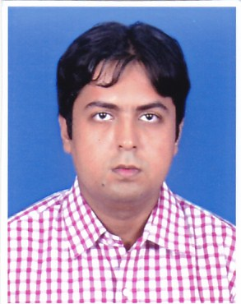

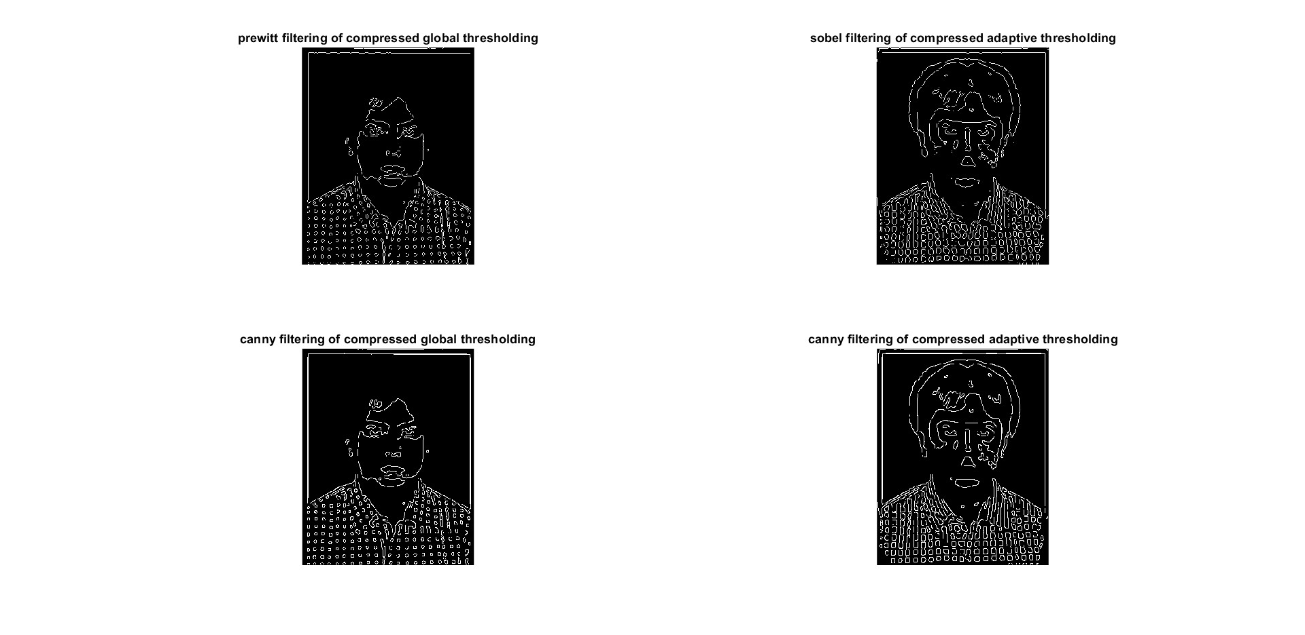

* 1. **ORIGINAL IMAGE 2**

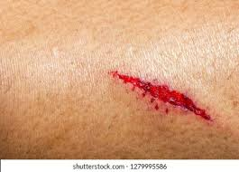

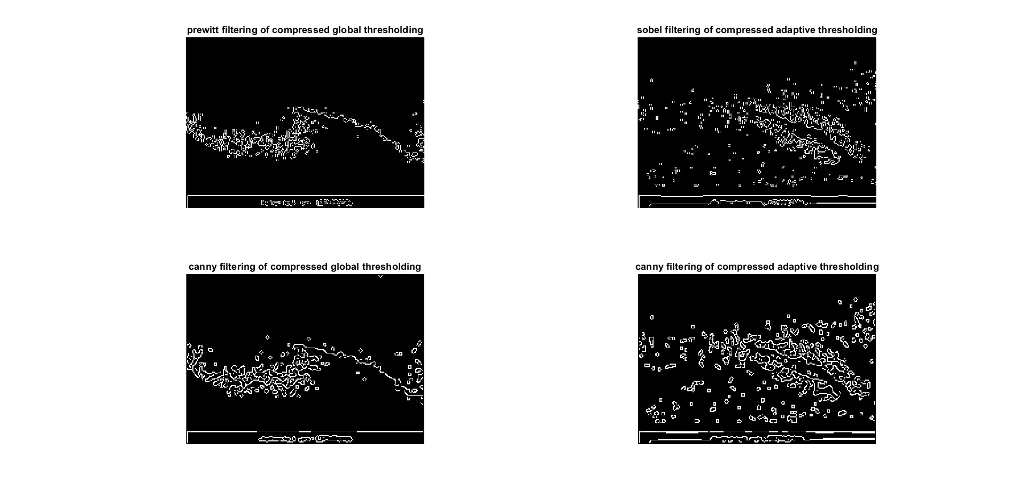

* 1. **ORIGINAL IMAGE 3**

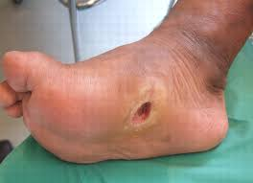

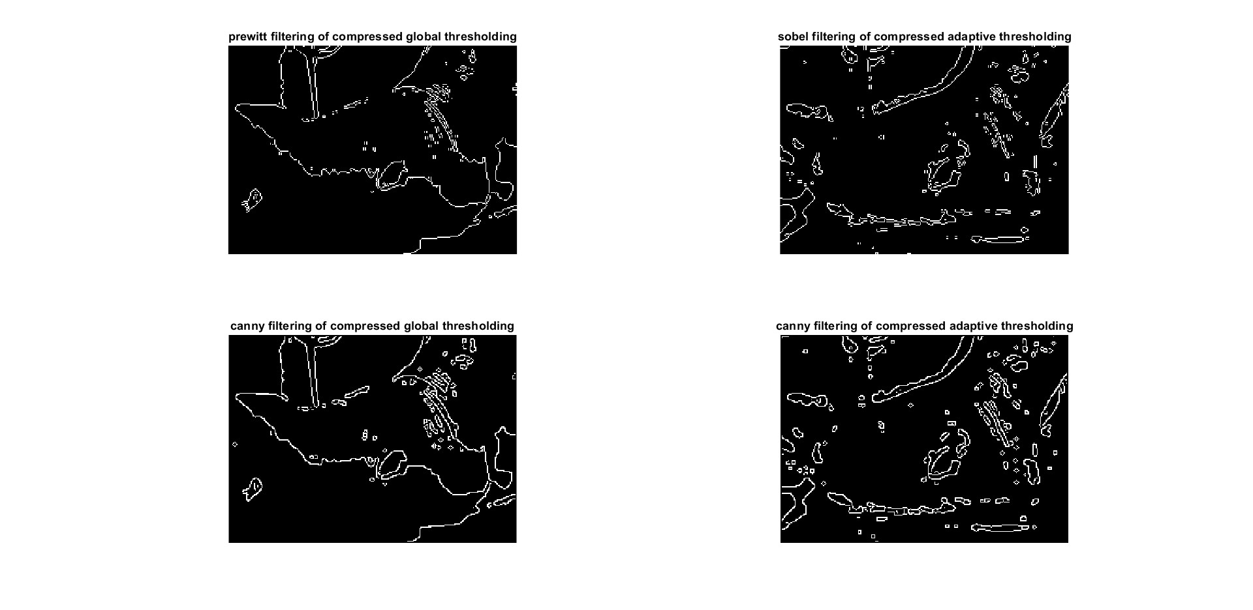

**5.TABLE OF CALCULATIONS:**

|  |  |  |  |
| --- | --- | --- | --- |
| **TYPES OF THRESHOLDING** | **SNR** | **PEAK SNR** | **MEAN SQUARE ERROR** |
| **PREWITT GLOBAL THRSHOLDING** | **17.3769** | **19.9457** | **645.6710** |
| **SOBEL ADAPTIVE THRESHOLDING** | **17.4950** | **19.9592** | **661.4120** |
| **CANNY GLOBAL THRESHOLDING** | **17.4660** | **19.9716** | **640.9656** |
| **SOBEL GLOBAL THRESHOLDING** | **17.5619** | **19.9556** | **650.3410** |

1. **DISCUSSIONS OF RESULTS:**

**As we have seen the in the table of data’s the values are deviating largely in case of mean square error and in case of adaptive thresholding based on sobel detection the deviation of mean square error is high. In the first and third case of global thresholding the edge detection gives sharp results compare to adaptive thrsholding but in second case adaptive thresholding has given better result in terms of edge detection.**

**7.FUTURE SCOPE OF WORK:**

**Here author has discussed only two types of thresholding along-with three edge detection methods for comparison purpose. But one can easily perform more such comparison with different other edge detection methods and different image thresholding techniques along-with other more parameters.**

**9. CONCLUSIONS:**

**Author has already mentioned that this paper is a continuation of his previous articles where has displayed applications of image segmentation and edge detection through image clustering for coloured , grey , and compressed images but here author has used edge detection techniques for compressed grey scale images with the help of image thresholding. So according to author people will get better idea if they study both the**

**REFERENCES:**

1. **“COMPARISON OF SIGNAL TO NOISE RATIO OF COLORED AND GRAY SCALE IMAGE IN CLUSTERED CONDITION FROM THE CONTOUR OF THE IMAGES WITH THE HELP OF DIFFERENT IMAGE FILTERING METHOD”- Abir Chakraborty, Volume 9, Issue 5 May 2024| ISSN: 2456-4184**
2. **Detection and Comparison of Signal To Noise Ratio’s and Other Dimensions Related Specifications From Contours of Several Images - A Matlab Syntax Based Applications of Biomedical and General Jpeg Images- Abir Chakraborty, Dr. Somshekhar Bhat, Dr. Kumar Shama [Volume 10, Issue 9, September-2022, Impact Factor: 7.429, ISSN: 2455-6211]**

**3.DETECTIONOFSIGNAL TONOISE RATIO FROM IMAGE CONTOUR -A MATLAB APPLICATION [Volume: 06 Issue: 09 | September – 2022, ISSN: 2582-3930]**

**4.APPLICATION OF IMAGE PROCESSING USING MATLAB- A PRACTICAL HANDBOOK FOR IMAGE PROCESSING LABORATORTY]-ABIR CHAKRABORTY**

**5.Detection and Comparison of Signal To Noise Ratio’s and Other Dimensions Related Specifications From Contours of Several Images - A Matlab Syntax Based Applications of Biomedical and General Jpeg Images-[ Abir Chakraborty1, Dr. Somshekhar Bhat2, Dr. Kumar Shama3, 1,2,3Manipal Institute of Technology, Mahe , Karanataka, India, Volume 10, Issue 9, September-2022, Impact Factor: 7.429, ISSN: 2455-6211]**

**6. Ahmed, S. & Alone, M. R. (2014). Image Compression using Neural Network. International Journal of Innovative Science and Modern Engineering, 2(5), 24-28.**

**7. Balasubramani, P., & Murugan, P. R. (2015). Efficient image compression techniques for compressing multimodal medical images using neural network radial basis function approach. International Journal of Imaging Systems and Technology, 25(2), 115-122. https://doi.org/10.1002/ima.22127**

**8. Fukushima, K. (1980). Neocognitron: A self-organizing neural network model for a mechanism of pattern recognition unaffected by shift in position. Biological Cybernetics, 36(4), 193-202. https://doi.org/10.1007/ Bf00344251**

**9.Grgic, S., Grgic, M., & Zovko-Cihlar, B. (2001). Performance analysis of image compression using wavelets. IEEE Transactions on Industrial Electronics, 48(3), 682-695. https://doi.org/10.1109/41.925596**

**10.Hussain, A. J., Al-Jumeily, D., Radi, N., & Lisboa, P. (2015). Hybrid neural network predictive-wavelet image compression system. Neurocomputing, 151, 975-984. https://doi.org/10.1016/j.neucom.2014.02.078.**

**11.Joe, A. R., & Rama, N. (2015). Neural network based image compression for memory consumption in cloud environment. Indian Journal of Science and Technology, 8(15), 1-6. https://doi.org/10.17485/i jst/2015/ v8i15/73855,**