 

**ADVANCEMENT IN ENERGY MANAGEMENT: A LoRa BASED REMOTE ENERGY MONITORING SYSTEM**

**A PROJECT REPORT**

***Submitted by***

**A.J.VISWANATH (913120105047)**

**M.S.KARPAGA VINAYAGAM (913120105013)**

***In partial fulfillment for the award of the degree***

***of***

**BACHELOR OF ENGINEERING**

***in***

**ELECTRICAL AND ELECTRONICS ENGINEERING**

**VELAMMAL COLLEGE OF ENGINEERING AND TECHNOLOGY,**

**MADURAI-625 009**

**ANNA UNIVERSITY::CHENNAI 600 025**

**MAY 2024**

## ANNA UNIVERSITY: CHENNAI 600 025

## BONAFIDE CERTIFICATE

Certified that is report **“ADVANCEMENT IN ENERGY MANAGEMENT: A LoRa BASED REMOTE ENERGY MONITORING SYSTEM”** is the Bonafide work of **A.J.VISWANATH (913120105047)** and **M.S.KARPAGA VINAYAGAM (913120105013)** who carried out the project under my supervision.

##### SIGNATURE SIGNATURE

**Dr.A.SHUNMUGALATHA, M.E., Ph.D., Mr. A. MADHAN, M.E., (Ph.D),.**

##### Dean (Academics) & Assistant Professor

##### Head of the Department

Electrical and Electronics Engineering, Electrical and Electronics Engineering, Velammal College of Engineering and Velammal College of Engineering and Technology, Technology,

Madurai–625009. Madurai –625009.

Certified that the candidate was examined on the Viva-Voce Examination held at Velammal College of Engineering and Technology, Madurai on .

**INTERNAL EXAMINER EXTERNAL EXAMINER**

**ACKNOWLEDGEMENT**

First of all we thank the Almighty for strengthening us throughout the project and helping us to complete it successfully.

We find immense pleasure to convey our sincere thanks to our honorable Principal **Dr.P.ALLI ,** for providing necessary facilities in carrying out our project work in our campus.

We would like to express our hearty thanks to our Head of the Department **Dr.A.SHUNMUGALATHA, M.E., Ph.D.,** for her constant encouragement.

We take this opportunity to express our sincere and heartfelt thanks to our guide, **Mr. A. MADHAN, M.E.,(Ph.D),.** for her patient guidance, timely suggestion technical and moral support and the immense part of her dedication in completing the project work successfully.

We express our special thanks to other staff members of our department, the non-teaching staff and our friends who assisted us, by their support and encouragement.

We also express our special thanks to our Parents who have sacrificed greatly in our education and welfare. We thank all those who have helped directly and indirectly in doing this project and bringing out this successful report.

**ABSTRACT**

This project introduces a pioneering approach to energy monitoring leveraging Long Range (LoRa) technology within the Internet of Things (IoT) framework. The integration of LoRa with IoT offers a robust, cost-effective solution for real-time energy data collection and analysis, addressing the pressing need for efficient resource management in diverse settings. Our proposed system harnesses LoRa's long-range, low-power capabilities to establish a wireless network of energy monitoring nodes distributed across a facility or infrastructure. These nodes, equipped with LoRa transceivers and sensors, collect data on energy consumption from various sources such as appliances, machinery, and lighting systems. By transmitting this data over long distances to a central gateway, the system provides comprehensive visibility into energy usage patterns with minimal infrastructure and operational costs. Key features of the LoRa based energy monitoring system include scalability, reliability, and adaptability to different environments. The LoRa protocol's robustness enables seamless communication even in challenging urban or industrial environments, ensuring uninterrupted data transmission for accurate monitoring and analysis. Additionally, the low-power consumption of LoRa devices extends battery life, reducing maintenance requirements and enhancing system longevity. Furthermore, the IoT interface enhances the functionality of the energy monitoring system by enabling remote access, data visualization, and analytics. Through cloud-based platforms and web interfaces, users can monitor real-time energy consumption, track historical trends, and receive alerts for abnormal usage patterns. This actionable intelligence empowers stakeholders to identify energy-saving opportunities, optimize operational efficiency, and reduce costs. The application of LoRa based IoT energy monitoring extends beyond traditional settings to encompass smart cities, industrial complexes, agricultural operations, and beyond. By providing a scalable, cost-effective solution for energy management, our proposed system contributes to sustainability goals, environmental stewardship, and economic competitiveness.

**LIST OF CONTENTS**

|  |  |  |
| --- | --- | --- |
| **CHAPTER NO.** | **TITLE** | **PAGE NO.** |
|  | **ACKNOWLEDGEMENT** | **iii** |
|  | **ABSTRACT** | **iv** |
|  | **LIST OF CONTENTS** | **v** |
|  | **LIST OF FIGURES** | **vii** |
|  | **LIST OF ABBREVATION** | **viii** |
| **1** | **INTRODUCTION** | **1** |
|  | 1.1 GENERAL | 1 |
|  | 1.2 OBJECTIVE | 6 |
|  | 1.3 EXISTING METHOD | 7 |
|  | 1.3.1 DRAWBACK | 7 |
| **2** | **LITERATURE SURVEY** | **8** |
|  | 2.1 IoT BASED SMART ENERGY METER FOR  EFFICIENT ENERGY UTILIZATION  IN SMART GRID | 8 |
|  | 2.2 IoT BASED ENERGY METER USING GSM | 9 |
|  | 2.3 ENHANCEMENT OF AUTOMATIC  READING SYSTEM FOR THE  ELECTRICAL | 10 |
|  | 2.4 ARDUINO BASED SMART ENERGY  METER USING GSM | 11 |
|  | 2.5 A UNIFIED METERING SYSTEM DEPLOYED FOR WATER AND ENERGY MONITORING IN SMART CITY | 12 |
| **3** | **PROPOSED SYSTEM** | **13** |
|  | 3.1 DESCRIPTION | 13 |
|  | 3.2 BLOCK DIAGRAM DESCRIPTION | 14 |
| **4** | **MODULE DESCRIPTION** | **17** |
|  | 4.1 ESP32 | 17 |
|  | 4.2 LoRa MODULE | 20 |
|  | 4.3 ENERGY METER | 21 |
|  | 4.4 CURRENT SENSOR MODULE | 22 |
|  | 4.5 LDR SENSOR | 24 |
|  | 4.6 LCD DISPLAY | 26 |
| **5** | **RESULTS AND DISCUSSION** | **28** |
|  | 5.1 RESULTS | 28 |
|  | 5.2 COST ESTIMATION | 33 |
| **6** | **CONCLUSION** | **34** |

**LIST OF FIGURES**

|  |  |  |
| --- | --- | --- |
| **FIGURE**  **NO.** | **DESCRIPTION** | **PAGE**  **NO.** |
| 3.1.1 | Block diagram of the proposed system | 13 |
| 4.1.1 | ESP32 function block diagram | 17 |
| 4.1.2 | ESP pin diagram | 19 |
| 4.2.1 | LoRa module | 20 |
| 4.3.1 | Energy Meter | 22 |
| 4.4.1 | ZMCT103C Precision current sensor | 22 |
| 4.4.2 | ZMCT103C current sensor pinout | 23 |
| 4.5.1 | Current Transformer | 24 |
| 4.5.2 | Current Transformer connection | 25 |
| 4.5.3 | ZMCT103C MODULE CONNECTION | 26 |
| 4.6.1 | LDR MODULE | 27 |
| 4.7.1 | LCD DISPLAY | 27 |
| 5.1.1 | Transmitting side/User prototype | 28 |
| 5.1.2 | Receiving side/ Provider’s prototype | 29 |
| 5.1.3 | Output on the receiver side LED display | 29 |
| 5.1.4 | Projected current and energy values from energy meter | 30 |
| 5.1.5 | Real time current data from energy meter | 31 |
| 5.1.6 | Projected values of voltage and current from energy meter | 31 |
| 5.1.7 | Real time voltage data from energy meter | 32 |

**LIST OF ABBREVATION**

* **IoT -** Internet of Things
* **LoRa -** Long Range
* **LDR -** Light Dependent Resistor
* **LCD -** Light Crystal Display
* **Wi-SUN -** Wireless Smart Utility Network
* **AMI -** Advanced Metering Infrastructure
* **AMR -** Advanced Meter Reading
* **PLC -** Programmable Logic Controller
* **PIR -** Passive Infrared Sensor
* **GSM -** Global System for Mobile Communications
* **SMS** - Short Message Service
* **RTC -** Real Time Clock
* **USB -** Universal Serial Bus
* **WAN -** Wide Area Network
* **PWM -** Pulse Width Modulation
* **LED -** Light Emitting Diode

**CHAPTER 1**

**INTRODUCTION**

**1.1 GENERAL**

**Smart meter**

A smart meter is an [electronic](https://en.wikipedia.org/wiki/Electronics" \o "Electronics) device that records information such as consumption of [electric energy](https://en.wikipedia.org/wiki/Electric_energy" \o "Electric energy), voltage levels, current, and power factor and [communicates the information](https://en.wikipedia.org/wiki/Telemetering" \o "Telemetering) to the consumer and [electricity suppliers](https://en.wikipedia.org/wiki/Public_utility" \o "Public utility). Such an Advanced Metering Infrastructure (AMI) differs from [automatic meter reading](https://en.wikipedia.org/wiki/Automatic_meter_reading" \o "Automatic meter reading) (AMR) in that it enables two-way communication between the meter and the supplier.

**Description**

The term smart meter often refers to an [electricity meter](https://en.wikipedia.org/wiki/Electricity_meter" \o "Electricity meter), but it also may mean a device measuring [natural gas](https://en.wikipedia.org/wiki/Natural_gas" \o "Natural gas), [water](https://en.wikipedia.org/wiki/Water" \o "Water) or [district heating](https://en.wikipedia.org/wiki/District_heating" \o "District heating) consumption. More generally, a smart meter is an [electronic](https://en.wikipedia.org/wiki/Electronics" \o "Electronics) device that records information such as consumption of [electric energy](https://en.wikipedia.org/wiki/Electric_energy" \o "Electric energy), voltage levels, current, and power factor. Smart meters [communicate the information](https://en.wikipedia.org/wiki/Telemetering" \o "Telemetering) to the consumer for greater clarity of consumption behavior, and [electricity suppliers](https://en.wikipedia.org/wiki/Public_utility" \o "Public utility) for system monitoring and customer billing. Smart meters typically record energy near real-time, and report regularly, short intervals throughout the day.[[1]](https://en.wikipedia.org/wiki/Smart_meter" \l "cite_note-1) Smart meters enable two-way communication between the meter and the central system. Smart meters may be part of a [smart grid](https://en.wikipedia.org/wiki/Smart_grid" \o "Smart grid), but do not themselves constitute a smart grid.

Such an Advanced Metering Infrastructure differs from [automatic meter reading](https://en.wikipedia.org/wiki/Automatic_meter_reading)  in that it enables two-way communication between the meter and the supplier. Communications from the meter to the network may be wireless, or via fixed wired connections such as power line carrier . Wireless communication options in common use include cellular communications, Wi-Fi (readily available), [wireless ad hoc networks](https://en.wikipedia.org/wiki/Wireless_ad_hoc_network" \o "Wireless ad hoc network) over Wi-Fi, [wireless mesh networks](https://en.wikipedia.org/wiki/Wireless_mesh_network" \o "Wireless mesh network), low power long-range wireless (LoRa), [Wize](https://en.wikipedia.org/wiki/Wize_technology" \o "Wize technology) (high radio penetration rate, open, using the frequency 169 MHz) [Zigbee](https://en.wikipedia.org/wiki/Zigbee" \o "Zigbee) (low power, low data rate wireless), and Wi-SUN (Smart Utility Networks).

As of January 2018, over 99 million electricity meters were deployed across the European Union, with an estimated 24 million more to be installed by the end of 2020. The European Commission [DG Energy](https://en.wikipedia.org/wiki/Directorate-General_for_Energy" \o "Directorate-General for Energy) estimates the 2020 installed base to have required €18.8 billion in investment, growing to €40.7 billion by 2030, with a total deployment of 266 million smart meters.

By the end of 2018, the U.S. had over 86 million smart meters installed. In 2017, there were 665 million smart meters installed globally Revenue generation is expected to grow from $12.8 billion in 2017 to $20 billion by 2022.

**Purpose**

Since the inception of electricity [deregulation](https://en.wikipedia.org/wiki/Deregulation" \o "Deregulation) and market-driven pricing throughout the world, utilities have been looking for a means to match consumption with generation. Non-smart electrical and gas meters only measure total consumption, providing no information of when the energy was consumed. Smart meters provide a way of measuring electricity consumption in near real-time. This allows utility companies to charge different prices for consumption according to the time of day and the season. It also facilitates more accurate cash-flow models for utilities. Since smart meters can be read remotely, labor costs are reduced for utilities.

Smart metering offers potential benefits to customers. These include, a) an end to estimated bills, which are a major source of complaints for many customers b) a tool to help consumers better manage their energy purchases smart meters with a display outside their homes could provide up-to-date information on gas and electricity consumption and in doing so help people to manage their energy use and reduce their energy bills. With regards to consumption reduction, this is critical for understanding the benefits of smart meters because the relatively small percentage benefits in terms of savings are multiplied by millions of users. Smart meters for water consumption can also provide detailed and timely information about customer water use and early notification of possible water leaks in their premises. Electricity pricing usually peaks at certain predictable times of the day and the season. In particular, if generation is constrained, prices can rise if power from other jurisdictions or more costly generation is brought online. Proponents assert that billing customers at a higher rate for peak times encourages consumers to adjust their consumption habits to be more responsive to market prices and assert further, that regulatory and market design agencies hope these "[price signals](https://en.wikipedia.org/wiki/Price_signal" \o "Price signal)" could delay the construction of additional generation or at least the purchase of energy from higher-priced sources, thereby controlling the steady and rapid increase of electricity prices.

**Connectivity**

Communication is a critical technological requirement for smart meters. Each meter must be able to reliably and securely communicate the information collected to a central location. Considering the varying environments and places where meters are found, that problem can be daunting. Among the solutions proposed are: the use of [cell](https://en.wikipedia.org/wiki/Mobile_phone" \o "Mobile phone) and [pager](https://en.wikipedia.org/wiki/Pager" \o "Pager) networks, [satellite](https://en.wikipedia.org/wiki/Satellite" \o "Satellite), licensed [radio](https://en.wikipedia.org/wiki/Radio" \o "Radio), combination licensed and unlicensed radio, and [power line communication](https://en.wikipedia.org/wiki/Power-line_communication" \o "Power-line communication). Not only the medium used for communication purposes, but also the type of network used, is critical. As such, one would find: fixed wireless, [wireless mesh network](https://en.wikipedia.org/wiki/Wireless_mesh_network" \o "Wireless mesh network) and [wireless ad hoc networks](https://en.wikipedia.org/wiki/Wireless_ad_hoc_network" \o "Wireless ad hoc network), or a combination of the two. There are several other potential network configurations possible, including the use of [Wi-Fi](https://en.wikipedia.org/wiki/Wi-Fi" \o "Wi-Fi) and other [internet](https://en.wikipedia.org/wiki/Internet" \o "Internet) related networks. To date no one solution seems to be optimal for all applications. [Rural utilities](https://en.wikipedia.org/wiki/Rural_electrification" \o "Rural electrification) have very different communication problems from urban utilities or utilities located in difficult locations such as mountainous regions or areas ill-served by wireless and internet companies.

In addition to communication with the head-end network, smart meters may need to be part of a [home area network](https://en.wikipedia.org/wiki/Home_network" \o "Home network), which can include an in-premises display and a hub to interface one or more meters with the head end. Technologies for this network vary from country to country, but include [power line communication](https://en.wikipedia.org/wiki/Power_line_communication" \o "Power line communication), [wireless ad hoc network](https://en.wikipedia.org/wiki/Wireless_ad_hoc_network" \o "Wireless ad hoc network), and [Zigbee](https://en.wikipedia.org/wiki/Zigbee" \o "Zigbee).

**Protocols**

ANSI C12.18 is an [ANSI](https://en.wikipedia.org/wiki/ANSI" \o "ANSI) Standard that describes a [protocol](https://en.wikipedia.org/wiki/Communications_protocol" \o "Communications protocol) used for two-way communications with a meter, mostly used in North American markets. The C12.18 Standard is written specifically for meter communications via an ANSI Type 2 Optical Port, and specifies lower-level protocol details. [ANSI C12.19](https://en.wikipedia.org/wiki/ANSI_C12.19" \o "ANSI C12.19) specifies the data tables that are used. [ANSI C12.21](https://en.wikipedia.org/wiki/ANSI_C12.21" \o "ANSI C12.21) is an extension of C12.18 written for modem instead of optical communications, so it is better suited to [automatic meter reading](https://en.wikipedia.org/wiki/Automatic_meter_reading" \o "Automatic meter reading). ANSI C12.22 is the communication protocol for remote communications.

IEC 61107 is a communication protocol for smart meters published by the [IEC](https://en.wikipedia.org/wiki/International_Electrotechnical_Commission" \o "International Electrotechnical Commission) that is widely used for utility meters in the European Union. It is superseded by [IEC 62056](https://en.wikipedia.org/wiki/IEC_62056" \o "IEC 62056), but remains in wide use because it is simple and well-accepted. It sends [ASCII](https://en.wikipedia.org/wiki/ASCII" \o "ASCII) data using a [serial port](https://en.wikipedia.org/wiki/Serial_port" \o "Serial port). The physical media are either modulated light, sent with an [LED](https://en.wikipedia.org/wiki/LED" \o "LED) and received with a [photodiode](https://en.wikipedia.org/wiki/Photodiode" \o "Photodiode), or a pair of wires, usually modulated by [EIA-485](https://en.wikipedia.org/wiki/EIA-485" \o "EIA-485). The protocol is [half-duplex](https://en.wikipedia.org/wiki/Duplex_(telecommunications)" \o "Duplex (telecommunications)). IEC 61107 is related to, and sometimes wrongly confused with, the FLAG protocol. [Ferranti](https://en.wikipedia.org/wiki/Ferranti" \o "Ferranti) and [Landis+Gyr](https://en.wikipedia.org/wiki/Landis%2BGyr" \o "Landis+Gyr) were early proponents of an interface standard that eventually became a sub-set of IEC1107.

**Safety**

Issues surrounding smart meters causing fires have been reported, particularly involving the manufacturer Sensus. In 2012. [PECO Energy Company](https://en.wikipedia.org/wiki/PECO_Energy_Company" \o "PECO Energy Company) replaced the Sensus meters it had deployed in the [Philadelphia](https://en.wikipedia.org/wiki/Philadelphia" \o "Philadelphia), US region after reports that a number of the units had overheated and caused fires. In July 2014, [SaskPower](https://en.wikipedia.org/wiki/SaskPower" \o "SaskPower), the province-run utility company of the Canadian province of [Saskatchewan](https://en.wikipedia.org/wiki/Saskatchewan" \o "Saskatchewan), halted its roll-out of Sensus meters after similar, isolated incidents were discovered. Shortly afterward, [Portland General Electric](https://en.wikipedia.org/wiki/Portland_General_Electric" \o "Portland General Electric) announced that it would replace 70,000 smart meters that had been deployed in the state of [Oregon](https://en.wikipedia.org/wiki/Oregon" \o "Oregon) after similar reports. The company noted that it had been aware of the issues since at least 2013, and they were limited to specific models it had installed between 2010 and 2012. On July 30, 2014, after a total of eight recent fire incidents involving the meters, SaskPower was ordered by the [Government of Saskatchewan](https://en.wikipedia.org/wiki/Government_of_Saskatchewan" \o "Government of Saskatchewan) to immediately end its smart meter program, and remove the 105,000 smart meters it had installed

**Privacy concern**

One technical reason for privacy concerns is that these meters send detailed information about how much electricity is being used each time. More frequent reports provide more detailed information. Infrequent reports may be of little benefit for the provider, as it doesn't allow as good demand management in the response of changing needs for electricity. On the other hand, widespread reports would allow the utility company to infer [behavioral patterns](https://en.wikipedia.org/wiki/Behavioral_pattern" \o "Behavioral pattern) for the occupants of a house, such as when the members of the household are probably asleep or absent. Furthermore, the fine-grained information collected by smart meters raises growing concerns of privacy invasion due to personal behavior exposure (private activity, daily routine, etc.) Current trends are to increase the frequency of reports. A solution that benefits both provider and user privacy would be to adapt the interval dynamically. Another solution involves energy storage installed at the household used to reshape the energy consumption profile In British Columbia the electric utility is government-owned and as such must comply with privacy laws that prevent the sale of data collected by smart meters; many parts of the world are serviced by private companies that are able to sell their data In Australia debt collectors can make use of the data to know when people are at home. Used as evidence in a court case in [Austin](https://en.wikipedia.org/wiki/Austin,_Texas" \o "Austin, Texas), [Texas](https://en.wikipedia.org/wiki/Texas" \o "Texas), police agencies secretly collected smart meter power usage data from thousands of residences to determine which used more power than "typical" to identify marijuana growing operations

**1.2 OBJECTIVE**

To integrate a LoRa module with a energy meter to facilitate wireless transmission of energy usage data from an energy meter to the provider and designing an online interactive interface to monitor view the energy meter data.

A transmitting side kit for the consumer which transmits energy meter data wireless to the electricity provider.

A receiving side kit receives the data from the sender and stores it in the cloud for user to access the data.

A thingspeak website which provides instant visualization of data received from the receiver kit which can be used to view, monitor, interact and analyze the energy use.

**1.3 EXISTING METHOD**

Many households in India have an electromechanic energy meter to measure the energy usage. The present electromechanical energy meter setup only provide cumulative energy usage data, which means they cannot provide real-time or detailed consumption information. This lack of real-time data makes it difficult for consumers to monitor their energy usage patterns and make adjustments to save energy. It also limits the ability of utility companies to implement dynamic pricing models based on real-time demand. Further electromechanical meters are more susceptible to tampering compared to their digital counterparts. individuals can manipulate the mechanical components or slow down the disc rotation, leading to lower readings. This not only results in revenue loss for utility companies, but also undermines the fairness and integrity of the energy distribution system

**DRAWBACKS**

* Lack of real- time data.
* Susceptibility to tampering.
* Limited functionality
* Less security

**CHAPTER 2**

**LITERATURE SURVEY**

**Title: IOT Based Smart Energy Meter for Efficient Energy Utilization in Smart Grid**

**Year: 2018**

**Author: Bibek Kanti Barman, Shiv Nath Yadav, Shivam Kumar, Sadhari Gope**

The proposed smart energy meter controls and calculates the energy consumption using ESP 8266 12E, a Wi-Fi module and uploads it to the cloud from where the consumer or producer can view the reading. Therefore, energy analyzation by the consumer becomes much easier and controllable. This system also helps in detecting power theft. Thus, this smart meter helps in home automation using IoT and enabling wireless communication which is a great step towards Digital India. The internet of things (IoT) is a network of connected smart devices enabling to transfer data. The ‘thing’ in IoT could be a person with a heart monitor or an automobile with built-in sensors, i.e. objects that have been assigned an IP address and have the ability to collect and transfer data over a network without manual assistance or intervention. The embedded technology in the objects helps them to interact with internal states or the external environment, which in turn affects the decisions taken.

**Title: IoT based smart energy meter using GSM**

**Year: 2021**

**Author: Chella Santosh, S.V.Aswin kumer, J. Gopi Krishna, M. Vashnavi**

S. V. Sreedevi, et al proposed a Smart meter (SMs) have taken advantage of technology advancements to become more than just instruments for monitoring energy use; they are now essential parts of energy management systems. The SEMS that is being shown integrates with any software-based smart solution with ease by using a variety of communication interfaces and protocols. En track software is used in this research to collect and analyze data. The examination of the case study shows how effective the loT based SEMS that is being presented is at improving energy management. It has become a pattern to coordinate programmed frameworks by means of wireless applications over organization. Energy is the most well-known and most significant asset furthermore; the requirement for it uses it in a controlled way is vital where the assets for it are scant

**Title: Enhancement of Automatic Reading system for the electrical**

**energy meter**

**Year: 2020**

**Author: Mohammed S .Alsoufi, Helena and Cruz Machado**

1. Alsoufi et al., proposed design converts the conventional digital electronic energy meters into AMRs, capable of communicating with the utility and the consumers. A Long Range (LoRa) WiFi-based wireless communication module is integrated with an electronic energy meter through a gateway and Raspberry pi module. An optocoupler is used to fetch the meter readings from the pulses of LEDs of the energy meter. A LoRa receiver at the other end, with a cloud database, acts as the billing point. The cloud storage used is Firebase. A responsive, user-friendly graphical user interface has developed for monitoring the consumption. With proper authentication, users can access the developed web page from anywhere in the world. The total energy consumption and the due bill of the customers can be obtained from this webpage. The consumers can also set their consumption limits and thereby reduce their overall energy consumption for energy management. The proposed system neglects the regular digital metering system and allows remote access to the electronic meter.

**Title: Arduino Based Smart Energy Meter using GSM**

**Year: 2019**

**Author: Himanshu K.Patel, Tanish Mody, Anshul Goyal**

H. K. Patel et. al.  proposed system is implemented using a GSM shield module on microcontroller (Arduino®) together with LDR sensor and relay. Existing metering system can be minutely modified to implement the proposed meter. The proposed scheme is to connect an LDR sensor with the blinking LED and send the data to micro controller via GSM shield. RTC provides delay and acts an interrupt. The system includes a provision of sending an SMS to user for update on energy consumption along with final bill generation along with the freedom of load re-configuration via SMS. The disconnection of power supply on demand or due to pending dues was implemented using a relay. Hardware implementation results suggest that the accuracy of the proposed system is slightly greater than that of existing smart meters. The cost of system has been estimated to be less than the available smart meters, offering the same functionality. Bilateral communication between user and system sets it apart from the commonly available smart meters.

**Title: A Unified Metering System Deployed For Water and Energy**

**Monitoring in Smart City.**

**Year: 2023**

**Author : N.Sushma, Suresh H N, Mohana Lakshmi Jayaramu**

N. Sushma, et al  proposes a smart, integrated wireless metering system to revolutionize customer engagement and energy and water utility management. This technology enables the transmission of precise and secure data on water and energy consumption in real-time by employing Low Power Wide Area Networks (LPWAN) technology, known for its low power consumption, cost-effectiveness, long-range coverage, and efficient penetration. The system has a water flow sensor and PZEM-004T for real-time water and energy consumption readings. The interoperable features in the integrated water flow and energy meter are achieved through trial-and-error methods. The trials led to experimental findings that enabled successful communication between the energy and water flow meters and recorded accurate readings. The device provides the utility provider with real-time consumption statistics and the flexibility to turn on and off the system remotely. The system also helps the users by giving them real-time consumption data and preventing overloading situations.

**CHAPTER 3**

**PROPOSED SYSTEM**

**3.1 DESCRIPTION**

The proposed system represents a groundbreaking approach to energy monitoring and management, utilizing Long Range (LoRa) technology within the Internet of Things (IoT) framework. At its core, this innovative system aims to revolutionize the way energy resources are monitored, analyzed, and optimized in diverse settings, ranging from residential buildings to industrial complexes and smart cities.

**Receiver side**

**Transmitter side**

**Fig. 3.1.1 Block Diagram of the proposed system**

**3.2 BLOCK DIAGRAM DESCRIPTION**

Central to the system's functionality is the deployment of LoRa enabled energy monitoring nodes strategically positioned throughout the infrastructure under observation. These nodes, equipped with LoRa transceivers and specialized sensors, serve as the frontline data collectors, capturing real-time information on energy consumption from various sources, including appliances, machinery, lighting systems, and HVAC (Heating, Ventilation, and Air Conditioning) units. The LoRa technology's exceptional range and low-power capabilities allow these nodes to communicate seamlessly over long distances, transmitting energy data to a central gateway or hub.

The central gateway acts as the nerve center of the system, aggregating and processing the incoming data from the distributed nodes. Through sophisticated algorithms and analytics engines, the gateway converts raw energy consumption data into actionable insights and performance metrics. These insights are then made accessible to end-users through intuitive web interfaces, mobile applications, or dashboard displays, providing stakeholders with real-time visibility into energy usage patterns, trends, and anomalies.

Key features of the proposed system include scalability, reliability, and adaptability to various environments and infrastructures. The LoRa technology's robustness ensures reliable communication even in challenging environments, such as dense urban areas or industrial facilities characterized by electromagnetic interference and physical obstacles. Moreover, the system's low-power consumption extends battery life, minimizing maintenance requirements and operational disruptions.

The integration of IoT capabilities enhances the system's functionality by enabling remote monitoring, control, and optimization of energy resources. Users can remotely access the system via web portals or mobile apps, allowing them to monitor energy consumption in real-time, set usage thresholds, and receive alerts for abnormal or inefficient energy usage patterns. This level of actionable intelligence empowers stakeholders to make informed decisions, implement energy-saving measures, and optimize operational efficiency.

In conclusion, the proposed LoRa based IoT energy monitoring interface represents a paradigm shift in energy management practices, offering a scalable, cost-effective solution for efficient resource utilization and sustainability. By harnessing the power of LoRa technology and IoT connectivity, this system lays the foundation for smarter, more resilient energy infrastructures capable of meeting the evolving needs of modern society.

**Working**

The proposed LoRa based IoT energy monitoring interface functions as a comprehensive system designed to revolutionize energy management across various sectors. At its core are strategically positioned energy monitoring nodes, equipped with LoRa transceivers and specialized sensors, tasked with capturing real-time data on energy consumption from diverse sources within the infrastructure. These nodes leverage LoRa's exceptional range and low-power capabilities to transmit this data over long distances to a central gateway or hub.

This central hub serves as the nerve center of the system, where incoming data from distributed nodes is aggregated, processed, and transformed into actionable insights through advanced algorithms and analytics engines. These insights are then disseminated to end-users via intuitive interfaces, accessible through web portals, mobile applications, or dashboard displays. This provides stakeholders with immediate visibility into energy usage patterns, enabling them to identify trends, anomalies, and opportunities for optimization.

The system boasts scalability, reliability, and adaptability, making it suitable for deployment in a wide range of environments, from residential buildings to industrial complexes and smart cities. Its robust LoRa technology ensures seamless communication even in challenging conditions, while its low-power consumption minimizes maintenance requirements, ensuring uninterrupted operation.

Integration with IoT capabilities further enhances the system's functionality, empowering users to remotely monitor, control, and optimize energy resources. Through web portals or mobile apps, stakeholders can access real-time energy consumption data, set usage thresholds, and receive alerts for abnormal or inefficient usage patterns. This level of actionable intelligence enables informed decision-making, facilitating the implementation of energy-saving measures and the optimization of operational efficiency.

In summary, the proposed LoRa based IoT energy monitoring interface represents a significant advancement in energy management practices, offering a scalable, cost-effective solution for efficient resource utilization and sustainability. By leveraging LoRa technology and IoT connectivity, this system lays the groundwork for smarter, more resilient energy infrastructures capable of meeting the evolving needs of modern society.

**CHAPTER 4**

**MODULE DESCRIPTION**

**HARDWARE DETAILS HARDWARE DESCRIPTION**

**4.1 ESP32**

ESP32 is a series of low-cost, low-power [system on a chip](https://en.wikipedia.org/wiki/System_on_a_chip" \o "System on a chip) [microcontrollers](https://en.wikipedia.org/wiki/Microcontroller" \o "Microcontroller) with integrated [Wi-Fi](https://en.wikipedia.org/wiki/Wi-Fi" \o "Wi-Fi) and dual-mode [Bluetooth](https://en.wikipedia.org/wiki/Bluetooth" \o "Bluetooth). The ESP32 series employs either a [Tensilica](https://en.wikipedia.org/wiki/Tensilica" \o "Tensilica) Xtensa LX6 microprocessor in both dual-core and [single-core](https://en.wikipedia.org/wiki/Single-core" \o "Single-core) variations, Xtensa LX7 dual-core microprocessor or a [single-core](https://en.wikipedia.org/wiki/Single-core" \o "Single-core) [RISC-V](https://en.wikipedia.org/wiki/RISC-V" \o "RISC-V) microprocessor and includes built-in antenna switches, [RF](https://en.wikipedia.org/wiki/Radio_frequency" \o "Radio frequency) [balun](https://en.wikipedia.org/wiki/Balun" \o "Balun), power amplifier, low-noise receive amplifier, filters, and power-management modules. ESP32 is created and developed by [Espressif Systems](https://en.wikipedia.org/wiki/Espressif_Systems" \o "Espressif Systems), a Chinese company based in Shanghai, and is manufactured by [TSMC](https://en.wikipedia.org/wiki/TSMC" \o "TSMC) using their 40 nm process. It is a successor to the [ESP8266](https://en.wikipedia.org/wiki/ESP8266" \o "ESP8266) microcontroller.

Features

**Figure 4.1.1 : ESP32 function block diagram.ESP32 Die shot**

Features of the ESP32 include the following:

Processors:

CPU: Xtensa dual-core (or single-core) 32-bit LX6 microprocessor, operating at 160 or 240 MHz and performing at up to 600 [DMIPS](https://en.wikipedia.org/wiki/Dhrystone" \o "Dhrystone)

Ultra low power (ULP) co-processor

Memory: 520 KiB RAM, 448 KiB ROM

Wireless connectivity:

Wi-Fi: [802.11](https://en.wikipedia.org/wiki/IEEE_802.11" \o "IEEE 802.11) b/g/n

Bluetooth: v4.2 BR/EDR and BLE (shares the radio with Wi-Fi)

Peripheral interfaces:

34 × programmable [GPIOs](https://en.wikipedia.org/wiki/GPIO" \o "GPIO)

12-bit [SAR ADC](https://en.wikipedia.org/wiki/Successive_approximation_ADC" \o "Successive approximation ADC) up to 18 channels

2 × 8-bit [DACs](https://en.wikipedia.org/wiki/Digital-to-analog_converter" \o "Digital-to-analog converter)

10 × touch sensors ([capacitive sensing](https://en.wikipedia.org/wiki/Capacitive_sensing" \o "Capacitive sensing) GPIOs)

4 × [SPI](https://en.wikipedia.org/wiki/Serial_Peripheral_Interface_Bus" \o "Serial Peripheral Interface Bus)

2 × [I²S](https://en.wikipedia.org/wiki/I%C2%B2S" \o "I²S) interfaces

2 × [I²C](https://en.wikipedia.org/wiki/I%C2%B2C" \o "I²C) interfaces

3 × [UART](https://en.wikipedia.org/wiki/Universal_asynchronous_receiver-transmitter" \o "Universal asynchronous receiver-transmitter)

[SD](https://en.wikipedia.org/wiki/Secure_Digital" \o "Secure Digital)/[SDIO](https://en.wikipedia.org/wiki/Secure_Digital" \l "SDIO_cards" \o "Secure Digital)/[CE-ATA](https://en.wikipedia.org/wiki/CE-ATA" \o "CE-ATA)/[MMC](https://en.wikipedia.org/wiki/MultiMediaCard" \o "MultiMediaCard)/[eMMC](https://en.wikipedia.org/wiki/MultiMediaCard" \l "eMMC" \o "MultiMediaCard) host controller

SDIO/SPI slave controller

[Ethernet](https://en.wikipedia.org/wiki/Ethernet" \o "Ethernet) MAC interface with dedicated DMA and planned [IEEE 1588 Precision Time Protocol](https://en.wikipedia.org/wiki/Precision_Time_Protocol" \o "Precision Time Protocol) support[[4]](https://en.wikipedia.org/wiki/ESP32" \l "cite_note-4)

[CAN bus](https://en.wikipedia.org/wiki/CAN_bus" \o "CAN bus) 2.0

Infrared remote controller (TX/RX, up to 8 channels)

Pulse counter (capable of full [quadrature](https://en.wikipedia.org/wiki/Incremental_encoder" \o "Incremental encoder) decoding)

Motor [PWM](https://en.wikipedia.org/wiki/Pulse-width_modulation" \o "Pulse-width modulation)

LED PWM (up to 16 channels)

Ultra low power analog pre amplifier

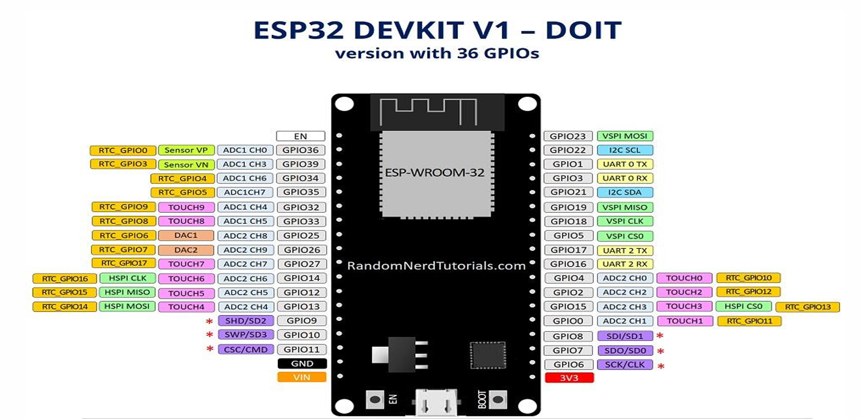

**Figure 4.1.2 : ESP pin diagram**

**4.2 LoRa module**

Since LoRa characterizes the lower actual layer, the upper systems administration layers were deficient. LoRaWAN is one of a few conventions that were created to characterize the upper layers of the organization. LoRaWAN is a cloudbased medium access control (MAC) layer convention yet acts principally as an organization layer convention for overseeing correspondence between LPWAN entryways and end-hub gadgets as a directing convention, kept up by the LoRa Alliance. LoRa WAN characterizes the correspondence convention and framework engineering for the organization, while the LoRa actual layer empowers the longrange correspondence connect. LoRa WAN is additionally answerable for dealing with the correspondence frequencies, information rate, and force for all devices. Devices in the organization are non concurrent and communicate when they have information accessible to send. Information sent by an end-hub gadget is gotten by various entryways, which forward the information parcels to an incorporated organization worker. Information is then sent to application workers. The innovation shows high dependability for the moderate burden, not with standing, it has some exhibition issues identified with sending affirmations.

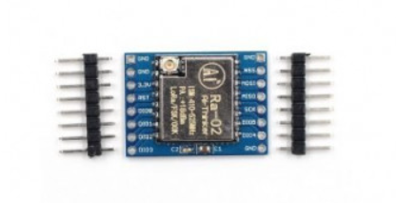

**Fig:4.2.1 : Lora Module**

#### 

#### ****Specification:****

1. Communication distance: 15KM
2. Sensitivity: down to -148dBm
3. Programmable bit rates: up to 300kbps
4. RSSI dynamic range: 127dB
5. Wireless frequency: 433MHz
6. Working voltage: 1.8-3.7v
7. Working temperature: -40-+80

**4.3 Energy meter:**

Energy meter are used for the measurement of energy and the energy is measured by measuring the power over a period of time.  Energy meters are also known as watt hour meter.

E=∫Pdt

The unit of power is watt and for time we used hour. So the unit for energy is watt hour. The energy meter measures the amount of power consumed by the electrical product.

The single-phase energy meter is directly connected between the line and load. It consists of two electromagnets one is the shunt magnet and other is the series magnet and in between these two magnets we are having the aluminium disk. So this aluminium disk is rotating in the magnetic field. The speed of this disk is proportional to the part which is consumed by the appliance.

[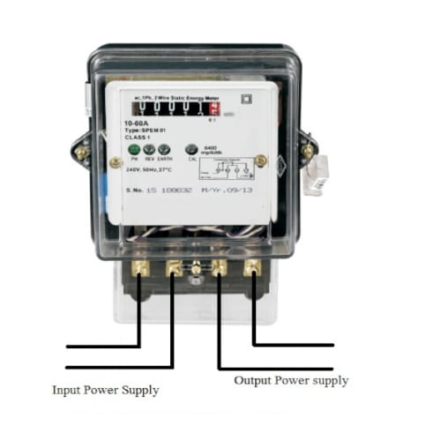](https://www.electroniclinic.com/wp-content/uploads/2020/12/single-phase-energy-meter.jpeg)

**Fig 4.3.1 : Energy meter**

**4.4 ZMCT103C Current Sensor Module**

The **micro current precision current sensor** is a module capable to measure a current level up to 5A. This current sensor module is based upon the ZMCT103C IC. The module has 4 output pins and provides an analog output corresponding to the AC current passing through the wire.

[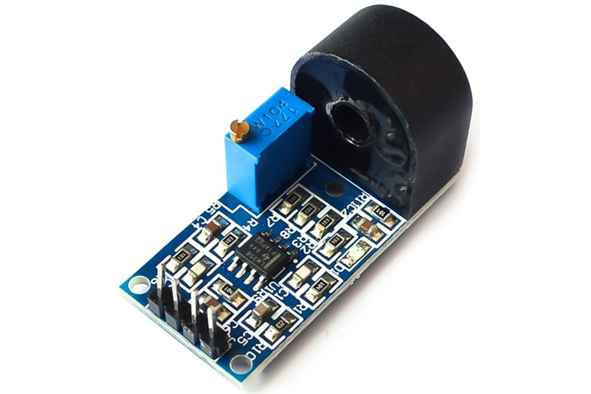](https://components101.com/sites/default/files/components/ZMCT103C-Precision-Current-Sensor.jpg)

**Fig 4.4.1 : ZMCT103C Precision Current Sensor**

[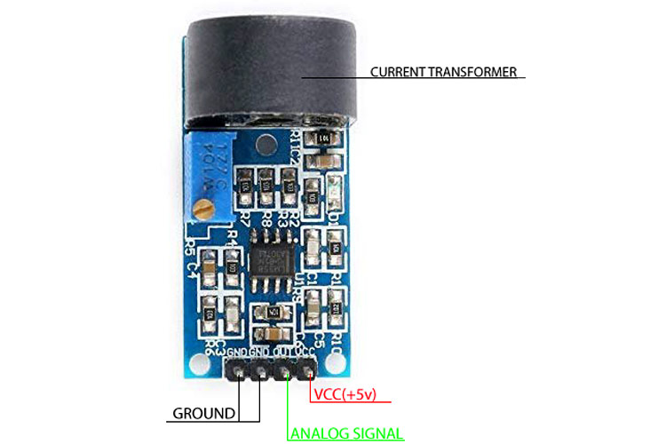](https://components101.com/sites/default/files/component_pin/ZMCT103C-Current-Sensor-Pinout.jpg)

**Fig 4.4.2 : ZMCT103C Current Sensor Pinout**

**Features of ZMCT103C Current Sensor Module**

ZMCT103C is a small size, high accuracy module with some features and specifications mentioned below:

1. Current Ratio: 5 A:5 mA
2. Rated Primary Current at 50/60 Hz: 5 A
3. Winding D.C. Resistance at 20 °C: 155 Ω
4. Maximum Primary Current at 50/60 Hz: 20 A
5. Transformer Turns Ratio: Np:Ns = 1000:1
6. Isolation Voltage: 4500V
7. Onboard sampling resistor, to drop the voltage to lower levels
8. Operating Temperature: -40 to 85 °C
9. Pin Length of the secondary coil (encapsulation) > 3mm
10. Epoxy Encapsulation

**Pin Configuration for ZMCT103C Current Sensor Module**

The ZMCT103C module has 4 pins, which are as follows:

1. Ground (G)
2. Ground(G)
3. Signal Out
4. VCC(+5V)

**4.5 Current Sensor**

Current sensors operate on the principle of variation of magnetic field change between two coils. It generates highly accurate, low noise output voltage signals which are proportional to the applied AC current.

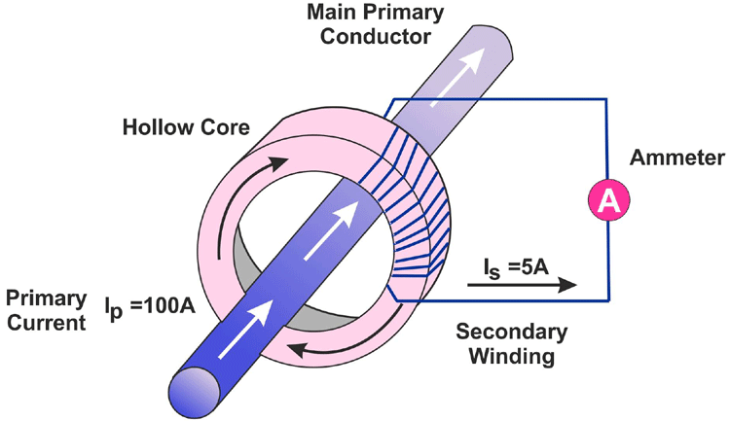

**Fig 4.5.1 : CT working**

The module is in a donut shape which has an epoxy encapsulation, inside which a secondary coil(Ns) is coiled around a ferrite bead. The wire whose current has to be measured is passed through the donut hole and the wire then acts as a primary coil and the change in the magnetic field results in the desired outputs. The measurement accuracy of the device can be improved by increasing the number of turns in the primary coil. This current transformer comes in use for multiple applications including HEV inverters, Electronic power steering systems, detecting circuit overload, load drop, and shutdown.

**Connecting ZMCT103C Current Sensor Module with MCU/MPU**

The ZMCT103 current sensor module can be connected to a micro controller or a processor easily. The module has 4 output pins, two of which are to be shorted. The output pins are as follows; VCC, Ground, Analog Output.

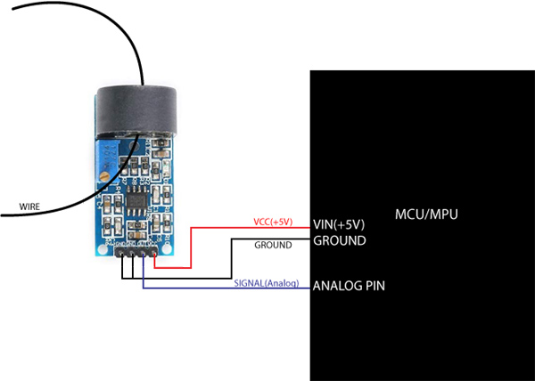

**Fig 4.5.2 : CT connection**

There are two grounds in the current sensor module which are to be shorted and connected to the ground of the MCU. The VCC pin is connected to the 5V of the MCU and the OUT pin on the module is to be connected to the Analog input pin of the MCU/MPU. Once the connections are completed, the wire whose current has to be measured is to be passed through the donut-shaped ZMCT103C IC as shown in the image above.

**Module Configuration of a ZMCT103C Current Sensor**

The ZMCT103C current sensor module consists of the donut-shaped IC which houses the secondary windings and acts as a transformer for current measurement, as discussed above in the ‘*working section’*. The module also consists of an OP07 operational amplifier which is connected along with a sampling resistor.

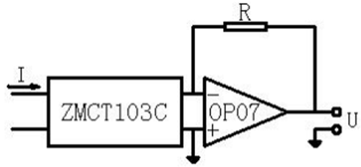

This is a basic circuitry used with the sensor, generally used to amplify the signals generated by the current transformer module.

**4.6 LDR MODULE**

The Digital LDR Module is used to detect the presence of light / measuring the intensity of light. The output of the module goes high in the presence of light and it becomes low in the absence of light. The sensitivity of signal detection can be adjusted using the potentiometer.You can adjust the threshold (sensitivity) of the digital output by tuning the onboard variable resistor (potentiometer). Simple usage as it is the digital output, so you will know is the light present and decide what to do with it.

It comes with an M3 mounting hole for ease of attaching it to an object. Onboard, it provides an LDR, high sensitivity and commonly being used for light detection. The module comes with a power LED and a status LED as an indicator.

LDR Module Photosensitive resistor module most sensitive to environmental light intensity is generally used to detect the ambient brightness and light intensity.

1. Operating Voltage: 3.3V to 5V DC.
2. Operating Current: 15ma.

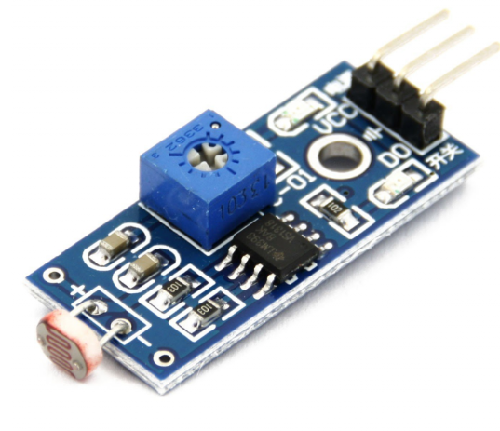

**Fig 4.6.1 : LDR Module**

**4.7 LCD DISPLAY**

LCD is essentially used for expose the information. Here we are using 2x16 LCD. It is used to display numbers, texts and graphics. This is in contrast to LEDs, which are limited to numbers and characters. The LCDs are fragile with only a few millimeter thickness. Since the LCDs utilize less power, the y are efficient with low power electronic circuits, and can be charged for long terms. The LCDs don’t provoke light and so light is needed to read the display. The LCDs have long lasting life and a wide operating temperature range.

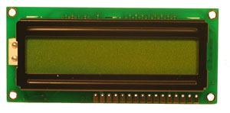

**Fig. 4.7.1 LCD Display**

**CHAPTER 5**

**RESULTS AND DISCUSSION**

**5.1 RESULTS**

The implementation of the LoRa-based IoT energy monitoring interface yielded promising results, showcasing its effectiveness in providing real-time insights into energy consumption patterns and facilitating informed decision-making for efficient resource management.

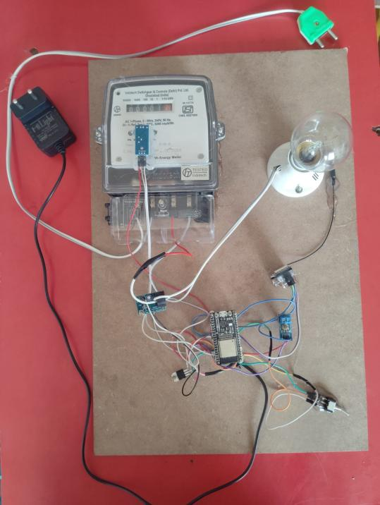

**Fig 5.1.1 : Transmitter side/user prototype**

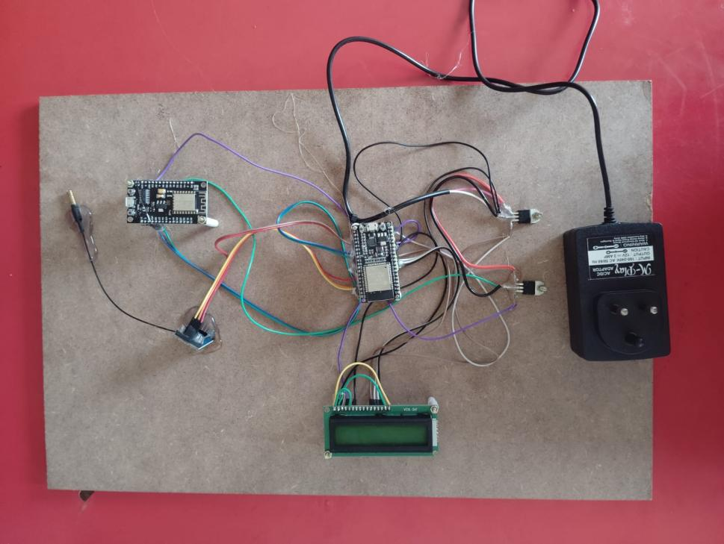

**Fig 5.1.2 : Receiver side/provider’s prototype**

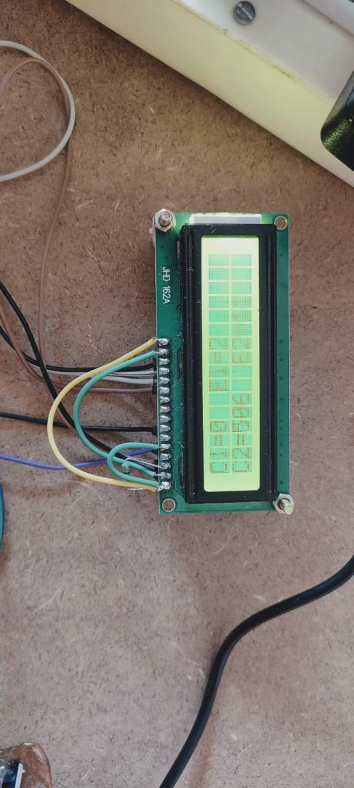

**Fig 5.1.3 : Output on the receiver side LED diplay**

Through the deployment of monitoring nodes equipped with LoRa transceivers and specialized sensors, the system successfully captured granular data on energy usage from various sources within the infrastructure. This data, transmitted over long distances to a central hub, was aggregated, processed, and analyzed in near real-time using advanced algorithms and analytics engines.

The system's intuitive interfaces, accessible through web portals, mobile applications, or dashboard displays, provided stakeholders with immediate visibility into energy consumption trends, anomalies, and optimization opportunities. This actionable intelligence empowered users to identify inefficiencies, implement energy-saving measures, and optimize operational processes to enhance efficiency and sustainability.

Furthermore, the robustness and reliability of LoRa technology ensured seamless communication even in challenging environments, while its low-power consumption minimized maintenance requirements, ensuring uninterrupted operation. Integration with IoT capabilities enabled remote monitoring, control, and optimization of energy resources, enhancing the system's functionality and adaptability across diverse settings.

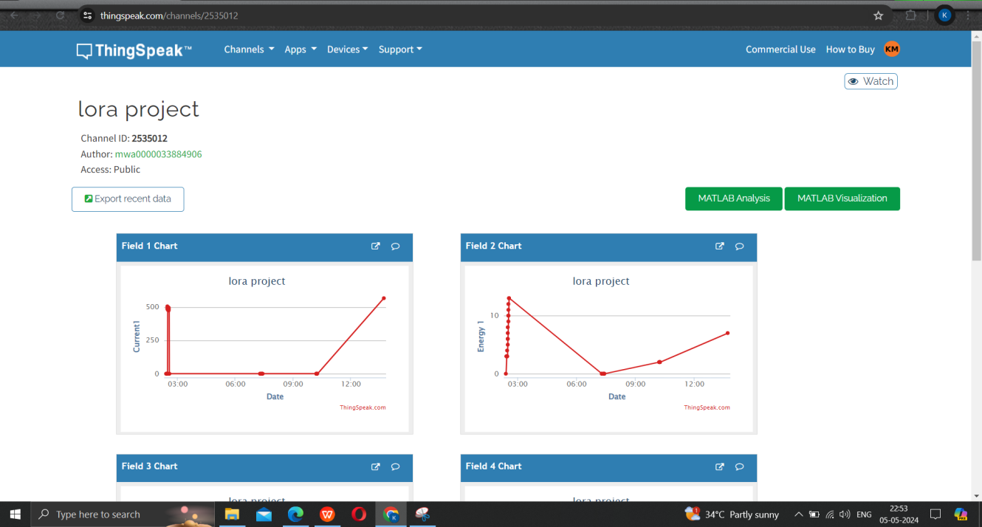

**Fig 5.1.4 : Projected current and energy values from Energy meter**

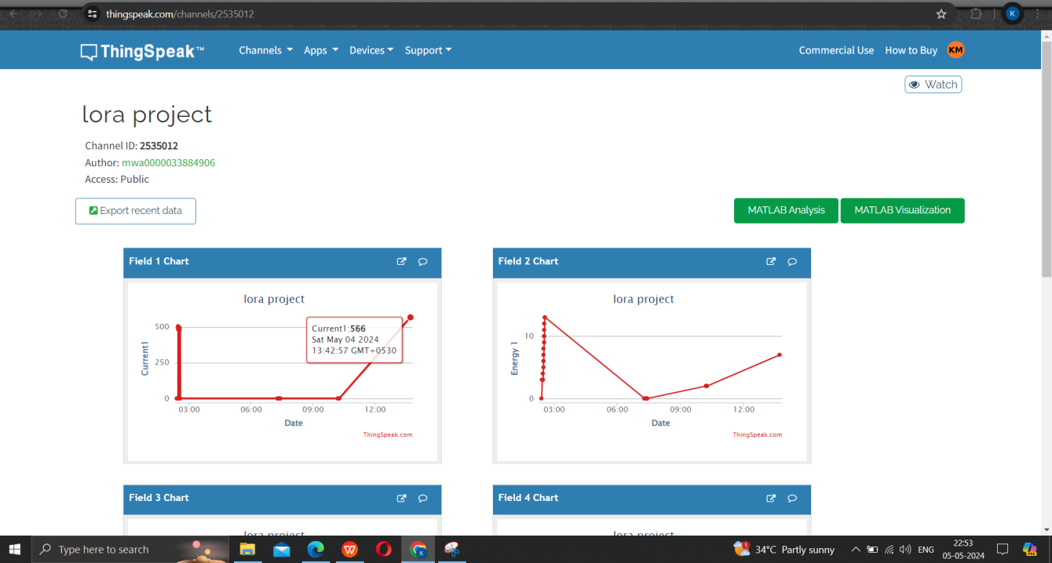

**Fig 5.1.5 : Real time current data from Energy meter**

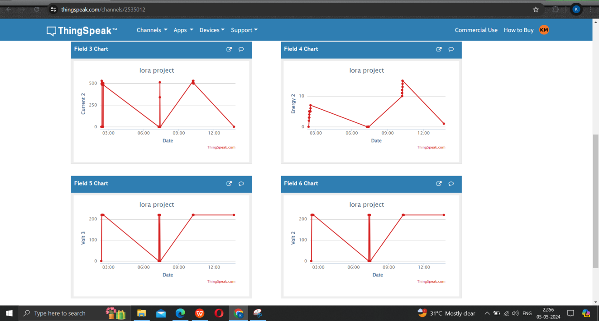

**Fig 5.1.6 : Projected values of voltage and current from Energy meter**

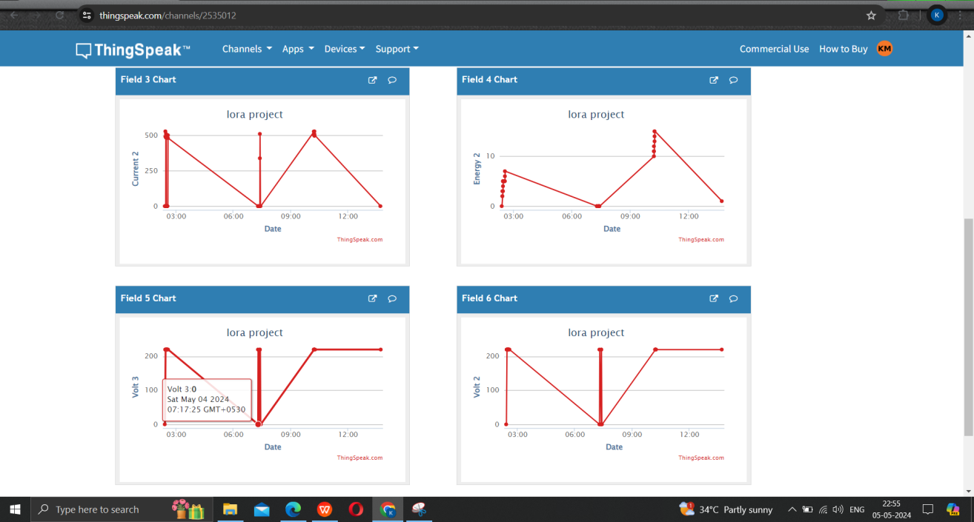

**Fig 5.1.7 : Real time voltage data from Energy meter**

Overall, the results demonstrate the potential of the LoRa based IoT energy monitoring interface to revolutionize energy management practices, offering a scalable, cost-effective solution for efficient resource utilization and sustainability. By leveraging cutting-edge technology and data-driven insights, this system represents a significant step forward in building smarter, more resilient energy infrastructures capable of meeting the evolving needs of modern society.

**5.2** **COST OF PROJECT**

|  |  |
| --- | --- |
| **COMPONENTS** | **COST in ₹** |
| ESP 32 development board, Power cable | 4100 |
| single phase static energy meter | 1100 |
| LoRa module | 3200 |
| WiFi module | 700 |
| 5v regulator | 760 |
| LCD display | 200 |
| LDR sensor | 150 |
| Bulb and bulb holder | 300 |
| ZMCT103C current sensor | 100 |
| **TOTAL** | 10610 |

**CHAPTER 6**

**CONCLUSION**

In conclusion, the integration of LoRa based IoT technology into energy monitoring systems heralds a new era of efficiency, sustainability, and informed decision-making. By harnessing the power of LoRa's long-range communication and low-power capabilities, coupled with the versatility of IoT interfaces, this innovative approach offers a scalable and cost-effective solution for managing energy resources across diverse environments. Through strategically positioned monitoring nodes and a central hub equipped with advanced analytics, the system provides real-time visibility into energy consumption patterns, enabling stakeholders to identify trends, anomalies, and optimization opportunities. This actionable intelligence, accessible through intuitive interfaces, empowers users to make informed decisions, implement energy-saving measures, and optimize operational efficiency. The robustness and reliability of LoRa technology ensure seamless communication even in challenging environments, while its low-power consumption minimizes maintenance requirements, ensuring uninterrupted operation. Furthermore, integration with IoT capabilities enables remote monitoring, control, and optimization of energy resources, enhancing the system's functionality and adaptability. In essence, the proposed LoRa-based IoT energy monitoring interface represents a significant step forward in energy management practices, offering a pathway to more sustainable and resilient energy infrastructures. By leveraging cutting-edge technology and data-driven insights, this system paves the way for smarter resource utilization, reduced environmental impact, and enhanced economic competitiveness in a rapidly evolving world.

**REFERENCES**

1. Kumar, S. Thakur and P. Bhattacharjee, "Real Time Monitoring of AMR Enabled Energy Meter for AMI in Smart City - An IoT Application," 2018 IEEE International Symposium on Smart Electronic Systems (iSES) (Formerly iNiS), Hyderabad, India, 2018, pp. 219-222, doi: 10.1109/iSES.2018.00055.
2. N. Sushma, H. N. Suresh, J. M. Lakshmi, P. N. Srinivasu, A. K. Bhoi and P. Barsocchi, "A Unified Metering System Deployed for Water and Energy Monitoring in Smart City," in IEEE Access, vol. 11, pp. 80429-80447, 2023, doi: 10.1109/ACCESS.2023.3299825.
3. R. Mishra, A. Pandey and J. Savariya, "Application of Internet of Things: Last meter smart grid and smart energy efficient system," 2020 First International Conference on Power, Control and Computing Technologies (ICPC2T), Raipur, India, 2020, pp. 32-37, doi: 10.1109/ICPC2T48082.2020.9071503.
4. T. Ranjith and P. Sivraj, "Futuristic Smart Energy Meter-Design Based on Embedded Perspective," 2018 Second International Conference on Intelligent Computing and Control Systems (ICICCS), Madurai, India, 2018, pp. 1379-1384, doi: 10.1109/ICCONS.2018.8663096.
5. A.P. Sai and A. K. Bohre, "Energy Trading in the Internet of Energy using Ethereum Smart Contracts and Smart Energy Meters," 2023 3rd International Conference on Intelligent Technologies (CONIT), Hubli, India, 2023, pp. 1-6, doi: 10.1109/CONIT59222.2023.10205731.
6. Mujawar, A. Mulla and T. Karbhari, "IoT-Based Smart Energy Meter for Recording Device-Level Electric Parameters," 2023 Innovations in Power and Advanced Computing Technologies (i-PACT), Kuala Lumpur, Malaysia, 2023, pp. 1-5, doi: 10.1109/i-PACT58649.2023.10434810.
7. A.Komathi, S. Durgadevi, K. Thirupura Sundari, T. R. Sree Sahithya and S. Vignesh, "Smart Energy Metering For Cost And Power Reduction In House Hold Applications," 2021 7th International Conference on Electrical Energy Systems (ICEES), Chennai, India, 2021, pp. 428-432, doi: 10.1109/ICEES51510.2021.9383725.
8. S. S. Chowdary, M. A. Abd El Ghany and K. Hofmann, "IoT based Wireless Energy Efficient Smart Metering System Using ZigBee in Smart Cities," 2020 7th International Conference on Internet of Things: Systems, Management and Security (IOTSMS), Paris, France, 2020, pp. 1-4, doi: 10.1109/IOTSMS52051.2020.9340230.
9. R. Sheeba et al., "Real-time Monitoring of Energy Meters Using Cloud Storage," 2021 IEEE International Power and Renewable Energy Conference (IPRECON), Kollam, India, 2021, pp. 1-5, doi: 10.1109/IPRECON52453.2021.9640636.
10. H. K. Patel, T. Mody and A. Goyal, "Arduino Based Smart Energy Meter using GSM," 2019 4th International Conference on Internet of Things: Smart Innovation and Usages (IoT-SIU), Ghaziabad, India, 2019, pp. 1-6, doi: 10.1109/IoT-SIU.2019.8777490.
11. . Tan, H. Yao, Y. Huang, H. Wang, Z. Zhao and Y. He, "Temperature-Controlled Smart Energy Meter Field Calibration System Based on Measurement Risk Rating," 2019 3rd International Conference on Smart Grid and Smart Cities (ICSGSC), Berkeley, CA, USA, 2019, pp. 60-64, doi: 10.1109/ICSGSC.2019.00-18.
12. . S. Metering, S. Visalatchi and K. K. Sandeep, "Smart energy metering and power theft control using arduino & GSM," 2017 2nd International Conference for Convergence in Technology (I2CT), Mumbai, India, 2017, pp. 858-961, doi: 10.1109/I2CT.2017.8226251.
13. S. V. Sreedevi, P. Prasannan, K. Jiju and I. J. Indu Lekshmi, "Development of Indigenous Smart Energy Meter adhering Indian Standards for Smart Grid," 2020 IEEE International Conference on Power Electronics, Smart Grid and Renewable Energy (PESGRE2020), Cochin, India, 2020, pp. 1-5, doi: 10.1109/PESGRE45664.2020.9070245. },
14. K. Barman, S. N. Yadav, S. Kumar and S. Gope, "IOT Based Smart Energy Meter for Efficient Energy Utilization in Smart Grid," 2018 2nd International Conference on Power, Energy and Environment: Towards Smart Technology (ICEPE), Shillong, India, 2018, pp. 1-5, doi: 10.1109/EPETSG.2018.8658501.