**AGE AND GENDER DETECTION USING DEEP LEARNING IN**

**OPEN CV**

**R. Nivethitha1, T.S.P. Ksheerabdinath2, A. Mohammed Navas3, T.S. Muneesh Wara Venkatesh4**

*1Assistant Professor Department of Computer Science and Engineering, K.L.N. College of Engineering, Sivagangai, Tamil Nadu, India.*

*2,3,4 Final Year Students, Department of Computer Science and Engineering, K.L.N. College of Engineering, Sivagangai, Tamil Nadu, India.*

**Abstract:** A lightweight CNN is designed for real-time detection of facial emotions, age, and gender. It integrates MTCNN for efficient face detection, passing coordinates to a custom emotion classifier and pre-trained Caffe models for age and gender prediction. MTCNN’s cascade detection optimizes memory and processing efficiency. The emotion model uses Global Average Pooling and depth-wise separable convolutions to improve interpretability and portability. Pre-trained Caffe models handle age and gender prediction with preprocessing like mean subtraction and blob formation. Real-time detection is achieved via OpenCV and Dlib, with results displayed when confidence exceeds 50%. Tested on the FER-2013 dataset, the emotion model achieves 67% accuracy using 0.496GB of memory, with a compact size of 872.9 kilobytes for deployment across both static and dynamic inputs.

**Keywords:** Lightweight CNN, MTCNN, Deep Learning, OpenCV, Dlib, Caffe Models, FER-2013 dataset.

# **I. INTRODUCTION**

Facial emotion, age, and gender detection are increasingly important in fields like healthcare, security, and human-computer interaction. Traditional systems often demand high computational resources, limiting real-time performance on devices with limited memory. To overcome these challenges, a lightweight Convolutional Neural Network (CNN) system is developed for real-time detection. It integrates Multi-Task Cascaded Convolutional Networks (MTCNN) for face detection, with custom CNN and pre-trained models handling emotion, age, and gender predictions. The system uses techniques like Global Average Pooling to optimize memory efficiency, and real-time processing is enabled via OpenCV and Dlib, ensuring effective performance across platforms..

## **II. OBJECTIVE**

The mission focuses on developing a real-time system for detecting facial emotions, age, and gender using a lightweight convolutional neural network (CNN) to enhance classification efficiency. It aims to integrate MTCNN for precise face detection, transmitting coordinates to custom models for emotion classification and pre-trained Caffe models for age and gender prediction. This approach will optimize memory usage and processing time by utilizing techniques like Global Average Pooling and depth-wise separable convolutions. Additionally, preprocessing steps such as mean subtraction and blob formation will be employed to improve real-time prediction accuracy. Ultimately, the aim is to provide a portable and efficient solution for facial emotion, age, and gender detection across both static and dynamic inputs, ensuring reliable performance and easy deployment.

## **III. LITERATURE SURVEY**

**1. Real-time Face Detection using MTCNN:**  
 Zhang et al. (2016) introduced Multi-Task Cascaded Convolutional Networks (MTCNN), a widely adopted approach for face detection. The model effectively handles facial landmarks and face detection in a cascaded manner, optimizing both accuracy and speed. MTCNN is highly efficient for real-time applications due to its ability to detect face regions while minimizing memory usage, making it suitable for tasks requiring low-latency processing, such as facial emotion and attribute detection.

**2. Emotion Classification using CNNs:**  
 Li et al. (2018) explored using deep convolutional neural networks (CNNs) for emotion classification based on facial expressions. Their work demonstrated the effectiveness of CNNs in extracting hierarchical features, achieving high accuracy on benchmark datasets like FER-2013. The use of Global Average Pooling layers in place of fully connected layers was found to enhance interpretability by associating feature maps with emotions, while reducing the model’s complexity and improving portability.

## **IV. EXISTING SYSTEM**

Facial emotion, age, and gender detection systems often rely on robust machine learning models that demand significant memory and processing power, making real-time performance challenging on resource-constrained devices. While Convolutional Neural Networks (CNNs) are effective for emotion detection, their size and computational intensity limit deployment. Pre-trained models like VGGNet or ResNet require high-end hardware, and Caffe-based models involve time-consuming preprocessing. Additionally, separate face detection algorithms, such as Haar cascades or HOG-SVM, introduce latency and increase memory overhead.

**V. PROPOSED SYSTEM**

This lightweight Convolutional Neural Network (CNN) detects facial emotions, age, and gender in real-time, prioritizing memory efficiency and interpretability. Utilizing Multi-Task Cascaded Convolutional Networks (MTCNN) for face detection, it transmits coordinates to custom models for classification. Global Average Pooling and depth-wise separable convolutions minimize memory usage and parameters. Pre-trained Caffe models normalize input, while OpenCV and Dlib enable real-time processing. The system achieves 67% accuracy on the FER-2013 dataset with only 0.496 GB memory usage.

## **VI. ARCHITECTURE DIAGRAM**

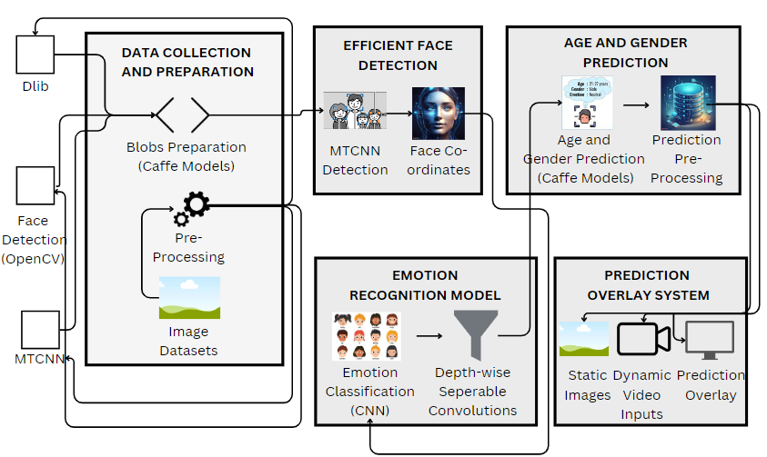

***Fig 6.1 Architecture Diagram***

**VII. SYSTEM OVERVIEW**

### **1. Training the Emotion Detection Model:**

### The focus is on developing an effective emotion classification model using a labelled dataset like FER-2013. Data preprocessing includes normalization and augmentation to enhance robustness. The architecture employs convolutional layers with Global Average Pooling for memory efficiency. The model is trained using supervised learning, with performance evaluated through accuracy metrics to ensure reliability in real-time predictions.

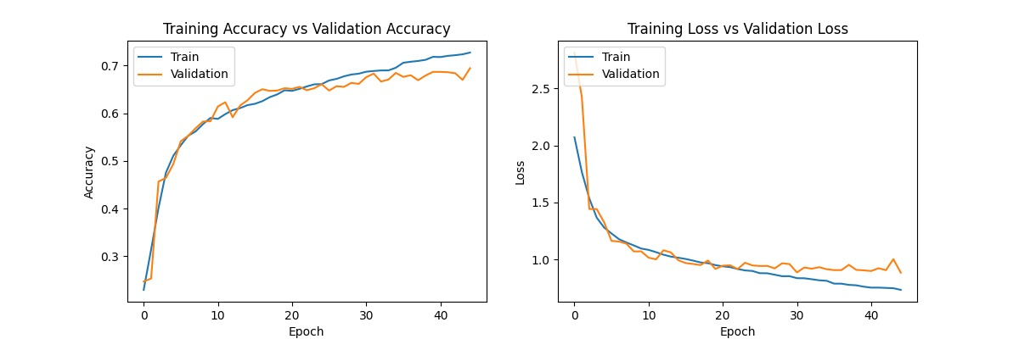

***Fig 7.1 Training of the image models***

### **2. Real-Time Detection System:**

The Real-Time Detection System analyses live video feeds or static images to detect facial emotions, age, and gender. Utilizing the MTCNN model for efficient face detection, it preprocesses images for consistency before classification. Predictions are made based on confidence thresholds and displayed in real-time, enabling immediate insights for applications in security, healthcare, and user interaction.

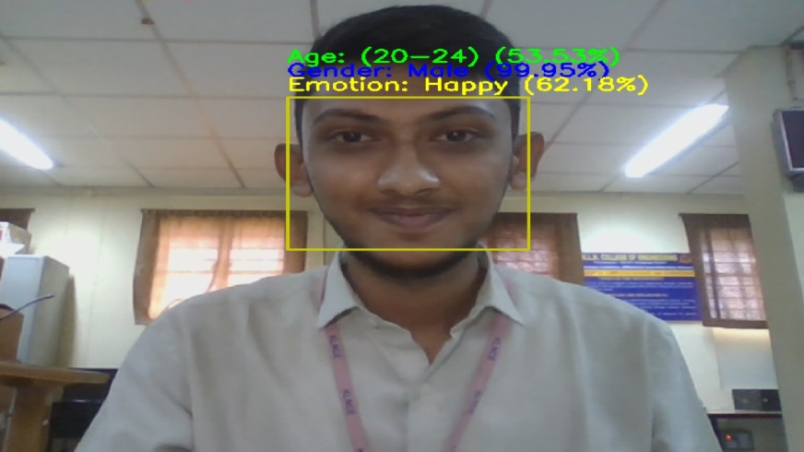

***Fig 7.2 Real-Time Detection***

### **3. User Interface Management:**

The User Interface Management module creates an intuitive and user-friendly interface for interacting with the facial emotion, age, and gender detection system. It facilitates easy input of images or video feeds, displays real-time predictions, and presents results in a visually appealing format. This module enhances user experience, ensuring seamless navigation and accessibility for various applications in real-time scenarios.

### **4. Preprocessing Functions:**

The Preprocessing Functions module prepares images for analysis by normalizing inputs to ensure consistency. This includes resizing images, applying mean subtraction, and enhancing features through data augmentation techniques. By standardizing the input format, the module improves the accuracy and reliability of subsequent facial emotion, age, and gender classifications, enabling the system to perform efficiently in real-time scenarios.

**IX. CONCLUSION**

The proposed lightweight Convolutional Neural Network (CNN) system effectively addresses real-time facial emotion, age, and gender detection challenges in resource-constrained environments. By integrating Multi-Task Cascaded Convolutional Networks (MTCNN) for efficient face detection and utilizing techniques like Global Average Pooling and depth-wise separable convolutions, the system achieves a balance between accuracy and memory efficiency. With 67% accuracy on the FER-2013 dataset and a compact memory footprint of 0.496 GB, this solution is suitable for diverse applications, paving the way for advancements in healthcare, security, and human-computer interaction.

**REFERENCES**

[1] Ala-Mutka KM (2005), ‘A survey of automated assessment approaches for programming assignments’ in Computer Science Education on Taylor Francis, Vol. 12, pp. 83–102.

[2] Blikstein P, Worsley M, Piech C, Sahami M, Cooper S, Koller D (2014). ‘Programming pluralism: Using learning analytics to detect patterns in the learning of computer programming’ in Journal of Learning Sciences on Taylor Francis, Vol. 23, pp. 561–99.

[3] Charlotte Van Petegem, Rien Maertens, Niko Strijbol, Jorg Van Renterghem, Felix Vander Jeugt, Rademeyer Dawyndt, Bart Mesuere (2023), ‘Dodona: Learn to code with a virtual co-teacher that supports active learning’ in SoftwareX on Science Direct, Vol. 24, pp. 101-578.

[4] Chow S, Yacef K, Koprinska I, Curran J (2017), ‘Automated data-driven hints for computer programming students.’ In: Adjunct publication of the 25th conference on user modeling, adaptation and personalization. New York, NY, USA: Association for Computing Machinery, pp. 5–10.

[5] Costa EB, Fonseca B, Santana MA, de Araújo FF, Rego J (2017), ‘Evaluating the effectiveness of educational data mining techniques for early prediction of students’ academic failure in introductory programming courses’ in Computers in Human Behavior on Science Direct, Vol. 73, pp. 247–256.

[6] Edwards SH, Perez-Quinones MA (2008). ‘Web-CAT: Automatically grading programming assignments’. In: Proceedings of the 13th annual conference on innovation and technology in computer science education. New York, NY, USA: Association for Computing Machinery; p. 328.

[7] Ferguson R (2012). ‘Learning analytics: Drivers, developments and challenges.’ in International Journal of Technology Enhanced Learning, pp. 304–17.

[8] Fonseca I, Martins NC, Lopes F (2023). ‘A web-based platform and a methodology to teach programming languages in electrical engineering education – evolution and student feedback’. In: 32nd annual conference of the European Association for Education in Electrical and Information Engineering, pp. 1–3.

[9] Hsi-min Chen, Bao - an Nguyen, Yi-Xiang Yan, and Chyi-Ren Dow (2020), ‘Analysis of Learning Behavior in an Automated Programming Assessment Environment: A Code Quality Perspective’ in Computer Science and Education on IEEE.

[10] Ihantola P, Ahoniemi T, Karavirta V, Seppälä O (2010). ‘Review of recent systems for automatic assessment of programming assignments’. In: Proceedings of the 10th Koli Calling International Conference on Computing Education Research. New York, NY, USA: Association for Computing Machinery; pp. 86–93.