An Intelligent Traffic Signalling System based on integration of an Arduino and infrared sensor

Jhansi Syamala Devi Nadimpalli

*Department of Computer Science and Engineering Kalasalingam Academy of Research and*

*Education*

Virudhunagar, India

Tulasi Doddaka

*Department of Computer Science and Engineering Kalasalingam Academy of Research and*

*Education*

Virudhunagar, India

Navya Sri Battula

*Department of Computer Science and Engineering Kalasalingam Academy of Research and*

*Education*

Virudhunagar, India

Vijay M

*Department of Computer Science and Engineering Kalasalingam Academy of Research and*

*Education*

Virudhunagar, India

[vijaymepcoece@gmail.com](mailto:Vijaymepcoece@gmail.com)

***Abstract—* Currently*,* traffic lights operate according to a predetermined timetable, which might cause issues if certain lanes are empty while others are congested. To fix this, we came up with a smart traffic system. Our method proposes leaving the green light on longer than usual when there are a lot of automobiles on one side of the road. To determine this, we employspecialized sensors known as PIR sensors. A tiny computer called an Arduino control how many cars are allowed to pass and how long the green signal lasts. The Arduino determines when to change the lights by using sensors along the road to determine whether there are any cars nearby. In the parts that follow, we will go over every detail of how this system operates. Our project's primary objective is to create a traffic system that can automatically adjust the lights at an intersection according to the number of cars there. We believe that it is time to replace the outdated light timing system with a new autonomous system, as traffic congestion is a major issue in cities worldwide.**

***Keywords—* traffic lights, lanes, jam-packed, PIR, Arduino.**

1. **INTRODUCTION**

Traffic lights have been used as signaling devices to regulate traffic at junctions, railroad crossings, pedestrian crossings, and other locations since they were invented in 1912.These signals consist of three conventional colored lights: a green light that allows traffic to go in the specified direction, a yellow light

that alerts motorists to the impending halt, and a red signal that forbids any traffic from moving forward. Nowadays, many countries struggle with traffic congestion, which has a major effect on urban transportation networks and raises important difficulties. The problem of excessive work hours lost at traffic signals affects society as a whole, in addition to impeding individual productivity. The large number of cars, the poor infrastructure, and the disorganized signaling system are the main causes of this chaotic congestion. Long-term engine idling, which frequently happens in traffic jams, also raises pollution levels and wastes a significant quantity of natural resources—petrol and diesel—without producing any noticeable results. To address these problems, or at least mitigate them, new concepts in the field of traffic signaling systems—such as sensor- based automation—must be introduced. In this project, we suggest using an IR sensor in conjunction with an Arduino to increase the efficacy and efficiency of traffic light management systems. We want to enhance the traffic signal system by addressing issues such as traffic congestion, energy and fuel waste, pollution, and time inefficiencies. Traffic administration's goal is to continuously improve traffic laws and regulations. Given the increasing number of vehicle users and the depletion of infrastructure resources, future needs will require prioritizing sophisticated traffic control. The economy and ecology benefit from the reduction of traffic bottle necks. Our project intends to create a traffic light controller for urban areas using an Arduino and an infrared sensor. Unlike fixed traffic control systems that operate based on preset programming, an intelligent transportation system (ITS)

assesses traffic conditions in real-time and adjusts signals to minimize vehicle delays and pauses. This study emphasizes the significance of the problem by proposing an intelligent system that is implemented with Arduino in order to alleviate the existing traffic difficulties. Because these vehicles may have difficulty navigating through crowded intersections, the seamless operation of higher-priority emergency vehicles, such as ambulances, rescue vehicles, fire brigades, police, and VIP convoys, is also a major concern. Moreover, the presence of pedestrian crossing lanes adds to the complexity of the traffic system. To address these concerns, improving the current transportation infrastructure is crucial. The aim is to mitigate severe traffic congestion, alleviate issues related to transportation, decrease traffic volume and wait times, reduce overall travel times, enhance vehicle efficiency and safety, and expand benefits into the domains of the environment, health, and economics. This study offers an intelligent traffic signal control system that is easy to use, reasonably priced, and real-time in order to boost traffic management and solve existing issues. Using infrared (IR) sensors, the system keeps an eye on traffic volume and density and modifies lighting transitions as needed. It also oversees several other operations.

1. **LITERATURE REVIEW**

Numerous research have examined the traffic control system. We'll look at some of the pertinent research that have been done in the area of traffic control systems.

[9] Arduino-based IOT system with infrared sensors for real-time vehicle speed detection. Akhil Ashok A, Ambili P S(2024).This study is an attempt for the development of a system that utilizes the power of IoT to detect and monitor the speed of vehicles on the roadways. The system comprises of a speed sensor that captures the speed of the vehicle and sends the data to a microcontroller, which in turn sends the data to a cloud-based platform through an IoT gateway.

[10] Density Based Traffic Light Control Using IR Sensors and Arduino. Km Manisha Rai, Dr. S. Vijayalakshmi (2023). At traffic junction now days we need a dynamic arrangement of traffic lights at the place of static so it can be quickly resolve the problem of traffic if any emergency vehicle is waiting in the queue or as per the need. which change the colour of traffic light according to density of traffic which is present at a particular side of traffic junction. To know the density of traffic we have to use sensors and IOT technology.

[1] Smart signal control by detecting traffic intensity using IR sensors. [Mididoddi Sai Praneeth](https://ieeexplore.ieee.org/author/988021313558254), [D Dhanalakshmi](https://ieeexplore.ieee.org/author/37089899108) (2023). The proposed study presents an approach to solve this traffic problem by Traffic Signal Automation by sensing traffic intensity by IR sensors using IoT (Internet of Things). So, The Proposed system can control the traffic by adjusting the timings of the signals based up on the calculations of Traffic intensity on all the sides of the roads.

[11] Integrated Traffic Control System for Emergency Vehicles. [Sarala T](https://ieeexplore.ieee.org/author/37089008347), [Sunitha S V](https://ieeexplore.ieee.org/author/423003273496795) (2024). The efficient movement of ambulances is crucial for timely response and effective emergency management in urban areas. However, congested road networks often impede their progress, leading to potentially life-threatening delays. It presents an innovative solution: an automated traffic system for emergency vehicles utilizing RF (Radio Frequency) modules. Real-time vehicle identification, intelligent traffic management algorithms, and enhanced safety measures are key features of this system. By dynamically managing traffic flow, optimizing signal timings, and granting priority access to ambulances.

[12] Traffic management System and traffic light control in smart city to reduce traffic congestion. [A Wided](https://scholar.google.com/citations?user=4ntk_3wAAAAJ&hl=en&oi=sra), [B Assia](https://scholar.google.com/citations?user=d7YInA8AAAAJ&hl=en&oi=sra), B Fatima (2023). The synchronization mechanism used by traditional circulation lighting systems changes light signals after a certain interval. This method is used when the roads are nearly empty. An intelligent traffic light system detects the presence, estimates the level of traffic, and reacts appropriately. Intelligent traffic systems are designed to prevent cars from impatiently waiting at traffic lights to change their signals when there are free roads.

1. **PROPOSED ARCHITECTURE**

The potential for sensory traffic signal control systems to revolutionize traffic management has drawn interest. The use of sensors—especially cameras and Internet of Things devices—for ongoing traffic monitoring is a topic covered in great detail in current research. These sensors give traffic lights the necessary data for dynamic signal control, which allows them to adapt to changing circumstances. Machine learning algorithms play a vital role in signal timing forecasting and optimization. In order to give accurate forecasts and effective traffic flow management, the literature highlights the significance of having dependable algorithms that can handle data from a range of sensors.Privacy concerns and system reliability remain significant barriers, despite recent developments.The gathering and processing of sensitive traffic data gives rise to privacy concerns, which require cautious planning and execution. Furthermore, the effective integration of these systems into urban infrastructure depends on guaranteeing their scalability and dependability. The technological components of sensory traffic signal control are the subject of most current studies; however, there is a significant study gap concerning the long-term efficacy and societal implications of this technology. Knowledge of how these technologies impact environmental factors, traffic dynamics in general, and driver behavior is essential for a thorough study and successful adoption of these technologies. To sum up, research on the topic of sensor and machine learning integration in sensory traffic signal control systems is quite informative. These innovative methods of optimizing urban traffic will become more sophisticated and commonly applied with the support of extended research and problem-solving.The proposed project aims to develop a sensory traffic control system using Arduino microcontrollers and infrared (IR) sensors. In this innovative approach, IR sensors will be strategically deployed at key points along roadways to detect the presence of vehicles and monitor traffic flow. These sensors will continuously collect data on vehicle movement, including speed and direction. The Arduino microcontrollers will serve as the brains of the system, processing the data collected by the IR sensors in real-time. Using programmed algorithms, the Arduino boards will analyze the incoming data to identify patterns and trends in traffic behavior.

In summary, our program aims to radically alter traffic management by implementing a density-based traffic light system. In contrast to conventional time-based signaling, our intelligent framework uses proximity infrared (PIR) sensors and an Arduino microcontroller to dynamically adjust signal timing based on actual traffic intensity at each intersection. These sensors are used to monitor the presence of vehicles and communicate with the microcontroller, allowing us to make sure that lanes with heavier traffic receive the best green light durations. This enhances the general effectiveness of traffic flow and lessens congestion. This innovative approach is a significant step toward automated, adaptive traffic control systems and addresses the pressing issues of urban congestion in depth. The device is intended to be put near intersections with traffic signals in order to lessen traffic at these crossings. The number of vehicles on each road is tracked and used to change the timing of each traffic light signal. The time delay for a particular traffic light signal increases proportionately with the number of vehicles on the same road.

**BLOCK DIAGRAM**

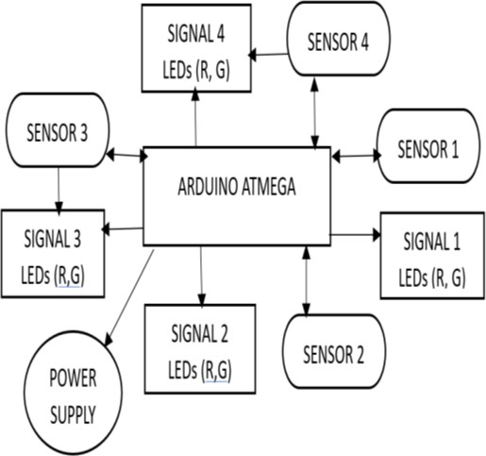

1. **METHODOLOGY** Fig.1 Block Diagram

To improve overall efficiency, an improved traffic light management system is built around the combination of an IR sensor and an Arduino. The major objective of this innovative system is to optimize the existing traffic signal infrastructure in order to successfully address problems associated with traffic congestion and related difficulties, such as fuel waste, energy inefficiency, pollution, and time consumption. The system is made up of infrared transmitters and receivers that are strategically positioned on both sides of roadways. When a vehicle passes through the region between the transmitter and receiver, the infrared system is activated. When the sensors detect the presence of autos, the microprocessor-controlled system responds dynamically. It's interesting to note that one of the microcontroller's functions is to determine how long the traffic signal flashes. The microcontroller plays a significant role in generating a more adaptable and efficient traffic control system by determining the traffic light's flashing time in reaction to varying car concentrations. Sensory traffic control is a technique that uses infrared (IR) sensors to monitor and manage traffic flow using infrared light.With the versatility these sensors offer, traffic control tasks—like vehicle identification and pedestrian monitoring—can be improved. The following describes a general approach to using infrared sensors to achieve sensory traffic control.At each intersection, the current traffic signal system follows set timetables and is unable to adjust to the ever- changing traffic situation. This rigidity could lead to inefficiencies, especially if traffic is denser on one side of the intersection than the other and longer than anticipated green durations are required.A prototype infrared sensor is being made. Certain roadways have infrared sensors installed to gauge traffic volume. These sensors are strategically placed along each route to accurately detect traffic density, even when lighting

conditions are restricted. Because these sensors are connected to an Arduino-based controller, they are able to continuously monitor traffic on specific routes. The controller uses inputs from the sensors to identify and control the traffic system. The amount of traffic on the route determines how dynamically traffic signal controls are set.

**HARDWARE COMPONENTS:**

1. **Arduino Uno board-01**

A popular microcontroller board is the Arduino Uno, which may be used for many different purposes. With its 6 analog and 14 digital pins, it may be utilized for a wide range of tasks. It is possible to connect it to a computer via USB for programming and power. The ATmega328P chip, which powers the board with a 5V operating voltage and 32 KB of flash memory for your programs, is the main component. Both inexperienced and seasoned users will find it to be an excellent tool due to its simplicity and large community support.

1. **IR sensors-04**

Incandescent light (IR) sensors are those that sense heat or infrared radiation emitted by objects. Infrared sensors come in two main varieties: passive infrared (PIR) sensors, which monitor temperature differences and are frequently used in motion detectors, and active infrared sensors, which emit infrared light and detect its interruption or reflection. These sensors are used in many applications, including TV remote controls, robotic object detection, and automated door activation.

For applications requiring non-contact temperature

monitoring, infrared sensors are quite helpful. In conclusion, because of their ability to recognize and respond to heat signals, they are crucial components of numerous electrical systems.

1. **Red LEDs-04**

Red LEDs, sometimes referred to as light-emitting diodes, emit red light when an electrical current passes through them. They are commonly used in indicators, displays, and electrical gadgets, providing a brilliant red color within the red spectrum.

1. **Green LEDs-04**

Green light is generated when electricity flows through light-emitting diodes, or LEDs. They are commonly used in indicators, displays, and electronics and offer a distinctive green hue. Because they are long-lasting and energy- efficient, green LEDs are extensively used in many different applications, including lighting and status indicators in electronic devices.

1. **Transformer-01**

A transformer is an electrical device that transfers power between circuits. It makes use of two coils as well as a magnetic core. When electricity passes through one coil, a magnetic field is produced, and this field transfers energy to the other coil. Transformers are essential for efficient power transmission over long distances and are found in a wide variety of electrical equipment.

1. **Bridge rectifier-01**

A bridge rectifier is a device that uses four diodes to convert alternating current (AC) to direct current (DC). Its job of transforming the AC voltage from outlets into a useful DC power source for electronic devices is crucial. It does this by maintaining a steady flow of electrical current in a single direction.

1. **Capacitor-01**

A capacitor is an electrical device that has the ability to store and release electrical energy. Among other things, electrical systems employ capacitors, which are made up of two plates spaced apart by an insulating material, for voltage stabilization and energy storage.

1. **Resistor-01**

A resistor is an electrical device that regulates the amount of current that may flow through a circuit. Its resistance is measured in ohms. It is essential for safeguarding electronic components since it controls voltages, currents, and circuit electrical characteristics.

1. **Led-01**

A semiconductor known as an LED (light-emitting diode) produces light when an electrical current flows through it.

The extended lifespan and energy economy of LEDs make them a popular choice for lights, displays, and indicators in a wide range of applications.

1. **7805 voltage Regulator-01**

The 7805voltage regulator is an integrated circuit that is widely used to consistently produce a 5-volt output from an input voltage source. One of its common purposes is to provide consistent and reliable power supply voltages for connected components in electronic circuits.

1. **Zero PCB board-01**

A Zero PCB board can be thought of as an electronic playground. It features holes where you can simply insert and connect components to experiment with various circuit designs without requiring a set plan.

1. **L-Clamps**

L-clamps are practical tools for metalworkers and woodworkers because they provide a sturdy grip for materials while welding or gluing, guaranteeing accuracy and steadiness in a variety of crafting activities.

1. **Connecting wires**

For electrical current to flow and for electronic devices to function properly, wires are essential for creating electrical connections between circuit components. They function as channels that carry power and signals between various circuit components.

1. **Electric Wire**

For many uses, electrical wires provide channels for moving electrical current between sites. Their job is to make it easier for electricity to move by connecting various parts and devices to form functional electrical circuits.

1. **pin plug**

A 2-pin plug is a straightforward electrical connector that has two prongs and is commonly used for low-power devices. It provides an easy way to connect to outlets that have two slots.

**SPECIFICATIONS OF SOFTWARE**

**Arduino IDE**

An open-source programming tool used for uploading and coding is the Arduino Integrated Development Environment (IDE). With the ability to upload code to the Cloud and support real-time work, it makes it possible to regularly and conveniently access your projects without requiring redundancy.

The Arduino Software (IDE) is used to communicate with Arduino boards and upload programs.

**CIRCUIT DIAGRAM**

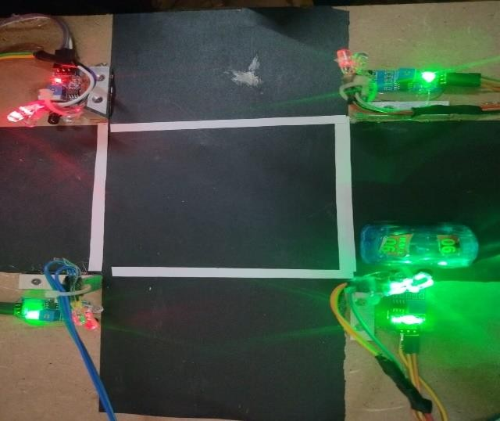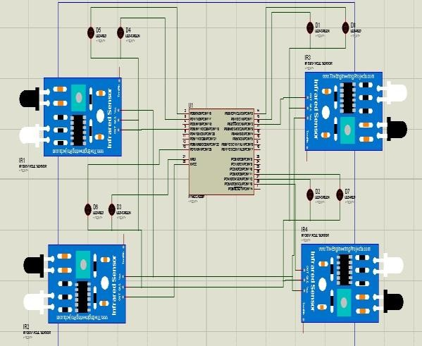

Fig.2 Circuit diagram

# EXPERIMENTATION AND RESULTS

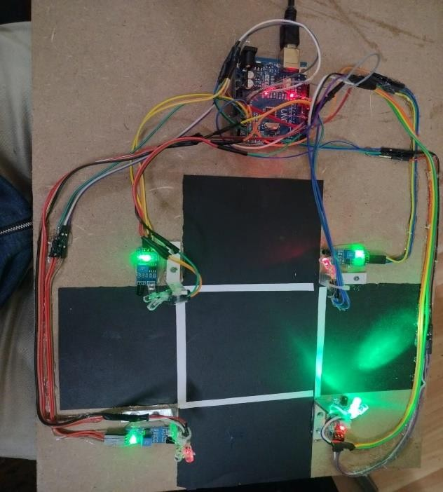We created a hardware-based system that uses infrared sensors to control a four-way intersection.

Fig.3 When no vehicle is passing in junction

The equivalent green light on one side turns on as a car goes through it, and the lights on the other sides turn red.

Fig.4 When a vehicle is passing from one side

Here's how it clearly looks: a green light turns on when a car approaches, and another green light appears to indicate that an infrared sensor has been activated.

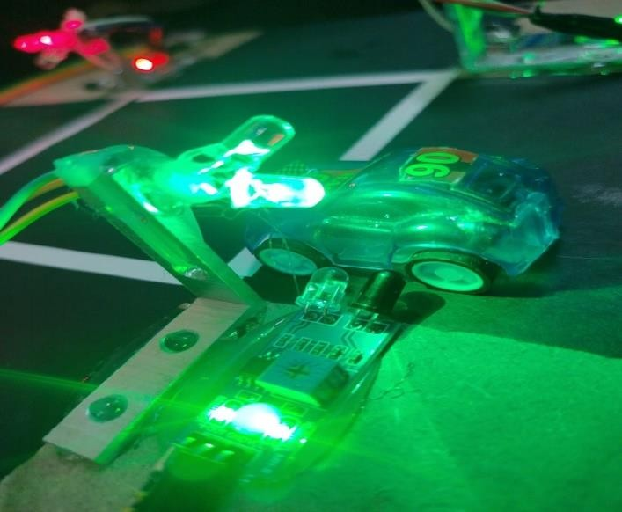

Fig.5 IR sensor and green light turns on by vehicle

# CONCLUSION

The Arduino and IR sensor-controlled traffic signal system provides a more effective way for ambulances to navigate traffic and reach hospitals. This technology can help ambulances escape traffic congestion, which is especially helpful in big cities. The technique prioritizes emergency vehicles and improves overall traffic control by allocating time periods based on the number of automobiles at multi- junction crossings. As a result, traffic congestion has successfully decreased. Finally, the concept encourages the integration of an Arduino and infrared sensor-based system to increase the effectiveness of traffic light control in urban settings. The current difficulties with traffic congestion, energy and fuel waste, pollution, and time inefficiencies underline the need for innovative solutions. The suggested intelligent traffic light control system, which can dynamically alter signals based on traffic conditions and functions in real-time, is meant to solve these issues. By prioritizing the effective operation of emergency vehicles and accounting for the complexity of pedestrian crossing lanes, the technique seeks to improve overall traffic management, reduce delays, and offer benefits to the economy, environment, and public health. The study emphasizes how important it is to put intelligent transportation technology into practice in order to meet the growing needs of urban mobility and create a more efficient and sustainable traffic infrastructure.

# REFERENCES

1. Praneeth, Mididoddi Sai, et al. "Smart signal control by detecting traffic intensity using IR Sensors." *2023* International Conference on Research Methodologies in Knowledge Management, Artificial Intelligence and Telecommunication Engineering *(RMKMATE)*. IEEE, 2023.
2. Atta, Ayesha, et al. "An adaptive approach: Smart traffic congestion control system." Journal of King Saud University-Computer and Information Sciences 32.9 (2020): 1012-1019.
3. SP, Krishnendhu, Prabu Mohandas, and Srijith CS. "Smart junction: advanced zone-based traffic control system with integrated anomaly detector." Annals of Operations Research (2023): 1-28.
4. Krishnendhu, S. P., & Mohandas, P. (2023). SAD: Sensor-based Anomaly Detection System for Smart Junctions. IEEE Sensors Journal.
5. Helmke, Hartmut, et al. "Automatic speech recognition and understanding for radar label maintenance support increases safety and reduces air traffic controllers’ workload." Fifteenth USA/Europe Air Traffic Management Research and Development Seminar (ATM2023). 2023.
6. Gupta, M., Miglani, H., Deo, P., & Barhatte, A. (2023). Real-time traffic control and monitoring. e-Prime-Advances in Electrical Engineering, Electronics and Energy, 5, 100211.
7. Rai, S.C., Nayak, S.P., Acharya, B., Gerogiannis, V.C., Kanavos, A. and Panagiotakopoulos, T., 2023. ITSS: An Intelligent Traffic Signaling System Based on an IoT Infrastructure. Electronics, 12(5), p.1177.
8. Akhil Ashok, A., and P. S. Ambili. "ARDUINO-BASED IOT SYSTEM WITH INFRARED SENSORS FOR REAL-TIME VEHICLE SPEED DETECTION." EPRAInternational Journal of Multidisciplinary Research *(IJMR)* 10.2 (2024): 366-369.
9. Rai, Km Manisha, and S. Vijayalakshmi. "Density Based Traffic Light Control Using IR Sensors and Arduino."
10. Sarala, T., S. V. Sunitha, and Ashwini S. Savanth. "Integrated Traffic Control System for Emergency Vehicles." *2024* International Conference on Intelligent and Innovative Technologies inComputing, Electrical and Electronics(IITCEE). IEEE, 2024.
11. Jahnavi, M., and M. Charan Sujay. "Traffic Congestion Management Using Intelligent Techniques."
12. Wided, Ali, Brek Assia, and Bouakkez Fatima. "Traffic Management system and Traffic Light Control in Smart City to Reduce Traffic Congestion." International Journal of Automation and Smart Technology 13.1 (2023): 2464-2464.
13. Rai, S.C., Nayak, S.P., Acharya, B., Gerogiannis, V.C., Kanavos, A. and Panagiotakopoulos, T., 2023. ITSS: An Intelligent Traffic Signaling System Based on an IoT Infrastructure. Electronics, 12(5), p.1177.