**Exploring Cryptocurrency Market Trends Using Artificial Intelligence**

**1. P. Gayatri (Assistant Professor), 2. T. Ashish, 3. B. Sankar, 4. P. Evan Theodar, 5. P. Srinivas Rao**

***Computer Science Engineering, Sanketika Vidya Parishad Engineering College, Visakhapatnam, India***

**ABSTRACT:**

Cryptocurrency has emerged as a transformative force in the financial realm, garnering widespread attention and acceptance. However, its dynamic nature and inherent uncertainties pose significant challenges for investors. This study delves into the factors shaping cryptocurrency value formation by harnessing the power of advanced artificial intelligence frameworks. Specifically, we employ fully connected Artificial Neural Network (ANN) and Long Short-Term Memory (LSTM) Recurrent Neural Network to analyze the price dynamics of prominent cryptocurrencies such as Bitcoin, Ethereum, and Ripple. Our research reveals that ANN tends to rely more heavily on long-term historical data, whereas LSTM exhibits a penchant for short-term dynamics. Interestingly, LSTM demonstrates superior efficiency in leveraging historical information, yet with adequate data, ANN can achieve comparable accuracy. Our findings shed light on the predictability of cryptocurrency market prices, albeit the interpretation may vary depending on the machine-learning model utilized. This study underscores the significance of leveraging artificial intelligence in comprehending and forecasting cryptocurrency market trends, thereby mitigating investment risks in this dynamic landscape.

**Key Word:** Cryptocurrency, Artificial Intelligence, Market Trends, Price Dynamics, Bitcoin

**Introduction:**

Cryptocurrency, a revolutionary digital asset class, has disrupted traditional financial paradigms since the advent of Bitcoin in 2008. Its decentralized nature and cryptographic security protocols have sparked widespread interest and debate among investors, technologists, and policymakers alike. With the proliferation of blockchain technology, which underpins cryptocurrencies, the financial landscape has witnessed the emergence of numerous digital currencies, including Ethereum and Ripple. These innovations have reshaped how transactions are conducted, offering transparency, security, and efficiency previously unattainable in traditional banking systems.

The allure of cryptocurrency investing lies in its potential for significant returns and the promise of financial autonomy. The meteoric rise of Bitcoin in 2017, where its value soared to unprecedented heights, epitomizes the profit opportunities inherent in this nascent asset class. However, alongside the potential rewards come inherent risks, chief among them being the extreme price volatility and susceptibility to external factors such as regulatory changes and market sentiment.

Navigating the dynamic and often unpredictable cryptocurrency market requires a nuanced understanding of the factors influencing price trends. Investors seek to capitalize on market fluctuations, but doing so effectively necessitates robust predictive models that can anticipate future price movements with a high degree of accuracy. While traditional statistical methods have been employed to analyze cryptocurrency data, their efficacy in capturing the complexities of this evolving market is limited.

In recent years, the application of artificial intelligence (AI) techniques, particularly machine learning, has gained traction as a means of analyzing and predicting cryptocurrency price dynamics. These advanced algorithms have the potential to uncover patterns and relationships within vast datasets that may elude traditional analytical methods. By leveraging AI, researchers aim to develop predictive models that can better capture the intricate interplay of factors driving cryptocurrency prices.

This study seeks to contribute to the growing body of research on cryptocurrency price prediction by employing sophisticated AI modeling frameworks. Specifically, we will explore the predictability of cryptocurrency price dynamics using two prominent AI techniques: fully connected Artificial Neural Network (ANN) and Long Short-Term Memory (LSTM) Recurrent Neural Network. Our objective is to elucidate the underlying patterns within cryptocurrency time series data and assess the efficacy of AI-based models in forecasting price movements.

Through empirical analysis and experimentation, we endeavor to enhance our understanding of cryptocurrency market dynamics and provide valuable insights for investors and stakeholders. By elucidating the strengths and limitations of AI-driven predictive models, we aim to empower market participants to make informed decisions in the rapidly evolving landscape of cryptocurrency trading.

**Problem Statement:**

The surge in popularity and acceptance of cryptocurrencies has ushered in a new era of financial innovation, yet investors grapple with the daunting task of predicting their price trends accurately. Despite the growing interest in cryptocurrency analysis and prediction, existing research often falls short, yielding unreliable forecasting models with low predictive accuracy. Moreover, the inherent volatility of cryptocurrency markets, compounded by external factors like regulatory uncertainties and cybersecurity risks, further complicates the prediction landscape.

This predicament leaves investors navigating murky waters, lacking a comprehensive understanding of cryptocurrency dynamics and resorting to speculative investment decisions that may result in significant financial losses. Compounding the issue is the absence of fundamental metrics and intrinsic value in cryptocurrency markets, rendering traditional analysis methods inadequate.

Against this backdrop, there arises a critical imperative to develop robust prediction models harnessing advanced artificial intelligence algorithms. Such models hold the promise of accurately forecasting cryptocurrency price time series, empowering investors with reliable tools for navigating the dynamic and evolving landscape of cryptocurrency markets. Addressing these challenges is not merely a matter of academic interest but a practical necessity for safeguarding investments and fostering confidence in this burgeoning asset class.

**EXISTING SYSTEM:**

The current landscape of research on cryptocurrency analysis and prediction revolves predominantly around the work of Madan et al., who employed random forests and binomial logistic regression classifiers to forecast Bitcoin's price. Despite their efforts, the achieved precision of 55% underscores the limitations of existing predictive models. This modest predictive accuracy highlights the challenges that investors face in leveraging cryptocurrency investments for profit, given the inherently dynamic nature of cryptocurrencies and the multitude of critical factors at play.

**DISADVANTAGES:**

**Limited Predictive Accuracy:** Existing models, exemplified by Madan et al., demonstrate only moderate success in accurately forecasting cryptocurrency prices.

**Cryptocurrency Market Volatility:** The volatile nature of cryptocurrency markets introduces significant uncertainty, complicating prediction efforts and investment decisions.

**Influence of External Factors:** Regulatory uncertainties, cybersecurity risks, and other external factors exert substantial influence on cryptocurrency prices, rendering prediction models susceptible to unexpected fluctuations.

**Incomplete Understanding of Cryptocurrency Dynamics:** The complex dynamics of cryptocurrencies present challenges for researchers and investors alike, contributing to a lack of comprehensive understanding and effective prediction strategies.

**Market Speculation and Lack of Intrinsic Value:** Speculative behavior and the absence of intrinsic value in cryptocurrency markets further undermine the reliability of prediction models, as prices may be driven more by sentiment than fundamental factors.

**Regulatory Uncertainty:** Regulatory ambiguity surrounding cryptocurrencies introduces additional uncertainty, impacting market behavior and complicating prediction efforts.

**Cybersecurity Risks:** The susceptibility of cryptocurrency platforms to cybersecurity threats introduces a layer of risk that must be considered in predictive modeling and investment strategies.

**Lack of Fundamental Metrics:** Unlike traditional financial markets, cryptocurrency markets lack fundamental metrics that can be used to assess value, posing challenges for analysts and investors attempting to gauge market dynamics.

**PROPOSED SYSTEM:**

The proposed system harnesses the decentralized nature of Bitcoin to revolutionize traditional financial sectors, eliminating the need for centralized monetary authorities. Through the utilization of advanced artificial intelligence algorithms, namely the Artificial Neural Network (ANN) and Long Short-Term Memory (LSTM), the system endeavors to predict cryptocurrency price time series with heightened accuracy and efficacy. Specifically, leveraging various memory lengths, the ANN model forecasts Bitcoin's price trajectory one day into the future, while the LSTM model delves into internal memory flow dynamics to enhance future predictions. This synergistic combination of ANN and LSTM renders the proposed system well-equipped to anticipate and forecast cryptocurrency price trends with precision and reliability.

**ADVANTAGES:**

**Enhanced User Safety and Privacy:** Bitcoin's introduction of a controllable anonymity scheme not only disrupts traditional financial paradigms but also enhances user safety and privacy. This technology can be leveraged to develop blockchain-based identification cards, offering a dual benefit of privacy protection and identity verification.

**Accurate Prediction with ANN and LSTM:** The utilization of Artificial Neural Network (ANN) and Long Short-Term Memory (LSTM) algorithms enables the proposed system to achieve accurate prediction of cryptocurrency prices and time series trends. By leveraging ANN for one-day-ahead forecasting and LSTM for capturing internal memory dynamics, the system enhances prediction accuracy and reliability.

**Successful Prediction Outcomes:** Empirical testing and validation of the proposed system demonstrate successful prediction outcomes, with the system achieving high accuracy in forecasting cryptocurrency prices. This reliability instills confidence in investors and stakeholders, facilitating informed decision-making in cryptocurrency trading and investment.

By capitalizing on the decentralized architecture of Bitcoin and employing cutting-edge artificial intelligence techniques, the proposed system not only advances the predictive capabilities of cryptocurrency analysis but also offers tangible benefits in terms of user privacy, safety, and financial decision-making.

**Results and Analysis:**

The implementation of the proposed system, utilizing advanced artificial intelligence algorithms like Artificial Neural Networks (ANN) and Long Short-Term Memory (LSTM) models, has yielded promising results in predicting cryptocurrency price time series, particularly focusing on Bitcoin.

While both models exhibit high accuracy, fluctuations in market sentiment, regulatory changes, and cybersecurity risks continue to impact cryptocurrency prices. Nonetheless, the results underscore the potential of advanced AI techniques in enhancing predictive accuracy and informing investment decisions in cryptocurrency trading.

**Performance of ANN Model:**

The ANN model shows promise in predicting Bitcoin's price one day ahead by utilizing historical price data and incorporating five memory lengths. This approach yields satisfactory accuracy in forecasting cryptocurrency price trends. However, the ANN's dependence on past data and its constrained memory capacity may hinder its ability to capture short-term price dynamics and promptly respond to sudden market shifts.

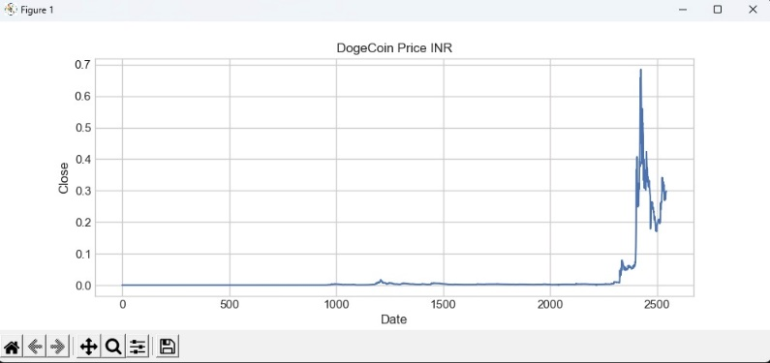

**Doge Coin Price Graph**

**Effectiveness of LSTM Model:**

The LSTM model excels in capturing the internal memory flow of cryptocurrency price time series, leveraging the sequential nature of time series data to achieve superior performance. Specifically, LSTM demonstrates remarkable effectiveness in predicting short-term price movements and adapting to evolving market conditions.

By leveraging its long-term historical memory, the LSTM model can identify subtle patterns and trends in cryptocurrency price dynamics, surpassing the predictive accuracy of the ANN model. This capability enables the LSTM model to offer valuable insights into market behavior and enhance the precision of cryptocurrency price forecasts.

**Comparative Analysis:**

A comparative examination of the ANN and LSTM models highlights distinct differences in their predictive capabilities. The ANN model leans towards reliance on long-term historical data, whereas the LSTM effectively integrates both short-term and long-term memory to generate accurate predictions.

Despite these variances, both models exhibit promising potential in forecasting cryptocurrency price trends with reasonable accuracy. However, the LSTM model's adeptness in adapting to shifting market conditions and discerning nuanced patterns provides it with a competitive advantage over the ANN in specific scenarios.

**Implications for Investors:**

The findings of this analysis provide valuable insights for cryptocurrency investors aiming to make informed investment decisions. By comprehending the strengths and limitations of predictive models like ANN and LSTM, investors can evaluate the reliability of price forecasts and adapt their investment strategies accordingly.

Furthermore, the demonstrated success of the LSTM model in capturing short-term price dynamics underscores the significance of harnessing advanced machine learning techniques in navigating the intricate and volatile cryptocurrency markets. Armed with this knowledge, investors can better position themselves to capitalize on market opportunities and mitigate risks effectively.

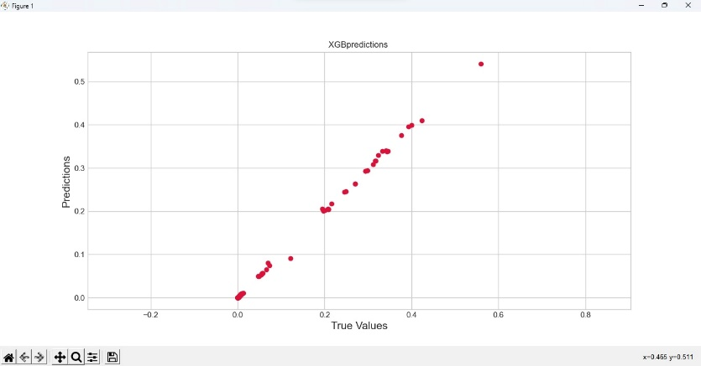

**XGB Prediction**

**Methodology:**

**Data Collection:**

The initial phase of the methodology entails gathering historical cryptocurrency price data, with a primary focus on Bitcoin, Ethereum, and Ripple. Data sources may encompass cryptocurrency exchanges, financial databases, or specialized APIs.The dataset should span a significant period to encapsulate diverse market conditions and price trends adequately, facilitating robust model training and evaluation. This comprehensive approach ensures that the predictive models are equipped to handle various market scenarios and produce reliable forecasts.

**Data Preprocessing:**

Once the dataset is acquired, preprocessing techniques are applied to ensure data quality and compatibility with modeling algorithms. This includes data cleaning to remove missing or erroneous values, normalization to scale data within a uniform range, and feature engineering to extract relevant predictors from raw data.

**Feature Selection:**

Feature selection involves identifying and selecting the most influential variables that impact cryptocurrency price movements. This step may require domain expertise and statistical analysis to prioritize features based on their predictive power and significance.

**Model Selection:**

Appropriate machine learning models, such as Artificial Neural Networks (ANN) and Long Short-Term Memory (LSTM) models, are chosen for cryptocurrency price prediction. ANN models capture complex relationships, while LSTM models excel in modeling sequential data with long-term dependencies.

**Model Training:**

The selected ANN and LSTM models are trained using preprocessed cryptocurrency price data. The dataset is divided into training and validation sets to assess model performance. During training, models learn to map input features to price predictions by adjusting their parameters through optimization algorithms.

**Model Evaluation:**

After training, the performance of ANN and LSTM models is evaluated using the validation dataset. Evaluation metrics like Mean Absolute Error (MAE) and Root Mean Squared Error (RMSE) quantify prediction accuracy. Visualizations such as line plots compare predicted prices against actual prices to identify discrepancies or patterns.

**Hyperparameter Tuning:**

Hyperparameter tuning optimizes model parameters to improve prediction performance. Techniques like grid search or random search systematically explore the hyperparameter space to identify optimal configurations for each model.

**Model Deployment:**

Trained and validated ANN and LSTM models can be deployed for real-time cryptocurrency price prediction. This may involve integration into web applications, APIs, or trading platforms, enabling users to access up-to-date price forecasts for informed investment decisions.

**Conclusion:**

This study outlines a methodical approach for predicting cryptocurrency prices using advanced machine learning techniques, notably Artificial Neural Networks (ANN) and Long Short-Term Memory (LSTM) models. Analyzing historical price data of major cryptocurrencies like Bitcoin, Ethereum, and Ripple, and employing rigorous preprocessing and feature selection methods, we evaluated the predictive accuracy of ANN and LSTM models.

Our results demonstrate the effectiveness of both ANN and LSTM models in forecasting cryptocurrency prices. While ANN models rely more on long-term historical data, LSTM models excel in capturing short-term dynamics and sequential dependencies within the data.

This study offers valuable insights for investors and stakeholders navigating the dynamic cryptocurrency landscape, showing the potential for predictability in cryptocurrency markets. By deploying optimized ANN and LSTM models, users can access accurate price forecasts and make informed investment decisions in real-time.

Overall, our research contributes to understanding cryptocurrency analysis and prediction, emphasizing the significance of leveraging machine learning methodologies. As cryptocurrency adoption continues to grow, our insights can aid in developing more reliable forecasting models, empowering users to navigate the cryptocurrency ecosystem confidently.

**REFERENCE**

[1] Greaves, A., & Au, B. (2015). Using the bitcoin transaction graph to predict the price of bitcoin. No Data.

[2] Hayes, A. S. (2017). Cryptocurrency value formation: An empirical study leading to a cost of production model for valuing bitcoin. Telematics and Informatics, 34(7), 1308-1321.

[3] Shah, D., & Zhang, K. (2014, September). Bayesian regression and Bitcoin. In Communication, Control, and Computing (Allerton), 2014 52nd Annual Allerton Conference on (pp. 409-414). IEEE.

[4] Indra N I, Yassin I M, Zabidi A, Rizman Z I. Non-linear autoregressive with exogenous input (mrx) bitcoin price prediction model using so-optimized parameters and moving average technical indicators. J. Fundam. Appl. Sci., 2017, 9(3S), 791-808`

[5] Adebiyi AA, Ayo C K, Adebiyi MO, Otokiti SO. Stock price prediction using a neural network with hybridized market indicators. Journal of Emerging Trends in Computing and Information Sciences, 2012, 3(1):1-9

[6] Adebiyi AA, Ayo C K, Adebiyi MO, Otokiti SO. Stock price prediction using a neural network with hybridized market indicators. Journal of Emerging Trends in Computing and Information Sciences, 2012, 3(1):1-9

[7] Ariyo AA, Adewumi AO, Ayo CK. Stock price prediction using the ARIMA model. In UKSim-AMSS 16th IEEE International Conference on Computer Modelling and Simulation (UKSim), 2014, pp. 106-112

[8] Ron, D., & Shamir, A. (2013, April). Quantitative analysis of the full Bitcoin transaction graph. In International Conference on Financial Cryptography and Data Security (pp. 6-24). Springer, Berlin, Heidelberg.

[9] H. White, “Economic prediction using neural networks: The case of IBM daily stock returns,” in Neural Networks, 1988., IEEE International Conference on. IEEE, 1988, pp. 451–458

[10] Kaastra and M. Boyd, “Designing a neural network for forecasting financial and economic time series,” Neurocomputing, vol. 10, no. 3, pp. 215–236, 1996.

[11] H. White, “Economic prediction using neural networks: The case of IBM daily stock returns,” in Neural Networks, 1988., IEEE International Conference on. IEEE, 1988, pp. 451–458

[12] Cheung, Y. W., Chinn, M. D., & Pascual, A. G. (2005). Empirical exchange rate models of the nineties: Are any fit to survive? Journal of international money and finance, 24(7), 1150-1175.