**Apple Leaf Disease Prediction Using Deep Learning Models**

*1Poorna Prakash S, 2Shanthini M,3Amrish Manickraj J, 4Hariharan A, 5Naresh S, 6 Suresh kumar A.*

*1,6Assistant Professor, Department of Computer Science and Engineering, Rathinam Technical Campus, Coimbatore-641021, India.*

*2,3,4,UG-Students, Department of Computer Science and Engineering, Rathinam Technical Campus, Coimbatore-641021, India.*

--------------------------------------------------------------------------------------------------------------------------

**Abstract**

In India, nearly two lakh people rely on apple production for a living, with apples accounting for approximately 16% of GDP in their respective states. Although apple production is second only to that of other fruits in terms of volume, it generates more revenue. In addition, India ranks fifth in total apple production worldwide. As a result, the apple is a fruit that has a significant impact on our economic situation. Apple productivity is primarily influenced by leaf diseases such as scab, cedar rust, black rot, and others. To prevent apple leaf diseases from spreading throughout the tree, it is critical to detect them in their early stages of infection. We proposed a convolutional neural network methodology to accurately and efficiently detect these leaf diseases.

The image pre-processing and augmentation methods help us distinguish the region of interest from the background. We then trained and validated our dataset of apple leaf images by applying deep learning algorithms. The DenseNet algorithm, which has a 98.42% accuracy rate, is used to label the leaf diseases in our model.

**Introduction**

The standard of the product in agriculture sector has been severely disturbed by diseases that influence plants. If the cause of infection is not identified and treated at prior stage, it may result in the reduction of yield production and affect the quality. Farmers face a huge difficulty to stop the infection to spread to the whole plant. Pests can be an effective option to reduce the infection. But the detection of disease in plant is essential to understand which type of pest should be used. Most of the farmers are dishearten due to the reduction of yield caused by the disease in leaves and leave farming.

Generally, the disease can be easily diagnosed with the plain sight. Proficient farmers can effortlessly detect disease nevertheless it has certain drawback concentration, which includes reduction of accuracy to keep up the standard, repetition of instruction and increase in cost. Moreover, it can be a complex job for the farmer to identify disease on an enormous area. Many of the disquets can be prevented by integration of image processing method and pattern recognition. In [2] it shows that the CNN algorithm was used to train an entire network using a new ROI subnetwork. [4] and [5] use the VGG16 technique in conjunction with a deep learning network to detect apple leaf diseases.

We have observed and analysed various models and created a CNN deep learning network that can distinguish between scab, black rust, cedar rust, and healthy leaves. A comparison of the DenseNet and AlexNet algorithms was also performed in order to study the significance of fully connected layers and image processing techniques and to develop a model that performs significantly better.

**Literature Survey**

[1] Apple leaf disease is predicted with a mechanism of 5 steps which includes description of the selected dataset, processing the image and segmenting the images followed by the feature extraction and eventually classifying the images using Support Vector machine. The depletion of noise is done by Gaussian smoothing filter. Following the elimination of noise, the Region of Interest depicts the area in leaf that is infected. While [3] recommended an approach that segments the extracted dimensions with an approach of heterogeneous Internet of things. The model in [6] uses a methodology to identify the disease in apple leaves by a residual network-based MSO-ResNet model, which is based on a network-ResNet50. The increment of recognition correctness and the pace of model is done by perishing Convolutional Network kernel, updation of identity mapping procedure, numerical reduction of residual modules, and substitution of the batch normalisation layer.

In [7] a technique of Deep Learning is used for the real-time diagnosis of diseases that affects the Apple leaves using augmented Convolutional Model. Similarly [8] uses a CNN model DF-Tiny-YOLO solution of systems for the identification of disease in apple leaves, the convolution kernels are used by network terminal to stipulate the reduction of feature dimension and extension of network without boosting computer difficulty, hence boosting the achievement and, [9] and [14] also identifies the leaf diseases by CNN models like RegNet and AlexNet respectively. Also [10] suggested an efficient approach by applying fuzzy C-Means segmentation in addition to CNN that assists in detection of Apple leaf disease and both [13] and [19] a comparison is made on two algorithms which are EffecientNet and DenseNet121 under Convolution Neural Network (CNN) model grounded on the working of other State of the Art models with their corresponding correctness and exactness, has a finer achievement of performance compared to other models.. Whereas [22] does CNN approach with a combination of both algorithms Xception and DenseNet for the identification of disease in infected leaves.

We have [11] which proposed a technique of hyperspectral analysis for the identification of fire blight and differentiates three distinct category of leaves which includes infected leaves, dry leaves and leaves that are healthy. the suggested technique for the recognition of disease in apple leaves has exhibited to be a best approach by the effective connection in addition to content of leaf water that plays an efficient part in the establishment of infection.[12] suggested an approach which employs a computer system vision-based model for the recognition of disease in apple leaves. The infected area was recognized by using color-codes for segmentation.

[15] and [16] uses CNN methodology where the former has two different stages where in first stage the images are categorized and in next stage it is processed, while the latter has MEAN-SSD approach which achieves by recognizing 5 common diseases in Apple leaves accurately.[21] uses ResNet and Visual Geometry Group CNN model and [23] incorporates execution of VGG16, a CNN based method is used for the classification of disease. The primary aim of the proposed technique is to subdue the difficulty during the classification of apple leaf disease.

**Methodology**

A convolutional neural network (CNNs) has been suggested to detect apple plant disease detection system using the algorithm DenseNet and AlexNet that predicts the disease with a higher accuracy.

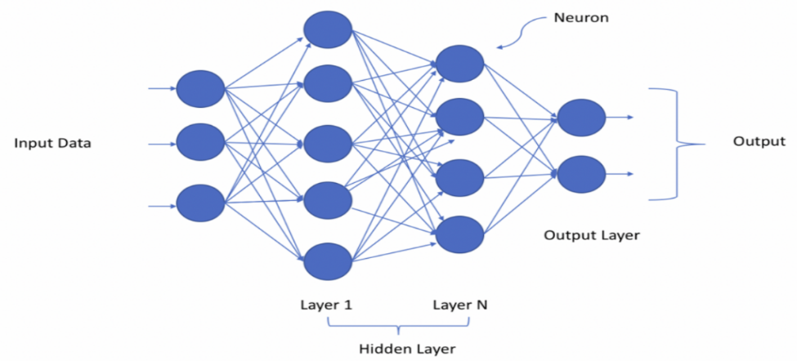

**DenseNet**

The deep learning model DenseNet is used to identify the apple leaf disease detection. DenseNet is an image classification algorithm, developed to handle the issue of vanishing gradient problem. Deep neural network contains plenty of hidden layers amidst input and output layer. Due to the extensive path between input layer and output layer, the detail vanishes prior it reaches its destination DenseNet overcome the vanishing gradient complexity and provide high accuracy by simply connecting every layer straight with each other DenseNet comprise 4 dense blocks where each block consist distinct amount of convolution layer in dense block each layer acquires the feature map from the preceding layer.

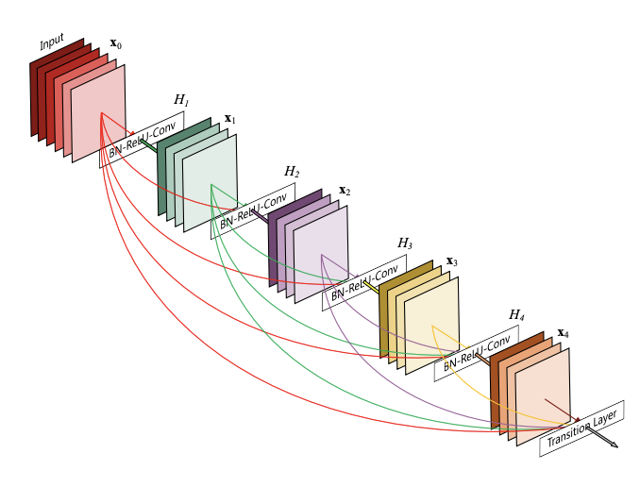

**AlexNet**

AlexNet architecture is used for detecting object and have various applications in computer vision section. It consists of 8 layers where 5 layers are convolution layers and other 3 layers are fully connected layers. The input size AlexNet accept is 227x227x3 where 3 represent to coloured image. 96 filters are applied by the first layer of 11x11 with stride of 4 pixels. After image is passed to the convolution layer, mathematical operation is performed. The formula that gets applied after every convolution layer is (n + 2p –f)/s + 1 where n=size of image, p= padding, f=filter and s=stride.

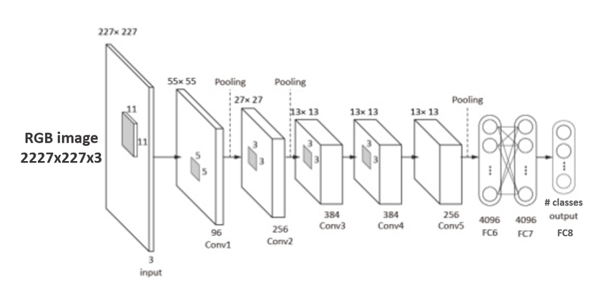

**Experiment analysis and results**

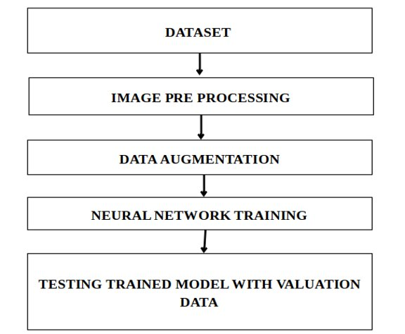

**Dataset collection:**

The gathering of images for the dataset were downloaded from the Internet, searched by name on various sources. There are 5828 images in the dataset which include the disease Black rot, Cedar rust, Scab and healthy leaves.

**Distribution of classes in our dataset**

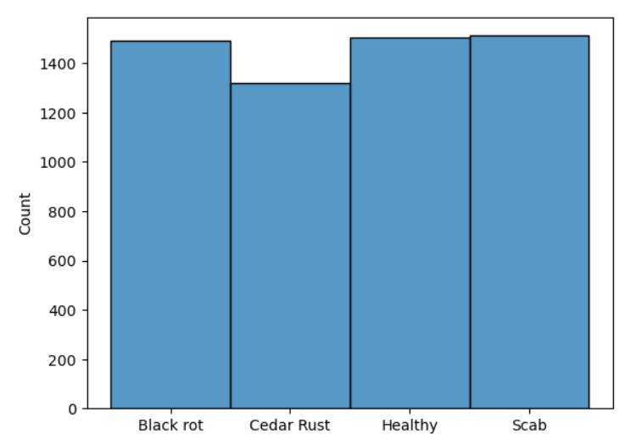

**Healthy leaves**

From the below image it is visible that healthy leaves do not contain any spot marks and are entirely in green colour.

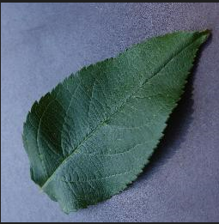

#### **Scab**

Apple scab is the common disease and is caused by a fungus. The affected leaves contain brown spots in it.

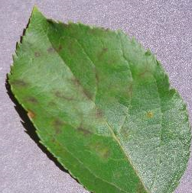

**Cedar Rust**

Cedar Rust develop light yellow spots as shown in the below image.

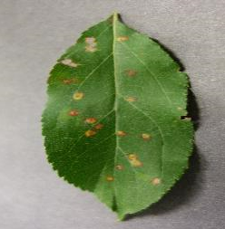

**Black Rot**

The leaves affected by Black Rot contains light brown patches.

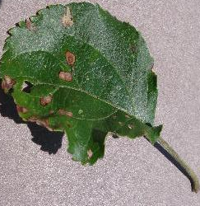

**Image Pre-processing**

Image pre-processing are the steps taken to clean raw images into format image that best upgrade the required model images might be of various size with distinct contrast levels where image pre-processing makes sure that all image dataset is equally formatted. One of the fundamental ideas in image pre-processing is image filters which is applied to subdue the dominant frequency in the image by smoothening the image or by lowering the frequency an image can be filtered either by utilizing a frequency domain or a spatial domain.

**Augmentation**

Augmentation is the process of transforming the input image into various distinct images by flipping, horizontal shifting, vertical shifting, zoom in, zoom out, adding noise. Data Augmentation generates data that solves the problem of data gathering which is a difficult and exorbitant process. It also minimizes the chance of overfitting. It works well for classifying images and recognizing objects.

**Neural Network Training**

Neural Network takes the data and train themselves to acknowledge the patterns and then forecast the output for the new set of alike data. They are composed of nodes which include input layer, hidden layer and output layer. The connection amidst the nodes determines how much influence each input has on the output. Neural networks consist layers of neuron. Neuron are the core processing unit of the network. All neurons are interconnected with a network which helps in data flow and processing it.

**Testing training model with valuation data**

When a model is built by applying deep learning or other means it is predominant to validate it with a test data set. The below image shows that our model has predicted the right disease.



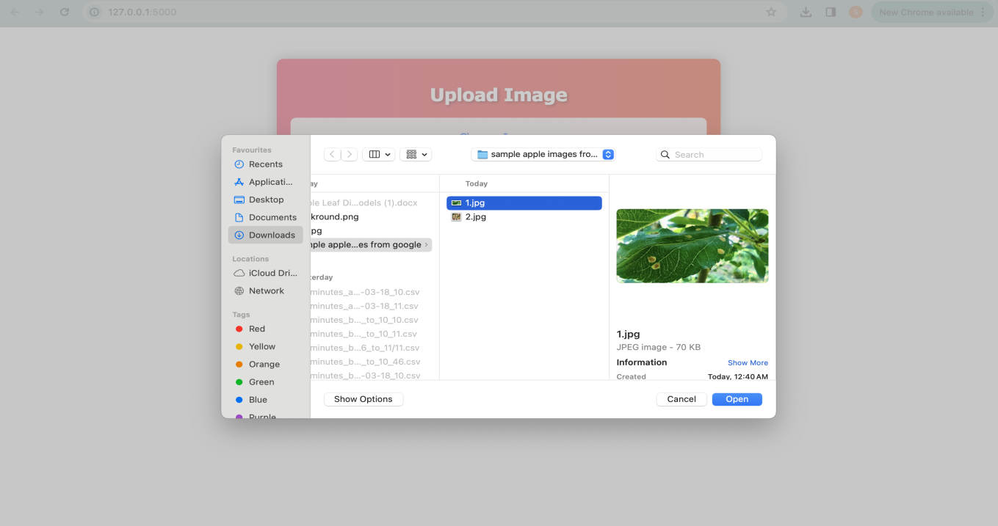



**Results**

In this proposed system the comparison between AlexNet and DenseNet is done to obtain better accuracy on apple leaf disease dataset.

**Conclusion**

In this paper, we have suggested a deep learning approach to identify disease in apple leaves using DenseNet and AlexNet algorithms and examined the performance of both the algorithms. The dataset incorporates 5828 images of both healthy and infected apple leaves which includes Black rot, Cedar rust and Scab.

We have done a comparative research between DenseNet and AlexNet methodologies to find the train accuracy and validation accuracy with validation loss and train loss.The accuracy of DenseNet and AlexNet algorithm have been observed, where the accuracy for AlexNet is 95.47% and for DenseNet is 98.42%. From this above accuracy measures we can infer that DenseNet algorithm performs and classifies the data better compared to AlexNet algorithm when the model is trained and tested.

**References**

[1] S. Chakraborty, S. Paul and M. Rahat-uz-Zaman, "Prediction of Apple Leaf Diseases Using Multiclass Support Vector Machine," 2021 2nd International Conference on Robotics, Electrical and Signal Processing Techniques (ICREST), 2021, pp. 147-151

[2] Hee-Jin Yu, & Chang-Hwan Son. (2019). Apple Leaf Disease Identification through Region-of-Interest-Aware Deep Convolutional Neural Network. Cornell University - ArXiv.

[3] Sanjeevi Pandiyan, Ashwin, M., Manikandan, R., Karthick Raghunath, K. M., & Anantha Raman, G. R. (2020). Heterogeneous Internet of things organization Predictive Analysis Platform for Apple Leaf Diseases Recognition. Computer Communications, 154, 99–110.

[4] M. Agarwal, R. K. Kaliyar, G. Singal and S. K. Gupta, "FCNN-LDA: A Faster Convolution Neural Network model for Leaf Disease identification on Apple's leaf dataset," 2019 12th International Conference on Information & Communication Technology and System (ICTS), 2019, pp. 246-251.

[5] Fang, T., Chen, P., Zhang, J., & Wang, B. (2019). Identification of Apple Leaf Diseases Based on Convolutional Neural Network. Intelligent Computing Theories and Application, 553–564.

[6] Yu, H., Cheng, X., Chen, C., Heidari, A. A., Liu, J., Cai, Z., & Chen, H. (2022, January 28). Apple leaf disease recognition method with improved residual network - multimedia tools and applications. *SpringerLink*. Springer US.

[7] P. Jiang, Y. Chen, B. Liu, D. He and C. Liang, "Real-Time Detection of Apple Leaf Diseases Using Deep Learning Approach Based on Improved Convolutional Neural Networks," in IEEE Access, vol. 7, pp. 59069-59080, 2019.

[8] Di, J., & Li, Q. (2022). A method of detecting Apple leaf diseases based on improved convolutional neural network. PLOS ONE, 17(2), e0262629.

[9] Li, L., Zhang, S., & Wang, B. (2021). Apple Leaf Disease Identification with a Small and Imbalanced Dataset Based on Lightweight Convolutional Networks. Sensors, 22(1), 173.

[10] Yadav, D., Akanksha, & Yadav, A. K. (2020). A Novel Convolutional Neural Network Based Model for Recognition and Classification of Apple Leaf Diseases. Traitement Du Signal, 37(6), 1093–1101.