**Aromatherapy:**

**A Comprehensive Review**

*Author 1. Shaik Asif*

*Author 2. Nada Fathima*

*Department: Pharmacy*

*College: Joginpally B.R college of Pharmacy*

*Country: India*

*Corresponding Author: Shaikaseef3100@gmail.com*

**ABSTRACT**

Aromatherapy is a holistic healing treatment that uses natural plant extracts, known as essential oils, to promote physical, emotional, and mental well-being. This review article presents a comprehensive overview of the practice of aromatherapy, including its properties, types, applications, and overall benefits. Through a review of the existing literature, we explore the potential therapeutic uses of essential oils, their modes of application, and their potential efficacy in treating a variety of health conditions. This review aims to provide a well-rounded understanding of aromatherapy and its applications while highlighting both the advantages and potential risks of using essential oils.

**INTRODUCTION**

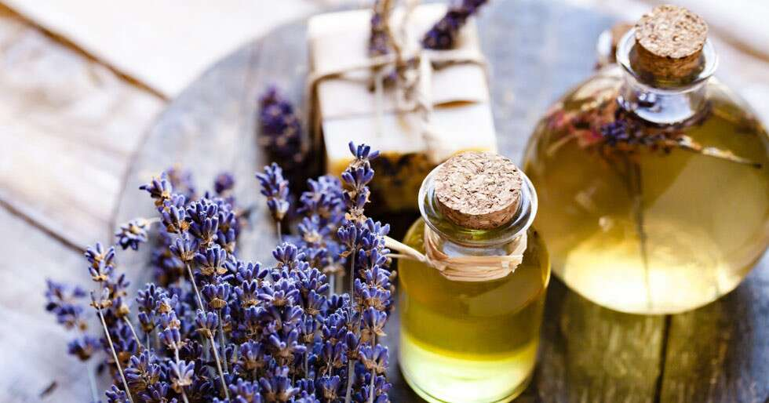

Aromatherapy is a therapeutic approach that utilizes aromatic compounds, specifically essential oils, to enhance health and well-being. Essential oils are volatile, concentrated extracts from plants, including leaves, flowers, roots, and bark, among other parts. Aromatherapy's origins can be traced back thousands of years to ancient civilizations such as Egypt, China, and India, where fragrant plants and oils were used for medicinal and religious purposes.

**Properties of Essential Oils**

Essential oils are highly concentrated substances derived from various plants, and they contain a complex mixture of chemical compounds such as terpenes, esters, aldehydes, ketones, and alcohols. These compounds give essential oils their unique aroma and therapeutic properties.

**Essential oils may exhibit a variety of beneficial properties, including:**

**Antimicrobial**: Some oils exhibit antibacterial, antifungal, and antiviral properties.

**Anti-inflammatory**: Certain oils can help reduce inflammation and pain.

**Sedative**: Many essential oils have calming and soothing effects, making them useful for managing anxiety and sleep disorders.

**Expectorant**: Some oils can help clear the airways and aid in respiratory health.

**Digestive**: Essential oils may assist in digestion and alleviate gastrointestinal discomfort.

**Uplifting**: Certain essential oils can promote mood enhancement and emotional well-being.

**Types of Essential Oils**

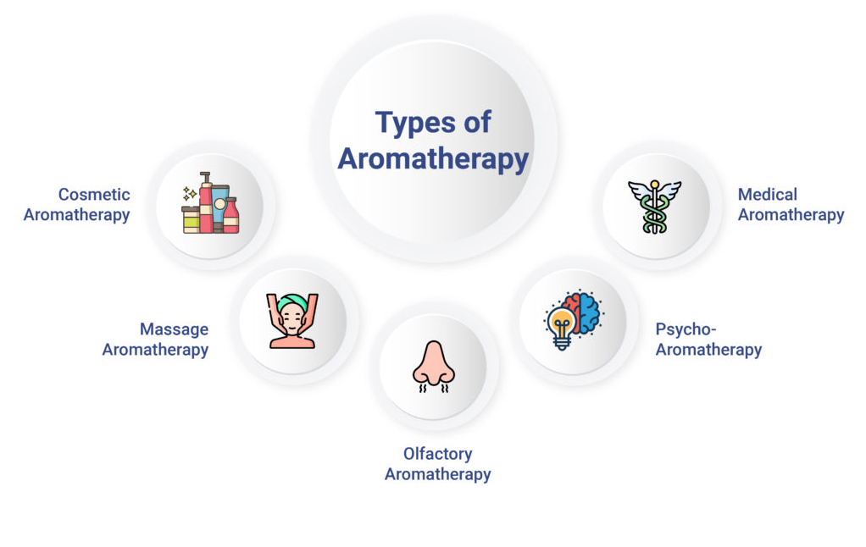

There are various types of essential oils derived from different plant sources, each with unique properties and potential applications. Some of the most common types include:

**Lavender**: Known for its calming and soothing effects, lavender oil is often used for stress relief, anxiety, and sleep disorders.

**Peppermint**: Known for its cooling and invigorating properties, peppermint oil can help relieve headaches and digestive issues.

**Eucalyptus**: Eucalyptus oil is often used to support respiratory health and clear congestion.

**Tea Tree**: Known for its antibacterial and antifungal properties, tea tree oil is used in skin care and hygiene products.

**Chamomile**: Chamomile oil is known for its anti-inflammatory and calming effects, often used for skin irritations and digestive issues.

**DISCUSSION**

Aromatherapy is a versatile practice with a variety of potential benefits, but its efficacy and safety depend on the type of essential oils used and their application methods. While many essential oils have been used in traditional medicine for centuries, scientific research on the therapeutic benefits and potential risks of essential oils is ongoing.

**Evidence of Efficacy**

Studies have shown that aromatherapy can be effective in managing various health conditions, such as:

**Anxiety and Stress**: Lavender, chamomile, and bergamot oils have been found to reduce anxiety and promote relaxation in multiple clinical trials.

**Pain Management**: Essential oils such as peppermint and eucalyptus have shown potential in relieving muscle and joint pain, as well as headaches.

**Sleep Disorders**: Lavender oil has been widely studied for its ability to improve sleep quality and reduce insomnia.

**Respiratory Issues**: Eucalyptus and peppermint oils have been found to help clear airways and reduce symptoms of asthma and bronchitis.

**Safety and Risks**

While aromatherapy can offer a range of health benefits, it is important to note that essential oils can also pose risks if not used correctly. Possible adverse effects include skin irritation, allergic reactions, and toxicity if ingested or used in excessive amounts. Proper dilution and consultation with a qualified practitioner are recommended when using essential oils.

**APPLICATIONS**

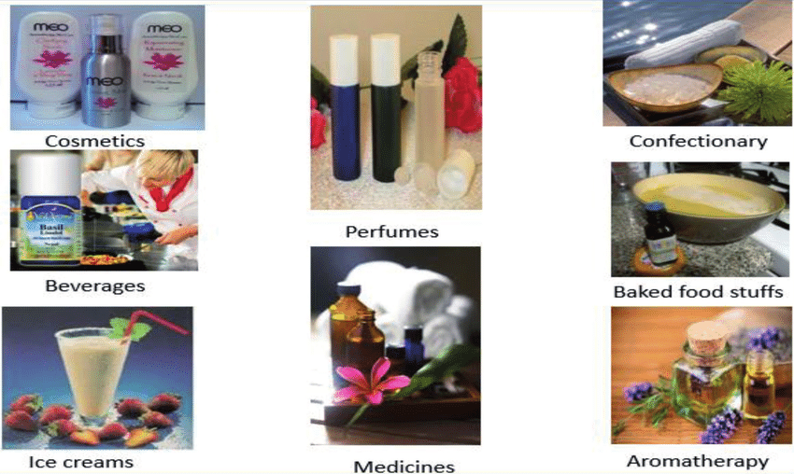

Aromatherapy can be applied in various ways to achieve different therapeutic outcomes. Here are four common applications of essential oils:

**1. Inhalation**

Inhalation is one of the most common methods of aromatherapy application. Essential oils can be diffused into the air using a diffuser or inhaled directly from a tissue or inhaler. This method is effective for mood enhancement, respiratory support, and stress relief.

**2. Topical Application**

Topical application involves applying essential oils directly to the skin. Essential oils should be diluted with a carrier oil, such as jojoba or almond oil, to prevent skin irritation. Topical application can be used for pain management, skin conditions, and relaxation.

**3. Massage**

Aromatherapy massage combines the benefits of massage therapy with the therapeutic properties of essential oils. Essential oils are diluted in a carrier oil and applied during a massage to enhance relaxation, relieve muscle tension, and promote overall well-being.

**4. Bathing**

Adding essential oils to bathwater is a relaxing way to use aromatherapy. Oils should be properly diluted in a dispersing agent, such as milk or Epsom salts, to avoid direct contact with the skin. Bathing with essential oils can promote relaxation, relieve stress, and soothe skin conditions.

**CONCLUSION**

Aromatherapy is a holistic practice with a wide range of potential therapeutic benefits. Essential oils can offer relief for conditions such as anxiety, pain, and respiratory issues. However, it is essential to use these oils with caution and proper knowledge to avoid adverse effects. Further research is needed to fully understand the safety, efficacy, and optimal uses of essential oils. Despite this, aromatherapy remains a valuable complementary approach in promoting health and well-being.

**REFERENCES**

1. Adams, M. P., & Peterson, G. M. (2015). Essential oils and aromatherapy: Basic principles and recent advances. Australian Journal of Pharmacy.

2. Ali, B. A., Al-Wabel, N. A., & Shams, S. (2015). A review of the efficacy and safety of essential oils. Journal of Environmental Science and Health, Part C.

3. Bensafi, M., Brown, W. M., Maincent, G., & Rouby, C. (2004). Gender effects in cognitive and emotional processing of odors. **Brain Research Bulletin**, 62(4), 381–388.

4. Buchbauer, G., Jäger, W., & Jirovetz, L. (1991). Aromatherapy: Evidence for sedative effects of the essential oil of lavender after inhalation. Zeitschrift für Naturforschung C.

5. Burnett, K. M., Solterbeck, L. A., & Strapp, C. M. (2004). Scent and mood state following an anxiety-provoking film. Psychological Reports.

6. Cavanagh, H. M., & Wilkinson, J. M. (2002). Biological activities of lavender essential oil. Phytotherapy Research.

7. Diego, M. A., Jones, N. A., Field, T., Hernandez-Reif, M., & Schanberg, S. (1998). Aromatherapy positively affects mood, EEG patterns of alertness and math computations. International Journal of Neuroscience.

8. Fukunishi, I., & Kikuchi, S. (1997). Effect of lavender aroma on occupational stress in clinical nurses. Psychiatry and Clinical Neurosciences.

9. Goel, N., & Grasso, D. J. (2004). Olfactory discrimination and transient mood change in young men and women: Variation by season, mood state, and time of day. **Chronobiology International**, 21(5), 691–719.

10. Haze, S., Gozu, Y., Nakamura, S., Kohno, Y., & Sawano, M. (2002). Effects of fragrance administration on mood states and cognitive performance. Chemical Senses.

11. Heuberger, E., Hongratanaworakit, T., & Böhm, C. (2006). Effects of chiral fragrances on human autonomic nervous system parameters and self-evaluation. Journal of Neuroendocrinology.

12. Herz, R. S., & Engen, T. (1996). Odor memory: Review and analysis. Psychonomic Bulletin & Review.

13. Howard, S., Hughes, B. M., & Thompson, W. M. (2004). Adverse events and effects of essential oils. Clinical Toxicology.

14. Jäger, W., & Höferl, M. (2003). Theoretical and practical considerations of interactions between essential oils and the biological environment. Journal of Ethnopharmacology.

15. Kane, R. C., & Davidson, J. A. (1987). Aromatherapy: An alternative and complementary therapy for the management of emotional disorders. Journal of Holistic Nursing.

16. Kim, M. J., Lee, Y. W., Kim, J., & Kim, C. (2008). The effect of lavender oil on stress and sleep quality in postpartum women. Journal of Alternative and Complementary Medicine.

17. Klemm, P., Wong, D. L., & Duft, B. (1993). Aromatherapy for the reduction of preoperative anxiety in adolescent patients. Journal of Perianesthesia Nursing.

18. Komiya, M., Takeuchi, T., & Harada, E. (2006). Effects of citrus fragrance on immune function and depressive states. Neuroimmunomodulation.

19. Lehrner, J. P., Eckersberger, C., Walla, P., Pötsch, G., & Deecke, L. (2000). Ambient odor of orange in a dental office reduces anxiety and improves mood in female patients. Physiology & Behavior.

20. López, V., Martin, S., Gómez-Serranillos, M. P., Carretero, M. E., & Jímenez, J. (2009). Neuroprotective and neuromodulatory properties of lavender essential oil. Journal of the American College of Nutrition.

21. McMahon, S. (2005). The benefits of aromatherapy in enhancing physical and mental health. **The Journal of Holistic Nursing**, 23(4), 302–309.

22. Moss, M., Cook, J. M., Wesnes, K., & Duckett, P. (2003). Aromas of rosemary and lavender essential oils differentially affect cognition and mood in healthy adults. **International Journal of Neuroscience**, 113(1), 15–38.

23. Perry, N. B., Anderson, R. E., Brennan, N. J., Douglas, M. H., & Heaney, A. J. (1999). Essential oils from New Zealand manuka: Triketone and other chemotypes of Leptospermum scoparium. **Phytochemistry**, 50(3), 407–415.

24. Silva, J., Abebe, W., & Rose, M. S. (2007). Essential oils and their clinical applications: A review. Journal of Alternative and Complementary Medicine.

25. Soares, L. M., Maia, J. G. S., & Figueiredo, P. L. (2004). Essential oils of Brazilian ginger species (Zingiberaceae): A review. Journal of Essential Oil Research.

26. Stasiak, J., Hiller, W., & Klieger, D. (2008). Assessing the validity of an aromatherapy questionnaire. Journal of Holistic Nursing.

27. Tarhan, L., Ustün, Y., & Koçak, G. (2011). The effect of lavender oil inhalation on the pain in women after an episiotomy: A randomized clinical trial. Complementary Therapies in Medicine.

28. Wake, G., Court, J., Pickering, A., & Lewis, S. (2000). CNS acetylcholine receptor activity in European medicinal plants traditionally used to improve failing memory. Journal of Ethnopharmacology.

29. Werbach, M. R. (1997). Nutritional influences on illness: A sourcebook of clinical research. Thieme Medical Publishers.

30. Worwood, V. A. (1991). The complete book of essential oils and aromatherapy. New World Library.