Assistance Internet of Things and Machine Learning Technology for Challenged People

**Vipanchika V S1, Shilpa V S2, Dr. S. Swapna Kumar3**,

*1,2B.Tech IV-Year, Department of Electronics and Communication Engineering, Vidya Academy of Science and Technology Thrissur, Kerala, India*

*3Professor & HoD, Department of Electronics and Communication Engineering, Vidya Academy of Science and Technology Thrissur, Kerala, India*

*vipanchikavs@gmail.com1, vssilpa03@gmail.c2, [swapnakumar.s@vidyaacademy.ac.in](mailto:drsswapnakumar@gmail.com)3,*

***Corresponding author:*** *vipanchikavs@gmail.com\**



***Abstract:*** *Assistive technologies powered by IoT (Internet of Things) and ML (Machine Learning) hold immense potential to enhance the quality of life for individuals with disabilities through tailored solutions. Wearable sensors integrated with IoT technology can detect falls or health issues and promptly notify caregivers or emergency services. IoT facilitates seamless connectivity among devices, enabling real-time data collection from sensors embedded in various assistive devices like smart prosthetics, wearable sensors, and environmental monitoring systems. Integration with the Blynk app allows for GPS tracking for live location monitoring, heart rate monitoring for emergencies, and accelerometer-based fall detection, enhancing user security within the Blink ecosystem. Machine learning algorithms play a vital role in adapting assistive technology to individual needs, learning user preferences, anticipating needs, and delivering personalized assistance. ML models are trained on databases of known facial images for tasks such as face recognition. The fusion of IoT and ML technologies holds the potential to transform assistive solutions, offering increased autonomy, efficiency, and effectiveness in addressing the diverse needs of individuals with disabilities.*

***Keywords****: Alzheimer's disease, Facial recognition, GPS tracking, Health monitoring, IoT, Machine Learning.*



## INTRODUCTION

Age-related disorders, including dementia and Alzheimer's disease (AD) [1], pose significant challenges, but by addressing the needs of Alzheimer's patients and mitigating adverse effects, quality of life can be maintained. Aging, physiological changes, and mental illnesses such as dementia and cognitive impairment are strongly linked with advancing age. Dementia, a prevalent neurological condition among the elderly, is characterized by long-term, degenerative brain deterioration that impairs cognitive function.

Alzheimer's disease, a progressive brain disorder, is distinguished by alterations leading to the accumulation of specific proteins in the brain, resulting in brain shrinkage and cell death. It is the most common form of dementia, leading to gradual declines in memory, reasoning, behavior, and social skills [2], significantly impacting daily functioning. Alzheimer's affects over 6.5 million Americans aged 65 and older, with more than 70% being 75 or older. Globally, 60% to 70% of the 55 million dementia cases are attributed to Alzheimer's. Early symptoms include forgetfulness and memory loss, eventually leading to impaired daily function. While medication may slow symptom progression, there is currently no cure for Alzheimer's disease. In advanced stages, dehydration, malnutrition, or infection can exacerbate cognitive decline, posing potentially life-threatening complications.

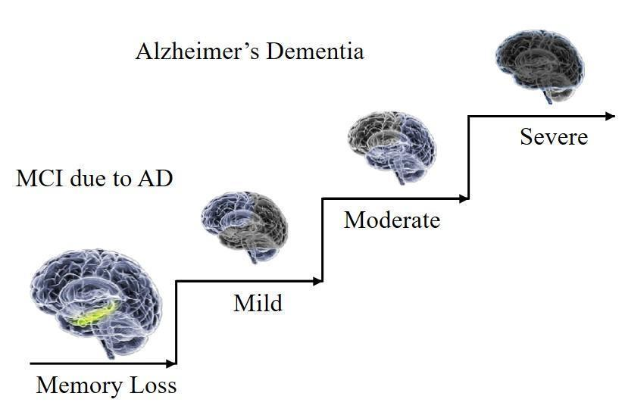

Figure 1: Stages of Alzheimer disease [3].

Utilizing our innovative technology, we seamlessly integrate GPS functionality to provide real-time location updates, enhancing safety and security. With an integrated heart rate sensor, users can promptly trigger notifications in case of emergencies. Moreover, the accelerometer automatically detects falls and alerts caregivers or emergency services without delay. This comprehensive system prioritizes user needs, enabling individuals to navigate their daily lives with ease and confidence.

Our groundbreaking technology effortlessly integrates GPS capabilities, delivering real-time position updates to enhance security and safety. Users can swiftly respond to emergencies by activating alarms with the integrated heart rate sensor. In the event of a fall, the accelerometer detects the occurrence and promptly notifies caregivers or emergency services. This comprehensive solution prioritizes user well-being, facilitating comfort and confidence in everyday life.

In the early stages of the illness, patients may experience forgetfulness and difficulty recalling the names of friends and family members [4]. As the condition progresses, they may also struggle to remember recently studied information and experience sleep disturbances, often due to syntactic compression. In the advanced stages, patients may become paranoid and exhibit total speech paralysis, often misinterpreting and reacting negatively to caregiver communication attempts.

Modern devices primarily focus on patient tracking using Global Positioning System (GPS) modules [5], alerting caregivers if patients exceed predetermined boundaries. Caregivers receive the patient's coordinates from the device, with outdoor tracking being more feasible than indoor tracking due to accuracy limitations. Individuals with heart issues or athletes should monitor their heart rates closely. While electrocardiography provides the most accurate measurement, heart rate monitors offer a simple alternative. Available in various forms such as smart watches, smartphones, and chest straps, heart rate sensors measure heartbeats per minute (bpm). In this project, we demonstrate heart rate monitoring using pulse oximetry. By prioritizing user well-being through specialized heart rate monitoring for stressful situations, our device solutions promote security and confidence in managing daily challenges.

Heart Rate Monitoring System [6]: Heart rate is assessed using an electrical device called a heart rate sensor. Regulating body temperature, heart rate, and blood pressure are fundamental aspects of maintaining health. Heart rate can be monitored using either a heart rate monitor or manually by checking the pulse on the wrist or neck. In this project, we utilize a pulse oximeter to measure heart rate by placing it on the fingers. Individuals with heart conditions or athletes should monitor their heart rates closely. While electrocardiography provides the most accurate measurement, using a heart rate monitor is the simplest method. Available in various forms such as smart watches, smartphones, and chest straps, heart rate sensors measure heartbeats per minute (bpm), indicating how often the heart contracts or expands per minute. In this project, we demonstrate heart rate monitoring using pulse oximetry.

Fall Detection Device for Elderly [7]: The fall detection device includes an alert system to provide immediate assistance to individuals at risk of falling. If a fall occurs, the system swiftly triggers the sensor. Depending on the device, the integrated technology can be worn on the wrist, neck, or both. The fall detection system utilizes accelerometers, a type of low-power radio wave technology sensor, to continuously monitor the user's movements. Many modern fall detection devices, including smartphones and smart watches, employ three-axis accelerometers. Equipped with an integrated three-axis accelerometer and a proprietary algorithm developed by Biosensor, certain fall detection systems can accurately detect falls by identifying sudden changes in body movement. The device assesses factors such as posture, physical activity, and movement acceleration to determine if a fall has occurred. If the parameters indicate a fall, the smart device automatically activates the emergency fall alarm and contacts emergency services for assistance.

Wearable technology plays a crucial role in IoT applications aimed at monitoring elderly individuals and Alzheimer's patients. These devices not only track vital signs such as blood pressure, oxygen saturation, and heart rate but also detect falls and accidents [8]. Furthermore, they provide location tracking, particularly beneficial for individuals with cognitive impairments who may wander. IoT technology facilitates real-time access to patient condition data for medical professionals, enabling proactive monitoring of vital signs, location, and activity to prevent emergencies and hospitalizations. Caregivers receive instant notifications in case of any anomalies, allowing for prompt intervention and appropriate treatment. Despite its significant potential, IoT technology faces challenges and limitations. Privacy and security concerns arise as IoT devices collect sensitive health data, posing risks of data breaches and unauthorized access. Standardization and harmonization are also critical challenges, given the diversity of IoT devices and platforms, making integration into a single network complex and potentially leading to data silos, hindering a comprehensive understanding of a patient's condition.

## LITERATURE SURVEY

An avenue for improving the quality of life for individuals with impairments involves integrating machine learning and IoT sensors into assistive technologies. By enabling real-time data collection and analysis, these systems can deliver personalized support tailored to the user's specific needs and capabilities. There is a pressing need for innovative approaches to support, detect, and prevent Alzheimer's disease (AD).

Utilizing modern technology, as documented in [9], is crucial for enhancing the security and well-being of individuals with impairments. The Glass tracking system, designed specifically for Alzheimer's patients, allows for real-time tracking and location monitoring on mobile devices equipped with GPS capabilities. Various GPS tracking and monitoring tools have emerged across different domains to aid individuals with Alzheimer's disease [10]. Home monitoring systems, for instance, focus on safeguarding elderly individuals who reside alone, while others primarily monitor health status. In contrast, this particular system prioritizes observation. The risk of dangerous situations arises when individuals forget their location or the duration since leaving home.

The fall detection system [11], based on the analysis of human fall patterns, integrates wearable technologies alongside integrated clocks, video displays, and other devices. While some researchers have explored wall-mounted solutions to replace wearables, various systems exist, including audio and video-based surveillance, installations on floors, walls, or ceilings, as well as portable systems. Each system has its limitations, such as coverage constraints due to stationary placement, performance irregularities, and high costs. Consequently, the first category of mobile devices faces two potential issues: the likelihood of events going unnoticed and the risk of individuals losing consciousness or control during falls.

An Internet of Things (IoT)-based medical assistance system [12] has been developed to enhance medication adherence. Unlike existing software, this system includes additional features such as phone call reminders to ensure patient engagement and weekly notifications to physicians regarding medication status. Utilizing Blynk software and NodeMCU, the system can operate seamlessly even without physical access. This approach aids senior citizens in remembering their medication schedules and reduces their reliance on younger generations. With the increasing affordability of smart programmable devices, the design process can now be conducted more cost-effectively.

The Internet has profoundly impacted people's daily lives, becoming an essential aspect thereof [13]. With frequent advertisements promoting the sophisticated features of smartphones, internet usage has surged, aligning with the increasing trend of smartphone adoption. This paper presents the implementation of a home security and management system, focusing on addressing the daily challenges faced by the people of Nepal. Issues such as frequent power outages, rapid urbanization, and labor shortages in farming and agriculture are prevalent. Our prototype system encompasses features for home security, control systems, remote monitoring, and real-time automation.

The Internet of Things (IoT) is a transformative technology poised to enhance various aspects of human life and streamline daily tasks [14]. Smart grid stations, smart homes, smart cities, smart agriculture, healthcare systems, and transportation services all leverage IoT technology. Through the integration of numerous sensors, IoT devices, and applications, patient health can be monitored effectively. While Alzheimer's remains an incurable disease, early detection and appropriate cognitive stimulation can mitigate its impact on older individuals and their families.

Table no 1: Literature survey

|  |  |  |  |
| --- | --- | --- | --- |
| **Author** | **Paper** | **Year** | **Findings** |
| Sonal Chandrakant Chavan, Dr. Arun Chavan | A smart wearable system for detecting falls. The elderly use the necessary internet platforms | 2017 | This paper has proposed smart wearable system |
| Sara Paivaa, Carlos Abreu | Low-Cost GPS Tracking for the Elderly and Alzheimer Patients | 2012 | This paper presents a low-cost GPS tracking system focused on Alzheimer’s patients. |
| Manukonda Praveen Kumar, Usha Rani, Nelakuditi | IoT and I2C Protocol Based M-Health Medication Assistive System for Elderly People. | 2019 | The system aids seniors in medication reminders and selection, lessening their reliance on younger generations. |
| Steffy Fernandes, Sahil Naik, Siraj Kachur, Nitin Pawar, Gopal Lamani | Detection and tracking of Alzheimer and amnesiac patients using IoT. | 2022 | IoT technology aimed at making life easier and helping people in all areas of life. |

Table 1 expresses the literature survey of the base article, reflecting the findings on the project work of the study findings.

## METHODOLOGY

The proposed solution aims to provide real-time security and health monitoring for individuals with impairments, with a particular emphasis on Alzheimer's patients.

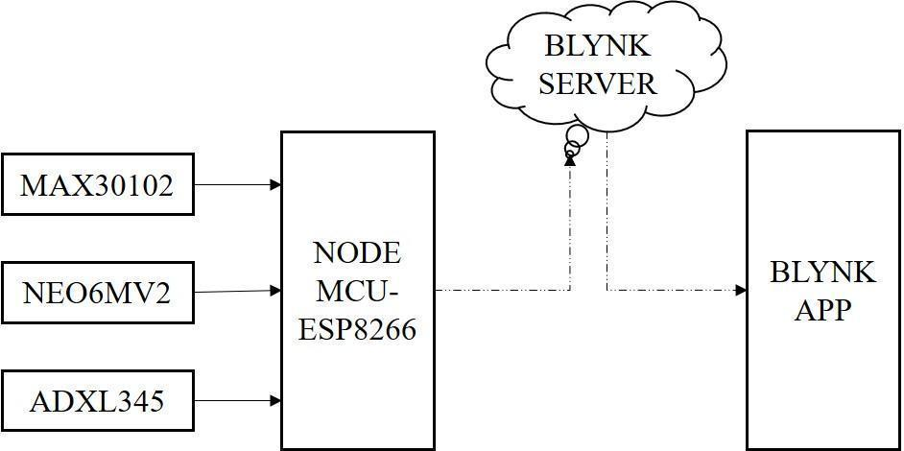

Figure 2: Block Diagram of Wearable Sensors

Key sensors integrated into this system include the accelerometer ADXL 345, GPS module NEO6MV2, and heart rate sensor MAX 30102. Once the caregiver activates the switch on their smartphone app, the device initiates data sharing immediately. Leveraging IoT technology, it sends the current location of the Alzheimer's patient to the Blynk app and provides updates on the patient's health status. Additionally, the system alerts the caregiver in the event of a fall by the patient.

Each GPS satellite emits signals to the GPS receiver [15], transmitting the precise time of signal transmission. By comparing this with the reception time, the GPS receiver calculates its distance from each satellite. Moreover, it knows its location in the sky during signal transmission, allowing it to determine the receiver's 3D position (latitude, longitude, and altitude) based on signal travel time and satellite positions. The sensor comprises a light detector and an intensely bright red LED [16]. The LED's brightness ensures maximum light transmission through the finger for detection. As blood flow varies with each heartbeat, the finger becomes slightly opaque, altering the detected light. This fluctuation is converted into an electrical pulse. The heartbeat sensor consists of an infrared LED and a photodiode on a clip, detecting pulses by monitoring changes in the amount of blood in the finger with each heartbeat.

Research into fall detection primarily focuses on analyzing acceleration changes occurring during a fall. iMEMS semiconductor technology integrates electrical circuits and micromechanical structures onto a single silicon chip [17], enabling iMEMS accelerometers to generate analog or digital outputs and sense acceleration across one, two, or three axes. Significant differences in acceleration occur during falls, typically with a brief period between a FREE_FALL interrupt (indicating weightlessness) and an ACTIVITY interrupt (signifying impact) [17]. Similarly, there should be minimal delay between an ACTIVITY interrupt and an INACTIVITY interrupt (indicating stillness). If a fall results in serious consequences like unconsciousness, the body may remain motionless for an extended period, detectable by the INACTIVITY interrupt. To account for this, a second critical alert may be triggered if inactivity persists beyond a set duration post-fall. Our approach utilizes a threshold-based technique, a conventional yet highly accurate method for fall detection. Central to our methodology is the orientation of the X, Y, and Z axes, with acceleration data collected across all three axes denoted as Bx, By, and Bz [18].

$B_{sum}=\sqrt{Bx^{2}+By^{2}+Bz^{2}}$ (1)

Fall detection analysis involves establishing threshold values and comparing them to accelerometer readings. Illustrated in Figure 3, a flowchart delineates the operation of the fall detection system.

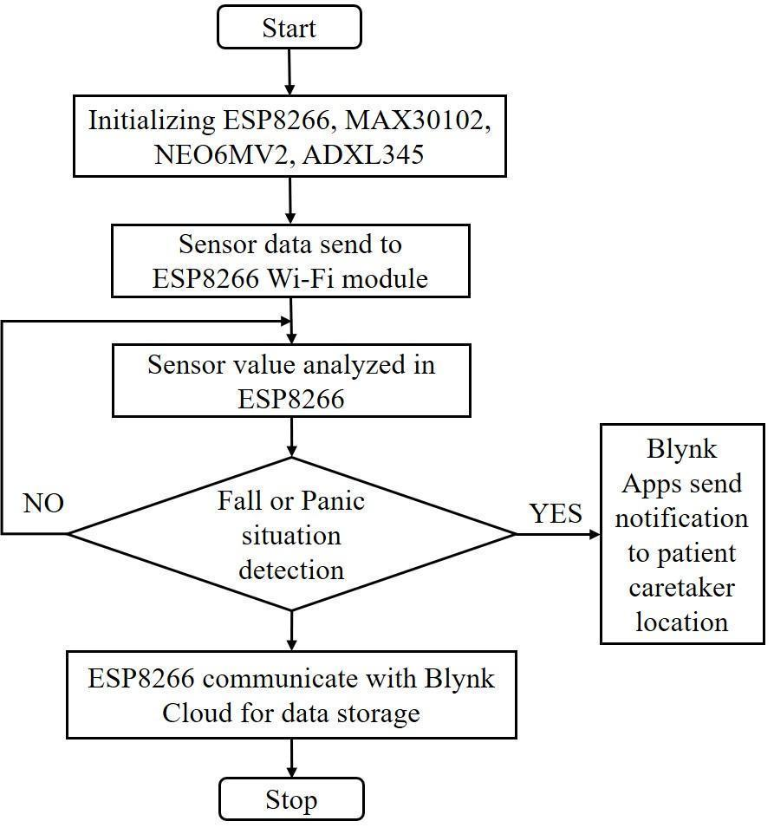

Figure 3: Flow Diagram of proposed system [19]

The ESP8266 WiFi module receives accelerometer data, and the fall detection algorithm is uploaded onto the device. When deviations from normal values (e.g., walking, running, or sitting) are detected, the device identifies it as a fall. These values are continuously monitored, and upon detection of a fall, the caregiver receives a real-time fall alert and the user's position through the Blynk app, facilitated by the Internet of Things (IoT).

## RESULT AND ANALYSIS

The circuit's complete configuration is depicted in Figure 5, showcasing its integration into an arm band for user comfort and portability [19]. Upon detecting a fall, the caregiver receives a "Fall detected" notification via the Blynk app on their smartphone. Additionally, the app provides real-time GPS-tracked latitude and longitude coordinates of the user's location. In the event of panic, a "Panic Patient" notification is sent to the Blynk app, alerting caregivers regardless of the circumstance or location. The tracking system outputs the precise location of the Alzheimer's disease (AD) patient, including latitude and longitudinal coordinates [20]. Caregivers utilize GPS integration to retrieve the AD patient's location from the tracking system. A panic button, integrated into the device via a microcontroller linkage [21], delivers distress messages to caregivers and family members' mobile devices. Initially, the pulse sensor measures the user's pulse rate, and the ESP8266 receives the converted BPM data [22]. Integrated into the band, the pulse sensor continuously detects the user's heart rate. To ensure comfort and mobility, the ESP8266 serves as a lightweight, wireless microcontroller. It assesses whether the BPM falls within a critical range, monitoring heart rate data for anomalies such as prolonged deviations from expected levels.

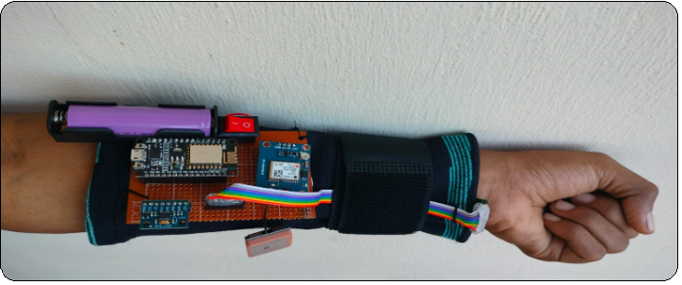

Figure 4: Complete hardware setup ArmBand

By leveraging sensors integrated into the patient's wearable wristband device, caregivers can receive real-time updates on fall detection events, panic warnings, and the patient's location simply by activating the switch on the app. Immediate alarms are dispatched in response to panic scenarios, such as abrupt increases in heart rate detected by the heart rate sensor, prompting caregivers to provide immediate assistance. The software also displays the precise location of the patient, obtained through GPS tracking, facilitating easy localization by caregivers.

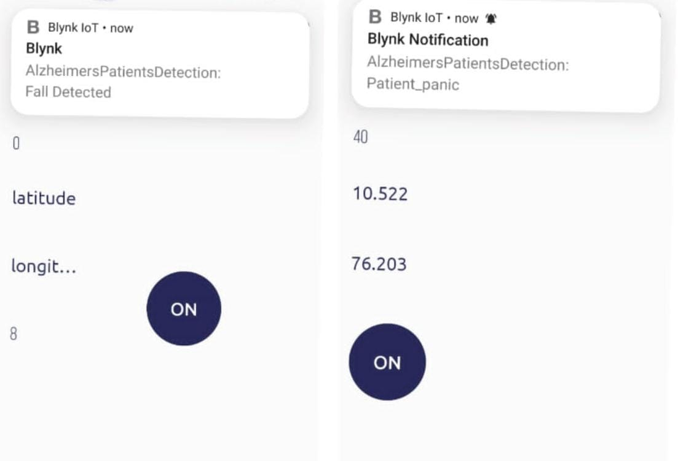

Figure 5: Blynk App Result

Furthermore, the Blynk app utilizes accelerometer data to notify caregivers of any detected falls, enabling prompt emergency response and intervention. This comprehensive output from the Blynk app empowers caregivers to proactively monitor and ensure the safety of Alzheimer's patients under their care, providing them with vital information to act upon.

## CONCLUSION

The proposed support system for Alzheimer's patients integrates accelerometer-based fall detection, heart rate sensor-driven panic detection, and GPS tracking to enhance patient safety and well-being. The system's monitoring capabilities are achieved through the synergistic combination of these technologies, enabling caregivers to monitor patient activities, identify potential crises such as falls or panic attacks, and respond promptly to patient needs. Furthermore, the system utilizes IoT connectivity to deliver notifications to caregivers via the Blynk app, enhancing usability and effectiveness. Caregivers can ensure the safety and security of Alzheimer's patients by leveraging real-time data and intelligent alerting systems to receive notifications and respond promptly to emergencies. This cutting-edge system represents a significant advancement in assistive technology, empowering caregivers to provide optimal care and assistance to patients with Alzheimer's disease.

## ACKNOWLEDGEMENT

We would like to thank each and every one of our team members who helped create the Internet of Things-based support system for Alzheimer's sufferers that is the subject of this project. We are appreciative of our advisor Dr. S. Swapna Kumar's commitment and knowledge, who was instrumental in providing direction for the project. We also thank people with Alzheimer's disease, their careers, and medical experts for their insightful comments and essential insights throughout the project's development.

## REFERENCES

1. [*Mohsen Rahmanian*](https://www.researchgate.net/profile/Mohsen-Rahmanian?_tp=eyJjb250ZXh0Ijp7ImZpcnN0UGFnZSI6InB1YmxpY2F0aW9uIiwicGFnZSI6InB1YmxpY2F0aW9uIn19) *,* [*Leili Mosalanejad*](https://www.researchgate.net/profile/Leili-Mosalanejad?_tp=eyJjb250ZXh0Ijp7ImZpcnN0UGFnZSI6InB1YmxpY2F0aW9uIiwicGFnZSI6InB1YmxpY2F0aW9uIn19) *,* [*Saeed Abdollahifard*](https://www.researchgate.net/profile/Saeed-Abdollahifard?_tp=eyJjb250ZXh0Ijp7ImZpcnN0UGFnZSI6InB1YmxpY2F0aW9uIiwicGFnZSI6InB1YmxpY2F0aW9uIn19)*, “An Alzheimer’s Intelligence Care System (AICS) to Assist Alzheimer’s Patients: Design and Development of Application” , Journal of Research in Medical and Dental Science 6(6):9-15,Volume 6, Issue 6, Page No: 9-15 ,2018*
2. R.*Reena Srishti., Harini.M Aezeden Mohamed Ergasheva Surayyo Rsenthil Kumar , “IoT-BASED ASSISTANT FOR ALZHEIMER'S PATIENT WITH REMINDER SYSTEM AND TRACKING USING GPS” , E3S Web of Conferences 399, 04053 (2023) , DOI:*[*10.1051/e3sconf/202339904053*](http://dx.doi.org/10.1051/e3sconf/202339904053)
3. [*https://agenebio.com/pipeline/about-amci-and-alzheimers-dementia/*](https://agenebio.com/pipeline/about-amci-and-alzheimers-dementia/)
4. *Pradyumna Shenvi , Pulkit Baheria , Shan Jose , Sachit Kumar , Jyothi S. Nayak, Wearable Tracking Device for Alzheimer’s Patients: A Survey , Volume 3, Issue 4 ,Page No: 147-151, April 2016.*
5. *doi:*[*http://www.jetir.org/papers/JETIR1604031.pdf*](http://www.jetir.org/papers/JETIR1604031.pdf)
6. [*Ved Prakash*](https://www.researchgate.net/profile/Ved-Prakash-23?_tp=eyJjb250ZXh0Ijp7ImZpcnN0UGFnZSI6InB1YmxpY2F0aW9uIiwicGFnZSI6InB1YmxpY2F0aW9uIn19) *,* [*manoj kumar pandey*](https://www.researchgate.net/scientific-contributions/manoj-kumar-pandey-2167097208?_tp=eyJjb250ZXh0Ijp7ImZpcnN0UGFnZSI6InB1YmxpY2F0aW9uIiwicGFnZSI6InB1YmxpY2F0aW9uIn19) *, “HEART RATE MONITORING SYSTEM”,Volume5 | Issue 5 | May 2018,doi:*[*https://www.jetir.org/papers/JETIR1805751*](https://www.jetir.org/papers/JETIR1805751.pdf)
7. *Hazem Ibrahim Shehata , Omar Reyad , “A Survey of IoT-Based Fall Detection for Aiding Elderly Care: Sensors, Methods, Challenges and Future Trends”,23 March 2022, doi:*[*https://doi.org/10.3390/app12073276*](https://doi.org/10.3390/app12073276)
8. [*Kazi Shahrukh Omar*](https://www.researchgate.net/profile/Kazi-Omar?_tp=eyJjb250ZXh0Ijp7ImZpcnN0UGFnZSI6InB1YmxpY2F0aW9uIiwicGFnZSI6InB1YmxpY2F0aW9uIn19)*,* [*Afia Anjum*](https://www.researchgate.net/profile/Afia-Anjum?_tp=eyJjb250ZXh0Ijp7ImZpcnN0UGFnZSI6InB1YmxpY2F0aW9uIiwicGFnZSI6InB1YmxpY2F0aW9uIn19) *,* [*Tahrima Oannahary*](https://www.researchgate.net/scientific-contributions/Tahrima-Oannahary-2156916700?_tp=eyJjb250ZXh0Ijp7ImZpcnN0UGFnZSI6InB1YmxpY2F0aW9uIiwicGFnZSI6InB1YmxpY2F0aW9uIn19) *,* [*Md. Rezaul Karim Rizvi*](https://www.researchgate.net/scientific-contributions/Md-Rezaul-Karim-Rizvi-2153932061?_tp=eyJjb250ZXh0Ijp7ImZpcnN0UGFnZSI6InB1YmxpY2F0aW9uIiwicGFnZSI6InB1YmxpY2F0aW9uIn19)*, “An Intelligent Assistive Tool for Alzheimer's Patients”,May 2019.* [*10.1109/ICASERT.2019.8934542*](http://dx.doi.org/10.1109/ICASERT.2019.8934542)*.*
9. *Aseel Thamer Ebrahem, Marwa Mawfaq Mohamedsheet Al-Hatab , Entisar Younis Abd Al-Jabbar , Warqaa H. Alkhaled , Zaid Husham Al-Sawaff , “Using IoT technology for monitoring Alzheimer’s and elderly patients” , Vol. 31, No. 2, pp. 986~994, August 2023. DOI:* [*http://doi.org/10.11591/ijeecs.v31.i2.pp986-994*](http://doi.org/10.11591/ijeecs.v31.i2.pp986-994)
10. *Sara Paivaa , Carlos Abreua , Low Cost GPS Tracking for the Elderly and Alzheimer Patients ,*[*Volume 5*](https://www.sciencedirect.com/journal/procedia-technology/vol/5/suppl/C)*, Pages 793-802, 2012.*
11. *doi:* [*https://doi.org/10.1016/j.protcy.2012.09.088*](https://doi.org/10.1016/j.protcy.2012.09.088)
12. *Sara Paiva, Rui Peleja, Jorge Cunha, Carlos Abreu, “Preventing Alzheimer’s Wandering: The Potential of Involving Communities” ,[International Journal of Healthcare Information Systems and Informatics](https://ideas.repec.org/s/igg/jhisi0.html) ,vol. 8(4), pages 32-43,December 2013.*
13. *Dr. Arun Chavan, Sonal Chandrakant Chavan, “Smart Wearable System For Fall Detection In Elderly People Using Internet of Things Platform”, Conference: 2017 International Conference on Intelligent Computing and Control Systems (ICICCS), 2017.DOI:*[*10.1109/ICCONS.2017.8250644*](http://dx.doi.org/10.1109/ICCONS.2017.8250644)
14. *Manukonda Praveen Kumar, Usha Rani. Nelakuditi , “IoT and I2C Protocol Based M-Health Medication Assistive System for Elderly People”, Conference: 2019 IEEE 16th India Council International Conference (INDICON) ,2019,*
15. *DOI:*[*10.1109/INDICON47234.2019.9030322*](http://dx.doi.org/10.1109/INDICON47234.2019.9030322)
16. *Bharat Bohara, Sunil Maharjan , Bibek Raj Shrestha , “IoT Based Smart Home Using Blynk Framework” ,ZERONE SCHOLAR, VOL. 1, (2016) 26-30,doi:https://arxiv.org/pdf/2007.13714*
17. *Asst. Prof. Steffy Fernandes, Sahil Naik , Siraj Kachur , Nitin Pawar , Gopal Lamani , DETECTION AND TRACKING OF ALZHEIMER & AMNESIAC PATIENT USING IOT , Volume:04/Issue:02/February-2022 .*
18. *MG_Gayatri_*[*https://ece.anits.edu.in/2019-20%20BE%20Project%20REPORTS/GG%20PJT%202019-20.pdf*](https://ece.anits.edu.in/2019-20%20BE%20Project%20REPORTS/GG%20PJT%202019-20.pdf)
19. *Sindhu B, Shravani N R, Pooja Rao K J, Yashaswini H Y, Nayana C G,”Real Time Health And Security Monitoring Device For Dementia Affected Elders”,IJERT,* [*NCESC – 2018 (Volume 6 – Issue 13)*](https://www.ijert.org/ncesc-2018-volume-6-issue-13)*, 2018, doi : 10.17577/IJERTCONV6IS13067*
20. *Fall_detection_*[*https://www.analog.com/en/resources/analog-dialogue/articles/detecting-falls-3-axis-digital-accelerometer.html*](https://www.analog.com/en/resources/analog-dialogue/articles/detecting-falls-3-axis-digital-accelerometer.html)
21. *Bharat Ananda Shinde, Prof. Pramila M. Chawan, Computer Engineering and “DEMENTIA PATIENT MOVEMENT DETECTION AND FALL DETECTION USING SMART PHONE TECHNOLOGY”,.Information Technology Department, VJTI, Mumbai, (India) .International Journal of Advanced Technology in Engineering and Science www.ijates.com Volume No.02, Issue No. 07 ,July 2014*
22. *Akash SD, Anusha Upadhya, Harshitha BR, Hemanth, Mr. Shivarudraiah B, “SMART WEARABLE SYSTEM FOR THE ELDERLY USING IOT”, International Research Journal of Modernization in Engineering Technology and Science, Volume:04/Issue:07/July-2022*
23. *Haroon Dar, Shreyansh Jain, Jyoti Shukla, V. M. Sardeshmukh.” Alzheimer Patient Tracking and Alert System”.International Journal of Trend in Scientific Research and Development (IJTSRD) ISSN: 2456-6470, Volume-2, Issue – 3, 2018.*
24. *doi:https://www.ijtsrd.com/papers/ijtsrd11218.pdf*
25. *Sarita, Tanupriya Choudhury, Saurabh Mukherjee, Chiranjit Dutta, Aviral Sharma, Ayan Sar.“A Wearable Device for Assistance of Alzheimer’s disease with Computer Aided Diagnosis”,EAI Endorsed Transactions on Pervasive Health and Technology Research Article.23 May 2022,doi:*[*10.1155/2022/9092289*](https://doi.org/10.1155%2F2022%2F9092289)
26. *Shailee Lohmor Choudhary, Anupam Singh, 1S. Manoharan, and Kayhan Zrar Ghafoor, “A Pulse Rate-Triggered Wearable Device for Critical AssistanceRohit Tanwar”, Research Article | Open Access Volume 2022.* [*https://doi.org/10.1155/2022/9807188*](https://doi.org/10.1155/2022/9807188)