# Automated Water Monitoring & Managing System For Aquaculture Using IoT

# Krishnapriya M1 Nandhu A. G1 Sreelekshmi L1 Rini T Jacob2 Bejoy Antony3

*1 B.Tech, Electronics and Communication, St.Thomas College of Engineering And Technology, Chengannur, India*

*1 B.Tech, Electronics and Communication, St.Thomas College of Engineering And Technology, Chengannur, India*

*1 B.Tech, Electronics and Communication, St.Thomas College of Engineering And Technology, Chengannur, India*

*2 B.Tech, Electronics and Communication, St.Thomas College of Engineering And Technology, Chengannur, India*

*3 B.Tech, Electronics and Communication, St.Thomas College of Engineering And Technology, Chengannur, India*

***Abstract***: *In recent years, the Internet of Things (IoT) has emerged as a transformative technology with profound implications for various sectors, including environmental monitoring and management. This paper presents an innovative IoT-based automated water quality monitoring and management system (AWQMS) designed to revolutionize the way we monitor and safeguard water resources.The AWQMS leverages a network of IoT-enabled sensors deployed at strategic locations throughout water bodies, continuously measuring crucial parameters such as pH, dissolved oxygen, turbidity, temperature, and conductivity. These sensors are equipped with wireless communication capabilities, enabling real-time data transmission to a centralized data acquisition and processing platform. At the heart of the AWQMS lies advanced data analytics and machine learning algorithms, which analyze incoming data streams to detect anomalies and deviations from predefined water quality thresholds.*

***Key Word* :** *Automated Water Monitoring and Managing system, IoT based solution, sensor-based monitoring, Real time monitoring system, cost-effectiveness.*

1. **Introduction**

In aquaculture, utilizing pond environments is crucial for successful fish farming, with water and soil serving as essential media for fish enlargement. However, the quality of pond environments degrades due to increased waste from feed remnants, feces, and fish excretion. Various water quality parameters, such as temperature, total dissolved solids (TDS), and pH, significantly influence fish growth and survival rates.

Temperature and dissolved oxygen levels are particularly pivotal, impacting fish appetite, metabolism, and overall growth. Factors like sunlight radiation, air temperature, weather conditions, and geographical location contribute to fluctuations in water temperature. Sunlight, especially, warms the water surface faster than deeper layers, leading to temperature stratification and the formation of distinct layers like epilimnion, hypolimnion, and thermocline. Another critical parameter is pH, indicating the water's acidity or alkalinity. pH values fluctuate dynamically throughout the day, with typical values rarely exceeding 8.5 in unaffected water but potentially reaching 9 or higher in fish or shrimp ponds subjected to biological activity.

1. **Proposed System**

This paper introduces a theoretical framework for real-time monitoring of water quality within an Internet of Things (IoT) environment. The proposed method incorporates a comprehensive block diagram elucidating each constituent component of the system. At its core, the system integrates multiple sensors, including those measuring temperature, pH, turbidity, and flow, which interface with a central controller unit.

Central to the architecture is the core controller, which orchestrates data acquisition and processing tasks. In this proposed methodology, an Arduino microcontroller serves as the core controller, leveraging its versatility and ease of integration with various sensor modules. The Arduino collects data from the connected sensors and executes algorithms for processing and analysis. The sensor suite provides real-time readings of critical water quality parameters, such as temperature, pH level, turbidity, and flow rate. These parameters are pivotal indicators of water health and are essential for assessing the suitability of water for various applications, including drinking, agriculture, and industrial processes.Once collected, the sensor data undergoes preprocessing within the core controller to ensure accuracy and reliability [9].

1. **Block diagram**

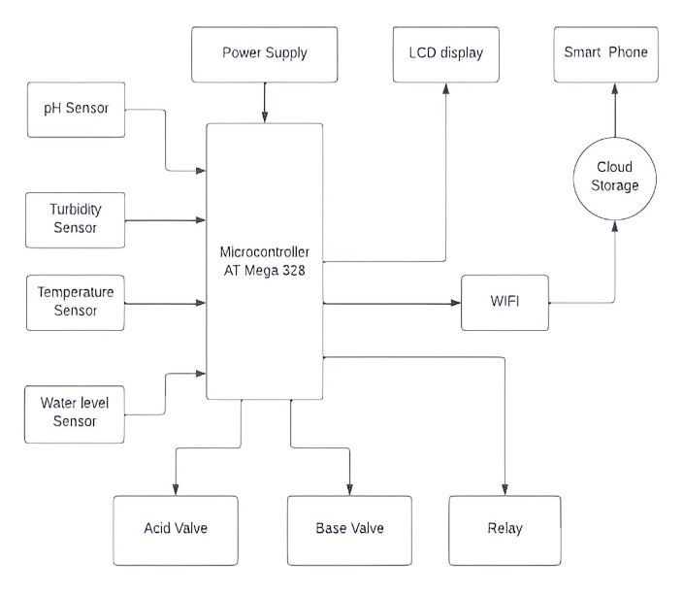

**Figure 1 :** Block diagram of the System

The major working components and connections of the Automated Water Quality Monitoring & Managing System is illustrated above. AT mega act as the main controller and brain of the system.Different sensors are uesd to sense different water parameters.The sensors includes temperature sensor to measure temperture of pond,turbidity sensor to sense turbidity,waterlevel sensor to sense the waterlevel and PH sensor to check whether the pond is acidic or basic in nature.Two solenoid valves are used to manage the acidic or basic nature and the other water parameters are measured by the sensors are managed by the relay system.

1. **Circuit diagram**

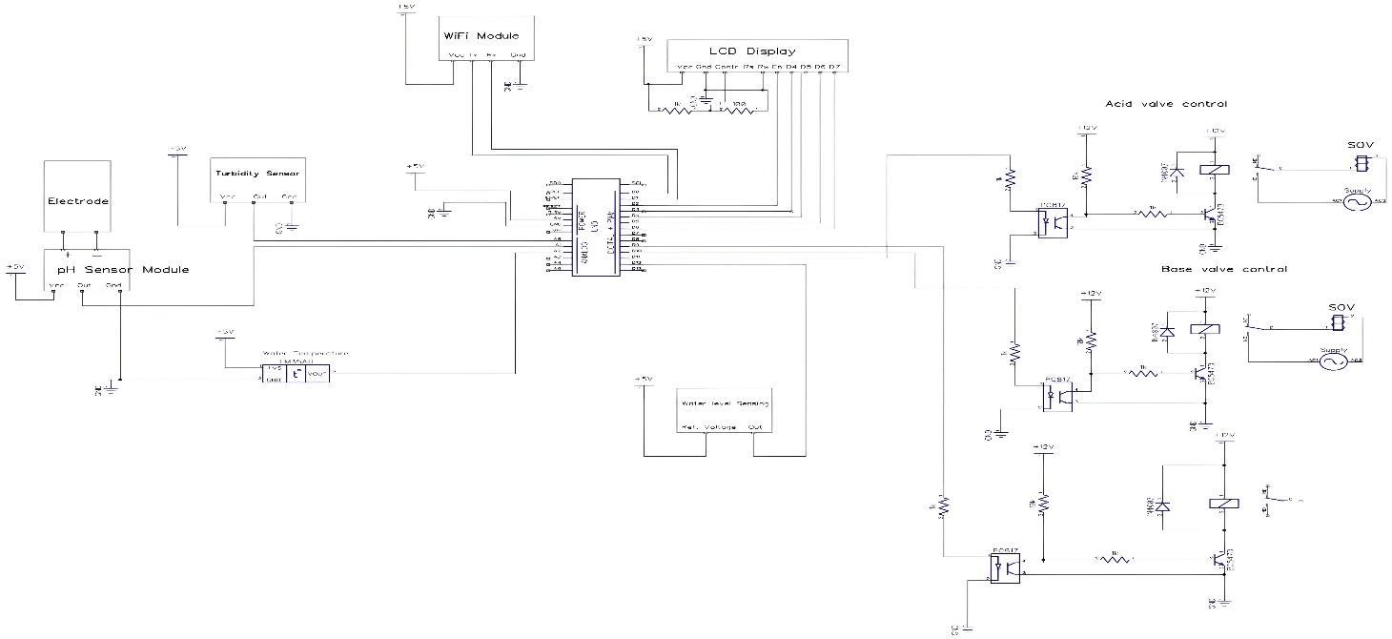

The Automated Water Quality Monitoring & Managing System is used to connect the sensor output pins to the analog input pins of ATmega328. Turbidity sensor, PH sensor, and Temperature sensors are connected to the analog input pins while only the water level sensor is connected to the digital input. The wifi module’s transmitter terminal is connected to the receiver terminal of the microcontroller and the receiver pin of wifi module to the transmitter terminal of the microcontroller.

The sensors will be provided with input terminal Vcc connected to +5 volts, the ground terminal will be grounded and output terminal connected to the corresponding pins in the microcontroller. The solenoid valves are worked with the help of an optocoupler.The optocoupler here act as an electrical isolator from the relay. An LCD display is connected to D2 to D6 pins of the microcontroller and relay is connected to the D9 pin. Enable pin of LCD display is connected to the D2 pin of microcontroller. D4 pin of the LCD display is coonected to the D3 pin of the microcontroller. D5 to the D4 of the microcontroller, D6 to the D5 pin and D7 to the D6 pin of the microcontroller. PH Sensor is connected to the analog inout pin A1, the sensed values will check with threshold value and enable the solenoid valves connected to the pin D10 and D11, if necessary.

1. **Working**

The AT Mega 328 microcontroller, commonly utilized in numerous projects requiring a simple, low-power, and cost-effective solution, is prominently featured in various Arduino development platforms such as the Arduino Uno, Arduino Pro Mini, and Arduino Nano models. Equipped with 14 digital input/output pins, 6 analog inputs, a 16 MHz ceramic resonator, a USB connection, power jack, ICSP header, and reset button, it offers comprehensive support for microcontroller operations. Its integration with the Arduino IDE software facilitates programming ease and efficiency.In the context of the Automated Water Quality Monitoring & Managing System, the Arduino Uno board serves as the central processing unit, orchestrating sensor inputs and relay outputs.

The system employs four inputs, with three connected to the microcontroller's analog pins and one to the digital input pin. While the microcontroller can accommodate up to six analog inputs, the current implementation utilizes only three, leaving room for expansion in advanced iterations of the system.Key sensor connections include the turbidity sensor to analog input pin A0, the temperature sensor to analog input pin A2, and the water level sensor to digital input pin D12. Threshold comparisons of sensor readings activate relays connected to pin D9, facilitating automated responses based on preset conditions. Internet connectivity for the microcontroller is facilitated through a WiFi module, which uploads sensor data to cloud storage.

The WiFi module interfaces with the microcontroller via Rx and Tx pins, providing seamless communication between the two components. To accommodate the voltage disparity between the microcontroller (operating at 5 volts) and the solenoidal valves and relay (requiring 12 volts), optocouplers serve as isolation devices. Optocouplers, connected between the microcontroller and the solenoidal valves/relay, prevent voltage feedback and potential damage to the microcontroller. This setup ensures reliable operation and protects against electrical disturbances. Threshold values, typically set between 7 and 8.5 for pH measurements, dictate the operation of solenoidal valves. Depending on whether the pH reading falls below 7 (acidic) or above 8.5 (basic), corresponding valves are activated to manage water quality parameters until neutralization is achieved.

1. **Implementation**
2. **Hardware implementation**
3. **Define requirements**

Clearly outline requirements of your water monitoring and management system. Determine what parameters you want to monitor (such as water level, quality, temperature, etc.), where the sensors will be placed, and what actions the system should take based on the data.

1. **Select sensors**

Choose appropriate sensors for monitoring water quality parameters based on your requirements. Consider factors such as accuracy, reliability, power consumption, and compatibility with IoT platforms.

1. **IOT platform selection**

Choose an IoT platform that supports data collection, storage, analysis, and visualization. Popular IoT platforms include AWS IoT, Microsoft Azure IoT, Google Cloud IoT, and open-source platforms like Arduino IoT Cloud or ThingsBoard.

1. **Hardware Setup**

Install sensors at the desired locations for water quality monitoring. Connect the sensors to microcontrollers or single-board computers (e.g., Arduino, Raspberry Pi) equipped with Wi-Fi or cellular connectivity for data transmission.

1. **Data Transmission**

Implement a communication protocol (e.g., MQTT, HTTP, CoAP) to transmit data from sensors to the IoT platform securely. Consider using encryption and authentication mechanisms to ensure data privacy and integrity.

1. **Data Storage and Processing**

Set up data storage and processing pipelines on the IoT platform to handle incoming sensor data. This may involve using databases (e.g., SQL, NoSQL) for data storage and analytics services for real-time or batch processing.

1. **Visualization and Dashboard**

Develop a user interface or dashboard to visualize water quality data in real time. This could include graphs, charts, maps, and alerts for abnormal readings. Make the interface accessible via web or mobile applications for easy monitoring.

1. **Alert and Notification**

Implement alerting mechanisms to notify stakeholders (e.g., water utility operators, and environmental agencies) about critical changes in water quality parameters. Alerts can be sent via email, SMS, or push notifications.

1. **Software implementation**

To implement microcontroller coding and Wi-Fi module program Embedded C program is used. In the microcontroller coding section, various sensor values are analyzed and processed based on conditions given in the program. The code provided is for an Arduino-based system designed to monitor and manage water quality in an aquaculture environment using various sensors and actuators.

1. **Installing Required Libraries**

The code includes libraries for interfacing with hardware components like the LCD, temperature sensors, and communication. Several global variables are declared to store sensor readings and system states.

1. **Setup Functions**

Initializes the pins for the acid and base valves, the pump, and the water level sensor.Sets initial states for the valves and pump (all turned off).Begin communication with the LCD and serial ports.

1. **Loop Functions**

Clears the LCD and requests temperature readings from the sensors. Displays the temperature on the LCD and sends it over the serialm connection.Reads turbidity and pH levels from analog pins A1 and A0, respectively.Depending on the pH value, it adjusts the state of the water by controlling the acid and base valves.Checks the water level sensor and turns the pump on or off accordingly.Packages the water state, water level state, temperature, and turbidity into a JSON object and sends it over a software serial connection.

### **IoT interference**

Graphical representation of the various water parameters using sensors can be implemented using the cloud space. Here we use the platform called Thingspeak. Capabilities of real-time data collection and visualizing the collected can be achieved using this. Data Collection can send sensor data privately to the cloud. Analyzing and visualizing your data with MATLAB. Triggerd actions based on the data received.It offers RESTful and MQTT APIs for data communication.ThingSpeak works with various devices like Arduino, ESP8266/ESP32 WiFi modules, Raspberry Pi, and more.

### **Android Application**

An Android application is built to analyze the water parameters of a pond developed by MIT App Inventor. MIT App Inventor is a web-based tool that allows you to create Android applications using a visual, drag-and-drop interface. MIT App Inventor can build fully functional apps for smartphones and tablets by piecing together logic blocks that represent different functions of the app.

1. **Conclusion**

A water quality monitoring system utilizing water detection sensors leverages a unique advantage alongside an existing GSM network. This system enables automatic monitoring of turbidity, pH, and temperature, offering cost-effectiveness and eliminating the need for on-site personnel. Consequently, water quality testing becomes more economical, convenient, and efficient. The system exhibits considerable flexibility as it can easily adapt to monitor other water quality parameters by simply replacing sensors and adjusting software programs. Its straightforward operation allows for potential expansion to monitor various environmental factors such as hydrology, air pollution, and industrial processes. This widespread applicability underscores its value in environmental monitoring and protection, contributing to the concept of a smart environment. Deployment of sensor devices facilitates data collection and analysis, enabling real-time interaction with other objects via the network. The collected data and analysis results are accessible to end-users through Wi-Fi connectivity.This research presents a low-cost water quality monitoring system for aquaculture, with a total expenditure of approximately 83.79 USD. The system comprises integrated sensors for monitoring water temperature, pH, and total dissolved solids (TDS), enabling remote monitoring via an Android platform. Real-time monitoring via smartphones offers significant advantages for fish farming, as water parameter data is recorded and stored in the memory card, providing valuable feedback for business owners to ensure optimal water quality.

**References**

1. Akanksha Purohit, Ulhaskumar Gokhale, *Real-Time Water Quality Measurement System onGSM, IOSR (IOSR-JECE)* Volume 9, Issue 3, Ver. V (May - Jun. 2014)
2. H. P. Luo, G. L. Li, W. F. Peng, J. Song, Q. W. Bai, *Real-time remote monitoring system foraquaculture water quality*, in International Journal of Agricultural and Biological Engineeringvol. 8, no. 6, 2015, pp. 136–143
3. Mithaila Barabde, Shruti Danve, *Real-Time Water Quality Monitoring System*, IJIRCCE, vol 3,June 2015.
4. Nikhil Kedia, *Water Quality Monitoring for Rural Areas- A Sensor Cloud Based Economical Project*, in 1st International Conference on Next Generation Computing Technologies (NGCT- 2015) Dehradun, India, 4-5 September 2015. 978-1-4673-6809- 4/15/$31.00 ©2015 IEEE
5. Jayti Bhatt, Jignesh Patoliya, *Iot Based Water Quality Monitoring System,* IRFIC, 21feb,2016.
6. Sokratis Kartakis, Weiren Yu, Reza Akhavan, and Julie McCann, 2016 IEEE First International *Conference on Internet-of-Things Design and Implementation*, 978-1-4673- 9948-7/16 © 2016IEEE

[7] Niel Andre Cloete, Reza Malekian and Lakshmi Nair, *Design of Smart Sensors for Real- TimeWater Quality Monitoring,* ©2016 IEEE conference.

[8] S. A. Z. Murad, A. Harun, S. N. Mohyar, R. Sapawi, S. Y. Ten*, Design of aquaponics water monitoring.*

*system using Arduino microcontroller*, in: A.I.P Conference Proceedings vol.1885, 2017, DOI: 10.1063/1.5002442

[9] J. P. C. Mandap, D. Sze, G. N. Reyes, S. Matthew Dumlao, R. Reyes, W. Y. Danny Chung, *Aquaponics pH Level, Temperature, and Dissolved Oxygen Monitoring and Control SystemUsing Raspberry Pi as Network Backbone*, in TENCON 2018 – 2018 IEEE Region 10 Conference, 2018, pp. 1381–1386.

[10] C. E. Boyd, F. Lichtkoppler, Water Quality Management In Pond Fish Culture Research andDevelopment Series vol. 22, no. 22, Auburn University, International Center for Aquaculture in 2020

[11] A. M. Nagayo, C. Mendoza, E, R. K. S. Al Izki, R. S.Jamisola, *An automated solar- poweredaquaponics system towards agricultural sustainability in the Sultanate of Oman*, in 2022 IEEEInternational Conference on Smart Grid and Smart Cities, ICSGSC 2022, 2022, pp. 42–4