BIRD SPECIES IDENTIFICATION USING AUDIO PROCESSING EMBEDDED WITH TRANSLATOR

# Akassh G

*Artificial Intellegence And Data Science Karpagam College Of Engineering* Coimbatore, India [akasshkrishnan1811@gmail.com](mailto:akasshkrishnan1811@gmail.com)

# Arnesh J

*Artificial Intellegence And Data Science Karpagam College Of Engineering* Coimbatore, India

[arnesh@gmail.com](mailto:arnesh@gmail.com)

# Jernik Galidine L

*Artificial Intellegence And Data Science Karpagam College Of Engineering* Coimbatore, India

[jernik@gmail.com](mailto:jernik@gmail.com)

***Abstract*—With their variety of vocalizations, birds contribute significantly to the acoustic fabric of our natural surroundings. Their songs and calls offer important clues into the health of ecosystems and biodiversity. Contributions from the project include the creation of effective and trustworthy systems for classifying bird species, which may find use in ecological studies, biodiversity monitoring, and ornithology. A system like this could be useful for monitoring migratory patterns, evaluating changes in bird populations, and supporting conservation initiatives. The domains of artificial intelligence and ornithology are connected by this research.**

***Index Terms*—Biodiversity, Acoustic fabric, Conservation, Vo- calizations, Ornithology**

1. Introduction

One of the most innovative projects that integrate ornithol- ogy, artificial intelligence, and environmental conservation is the audio-processing identification of bird species. This research uses cutting-edge audio processing techniques to aid in the monitoring and protection of bird populations. Because of habitat loss and climate change, the biodiversity of birds worldwide is in danger. This ground-breaking initiative aims to create a highly accurate, non-invasive tracking and identifica- tion system for birds in their natural habitats by recording and analyzing the distinct aural fingerprints of several bird species. This research has the potential to transform international ef- forts to conserve birds and improve our understanding of avian habitats through the use of bioacoustics, signal processing, and machine learning. This research has the potential to transform international efforts to conserve birds and improve our un- derstanding of avian habitats through the use of bioacoustics, signal processing, and machine learning. This work seeks to bridge that important gap and offer a reliable and efficient technique of species detection by capturing and analyzing the unique aural signatures of many bird species. Modern machine learning, signal processing, and bioacoustics are used in this research project to enhance our knowledge of avian habitats and possibly transform global bird conservation initiatives. It will help several bird species survive in an ever-changing

Identify applicable funding agency here. If none, delete this.

environment and foster a stronger relationship between hu- mans and birds. Audio processing for the identification of bird species has significant promise for ecological study, as well as providing hope for the preservation of our natural habitat and the birds who reside there. This study suggests using sound processing and convolutional neural networks to automate the entire bird sound recognition procedure. Building a database including each sound recording is the first step. Subsequently, sound pre-processing techniques like pre-emphasis, silence removal, reconstruction, and framing are applied to these recordings. A real-time implementation model was supplied to the trained CNN model. The project is a driving force behind the creation of a stronger relationship between people and the natural environment in addition to acting as evidence of the successful fusion of science, technology, and conservation.

1. Methodology
2. *Data Collection*

The project’s bird vocalizations came from Xeno-Canto, a reliable global internet repository of bird sound recordings made by scientists, ornithologists, and bird watchers. The per- fect data source was Xeno-Canto because of its vast collection of bird vocalizations from various geographical places. Filters were applied, taking into account variables like location, date, and species, to guarantee dataset variability. To preserve the richness and authenticity of the dataset, only uncut, original recordings were used. To preserve data quality, records with significant background noise, poor audio quality, or missing information were carefully examined and eliminated.

1. *Data Preprocessing*

Through the data pretreatment process, our dataset is certain to be prepared for the feature engineering and model devel- opment phases that come after. Ultimately, this helps to fulfill the project goals of accurate bird species identification and integrated translation capabilities by transforming raw audio recordings into a format that is compatible with deep learning models in our application.

1. *Standardization Of Audio Format*

Audio recordings are available for download from Xeno- Canto in a range of formats and sampling rates. To ensure uniformity, every audio file was converted to a common format (such WAV) and resampled to a consistent sample rate. You can be certain that the data will cooperate with the subsequent processing stages if you do this.

1. *Feature extraction*

Direct machine learning is not acceptable for unprocessed audio data. Thus, relevant acoustic parameters were extracted from the split audio recordings. Mel-frequency cepstral co- efficients (MFCCs) and spectrograms are significant features. These characteristics give an audio stream a time-frequency representation while also capturing the essential characteristics needed for species classification.

1. *Normalization*

To ensure consistent data distribution and minimize vari- ations in audio amplitude, all the gathered features were standardized. By keeping particular features from taking center stage throughout the model training process, this step aids in improving convergence during neural network training.

1. *Data Cleaning*

The dataset underwent a thorough quality control process. Audio samples with anomalies—such as partial vocalizations, excessive background noise, or other problems—were ana- lyzed and, if necessary, removed in order to guarantee the quality of the data.

1. *Data Splitting*

Training and validation sets of preprocessed data were produced. While the training set was used to train the deep learning models, the validation set allowed us to monitor and evaluate model performance.

1. Choosing Machine Learning Models

For the purpose of this study, we thoroughly assess machine learning algorithms in order to attain precise identification of bird species and smooth translation integration. The selected translation and classification algorithms are trained on our meticulously produced dataset and then put through a thorough evaluation utilizing performance metrics. Through a system- atic comparison of performance indicators and outcomes, we determine which algorithm performs best, guaranteeing that our system is highly effective in accurately identifying bird species and being multilingual. This method, which connects ornithology, artificial intelligence, and public participation in avian diversity and conservation, is a perfect fit with the goals of our study.

1. *Recurrent Neural Networks (RNNs) and Long Short-Term Memory (LSTM):*

For audio-based bird species identification, LSTM (Long Short-Term Memory) networks and RNNs (Recurrent Neural Networks) are essential. The temporal dynamics and sequential patterns present in bird vocalizations are exceptionally well- captured by these techniques. When processing audio data, RNNs take into account the timing and sequence of sound events, which makes them useful for modeling complex tem- poral structures like bird calls and songs. However, because of disappearing or exploding gradients, typical RNNs may have trouble with long-range dependencies. In order to overcome this restriction, LSTM networks include memory cells that can hold onto important information across longer sequences. Their suitability for auditory recognition tasks stems from their capacity to maintain context and identify intricate patterns in bird vocalizations, which facilitates precise species identifica- tion. When it comes to audio recognition, RNNs and LSTMs are both valuable tools for building robust and context-aware models to classify diverse bird species.

1. *Support Vector Machines (SVMs) with Handcrafted Fea- tures:*

Support vector machines (SVMs) with handcrafted features are a conventional but effective technique for audio-based bird species identification. To extract pertinent information, they first convert audio signals into manually designed properties including spectral contrast, zero-crossing rate, and MFCCs. In order to properly distinguish bird species, SVMs then generate decision boundaries based on these properties. Be- cause of its simplicity, this method is useful for smaller acoustic datasets and computers with constrained resources. It provides interpretability, enabling people to comprehend the choices made for classification. Handcrafted feature SVMs are still a dependable option for preserving and comprehending avian biodiversity, especially when features highlight unique auditory characteristics of different bird species.

1. *Convolutional Neural Network:*

Convolutional neural networks (CNNs) are flexible models utilized in many domains such as image analysis. They are well-known for their notable influence on computer vision. CNNs are made up of layers such as convolutional, pooling, and fully connected layers, which are modeled after the human visual system. Local patterns are extracted using convolutional layers, and complexity is decreased by pooling layers via downsampling. Using this hierarchical method, CNNs are able to extract abstract representations and fine details from input. CNNs can be configured to interpret time-frequency representations such as spectrograms for the purpose of au- ditory recognition-based bird species identification. They aid in the identification of pertinent bird species traits by capturing spectral patterns and textures in audio. Using pre-trained CNN models from ImageNet, one method entails converting audio spectrograms into images. On the other hand, specialized CNN architectures created for audio identification are able to

efficiently extract both temporal and spectral patterns, allowing accurate categorization based on bird sounds.

1. *Convolutional Recurrent Neural Networks (CRNNs):*

A particular kind of neural network called Convolutional Recurrent Neural Networks (CRNNs) combines the advan- tages of Convolutional Neural Networks (CNNs) and Recur- rent Neural Networks (RNNs). They are especially useful for audio recognition-based bird species identification, where temporal and spectral patterns are crucial. When displayed as spectrograms, CRNNs are particularly effective at capturing the intricate temporal and spectral patterns found in audio data.

1. Model Workflow

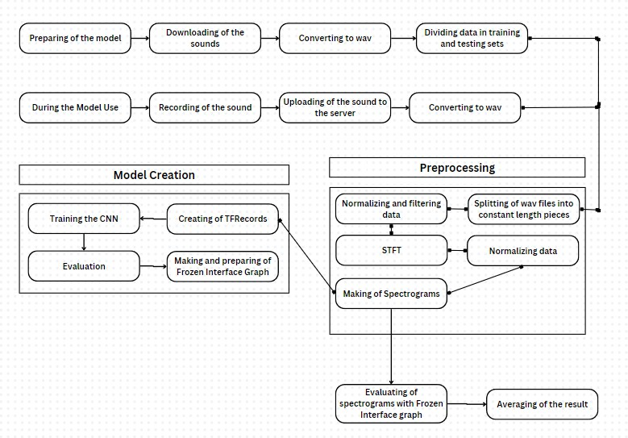

Fig. 1. Model Workflow of Bird Species Identification Using Audio Process- ing.

1. Implementation
2. *Project Initialization:*

Set up the Development Environment:Install Python and necessary libraries such as NumPy, SciPy, and scikit-learn. Python 3.6+ is recommended. Acquire Audio Data:Gather a diverse dataset of bird vocalizations, including recordings

from various species in different habitats and environmental conditions.

1. *Data Preprocessing*

Noise Reduction:Apply noise reduction techniques to elim- inate background noise from audio recordings. Silence Re- moval:Remove silent portions of audio clips to focus on bird vocalizations. Framing:Divide audio clips into smaller, overlapping frames to facilitate feature extraction. Feature Extraction:Extract relevant audio features, including spectro- grams, Mel-Frequency Cepstral Coefficients (MFCCs), and chroma features, to capture the unique acoustic characteristics of bird vocalizations.

1. *Data Labeling*

Expert Annotation:Engage ornithologists or experts to label the audio data with the corresponding bird species to create a labeled dataset for supervised learning.

1. *Model Selection*

Choose Machine Learning Models:Select appropriate ma- chine learning models for bird species identification. Common choices include Convolutional Neural Networks (CNNs) and Recurrent Neural Networks (RNNs).

1. *Training and Fine-Tuning*

Model Training:Train the selected models using the labeled dataset, adjusting model parameters, and optimizing perfor- mance. Cross-Validation:Employ cross-validation techniques to assess model performance and generalization.

1. *Validation and Testing*

Validation Set:Use a separate validation dataset to assess the accuracy and performance of the trained models. Testing Set:Evaluate the models’ ability to identify bird species with a separate testing dataset, ensuring real-world applicability.

1. *Real-Time Implementation*

Integration:Implement the trained models into real-time applications or monitoring devices for on-site bird species identification. Mobile Application:Develop user-friendly mo- bile applications for bird enthusiasts and field researchers to identify species using their smartphones.

1. *User Feedback and Improvement*

Continuous Enhancement:Gather user feedback to identify areas for improvement, such as model accuracy, user interface, and system reliability. Model Refinement:Continuously update and refine the machine learning models based on user feedback and technological advancements.

1. *Outreach and Education*

Awareness Campaigns:Promote awareness of the impor- tance of bird conservation and avian biodiversity through outreach initiatives. Citizen Science Engagement:Encourage public engagement in citizen science programs, fostering collaboration between environmentalists, bird watchers, and scientists for data collection and conservation efforts.

1. *Geographic Tagging and Real-Time Monitoring (Future Enhancements)*

Geographic Tagging:Implement geographical tagging to provide location-specific bird species data, enhancing the understanding of local avian ecosystems and migration pat- terns. Real-Time Monitoring:Enable real-time monitoring ca- pabilities for immediate bird species identification and data collection during fieldwork. This comprehensive implemen- tation process combines technology, ecological insights, and community engagement to advance the field of bird species identification using audio recognition.

1. Experiment and Result

The project’s completion showcases a ground-breaking ac- complishment: the accurate identification of bird species by their unique auditory signatures. Furthermore, by smoothly converting the scientific bird names into regional names ap- propriate for the areas they live in, this creative system goes one step further.The results of this project have not only opened our eyes to the wealth of knowledge contained in bird vocalizations, but they have also helped us to appreciate our feathered neighbors even more. It’s a big step toward a future in which bird species’ beauty can be appreciated, conserved, and shared by people of all ages, nationalities, and languages.

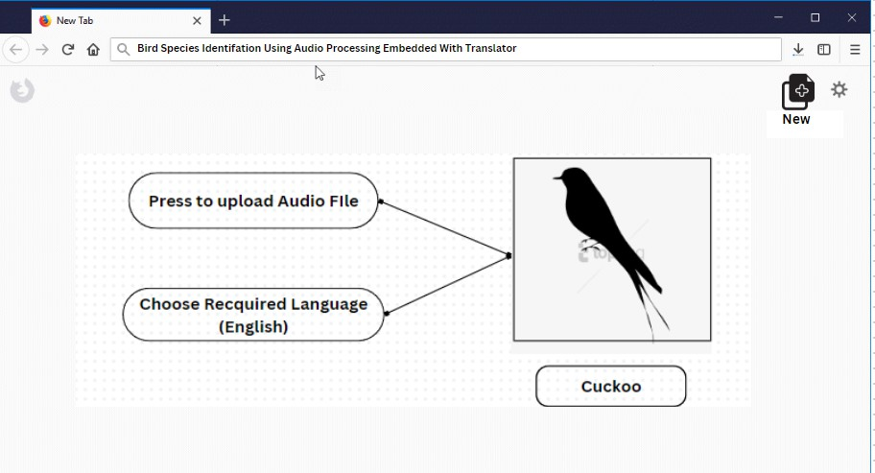

Fig. 2. Final display of bird species using audio processing application

1. Conclusion

In conclusion, the integration of deep learning and acoustic signal processing in this project represents a significant leap forward in bird species identification. Its applications in or- nithology, ecological research, and conservation align with the ever-growing need to monitor and protect avian biodiversity. This innovative system not only advances scientific inquiry but also offers a bridge for the public to actively engage in the preservation of our avian companions. By transforming bird vocalizations into a valuable source of ecological data, this project not only unlocks the potential for efficient bird species identification but also reinforces the interconnectedness of nature and technology. Bird vocalizations, once a symphony of nature, now play a vital role in our collective efforts to understand and safeguard our feathered neighbors and the

ecosystems they inhabit. This endeavor promises to harmonize the worlds of science, technology, and conservation in a symphony of its own, working toward a brighter and more harmonious future for avian biodiversity. In this endeavor, a new era of avian research is ushered in by the harmonious fusion of artificial intelligence and ornithology. It gives us the ability to not only understand the language of our feathered friends but also collaborate with them to protect their habitats. This project creates a path for a sustainable coexistence between humans and the avian world, with the potential to restore the natural order.

1. References References
2. Rose Priyanka, Aishwarya M , Ambika Katta, Gurupriya,Reddy.V, Keerthana S Gowda.Identification of Bird Species using Automation ToolISO 9001:2008 Certified Journal[Publication number:978-1-5090- 1269-5/17][ANN].
3. Aymen Saad, Javed Ahmed , Ahmed Elaraby Classification of Bird Sound Using High-and Low-Complexity Convolutional Neural Net- works28 February 2022 [DOI: https://doi.org/10.18280/ts.390119] .
4. Agnes Incze, Henrietta-Bernadett Jancso, Zoltan Szilagyi, Attila Farkas and Csaba Sulyok Bird Sound Recognition Using a Convolutional Neural Network 2022 [DOI:10.1109/SISY.2018.8524677].
5. Avinash Tatar, 2 Bhushan Chavan, 3 Kashyap Bhamare, 4 Snehal Shirode, 5 Abhay Gaidhani Automated Bird Species Identification using Audio Signal Processing and Neural Networks.[Publication number:978- 1-5090-1269-5/17] International Conference on Informatics, Electronics and Vision],[Decision tree(86
6. Chandu B, Akash Munikoti, Karthik S Murthy, Ganesh Murthy V, Chaitra Nagaraj.(2020). Automated Bird Species Identification using Audio Signal Processing and Neural Networks. [AISP,BNM Institute of Technology, Electronics and Communication Department],[CNN,Matlab function(97
7. Aparna Rong Sun Mita, N. (2012).Nocturnal wild bird species iden- tification by sound information using waveC, A. P. (2015). Automatic Recognition of Birds through Audio Spectral Analysis. 2015 Fifth Inter- national Conference on Advances in Computing and Communications

.

1. Elias Sprengel, Martin Jaggi, Yannic Kilcher, and Thomas Hof- mann.(2016).Audio Based Bird Species Identification using Deep Learn- ing.[CNN(94
2. Thiago L. F. Evangelista, Thales M. Priolli, Carlos N. Silla Jr, Bruno

A. Angelico, Celso A. A. Kaestner.(2014). Automatic Segmentation of Audio Signals for Bird Species Identification. [Federal University of Technology – Parana],[SVM(94

1. Rai, P. , Golchha, V., Srivastava, A., Vyas, G. Mishra, S. (2016). An automatic classification of bird species using audio feature extraction and support vector machines. 2016 International Conference on Inventive Computation Technologies (ICICT).
2. McIlraith, A. L., Card, H. C. (n.d.). Bird song identification using artificial neural networks and statistical analysis. CCECE ’97. Cana- dian Conference on Electrical and Computer Engineering. Engineering Innovation: Voyage of Discovery. Conference Proceedings.
3. Sujoy Debnath , Partha Protim Roy, Amin Ahsan Ali, M Ashraful Amin. (2016). Identification of Bird Species from Their Singing.[Publication number:978-1-5090-1269-5/16] International Conference on Informat- ics, Electronics and Vision],[Decision tree(96
4. Muhammad Mujjajdid Mohd Sukri, Tun Hussein Onn, Abd Kadir Mahamad ,Umi Fadlilah ,Mohamad Md ,Sharifah Salon ,Azmi Sidek. (2020).Bird Sound Identification based on Artificial Neural Net- work.[Publication number:978-1-7281-5/20].[University of western on- tario],[Matplot function][SVM(97
5. Avinash Tatar, Bhushan Chavan, Kashyap Bhamare, Snehal Shirode, Abhay Gaidhani.(2023).Automated Bird Species Identification using Audio Signal Processing and Neural Networks.[Publication num- ber:IJCRT2303539].
6. Gavali, P., Banu, J. S. (2020) Bird Species Identification using Deep Learning on GPU platform.[ANN(95
7. Kojima, R., Sugiyama, O., Suzuki, R., Nakadai, K., Taylor, C. E. (2016). Semi-automatic bird song analysis by spatial-cue-based integration of sound source detection, localization, separation, and identification. 2016 IEEE/RSJ International Conference on Intelligent Robots and Systems (IROS).
8. Debnath, S., Roy, P. P., Ali, A. A., Amin, M. A. (2016). Identification of bird species from their singing.[doi:10.1109/iciev.2016.7759992] [2016 5th International Conference on Informatics, Electronics and Vision (ICIEV).]
9. Aravinda, S. P. P., Gunawardene, S., Kottege, N. (2016). An acoustic Wireless Sensor Network for remote monitoring of bird calls. 2016 IEEE International Conference on Information and Automation for Sustainability (ICIAfS). doi:10.1109/iciafs.2016.7946538
10. Tivarekar, R. P., Virani, H. G. (2017). Species recognition using au- dio processing algorithm. 2017 International Conference on Trends in Electronics and Informatics (ICEI). doi:10.1109/icoei.2017.8300715 .
11. Nikitha Sharma; Aditi Vijayeendra; Vishnu Gopakumar; Prakhar Patni; Ashwini Bhat Automatic Identification of Bird Species using Audio/Video Processing[DOI: 10.1109/ICONAT53423.2022.9725906] [SVM 90
12. Ching Seh Wu; Sasanka Kosuru; Samaikya Tippareddy Bird Species Identification from Audio Data 17-20 July 2023 DOI: 10.1109/Big-

DataService58306.2023.00015[KNN 92

1. Peter Jancovic; Mu¨nevver Ko¨ku¨er Bird Species Recognition Us- ing Unsupervised Modeling of Individual Vocalization Elements[DOI: 10.1109/TASLP.2019.2904790] [HMM 90
2. Kelsey H Lo Bird Audio Recognition Using Convolutional Neural Networks[2020 5th International Conference on Informatics, Electronics and Vision (ICIEV).] [DOI 10.1109/ISEC54952.2022.10025105][CNN 86
3. Angie K. Reyes; Jorge E. Camargo Visualization of audio records for automatic bird species identification (19 November 2015)DOI: 10.1109/STSIVA.2015.7330415.
4. Rajeev Rajan; Noumidia AMulti-label Bird Species Classification Using Transfer Learning Publisher: IEEE(20 July 2021) [DOI: 10.1109/IC-

CISc52257.2021.9484858[.[86

1. Carlos N. Silla; Celso A.A. Kaestner rHierarchical Classifica- tion of Bird Species Using Their Audio Recorded Songs [DOI: 10.1109/SMC.2013.326][hierarchical clustering 79