**Design and Operation of Clap Switch Based Bulb Control**

Vijay Pratap Singh1, Amarjeet Singh2

1Student, [*vijaypratapsingh4922@gmail.com*](mailto:vijaypratapsingh4922@gmail.com)*, Department of Electrical Engineering, School of Management Sciences, Lucknow, Uttar Pradesh, India*

2Professor and Head, [*amarjeetsingh@smslucknow.ac.in*](mailto:amarjeetsingh@smslucknow.ac.in)*, Department of Electrical Engineering, School of Management Sciences, Lucknow, Uttar Pradesh, India*

**Abstract:** There is a light switch that may be used to turn ON bulb or other electrical appliances by simply clapping one's hand. The gadget serves as a security feature in addition to being able to "ON" or "OFF" lights and other electrical appliances in our house. For example, if armed robbers break into a building, the security guard will clap his hands to turn on lights or other equipment to alert the occupants. The dynamic microphone in the system detects a single clap and generates a little signal, which is then amplified by the transistor stage that comes next. A bistable multivibrator, which consists of two cross-connected transistors, changes its state with each signal. One of these transistors powers a heavier transistor, which regulates the lightbulb or other electrical appliances**.**

A microphone that is interfaced with an amplifier circuit is part of this investigation. When a user claps, the circuit amplifies the sound that is received by the MIC. The multivibrator circuit, also referred to as the latch circuit, is next used to pass the signal. The transistor receives the final signal, and via a relay, it switches on the lightbulb or other electrical appliances in our house.

**Key Word:** Amplifier, bistable multivibrator, clap light switch, microphone.

1. **INTRODUCTION**

Electrical signals that have an ON or OFF function are essential to the operation of nearly all electronic equipment. Because switches can only be in the ON or OFF states, they are therefore necessary for the functioning of electronic circuits. Because they are used in so many different machinery and electronic circuits that form the foundation of modern industrial technology, they are significant in the field of engineering [1]. A circuit known as a "clap switch bulb" illuminates a light when a sound is generated, such as a hand clap or the sound of an approaching car horn.

The binary "ON" and "OFF" states of a clap switch light indicate that it functions as a digital circuit [2]. A triggered clap switch that allows you to toggle ON or OFF clapping. The circuit converts the sound energy into electrical energy before changing its final output state to light energy [3].

1. **OBJECTIVE**

The main aim of the Clap Switch Project is to create and execute an electronic switch system that is dependable and easy to operate. This entails using sound recognition technology to identify particular acoustic patterns—clapping sounds, in this case—in order to operate different electronic equipment. The project intends to give anyone, particularly those with physical disabilities, an accessible and alternative way to engage with their environment. Achieving a smooth integration of technology into daily life is the main goal in order to promote accessibility and convenience.

The project's specific objectives are to:

• Create a sound sensor that is sensitive enough to identify different clapping patterns [4].

• Put in place a system that can control electronic devices, like bulbs or other electrical appliances [5], in response to clapping patterns that are identified.

• Increase system responsiveness & efficiency [6], and reduce false positives [7].

1. **MATERIALS**
2. **THE BIPOLAR JUNCTION TRANSISTOR**

Three doped semiconductor areas, divided by two P-N junctions, make up the bipolar junction building block. A bipolar junction transistor, to put it another way, is made up of two P-N junctions that are produced back-to-back in a single semiconductor crystal [8]. The regions known as emitter, base, and collector originate from these two junctions. Applying voltages with the correct polarity across its two junctions is crucial for it to function properly. As electrical switches, bipolar junction transistors are widely utilised. An ON or OFF tiny control signal can be applied to a specified load with the aid of such a switch.

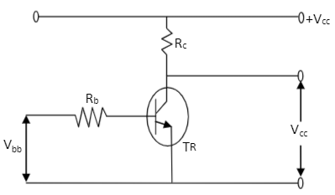Transistor switching circuit is shown in Fig 1.

**Fig.1. A transistor switching circuit.**

1. **MULTIVIBRATOR**

The bistable multivibrator's fundamental circuit is depicted in Fig. 2. It has two linked fundamental switching stages and a two-stage positive feedback-applied common-emitter amplifier, just as the bipolar junction transistor. There are two perfectly stable states [9] for it. Until an external trigger pulse changes it from one state to the other, it can stay in any of these two states indefinitely (as long as power is given).

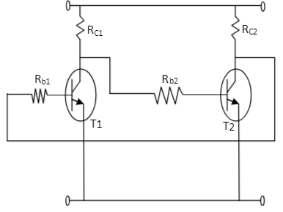

**Fig.2. Multivibrator**

1. **MICROPHONE**

An apparatus that transforms sound waves into electrical impulses is called a microphone. To detect the clap sound and produce a little voltage, we employed a condenser microphone as a sound sensor.

Dynamic microphones, the most popular kind, use a coil hung in a magnetic field that can be fastened to several membranes to provide a wider frequency response.

Dynamic microphones generate the audio signal by the utilisation of electrical energy in the form of induction [10]. These microphones are ideal for use in live performances.

A tiny diaphragm attached to a rotating coil is found inside the microphone capsule. The diaphragm vibrates as sound waves strike it [11]. As a result, the coil oscillates within the magnet's field, producing an electrical current.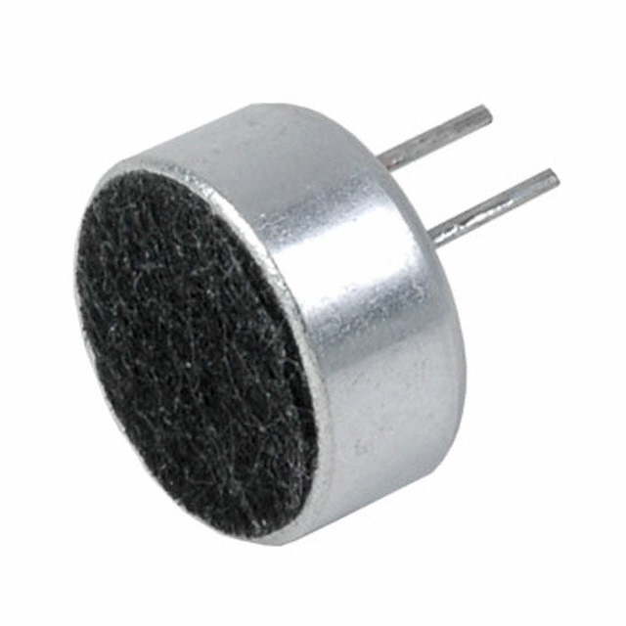

**Fig.3. Microphone**

1. **CAPACITOR**

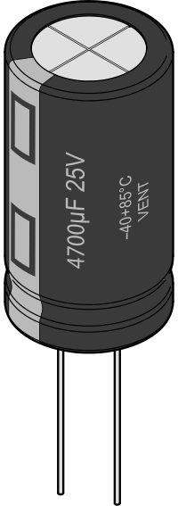A capacitor is a device that can store electrical charge [12]. In our circuit, we employed both ceramic and electrolytic capacitors. Ceramic capacitors have low capacitance values [13] and are compact. They were employed to remove high-frequency interference from the transmission [14]. Large and with high capacitance values are electrolytic capacitors. They served as a time delay for the relay and a means of adjusting the signal.

**Fig.4. Capacitor**

1. **RESISTOR**

A resistor is a passive electrical component with two terminals that is used to implement electrical resistance in circuits [15]. Resistors have a variety of applications in electronic circuits, including lowering current flow, adjusting signal levels, dividing voltages, biasing active components, and ending transmission lines [16]. High-power resistors are useful in power distribution systems, motor controllers, and generator test loads because they can dissipate a lot of electrical power as heat [17]. Resistances of fixed resistors only vary with operation voltage, temperature, or time. Variable resistors can be force- or chemical activity-sensing devices, or they can be employed to alter circuit elements (such a lamp dimmer or volume control) [18].

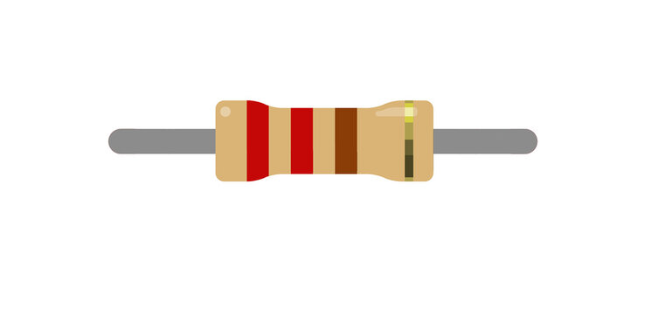

**Fig.5. Resistor**

1. **DIODE**

A diode is a component that only permits one direction of current passage [19]. To shield the transistor from harm caused by the relay coil's reverse current, we employed a diode.

The most often used kind of semiconductor diode nowadays is a crystalline piece of material with a p–n junction attached to two electrical terminals [20].Its current-voltage characteristic is exponential. The first semiconductor-based electronic devices were semiconductor diodes. German physicist Ferdinand Braun discovered asymmetric electrical conductivity at the contact between a crystalline mineral and a metal in 1874[21]. While silicon still makes up the majority of diodes today, other semiconducting semiconductors including germanium and gallium arsenide are also utilised [22].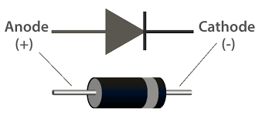

**Fig.6. Diode**

1. **BULB**

A bulb is a device that can produce light when an electric current passes through a filament. We used a bulb as the load that we wanted to control with our clap switch circuit [23].

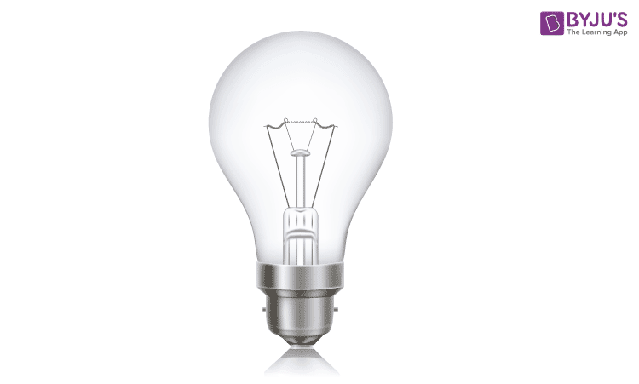

**Fig.7. Bulb**

1. **RELAY**

A switch that is powered by electricity is called a relay. Although solid-state relays and other operating principles are also employed, most relays use an electromagnet to mechanically operate a switch [24]. When multiple circuits need to be controlled by a single signal or when a low-power signal is required to control a circuit (with total electrical isolation between the controlled and control circuits), relays are employed [25].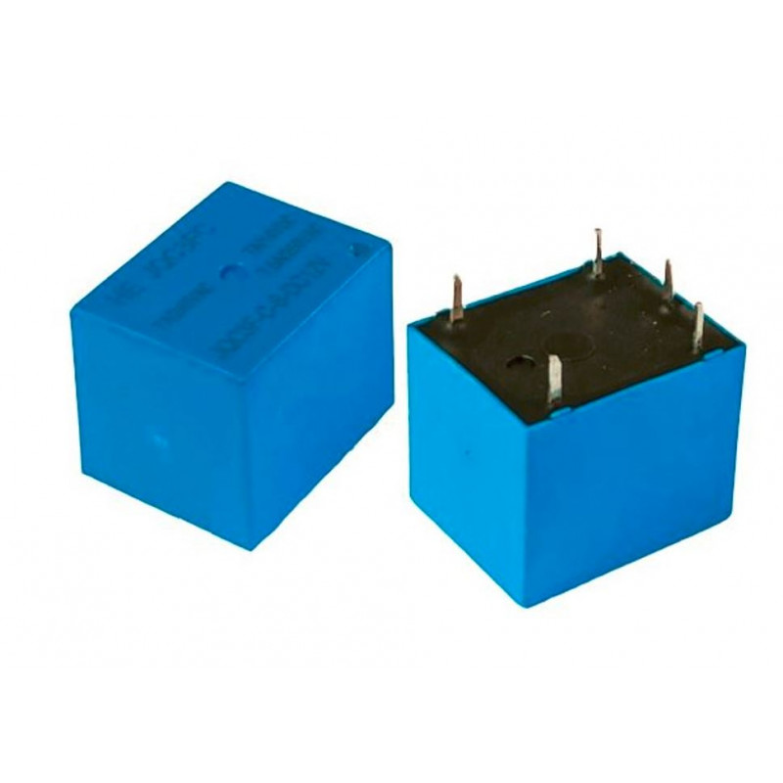

**Fig. 8.Relay**

**IV. METHOD**

All additional components, including resistors, capacitors, diodes, and transistors, were installed and soldered on the Vero board, which serves as the chassis, as indicated by the circuit diagram in Fig. 3. The circuit was carefully designed to prevent bridging.

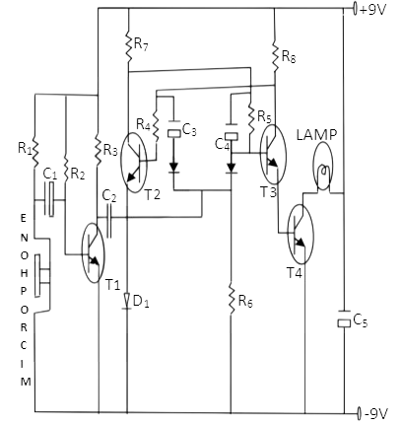

**Fig.9. Circuit diagram of the constructed clap light switch**

T1 functions as an amplifier and is wired so that the output current (Ic) from the collector terminal is transferred via C2 and into the bistable state stage, and the emitter is linked to the ground. T2 was wired so that its positive terminal's emitter terminal was linked to a diode D1, and its negative terminal was connected to ground. The connections to Darlington are T3 and T4. The collector terminal of T4 is linked to the lamp, and the other terminal is connected to the ground via an electrolytic capacitor C5. The emitter of T3 is connected to the base terminal of T4, and the emitter of T4 is connected to the ground [26]. As seen by the circuit diagram above, the microphone and battery were then connected.

The created clap light switch circuit diagram in Figure 9 aids in illuminating the location of each component and their connections to other parts of the circuit.

**V. OPERATION**

The microphone detects sound when a hand is clapped, converts acoustic sound energy into electrical current, and outputs voltage since it is connected in parallel to the resistor (using the voltage divider method) [27]. The next transistor stage (T1) amplifies the output signal after that. After the amplified signal has passed through a ceramic capacitor to eliminate ripples, it moves on to the bistable stage, which alternates between a first and second clap for each signal. Put another way, the bistable multivibrator is created by joining two switches together in a way that allows regeneration. Resistances R7 and R8 have the same value as resistors R4 and R5, so when an amplified signal travels through capacitor C2, it will cause the base current of transistor 1, T1 to slightly decrease. This will reduce the collector current of transistor 2, T2, and increase the voltage across the collector of transistor 1, T1. Transistor 2, T2, has a decrease in base current as a result.

The base current (Ib) of transistor 1 decreases more as a result of the decrease in the voltage of transistor 2's collector current (Ic). Due to positive feedback, transistors 2 and T1 turn ON and OFF, respectively, until the circuit reaches its final state, in which T2 is ON and T1 is OFF. After passing through T3 (the Darlington connection), the output signal from T2 will become even more amplified, causing the lamp to turn on. The situation will be reversed at the second clap, at which point the lamp will turn off.

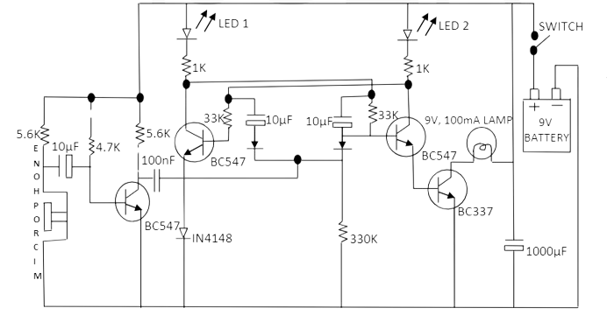

**Fig.10. Schematic diagram of a clap switch based bulb**

**VI. TEST AND RESULTS**

Upon completion of the circuit construction, tests were required to verify that the circuit is operating as intended. The battery provided the necessary 9V dc to power or turn ON the lamp when it was attached to the switch and the switch was closed. Transistor 2, T2, and transistor 3, T3 were triggered to indicate that the transistors were operational, and at that point, LEDs 1 and 2 were "ON." In order to verify that the battery was providing the necessary voltage, the bulb finally shines when the switch is closed and the microphone detects a sound (a clap). The lamp will turn off at the second clap when the situation is reversed.

Thus, the test's result demonstrates that the intended circuit functioned as intended and that there was no short circuit in the system.

**VII. CONCLUSION**

Like any other electronic equipment, building a clap light switch is an exciting but a challenging procedure. This is caused by differences between the values of the components that are actually used and those that are theoretically computed. When a researcher is unfamiliar with electronics, the variations provide challenges. The multimeter reading for the clap light switch, for example, indicated an actual output voltage of 8.85V, whereas the theoretical calculation derived from the component values was 9.0V. The component tolerances are primarily to blame for this issue.

Since the acoustical sound signal created was used to control the lamp's ON and OFF functions, the outcome achieved more or less met the intended objective.

**REFERENCE**

1. Try Engineering Summer Institute

https://tryengineeringinstitute.ieee.org/what-is-electrical-engineering/

1. Construction and Operation of a Clap Light Switch

<https://www.academia.edu/35754984/Construction_and_Operation_of_a_Clap_Light_Switch>

1. Transformation of Sound Energy into Electrical Energy Using IoT

https://www.ijraset.com/research-paper/transformation-of-sound-energy-into-electrical-energy-using-iot

1. [Digital Sound sensor](https://arduino.stackexchange.com/questions/54489/digital-sound-sensor)

https://arduino.stackexchange.com/questions/54489/digital-sound-sensor

1. IRJET-Clap Pattern Based Electrical Appliance control

https://www.academia.edu/31703552/IRJET_Clap_Pattern_Based_Electrical_Appliance_control

1. Efficient Vs Responsive Supply Chain

<https://spotos.eu/blog/efficient-vs-responsive-supply-chain>

1. Comply Advantage

<https://complyadvantage.com/insights/reduce-false-positives-with-machine-learning/>

1. bipolar junction transistor

<https://testbook.com/question-answer/in-bipolar-junction-transistor-bjt-which-layer--613317e5655f23bc6e63a302>

1. Introduction of transistor Bi-Stable Multivibrator

<http://www.lscollege.ac.in/sites/default/files/e-content/Introduction%20of%20Transistor%20Bi-Stable%20Multivibrator%20%28PART%20-%201%29%2C%20Lecture%20-%2015%2C%20TDC%20Part%20-%20III%2C%20Paper%20-%20VI%2C%20Unit%20-%208%2C%20By%20-%20Dr.%20Niraj%20Kumar.pdf>

1. Microphone

<https://www.techtarget.com/whatis/definition/microphone>

1. Diaphragm (acoustics)

<https://en.wikipedia.org/wiki/Diaphragm_(acoustics)>

1. Study.com

https://homework.study.com/explanation/capacitors-are-devices-that-store-electric-charges-true-or-false.html

1. EE Power

https://eepower.com/capacitor-guide/types/ceramic-capacitor/#

1. Liron

https://www.chinacapacitor.com/news/what-are-large-can-aluminum-electrolytic-capacitors.html

1. [Resistors In Series and Parallel](https://byjus.com/physics/resistors-in-series-parallel/) Combination

https://byjus.com/physics/resistors-in-series-parallel/

1. Uses of Resistors

<https://testbook.com/physics/uses-of>-resistor#:~:text=A%20resistor%20is%20a

%20passive,components%2C%20and%20terminating%20transmission%20lines

1. Uses of Resistor

<https://unacademy.com/content/jee/study-material/physics/uses-of-resistor/>

1. Resistor

<https://en.wikipedia.org/wiki/Resistor#:~:text=Variable%20resistors%20can%20be%20used,%2C%20force%2C%20or%20chemical%20activity.&text=Resistors%20are%20common%20elements%20of,are%20ubiquitous%20in%20electronic%20equipment>

1. Diode Current Flow

https://resources.pcb.cadence.com/blog/2020-diode-current-flow-functionality-and-characteristics

1. Diode

<https://en.wikipedia.org/wiki/Diode#:~:text=A%20semiconductor%20diode%2C%20the%20most,the%20first%20semiconductor%20electronic%20devices>

1. Semiconductor Diode

<https://byjus.com/physics/semiconductor-diode-questions/>

1. Diode

<https://en.wikipedia.org/wiki/Diode>

1. Project Report on Design a Clap Switch and Its Application

<https://www.researchgate.net/publication/375754095_Project_Report_on_Design_a_Clap_Switch_and_Its_Application>

1. Autodesk Instructables

<https://www.instructables.com/All-You-Need-to-Know-About-Relays/>

1. Relay

<https://www.instructables.com/All-You-Need-to-Know-About-Relays/>

1. Logic Gates

<https://www.homofaciens.de/technics-base-circuits-logic-gates_en.htm>

1. Clap Switch

<https://www.slideshare.net/iindranilsarkar/report-5-41247846>