**CUSTOM VOICE CLONER**

**USHARANI.K1, NANDHAKUMARAN.H2,NIKHILESH PRANAV.M.S3, NITHISHKUMAR.K.K4, PRASANNA KRISHNA.A.S5**

*1Assistant Professor Department of Computer Science and Engineering,*

*K.L.N. College of Engineering and Technology, Sivagangai, India*

*2,3,4,5Student, Department of Computer Science and Engineering,*

*K.L.N. College of Engineering and Technology, Sivagangai, India*

*Corresponding Author: usharanibe@gmail.com*

|  |
| --- |
| ***Abstract:****The CUSTOM VOICE CLONER is based on voice signal speech synthesizer. It is a technology that converts text into audible speech, simulating human speech characteristics like pitch and tone. It finds applications in virtual assistants, navigation systems, and accessibility tools. Building one in Python typically involves Text-to-Speech (TTS) libraries such as gTTS, pyttsx3, or platform-specific options for Windows and macOS, offering easy text-to-speech conversion.However, TTS libraries might lack customization and voice quality needed for advanced projects. For more sophisticated applications, custom voice synthesizers can be built using deep learning techniques like Tacotron and WaveNet. These models learn speech nuances for more natural output.Creating a custom voice synthesizer is challenging, requiring high-quality training data, machine learning expertise, and substantial computational resources. It goes beyond generating speech to convey emotions and nuances in pronunciation for natural and expressive voices.*  ***Key Word****:* *Voice signal speech synthesizer,text-to-speech conversion, deep learning,TTS, gTTS, pyttsx3,etc.* |

1. **Introduction**

Voice signal speech synthesizers in Python can be built using TTS libraries like gTTS or pyttsx3, and advanced projects may involve deep learning techniques like Tacotron or WaveNet. Challenges include obtaining high-quality training data and conveying emotions. Applications include enhancing accessibility, powering virtual assistants, and improving user experiences. Voice recognition, transforming spoken language into text or commands, involves key concepts like speech input, transcription, and natural language understanding. Applications span virtual assistants, transcription services, customer service, and healthcare, offering convenience and efficiency in human-computer interaction. In healthcare, voice recognition facilitates efficient medical transcription, allowing professionals to focus on patient care. Overall, voice recognition technology bridges the gap between spoken language and machine understanding in diverse applications.

1. **Research And Findings**

Text-to-speech (TTS) applications in Python offer a powerful tool to convert written text into audible speech, enhancing accessibility and finding applications in various domains. Leveraging Python's capabilities and TTS libraries allows developers to create immersive user experiences, from voice assistants to multimedia content creation. The flexibility of Python enables the extension of TTS functionality, including multilingual support, emotion-infused speech, and real-time interaction, contributing to the development of inclusive and engaging applications.

However, TTS systems have certain disadvantages. Artificial-sounding speech remains a challenge, especially in freely available systems, impacting user experiences in applications where natural-sounding speech is crucial. Additionally, limited language and accent support can lead to mispronunciations and hinder the creation of globally accessible content. Despite these challenges, Python's role in TTS continues to shape the future of digital communication and accessibility.

The Existing Python's TTS applications provide a powerful tool for converting text to speech, benefiting accessibility and applications like voice assistants and Customer Support.These applications enable developers to create interactive user experiences with spoken content, enhancing usability and engagement. Applications like Google Translate, Voice Aloud, Narrator’s Voice.

Creating a speech-to-speech voice changer application in Python involves transforming input voice streams into modified output streams in real-time. Developers can explore transformative effects like gender swapping, robotic voices, or celebrity impersonations, adding creativity to voice-based communication and multimedia projects. While such applications hold potential for entertainment, gaming, and privacy enhancement, responsible usage is crucial. Python's vast libraries and machine learning tools enable developers to design voice-changing applications that cater to diverse preferences while promoting ethical and responsible usage.

In Entertainment and Gaming, Enhance gaming experiences by adopting different character voices, adding creativity to in-game characters, or entertaining audiences during streams. In Multimedia Content Creation, Content creators use voice changers to add variety to videos, podcasts, and animations, bringing uniqueness and engagement. In Education and Language Learning, Language learners improve pronunciation by mimicking diverse voices, while educators make lessons interactive and engaging.

**III. System Implementation**

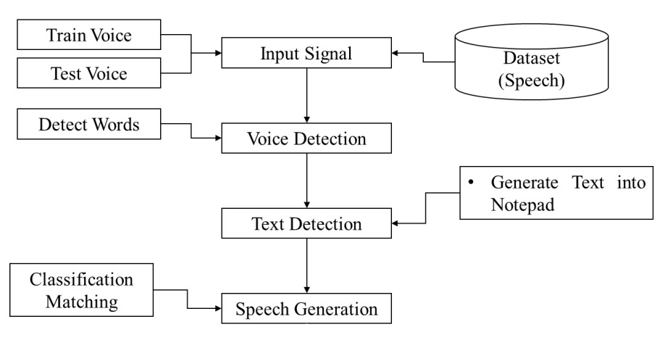

These diagrams help us understand the flow of our proposed system in a simple way. The input signal, consisting of training and testing voices along with a speech dataset, is utilized in voice detection to discern spoken words. Additionally, text detection capabilities are employed to transcribe and generate text into a notepad. The speech generation process involves classifying and matching patterns. Following are the major components used in our system,

1) Voice Input

Voice recognition systems involve two fundamental processes: obtaining input voices and reading or interpreting them. These processes are at the core of the technology, enabling computers to understand and respond to spoken language.

2) Voice Detection

Voice matching, or speaker recognition, is a biometric technology that verifies or identifies individuals based on unique voice patterns. It involves capturing vocal traits and comparing them to a stored voiceprint for authentication. Analyzing pitch, cadence, and vocal resonances, it confirms if the provided voice sample matches the authorized speaker. This technology finds applications in security, access control, and voice-based user authentication, offering a secure and convenient means of confirming identity. Used in unlocking smartphones, securing access to devices, and enhancing call center and financial transaction security, voice matching evolves with machine learning and AI advancements, becoming a valuable tool for identity verification in the digital age.

3) Text Detection

Voice-to-text technology, or automatic speech recognition (ASR), converts spoken language into written text. Text detection techniques applied to the transcribed text enable tasks like keyword identification, sentiment analysis, and named entity recognition. Used in transcription services, voice assistants, and content analysis, these processes facilitate seamless human-computer interactions and data-driven insights by bridging the gap between spoken and written language.

4) Speech Generation

Voice synthesis, or text-to-speech (TTS), transforms written text into audible speech using techniques like concatenate synthesis and neural networks. Widely used in voice assistants, accessibility tools, and content narration, it enhances user experiences and accessibility. Advantages include dynamic and engaging applications, improved accessibility for visually impaired individuals, enhanced e-learning experiences, and consistent multilingual pronunciation. In customer service, it supports cost-effective interactive voice response (IVR) systems. Overall, voice synthesis fosters inclusivity, efficiency, and user-centricity in the digital environment.

**IV.CONCLUSION**

* **Introduction to Voice Recognition:** Voice recognition is a transformative technology enabling machines to understand and process spoken language. It acts as a bridge between human communication and computers, revolutionizing interaction.
* **Mechanics of Voice Recognition:** Voice recognition involves acquiring audio inputs and interpreting them, often using voice matching techniques. Voice matching enhances the accuracy of systems, making voice recognition more effective.
* **Applications of Voice Recognition:** Voice assistants and transcription services demonstrate the practical applications of this technology. Accessibility tools and secure voice-based authentication showcase its versatility**.**
* **Voice Synthesis and its Role:** Voice synthesis brings written text to life by generating spoken words. It plays a crucial role in making information more accessible to a diverse audience.
* **Combined Power of Voice Technologies:** The synergy of voice recognition, voice matching, and voice synthesis creates an intuitive and inclusive digital landscape. This combined power enhances responsiveness to human needs in technology.
* **Impact on User Experiences:** Ongoing evolution of voice technologies significantly impacts user experiences. These technologies contribute to a user-friendly digital environment, shaping the future of human-computer interaction.

**References**

1. Dzmitry Bahdanau,KyungHyun Cho,Yoshua Bengio.,“Neural Machine Translation by Jointly Learning to Align and Translate" in International Conference on Learning Representations on September 2014.
2. Dzmitry Bahdanau,KyungHyun Cho,Yoshua Bengio.,“Neural Machine Translation by Jointly Learning to Align and Translate" in International Conference on Learning Representations on September 2014.
3. Jan K. Chorowski, Dzmitry Bahdanau, Dmitriy Serdyuk, Kyunghyun Cho, Yoshua Bengio.,“Attention-Based Models for Speech Recognition” in 29th Annual Conference on Neural Information Processing Systems on June 2015.
4. [L. Deng](https://www.semanticscholar.org/author/L.-Deng/144718788), [Jinyu Li](https://www.semanticscholar.org/author/Jinyu-Li/152319568), [J. Huang](https://www.semanticscholar.org/author/J.-Huang/117578378), [K. Yao](https://www.semanticscholar.org/author/K.-Yao/39922478), [Dong Yu](https://www.semanticscholar.org/author/Dong-Yu/144580027), [F. Seide](https://www.semanticscholar.org/author/F.-Seide/1745715), [M. Seltzer](https://www.semanticscholar.org/author/M.-Seltzer/1727524), [G. Zweig](https://www.semanticscholar.org/author/G.-Zweig/1681543), [Xiaodong He](https://www.semanticscholar.org/author/Xiaodong-He/144137069), [J. Williams](https://www.semanticscholar.org/author/J.-Williams/47271859), [Y.Gong](https://www.semanticscholar.org/author/Y.-Gong/1777280), [A.Acero](https://www.semanticscholar.org/author/A.-Acero/1723644).,“Recent advances in deep learning for speech research at Microsoft” in International Conference on Acoustics, Speech and Signal Processing (ICASSP) on May 2013.
5. [Awni Y. Hannun](https://www.semanticscholar.org/author/Awni-Y.-Hannun/144479015), [Carl Case](https://www.semanticscholar.org/author/Carl-Case/2065131508), [J. Casper](https://www.semanticscholar.org/author/J.-Casper/48991386), [Bryan Catanzaro](https://www.semanticscholar.org/author/Bryan-Catanzaro/2301680), [G. Diamos](https://www.semanticscholar.org/author/G.-Diamos/2040049), [Erich Elsen](https://www.semanticscholar.org/author/Erich-Elsen/152585800), [R. Prenger](https://www.semanticscholar.org/author/R.-Prenger/3283879), [S. Satheesh](https://www.semanticscholar.org/author/S.-Satheesh/145031342), [Shubho Sengupta](https://www.semanticscholar.org/author/Shubho-Sengupta/2264597), [Adam Coates](https://www.semanticscholar.org/author/Adam-Coates/144638694), [A. Ng](https://www.semanticscholar.org/author/A.-Ng/34699434).,“Deep speech: Scaling up end-to-end speech recognition” in International Conference on Machine Learning(ICML) on December 2014.
6. Alex Graves, Santiago Fern´andez, Faustino Gomez, J¨urgen Schmidhuber., “Connectionist temporal classification: labeling unsegmented sequence data with recurrent neural networks“ in Proceedings of the 23rd International conference on Machine learning(ICML) on January 2006.