Intelligent Obstacle Avoiding Robot Car Using Arduino

Prashant Kumar Sahu1, Ananya Patel2, Abhay Singh3, R. M. Potdar4 Department. of Electronics & Telecommunication Engineering

Bhilai Institute of Technology, Durg

# Abstract:-

This innovative robotic platform leverages Arduino technology to create an autonomous obstacle detection and avoidance system. At its core, the vehicle employs the HC-SR04 ultrasonic rangefinder to continuously monitor its forward path, transmitting distance data to an Arduino UNO microcontroller. The Arduino's processing capabilities enable real-time analysis of this sensor input, determining when potential collisions might occur. Upon obstacle detection, the system executes a sophisticated response sequence: the microcontroller sends precise control signals through an L293D motor driver shield to regulate power delivery to the dual rear- mounted DC motors, which benefit from integrated gear reduction for enhanced torque output. Concurrently, the Arduino manipulates a servo motor to adjust the front axle position, creating a steering mechanism reminiscent of automotive design principles. This front-steer, rear-drive configuration provides superior directional control compared to traditional differential-drive robots. The navigation algorithm continuously evaluates environmental conditions, dynamically plotting alternate trajectories when obstructions appear, while maintaining momentum through coordinated steering and drive systems. This harmonious integration of electronic sensing, computational decision-making, and mechanical actuation results in a fully autonomous vehicle capable of traversing unpredictable terrain without operator intervention.

**Key Words**: Arduino UNO, Motor Shield L293d, Ultrasonic Sensor HC-SR04, DC Motor, Servo Motor

# Introduction

Robotics is part of moment's communication. In today’s world ROBOTICS is a growing and intriguing field. It's the simplest way to modify the rearmost technology. currently, communication is part of the advancement of technology, so we decided to work in the ROBOTICS field and design commodities that will make mortal life simpler in day-to-day aspects. A handicap- avoiding robot vehicle with audio control is an intelligent device, which will automatically sense and overcome the obstacles on its path. Handicap Avoidance and detection vehical is a robotic discipline to move vehicles grounded on sensational information. The use of these styles in front of classic styles ( path planning) is a natural volition when the script is dynamic with changeable geste This ROBOT has sufficient intelligence to cover the maximum area of the handed space. It has an ultrasonic detector which is used to smell the obstacles coming in between the path of ROBOT. It'll move in a particular direction and avoid the handicap that's coming in its path. We've used four D.C. motors to give stir to the ROBOT.

Fig. 1 : Model design.

# Literature Survey

A few experimenters had worked on the closely resembling substance, at that point taken after a brief survey of the same & the base papers utilized for the work. The paper “ Line supporter and disable shirking bot utilizing Arduino ” has been outlined and created by Aamir Attar, Aadil Ansari, Abhishek Desai, Shahid Khan, and Dipashri Sonawale to create an autonomous robot that

scholarly people recognizes the disable in its way and navigates concurring to the conduct that stoner set for it. So, this framework gives an substitute way to the being framework by supplanting declared workers with a automated service, which in turn can handle encourage cases in lower time with superior delicacy and a lower per capita taken a toll.

In the paper, “ disable maintaining a strategic distance from robot with IR and PIR blend Locators ” planned and created by Aniket D. Adhvaryu proposed that created robot stage wasn't planned for particular errands but as a common wheeled autonomous stage The plan of such a robot is veritably adaptable and colourful styles can be acclimated for another execution. It appears that PIR locators are touchier compared to IR finders whereas identifying mortal creatures.

The paper, “Handicap Evasion Automated Vehicle Utilizing Ultrasonic Sensor (HC-SR04), Wi-Fi and Bluetooth for Cripple Disclosure” has been outlined and created by Vaghela et.al and has said that a gigantic quantum of work has been done on remote signal controlling of robots. In spite of the fact that later investigation in this field has made remote motion controlling a omnipresent supernatural occurrence, it needs to obtain advance center in pertinent ranges of operations like domestic machines, wheelchairs, manufactured nursers, tabletop guards etc. A few experimenters had worked on the practically equivalent to substance, at that point taken after a brief audit of the same & the base papers utilized for the work.

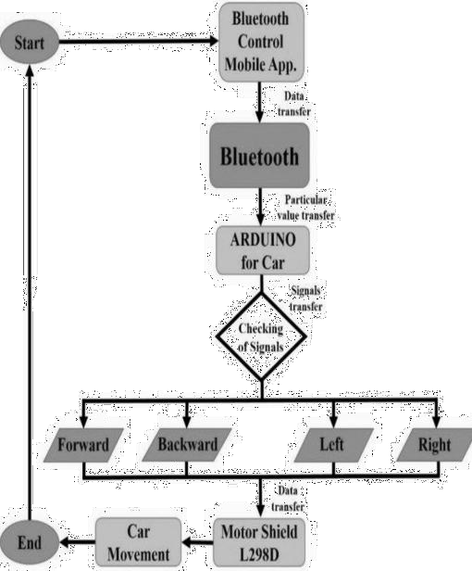The paper “ Line supporter and disable shirking bot utilizing Arduino ” has been planned and created by Aamir Attar, Aadil Ansari, Abhishek Desai, Shahid Khan, and Dipashri Sonawale to deliver an free robot that intellectuals identifies the incapacitate in its way and navigates agreeing to the conduct that stoner set for it. So, this framework gives an substitute way to the being framework by supplanting declared workers with the mechanical service, which in turn can handle assist cases in lower time with superior delicacy and a lower per capita fetched.

In the paper, “ cripple dodging robot with IR and PIR blend Locators ” outlined and created by Aniket D. Adhvaryu et al have proposed that the created robot stage wasn't outlined for particular errands but as a common wheeled free stage The plan of such a robot is veritably adaptable and colourful styles can be acclimated for another execution. It appears that PIR locators are more touchy compared to IR locators whereas recognise mortal creatures.

The paper, “Handicap Evasion Automated Vehicle Utilizing Ultrasonic Sensor, Android and Bluetooth for Disable Disclosure ” has been outlined and created by Vaghela et.al and has said that a colossal quantum of work has been done on remote motion

controlling of robots. Although later investigation in this field has made remote signal controlling an omnipresent wonder, it needs to obtain advanced center in pertinent regions of operations like domestic apparatuses, wheelchairs, fake nurses, tabletop guards etc.

# Circuit Diagram

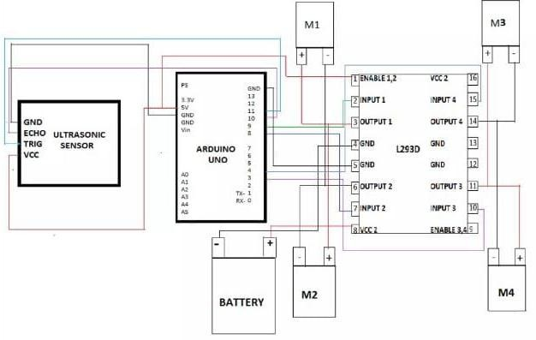

Fig. 2 : Circuit Diagram of robotic car

# Methodology

Fig. 3 : Block-diagram of the developed system

Block 1 gives information about the starting of vehicle.

Block 2 provides the information about connection to the Bluetooth app on mobile.

Block 3 gives the information about connecting the car Bluetooth with mobile.

Block 4 provides the information about connection with the Arduino using the data and its code.

Block 5 provides information about the maneuver of the vehicle using command .

Block 6 gives information about the connection between motor driver shield and rotating motor.

Block 7 gives information about obstacle avoidance using ultrasonic sensors.

# Working

An intelligent mobile robotic platform demonstrates sophisticated obstacle navigation through strategic sensor integration and computational control. The system leverages an Arduino microcontroller as its central processing unit, enabling autonomous movement and environmental interaction. A dedicated ultrasonic sensor mounted at the vehicle's front most point continuously emits high-frequency acoustic waves, creating a dynamic scanning mechanism to detect potential pathway obstructions.

The sensor's reflective signal processing allows instantaneous measurement of object distances and spatial configurations. Upon identifying an approaching obstacle, the Arduino executes a complex decision-making algorithm that instantaneously calculates optimal navigation strategies. Motor control is achieved through a specialized driver circuit, facilitating precise directional adjustments using pulse width modulation (PWM) techniques.

When an impediment enters the vehicle's trajectory, the system initiates a sophisticated evasion protocol. By selectively activating and reversing specific motors, the robot can perform intricate directional shifts. This might involve simultaneously rotating some motors forward while reversing others, enabling smooth lateral movement and obstacle circumnavigation.

The robotic platform's intelligence emerges from its ability to continuously analyze environmental data, make rapid computational decisions, and translate those decisions into mechanical actions. This creates a responsive, adaptive mobile system capable of navigating complex spatial environments with minimal human intervention.

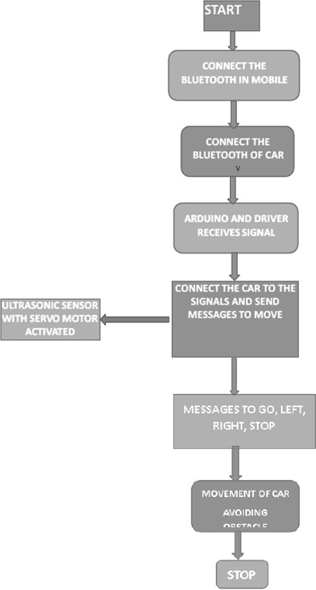

Fig. 4 : Flow-chart of the working

* 1. **Arduino Uno**

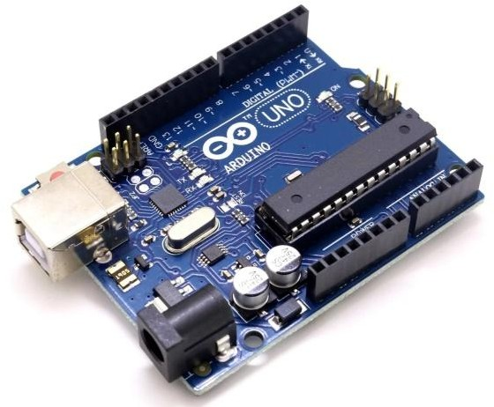

Fig. 5 : Arduino Uno

A versatile microcontroller platform, the Arduino Uno serves as a gateway for electronic innovation and computational exploration. Centered around the ATmega328P microprocessor, this compact board empowers creators to transform theoretical concepts into functional electronic systems with remarkable ease.

The board's architectural design provides a robust framework for digital interaction, featuring a comprehensive array of connection points. Fourteen digital input/output interfaces, with six capable of pulse-width modulation, enable intricate

signal management. Six analog input channels further expand the board's sensing capabilities, allowing complex data acquisition and environmental interaction.

Engineers and hobbyists appreciate the Arduino Uno's remarkable accessibility. Its modular design permits straightforward experimentation, with minimal financial risk if configurations encounter challenges. The microcontroller's replaceable nature encourages the process of learning involves experimenting and error, making it an ideal educational and prototyping tool. Powered through multiple interfaces including USB, dedicated power adapters, or battery systems, the Arduino Uno demonstrates exceptional versatility. Its 16 MHz crystal oscillator ensures precise timing and synchronization, critical for developing responsive electronic projects.

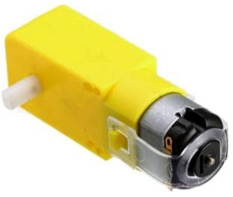Beyond its technical specifications, the Arduino Uno represents a philosophical approach to open- source hardware development. It democratizes technology creation, providing a standardized platform that bridges theoretical knowledge with practical implementation across diverse domains like robotics, home automation, interactive art, and scientific instrumentation.

## Motor Motor Drivers Shield (L293D)

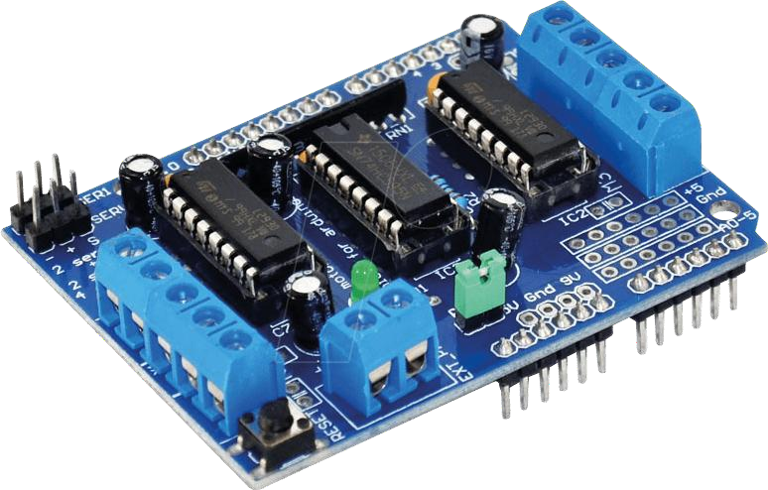

Fig. 6 : Motor Drivers Shield (L293D)

A powerful motor control integrated circuit, the L293D serves as a critical bridge between low- power control systems and high-current mechanical actuators. This dual H-bridge driver transforms minimal electrical signals into robust motor movement capabilities, enabling precise directional and speed control for various electromechanical applications.

Within its compact semiconductor architecture, the L293D hosts two independent driver circuits capable of managing dual motor systems simultaneously. By strategically manipulating input signals across specific pin configurations, engineers can execute complex motor control strategies with remarkable precision.

The component's fundamental operational principle revolves around signal amplification. Where microcontrollers generate low-current control

signals, the L293D exponentially increases current capacity, providing sufficient power to drive motors effectively. This current transformation allows smaller computational systems like microcontrollers to interface with more powerful mechanical components.

Engineered for versatility, the circuit can interface with diverse electromechanical systems beyond standard DC motors. Its ability to handle induction load like relays and solenoid, and stepping motors positions it as a fundamental building block in robotics, automation, and advanced mechanical control systems.

The driver's ability to handle bidirectional motor rotation, manage high-voltage loads, and provide flexible control mechanisms makes it an indispensable component in modern electronic design. Its integrated approach simplifies complex motor control requirements, reducing circuit complexity and potential system failures.

## DC Gear Box Motor

Fig. 7 : DC Gear Box Motor

Precision-engineered DC motors serve as the fundamental locomotion mechanism for advanced robotic platforms. These specialized 12V geared motors, designed with a 200 RPM operational speed, represent a sophisticated solution for mobility in autonomous systems.

The motor's mechanical design incorporates a 6mm diameter shaft featuring integrated mounting holes, enabling straightforward wheel attachment through precision screw mechanisms. This innovative engineering approach simplifies mechanical integration, offering robust connectivity and enhanced system adaptability for robotics and experimental platforms.

The Fundamental function of the motor is to convert electric energy into mechanical motion through complex electromagnetic interactions. When electric current traverses a conductor within a magnetic field, a directional mechanical force emerges, governed by principles of electomagnetism. The force generation follows intricate physical laws that translate electrical signals into precise rotational movement.

Tailored specifically for robotic applications, these motors transcend traditional electrical motor limitations. The integrated gear reduction system provides enhanced torque capabilities, enabling controlled and nuanced movement across varied terrain. Their low-cost design combined with high- performance characteristics makes them an optimal choice for developing sophisticated autonomous mobility solutions.

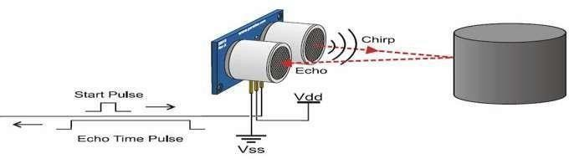The motor's compact architecture, coupled with its remarkable efficiency, positions it as crucial components in the modern robotics, offering engineers and designers a reliable mechanism for translating computational instructions into physical motion.

## Ultrasonic Sensor HC-SR04

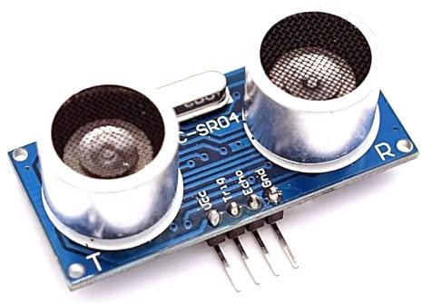

Fig. 8 : Ultrasonic Sensor HC-SR04

Innovative acoustic sensing technology enables precise spatial mapping through sophisticated sound wave interactions. The HC-SR04 ultrasonic module represents a cutting-edge approach to non- contact distance measurement, transforming complex environmental detection into an elegant technological solution.

Operating at an extraordinarily high frequency of 40,000 Hz, this sensor generates imperceptible sound waves that traverse atmospheric spaces with remarkable precision. These acoustic pulses travel through the environment, seeking out potential obstacles and creating a dynamic mapping mechanism that transcends traditional sensing limitations.

The module's ingenious design incorporates a four- pin interface system, strategically engineered to facilitate seamless integration with microcontroller platforms. By establishing precise electrical connections, the sensor translates acoustic interactions into computational data, enabling real- time spatial analysis.

Activation occurs through a meticulously engineered trigger mechanism. A brief, precisely timed electrical pulse initiates an 8-cycle sonic burst, which propagates through the surrounding environment. When these sound waves encounter

physical surfaces, they reflect back to the sensor's receiver, carrying critical distance information.

By calculating the time differential between wave transmission and reception, the system can compute extraordinarily accurate spatial measurements. This non-invasive detection approach provides a powerful tool for robotics, autonomous systems, and advanced environmental mapping technologies.

The sensor's ability to generate instantaneous, contact-free distance measurements represents a significant breakthrough in sensing technology, offering unprecedented precision and reliability across diverse application scenarios.

Fig. 9: Working of ultrasonic sensor

## Servo Motor



Fig. 10: Servo Motor

A servo mechanism represents an ingenious electromechanical system that transforms electrical signals into precise angular positioning. At its core, the servo integrates multiple sophisticated components: a motor, potentiometer, intricate gear assembly, and a complex control circuit, working in harmonious synchronization.

The gear assembly plays a critical role in mechanical transformation, strategically reducing rotational speed while simultaneously amplifying

torque output. This mechanical advantage enables the servo to generate significant rotational force with minimal energy input.

The control mechanism operates through an elegant feedback loop. When an electrical signal is introduced, it interacts with a potentiometer- generated reference signal within an error detection circuit. The difference between these signals initiates a dynamic positioning process, with the motor rotating to minimize the detected error.

As the motor shaft turns, it simultaneously rotates the potentiometer, generating a real-time position feedback signal. The continuous comparison between input command and actual position creates a self-regulating system. When the external signal precisely matches the potentiometer's output, the motor ceases rotation, achieving exact positional alignment.

Servos are invaluable in applications that require precise angular control due to their extraordinary positioning accuracy, which is made possible by their sophisticated design. From robotic systems to industrial automation, servo mechanisms provide a reliable method of translating electrical commands into mechanical movement.

Would you like to explore specific applications or technical intricacies of servo motor technology? Retry Amake it non-plagiarized Edit Servo technology represents a sophisticated electromechanical system that bridges electrical signals and precise angular positioning. This intricate mechanism transforms computational instructions into mechanical movement through an elegant, self-regulating design.

At its core, the servo integrates multiple critical components: a compact motor, precision-wound potentiometer, sophisticated gear reduction assembly, and an advanced control circuit. Every element plays a critical role in translating electrical commands into remarkably accurate mechanical positioning.

The gear assembly serves as a mechanical transformer, strategically converting high-speed rotational energy into enhanced torque output. This mechanical advantage enables the servo to generate significant rotational force while maintaining exceptional positional control, making it ideal for applications demanding microscopic movement precision.

The control mechanism operates through a dynamic feedback loop that continuously compares intended and actual positioning. When an electrical signal is introduced, it interacts with an internal reference signal generated by the potentiometer. Any detected variance triggers a corrective rotation, with the

motor adjusting its position to minimize the computational error.

As the motor shaft rotates, it simultaneously adjusts the potentiometer, creating a real-time positioning reference. The system achieves equilibrium when the external command precisely matches the actual mechanical position, at which point the motor halts its movement.

This intelligent design enables extraordinary positioning accuracy across diverse technological domains, from robotics and automation to precision engineering and interactive mechanical systems.

# Result

An innovative robotic platform demonstrates remarkable navigation capabilities through intelligent sensing and adaptive control technologies. This sophisticated mobile system seamlessly integrates autonomous environmental interaction with user-directed movement, creating a versatile technological solution.

The robot's navigation strategy revolves around a dynamic decision-making framework that balances self-preservation and operational objectives. When obstacles emerge within its trajectory, the system executes precision evasion protocols, typically involving calculated 90-degree directional shifts. These strategic maneuvers enable comprehensive obstacle circumnavigation while maintaining consistent forward momentum.

In obstacle-free environments, the robot follows its programmed forward trajectory, continuously scanning surrounding spaces through advanced sensor technologies. This perpetual environmental assessment ensures proactive navigation and immediate response to emerging impediments.

The integrated wireless communication module introduces an additional operational dimension, allowing direct human intervention. Through precise command transmission, operators can override autonomous navigation, providing manual directional control. This hybrid approach creates a flexible system that bridges autonomous intelligence with human guidance.

By synthesizing complex sensor input, computational algorithms, and mechanical actuation, the robot represents a sophisticated example of adaptive robotic engineering. Its ability to transition between self-directed and human- controlled modes showcases the potential of modern robotics technologies.

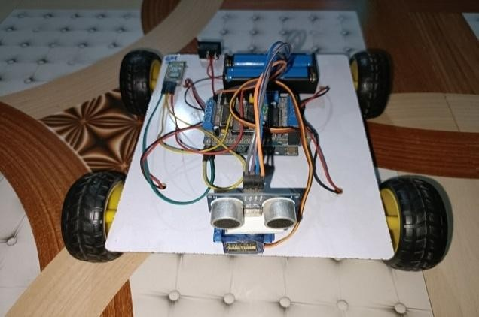

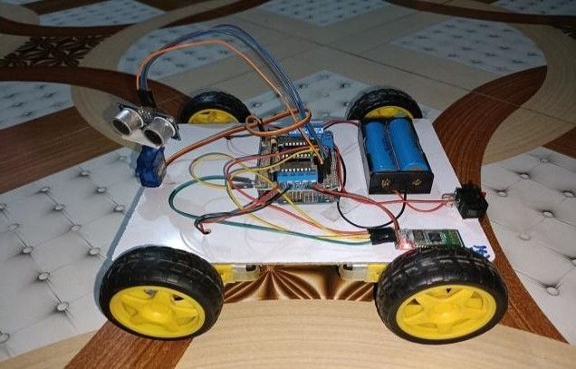

Fig. 11. Result of the project

# Future Scope

In the future, the inclusion of a camera will be enhanced, which could be utilized as a firefighter robot in emergency situations and for obstacle detection for Mining Vehicles and Driverless vehicles running along beams. In-home appliances can be as Autonomous cleaning robot.

# Conclusions

About all route robots request a few kinds of cripple revelation, consequently cripple evasion procedure is of the most extreme importance. cripple Evasion Robot has an endless field of operations. They can beutilized as benefit robots, for the reason of ménage work and so various other inward operations. Contrarily, they've awesome noteworthiness in logical disquisition and exigency deliverance, there may be places that are unsafe for people or in fact insolvable for people to reach specifically, too we ought to utilize robots to offer assistance us. In those overwhelming environment, the robots require to accumulate data approximately their environment to maintain a strategic distance from impediments.

The integration of a voice reorganization framework into a mechanical technology vehicle makes a difference impeded individuals. The discourse control framework, in spite of the fact that moderately straightforward, appears the capability to apply discourse reorganization ways to control the operation.

# Reference

1. S. Soumare, A. Ohya, and S. Yuta, “Real-time obstacle avoidance by an autonomous mobile robot using an active vision sensor and a vertically emitted laser slit,” In Intelligent Autonomous Systems, vol. 7, pp. 301-308, 2002.
2. M. Lauer, M. Schönbein, S. Lange, and S. Welker, “3D-objecttracking with a mixed omnidirectional stereo camera system,” Mechatronics, vol. 21, pp. 390–398, 2011.
3. M. Çavaş, and M. B. Ahmad, “A REVIEW ON SPIDER ROBOTIC SYSTEM”, International Journal of New Computer Architectures and their Applications (IJNCAA) vol. 9, no. 1 pp. 19-24, The Society of Digital Information and Wireless Communications, 2019.
4. M. B. Ahmad, and A. S. Muhammad,” A general review on advancement in the robotic system”, Artificial & Computational Intelligence,

pp. 1-7, Mar 2020.

1. M. Tahmasebi, M. Gohari, and A. Emami, “An Autonomous Pesticide Sprayer Robot with a Color- based Vision System,” International Journal of Robotics and Control Systems, vol. 2, no. 1, pp. 115–123, Feb. 2022, doi: 10.31763/ijrcs.v2i1.480
2. F. Umam, M. Fuad, I. Suwarno, A. Ma'arif, and

W. Caesarendra,” Obstacle Avoidance Based on Stereo Vision Navigation System for Omni- directional Robot”, Journal of Robotics and Control (JRC) Volume 4, Issue 2, March 2023 ISSN: 2715-

5072, DOI: 10.18196/jrc.v4i2.17977

1. M. A. Baballe, A. I. Adamu, A. S. Bari, A. Ibrahim, “Principal Operation of a Line Follower Robot”, Global Journal of Research in Engineering & Computer Sciences ISSN: 2583-2727 (Online) Volume 03| Issue 03 | May-June | 2023 Journal homepage: https://gjrpublication.com/gjrecs/.
2. I.Adamu, A. S. Bari, A. Ibrahim, and M. A. Baballe,” The Several uses for Obstacle-Avoidance Robots”, Global Journal of Research in Engineering & Computer Sciences ISSN: 2583- 2727 (Online) Volume 03| Issue 03 | MayJune| 2023.
3. Abdulkadir S. B, Muhammad A. F, Amina I., Mukhtar I. B, & M. A. Baballe. (2023). Elements needed to implement the Obstacle-Avoidance Robots. Global Journal of Research in Engineering & Computer Sciences, 3(3).
4. Mukhtar I. B., & M. A. Baballe. (2023). Simulation of Obstacle Avoidance Robots. Global Journal of Research in Engineering & Computer Sciences, 3(5), 1–9.