Textile antenna for UWB application

Miss. Monisha R

Asst. Professor

Panimalar Engineering College

Poonamallee, Chennai

monishamadhu@gmail.com

Ishmitha A

Electronics and Communication Engineering

Panimalar Engineering College

Poonamallee, Chennai

ishmitha2002@gmail.com

Johana Sherin A

Electronics and Communication Engineering

Panimalar Engineering College

Poonamallee,

Chennai

johanasherin@gmail.com

Anchana Jegath J

Electronics and Communication Engineering

Panimalar Engineering College

Poonamallee, Chennai

anchanaj3182@gmail.com

Akshaya P

Electronics and Communication Engineering

Panimalar Engineering College

Poonamalle, Chennai

akshayaak2002@gmail.com

***Abstract*— The antenna covers the ultra-wideband (UWB) frequency range (3 GHz to 10 GHz). As a result, a pentagonal patch, tiny design, and partial ground plane ultra-wideband (UWB) antenna developed for efficient transmission. Jeans with a 1.6 mm thickness, a relative dielectric constant of 1, and a loss tangent of 0.009 are used as the substrate in the antenna design. This antenna provides users with discreet and intelligent support by blending in perfectly with regular clothing.** **The S-Parameter value at maximum is 6.6857 and the gain is 3.042 . Hence the constructed UWB antenna with a pentagonal patch and partial ground plane, optimized for medical imaging systems and other applications, shows the potential to advance healthcare technologies.**

***Keywords—pentagonal, FR-4, medical imaging, Ultra-wideband***

1. INTRODUCTION

In the recent years, Ultra-wideband (UWB) technology has gained significant attention due to its ability to enable high-speed data transmission, precise ranging, and robust communication in various applications such as wireless sensor networks, radar systems, and biomedical devices. UWB communication systems operate over a broad frequency range, typically spanning from 3 GHz to 10 GHz, or even higher, with very low power spectral density, making them suitable for short-range, high-data-rate transmissions while coexisting with other wireless systems. Patch antennas have emerged as popular candidates for UWB applications due to their compact size, low profile, and compatibility with modern printed circuit board (PCB) technology. These antennas offer advantages such as wide impedance bandwidth, omnidirectional radiation patterns, and ease of integration with RF front-end circuits, making them ideal choices for UWB communication systems. Our research developed a wearable material-based UWB antenna and simulated it to support health surveillance applications in body sensor networks system. The UWB antenna has band-notch characteristics in the WLAN spectrum, which is specific to wireless local area networks.[7]. The findings of the antenna's simulation, along with its structure, have been provided.

1. RELATED WORKS

Wearable antenna development operating at Ultra-Wideband (UWB) frequencies has attracted a lot of attention lately because of its possible use in Wireless Body Area Networks (WBANs). Interestingly, studies have looked into different substrates to maximize antenna performance. As an illustration, the usage of flexible cotton materials [2] and textiles with a thickness of 3 mm [3] highlights the investigation of novel substrates to get desirable properties. The antenna structures have been fine-tuned using methods such slotted line tuning [2], which have helped overcome the drawbacks of microstrip antennas, which are infamous for having a restricted bandwidth. Additionally, design breakthroughs have produced creative fixes, such as the band-notching features [7], the integration of metamaterials, and altered radiating patch designs [4]. The creation of unit cells with diamond-shaped structures on FR-4 substrates, for example, shows great progress toward the suggested antenna functioning throughout a broad bandwidth of 6 GHz to 16.5 GHz [5]. Building on this foundation, this project intends to take advantage of these insights by building a UWB wearable antenna with a substrate made of jean material, using performance-optimized patch and ground materials, and taking into account the conclusions and techniques from these studies that are cited.

1. ANTENNA DESIGN

The optimal layout for the suggested antenna was achieved using the Computer Simulation Technology (CST) Microwave Studio program, as shown in Figure 1. The Pentagonal antenna was printed on a Jeans material, which has a thickness of 1.6 mm, the relative dielectric constant is 1, and the loss tangent is 0.009, according to the simulation results.

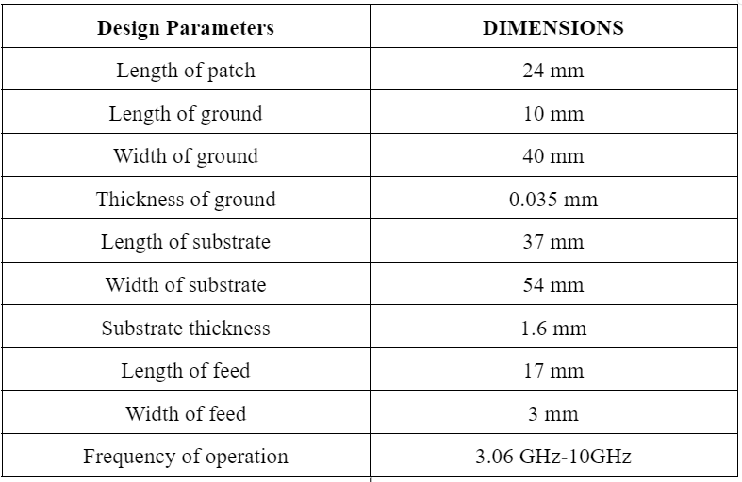

Table 1. Parameters and Dimensions

However, some tuning needs to be done throughout the antenna design process in order to obtain the desired frequency. As a result, the reflection coefficient's outcome will rely on specific antenna dimensions.[2].



Fig.1. Antenna design

Defected Ground Structure:

In Fig. 2, the compact geometrical slots inserted on the ground plane of microwave circuits are called Defected Ground Structures (DGS).



Fig.2. Partial Ground

The thickness of the ground is kept constant as 0.035mm. PEC is a common ground material used in slot antennas, microstrip patch antennas, and other planar antenna topologies, making PEC ground planes frequently used in their analysis and design.

To achieve the desired frequency range, which is typically 3.06 GHz to 10 GHz, this process often involves reducing the ground plane size, creating a 3 mm slot in the centre, and changing the width.

Substrate:

The substrate material is responsible for providing mechanical stability to the antenna. As the size of the dielectric substrate increases, the antenna's volume also increases. The substrate plays a significant role in determining the amount of radiation energy emitted by the antenna. In this case, jeans with a thickness of 1.6 mm are being used as the substrate material.



Fig.3. Substrate

Patch:

The patch antenna is a remarkable invention. Its broadside emission pattern and ability to integrate into two-dimensional arrays make it highly advantageous. The pentagonal patch's dimensions are a testament to the precise construction of this technology.

Fig.4. Pentagonal Patch

Coupled with its permeability, which describes the material's response to magnetic fields, jeans provide a balanced and efficient medium for antenna operation.

  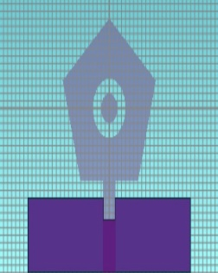

Fig.5. Development of the antenna's bottom layer

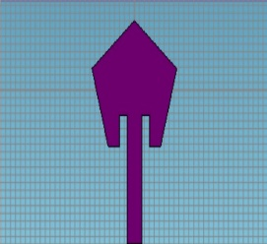 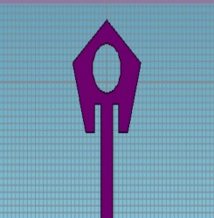 

Fig.6. Development of the antenna's top portion

1. RESULTS AND DISCUSION

With a dielectric constant of 1.6, jeans demonstrate a moderate level of interaction with incident electromagnetic waves, making them conducive for antenna applications.

The designed Pentagonal antenna, which was printed on the Jeans substrate as per precise specifications, underwent extensive testing and optimization to achieve peak performance. Thanks to the dimensions, we are confident that the antenna is now operating at its best possible level.

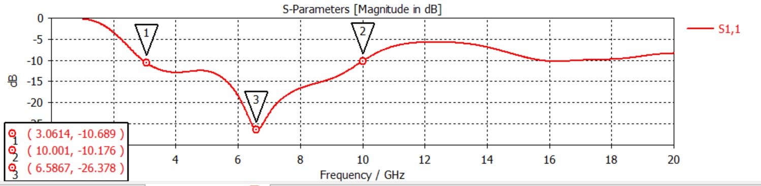

Fig.7. S – parameter

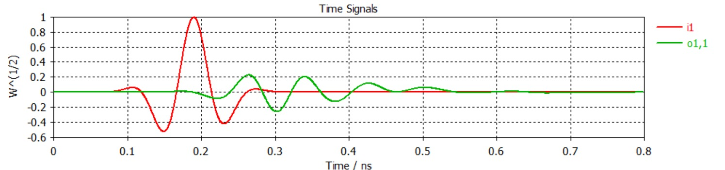

Fig.8. Port Signal

In the S-parameter graph Fig.3 for a UWB antenna, typically the S11 parameter (also known as the reflection coefficient or return loss) is of primary interest. Generally, the UWB spectrum encompasses frequencies from several hundred megahertz (MHz) to several gigahertz(GHz).

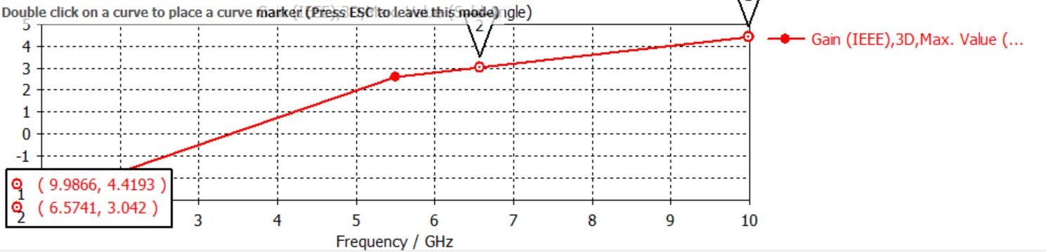

Fig.9. Gain

1. CONCLUSION

The design of an ultra-wideband antenna for wearable applications is a remarkable achievement. With an operational bandwidth falling between 3 GHz and 10.5 GHz, it meets the requirements of the FCC UWB standard, setting a new standard for innovation and excellence.

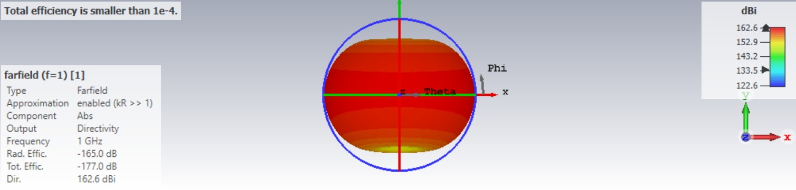

Fig.10. Pattern of Radiation at f=1.

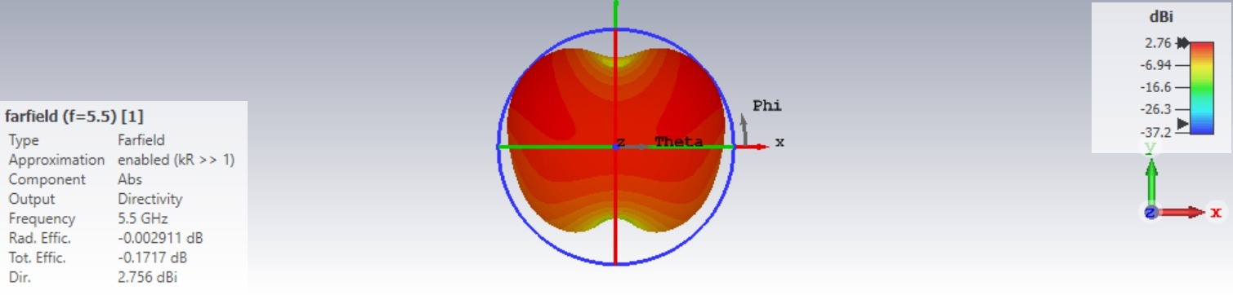

Fig.11.Pattern of Radiation at f=5.5

By reducing a portion of the ground plane, the impedance bandwidth is increased, making the antenna suitable for body area networks (BAN). This innovative antenna is made of jeans, a textile material, and has the potential to revolutionize healthcare technology. With further development and integration, this antenna could pave the way for a new era of wearable health devices.

1. REFERENCES
2. The Nanjing University of Aeronautics and Astronautics, College of Electronic and Information Engineering, Ministry of Education, Huangjuan Dai, Yuongjiu Zhao, and Chen Yu ,Nanjing 210016, China
3. Mohamed Nasrun Osman1, Hasliza A. Rahim1, Mohamed Nasrun Osman1, Muzammil Jusoh1, Muammar Mohamad Isa2, Thennarasan Sabapathy1, Samir Salem Al-Bawri 1, and Mohd Najib Yasin
4. Purna B. Samal 1, Ping Jack Soh 2, and Zahriladha Zakaria 31 Electronics and Communication Engineering Department, College of Science and Technology, Center of Excellence for Advanced Communication Engineering (ACE), School of Computer and Communication Engineering, Universiti Malaysia Perlis (UniMAP), Pauh Putra Campus,
5. Perlis, Malaysia; 02600 Arau3 The Center for Research and Innovation in Telecommunication (CeTRI).
6. MOHAMMED SAMIR SALEM AL-BAWRI, MUHAMMAD FARHAN SHAFIQUE, RASHID SALEEM, TAYYAB SHABBIR, AND MOHAMMAD SAMIR SALEM AL-BAWRI, (Member, IEEE)
7. Madan Kumar Sharma,Hridesh Kumar Verma, Abhishek yadav, Anshuman, Anurag verma Fawzy Alsharif , and Çetin Kurnaz2.
8. Fawzy Alsharif , and Çetin Kurnaz, Department of Electrical and Electronics Engineering Ondokuz Mayis University Samsun, Turkey
9. Srijita Chakraborty, Institute of Engineering & Management, Kolkata, India, N.N.Pathak Dept. of Electronics & Communication Engineering Dr. B.C. Roy, Engineering College Durgapur, India, Mrinmoy Chakraborty Dept. of Electronics & Communication Engineering Dr. B.C. Roy Engineering College, Durgapur, India
10. Mukesh Kumar Khandelwal,Binod Kumar Kanaujia,and Sachin Kumar, Bhagwan Parshuram Institute of Technology, Sector 17, Rohini 110089, India ,School of Computational and Integrative Sciences, Jawaharlal Nehru University, DEngineering College, Ghaziabad 201009, India
11. Dr. Ramya P Assistant professor, Electronics and Communication Engineering, Bannari Amman Institute of Technology, Erode, Tamil Nadu