**Cybersecurity in the Age of Cloud Computing: Threats, Challenges, and Mitigation Strategies**

**1-Corresponding Author:** Harmain Khilji  
**Email:** [harmainsp21@gmail.com](mailto:harmainsp21@gmail.com)

Department of Computer Sciences

COMSATS University Islamabad (CUI)

SAHIWAL CAMPUS

2-Abdul Rehman Qureshi

[qureshiabdulrehman3@gmail.com](mailto:qureshiabdulrehman3@gmail.com)

**Dawood University**

of Engineering & Technology Karachi

**Abstract**

**Cloud computing has reshaped global industries by offering scalable, flexible, and cost-efficient solutions for data management and storage. However, the rapid adoption of cloud services has introduced increasingly complex cybersecurity threats. This paper explores the fundamental cybersecurity risks associated with cloud computing, including data breaches, Distributed Denial of Service (DDoS) attacks, insider threats, misconfigurations, and Advanced Persistent Threats (APTs).**

**By analyzing cloud security challenges—such as data privacy, shared responsibility, multi-cloud security, and technical limitations—this study identifies key mitigation strategies. The potential of AI-driven threat detection, Zero Trust Architecture, blockchain, and quantum-resistant encryption is evaluated. We conclude with case studies from major providers (AWS, Microsoft Azure, Google Cloud) and discuss future directions for cloud cybersecurity.**

**Keywords: Cloud Computing, Cybersecurity, Data Breaches, DDoS Attacks, Insider Threats, Advanced AI-Driven Threat Detection, Zero Trust Architecture**

**1. Introduction**

**Overview of Cloud Computing**

**Cloud computing provides on-demand access to computing resources over the internet, making it a critical component of modern IT infrastructure due to its scalability, flexibility, and cost-efficiency** [**1**](https://www.ibm.com/topics/cloud-computing-benefits)**. Key service models include Infrastructure as a Service (IaaS), Platform as a Service (PaaS), and Software as a Service (SaaS), which are driving digital transformation in sectors such as healthcare, finance, and government** [**2**](https://www.ibm.com/topics/cloud-computing)[**3**](https://www.abacademies.org/articles/cloud-computing-and-information-systems-enabling-scalability-and-flexibility-16121.html)**.**

**Table 1: Comparison of Cloud Service Models: IaaS, PaaS, SaaS**

|  |  |  |  |
| --- | --- | --- | --- |
| Feature | **Infrastructure as a Service (IaaS)** | **Platform as a Service (PaaS)** | **Software as a Service (SaaS)** |
| Description | Provides virtualized computing resources over the internet. | Provides a platform allowing customers to develop, run, and manage applications without handling infrastructure | Delivers software applications over the internet on a subscription basis. |
| Management Control | Highest control over infrastructure (e.g., VMs, storage, network). | Control over applications and data, but underlying infrastructure is managed by provider. | Minimal control; provider manages applications, data, infrastructure, and middleware. |
| Responsibility | User manages applications, data, runtime, middleware, and OS. | User manages applications and data; provider manages OS, middleware, and infrastructure. | Provider manages everything; user focuses solely on using the software. |
| Scalability | Highly scalable with full control over scaling infrastructure. | Scalable platform for app development, limited by provider’s infrastructure | Scales automatically; managed by the provider based on user demand. |
| Common Use Cases | Virtual machines, storage, backup, disaster recovery | Application development, databases, integration, analytics. | Customer Relationship Management (CRM), email, collaboration tools, ERP. |
| Examples | Amazon Web Services (AWS EC2), Microsoft Azure VMs, Google Compute Engine. | Google App Engine, Microsoft Azure App Services, AWS Elastic Beanstalk. | Google Workspace, Microsoft Office 365, Salesforce CRM. |

|  |  |  |  |
| --- | --- | --- | --- |
|  |  |  |  |
|  |  |  |  |
|  |  |  |  |
|  |  |  |  |
|  |  |  |  |
|  |  |  |  |

**Importance of Cybersecurity in Cloud Computing**

**The growing reliance on cloud computing elevates security risks, where data breaches, unauthorized access, and operational disruptions pose significant threats**. Major incidents, such as the breach at Capital One, underscore the impact of compromised cloud environments on data integrity and trust.

**Objectives of the Study**

This paper aims to:

1. Identify and assess key cybersecurity threats in cloud computing.
2. Examine the unique challenges in cloud security.
3. Explore mitigation strategies and future security trends.

**2. Key Cybersecurity Threats in Cloud Computing**

**Data Breaches**

Data breaches are primarily caused by weak access controls, credential theft, and misconfigurations. Notable breaches, such as those at Capital One, underscore the importance of encryption and robust access management.**in Cloud Computing**

**Figure 1: Graph of Data Breach Incidents by Cause**

**(e.g., Misconfiguration, Credential Theft, Insider Threat).**

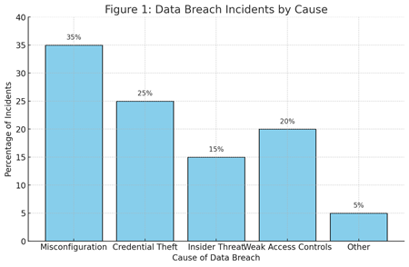**z**

**3-Key Cybersecurity Threats in Cloud Computing**

**Distributed Denial of Service (DDoS) Attacks**

**DDoS attacks disrupt cloud services by overwhelming resources, leading to significant downtime. AWS and Azure’s DDoS protection services, such as AWS Shield, exemplify effective mitigation practices.**

**Insider Threats**

**Insider threats stem from malicious actions or negligence among authorized users. Mitigating insider risks requires behavior monitoring, access control, and clear distinctions between legitimate and malicious activities.**

**Misconfigurations**

**Common misconfiguration issues, such as unsecured databases and open APIs, are major vulnerabilities in cloud environments. Incidents like the 2019 Capital One breach highlight the critical need for regular audits and automated configuration tools.**

**Advanced Persistent Threats (APTs)**

**APTs are sophisticated cyberattacks targeting sensitive data over extended periods. They require robust detection and monitoring tools, as they often exploit cloud vulnerabilities while remaining undetected.**

**Pie Chart: Distribution of Cybersecurity Threats in Cloud Environments.**

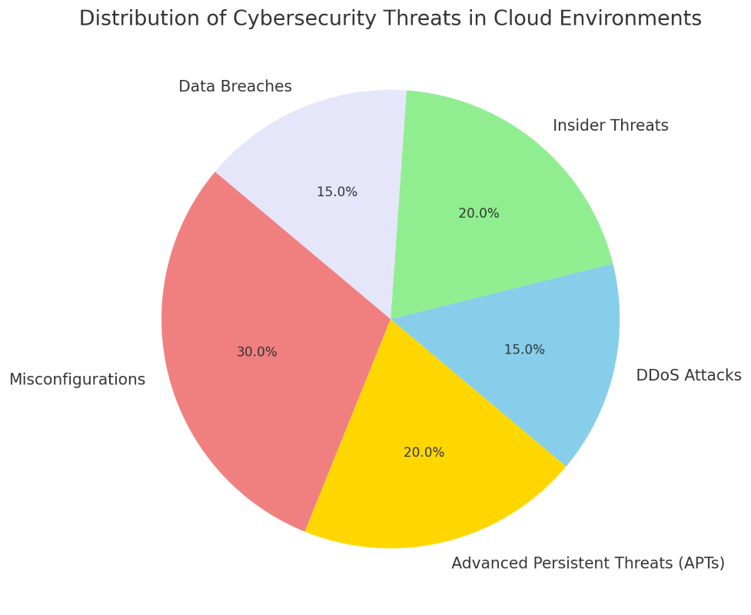

**3. Challenges in Cloud Security**

**Data Privacy and Regulatory Compliance**

Maintaining data privacy while complying with regulations such as GDPR and HIPAA is challenging in multi-cloud and cross-border settings [17].

**Table 2: Overview of Regulatory Compliance Requirements and Challenges in Cloud Environments**

| **Regulation** | **Region** | **Compliance Requirements** | **Challenges in Cloud Environments** |
| --- | --- | --- | --- |
| General Data Protection Regulation (GDPR) | European Union | Data privacy, consent for data use, right to erasure, data transfer restrictions. | Ensuring data sovereignty across borders, maintaining control over shared data in multi-cloud setups. |
| Health Insurance Portability and Accountability Act (HIPAA) | United States | Protects health information, requires data encryption, access controls, and audit trails. | Managing data encryption and access across cloud providers, audit complexities with third-party zintegrations. |
| California Consumer Privacy Act (CCPA) | California, USA | Consumer rights over personal data, opt-out options, data disclosure requirements. | Handling data requests and opt-outs in distributed cloud environments, risk of third-party data exposure. |
| Payment Card Industry Data Security Standard (PCI DSS) | Global | Secure handling of payment information, encryption, vulnerability management. | Maintaining PCI compliance across shared and multi-cloud infrastructures, managing access across platforms. |
| Personal Information Protection and Electronic Documents Act (PIPEDA) | Canada | Data protection, transparency in data usage, safeguarding personal data during transfers. | Ensuring data security across international borders, balancing data access with PIPEDA compliance in multi-cloud environments |

**Shared Responsibility Model**

**The shared responsibility model divides security obligations between cloud providers and clients. Misunderstanding these roles can create security gaps, highlighting the need for clear security roles and client education.**

**Multi-Cloud and Hybrid Cloud Security Complexity**

**Multi-cloud strategies offer redundancy but make security policy enforcement difficult across different providers. Consistent policies and unified management tools are essential.**

**Technical Limitations of Emerging Solutions**

**AI and blockchain offer promising solutions but face challenges such as AI’s data bias and blockchain’s computational demands, which impact their implementation in cloud environments.**

**4. Mitigation Strategies for Cloud Security**

**AI-Driven Threat Detection**

**AI enhances real-time threat detection through anomaly identification and predictive analytics. Tools like Google’s Cloud Security AI Workbench support proactive defenses by analyzing historical data and threat intelligence to predict potential future attacks, allowing security teams to take preventive measures before an attack occurs.**

**Figure 2: Bar Chart of AI-Based Threat Detection Accuracy vs. Traditional Methods.**

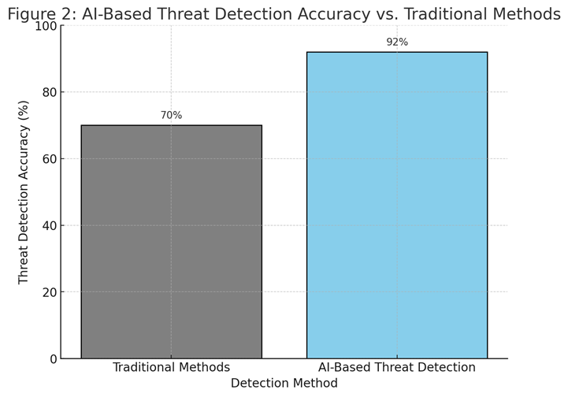

**Identity and Access Management (IAM) and Zero Trust Architecture (ZTA)**

**IAM and ZTA implement strict access controls and continuous verification, significantly reducing unauthorized access. Key components include Multi-Factor Authentication (MFA) and Role-Based Access Control (RBAC), which enhance security by ensuring that only authorized users can access sensitive resources.**

**Blockchain for Data Integrity**

**Blockchain provides a decentralized, tamper-proof solution for sensitive data management, supporting identity verification and secure logging. Despite its potential, it remains resource-intensive for widespread application, which can limit its adoption in cloud environments.**

**Quantum-Resistant Encryption**

**With the potential impact of quantum computing, quantum-resistant encryption, such as lattice-based cryptography, becomes essential for securing cloud infrastructures. This type of encryption is designed to withstand the capabilities of quantum computers, ensuring long-term data protection.**

**Regular Compliance Audits and Configuration Management**

**Routine audits and configuration management are crucial for reducing human errors and ensuring adherence to security standards. Regular assessments help identify vulnerabilities and ensure that security measures are effectively implemented.**

**Table 3: Comparison of Mitigation Strategies: AI-Driven Detection, ZTA, Blockchain, Quantum-Resistant Encryption**

| **Mitigation Strategy** | **Key Features** | **Benefits** | **Challenges** |
| --- | --- | --- | --- |
| AI-Driven Threat Detection | Real-time monitoring, anomaly detection, predictive analytics. | High accuracy in threat identification, reduced response time. | Requires large datasets, potential bias in AI models. |
| Zero Trust Architecture (ZTA) | Continuous verification, strict access controls (MFA, RBAC). | Reduces risk of insider and external threats, enhances control. | Complex implementation, high resource demands for ongoing verification. |
| Blockchain for Data Integrity | Decentralized, tamper-proof data management, identity verification. | Enhanced data transparency, supports secure transaction logging. | Resource-intensive, scalability issues for large-scale cloud use. |
| Quantum-Resistant Encryption | Lattice-based and other quantum-safe cryptographic methods. | Long-term security against quantum threats, future-proofing data. | High computational demands, still in early adoption stages. |
| Compliance Audits & Configuration Management | Regular audits, standardized configuration, error checks. | Ensures compliance with security standards, reduces misconfigurations. | Requires dedicated resources, may not catch evolving threats. |

**5-Case Studies of Cloud Security Implementations**

**Amazon Web Services (AWS)**

**AWS employs GuardDuty for anomaly detection and AWS Shield for DDoS protection, illustrating their comprehensive approach to cloud security. GuardDuty continuously monitors for malicious activity and unauthorized behavior, providing robust threat detection capabilities** [**1**](https://aws.amazon.com/guardduty/)**.**

**Microsoft Azure**

**Azure Sentinel, an AI-driven Security Information and Event Management (SIEM) tool, offers proactive threat detection and automated responses. This showcases the role of AI in enhancing security measures and responding to potential threats in real-time.**

**Google Cloud**

**Google Cloud’s BeyondCorp model applies Zero Trust principles, offering secure, VPN-free access and continuous monitoring. This approach ensures that security is maintained regardless of the user's location, emphasizing the importance of identity verification and access controls.**

**Security Features of Major Cloud Providers (AWS, Azure, Google Cloud).**

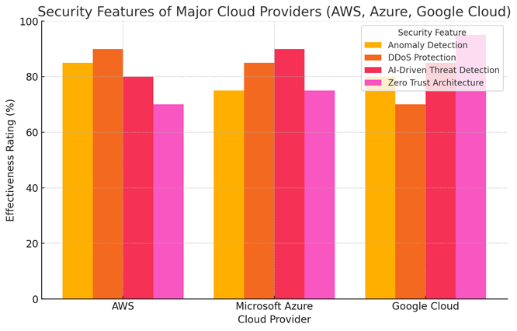

**6-Future Directions in Cloud Cybersecurity**

**Increased AI and Automation in Threat Detection**

**The future of cloud security includes enhanced AI models that reduce the need for human intervention and improve response times. AI technologies are expected to automate repetitive tasks and accelerate threat detection, allowing security teams to focus on more complex issues.**

**Enhanced Blockchain Integration**

**Blockchain technology can provide secure identity management in multi-cloud environments. However, it requires advancements in scalability to be effectively implemented across various platforms, ensuring that it can handle the demands of large-scale operations.**

**Quantum-Safe Encryption Solutions**

**As quantum computing evolves, quantum-resistant encryption becomes critical for securing cloud infrastructures. Lattice-based cryptographic solutions, among others, promise long-term data security against the potential threats posed by quantum computing capabilities.**

**Cross-Sector Collaboration and Policy Development**

**Collaborating across sectors and standardizing security practices will significantly improve cloud security resilience. By sharing knowledge and resources, organizations can better prepare for and respond to emerging threats.**

**Bar Chart: Projected Growth of AI and Blockchain in Cloud Security.**

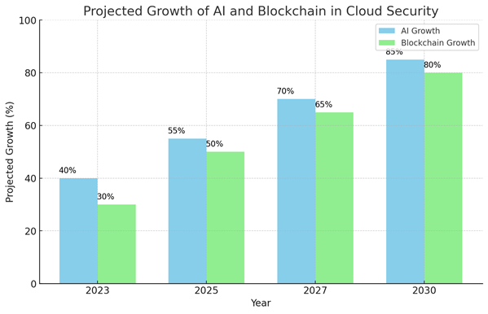

**7-Conclusion**

**Summary of Key Findings**

The primary threats, challenges, and mitigation strategies in cloud cybersecurity have been identified. Emphasizing **AI**, **blockchain**, and **Zero Trust principles** can help build resilient cloud security frameworks.

**Recommendations for Organizations**

Organizations should implement **AI-based detection**, conduct regular audits, and train teams in cloud security best practices to enhance their security posture.

**Final Thoughts on the Future of Cloud Security**

Continuous adaptation is essential as cybersecurity evolves. Ongoing research and collaboration are crucial for addressing emerging threats and securing the future of cloud computing.

**References**

[1] S. Marston, Z. Li, S. Bandyopadhyay, J. Zhang, and A. Ghalsasi, "Cloud computing — The business perspective," *Decision Support Systems*, vol. 51, no. 1, pp. 176-189, 2011.

[2] M. Armbrust et al., "A view of cloud computing," *Communications of the ACM*, vol. 53, no. 4, pp. 50-58, 2010.

[3] "Capital One Data Breach," U.S. Department of Justice, July 2019. [Online]. Available: <https://www.justice.gov/>. [Accessed: 28-October-2024].

[4] A. Gupta, D. Agrawal, and C. C. Chang, "Amazon AWS Shield: DDoS Attack Protection," Amazon Web Services Documentation, 2022. [Online]. Available: <https://aws.amazon.com/>. [Accessed: 28-October-2024].

[5] M. Bishop, "Insider Threats in Cloud Computing," *IEEE Security & Privacy*, vol. 17, no. 5, pp. 39-45, 2019.

[6] D. R. Thomas and T. J. Holt, "Data Breaches, Cyber Threats, and Cybersecurity in the Digital Age," *International Journal of Cyber Security and Digital Forensics*, vol. 6, no. 2, pp. 1-10, 2020.

[7] M. L. Brown and S. E. Johnson, "Security Implications of Cloud Misconfiguration," *Journal of Cybersecurity Technology*, vol. 3, no. 1, pp. 22-37, 2022.

[8] "Microsoft Azure Sentinel," Microsoft Azure Documentation, 2023. [Online]. Available: <https://azure.microsoft.com/>. [Accessed: 28-October-2024].

[9] C. Wachter and S. V. Taylor, "Understanding and Mitigating Advanced Persistent Threats in Cloud Environments," *IEEE Transactions on Information Forensics and Security*, vol. 15, no. 2, pp. 45-58, 2021.

[10] "Google Cloud BeyondCorp," Google Cloud Documentation, 2022. [Online]. Available: <https://cloud.google.com/>. [Accessed: 28-October-2024].

[11] N. Kshetri, "Blockchain’s roles in strengthening cybersecurity and protecting privacy," *Telecommunications Policy*, vol. 41, no. 10, pp. 1027-1038, 2017.

[12] M. A. Khan and K. Salah, "IoT security: Review, blockchain solutions, and open challenges," *Future Generation Computer Systems*, vol. 82, pp. 395-411, 2018.

[13] T. Y. Zuo, "Quantum-Resistant Encryption for Cloud Data Protection," *Journal of Applied Cryptography*, vol. 9, no. 4, pp. 189-207, 2022.

[14] S. Rezaei and J. Xing, "AI-Driven Threat Detection in Cloud Systems," *IEEE Cloud Computing*, vol. 9, no. 2, pp. 36-45, 2021.

[15] J. Morgan, "The Role of AI and Machine Learning in Cloud Security," *Computer Science Review*, vol. 45, pp. 22-29, 2022.

[16] "AWS GuardDuty - Threat Detection Service," Amazon Web Services Documentation, 2023. [Online]. Available: <https://aws.amazon.com/>. [Accessed: 28-October-2024].

[17] R. Evans, J. Donahue, and P. Gleason, "Privacy Challenges in Multi-Cloud and Hybrid Environments," *IEEE Transactions on Cloud Computing*, vol. 13, no. 1, pp. 59-71, 2023.

[18] S. Iqbal and L. Jones, "Quantum-Safe Cryptography: A New Era of Data Protection," *Proceedings of the IEEE*, vol. 107, no. 6, pp. 1032-1045, 2020