**JASMONOMICS: Jasmonic Acid Dynamics in Regulating Plant Stress Responses and Developmental Homeostasis: Biosynthesis, Signaling, and Antioxidant Mechanisms & Crosstalk with Phytohormones**

**Gurjant Singh1, Kumari Sakshi2**

**1,2MSc. Botany, Department of Botanical and Environmental Sciences, Guru Nanak Dev University, Amritsar, Punjab (INDIA)**

**1**[**gurjantaulakh008@gmail.com**](mailto:gurjantaulakh008@gmail.com) **2**[**sakshisinhmar100@gmail.com**](mailto:sakshisinhmar100@gmail.com)

**ABSTRACT**

***“Jasmonomics”*** *refers to the comprehensive study of jasmonic acid (JA) dynamics, highlighting its role in plant stress responses, growth regulation, and developmental processes. Abiotic stresses, including extreme temperatures, salinity, drought, and heavy metal toxicity, provide substantial challenges to global agricultural productivity, leading to major losses in crop yields. JA, a lipid-derived phytohormone, is essential in these stress responses. Produced via the octadecanoid pathway, with 12-oxo-phytodienoic acid (12-OPDA) as a crucial step, jasmonic acid (JA) regulates multiple stress-adaptive pathways, including the initiation of antioxidant defence systems. JA also promotes the formation of secondary metabolites, such as flavonoids and alkaloids, which aid in stress resilience and cellular detoxification. The interaction with other phytohormones, including abscisic acid, ethylene, and salicylic acid, enhances stress responses by synchronising transcriptional and post-transcriptional regulatory networks. The interplay of JA, JAZ repressors, and MYC transcription factors is essential for regulating gene expression and optimising resource distribution between growth and defence under stress circumstances. Future study seeks to elucidate jasmonic acid transport routes, its function in signal perception, and its synergistic or antagonistic interactions with other hormonal pathways. Progress in JA-mediated metabolic engineering presents promising approaches for improving crop resilience by focussing on stress response pathways. This study underscores the diverse function of JA in alleviating abiotic stress and accentuates its potential as a natural regulator to enhance plant development and defence, so supporting sustainable agricultural operations amid shifting climatic conditions.*

**Keywords:** Jasmonomics, Jasmonic acid, abiotic stress, antioxidant defense, phytohormone crosstalk, signal transduction, drought tolerance, salinity stress.

**INTRODUCTION:**

Plant hormones govern many signalling pathways that enable plants to efficiently allocate scarce resources in reaction to significant environmental challenges. This coordination is essential for sustaining equilibrium among plant growth, development, and defence systems (Sharma, R. et al., 2013). The intricate interaction among various signalling pathways is crucial for enhancing agricultural productivity, as it enables plants to adjust to adverse environmental conditions. Key plant hormones, including auxin, cytokinin, abscisic acid (ABA), ethylene, gibberellins (GA), jasmonic acid (JA), brassinosteroids, salicylic acid, and strigolactones, are diminutive, endogenous compounds that affect multiple facets of plant physiology and stress response (Kamiya Y., 2010).

The word “Jasmonomics” (term coined by Gurjant Singh & Kumari Sakshi) presumably merges “Jasmonic Acid” with “omics,” denoting extensive analyses of biological systems. “Omics” includes disciplines such as genomics, proteomics, and metabolomics. In this context, “Jasmonomics” denotes the extensive examination of jasmonic acid dynamics, its manufacture, signalling, and interactions with other molecular pathways in plants, especially concerning stress and development.

Jasmonic acid, a crucial regulator of plant stress responses, was originally believed to serve predominantly as a stress-related phytohormone. Nonetheless, it has progressively gained acknowledgement for its extensive function in governing both growth and development in plants. Jasmonic acid is synthesised from 3-Oxo-2-(2-penten-1-yl)-cyclopentaneacetic acid, an organic compound involved in numerous growth processes in plants, particularly in Gymnosperms and Angiosperms (Campos, M. L. et al., 2014). Recent studies have underscored the significance of jasmonic acid (JA) biosynthesis in monocots and dicots, especially in model organisms like as Arabidopsis, revealing numerous genes and transcription factors that are pivotal in signal transmission and the regulation of JA biosynthesis. These studies have enhanced our comprehension of the molecular mechanisms governing plant development and their reactions to environmental stress (Wasternack, C., 2014).

In Arabidopsis, jasmonic acid production commences via two principal pathways: the hexadecatrienate pathway, launched by long-chain fatty acids, and the alpha-linolenic acid pathway, which leads to the octadecane pathway. Both processes facilitate the synthesis of 12-oxo-phytodienoic acid (OPDA), a principal precursor of jasmonic acid, and deoxy-methylated plant dienic acid (Liechti R, Farmer EE. 2006). These chemicals are synthesised in the chloroplasts and subsequently oxidised in the peroxisome, yielding JA. Within the cytoplasm, jasmonic acid (JA) is converted into its bioactive form, jasmonic acid-isoleucine (JA-Ile), which is the physiologically active variant that facilitates diverse plant responses (Kazan, K. 2015). The production of jasmonic acid in reaction to stressors, particularly abiotic stresses, is an essential aspect of a plant’s adaptation strategy.

Jasmonic acid is a naturally occurring plant growth regulator that participates in various processes, including growth, development, and defence against biotic and abiotic challenges (Ahmad, P. et al., 2016). Research indicates that jasmonic acid (JA) is crucial for regulating plant responses to several environmental stressors, including drought, elevated salt, severe temperatures, and mechanical damage. It accomplishes this through a highly coordinated interaction with other plant hormones. JA and abscisic acid (ABA) share concurrent functions in managing water stress responses, with JA significantly influencing stomatal closure and ABA regulating the expression of stress-responsive genes. Similarly, jasmonic acid (JA) can affect the manufacture of ethylene (ET), another hormone implicated in stress responses, but these two hormones frequently have antagonistic effects on plant growth and development (Wang J. et al., 2020).

Research indicates that the interaction between jasmonic acid and other hormones, including ethylene, abscisic acid, and gibberellins, is essential for modulating plant responses to abiotic stressors (Wasternack, C., Song, S. 2016). Ethylene and jasmonic acid (JA) frequently exhibit antagonism, with JA inhibiting stomatal growth and facilitating stomatal closure, hence constraining transpiration, especially in plants such as rice that depend significantly on transpiration for thermotolerance (Tanaka Y. et al., 2005). Conversely, under specific conditions, the application of JA can bolster plant tolerance to stressors such as elevated salinity and temperature by activating stress-related proteins, including heat shock proteins (HSPs) and antioxidant enzymes (Ul Haq S. et al., 2019). These enzymes preserve cellular integrity and mitigate oxidative damage under stress, hence enhancing the plant’s overall stress resilience.

JA is essential for activating the production of transcription factors, including WRKY and MYC2, which facilitate the plant’s response to environmental stimuli. The interaction between jasmonic acid (JA) and other hormones such as gibberellins (GA), abscisic acid (ABA), and ethylene creates a sophisticated signalling network that precisely regulates plant responses to growth and stress situations (Wasternack, C., Strnad, M. 2016). During drought and salt stress, jasmonic acid regulates the expression of genes associated with osmotic stress responses, including aquaporins and protective proteins. Furthermore, JA’s interaction with gibberellins, which govern plant growth and elongation, highlights its function in reconciling growth and defence mechanisms, particularly in stressful environments.

This research highlights the significance of jasmonic acid in regulating the balance between plant growth and defence in response to abiotic stress situations. By orchestrating responses to environmental pressures, JA enables plants to maximise development while improving resilience to abiotic problems, including severe temperatures, drought, and salinity. Jasmonic acid, through its interactions with other phytohormones, functions as a pivotal component in the intricate regulatory network that orchestrates plant responses to stress, so facilitating the adaptation and survival of plants in various environments.

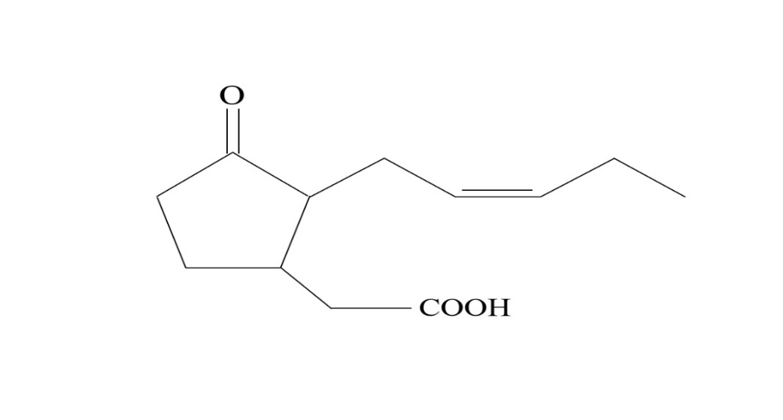

*Figure 1. Jasmonomics: A Typical Structure Of Wonder Compound (Jasmonic Acid: The Savior Compound).*

**LITERATURE REVIEW:**

Jasmonic acid (JA) is a lipid-derived phytohormone that is pivotal in modulating plant responses to biotic and abiotic stressors, in addition to governing different growth and developmental processes. Abiotic stressors, including drought, salt, temperature extremes, and heavy metal toxicity, are critical variables that hinder plant growth and diminish agricultural productivity globally. In reaction to these challenges, JA initiates various adaptation mechanisms that assist plants in reducing oxidative damage, improving stress tolerance, and preserving homeostasis. This literature review examines the function of jasmonic acid (JA) in modulating stress responses, its interplay with other phytohormones, and its participation in antioxidant pathways, enhancing our comprehension of plant resilience in challenging environments.

1. **Jasmonic Acid Biosynthesis Pathways**

Jasmonic acid is produced via the octadecanoid pathway, commencing with the transformation of linolenic acid into 12-oxo-phytodienoic acid (12-OPDA), a crucial step (Kazan, K., 2015). This pathway is triggered by several stress inputs and is essential for orchestrating stress responses in plants. In Arabidopsis, jasmonic acid biosynthesis transpires through two principal pathways: the hexadecatrienate pathway and the alpha-linolenic acid pathway, both of which facilitate the production of OPDA. OPDA is subsequently oxidised in peroxisomes to produce JA, which is then conjugated with isoleucine to provide its bioactive form, JA-Isoleucine (Wasternack, C., 2017). The synthesis of jasmonic acid (JA) is meticulously controlled by numerous transcription factors and enzymes, including lipoxygenases, allene oxide synthase, and allene oxide cyclase, which maintain equilibrium between growth and defence mechanisms during stress circumstances (C. Wasternack, et al., 2013).

1. **Role of Jasmonic Acid in Abiotic Stress Responses**

Jasmonic acid is acknowledged for its role in enhancing plant tolerance to abiotic stressors, including drought, salinity, and extreme temperatures. JA facilitates stomatal closure, a critical response to water stress, by its interaction with other hormones, notably abscisic acid (ABA). Abscisic acid (ABA), typically associated with drought stress, collaborates with jasmonic acid (JA) to regulate water loss through stomatal regulation and the expression of stress-responsive genes (Ali MS et al., 2020). Furthermore, JA aids plants in coping with salt and temperature stress by augmenting the expression of heat shock proteins (HSPs) and antioxidant enzymes, such as superoxide dismutase (SOD) and catalase, which mitigate oxidative damage caused by reactive oxygen species (ROS) (Rahman MA et al., 2022).

JA’s function in modulating the expression of stress-responsive genes is essential for plant adaptation to adverse environmental conditions. During drought and salinity stress, JA enhances the synthesis of protective proteins and aquaporins that facilitate cellular homeostasis and osmotic balance. Additionally, JA’s role in regulating the expression of transcription factors such as WRKY and MYC2 is crucial for enhancing the plant’s stress response (Riemann, Michael et al., 2015). The transcription factors induced by JA govern the expression of genes related to oxidative stress, cell wall reinforcement, and osmotic control.

1. **Crosstalk Between Jasmonic Acid and Other Phytohormones**

Jasmonic acid significantly interacts with other phytohormones, creating a complex network that regulates numerous facets of plant physiology. The relationship between jasmonic acid (JA) and ethylene (ET) is one of the most well-documented instances of phytohormone crosstalk. Jasmonic acid (JA) and ethylene (ET) frequently demonstrate opposing influences on development, with JA facilitating stomatal closure and diminishing transpiration, whereas ethylene generally encourages growth and fruit maturation. The antagonistic link is notably apparent in thermotolerance, where jasmonic acid (JA) enhances resistance to heat stress by bolstering antioxidant defence mechanisms, while ethylene (ET) suppresses this process under specific conditions (Liu H. et al., 2021). JA and ABA have concurrent functions in the regulation of water stress responses. ABA predominantly affects gene expression associated with drought tolerance, whereas JA augments this by regulating stomatal mobility and improving the plant’s resilience to oxidative stress (Muhammad Aslam M. et al., 2022).

The interaction between jasmonic acid (JA) and gibberellins (GA) further illustrates the equilibrium between growth and defence mechanisms. JA regulates the production of genes associated with growth inhibition during stress, whereas gibberellins generally facilitate plant elongation and growth. In reaction to abiotic stress, jasmonic acid (JA) indicates a necessity for diminished growth and energy distribution towards defence, thereby preserving a balance between survival and growth (Hou X. et al., 2013).

1. **Jasmonic Acid and Antioxidant Defense Mechanisms**

The principal function of JA The control of antioxidant defence pathways Is crucial to stress responses. Oxidative stress circumstances, such as dehydration, salinity, and extreme temperatures, can induce the generation of reactive oxygen species (ROS), potentially harming cellular constituents. JA enhances the plant’s antioxidant capacity by upregulating enzymes like superoxide dismutase (SOD), catalase (CAT), and peroxidase (POD), which are crucial for the detoxification of reactive oxygen species (ROS) (Hasanuzzaman M. et al., 2020).

Research reveals that JA can substantially mitigate oxidative damage, hence decreasing cellular injury and improving plant resilience under stress. In addition to activating antioxidant enzymes, JA also promotes the synthesis of secondary metabolites such as flavonoids, alkaloids, and phenolics, which bolster the plant’s defensive mechanisms. These compounds serve as antioxidants and aid in the elimination of reactive oxygen species (ROS) while detoxifying harmful metabolites produced under stress conditions (Matthias Erb et al., 2020). The ability of JA to modulate several metabolic pathways highlights its essential role in maintaining cellular integrity during environmental stress.

1. **Future Directions in Jasmonic Acid Research**

As the function of JA in stress reactions becomes more evident, forthcoming research intends to further clarify its transport mechanisms, signal perception routes, and interactions with other hormonal networks. Comprehending the movement of JA throughout plant tissues, its perception by receptors, and its modulation of downstream signalling cascades will yield essential insights into its regulatory function in stress adaption. Furthermore, investigating the synergistic or antagonistic interactions between jasmonic acid and other phytohormones such as auxins, cytokinins, and brassinosteroids would enhance our comprehension of how plants distribute resources for development and defence.

Recent advancements in metabolic engineering have demonstrated significant potential in improving crop resilience via jasmonic acid-mediated pathways. Researchers seek to enhance plant stress tolerance, augment crop yields, and optimise agricultural output under fluctuating climatic conditions by modulating the jasmonic acid biosynthesis or signalling pathways (Kazan, K., 2015).

**Table 1. Overview Of Literature Review Employed In Paper “Jasmonomics**.”

|  |  |  |
| --- | --- | --- |
| **SECTION** | **KEY POINTS** | **REFERENCES** |
| **JA Biosynthesis Pathways** | Jasmonic acid is synthesized through the octadecanoid pathway, starting with the conversion of linolenic acid to 12-OPDA.  JA synthesis involves transcription factors and enzymes like lipoxygenases, allene oxide synthase, and allene oxide cyclase, ensuring a balance between growth and defense responses under stress conditions. | Kazan, K., 2015; Wasternack, C., 2017; Wasternack C. et al., 2013 |
| **JA in Abiotic Stress Responses** | Enhances resistance to drought, salinity, and extreme temperatures by regulating stomatal closure, heat shock proteins (HSPs), and antioxidant enzymes like superoxide dismutase (SOD) and catalase.  Modulates stress-responsive genes, transcription factors (e.g., WRKY, MYC2), and aquaporins for osmotic balance and cellular homeostasis. | Ali MS. et al., 2020; Rahman MA. et al., 2022; Riemann, Michael et al., 2015 |
| **Crosstalk with Other Hormones** | Interacts with abscisic acid (ABA) to regulate drought stress through stomatal movement and oxidative stress responses.  Exhibits antagonistic interaction with ethylene (ET) in thermotolerance and growth regulation.  Modulates the growth-defense trade-off by interacting with gibberellins (GA) during abiotic stress. | Muhammad Aslam M. et al., 2022; Liu H. et al., 2021; Hou X. et al., 2013 |
| **Antioxidant Defense Mechanisms** | Enhances antioxidant enzyme activity (SOD, CAT, POD) for ROS detoxification, reducing oxidative damage during stress.  Induces secondary metabolites like flavonoids, alkaloids, and phenolics to scavenge ROS and detoxify harmful metabolites. | Hasanuzzaman M. et al., 2020; Matthias Erb. et al., 2020 |
| **Future Directions in JA Research** | Investigate JA transport mechanisms, receptor perception, and downstream signaling processes.  Explore interactions with other hormones like auxins, cytokinin, and brassinosteroids to refine plant resource allocation for growth and defense.  Develop stress-tolerant crops through JA biosynthetic and signaling pathway engineering to enhance yields and agricultural productivity under changing climatic conditions. | Kazan, K., 2015 |

**RESEARCH METHODOLOGIES:**

This paper’s study technique aims to carefully gather, analyse, and synthesise existing literature about the role of Jasmonic Acid (JA) in regulating plant stress responses and developmental homeostasis. This thorough approach guarantees the incorporation of high-caliber, peer-reviewed research that offers significant insights into JA’s production, signalling pathways, and its role in antioxidant mechanisms during abiotic stress situations. This methodology seeks to consolidate the existing knowledge on JA’s diverse roles through a rigorous search strategy, the careful selection of pertinent studies, and a critical analysis of findings. The study identifies research gaps, emphasises trends, and integrates cross-disciplinary viewpoints, providing a comprehensive understanding of JA’s contributions to plant stress tolerance and growth control.

**1. Literature Search Strategy**

A thorough literature study was performed to locate peer-reviewed publications, books, and other academic sources addressing the biosynthesis, signalling, and functional functions of Jasmonic Acid in plant responses to abiotic stressors, including drought, salinity, and temperature stress. Prominent scientific databases, including PubMed, Web of Science, Scopus, Google Scholar, and SpringerLink, were utilised to collect papers from the year 2000 to the present.

**Keywords**: The search phrases encompassed combinations of the following keywords: “jasmonic acid,” “plant stress responses,” “abiotic stress,” “signal transduction,” “antioxidant defence,” “phytohormone crosstalk,” “jasmonic acid biosynthesis,” “stress tolerance,” and “plant growth regulation.”

**Inclusion Criteria:** The studies incorporated in this review fulfilled the subsequent criteria: Scholarly articles and conference proceedings that have undergone peer review Concentrated on jasmonic acid and its function in the regulation of abiotic stress Research disseminated in the English language Research on model plants, monocots, dicots, and crops pertinent to stress resilience Empirical investigations, meta-analyses, and review papers.

**Exclusion Criteria:** Articles were excluded if they concentrated solely on biotic pressures without addressing abiotic stress. Failed to present experimental data regarding JA’s role in stress responses. Were not accessible in complete text or published in languages other than English.

**2. Data Extraction and Synthesis**

Subsequent to the preliminary search, the abstracts and complete texts of the papers underwent meticulous examination. Data was extracted according to the following categories: production of Jasmonic Acid:

Principal enzymes implicated in JA production encompass lipoxygenases, allene oxide synthases, and OPDA reductases. Yes Signalling Mechanisms: Pathways and transcription factors (e.g., MYC2, WRKY) triggered by jasmonic acid in response to abiotic stresses.

Antioxidant Mechanisms: The function of JA in enhancing antioxidant defence mechanisms, including superoxide dismutase (SOD), catalase (CAT), and peroxidase (POD).

Interactions with Other Phytohormones: The relationship between jasmonic acid (JA) and other hormones like as abscisic acid (ABA), ethylene, and salicylic acid in the modulation of stress responses.

Influence on Plant Growth and Development: The role of jasmonic acid in regulating growth and defence, especially under stress situations.

All pertinent articles were meticulously reviewed, and data were carefully categorised according to these classifications. Special emphasis was placed on experimental outcomes and discoveries from model organisms including Arabidopsis thaliana, Oryza sativa, and crop species frequently examined in stress-related studies.

**3. Critical Analysis**

The literature analysis focused on identifying trends and gaps in the research.

Trends in the functional roles of jasmonic acid in stress tolerance mechanisms, the integration of several hormonal pathways, and the comprehension of how jasmonic acid affects plant growth and development. The analysis underscores deficiencies in the existing comprehension of JA signalling, especially in intricate environmental stress situations.

Mechanisms and Pathways: The review consolidates discoveries on essential molecular and metabolic processes implicated in JA-mediated responses, including the manufacture of secondary metabolites, activities of antioxidant enzymes, and expression of stress-related genes.

Inconsistent Findings: Certain research indicate conflicting results concerning the role of JA in specific stress reactions or its interaction with other hormones. The contradicting results were meticulously examined, and possible explanations, such as variations in experimental circumstances, plant species, and forms of stress, were deliberated.

**4. Meta-Analysis**

A meta-analysis was performed utilising data from multiple research to objectively evaluate the impact of JA on plant stress tolerance. This entailed aggregating data on stress-related metrics (e.g., antioxidant enzyme activity, reactive oxygen species levels, gene expression) from various independent trials. Statistical methods (e.g., effect size computation) were utilised to assess the overall influence of JA on stress tolerance among various species and stress circumstances.

**5. Organization and Synthesis of Findings**

The analysed literature was synthesised and thematically organised to offer a coherent knowledge of JA’s function in plant stress responses. The principal findings were grouped into separate categories, including: The Role of JA in Mitigating Abiotic Stress Antioxidant Mechanisms Involving Jasmonic Acid Interaction with Other Phytohormones Consequences for Agricultural Practices and Future Research Avenues

**6. References and Citations**

The references selected for this study were based on their pertinence, rigour, and publishing in esteemed publications. All referenced papers adhered to the standard citation format used in the discipline (e.g., APA).

BIOSYNTHESIS OF JASMONIC ACID:

Biosynthesis of Jasmonic Acid in Plants

Jasmonic acid (JA) is a crucial plant hormone that plays a significant role in multiple activities, such as stress responses, growth, and development. It is present in nearly all plant organs that contain plastids, with heightened concentrations noted in the fruits of terrestrial plants (Wasternack, C. et al., 2018). The manufacture of jasmonic acid predominantly occurs in two organelles: chloroplasts, where the process commences, and peroxisomes, where the concluding stages transpire (Theodoulou et al., 2005). An overview of the principal stages and enzymes involved in jasmonic acid production is provided below.

1. Conversion of Diunsaturated Fatty Acids to Triunsaturated Fatty Acids

The initial phase of jasmonic acid production involves the transformation of diunsaturated fatty acids (18:2) into triunsaturated fatty acids (18:3). The enzyme fatty acid desaturase catalyses this reaction (He, M. et al., 2020).

1. Formation of Linolenic Acid from Galactolipids

Linolenic acid (18:3) is synthesised from galactolipids within the chloroplast membranes. The hydrolysis of galactolipids at the sn1 location liberates alpha-linolenic acid (alpha-LeA) in the presence of phospholipase A1 (PLA1). This enzyme is crucial for jasmonic acid production (Kun Wang et al., 2018; Scherer et al., 2010). DAD1 (Defective in Anther Dehiscence), a member of the PLA family, is essential for JA synthesis but not for reactions caused by wounding (Ishiguro et al., 2001). DAD1 is a protein specific to flowers that regulates stamen formation by modulating the AGAMOUS protein (Ito et al., 2007).

DGL (DONGLE), an additional PLA1 enzyme, is involved in both wound-induced reactions and jasmonic acid production (Kimberlin, AN. Yang et al., 2022). Research indicates that wound responses are crucial for jasmonic acid generation, with phospholipase A enzymes having a pivotal part in these reactions (Shradha Nirwan et al., 2023). Zdyb A. et al. (2018) indicated that enzymes such as AOS, AOC, and OPR3 participate in JA biosynthesis and may be blocked by the Anther Indehiscence Factor.

1. Lipoxygenases (LOXs)

Lipoxygenases are enzymes that facilitate the oxygenation of fatty acids, hence commencing the jasmonic acid biosynthesis pathway. The structure features a helical core with a conserved iron coordination site and a hydrophobic U-shaped channel for the binding of fatty acid substrates. The oxygenation of alpha-linolenic acid (alpha-LeA) at the C-13 position results in the production of 13-hydroperoxylinoleic acid (13-HPOT), a crucial intermediate in jasmonic acid synthesis. This reaction is facilitated by lipoxygenase (LOX) enzymes located in plastids (Hofmann, Eckhard & Pollmann, Stephan, 2008).

Arabidopsis possesses six LOX genes, namely LOX2, LOX3, LOX4, and LOX6, which participate in wound responses and stress reactions (Maynard D. et al., 2021). The functions of these LOXs encompass:

LOX2: Integral to lipid peroxidation and wound-induced responses in Arabidopsis (Kaur D. et al., 2024).

LOX3 and LOX4: Crucial for vascular tissue injury response and the growth and reproductive success of flowers. LOX3 is implicated in responses to salt stress (Ozalvo R. et al., 2014).

LOX6: Engaged in the initial injury response of xylem cells (Claus Wasternack et al., 2017).

1. Allene Oxide Synthase (AOS)

Allene oxide synthase (AOS) is a crucial enzyme in the biosynthetic pathway of jasmonic acid (JA). It is a member of the cytochrome P450 family (CYP74) and facilitates the transformation of hydroperoxide derivatives into allene oxide, a reactive intermediate. The enzyme has positional specificity at the 9th and 13th positions of the fatty acid chain and preferentially acts on derivatives from both positions (Toporkova, Y. Y. et al., 2020). AOS was initially extracted from flaxseed (Linum usitatissimum), and enzymes such as AOS1 from rice and barley exhibit dual positional specificity (Maucher, Helmut et al., 2000).

1. Allene Oxide Cyclase (AOC)

Allene oxide cyclase (AOC) is an enzyme that catalyses the transformation of allene oxide into its stable form. AOCs belong to a limited gene family and are crucial for the oxygenation of fatty acids in numerous plants. AOC1, AOC2, and AOC3 are broadly expressed in the leaf tissues of Arabidopsis, whereas AOC4 is exclusively expressed in the leaf veins (Stenzel I. et al., 2012). AOCs are essential in JA biosynthesis, especially in the roots and meristematic regions.

1. OPDA Reductase

OPDA reductase is an additional enzyme implicated in jasmonic acid production. It is located in chloroplasts and is instrumental in the reduction of OPDA (12-oxo-phytodienoic acid), a precursor of jasmonic acid (JA). Numerous subtypes of OPDA reductase exist, including OPR1, which lowers phytoprostanes, and OPR3, which plays a role in primary root growth under phosphorus deprivation (Schaller F. et al., 2000). OPR7 directly contributes to jasmonic acid production.

In conclusion, The production of jasmonic acid is a complex, multi-step process that involves enzymes like lipoxygenases (LOXs), allene oxide synthase (AOS), allene oxide cyclase (AOC), and OPDA reductase. These enzymes collaborate to transform alpha-linolenic acid into the physiologically active form of jasmonates, hence controlling plant responses to stress. Comprehending this process and the function of each enzyme offers significant insights into how plants regulate stress and sustain homeostasis.

Table 2. Overview Of Jasmonic Acid Biosynthesis, Enzymes Involved, Functions And Significance.

|  |  |  |  |  |
| --- | --- | --- | --- | --- |
| STEP | ENZYME(S) INVOLVED | PROCESS/FUNCTION | SIGNIFICANCE | REFERENCES |
| Conversion of Diunsaturated Fatty Acids to Triunsaturated Fatty Acids | Fatty Acid Desaturase | Converts diunsaturated fatty acids (18:2) into triunsaturated fatty acids (18:3). | Initial step, providing substrate for further reactions. | He et al., 2020. |
| Formation of Linolenic Acid from Galactolipids | Phospholipase A1 (PLA1) | Hydrolyzes galactolipids to release alpha-linolenic acid (alpha-LeA) | Supplies alpha-LeA, precursor of JA biosynthesis. | Kun Wang et al., 2018. |
| DAD1 | Flower-specific PLA1; involved in stamen development and JA formation. | Essential for floral development but not wound responses. | Ishiguro et al., 2001. |
| DGL (DONGLE) | Participates in wound-induced responses and JA biosynthesis. | Plays dual roles in JA synthesis and stress responses. | Kimberlin et al., 2022. |
| Oxygenation by Lipoxygenases (LOXs) | Lipoxygenases (LOX2, LOX3, LOX4, LOX6) | Oxygenates alpha-linolenic acid at C-13 to form 13-HPOT (13-hydroperoxylinolenic acid). | Initiates oxygenation pathway for JA biosynthesis. | Hofmann et al., 2008. |
| LOX2 | Lipid peroxidation and wound responses. | Induces JA biosynthesis under wounding stress. | Kaur et al., 2024. |
| LOX3 & LOX4 | Essential for vascular tissue wounding, floral development, and stress responses. | Support plant defense and fertility mechanisms. | Ozalvo et al., 2014. |
| LOX6 | Involved in early xylem cell wounding. | Provides early signaling in JA-mediated defense pathways. | Wasternack et al., 2017. |
| Conversion by Allene Oxide Synthase (AOS) | Allene Oxide Synthase (AOS) | Converts 13-HPOT into allene oxide, a reactive intermediate. | Produces a key intermediate for subsequent cyclization. | Toporkova et al., 2020. |
| Cyclization by Allene Oxide Cyclase (AOC) | Allene Oxide Cyclase (AOC1, AOC2, AOC3, AOC4) | Converts allene oxide into 12-oxo-phytodienoic acid (OPDA). | Stabilizes intermediates critical for JA synthesis. | Stenzel et al., 2012. |
| Reduction by OPDA Reductase | OPR1 | Reduces phytoprostanes. | Supports alternative fatty acid pathways. | Schaller et al., 2000. |
| OPR3 | Converts OPDA into JA precursors. | Bridges chloroplast and peroxisomal phases of JA biosynthesis. | Schaller et al., 2000. |
| OPR7 | Directly involved in JA biosynthesis. | Maintains primary JA biosynthetic pathways under various stresses. | Schaller et al., 2000. |

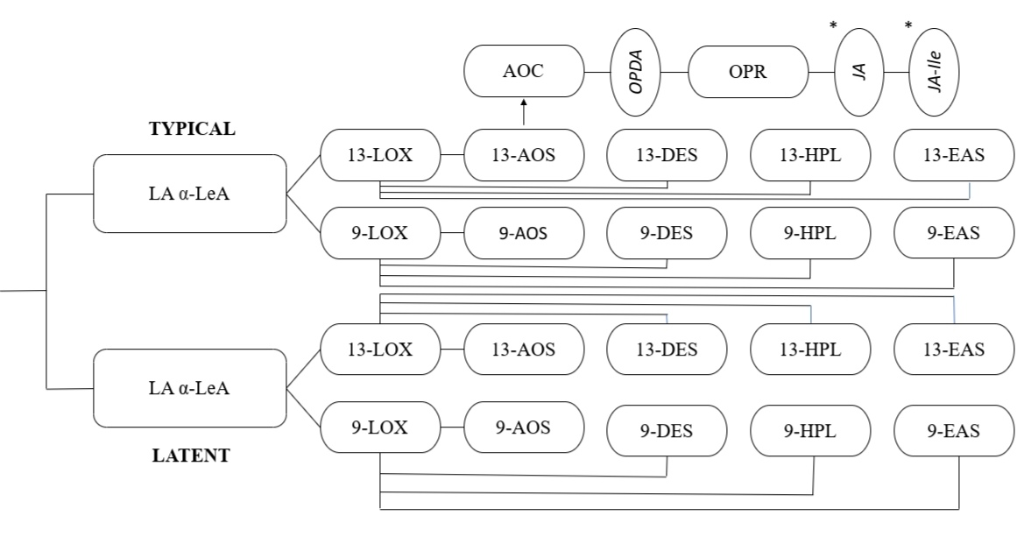

*Figure 2. Representation Of Lipoxygenase Reaction Pathway Which Leads To The Formation Of Jasmonic Acid.*

*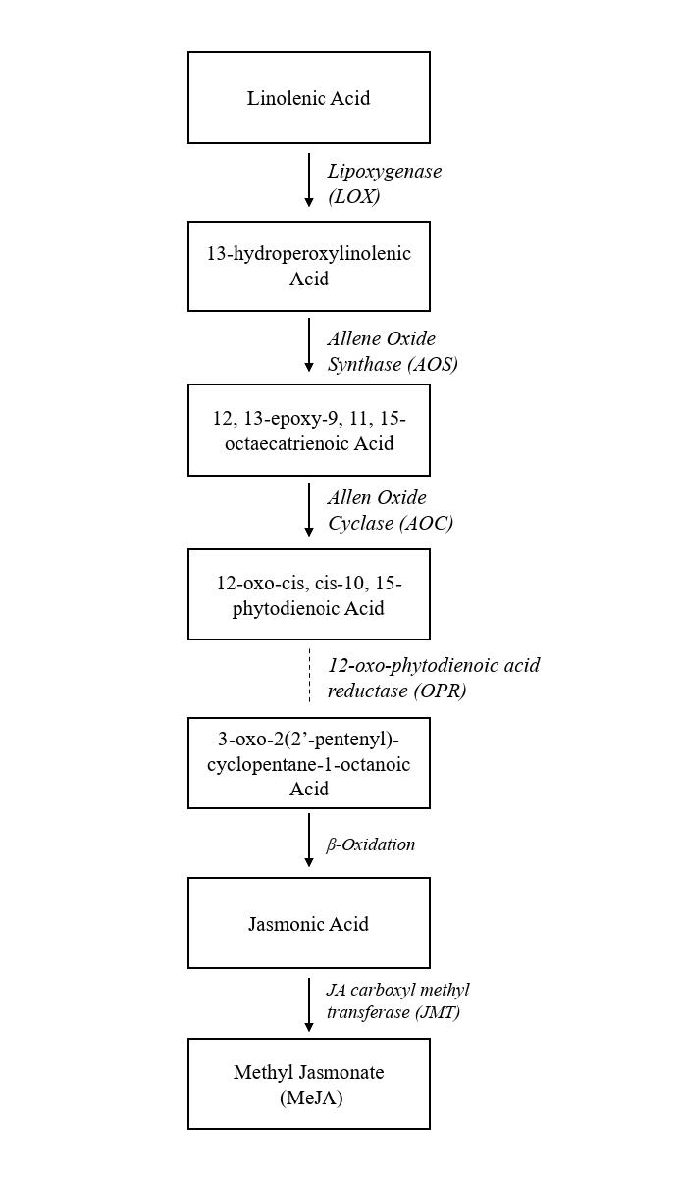Figure 3. Enzymes Involved In The Synthesis Of Jasmonic Acid.*

**EFFECT OF JASMONIC ACID IN ALLEVIATION OF ABIOTIC STRESSES**

Various abiotic factors can influence plant growth and development, potentially resulting in considerable ecological imbalances. Bartas M. et al. (2024). Phytohormones have a vital role in various physiological processes and are considered stress tolerants in plants (EL Sabagh A. et al. 2022). The external application of phytohormones exhibited a positive effect in alleviating the adverse effects of drought stress in numerous plants by improving photosynthesis rates, photosynthetic pigments, stomatal conductance, transpiration rates, and antioxidant defence mechanisms (Karumannil S. et al. 2023). Phytohormones, such as jasmonic acid, are essential for plant growth and development.Rehman M. et al., 2023. Linolenic acid functions as the precursor for jasmonic acid and its derivatives, termed jasmonates. They serve as essential signalling molecules in response to biotic and abiotic stresses (Ali MS, Baek KH. 2020). Jasmonic acid and methyl jasmonates utilise common strategies in response to diverse stressors, including oxidative and drought stress, which involve stomatal closure, root development, reactive oxygen species scavenging, and the activation of enzymatic and non-enzymatic antioxidants (such as proline), along with the biosynthesis of proteins and secondary metabolites (Wang Y. et al., 2021). Research indicates that during abiotic stress in plants, endogenous levels of jasmonic acid and methyl jasmonates rise, while exogenous application of jasmonic acid promotes plant growth under diverse environmental stresses by augmenting the production of antioxidants like proline (Rehman M. et al. 2023).

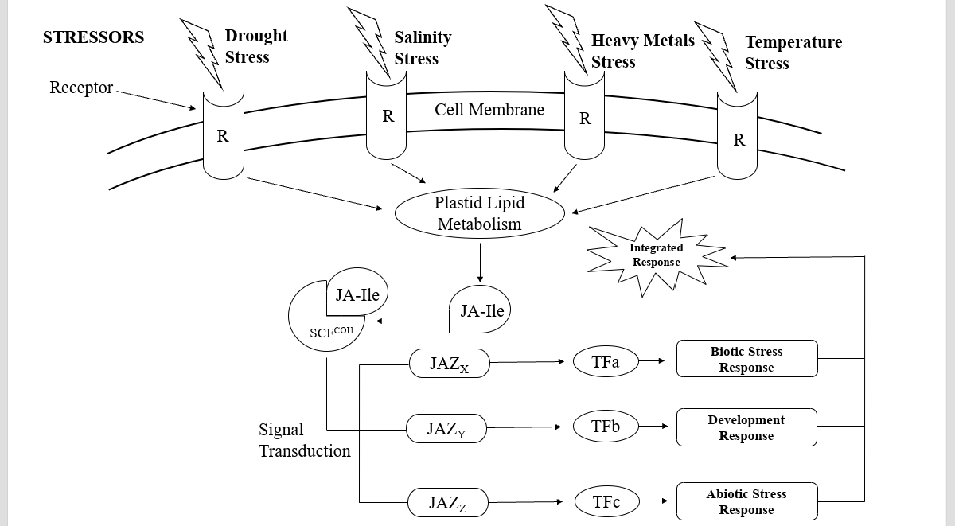

*Figure 4. Schematic Representation Of Various Stresses To Biotic, Department & Abiotic Stress.*

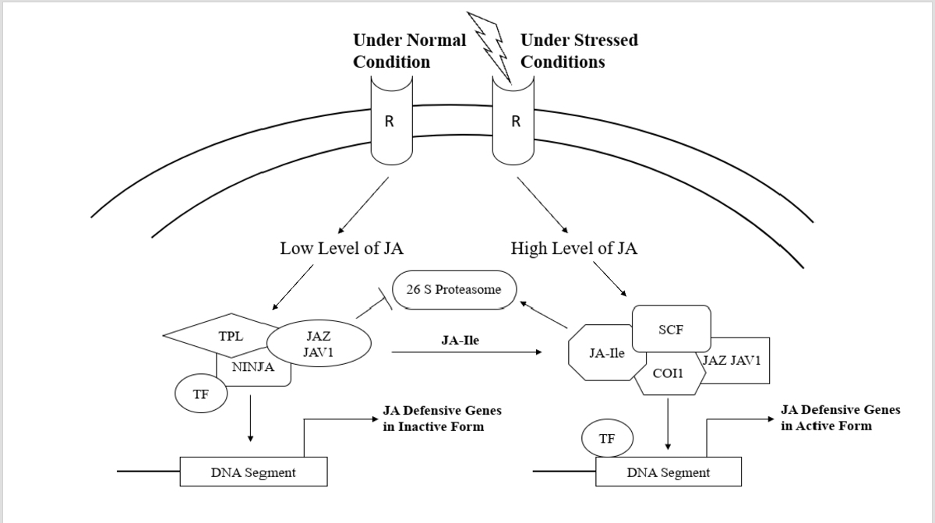

*Figure 5. Jasmonic Acid Response To Stress Under Normal Versus Stressed Conditions.*

***Mechanism of drought stress tolerance in plants via jasmonates***

Drought stress is categorised as an abiotic stressor. It transpires due to lack soil moisture and inadequate precipitation. Drought stress primarily manifests in arid and semi-arid locations, leading to metabolic disruptions in plants and affecting the ecosystem. Seleiman MF et al., 2021. Research findings demonstrated that drought stress directly affects plant biomass and relative water content (Yan S. et al., 2023). Research by Ahmad et al. (2016) demonstrated that drought stress often results in a reduction of water content in organs compared to their metabolic activity; yet, the water content distribution ratio in the roots increased by 1.83% to 2.35%, and in the stems by 0.52% to 1.40%. The subject of the experiment was Summer Maize. The relationship between plant hydration and osmotic stress subsequently induces more stress in plants, ultimately affecting their growth and development (Yang, X. et al. 2021). Drought stress impacts photosynthesis by inducing the production of reactive oxygen species. Reactive oxygen species (ROS) induce the oxidation of photosynthetic pigments, leading to the degradation of chlorophyll structure, stomatal closure, and a reduction in the biosynthesis of pigments (chlorophyll, carotenoids, and anthocyanins) that are directly involved in photosynthesis (Chauhan, J. 2023). Drought-induced oxidative damage negatively impacts organelles including chloroplasts, mitochondria, and peroxisomes, thereby hindering plant growth and development by restricting biomass production, hastening lipid peroxidation, degrading nucleic acids, and diminishing chlorophyll content, ultimately resulting in plant mortality (Sachdev S. et al. 2021). The tolerance of plants to drought stress is enhanced via mechanisms that involve the synthesis of jasmonic acid.

## Production of non -enzymatic and enzymatic antioxidants

Drought stress induces the generation of reactive oxygen species, including O2–, O2, and H2O2, which inflict detrimental effects on macromolecules such as DNA, lipids, proteins, and carbohydrates. Reactive oxygen species (ROS) subsequently induce fast programmed cell death (Cruz de Carvalho MH. 2008). The exogenous injection of jasmonic acid led to an elevation in the concentration of osmolytes (proline, glycine betaine, and free amino acids), thus increasing cellular osmotic potential during drought stress (Sharma A. et al. 2019). It also impeded ROS-induced membrane damage (Huang H. et al. 2019). Proline, a nonenzymatic antioxidant, functions as a buffer to mitigate reduced water capacity in cells. The accumulation of proline is a method employed by plants to combat drought stress, facilitating their growth and development under adverse conditions.(Hayat S et al., 2012). Yu, X. (2018) applied 0.75mM methyl jasmonates to both surfaces of summer savoury seedling leaves, leading to enhanced protein content, improved relative water content, and increased crop production. Oxidative stress induces lipid peroxidation in the phospholipid bilayer of cell membranes containing unsaturated fatty acids. The damage subsequently resulted in an elevated quantity of reactive oxygen species (ROS) within the cells (Martinez et al. 2018). Malondialdehyde (MDA) serves as a biomarker for oxidative stress, exhibiting an elevation in response to stress.An experimental study demonstrated that drought stress on the roots of Brassica rapa resulted in an increase of reactive oxygen species within the cells, subsequently elevating the levels of malondialdehyde (MDA). The exogenous application of jasmonic acid (JA) led to a reduction in ROS levels, safeguarded against membrane lipid peroxidation, and promoted the synthesis of osmolytes. Kumar, A. et al. (2023). Sheteiwy, Mohamed. (2018) reports that the administration of 2.5 mM or 5 mM methyljasmonate enhances osmotic stress tolerance in Oryza sativa seedlings subjected to simulated osmotic stress using 30 g/L of polyethylene glycol (PEG, 6000). JA also stimulates the activity of antioxidant enzymes such as SOD, POD, CAT, GR, and APX to mitigate the effects of heightened stress conditions. Initially, the antioxidant enzyme SOD converts O2- into O2 and H2O2, which are then degraded by APX and CAT in the cytosol and peroxisomes (Sharma, P. et al. 2012). Gene transcription is initiated by JA, which encodes antioxidant enzymes (Wang J. et al. 2020).

## Over expression of phenolics

JA promotes the overexpression of phenolics in dry conditions, resulting in an increase in PAL (phenylalanine ammonia lyase) activity. Kumar, K. et al. (2023). Phenolics, due to the existence of a phenol ring, play a crucial function in mitigating drought stress by stabilising the membrane (Park YJ et al. 2023).

## Stomatal closure

Drought stress induces the generation of reactive oxygen species (ROS) and phytohormones such as methyl jasmonates and abscisic acid (ABA). These phytohormones promote stomatal closure as a defensive strategy in plants to prevent more water loss (Riemann M. et al. 2015). During the examination of the function of reactive oxygen species (ROS) Gonugunta VK et al. (2009) proposed that cytoplasmic alkalisation is an initial mechanism for inducing stomatal closure. MJ-induced ROS generation also prompts allyl isothiocyanate for stomatal closure. JA and ABA are functionally interdependent for the regulation of stomatal opening under stress conditions.The intracellular calcium concentration influenced by JA is crucial in this process.(Lim CW et al., 2015;) Hossain MA et al. (2014) noted that cyclic guanosine 3′,5′-monophosphate (cGMP) and cyclic adenosine 5′-diphosphoribose (cADPR) are crucial in elevating Ca2+ levels during methyl jasmonate-induced stomatal closure. Kolupaev YE et al. (2023) demonstrated that in Arabidopsis thaliana, jasmonic acid activates adenyl cyclase through an unidentified mechanism, resulting in elevated cAMP levels that open the cyclic nucleotide-regulated channel 2 (AtCNGC2). The channel’s opening facilitates the influx of calcium from the apoplast into the cytosol. Calcium that is already present within the endoplasmic reticulum is also released. The rise in calcium content within the cytosol aids the plant in mitigating stress circumstances by interacting with CDPKs. (Tuteja N. et al., 2007). The influence of methyl jasmonate on stomatal closure through increased calcium concentration can be entirely negated by the application of calcium channel blockers such as lanthanum chloride and ruthenium red to the Arabidopsis plant (Munemasa S. et al., 2011). A partial reversal of the impact occurs with the application of the extracellular chelator EGTA, since the intracellular calcium concentration in the endoplasmic reticulum surpasses the influence of the chelator, hence sustaining calcium levels to some degree (Chen JL et al., 2002).

Calcium-dependent protein kinases (CDPKs) participate in multiple signalling pathways, such as ABA-induced stomatal closure, and function as calcium sensors in plants (calcium signalling). Schulz P. et al., 2013. Mori et al. (2006) discovered 34 CDPKs in Arabidopsis (including CPK3, CPK6, CPK4, and CPK11), 31 in Oryza sativa, 35 in Zea mays, and 20 in Populus trichocarpa. In vitro phosphorylation of ABA-responsive transcription factors ABF1 and ABF4 by CPK4 and CPK11 (Zhu et al., 2007). CPK3 and CPK6 facilitate the opening of calcium and slow-type (S-type) anion channels in the guard cell plasma membrane, hence activating ABA signalling (Mori et al., 2006).

***Ca2+ and protein kinase activation*:**

MJ also activates signalling pathways and certain protein kinases, including Ca2+ signalling, CPKs, and mitogen-activated protein kinases (MPK9 and MPK12) (Khokon et al. 2015). Hossain et al. (2014) noted that cyclic guanosine 3′,5′-monophosphate (cGMP) and cyclic adenosine 5′-diphosphoribose (cADPR) are crucial in elevating Ca2+ levels during methyl jasmonate-induced stomatal closure.

## MYC2 activation

MYC2 is a fundamental basic helix-loop-helix (bHLH) transcription factor that is pivotal in the jasmonate (JA) signalling pathway. It governs numerous physiological and developmental processes in plants, encompassing growth, defence mechanisms, and stress resilience. MYC2 is regarded as a master regulator because of its capacity to modulate the expression of jasmonic acid-responsive genes and to integrate many hormone signalling pathways, including abscisic acid (ABA), gibberellins (GA), and ethylene (ET) (Sasaki-Sekimoto Y. et al., 2013).

The JA signalling pathway involves JAZ proteins that inhibit the function of MYC2 and other transcription factors when the concentration of JA is below normal levels. Under stress situations, JA concentration will increase, leading to the inhibition of JAZ proteins, which facilitates the activation of MYC2 and other factors to regulate genes related with the stress response.(Luo L. et al., 2023)

## Root length

Methyl jasmonates preserve water content during drought stress by enhancing hydraulic conductivity in plant roots. (Luo Z. et al., 2019) such as soybean (Mohamed Hi. 2017) Crops cultivated in drought conditions develop deeper roots to collect soil moisture and withstand stress. ABA regulates the elongation of roots, which is likewise temporally dependent on JA biosynthesis.(Harris JM et al., 2015). Under drought stress circumstances, certain plants such as maize, soybean, and Brassica rapa exhibit an increase in the total concentration of soluble sugars, carbohydrates, polysaccharides, free amino acids, and proline due to methyl jasmonates (Abdelgawad, Z. A. et al., 2014; Heba Ibrahim Mohamed and Franks, S. J., 2011).

In short, Drought stress activates a receptor in plants, initiating the synthesis of 12-oxo-phytodienoic acid (12-OPDA) via the enzymatic activities of LeA and LOX6. The 12-OPDA is later transformed into jasmonic acid (JA), which is pivotal in orchestrating drought responses (Wang Y. et al., 2021). JA governs essential functions, including stomatal closure to reduce water loss and root hydraulic conductivity to improve water absorption. Proteins such as OsbHLH148 and OsJAZ1, which exhibit inhibitory expression, combine to activate the transcription factor DREB1, hence enhancing the expression of drought tolerance genes (Cao, B. et al., 2022).Collectively, these processes enable plants to preserve water and sustain physiological equilibrium during drought circumstances.

*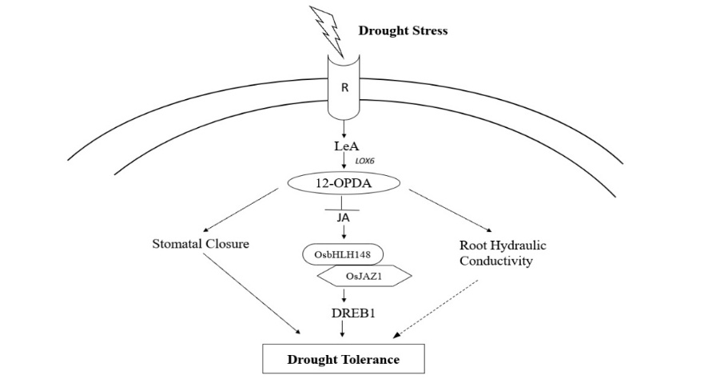Figure 6. Jasmonic Acid Mediated Drought Stress Tolerance.*

***Mechanism of salinity stress tolerance in plants via jasmonates:***

The fundamental metabolic and crucial growth processes of plants are profoundly Influenced by critical conditions, such as the inability to absorb important nutrients and minerals, frequently resulting in salt stress (Balasubramaniam T. et al., 2023). Salinity impedes plant growth by processes such as particular ion toxicity, nutritional shortage, and osmotic effects (Shrivastava and Kumar, 2015). Researchers have extensively employed jasmonic acid (JA) to improve plant resilience to salinity and drought stress (Zhu M. et al., 2022).

The foliar application of jasmonic acid in Catharanthus roseus has been demonstrated to augment nutrient absorption, enhance growth metrics, and strengthen the antioxidative system in conditions of salt stress. Furthermore, the JA administration enhances the proliferation of vegetative roots and shoots while facilitating chlorophyll production in leaf tissues (Sheyhakinia, Shahram et al., 2022). This corresponds with research indicating that JA is an essential molecule activated in plants subjected to both biotic and abiotic stressors (Wang J. et al., 2020). Salinity stress, evident in crops such as wheat (Ashraf et al., 2002), pea (Ahmad and Jhon, 2005), tomato (Al-Aghabary et al., 2004), and rice (Anuradha and Rao, 2001), frequently leads to reduced chlorophyll concentrations, highlighting their susceptibility to salt. Treatments like Methyl Jasmonate (MeJA) administration have been utilised to increase chlorophyll content, therefore enhancing photosynthesis and alleviating the detrimental effects of salt (Yoon, Ji et al., 2009).

Jasmonic acid (JA) and its methyl ester function as signal transducers under stress conditions by activating genes related to plant responses to biotic and abiotic challenges (Wang Y. et al., 2021). JA has been documented to enhance the buildup of H₂O₂, facilitating stress alleviation (Liu Y. et al., 2007). Furthermore, jasmonates can mitigate damage caused by water-related stressors, including drought, cold, and salinity. They also enhance secondary metabolites using natural substances such as MeJA (Siddiqi K. S. et al., 2008).

Salinity stress negatively impacts plant morphology, physiology, anatomy, and yield, resulting in the loss of leaves, stems, roots, and overall biomass (Ji X. et al., 2022). In tomatoes, salt diminishes total biomass and net production (Pengfei et al., 2016). Nonetheless, the application of MeJA, even at minimal concentrations, has demonstrated considerable beneficial effects on morphological characteristics and floral output in chamomiles, effectively alleviating salinity-induced stress (Salimi F. et al., 2016). Moreover, the foliar treatment of jasmonic acid (JA) and salicylic acid (SA) augments proline synthesis, hence improving salinity tolerance in rosemary plants (Hayat S. et al., 2012). Proline buildup in response to salinity stress occurs naturally in plants via physiological self-regulation (El Moukhtari A. et al., 2020), and hormone treatments enhance this effect, aiding plants in managing stress.

Proline buildup arises from heightened biosynthesis, diminished oxidation to glutamate, reduced proline utilisation, and augmented protein synthesis, establishing it as a crucial adaptation mechanism in response to salinity stress (Liang X. et al., 2013). The foliar application of jasmonic acid (JA) in several plant species has demonstrated a reduction in salinity-induced toxicity and an enhancement in productivity by stimulating reactive oxygen species (ROS)-scavenging enzymes and improving ion absorption (Sheteiwy M. S. et al., 2020). In response to salinity stress, plants elevate osmotic regulators and solutes within their cells, preserving water potential, augmenting invertase activity, and facilitating starch buildup alongside soluble sugars, all of which enhance stress tolerance (Hao S. et al., 2021). Amino acids, particularly proline, serve as vital osmoprotectants, enabling tissues to endure saline toxicity (Jiménez-Arias D. et al., 2021; Claussen, Wilfried, 2005).

Foliar treatments of jasmonic acid (JA) and salicylic acid (SA) have been employed to modify gene expression and augment invertase activity for enhanced osmotic regulation in plant cells (Ma Y., Dias M. C., and Freitas H., 2020). In soybeans, oxidative damage is alleviated by increased antioxidant enzyme activity induced by JA and SA treatments (Moustafa-Farag, M. et al., 2020). In peanut seedlings, jasmonic acid treatments enhance antioxidant enzyme activity, hence diminishing lipid peroxidation and oxidative stress (Hasanuzzaman M. et al., 2021).

Salinity stress initiates with the activation of a receptor, resulting in the synthesis of JA-Ile, a derivative of jasmonate (Camilo E. et al., 2016). JA-Ile engages with regulatory proteins, including OsbHLH062 and OsJAZ9, which exhibit inhibitory expression and are essential for sustaining ion homeostasis in high salinity environments (Wu H. et al., 2015). This route alleviates the detrimental consequences of salt stress by regulating intracellular ionic concentrations. This signalling cascade ultimately improves the plant’s salt tolerance by mitigating ion toxicity and maintaining cellular stability (Fu H. et al., 2023).

*Figure 7. 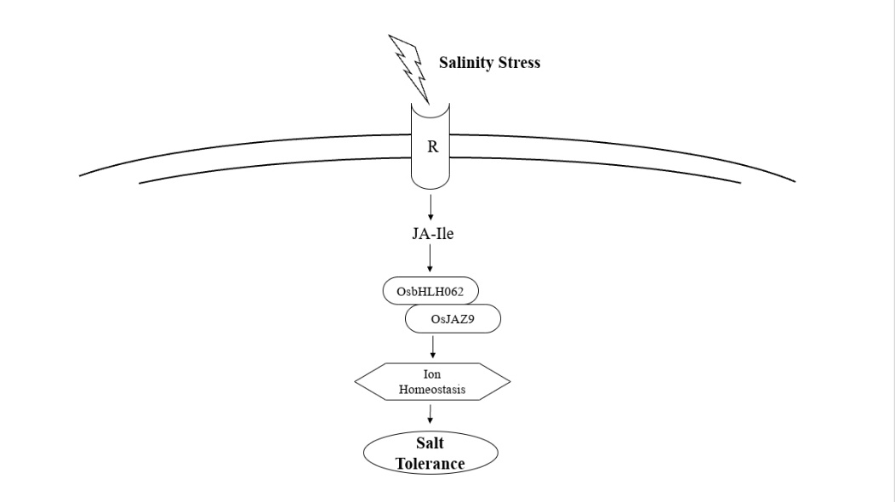Jasmonic Acid Mediated Salinity Stress Tolerance.*

***Mechanism Of Heavy Metal Stress Tolerance In Plants Via Jasmonates:***

Heavy metals, defined by their elevated atomic weights and densities, including mercury, chromium, cadmium, and arsenic, infiltrate the environment chiefly from industrial waste and natural sources. When their concentrations beyond crucial threshold levels, they demonstrate harmful effects on plant growth and development (Tchounwou PB et al., 2012). Jasmonic acid (JA), a naturally occurring phytohormone, is integral to numerous biological processes (Wang Y. et al., 2021). It has attracted considerable interest for its defence mechanisms that safeguard plants against various abiotic stresses, such as salinity (Rehman M. et al., 2023), drought (Creelman and Mullet, 1997), and exposure to fertilisers or herbicides (Sharma, Anket et al., 2018).

Nonetheless, the function of jasmonic acid in alleviating heavy metal stress in plants is still a developing field of study. Heavy metals and metalloids frequently induce an elevation in endogenous jasmonic acid levels to alleviate toxicity. This is accomplished via calcium-dependent signalling pathways, improved reactive oxygen species (ROS) scavenging capabilities, and protection against oxidative stress induced by free radicals (Attia H. et al., 2024). JA enhances membrane stability and promotes interconnected transport networks. Exogenous treatments of jasmonic acid have shown advantages including elevated expression of glutathione S-transferase genes, augmented reactive oxygen species scavenging activity, and mitigation of copper stress in wheat (Aslam S. et al., 2021). Treatments that combine jasmonic acid, proline, and salicylic acid have effectively mitigated lead (Pb)-induced stress in maize by promoting plant growth, defence mechanisms, and overall development (Sofy et al., 2020).

The manufacture and degradation of jasmonic acid, evident even in Streptophyte algae, likely evolved concurrently with mechanisms to mitigate heavy metal toxicity. Jasmonic acid mitigates heavy metal-induced inhibition of hydrogen peroxide, lipid peroxidation, antioxidant enzyme activity, and chlorophyll content, as evidenced in lucerne subjected to copper stress (Chen X. et al., 2021). Exogenous JA treatments augment secondary metabolite production, regulate antioxidant defences, and elevate chlorophyll levels. In soybean seedlings, the antioxidant enzyme activity stimulated by JA mitigated nickel toxicity (Sirhindi G. et al., 2016).

Recent research on Brassica napus underscores the significance of jasmonic acid (JA) in alleviating cadmium (Cd)-induced harm. Cadmium impairs the antioxidant system in plants (Zhang ZW et al., 2020). JA diminishes cadmium accumulation in leaves, therefore safeguarding plants by reducing ROS-induced damage to membrane systems under oxidative stress. Antioxidant defence enzymes, including superoxide dismutase (SOD), peroxidase (POD), ascorbate peroxidase (APX), and catalase (CAT), are essential in protecting plant cells from oxidative damage (Li Y. et al., 2022).

Furthermore, JA improves the uptake of vital nutrients necessary for plant development. These nutrients frequently function as cofactors for enzymes associated with photosynthesis, hence enhancing photosynthetic activity (Aslam S. et al., 2021). JA also modulates stress-related enzymes, enhancing plant defence mechanisms. JA stimulates the synthesis of secondary metabolites such as alkaloids, phenols, and anthocyanins, thereby safeguarding photosynthetic pigments and maintaining normal chloroplast function under stress (Ramakrishna A. et al., 2011). In rapeseed (Brassica napus), jasmonic acid was observed to safeguard chloroplasts against reactive oxygen species damage induced by cadmium stress, preserving chloroplast integrity, gas exchange, and photosynthetic pigment concentrations (Ali Essa et al., 2018).

In response to heavy metal stress, plants initiate a complex signalling pathway to alleviate toxicity. Stress is initially identified by the buildup of reactive oxygen species (ROS) and changes in calcium (Ca²⁺) signalling (Simon Gilroy et al., 2016). Proteins like GRLs, ANNEXINS, CAXs, CaMs, CDPKs, CBLs, and CMLs are integral to the transduction of stress signals. Jasmonate (JA), an essential hormone, is recognised by the SCF^COI1 complex, which enables subsequent signalling (Chen X. et al., 2021). Three kinds of transcription factors (TFA, TFB, TFC) are activated to regulate the stress response (Meraj, T. A. et al., 2020). TFA stimulates the synthesis of ROS-scavenging enzymes such as catalase (CAT), peroxidase (POD), superoxide dismutase (SOD), ascorbate peroxidase (APX), and glutathione reductase (GR), which mitigate ROS and diminish oxidative damage. Yadav, N., & Sharma, S. (2016). TFB facilitates the production of chelators, including glutathione (GSH), phytochelatins (PC), and metallothioneins (MT), which sequester heavy metals, thereby diminishing their toxicity. TFC governs transport mechanisms that facilitate the absorption, root-to-shoot movement, and storage of heavy metals. Cobbett, Christopher. (2000). Genes such as AtIRT1, AtHMA2, AtHMA3 (pertaining to cadmium) and OsLsi1, OsNIP3;1, OsLsi6, OsINT5 (related to arsenic) are upregulated to support these mechanisms (Chen X. et al., 2021).Collectively, these responses mitigate oxidative stress, eliminate heavy metals, and preserve cellular homeostasis, facilitating plant survival in hazardous environments.

Subsequent studies have shown that exogenous jasmonic acid elevates secondary metabolite concentrations in tomato seedlings subjected to lead (Pb) toxicity, encompassing substances such as polyphenols, organic acids, and phenols (Shagun Bali et al., 2019). Although these findings offer insights into the potential mechanisms of JA-mediated resistance, comprehensive molecular studies are essential to completely elucidate JA’s function in alleviating various heavy metal stressors.

*Figure 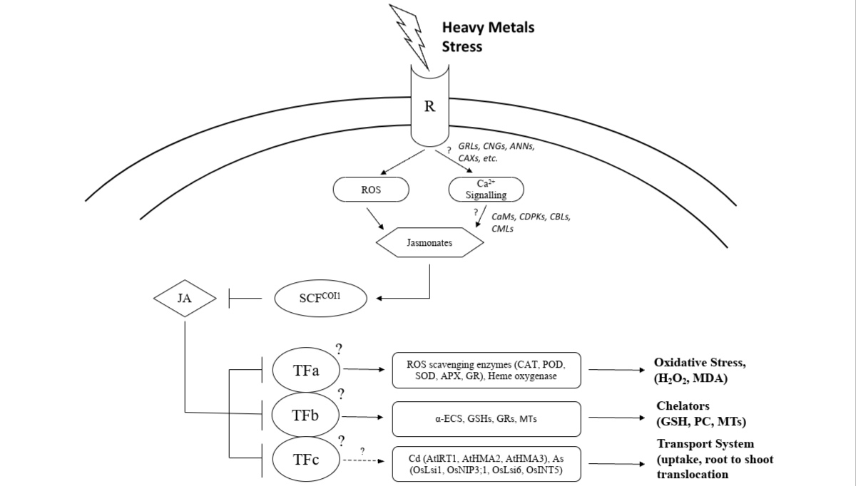8. Jasmonic Acid Mediated Heavy Metals Stress Tolerance.*

### **Mechanism Of Temperature Stress Tolerance In Plants Via Jasmonates:**

Jasmonic acid (JA) is an organic signalling molecule in plants that is essential for their resilience against diverse abiotic challenges. It largely facilitates physiological and molecular reactions (Ali MS et al., 2020). Abiotic stresses encompass heavy metals (Maksymiec et al., 2005), water shortages (Osakabe Y. et al., 2014), salinity (Qiu et al., 2019), elevated temperatures (Clarke et al., 2009), and ultraviolet radiation (Miura K. & Tada Y. 2014). A multitude of studies has investigated the function of JA in facilitating plant responses to these stressors. Physiological reactions typically entail the activation of the antioxidant system, the accumulation of amino acids and soluble carbohydrates, and the modulation of stomatal mobility (Wang J. et al., 2020). At the molecular level, genes associated with jasmonic acid, including JA2, AOC (allene oxide cyclase), LOX2 (lipoxygenase), and COI1 (cytochrome oxidase subunit), are often implicated (Yang L. et al., 2023).

***High Temperature***

Heat stress presents a considerable global challenge to plant production, inducing physiological and ecological alterations that hinder plant growth and development (Hasanuzzaman M. et al., 2013). Elevated temperatures can impair cell membranes, deactivate enzymes, obstruct photosynthesis, and elevate respiration rates, ultimately diminishing crop production (Mishra S. et al., 2023). Moreover, cellular mechanisms and many plant functions are impaired, resulting in a disruption of homeostasis and further jeopardising plant vitality (Gönül Dündar et al., 2024).

To alleviate heat stress, plants synthesise heat shock proteins (HSPs) that assist in stabilising and refolding damaged proteins, hence preserving cellular integrity (Hu C. et al., 2022). Jasmonic acid (JA) signalling is essential for thermotolerance, evidenced by wild-type Arabidopsis plants, in which methyl jasmonate (MeJA) treatment markedly increased ethylene production after 24 hours of heat exposure (Robson F. et al., 2010). JA and ethylene (ET) frequently function as antagonists in responses to heat stress, with JA inhibiting stomatal growth and inducing stomatal closure, which may restrict transpiration. For crops such as rice, which depend on transpiration for thermotolerance, the application of JA may be detrimental (Iqbal N. et al., 2017).

Ethylene and jasmonic acid cooperate to mitigate the impacts of heat stress, while ethylene may occasionally impede thermotolerance. Heat stress induces ethylene synthesis, however excessive ethylene production might worsen damage and hinder plant responses (Clarke et al., 2009). Conversely, MeJA-treated plants demonstrate analogous ethylene production patterns under thermal stress, indicating that jasmonates play a role in stress adaptation via modulating ethylene levels (Hudgins JW et al., 2004). Additionally, JA may govern plant heat stress responses by activating WRKY transcription factors, which regulate gene expression and improve thermotolerance (Liu S. et al., 2022).

This underscores the intricate function of JA in moderating heat stress responses and enhancing plant resistance in elevated temperature environments. Plants perceive elevated temperatures via a receptor that initiates the jasmonate and ethylene signalling pathways. These two hormonal mechanisms synergistically cooperate to improve heat tolerance. Plants can alleviate the detrimental impacts of high temperatures by activating stress-responsive genes, hence preserving cellular integrity and function (Wang M. et al. 2023).

*Figure 9.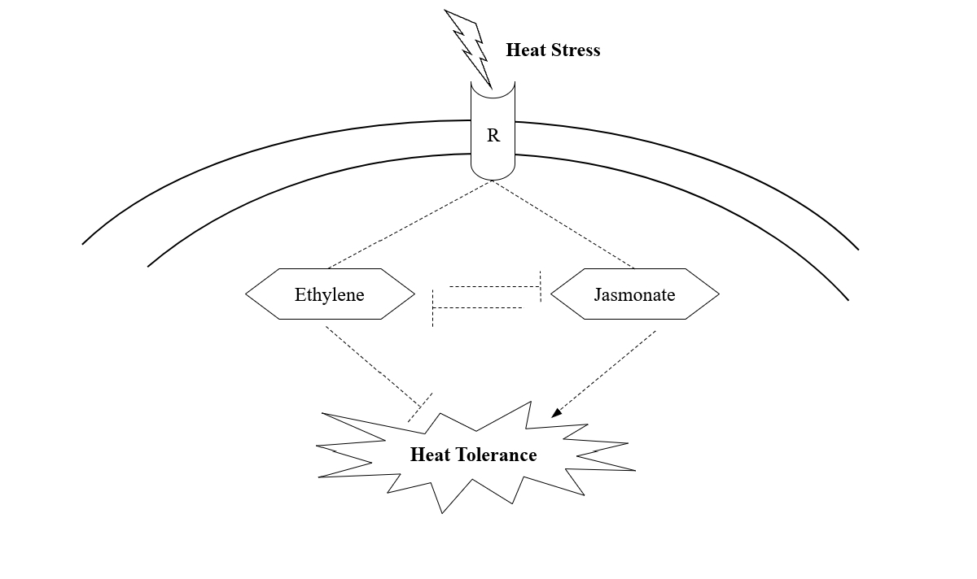 Jasmonic Acid Mediated High Temperature (Heat) Stress Tolerance.*

***Low Temperature***

Low temperature stress markedly affects plant development and defence, constraining their geographic expansion. Chilling stress (above 0°C) and freezing stress (below 0°C) compromise cell membranes and disrupt vital cellular functions, ultimately jeopardising plant existence (Devi, Veena et al., 2023). In reaction to these challenges, plants have developed tolerance mechanisms, such as the accumulation of stress-related proteins, soluble carbohydrates, and amino acids, which aid in safeguarding cell membranes and preserving biological activities under stress circumstances (Satyakam, Zinta G et al., 2022).

Abiotic stress induces the synthesis of abscisic acid (ABA) and jasmonic acid (JA), both of which are essential in orchestrating stress responses. The use of exogenous methyl jasmonate (MeJA) in bananas rapidly activated MY2 transcription factors, thereby improving the plant’s resilience to cold stress (Wang J. et al., 2020). The ICE-CBF (Inducer of CBF Expression) transcriptional cascade is a crucial mechanism in plant cold tolerance, governing the expression of cold-responsive genes that facilitate adaptation to low temperatures (Hwarari D. et al., 2022). Furthermore, JA biosynthesis-associated genes, such as AOS1 (allene oxide synthase), LOX2 (lipoxygenase), DAD1 (dolichyl-diphosphooligosaccharide), and AOC (allene oxide cyclase), are upregulated under low-temperature stress, enhancing the plant’s cold tolerance (Zdyb A. et al., 2018).

The interaction between jasmonic acid and other hormones, including abscisic acid and gibberellins, has been well investigated for its function in regulating plant responses to cold stress (Verma V. et al., 2016). Research on loquat fruit indicated that MeJA treatment diminished lipoxygenase activity while augmenting the activity of catalase, ascorbate peroxidase, and superoxide dismutase, essential enzymes in oxidative stress defence, thus promoting cold tolerance (Cao Shifeng et al., 2009). This emphasises the complex hormonal connections that enhance plant resilience to cold stress, highlighting the significance of JA in governing cold tolerance mechanisms in plants.

Plants employ distinct signalling mechanisms to mitigate diverse environmental stressors. A receptor initiates the jasmonic acid (JA) pathway in response to cold stress. Enzymes include AOS1, AOS2, LOX2, and AOC facilitate the synthesis of JA, which is subsequently transformed into its active form, JA-Ile (Meng-Meng Yu et al., 2023). This active form engages with JAZ proteins (JAZ1/4) to modulate transcription factors such as CBF/DREB1 through ICE1/2 (Hu Y. et al., 2013). These substances activate the production of cold tolerance genes, augmenting the plant’s capacity to endure low temperatures.

*Figure 10. 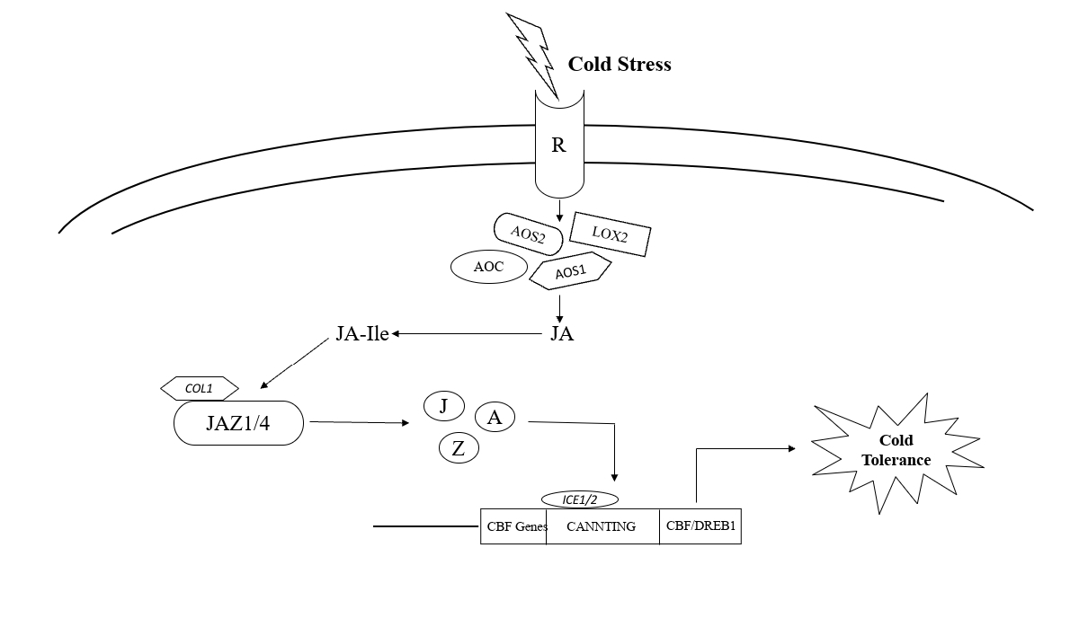Jasmonic Acid Mediated Low Temperature (Cold) Stress Tolerance.*

**Table 3. Summary Of Various Stress Types Their Mode Of Action And Expression**.

|  |  |  |  |
| --- | --- | --- | --- |
| **STRESS TYPE** | **MECHANISM** | **KEY POINTS** | **REFERENCES** |
| **Drought Stress** | Antioxidants & Osmolytes | Production of enzymatic (SOD, CAT, APX) and non enzymatic antioxidants (proline)  stomatal closure mediated by a JA and ROS.  Activation of MYC2 and JAZ protein | Riemann M. et al., (2015); Luo L. et al., (2023) |
| Phenolic Accumulation | Overexpression of phenolics stabilises membranes.  Enhanced PAL activity. | Kumar K. et al., (2023) |
| Root Morphology | Deeper roots to enhance water absorption.  Increased hydraulic conductivity and soluble sugars. | Abdelgawad et al., (2014) |
| **Salinity Stress** | Antioxidants and Nutrient Uptake | JA enhances antioxidant enzyme activities (SOD, POD, CAT).  Improve nutrient uptake growth parameters and chlorophyll synthesis. | Sheyhakinia, Shahram et al., (2022) |
| Osmotic Regulation | Proline accumulation aids osmotic adjustment.  Invertase activity and soluble sugar levels increase. | Liang X. et al., (2013) |
| Photosynthetic Efficiency | Protects photosynthetic pigments.  Enhances photosynthesis and reduces salinity effects. | Yoon, Ji et al., (2013) |
| **Heavy Metals Stress** | Antioxidants Defense | Enhances ROS scavenging enzymes (SOD, POD, APX).  Reduces lipid peroxidation and oxidative stress. | Sofy et al., (2020); Chen X. et al., (2021) |
| Nutrient Uptake and Secondary Metabolites | Promotes uptake of essential nutrients and synthesis of scandal metabolites (phenols, alkaloids).  Protects chloroplast under stress. | Aslam S. et al., (2021) |
| Membrane Stability | Enhances membrane stability and minimises ROS damage. | Ramakrishna A. et al., (2011) |
| **Temperature Stress** | High Temperature | JA signalling promotes ethylene synthesis.  Induces heat shock proteins (HSPs) and WRKY transcription factors.  Balances stomatal movement for thermotolerance. | Robson F. et al., (2010); Liu S. et al., (2022) |
| Low Temperature | Activates JA related genes like LOX2 and AOC.  Regulates antioxidant system to combat chilling and freezing stress. | Hudgins JW. et al., (2004) |

**JASMONIC ACID CROSSTALK:**

Comprehensive studies indicate that various plant signalling pathways, including those mediated by auxin, gibberellic acid (GA), and jasmonic acid (JA), display overlapping mechanisms and regulatory proteins, culminating in a complex network of interactions that govern plant growth and stress responses (Liu H. et al., 2021). Plant stress responses are primarily governed by hormonal communication, in which multiple phytohormones interact to coordinate appropriate cellular responses (Verma V. et al., 2016). JA signalling is not autonomous; rather, it integrates with other hormonal pathways, allowing plants to react to various environmental stimuli and challenges (Yang J. et al., 2019).

A common mechanism in phytohormone signalling involves the degradation of repressor proteins via the SCF-E3 ligase complex, a critical process for the activation of key transcription factors (TFs) that govern stress and developmental responses. Coronatine-Insensitive 1 (COI1), an F-box protein within the SCF^COI complex, is an essential regulator of jasmonic acid (JA) signalling, facilitating the degradation of JAZ repressors and so activating MYC transcription factors that regulate JA-responsive genes (Katsir L. et al., 2008; Yan J. et al., 2013). In auxin signalling, the degradation of AUX/IAA repressors enables the release of AUXIN Response Factors (ARFs), which then activate the transcription of auxin-responsive genes. In GA signalling, DELLA repressor proteins undergo SCF-mediated degradation upon GA detection, enabling the activation of following responses, including growth regulation and stress adaptation (Piskurewicz U. et al., 2008). The coordinated degradation of repressor proteins across many signalling pathways is a crucial regulatory mechanism for plant growth, development, and stress responses.

Recent studies have clarified the function of epigenetic enzymes in signalling pathways, underscoring their significance in regulating gene expression in response to hormonal signals. Jasmonic acid is regarded as a stress hormone because of its crucial function in regulating plant responses to biotic and abiotic stressors, including pathogen defence and environmental adaptability (Rehman M. et al., 2023). In addition to stress responses, jasmonic acid (JA) governs various developmental processes, such as fruit ripening, floral senescence, and root development. The jasmonic acid (JA) signalling network interacts with multiple plant hormones, creating a complex and sequential regulatory system that includes receptors, kinases, transcription factors, and other regulatory proteins, which enable the plant to adapt to changing environmental conditions (Zhang Y. et al., 2023; Liu H. et al., 2021).

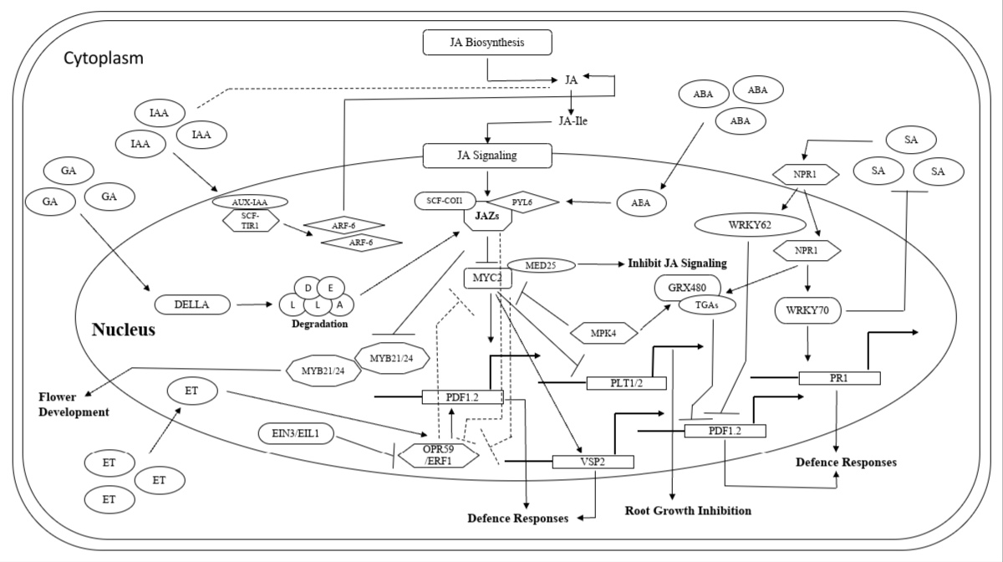Transcription factors such as bHLH, MYB, ERF, and WRKY are crucial in mediating the interaction between jasmonic acid and other phytohormonal pathways. The Jasmonate ZIM-domain (JAZ) proteins and MYC2 transcription factors are crucial in regulating the interactions between jasmonic acid (JA) and other plant hormones, including as auxin, ethylene, abscisic acid, and gibberellic acid (Song C. et al., 2022). These transcription factors act as essential regulators in maintaining equilibrium among growth, development, and stress responses by synthesising information from many hormonal pathways. The intricate interplay between JA and these hormones augments the plant’s ability to accurately modulate its responses to developmental cues and environmental stressors, so ensuring optimal growth and survival.

*Figure 11. Jasmonic Acid Crosstalk With Other Phytohormones Under Stressed Conditions.*

***Jasmonic acid vs Auxin:***

The Interplay between jasmonic acid (JA) and auxin signalling is essential for the regulation of plant growth and development. Research indicates that jasmonic acid positively affects auxin synthesis, which is crucial for lateral root development (Xu P. et al., 2020). This connection commences with JA stimulating the production of ERF109, a pivotal transcription factor that directly activates ASA1 (anthranilate synthase alpha subunit 1) and YUC2 (YUCCA2), two genes essential for auxin biosynthesis. These genes facilitate the synthesis of auxin precursors, hence promoting the development of lateral roots and influencing the overall architecture of the root system (Liu H. et al., 2021).

JA facilitates lateral root development but inhibits primary root growth, illustrating its dual regulatory function in root architecture. JA does this by activating MYC2, a bHLH transcription factor, which directly inhibits the production of PLT1 and PLT2 (PLETHORA1 and PLETHORA2), essential regulators in primary root meristem activity and elongation. This inhibition limits primary root elongation, enabling plants to modify their root growth in reaction to stress circumstances or environmental stimuli (Qian Chen et al., 2011).

In addition to root growth, JA interacts with WRKY57, a transcription factor that regulates leaf senescence and plant defence mechanisms. WRKY57 inhibits the function of SEN4 (senescence-associated gene 4) and SAG12 (senescence-associated gene 12), both of which are crucial components in the senescence process. This inhibition establishes WRKY57 as a negative regulator of jasmonic acid-mediated leaf senescence. WRKY57 also interacts antagonistically with JAZ1 and JAZ5, two negative regulators in the jasmonic acid signalling pathway, illustrating the intricate feedback loops within this hormonal network (Jiang Y. et al., 2016).

Auxin signalling has been discovered to adversely affect WRKY57 protein levels. This signifies a closely regulated Interaction between auxin and JA signalling, wherein both pathways influence each other’s components to attain equilibrium in growth and stress responses (Jiang Y. et al., 2016). This dynamic relationship is further demonstrated in reproductive development, where MYB21 and MYB24, transcription factors downstream of JAZ in jasmonic acid signalling, collaborate with ARF6 and ARF8 from the auxin signalling pathway. Collectively, these transcription factors govern petal and stamen development by influencing endogenous JA levels, underscoring their significance in the growth and maturity of reproductive organs (Yang J. et al., 2019).

The interaction between jasmonic acid and auxin signalling highlights their cooperative and opposing functions in plant development. JA stimulates auxin production to facilitate lateral root development, while concurrently suppressing primary root elongation and affecting reproductive growth, thus ensuring adaptive responses to diverse environmental situations. The interactions facilitated by transcription factors such as MYC2, WRKY57, MYB21, and MYB24 illustrate the complex regulatory networks that sustain plant development and resilience.

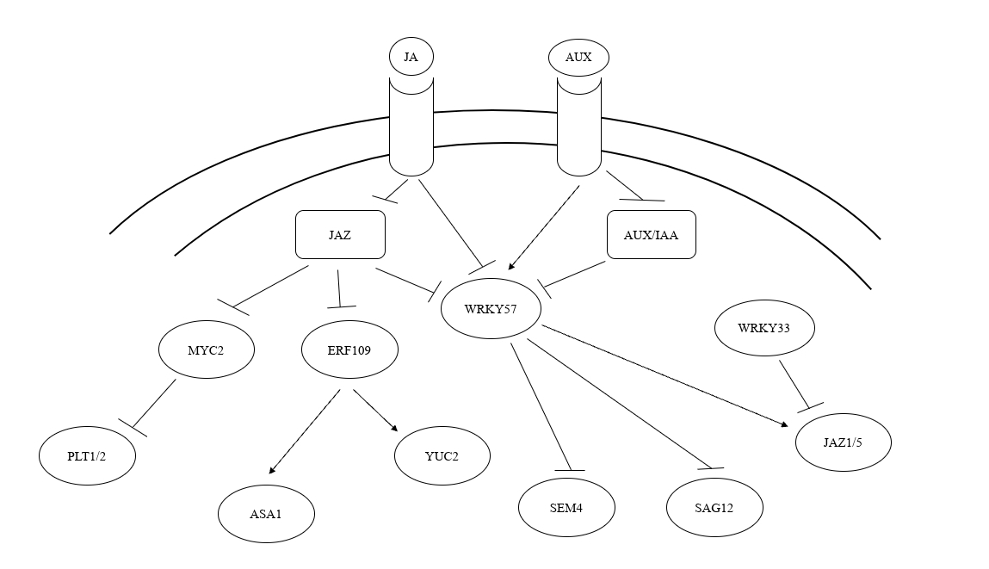

*Figure 12. Simplified Schematic Crosstalk Between Jasmonic Acid And Auxin.*

***Jasmonic acid vs Ethylene:***

Ethylene (ET) is another significant phytohormone that regulates plant growth and offers protection against necrotrophic fungi (Chanclud E. et al., 2016). Ethylene (ET) and jasmonic acid (JA) engage in complex interactions, either antagonistically or synergistically, to modulate plant stress responses and developmental processes (Wang J. et al., 2020). JA is essential for initiating protective responses by promoting the transactivation of defence genes like VSP2. This activation engages the MYC2 transcription factor, which governs responses to injury and herbivory, hence ensuring plant survival under biotic stress circumstances (Pérez-Alonso M. et al., 2021).

JA further affects ET signalling by facilitating the degradation of JA2, a repressor, hence de-repressing the two principal ET signalling transcription factors, EIL1 and EIN3. Upon activation, these transcription factors influence downstream ERF transcription factors, including ERF1 and ORA59, which subsequently activate genes associated with pathogen defence, such as PDF1:2 (Zhu et al., 2011). This interaction emphasises the intricate coordination between jasmonic acid and ethylene signalling pathways, especially in relation to pathogen resistance.

Furthermore, MYC2 and EIN3, pivotal transcription factors in jasmonic acid and ethylene signalling respectively, engage in physical interactions that mutually suppress each other’s transcriptional functions. This interaction maintains equilibrium between various defensive and developmental responses, enabling plants to prioritise their reactions according to environmental signals and stress circumstances (Zheng Y. et al., 2017). The exact processes via which MYC2 and EIN3/EIL1 interact or contend to govern their respective gene networks under different stress and developmental situations are still ambiguous (Song S. et al., 2014).

The interplay between jasmonic acid and ethylene signalling pathways illustrates the intricacy of hormonal interactions in plants. MYC2 and EIN3 function as principal regulators, with their reciprocal inhibition and cooperation exemplifying the precise equilibrium plants uphold to respond to various biotic stressors and developmental requirements.

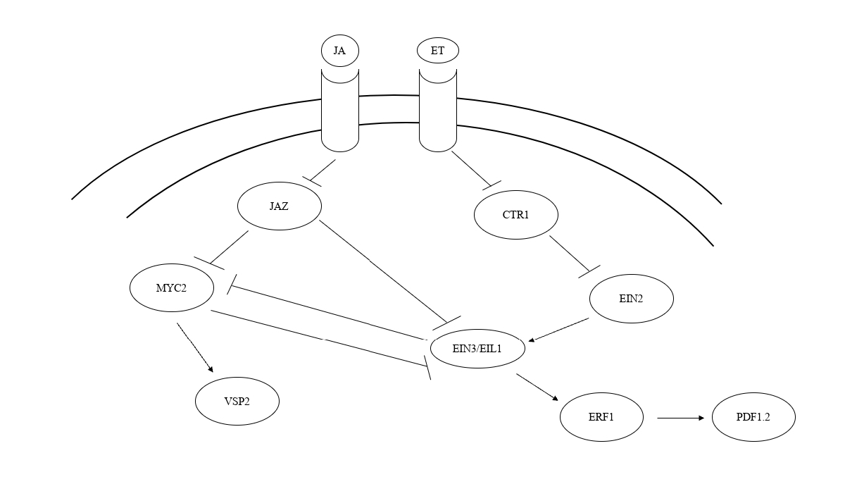

*Figure 13. Simplified Schematic Crosstalk Between Jasmonic Acid And Ethylene.*

***Jasmonic acid vs Abcisic acid:***

Abscisic acid (ABA), a phytohormone, is acknowledged for its role in enhancing abiotic stress tolerance, particularly in relation to salinity and drought stress, as well as regulating developmental processes (Tuteja N. et al., 2007). The interaction between jasmonic acid (JA) and abscisic acid (ABA) involves complex communication that influences plant growth and stress responses. An significant component of this link is the collaboration among JAZ proteins, ABI3, and ABI5, which is crucial for the coordination of the signalling pathways of both hormones (Liu H. & Timko MP. et al., 2021).

ABA-responsive transcription factors (TFs) govern ABA-mediated responses and also promote JA biogenesis. Recent study undertaken in many crop species suggests that this relationship is promoted by ABA-activated ABF transcription factors (Choi H. et al., 2000). The degradation of JAZ proteins, facilitated by JA, liberates ABI3 and ABI5, which are essential regulators in ABA signalling pathways (Liu H. & Timko MP. Et al., 2014). This process highlights the complex role of JAZ proteins and MYC2 in the interaction between JA and ABA signalling, influencing plant development and defence systems (Jang G. et al., 2011).

Notably, ABA interacts with MYC2 in an ABA-dependent manner, inhibiting its activity. This introduces an additional layer of complexity to the interaction between the two signalling pathways (Aleman et al., 2016). The protein KEG stabilises JAZ12 and promotes the degradation of ABI5, functioning as a suppressor in both JA and ABA signalling (Pauwels et al., 2015). Furthermore, the transcriptional activity of ABI5 is suppressed via a physical contact with ICE1, underscoring the interrelatedness of these regulatory networks (Zhiyong Li et al., 2024).

This interaction presents complications. The interaction between JA and ABA signalling pathways might occasionally impede the elicitor-induced reorganisation of plant metabolic processes and development, indicating a trade-off between stress responses and growth (Anderson JP et al., 2004). Furthermore, DELLA proteins, integral to the gibberellic acid (GA) pathway, antagonistically modulate ABA signalling by suppressing ICE1. This introduces further regulatory complexity, as JAZ proteins interact with ABI5, ICE1, and DELLA proteins, highlighting their significance as pivotal mediators in hormonal crosstalk (Hu Y. et al., 2019).

The Jasmonate Zim Domain protein (JAZ12), which plays a distinct role in JA-ABA interactions, is selectively degraded in response to ABA, hence connecting the two pathways (Pauwels et al., 2011). This complex network of interactions underscores the advanced regulatory mechanisms plants utilise to assimilate hormone signals, guaranteeing optimal growth and resilience to stress.

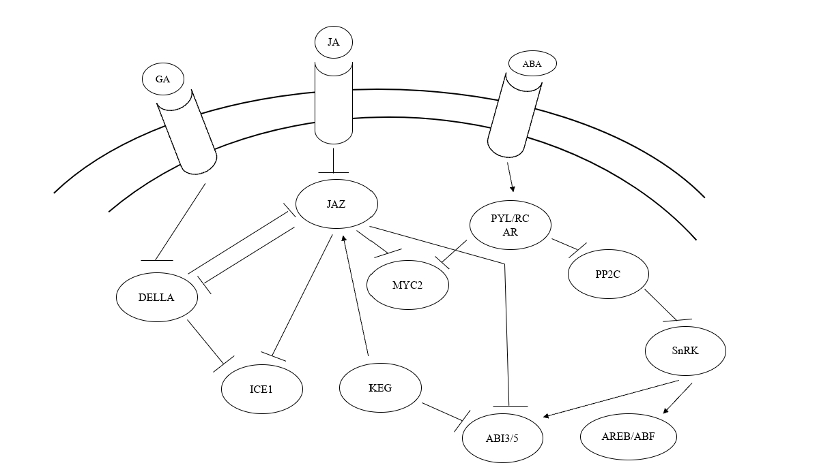

*Figure 14. Simplified Schematic Crosstalk Between Jasmonic Acid And ABA.*

***Jasmonic acid vs Gibberellic acid:***

The Interaction between Jaz and Della proteins is crucial for regulating plant development and defence mechanisms, enabling the concurrent yet contrasting engagement of Jasmonic Acid (JA) and Gibberellic Acid (GA) signalling pathways. This crosstalk facilitates the intricate equilibrium between the activation of defence responses and the suppression of growth responses, wherein the activation of one route frequently compromises the other (Yang Jing et al., 2019). Jaz and Della proteins are essential for regulating their target transcription factors (TFs) via competitive binding. Jaz proteins inhibit these transcription factors through direct interaction, whereas Della proteins compete for binding sites, consequently affecting the transcriptional activity of downstream targets (Liu, Hai & Timko, Michael, 2021).

The interaction between Della and Jaz proteins is chiefly facilitated by their corresponding C-terminal domains. The carboxyl terminus of jasmonic acid is essential for the interaction between Jasmonate Zim Domain (JAZ) proteins and MYC2, a pivotal transcription factor in the jasmonic acid signalling pathway. This area is crucial for the interaction between JAZs and Della proteins, therefore facilitating the cross-regulation of GA and JA signalling (Hou et al., 2010). In the regulatory networks including WD-repeat and MYC-MYB complexes, Jaz and Della interact with basic helix-loop-helix (bHLH) and MYB proteins to regulate transcriptional repression and the regulatory activities of target genes (Hou et al., 2010).

The interaction between Jasmonic Acid and Gibberellic Acid also influences hormonal crosstalk. Jasmonic Acid has been demonstrated to postpone the GA-dependent degradation of Della proteins, and this regulation profoundly influences the plant’s responsiveness to growth and defence signalling. In plants with mutant Della proteins, the response to Jasmonic Acid is reduced, resulting in inhibited growth suppression, indicating that Della is a crucial mediator of JA signalling (Fukazawa J. et al., 2023). Moreover, AtJAZ9 has been shown to diminish the crosstalk between PHYTOCHROME INTERACTING FACTOR 3 (PIF3) and Della proteins, suggesting that the complex interplay between these two protein classes can modulate plant growth and defence responses in response to external stimuli.

Additionally, other transcription factors, such MYC and MYB, are recognised for their interaction with Della proteins, reinforcing the concept that jasmonic acid and gibberellin signalling pathways together influence plant development and defence mechanisms (Pauwels L. et al., 2011). The synergistic interaction of jasmonic acid (JA) with gibberellins (GA) is particularly pronounced in processes including trichome formation, filament elongation, and photomorphogenesis, resulting in improved plant development and stress responses (Traw MB et al., 2003). Jasmonic Acid and Gibberellic Acid jointly expedite the degradation of Della proteins, thereby sustaining active signalling facilitated by both hormones, which eventually coordinates growth and defence responses essential for plant survival in variable conditions.

Crosstalk between Jaz and Della proteins modulates plant growth and defence through the regulation of Jasmonic Acid (JA) and Gibberellic Acid (GA) signalling. Jaz and Della proteins vie for binding transcription factors, with JA affecting Della protein stability. Jasmonic Acid postpones GA-induced Della degradation, influencing growth suppression. AtJAZ9 diminishes the interaction between PIF3 and Della proteins. JA and GA collaboratively regulate activities such as trichome synthesis and filament elongation, underscoring their joint influence on plant development and stress response.

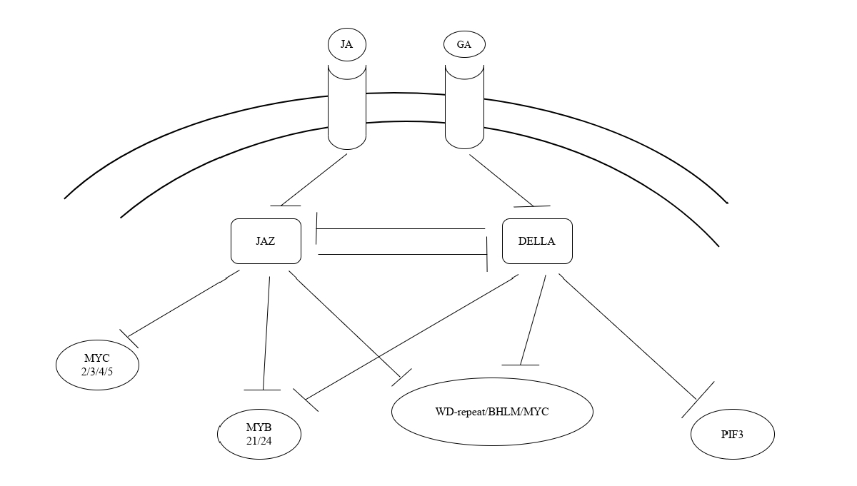

*Figure 15. Specified Schematic Crosstalk Between Jasmonic Acid And Gibberellic Acid.*

***Jasmonic acid vs Salicylic acid:***

Salicylic acid (SA) and ethylene/jasmonate (ET/JA) signalling pathways are essential for plants to adapt and respond to various abiotic stressors (Cengiz Kaya et al., 2023). These signalling pathways orchestrate many physiological and molecular mechanisms, enabling plants to alleviate stress-induced damage and sustain development in unfavourable environmental conditions. SA is primarily linked to mitigating oxidative stress by augmenting antioxidant activity and activating several defense-related genes (Liu J. et al., 2022). This is especially vital under situations of elevated salinity and harsh temperatures, where the production of reactive oxygen species (ROS) can lead to significant cellular damage.

Conversely, ET/JA pathways are well-established for their functions in facilitating drought and salinity tolerance, along with responses to mechanical stress, via regulating stomatal closure, root architecture, and osmotic adjustments (Liu J. et al., 2022). The interplay between SA and ET/JA pathways is significantly context-dependent, with interactions that may either inhibit or enhance the plant’s overall stress response, contingent upon the particular environmental stressor faced (Aerts N. et al., 2020). This duality guarantees that the plant efficiently allocates resources for stress adaptation while maintaining critical growth functions.

A crucial component in this interaction is NPR1 (Nonexpressor of Pathogenesis-Related Genes 1), which governs the interplay between salicylic acid and jasmonic acid signalling pathways. NPR1 does this by stabilising JAZ proteins and regulating the activity of JA-dependent transcription factors, such as MYCs, thus preserving a delicate equilibrium between the two pathways (Mika Nomoto et al., 2021). This regulatory mechanism highlights the significance of precise signalling in shaping plant responses to concurrent or successive stressors.

In the realm of abiotic stress responses, salicylic acid signalling is crucial for augmenting the plant’s antioxidant defence by upregulating enzymes and metabolites that neutralise reactive oxygen species, thus safeguarding cellular components from oxidative damage. Concurrently, ET and JA play a crucial role by activating Ethylene-Responsive Factors (ERFs), which govern stomatal mobility, enhance water-use efficiency, and facilitate ROS detoxification under stress conditions including drought and salinity (Wang J. et al., 2020). These pathways combine external signals with internal defence systems, creating a resilient system that enables plants to adjust to varying environmental conditions.

This complex signalling interaction underscores the sophistication and flexibility of plant stress responses. Through the optimisation of physiological and molecular mechanisms, plants may adeptly regulate abiotic stressors and maintain productivity. Comprehending the functions and interrelations of SA and ET/JA signalling pathways yields significant insights into plant stress biology and presents prospective solutions for improving crop tolerance via targeted modification of these pathways (Mohsin Nawaz et al., 2023). This understanding may facilitate the development of stress-resilient crops that can flourish amid climate change and escalating environmental problems.

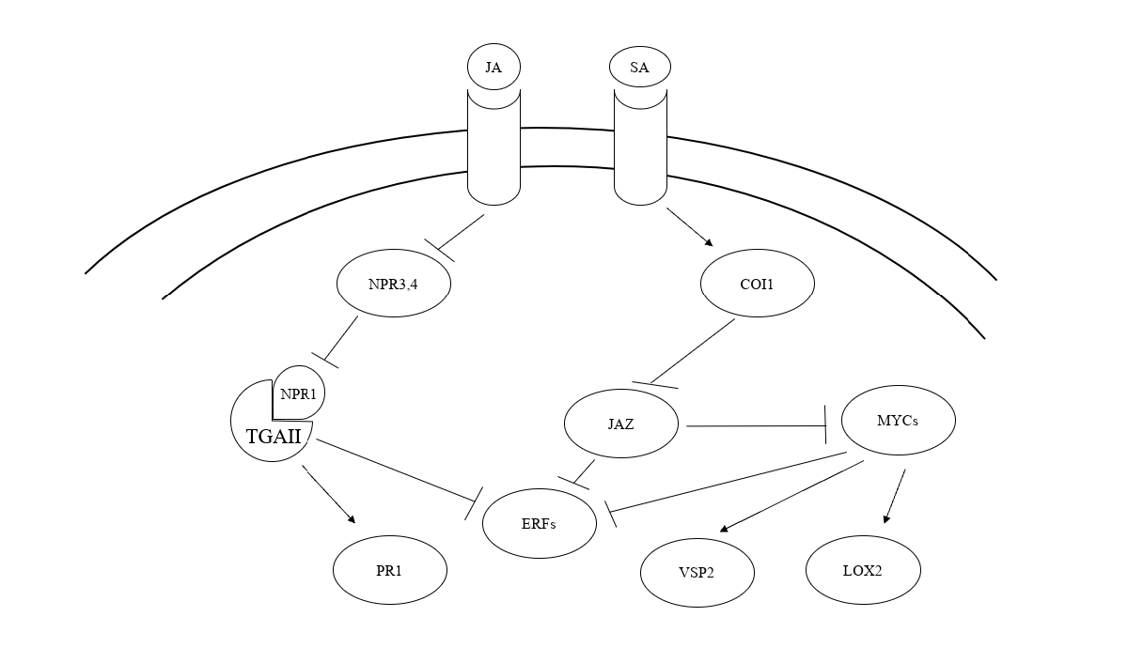

*Figure 16. Specified Schematic Crosstalk Between Jasmonic Acid And Salicylic Acid.*

**Table 4. Overview Of Jasmonic Acid Crosstalk With Various Phytohormones And Their Biological Outcomes.**

|  |  |  |  |
| --- | --- | --- | --- |
| **PHYTOHORMONES** | **INTERACTION MECHANISMS** | **BIOLOGICAL OUTCOMES** | **REFERENCES** |
| **Auxin (IAA)** | JA induces ERF109, activating ASA1 and YUC2, promoting auxin biosynthesis.  JA activates MYC2, suppressing PLT1 and PLT2, restricting primary root growth.  JA interacts with auxin for lateral root formation and inhibits primary root elongation. | Enhanced lateral root formation.  Reduced primary root elongation under stress.  Modulation of root architecture. | Xu et al., 2020; Liu et al., 2021; Chen et al., 2011. |
| **Ethylene (ET)** | JA degrades JAZ proteins, activating EIL1 and EIN3, which regulate ERF1 and ORA59.  JA and ET pathways modulate pathogen defense via PDF1.2 expression.  MYC2 and EIN3 interact antagonistically. | Improved resistance to necrotrophic pathogens.  Fine-tuned defense vs. growth trade-offs. | Wang et al., 2020; Zhu et al., 2011; Zheng et al., 2017. |
| **Abscisic Acid (ABA)** | JA degrades JAZ proteins, releasing ABI3 and ABI5 to modulate ABA signaling.  ABA induces JA biogenesis via ABF transcription factors.  JAZ12 degraded in an ABA-dependent manner.  KEG stabilizes JAZ12, inhibiting ABI5. | Enhanced drought and salinity stress tolerance.  Modulation of stomatal closure and seed dormancy.  Balanced growth and stress responses. | Choi et al., 2000; Pauwels et al., 2011; Hu et al., 2019. |
| **Gibberellic Acid (GA)** | JA delays GA-induced degradation of DELLA proteins.  JAZ proteins interact with MYC2 and DELLA proteins, balancing growth and defense.  JA modulates PIF3-DELLA interaction through AtJAZ9. | Suppressed growth during defense activation.  Regulation of processes like trichome production, filament elongation, and photomorphogenesis. | Hou et al., 2010; Fukazawa et al., 2023; Pauwels et al., 2011. |
| **Salicylic Acid (SA)** | JA-SA antagonism regulates systemic acquired resistance (SAR).  JA suppresses SA-mediated defense pathways in necrotrophic pathogen response. | Improved response to necrotrophic pathogens.  Balanced SAR and JA-mediated defenses. | Vlot et al., 2009; Zheng et al., 2012. |
| **Cytokinins (CKs)** | JA antagonizes CK signaling by repressing ARR transcription factors, balancing growth and defense. | Regulation of shoot branching and growth under stress. | Nemhauser et al., 2006; Smets et al., 2008. |

**DISCUSSION:**

Jasmonic acid (JA) has become a crucial regulator of antioxidant defence systems in plants, particularly under abiotic stress conditions. JA considerably mitigates oxidative stress by inducing major antioxidant enzymes, including superoxide dismutase (SOD), catalase (CAT), and peroxidase (POD), and modulating reactive oxygen species (ROS) scavenging pathways (Ali MS. et al., 2020). The interaction between jasmonic acid (JA) and other phytohormones, including abscisic acid (ABA), ethylene, and salicylic acid (SA), augments the plant’s capacity to manage stress by precisely modulating its response across several levels (Yang J. et al., 2019).

The antioxidant processes governed by JA are crucial for sustaining redox equilibrium in plant cells. The heightened activity of antioxidant enzymes, along with the activation of the ascorbate-glutathione cycle and the accumulation of non-enzymatic antioxidants such as flavonoids and carotenoids, enhances the plant’s capacity to endure oxidative damage (Hasanuzzaman M. et al., 2019). Given that reactive oxygen species (ROS) participate in signalling pathways governing growth and development, jasmonic acid (JA) facilitates the regulation of ROS levels, hence coordinating stress responses and preserving cellular integrity (Hong Y. et al., 2024).

The synergistic interaction of JA with other phytohormones, particularly ABA, is highly significant. JA’s engagement with ABA facilitates water conservation in plants under drought conditions by inducing stomatal closure and concurrently activating antioxidant defence mechanisms to mitigate oxidative damage resulting from ROS buildup (Evandro Alves Vieira 2023). JA’s interaction with ethylene and SA indicates a sophisticated hormonal network that governs stress tolerance and plant defence (Wang J, et al., 2020). Comprehending these hormonal interconnections is essential for elucidating the role of JA within the wider framework of plant stress physiology.

Nonetheless, despite the well described function of JA in modulating antioxidant pathways, significant gaps in our comprehension persist. Many research have concentrated on the enzymatic pathways associated with ROS detoxification, although insufficient emphasis has been directed into the regulatory mechanisms governing the expression of antioxidant genes in response to JA (Schieber M, Chandel NS. 2014). The exact molecular connections between JA and other phytohormones in various stress settings are still ambiguous. Future study should seek to clarify these connections and find new elements implicated in JA-mediated antioxidant control.

**IMPLICATIONS FOR AGRICULTURAL PRACTICES**

Recent research has enhanced our comprehension of Jasmonic Acid (JA) in plant stress responses and developmental control, presenting exciting opportunities for agricultural uses. The subsequent ideas elucidate how JA dynamics might be utilised to improve crop resilience and productivity:

1. ***Enhanced Crop Stress Tolerance***

Management of Abiotic Stress: The exogenous administration of jasmonic acid has demonstrated enhancement of plant tolerance to several abiotic challenges. The foliar application of methyl jasmonate (MeJA) on soybean leaves improved water stress tolerance, associated with elevated levels of sugars, phenolic compounds, and flavonoids (Mohamed HI, Latif HH. 2017).

Antioxidant Regulation: JA is essential for enhancing antioxidant defence mechanisms. Research demonstrates that JA therapy can augment the activity of antioxidant enzymes, therefore alleviating oxidative damage during stress situations (Rajput, V. D. et al. 2021).

1. ***Hormonal Manipulation for Growth-Defense Balance***

Phytohormone Interactions: Jasmonic acid (JA) engages with other hormones, including abscisic acid (ABA) and salicylic acid (SA), to regulate plant responses. Comprehending these connections facilitates the formulation of methods to equilibrate growth and defence systems, hence enhancing crop performance under stress (Yang J. et al., 2019).

Genetic Engineering: Progress in biotechnology facilitates the alteration of jasmonic acid production and signalling mechanisms. The overexpression of jasmonic acid-related genes has been linked to enhanced tolerance to simultaneous high light and heat stress in Arabidopsis thaliana, indicating possible uses in agricultural enhancement (Damián Balfagón et al., 2019).

1. ***Development of Stress-Tolerant Varieties***

Breeding Programs: The identification of JA-responsive genes can enhance marker-assisted selection in breeding programs focused on creating stress-resilient cultivars. JA has been associated with the augmentation of osmotic stress responses via the activation of certain transcription factors (Zhao, W. et al., 2022).

Biotechnological Applications: Gene-editing technologies can focus on JA-related pathways to develop crops with improved stress resilience. Research indicates that JA signalling is essential for plant adaptation to external stresses, highlighting its potential in crop enhancement tactics (Damián Balfagón et al., 2019).

1. ***Sustainable Agricultural Practices***

Minimisation of Chemical Inputs: Employing JA or its analogues as natural elicitors can diminish dependence on synthetic agrochemicals, so fostering sustainable agriculture. The JA application has demonstrated the ability to bolster plant resistance against necrotrophic diseases and regulate physiological processes, providing an environmentally sustainable alternative to chemical treatments (Wu, J. et al. 2024).

Precision Agriculture: The integration of JA-based treatments with precision farming techniques can enhance stress management, resulting in effective resource utilisation and increased crop yields.

1. ***Crop Productivity and Food Security***

Enhanced Yield Stability: JA-induced augmentation of stress resilience fosters yield stability in adverse environmental conditions, bolstering food security initiatives. The JA application has been linked to enhanced growth and yields under salt stress, yielding results equivalent to control plants unaffected by salinity stress (Sheteiwy MS et al., 2022).

Climate Resilience: Comprehending JA dynamics provides farmers with resources to modify crops in response to evolving climatic conditions, hence guaranteeing stable agricultural production. The role of JA in regulating plant responses to many stressors underscores its importance in the development of climate-resilient crops (Damián Balfagón et al., 2019).

**Table 5. Summary Of Jasmonic Acid Aided Implications For Agricultural Practices**.

|  |  |  |
| --- | --- | --- |
| **AREA** | **KEY POINTS** | **REFERENCE** |
| **Stress Tolerance** | JA enhances plant tolerance to abiotic stress, boosts antioxidant activity, and reduces oxidative damage | (Mohamed HI, Latif HH. 2017; Rajput, V. D. et al. 2021) |
| **Growth-Defense Balance** | JA interacts with other hormones (ABA, SA) to balance growth and defense. Genetic engineering of JA-related genes improves stress tolerance | (Yang J. et al., 2019; Damián Balfagón et al., 2019). |
| **Stress-Tolerant Varieties** | JA-responsive genes help in breeding stress-resilient crops, and gene editing can enhance stress tolerance | (Zhao, W. et al., 2022; Damián Balfagón et al., 2019). |
| **Sustainable Practices** | JA reduces dependence on agrochemicals, boosts disease resistance, and supports precision farming | (Wu, J. et al. 2024). |
| **Productivity & Food Security** | JA improves yield stability and climate resilience, ensuring stable crop production | (Sheteiwy MS et al., 2022; Damián Balfagón et al., 2019). |

**SUCCESSFUL CASE STUDIES:**

Recent studies have elucidated the pivotal role of Jasmonic Acid (JA) in augmenting plant resilience to diverse abiotic stressors, including drought, salt, heat, cold, and heavy metal toxicity, across many species. These results underscore JA’s diverse roles in stress detection, signalling, and the initiation of defence mechanisms, which ultimately enhance plant growth and survival in challenging environmental situations.

***Wheat (Triticum aestivum)***

JA priming in wheat seeds has been demonstrated to alleviate salt stress by augmenting antioxidant enzyme activities, diminishing reactive oxygen species (ROS) buildup, and promoting overall plant growth in saline environments (Sheteiwy MS et al., 2022).

***Arabidopsis (Arabidopsis thaliana)***

Jasmonic acid is crucial for adaptation to simultaneous high light and thermal stress in Arabidopsis thaliana. JA signalling pathways regulate the expression of stress-responsive genes, allowing the plant to endure simultaneous environmental stresses (Damián Balfagón et al., 2019).

***Soybean (Glycine max)***

The external application of methyl jasmonate (MeJA) to soybean foliage has been documented to improve drought resistance. This treatment enhances the accumulation of osmoprotectants and antioxidants, consequently augmenting the plant’s capacity to withstand water deficit circumstances (Wang J. et al., 2020).

***Rice (Oryza sativa)***

JA signalling enhances rice plant resilience to heavy metal toxicity. JA regulates the expression of metal transporter genes and antioxidant enzymes, thereby diminishing metal buildup and oxidative damage in rice tissues. (Wang Y. et al., 2021).

***Tomato (Solanum lycopersicum)***

JA improves osmotic stress tolerance in tomato by activating the MYC2 transcription factor, which suppresses negative regulators such as protein phosphatase 2C1. This results in the activation of stress-responsive genes and enhanced physiological responses, including improved water use efficiency and augmented root growth under drought and salinity stress (Zhao W. et al., 2023).

***Maize (Zea mays)***

Jasmonic acid treatment in maize enhances cold stress tolerance via altering lipid content in cell membranes and activating cold-responsive genes. This preserves membrane stability and metabolic function at reduced temperatures (Zhou X. et al., 2022).

**Table 6. Summary Of Successful Case Studies.**

|  |  |  |  |
| --- | --- | --- | --- |
| **PLANT SPECIES** | **ABIOTIC STRESS** | **JA ROLE/MECHANISM** | **REFERENCE** |
| **Wheat *(Triticum aestivum)*** | Salt stress | JA Role/Mechanism: JA priming enhances antioxidant enzyme activities, reduces ROS buildup, and promotes overall growth in saline environments. | Sheteiwy MS et al., 2022 |
| **Arabidopsis *(Arabidopsis thaliana)*** | High light and thermal stress | JA Role/Mechanism: JA signalling regulates stress-responsive genes, enabling the plant to adapt to simultaneous environmental stresses. | Damián Balfagón et al., 2019 |
| **Soybean *(Glycine max)*** | Drought | JA Role/Mechanism: External MeJA application boosts drought resistance by enhancing osmoprotectants and antioxidants, improving the plant’s ability to withstand water deficits. | Wang J. et al., 2020 |
| **Rice *(Oryza sativa)*** | Heavy metal toxicity | JA Role/Mechanism: JA signalling regulates metal transporter genes and antioxidant enzymes, reducing metal accumulation and oxidative damage. | Wang Y. et al., 2021 |
| **Tomato *(Solanum lycopersicum)*** | Osmotic stress (drought and salinity) | JA Role/Mechanism: JA activates the MYC2 transcription factor, suppressing negative regulators and enhancing stress-responsive genes, improving water use efficiency and root growth. | Zhao W. et al., 2023 |
| **Maize *(Zea mays)*** | Abiotic Stress: Cold stress | JA Role/Mechanism: JA enhances cold tolerance by modifying lipid content in membranes and activating cold-responsive genes, maintaining membrane stability and metabolic functions at low temperatures. | Zhou X. et al., 2022 |

**FUTURE DIRECTIONS:**

1. ***Elucidating the Molecular Mechanisms of JA-Mediated Antioxidant Gene Expression***

Future studies should investigate the molecular mechanisms that govern the JA-induced expression of antioxidant genes. Although transcription factors such as MYC2 and WRKY are recognised for their substantial involvement in JA signalling, the specific routes and regulatory networks that activate antioxidant defence systems necessitate additional research (Phukan UJ et al., 2016). Comprehending the interaction of JA signalling with other stress pathways across many regulatory levels—transcriptional, post-transcriptional, and epigenetic—will yield essential insights into the control of antioxidant responses. Progress in high-throughput sequencing, transcriptomics, and gene-editing technologies will enable the discovery of critical regulators and their target genes, hence improving our comprehension of JA-mediated stress defence (Abdulraheem MI. et al., 2024).

1. ***Investigating JA’s Role in Antioxidant Defense Under Multiple Stress Conditions***

Recent research have predominantly concentrated on singular stressors such as drought, heat, or salinity. Plants frequently experience many abiotic stressors concurrently in their natural environment (Jing Z. et al., 2024). The research should focus on examining how JA modulates antioxidant defence in relation to various combination stressors. Comprehending the interplay between JA-mediated antioxidant responses and other physiological adaptations, including osmotic regulation, heat shock protein synthesis, and ion homeostasis, will yield a more thorough understanding of plant resilience under multifaceted environmental stressors (Rehman M. et al. 2023).

1. ***Exploring Hormonal Cross-Talk in Antioxidant Defense Mechanisms***

The Interaction between jasmonic acid (JA) and other phytohormones, such as abscisic acid (ABA), ethylene, and salicylic acid (SA), is essential for the regulation of stress responses (Yang J. et al., 2019). Nonetheless, the precise molecular interactions and signalling channels that regulate this coordination are not well understood. Future research should concentrate on analysing the intricate hormonal networks that affect antioxidant defence mechanisms. A comprehensive comprehension of the molecular interactions among these hormones will elucidate the mechanisms by which jasmonic acid and other hormones regulate plant growth, defence, and stress resilience. Investigations should examine the potential synergistic or antagonistic interactions between jasmonic acid and other phytohormones across various stress circumstances (Wang Y. et al., 2021).

1. ***Harnessing JA for Crop Improvement and Stress Tolerance***

Due to JA’s pivotal function in modulating antioxidant defence, it possesses significant potential for enhancing crop tolerance to oxidative stress (Md. Mezanur Rahman, et al., 2024). Future research should concentrate on identifying and functionally characterising JA-responsive genes that govern antioxidant defence. Genetic alteration of these processes may provide crops with improved resilience to environmental stresses, including drought, salinity, and elevated temperatures. The introduction of exogenous jasmonic acid or related chemicals to crops may provide effective strategies for enhancing stress tolerance in agricultural environments (Villalobos-López MA et al., 2022). Additional investigation into the optimisation of JA utilisation in crop management, encompassing application timing and dosage, is essential to enhance its efficacy under field circumstances.

1. ***Integrating Metabolomics and Proteomics to Explore JA-Mediated Stress Responses***

Progress in metabolomics, proteomics, and other ‘omics’ technologies offers essential instruments for examining the extensive biochemical and proteomic alterations resulting from JA-mediated antioxidant regulation (Katam, R. et al. 2022). Subsequent research should employ these methodologies to identify other metabolites, proteins, and signalling molecules implicated in jasmonic acid-mediated stress responses. This thorough method may uncover new biomarkers and offer insights into the complex biochemical mechanisms that support plant resilience under stress. Moreover, by synthesising metabolomic and transcriptome data, researchers can attain a comprehensive understanding of the interactions between JA and other metabolic networks (Roychowdhury R. et al. 2023).

1. ***Species-Specific and Ecotypic Variations in JA-Mediated Antioxidant Responses***

The efficacy of JA-mediated antioxidant defence may vary among species and ecotypes, contingent upon their environmental adaption. Future research should investigate inter-species differences and evaluate the responses of diverse plant varieties or ecotypes to jasmonic acid under varied stress circumstances. This research may uncover inherent variations in jasmonic acid signalling pathways and antioxidant capacity that provide stress resilience in specific plants. Comprehending these distinctions would facilitate the creation of stress-resistant crops adapted to certain climatic circumstances, hence enhancing agricultural production across varied climates (Juraniec, M. et al. 2024).

1. ***Linking JA-Mediated Antioxidant Mechanisms with Broader Stress Adaptation Pathways***

The role of JA In regulating antioxidant defence should be examined within the broader framework of plant stress adaption. Future study should investigate the interactions between JA-mediated antioxidant processes and other stress-related pathways, including those governing osmotic adjustment, protein repair, and cell wall fortification. Through the examination of the integration of various mechanisms, researchers can acquire insights into how jasmonic acid facilitates the coordination of complex stress responses in plants. Moreover, comprehending the interplay between JA and other stress adaption pathways would create new opportunities for enhancing overall plant resistance against various environmental stresses (Rehman M. et al., 2023).

The aforementioned prospective directions present potential opportunities for enhancing our comprehension of jasmonic acid’s function in antioxidant defence and stress tolerance in plants. By examining the molecular, hormonal, and metabolic mechanisms governing JA-mediated responses to abiotic stressors, researchers can identify novel techniques for improving crop resilience. The utilisation of JA-based technologies in agriculture, alongside advancements in plant breeding and genetic engineering, presents significant potential for mitigating the difficulties of climate change and enhancing global food security.

**Table 7. Overview Of Key Insights And Future Directions.**

|  |  |  |
| --- | --- | --- |
| **FOCUS AREA** | **KEY INSIGHTS & FUTURE DIRECTIONS** | **REFERENCES** |
| **Molecular Mechanisms of JA-Mediated Gene Expression** | Investigate pathways involving transcription factors like MYC2 and WRKY, regulatory networks, and interactions with other stress pathways at transcriptional and epigenetic levels. | Phukan UJ. et al., 2016; Abdulraheem MI. et al., 2024 |
| **JA’s Role Under Multiple Stress Conditions** | Study JA’s role in antioxidant defense under combined abiotic stresses such as drought, salinity, and heat. Explore its interaction with osmotic regulation and ion homeostasis. | Jing Z. et al., 2024; Rehman M. et al., 2023 |
| **Hormonal Cross-Talk in Antioxidant Defense** | Explore JA’s interaction with phytohormones like abscisic acid (ABA), ethylene, and salicylic acid (SA) to understand synergistic or antagonistic effects on plant growth and stress tolerance. | Yang J. et al., 2019; Wang Y. et al., 2021 |
| **Harnessing JA for Crop Improvement** | Identify and manipulate JA-responsive genes to develop stress-tolerant crops. Optimize the use of exogenous JA for practical agricultural applications. | Md. Mezanur Rahman et al., 2024; Villalobos-López MA. et al., 2022 |
| **Integrating Metabolomics and Proteomics** | Utilize ‘omics’ technologies to identify metabolites, proteins, and biomarkers involved in JA-mediated stress responses. Combine metabolomics and transcriptomics for holistic insights. | Katam R. et al., 2022; Roychowdhury R. et al., 2023 |
| **Species-Specific Variations in JA Responses** | Examine inter-species and ecotypic differences in JA signaling and antioxidant defenses to develop crops tailored for specific environmental conditions. | Juraniec M. et al., 2024 |
| **Linking JA Mechanisms with Broader Adaptation** | Investigate how JA-mediated antioxidant pathways integrate with other stress adaptation mechanisms like osmotic adjustment, protein repair, and cell wall strengthening for multifaceted stress responses. | Rehman M. et al., 2023 |

**CONCLUSION**:

The capacity of plants to resist and adapt to biotic and abiotic stresses Is significantly affected by Jasmonic Acid (JA) and its derivatives. JA is pivotal in initiating plant defence systems and enhancing resilience, specifically by activating antioxidant enzymes and other protective substances in response to stress. As a crucial regulator of stress tolerance, JA enables plants to respond adeptly to various environmental challenges, hence assuring survival and growth in harsh situations. Future study should concentrate on elucidating the complex mechanisms of JA signalling, namely the interactions between transcription factors and JAZ repressors in the initial phases of JA signal transduction. These investigations will improve our comprehension of how plants detect and react to various environmental stimuli. Furthermore, investigating the molecular mechanisms of jasmonate transport, the allocation of resources between growth and defence processes, and its possible connections with other hormonal signalling pathways may yield essential insights into the overarching regulatory networks associated with stress resilience. These investigations will elucidate the intricate mechanisms of JA’s function in stress adaptation and facilitate the development of novel ways to improve crop resilience and optimise plant growth under fluctuating climatic conditions. Unlocking the complete potential of JA-mediated stress responses will considerably advance studies aimed at developing sustainable agricultural techniques that guarantee food security during climate change.

**ACKNOWLEDGEMENT:**

Our sincere appreciation goes out to all the people and institutions whose assistance enabled this review. We are especially grateful to Guru Nanak Dev University, Amritsar, for their support and resources during our research. Additionally, we are grateful to the peer reviewers for their insightful comments, which significantly improved the calibre of this paper.

**AUTHORS CONTRIBUTION:**

Gurjant Singh drafted the manuscript. Gurjant Singh & Kumari Sakshi wrote the paper and approved the final manuscript. The authors confirms that no paper mill and artifcial intelligence was used.

Data availability Not applicable.

**DECLARATIONS:**

Ethical approval Not applicable.

Competing interests The authors declare no competing interests

**REFERENCES**:

1. Sharma, R., De Vleesschauwer, D., Sharma, M. K., & Ronald, P. C. (2013). Recent advances in dissecting stress-regulatory crosstalk in rice. Molecular Plant, 6(2), 250–260. <https://doi.org/10.1093/mp/sss147>
2. Kamiya, Y. (2010). Plant hormones: Versatile regulators of plant growth and development. Annual Review of Plant Biology, 61, 10.1146/annurev.arplant.61.031110.100001
3. Campos, M. L., Kang, J. H., & Howe, G. A. (2014). Jasmonate-triggered plant immunity. Journal of Chemical Ecology, 40(7), 657–675. <https://doi.org/10.1007/s10886-014-0468-3>
4. Wasternack, C. (2014). Action of jasmonates in plant stress responses and development—Applied aspects. Biotechnology Advances, 32(1), 31–39. <https://doi.org/10.1016/j.biotechadv.2013.09.009>
5. Liechti, R., & Farmer, E. E. (2006). Jasmonate biochemical pathway. Science Signaling, 2006(322), cm3. <https://doi.org/10.1126/stke.3222006cm3>
6. Kazan, K. (2015). Diverse roles of jasmonates and ethylene in abiotic stress tolerance. Trends in Plant Science, 20(4), 219–229. <https://doi.org/10.1016/j.tplants.2015.02.001>
7. Wasternack, C., & Strnad, M. (2016). Jasmonate signaling in plant stress responses and development–Active and inactive compounds. New Biotechnology, 33(5), 604–613.
8. Ahmad, P., Rasool, S., Gul, A., Sheikh, S. A., Akram, N. A., Ashraf, M., et al. (2016). Jasmonates: Multifunctional roles in stress tolerance. Frontiers in Plant Science, 7, 813. <https://doi.org/10.3389/fpls.2016.00813>
9. Wang, J., Song, L., Gong, X., Xu, J., & Li, M. (2020). Functions of jasmonic acid in plant regulation and response to abiotic stress. International Journal of Molecular Sciences, 21(4), 1446. <https://doi.org/10.3390/ijms21041446>
10. Wasternack, C., & Song, S. (2016). Jasmonates: Biosynthesis, metabolism, and signaling by proteins activating and repressing transcription. Journal of Experimental Botany, 68(6), 1303–1321. <https://doi.org/10.1093/jxb/erw443>
11. Tanaka, Y., Sano, T., Tamaoki, M., Nakajima, N., Kondo, N., & Hasezawa, S. (2005). Ethylene inhibits abscisic acid-induced stomatal closure in Arabidopsis. Plant Physiology, 138(4), 2337–2343. <https://doi.org/10.1104/pp.105.063503>
12. Ul Haq, S., Khan, A., Ali, M., Khattak, A. M., Gai, W. X., Zhang, H. X., Wei, A. M., & Gong, Z. H. (2019). Heat shock proteins: Dynamic biomolecules to counter plant biotic and abiotic stresses. International Journal of Molecular Sciences, 20(21), 5321. <https://doi.org/10.3390/ijms20215321>
13. Kazan, K. (2015). Diverse roles of jasmonates and ethylene in abiotic stress tolerance. Trends in Plant Science, 20(4), 219–229. <https://doi.org/10.1016/j.tplants.2015.02.001>
14. Wasternack, C., & Song, S. (2017). Jasmonates: Biosynthesis, metabolism, and signaling by proteins activating and repressing transcription. Journal of Experimental Botany, 68(6), 1303–1321. <https://doi.org/10.1093/jxb/erw443>
15. Wasternack, C., & Hause, B. (2013). Jasmonates: Biosynthesis, perception, signal transduction, and action in plant stress response, growth, and development. Annals of Botany, 111(6), 1021–1058. <https://doi.org/10.1093/aob/mct067>
16. Ali, M. S., & Baek, K. H. (2020). Jasmonic acid signaling pathway in response to abiotic stresses in plants. International Journal of Molecular Sciences, 21(2), 621. <https://doi.org/10.3390/ijms21020621>
17. Rahman, M. A., Woo, J. H., Song, Y., Lee, S. H., Hasan, M. M., Azad, M. A. K., & Lee, K. W. (2022). Heat shock proteins and antioxidant genes involved in heat combined with drought stress responses in perennial ryegrass. Life, 12(9), 1426. <https://doi.org/10.3390/life12091426>
18. Riemann, M., Dhakarey, R., Hazman, M., Miro, B., Kohli, A., & Nick, P. (2015). Exploring jasmonates in the hormonal network of drought and salinity responses. Frontiers in Plant Science, 6, 1077. <https://doi.org/10.3389/fpls.2015.01077>
19. Liu, H., & Timko, M. P. (2021). Jasmonic acid signaling and molecular crosstalk with other phytohormones. International Journal of Molecular Sciences, 22(6), 2914. <https://doi.org/10.3390/ijms22062914>
20. Aslam, M. M., Waseem, M., Jakada, B. H., Okal, E. J., Lei, Z., Saqib, H. A. S., Yuan, W., Xu, W., & Zhang, Q. (2022). Mechanisms of abscisic acid-mediated drought stress responses in plants. International Journal of Molecular Sciences, 23(3), 1084. <https://doi.org/10.3390/ijms23031084>
21. Aslam, M. M., Waseem, M., Jakada, B. H., Okal, E. J., Lei, Z., Saqib, H. A. S., Yuan, W., Xu, W., & Zhang, Q. (2022). Mechanisms of abscisic acid-mediated drought stress responses in plants. International Journal of Molecular Sciences, 23(3), 1084. <https://doi.org/10.3390/ijms23031084>
22. Ellinger, D., Stingl, N., Kubigsteltig, I., Bals, T., Jünger, M., Pollmann, S., Berger, S., Schünemann, D., & Mueller, M. (2010). DONGLE and DEFECTIVE IN ANTHER DEHISCENCE1 lipases are not essential for wound- and pathogen-induced jasmonate biosynthesis: Redundant lipases contribute to jasmonate formation. Plant Physiology, 153(1), 114–127. <https://doi.org/10.1104/pp.110.155093>
23. Erb, M., & Kliebenstein, D. J. (2020). Plant secondary metabolites as defenses, regulators, and primary metabolites: The blurred functional trichotomy. Plant Physiology, 184(1), 39–52. <https://doi.org/10.1104/pp.20.00433>
24. Hasanuzzaman, M., Bhuyan, M. H. M. B., Zulfiqar, F., Raza, A., Mohsin, S. M., Mahmud, J. A., Fujita, M., & Fotopoulos, V. (2020). Reactive oxygen species and antioxidant defense in plants under abiotic stress: Revisiting the crucial role of a universal defense regulator. Antioxidants, 9(8), 681. <https://doi.org/10.3390/antiox9080681>
25. He, M., Qin, C. X., Wang, X., & Ding, N. Z. (2020). Plant unsaturated fatty acids: Biosynthesis and regulation. Frontiers in Plant Science, 11, 390. <https://doi.org/10.3389/fpls.2020.00390>
26. Hofmann, E., & Pollmann, S. (2008). Molecular mechanism of enzymatic allene oxide cyclization in plants. Plant Physiology and Biochemistry, 46(4), 302–308. <https://doi.org/10.1016/j.plaphy.2007.12.007>
27. Hou, X., Ding, L., & Yu, H. (2013). Crosstalk between GA and JA signaling mediates plant growth and defense. Plant Cell Reports, 32(7), 1067–1074. <https://doi.org/10.1007/s00299-013-1423-4>
28. Ishiguro, S., Kawai-Oda, A., Ueda, J., Nishida, I., & Okada, K. (2001). The DEFECTIVE IN ANTHER DEHISCENCE gene encodes a novel phospholipase A1 catalyzing the initial step of jasmonic acid biosynthesis, which synchronizes pollen maturation, anther dehiscence, and flower opening in Arabidopsis. The Plant Cell, 13(10), 2191–2209. <https://doi.org/10.1105/tpc.010192>
29. Ito, T., Ng, K. H., Lim, T. S., Yu, H., & Meyerowitz, E. M. (2007). The homeotic protein AGAMOUS controls late stamen development by regulating a jasmonate biosynthetic gene in Arabidopsis. The Plant Cell, 19(11), 3516–3529. <https://doi.org/10.1105/tpc.107.055467>
30. Kazan, K. (2015). Diverse roles of jasmonates and ethylene in abiotic stress tolerance. Trends in Plant Science, 20(4), 219–229. <https://doi.org/10.1016/j.tplants.2015.02.001>
31. Kimberlin, A. N., Holtsclaw, R. E., Zhang, T., Mulaudzi, T., & Koo, A. J. (2022). On the initiation of jasmonate biosynthesis in wounded leaves. Plant Physiology, 189(4), 1925–1942. <https://doi.org/10.1093/plphys/kiac163>
32. Kaur, D., Schedl, A., Lafleur, C., Martinez Henao, J., van Dam, N. M., Rivoal, J., & Bede, J. C. (2024). Arabidopsis transcriptomics reveals the role of lipoxygenase2 (AtLOX2) in wound-induced responses. International Journal of Molecular Sciences, 25(11), 5898. <https://doi.org/10.3390/ijms25115898>
33. Maynard, D., Chibani, K., Schmidtpott, S., Seidel, T., Spross, J., Viehhauser, A., & Dietz, K. J. (2021). Biochemical characterization of 13-lipoxygenases of Arabidopsis thaliana. International Journal of Molecular Sciences, 22(19), 10237. <https://doi.org/10.3390/ijms221910237>
34. Newcomer, M. E., & Brash, A. R. (2014). The structural basis for specificity in lipoxygenase catalysis. Protein Science, 24(3), 298–309. <https://doi.org/10.1002/pro.2626>
35. Nirwan, S., Sharma, A. K., Tripathi, R. M., Pati, A. M., & Shrivastava, N. (2023). Resistance strategies for defense against Albugo candida causing white rust disease. Microbiological Research, 270, 127317. <https://doi.org/10.1016/j.micres.2023.127317>
36. Ozalvo, R., Cabrera, J., Escobar, C., Christensen, S. A., Borrego, E. J., Kolomiets, M. V., Castresana, C., Iberkleid, I., & Brown Horowitz, S. (2014). Two closely related members of Arabidopsis 13-lipoxygenases (13-LOXs), LOX3 and LOX4, reveal distinct functions in response to plant-parasitic nematode infection. Molecular Plant Pathology, 15(4), 319–332. <https://doi.org/10.1111/mpp.12094>
37. Scherer, G., Ryu, S., Wang, X., Matos, A., & Heitz, T. (2010). Patatin-related phospholipase A: Nomenclature, subfamilies, and functions in plants. Trends in Plant Science, 15(12), 693–700. <https://doi.org/10.1016/j.tplants.2010.09.005>
38. Theodoulou, F. L., Job, K., Slocombe, S. P., Footitt, S., Holdsworth, M., Baker, A., Larson, T. R., & Graham, I. A. (2005). Jasmonic acid levels are reduced in COMATOSE ATP-binding cassette transporter mutants: Implications for transport of jasmonate precursors into peroxisomes. Plant Physiology, 137(3), 835–840. <https://doi.org/10.1104/pp.105.059352>
39. Wasternack, C., & Strnad, M. (2018). Jasmonates: News on occurrence, biosynthesis, metabolism, and action of an ancient group of signaling compounds. International Journal of Molecular Sciences, 19(9), 2539. <https://doi.org/10.3390/ijms19092539>
40. Wang, K., Guo, Q., Froehlich, J. E., Hersh, H. L., Zienkiewicz, A., Howe, G. A., & Benning, C. (2018). Two abscisic acid-responsive plastid lipase genes involved in jasmonic acid biosynthesis in Arabidopsis thaliana. The Plant Cell, 30(5), 1006–1022. <https://doi.org/10.1105/tpc.18.00250>
41. Zdyb, A., Salgado, M. G., Demchenko, K. N., Brenner, W. G., Płaszczyca, M., Stumpe, M., Herrfurth, C., Feussner, I., & Pawlowski, K. (2018). Allene oxide synthase, allene oxide cyclase, and jasmonic acid levels in Lotus japonicus nodules. PLOS ONE, 13(1), e0190884. <https://doi.org/10.1371/journal.pone.0190884>
42. Newcomer, M. E., & Brash, A. R. (2014). The structural basis for specificity in lipoxygenase catalysis. Protein Science, 24(3), 298–309. <https://doi.org/10.1002/pro.2626>
43. Hofmann, E., & Pollmann, S. (2008). Molecular mechanism of enzymatic allene oxide cyclization in plants. Plant Physiology and Biochemistry, 46, 302–308. <https://doi.org/10.1016/j.plaphy.2007.12.007>
44. Maynard, D., Chibani, K., Schmidtpott, S., Seidel, T., Spross, J., Viehhauser, A., & Dietz, K. J. (2021). Biochemical characterization of 13-lipoxygenases of Arabidopsis thaliana. International Journal of Molecular Sciences, 22(19), 10237. <https://doi.org/10.3390/ijms221910237>
45. Kaur, D., Schedl, A., Lafleur, C., Martinez Henao, J., van Dam, N. M., Rivoal, J., & Bede, J. C. (2024). Arabidopsis transcriptomics reveals the role of lipoxygenase2 (AtLOX2) in wound-induced responses. International Journal of Molecular Sciences, 25(11), 5898. <https://doi.org/10.3390/ijms25115898>
46. Ozalvo, R., Cabrera, J., Escobar, C., Christensen, S. A., Borrego, E. J., Kolomiets, M. V., Castresana, C., Iberkleid, I., & Brown Horowitz, S. (2014). Two closely related members of Arabidopsis 13-lipoxygenases (13-LOXs), LOX3 and LOX4, reveal distinct functions in response to plant-parasitic nematode infection. Molecular Plant Pathology, 15(4), 319–332. <https://doi.org/10.1111/mpp.12094>
47. Wasternack, C., & Song, S. (2017). Jasmonates: Biosynthesis, metabolism, and signaling by proteins activating and repressing transcription. Journal of Experimental Botany, 68(6), 1303–1321. <https://doi.org/10.1093/jxb/erw443>
48. Toporkova, Y. Y., Askarova, E. K., Gorina, S. S., Ogorodnikova, A. V., Mukhtarova, L. S., & Grechkin, A. N. (2020). Epoxyalcohol synthase activity of the CYP74B enzymes of higher plants. Biochimica et Biophysica Acta (BBA) – Molecular and Cell Biology of Lipids, 1865(9), 158743. <https://doi.org/10.1016/j.bbalip.2020.158743>
49. Nuñez, A., Savary, B. J., Foglia, T. A., & Piazza, G. J. (2002). Purification of lipoxygenase from Chlorella: Production of 9- and 13-hydroperoxide derivatives of linoleic acid. Lipids, 37(11), 1027–1032. <https://doi.org/10.1007/s11745-002-0996-x>
50. Maucher, H., Hause, B., Feussner, I., Ziegler, J., & Wasternack, C. (2000). Allene oxide synthases of barley (Hordeum vulgare cv. Salome): Tissue-specific regulation in seedling development. The Plant Journal, 21(2), 199–213. <https://doi.org/10.1046/j.1365-313x.2000.00669.x>
51. Wasternack, C., & Strnad, M. (2018). Jasmonates: News on occurrence, biosynthesis, metabolism, and action of an ancient group of signaling compounds. International Journal of Molecular Sciences, 19(9), 2539. <https://doi.org/10.3390/ijms19092539>
52. Miersch, O., Neumerkel, J., Dippe, M., Stenzel, I., & Wasternack, C. (2007). Hydroxylated jasmonates are commonly occurring metabolites of jasmonic acid and contribute to a partial switch-off in jasmonate signaling. New Phytologist, 177(1), 114–127. <https://doi.org/10.1111/j.1469-8137.2007.02252.x>
53. Stenzel, I., Otto, M., Delker, C., Kirmse, N., Schmidt, D., Miersch, O., Hause, B., & Wasternack, C. (2012). Allene Oxide Cyclase (AOC) gene family members of Arabidopsis thaliana: Tissue- and organ-specific promoter activities and in vivo heteromerization. Journal of Experimental Botany, 63(17), 6125–6138. <https://doi.org/10.1093/jxb/ers261>
54. Schaller, F., Biesgen, C., Müssig, C., Altmann, T., & Weiler, E. W. (2000). 12-Oxophytodienoate reductase 3 (OPR3) is the isoenzyme involved in jasmonate biosynthesis. Planta, 210(6), 979–984. <https://doi.org/10.1007/s004250050706>
55. Bartas, M. (2024). Abiotic stresses in plants: From molecules to environment. International Journal of Molecular Sciences, 25(15), 8072. <https://doi.org/10.3390/ijms25158072>
56. EL Sabagh, A., Islam, S. S., Hossain, A., Iqbal, M. A., Mubeen, M., Waleed, M., Reginato, M., Battaglia, M., Ahmed, S., Rehman, A., Arif, M., Athar, H. U. R., Ratnasekera, D., Danish, S., Raza, M. A., Rajendran, K., Mushtaq, M., Skalicky, M., Brestic, M., … Abdelhamid, M. T. (2022). Phytohormones as growth regulators during abiotic stress tolerance in plants. Frontiers in Agronomy, 4, 765068. <https://doi.org/10.3389/fagro.2022.765068>
57. Karumannil, S., Khan, T. A., Kappachery, S., & Gururani, M. A. (2023). Impact of exogenous melatonin application on photosynthetic machinery under abiotic stress conditions. Plants, 12(16), 2948. <https://doi.org/10.3390/plants12162948>
58. Rehman, M., Saeed, M. S., Fan, X., Salam, A., Munir, R., Yasin, M. U., Khan, A. R., Muhammad, S., Ali, B., Ali, I., Khan, J., & Gan, Y. (2023). The multifaceted role of jasmonic acid in plant stress mitigation: An overview. Plants, 12(23), 3982. <https://doi.org/10.3390/plants12233982>
59. Ali, M. S., & Baek, K. H. (2020). Jasmonic acid signaling pathway in response to abiotic stresses in plants. International Journal of Molecular Sciences, 21(2), 621. <https://doi.org/10.3390/ijms21020621>
60. Wang, Y., Mostafa, S., Zeng, W., & Jin, B. (2021). Function and mechanism of jasmonic acid in plant responses to abiotic and biotic stresses. International Journal of Molecular Sciences, 22(16), 8568. <https://doi.org/10.3390/ijms22168568>
61. Rehman, M., Saeed, M. S., Fan, X., Salam, A., Munir, R., Yasin, M. U., Khan, A. R., Muhammad, S., Ali, B., Ali, I., Khan, J., & Gan, Y. (2023). The multifaceted role of jasmonic acid in plant stress mitigation: An overview. Plants, 12(23), 3982. <https://doi.org/10.3390/plants12233982>
62. Seleiman, M. F., Al-Suhaibani, N., Ali, N., Akmal, M., Alotaibi, M., Refay, Y., Dindaroglu, T., Abdul-Wajid, H. H., & Battaglia, M. L. (2021). Drought stress impacts on plants and different approaches to alleviate its adverse effects. Plants, 10(2), 259. <https://doi.org/10.3390/plants10020259>
63. Yan, S., Weng, B., Jing, L., & Bi, W. (2023). Effects of drought stress on water content and biomass distribution in summer maize (Zea mays L.). Frontiers in Plant Science, 14, 1118131. <https://doi.org/10.3389/fpls.2023.1118131>
64. Ahmad, N., Malagoli, M., & Wirtz, M. (2016). Drought stress in maize causes differential acclimation responses of glutathione and sulfur metabolism in leaves and roots. BMC Plant Biology, 16, 247. <https://doi.org/10.1186/s12870-016-0940-z>
65. Yang, X., Lu, M., Wang, Y., Wang, Y., Liu, Z., & Chen, S. (2021). Response mechanism of plants to drought stress. Horticulturae, 7(3), 50. <https://doi.org/10.3390/horticulturae7030050>
66. Chauhan, J., Prathibha, M., Singh, P., Choyal, P., Mishra, U. N., Saha, D., Kumar, R., Anuragi, H., Pandey, S., Bose, B., Mehta, B., Dey, P., Dwivedi, K. K., Gupta, N. K., & Singhal, R. K. (2023). Plant photosynthesis under abiotic stresses: Damages, adaptive, and signaling mechanisms. Plant Stress, 10, 100296. <https://doi.org/10.1016/j.stress.2023.100296>
67. Sachdev, S., Ansari, S. A., Ansari, M. I., Fujita, M., & Hasanuzzaman, M. (2021). Abiotic stress and reactive oxygen species: Generation, signaling, and defense mechanisms. Antioxidants, 10(2), 277. <https://doi.org/10.3390/antiox10020277>
68. Cruz de Carvalho, M. H. (2008). Drought stress and reactive oxygen species: Production, scavenging, and signaling. Plant Signaling & Behavior, 3(3), 156–165. <https://doi.org/10.4161/psb.3.3.5536>
69. Sharma, A., Shahzad, B., Kumar, V., Kohli, S. K., Sidhu, G. P. S., Bali, A. S., Handa, N., Kapoor, D., Bhardwaj, R., & Zheng, B. (2019). Phytohormones regulate accumulation of osmolytes under abiotic stress. Biomolecules, 9(7), 285. <https://doi.org/10.3390/biom9070285>
70. Huang, H., Ullah, F., Zhou, D.-X., Yi, M., & Zhao, Y. (2019). Mechanisms of ROS regulation of plant development and stress responses. Frontiers in Plant Science, 10, 800. <https://doi.org/10.3389/fpls.2019.00800>
71. Hayat, S., Hayat, Q., Alyemeni, M. N., Wani, A. S., Pichtel, J., & Ahmad, A. (2012). Role of proline under changing environments: A review. Plant Signaling & Behavior, 7(11), 1456–1466. <https://doi.org/10.4161/psb.21949>
72. Yu, X., Zhang, W., Zhang, Y., Zhang, X., Lang, D., & Zhang, X. (n.d.). The roles of methyl jasmonate in stress in plants. Functional Plant Biology. <https://doi.org/10.1071/FP18106>
73. Catalá, A., & Díaz, M. (2016). Impact of lipid peroxidation on the physiology and pathophysiology of cell membranes. Frontiers in Physiology, 7, 423. <https://doi.org/10.3389/fphys.2016.00423>
74. Kumar, A., Prasad, A., Sedlářová, M., & Pospíšil, P. (2023). Malondialdehyde enhances PsbP protein release during heat stress in Arabidopsis. Plant Physiology and Biochemistry, 202, 107984. <https://doi.org/10.1016/j.plaphy.2023.107984>
75. Sheteiwy, M. (2018). Priming with methyl jasmonate alleviates polyethylene glycol-induced osmotic stress in rice seeds by regulating the seed metabolic profile. Environmental and Experimental Botany, 153, 236–248. <https://doi.org/10.1016/j.envexpbot.2018.06.001>
76. Sharma, P., Jha, A. B., Dubey, R. S., & Pessarakli, M. (2012). Reactive oxygen species, oxidative damage, and antioxidative defense mechanism in plants under stressful conditions. Journal of Botany, 2012, 217037. <https://doi.org/10.1155/2012/217037>
77. Wang, J., Song, L., Gong, X., Xu, J., & Li, M. (2020). Functions of jasmonic acid in plant regulation and response to abiotic stress. International Journal of Molecular Sciences, 21(4), 1446. <https://doi.org/10.3390/ijms21041446>
78. Kumar, K., Debnath, P., Singh, S., & Kumar, N. (2023). An overview of plant phenolics and their involvement in abiotic stress tolerance. Stresses, 3(3), 570-585. <https://doi.org/10.3390/stresses3030040>
79. Park, Y. J., Kwon, D. Y., Koo, S. Y., Truong, T. Q., Hong, S. C., Choi, J., Moon, J., & Kim, S. M. (2023). Identification of drought-responsive phenolic compounds and their biosynthetic regulation under drought stress in Ligularia fischeri. Frontiers in Plant Science, 14, 1140509. <https://doi.org/10.3389/fpls.2023.1140509>
80. Riemann, M., Dhakarey, R., Hazman, M., Miro, B., Kohli, A., & Nick, P. (2015). Exploring jasmonates in the hormonal network of drought and salinity responses. Frontiers in Plant Science, 6, 1077. <https://doi.org/10.3389/fpls.2015.01077>
81. Gonugunta, V. K., Srivastava, N., & Raghavendra, A. S. (2009). Cytosolic alkalinization is a common and early messenger preceding the production of ROS and NO during stomatal closure by variable signals, including abscisic acid, methyl jasmonate, and chitosan. Plant Signaling & Behavior, 4(6), 561-564. <https://doi.org/10.4161/psb.4.6.8847>
82. Lim, C. W., Baek, W., Jung, J., Kim, J. H., & Lee, S. C. (2015). Function of ABA in stomatal defense against biotic and drought stresses. International Journal of Molecular Sciences, 16(7), 15251-15270. <https://doi.org/10.3390/ijms160715251>
83. Hossain, M. A., Ye, W., Munemasa, S., Nakamura, Y., Mori, I. C., & Murata, Y. (2014). Cyclic adenosine 5’-diphosphoribose (cADPR) and cyclic guanosine 3’,5’-monophosphate positively function in Ca(2+) elevation in methyl jasmonate-induced stomatal closure, cADPR is required for methyl jasmonate-induced ROS accumulation NO production in guard cells. Plant Biology, 16(6), 1140-1144. <https://doi.org/10.1111/plb.12175>
84. Kolupaev, Y. E., Yastreb, T. O., & Dmitriev, A. P. (2023). Signal mediators in the implementation of jasmonic acid’s protective effect on plants under abiotic stresses. Plants, 12(14), 2631. <https://doi.org/10.3390/plants12142631>
85. Tuteja, N., & Mahajan, S. (2007). Calcium signaling network in plants: An overview. Plant Signaling & Behavior, 2(2), 79-85. <https://doi.org/10.4161/psb.2.2.4176>
86. Munemasa, S., Mori, I. C., & Murata, Y. (2011). Methyl jasmonate signaling and signal crosstalk between methyl jasmonate and abscisic acid in guard cells. Plant Signaling & Behavior, 6(7), 939-941. <https://doi.org/10.4161/psb.6.7.15439>
87. Chen, J. L., Ahluwalia, J. P., & Stamnes, M. (2002). Selective effects of calcium chelators on anterograde and retrograde protein transport in the cell. Journal of Biological Chemistry, 277(38), 35682-35687. <https://doi.org/10.1074/jbc.M204157200>
88. Schulz, P., Herde, M., & Romeis, T. (2013). Calcium-dependent protein kinases: Hubs in plant stress signaling and development. Plant Physiology, 163(2), 523-530. <https://doi.org/10.1104/pp.113.222539>
89. Mori, I. C., Murata, Y., Yang, Y., Munemasa, S., Wang, Y. F., Andreoli, S., Tiriac, H., Alonso, J. M., Harper, J. F., Ecker, J. R., Kwak, J. M., & Schroeder, J. I. (2006). CDPKs CPK6 and CPK3 function in ABA regulation of guard cell S-type anion- and Ca(2+)-permeable channels and stomatal closure. PLoS Biology, 4(10), e327. <https://doi.org/10.1371/journal.pbio.0040327>
90. Zhu, S. Y., Yu, X. C., Wang, X. J., Zhao, R., Li, Y., Fan, R. C., Shang, Y., Du, S. Y., Wang, X. F., Wu, F. Q., Xu, Y. H., Zhang, X. Y., & Zhang, D. P. (2007). Two calcium-dependent protein kinases, CPK4 and CPK11, regulate abscisic acid signal transduction in Arabidopsis. Plant Cell, 19(10), 3019-3036. <https://doi.org/10.1105/tpc.107.050666>
91. Khokon, M. A., Salam, M. A., Jammes, F., Ye, W., Hossain, M. A., Uraji, M., Nakamura, Y., Mori, I. C., Kwak, J. M., & Murata, Y. (2015). Two guard cell mitogen-activated protein kinases, MPK9 and MPK12, function in methyl jasmonate-induced stomatal closure in Arabidopsis thaliana. Plant Biology, 17(5), 946-952. <https://doi.org/10.1111/plb.12321>
92. Sasaki-Sekimoto, Y., Jikumaru, Y., Obayashi, T., Saito, H., Masuda, S., Kamiya, Y., Ohta, H., & Shirasu, K. (2013). Basic helix-loop-helix transcription factors JASMONATE-ASSOCIATED MYC2-LIKE1 (JAM1), JAM2, and JAM3 are negative regulators of jasmonate responses in Arabidopsis. Plant Physiology, 163(1), 291-304. <https://doi.org/10.1104/pp.113.220129>
93. Luo, L., Wang, Y., Qiu, L., Han, X., Zhu, Y., Liu, L., Man, M., Li, F., Ren, M., & Xing, Y. (2023). MYC2: A master switch for plant physiological processes and specialized metabolite synthesis. International Journal of Molecular Sciences, 24(4), 3511. <https://doi.org/10.3390/ijms24043511>
94. Luo, Z., Kong, X., Zhang, Y., Li, W., Zhang, D., Dai, J., Fang, S., Chu, J., Dong, H. (2019). Leaf-derived jasmonate mediates water uptake from hydrated cotton roots under partial root-zone irrigation. Plant Physiology, 180(3), 1660-1676. <https://doi.org/10.1104/pp.19.00315>
95. Harris, J. M. (2015). Abscisic acid: Hidden architect of root system structure. Plants, 4(3), 548-572. <https://doi.org/10.3390/plants4030548>
96. Abdelgawad, Z. A., Khalafaallah, A. A., & Abdallah, M. M. (2014). Impact of methyl jasmonate on antioxidant activity and some biochemical aspects of maize plant grown under water stress condition. Agricultural Sciences, 5(12), 1069–1081. <https://doi.org/10.4236/as.2014.512115>
97. Franks, S. J. (2011). Plasticity and evolution in drought avoidance and escape in the annual plant Brassica rapa. New Phytologist, 190(1), 249–257. <https://doi.org/10.1111/j.1469-8137.2010.03603.x>
98. Wang, Y., Mostafa, S., Zeng, W., & Jin, B. (2021). Function and mechanism of jasmonic acid in plant responses to abiotic and biotic stresses. International Journal of Molecular Sciences, 22(16), 8568. <https://doi.org/10.3390/ijms22168568>
99. Cao, B., Bai, J., Wang, X., Zhang, Y., Yu, X., Hu, S., & He, Y. (2022). BnA.JAZ5 attenuates drought tolerance in rapeseed through mediation of ABA–JA crosstalk. Horticulturae, 8(2), 131. <https://doi.org/10.3390/horticulturae8020131>
100. Balasubramaniam, T., Shen, G., Esmaeili, N., & Zhang, H. (2023). Plants’ response mechanisms to salinity stress. Plants (Basel), 12(12), 2253. <https://doi.org/10.3390/plants12122253>
101. Shrivastava, P., & Kumar, R. (2015). Soil salinity: A serious environmental issue and plant growth-promoting bacteria as one of the tools for its alleviation. Saudi Journal of Biological Sciences, 22(2), 123-131. <https://doi.org/10.1016/j.sjbs.2014.12.001>
102. Zhu, M., Liu, Y., Cai, P., Duan, X., Sang, S., & Qiu, Z. (2022). Jasmonic acid pretreatment improves salt tolerance of wheat by regulating hormone biosynthesis and antioxidant capacity. Frontiers in Plant Science, 13, 968477. <https://doi.org/10.3389/fpls.2022.968477>
103. Sheyhakinia, S., Bamary, Z., Einali, A., & Valizadeh, J. (2020). The induction of salt stress tolerance by jasmonic acid treatment in roselle (Hibiscus sabdariffa L.) seedlings through enhancing antioxidant enzymes activity and metabolic changes. Biologia, 75. <https://doi.org/10.2478/s11756-020-00444-8>
104. Wang, J., Song, L., Gong, X., Xu, J., & Li, M. (2020). Functions of jasmonic acid in plant regulation and response to abiotic stress. International Journal of Molecular Sciences, 21(4), 1446. <https://doi.org/10.3390/ijms21041446>
105. Ashraf, M. (2002). Exploitation of genetic variation for improvement of salt tolerance in spring wheat. In R. Ahmad & K. A. Malik (Eds.), Prospects for saline agriculture (pp. 113-121). Kluwer Academic Publishers. <https://doi.org/10.1007/978-94-017-0067-2_11>
106. Ahmad, P., & Jhon, R. (2005). Effect of salt stress on growth and biochemical parameters of Pisum sativum L. Archives of Agronomy and Soil Science, 51, 665-672. <https://doi.org/10.1080/03650340500274151>
107. Al-aghabary, K., Zhu, Z., & Shi, Q. (2004). Influence of silicon supply on chlorophyll content, chlorophyll fluorescence, and antioxidative enzyme activities in tomato plants under salt stress. Journal of Plant Nutrition, 27(12), 2101-2115.
108. Anuradha, S., & Rao, S. S. R. (2001). Effect of brassinosteroids on salinity stress-induced inhibition of germination and seedling growth of rice (Oryza sativa L.). Plant Growth Regulation, 33, 151–153.
109. Yoon, J., Hamayun, M., Lee, S. K., & Lee, I. J. (2009). Methyl jasmonate alleviated salinity stress in soybean. Journal of Crop Science and Biotechnology, 12, 63-68. <https://doi.org/10.1007/s12892-009-0060-5>
110. Wang, Y., Mostafa, S., Zeng, W., & Jin, B. (2021). Function and mechanism of jasmonic acid in plant responses to abiotic and biotic stresses. International Journal of Molecular Sciences, 22(16), 8568. <https://doi.org/10.3390/ijms22168568>
111. Liu, Y., Pan, Q. H., Yang, H. R., et al. (2008). Relationship between H₂O₂ and jasmonic acid in pea leaf wounding response. Russian Journal of Plant Physiology, 55, 765–775. <https://doi.org/10.1134/S1021443708060058>
112. Siddiqi, K. S., & Husen, A. (2019). Plant response to jasmonates: Current developments and their role in changing environment. Bulletin of the National Research Centre, 43, 153. <https://doi.org/10.1186/s42269-019-0195-6>
113. Ji, X., Tang, J., & Zhang, J. (2022). Effects of salt stress on the morphology, growth, and physiological parameters of Juglans microcarpa L. seedlings. Plants (Basel), 11(18), 2381. <https://doi.org/10.3390/plants11182381>
114. Zhang, P., 千家, 正照, & Dai, Y. (2016). Effects of salinity stress on growth, yield, fruit quality, and water use efficiency of tomato under hydroponics system. Reviews in Agricultural Science, 4. <https://doi.org/10.7831/ras.4.46>
115. Salimi, F., Shekari, F., & Hamzei, J. (2016). Methyl jasmonate improves salinity resistance in German chamomile (Matricaria chamomilla L.) by increasing activity of antioxidant enzymes. Acta Physiologiae Plantarum, 38. <https://doi.org/10.1007/s11738-015-2023-4>
116. Hayat, S., Hayat, Q., Alyemeni, M. N., Wani, A. S., Pichtel, J., & Ahmad, A. (2012). Role of proline under changing environments: A review. Plant Signal & Behavior, 7(11), 1456–1466. <https://doi.org/10.4161/psb.21949>
117. El Moukhtari, A., Cabassa-Hourton, C., Farissi, M., & Savouré, A. (2020). How does proline treatment promote salt stress tolerance during crop plant development? Frontiers in Plant Science, 11, 1127. <https://doi.org/10.3389/fpls.2020.01127>
118. Liang, X., Zhang, L., Natarajan, S. K., & Becker, D. F. (2013). Proline mechanisms of stress survival. Antioxidants & Redox Signaling, 19(9), 998–1011. <https://doi.org/10.1089/ars.2012.5074>
119. Sheteiwy, M. S., Shao, H., Qi, W., Daly, P., Sharma, A., Shaghaleh, H., Hamoud, Y. A., El-Esawi, M. A., Pan, R., Wan, Q., & Lu, H. (2020). Seed priming and foliar application with jasmonic acid enhance salinity stress tolerance of soybean (Glycine max L.) seedlings. Journal of the Science of Food and Agriculture, 101(5), 2027–2041. <https://doi.org/10.1002/jsfa.10822>
120. Hao, S., Wang, Y., Yan, Y., Liu, Y., Wang, J., & Chen, S. (2021). A review on plant responses to salt stress and their mechanisms of salt resistance. Horticulturae, 7(6), 132. <https://doi.org/10.3390/horticulturae7060132>
121. Jiménez-Arias, D., García-Machado, F. J., Morales-Sierra, S., García-García, A. L., Herrera, A. J., Valdés, F., Luis, J. C., & Borges, A. A. (2021). A beginner’s guide to osmoprotection by biostimulants. Plants, 10(2), 363. <https://doi.org/10.3390/plants10020363>
122. Claussen, W. (2005). Proline as a measure of stress in tomato plants. Plant Science, 168(2), 241–248. <https://doi.org/10.1016/j.plantsci.2004.07.039>
123. Ma, Y., Dias, M. C., & Freitas, H. (2020). Drought and salinity stress responses and microbe-induced tolerance in plants. Frontiers in Plant Science, 11, 591911. <https://doi.org/10.3389/fpls.2020.591911>
124. Moustafa-Farag, M., Mohamed, H. I., Mahmoud, A., Elkelish, A., Misra, A. N., Guy, K. M., Kamran, M., Ai, S., & Zhang, M. (2020). Salicylic acid stimulates antioxidant defense and osmolyte metabolism to alleviate oxidative stress in watermelons under excess boron. Plants, 9(6), 724. <https://doi.org/10.3390/plants9060724>
125. Hasanuzzaman, M., Raihan, M. R. H., Masud, A. A. C., Rahman, K., Nowroz, F., Rahman, M., Nahar, K., & Fujita, M. (2021). Regulation of reactive oxygen species and antioxidant defense in plants under salinity. International Journal of Molecular Sciences, 22(17), 9326. <https://doi.org/10.3390/ijms22179326>
126. Valenzuela, C. E., Acevedo-Acevedo, O., Miranda, G. S., Vergara-Barros, P., Holuigue, L., Figueroa, C. R., & Figueroa, P. M. (2016). Salt stress response triggers activation of the jasmonate signaling pathway leading to inhibition of cell elongation in Arabidopsis primary root. Journal of Experimental Botany, 67(14), 4209–4220. <https://doi.org/10.1093/jxb/erw202>
127. Wu, H., Ye, H., Yao, R., Zhang, T., & Xiong, L. (2015). OsJAZ9 acts as a transcriptional regulator in jasmonate signaling and modulates salt stress tolerance in rice. Plant Science, 232, 1–12. <https://doi.org/10.1016/j.plantsci.2014.12.010>
128. Fu, H., & Yang, Y. (2023). How plants tolerate salt stress. Current Issues in Molecular Biology, 45(7), 5914–5934. <https://doi.org/10.3390/cimb45070374>
129. Mohamed, H. I., & Latif, H. H. (2017). Improvement of drought tolerance of soybean plants by using methyl jasmonate. Physiology and Molecular Biology of Plants, 23(3), 545–556. <https://doi.org/10.1007/s12298-017-0451-x>
130. Tchounwou, P. B., Yedjou, C. G., Patlolla, A. K., & Sutton, D. J. (2012). Heavy metal toxicity and the environment. Experimental Supplement, 101, 133–164. <https://doi.org/10.1007/978-3-7643-8340-4_6>
131. Wang, Y., Mostafa, S., Zeng, W., & Jin, B. (2021). Function and mechanism of jasmonic acid in plant responses to abiotic and biotic stresses. International Journal of Molecular Sciences, 22(16), 8568. <https://doi.org/10.3390/ijms22168568>
132. Rehman, M., Saeed, M. S., Fan, X., Salam, A., Munir, R., Yasin, M. U., Khan, A. R., Muhammad, S., Ali, B., Ali, I., Khan, J., & Gan, Y. (2023). The multifaceted role of jasmonic acid in plant stress mitigation: An overview. Plants, 12(23), 3982. <https://doi.org/10.3390/plants12233982>
133. Creelman, R. A., & Mullet, J. E. (1997). Biosynthesis and action of jasmonates in plants. Annual Review of Plant Physiology and Plant Molecular Biology, 48, 355–381. <https://doi.org/10.1146/annurev.arplant.48.1.355>
134. Sharma, A., Kumar, V., Yuan, H., Kanwar, M., Bhardwaj, R., Thukral, A., & Zheng, B. (2018). Jasmonic acid seed treatment stimulates insecticide detoxification in Brassica juncea L. Frontiers in Plant Science, 9, 1609. <https://doi.org/10.3389/fpls.2018.01609>
135. Attia, H., & Alamer, K. H. (2024). Supplementation of jasmonic acid mitigates the damaging effects of arsenic stress on growth, photosynthesis, and nitrogen metabolism in rice. Rice, 17, 31. <https://doi.org/10.1186/s12284-024-00709-9>
136. Aslam, S., Gul, N., Mir, M. A., Asgher, M., Al-Sulami, N., Abulfaraj, A. A., & Qari, S. (2021). Role of jasmonates, calcium, and glutathione in plants to combat abiotic stresses through precise signaling cascade. Frontiers in Plant Science, 12, 668029. <https://doi.org/10.3389/fpls.2021.668029>
137. Sofy, M. R., Seleiman, M. F., Alhammad, B. A., Alharbi, B. M., & Mohamed, H. I. (2020). Minimizing adverse effects of Pb on maize plants by combined treatment with jasmonic, salicylic acids, and proline. Agronomy, 10(5), 699. <https://doi.org/10.3390/agronomy10050699>
138. Chen, X., Jiang, W., Tong, T., Chen, G., Zeng, F., Jang, S., Gao, W., Li, Z., Mak, M., Deng, F., & Chen, Z.-H. (2021). Molecular interaction and evolution of jasmonate signaling with transport and detoxification of heavy metals and metalloids in plants. Frontiers in Plant Science, 12, 665842. <https://doi.org/10.3389/fpls.2021.665842>
139. Sirhindi, G., Mir, M. A., Abd-Allah, E. F., Ahmad, P., & Gucel, S. (2016). Jasmonic acid modulates the physio-biochemical attributes, antioxidant enzyme activity, and gene expression in Glycine max under nickel toxicity. Frontiers in Plant Science, 7, 591. <https://doi.org/10.3389/fpls.2016.00591>
140. Zhang, Z. W., Dong, Y. Y., Feng, L. Y., Deng, Z. L., Xu, Q., Tao, Q., Wang, C. Q., Chen, Y. E., Yuan, M., & Yuan, S. (2020). Selenium enhances cadmium accumulation capability in two mustard family species—Brassica napus and B. juncea. Plants, 9(7), 904. <https://doi.org/10.3390/plants9070904>
141. Li, Y., Zhang, S., Bao, Q., Chu, Y., Sun, H., & Huang, Y. (2022). Jasmonic acid alleviates cadmium toxicity through regulating the antioxidant response and enhancing the chelation of cadmium in rice (Oryza sativa L.). Environmental Pollution, 304, 119178. <https://doi.org/10.1016/j.envpol.2022.119178>
142. Aslam, S., Gul, N., Mir, M. A., Asgher, M., Al-Sulami, N., Abulfaraj, A. A., & Qari, S. (2021). Role of jasmonates, calcium, and glutathione in plants to combat abiotic stresses through precise signaling cascade. Frontiers in Plant Science, 12, 668029. <https://doi.org/10.3389/fpls.2021.668029>
143. Ramakrishna, A., & Ravishankar, G. A. (2011). Influence of abiotic stress signals on secondary metabolites in plants. Plant Signaling & Behavior, 6(11), 1720–1731. <https://doi.org/10.4161/psb.6.11.17613>
144. Ali, E., Hussain, N., Shamsi, I., Jabeen, Z., Siddiqui, M., & Jiang, L. X. (2018). Role of jasmonic acid in improving tolerance of rapeseed (Brassica napus L.) to Cd toxicity. Journal of Zhejiang University Science B, 19, 130–146. <https://doi.org/10.1631/jzus.B1700191>
145. Gilroy, S., Białasek, M., Suzuki, N., Górecka, M., Devireddy, A. R., Karpiński, S., & Mittler, R. (2016). ROS, calcium, and electric signals: Key mediators of rapid systemic signaling in plants. Plant Physiology, 171(3), 1606–1615. <https://doi.org/10.1104/pp.16.00434>
146. Chen, X., Jiang, W., Tong, T., Chen, G., Zeng, F., Jang, S., Gao, W., Li, Z., Mak, M., Deng, F., & Chen, Z.-H. (2021). Molecular interaction and evolution of jasmonate signaling with transport and detoxification of heavy metals and metalloids in plants. Frontiers in Plant Science, 12, 665842. <https://doi.org/10.3389/fpls.2021.665842>
147. Meraj, T. A., Fu, J., Raza, M. A., Zhu, C., Shen, Q., Xu, D., & Wang, Q. (2020). Transcriptional factors regulate plant stress responses through mediating secondary metabolism. Genes, 11(4), 346. <https://doi.org/10.3390/genes11040346>
148. Yadav, N., & Sharma, S. (2016). Reactive oxygen species, oxidative stress, and ROS scavenging system in plants. Journal of Chemical and Pharmaceutical Research, 8(5), 595–604.
149. Cobbett, C. (2000). Phytochelatins and their roles in heavy metal detoxification. Plant Physiology, 123(3), 825–832. <https://doi.org/10.1104/pp.123.3.825>
150. Chen, X., Jiang, W., Tong, T., Chen, G., Zeng, F., Jang, S., Gao, W., Li, Z., Mak, M., Deng, F., & Chen, Z.-H. (2021). Molecular interaction and evolution of jasmonate signaling with transport and detoxification of heavy metals and metalloids in plants. Frontiers in Plant Science, 12, 665842. <https://doi.org/10.3389/fpls.2021.665842>
151. Bali, S., Jamwal, V. L., Kohli, S. K., Kaur, P., Tejpal, R., Bhalla, V., Ohri, P., Gandhi, S. G., Bhardwaj, R., Al-Huqail, A. A., Siddiqui, M. H., Ali, H. M., & Ahmad, P. (2019). Jasmonic acid application triggers detoxification of lead (Pb) toxicity in tomato through modifications of secondary metabolites and gene expression. Chemosphere, 235, 734–748. <https://doi.org/10.1016/j.chemosphere.2019.06.188>
152. Ali, M. S., & Baek, K. H. (2020). Jasmonic acid signaling pathway in response to abiotic stresses in plants. International Journal of Molecular Sciences, 21(2), 621. <https://doi.org/10.3390/ijms21020621>
153. Maksymiec, W., Wianowska, D., Dawidowicz, A. L., Radkiewicz, S., Mardarowicz, M., & Krupa, Z. (2005). The level of jasmonic acid in Arabidopsis thaliana and Phaseolus coccineus plants under heavy metal stress. Journal of Plant Physiology, 162(2), 133–140. <https://doi.org/10.1016/j.jplph.2004.01.005>
154. Osakabe, Y., Osakabe, K., Shinozaki, K., & Tran, L.-S. P. (2014). Response of plants to water stress. Frontiers in Plant Science, 5, 86. <https://doi.org/10.3389/fpls.2014.00086>
155. Qiu, Y.-W., Feng, Z., Fu, M.-M., Yuan, X.-H., Luo, C.-C., Yu, Y.-B., Feng, Y.-Z., Wei, Q., & Li, F.-L. (2019). GsMAPK4, a positive regulator of soybean tolerance to salinity stress. Journal of Integrative Agriculture, 18(2), 372–380. <https://doi.org/10.1016/S2095-3119(18)62074-3>
156. Clarke, S. M., Cristescu, S. M., Miersch, O., Harren, F. J. M., Wasternack, C., & Mur, L. A. J. (2009). Jasmonates act with salicylic acid to confer basal thermotolerance in Arabidopsis thaliana. New Phytologist, 182(1), 175–187. <https://doi.org/10.1111/j.1469-8137.2008.02735.x>
157. Miura, K., & Tada, Y. (2014). Regulation of water, salinity, and cold stress responses by salicylic acid. Frontiers in Plant Science, 5, 4. <https://doi.org/10.3389/fpls.2014.00004>
158. Wang, J., Song, L., Gong, X., Xu, J., & Li, M. (2020). Functions of jasmonic acid in plant regulation and response to abiotic stress. International Journal of Molecular Sciences, 21(4), 1446. <https://doi.org/10.3390/ijms21041446>
159. Yang, L., Sun, Q., Geng, B., Shi, J., Zhu, H., Sun, Y., Yang, Q., Yang, B., & Guo, Z. (2023). Jasmonate biosynthesis enzyme allene oxide cyclase 2 mediates cold tolerance and pathogen resistance. Plant Physiology, 193(2), 1621–1634. <https://doi.org/10.1093/plphys/kiad362>
160. Hasanuzzaman, M., Nahar, K., Alam, M. M., Roychowdhury, R., & Fujita, M. (2013). Physiological, biochemical, and molecular mechanisms of heat stress tolerance in plants. International Journal of Molecular Sciences, 14(5), 9643–9684. <https://doi.org/10.3390/ijms14059643>
161. Mishra, S., Spaccarotella, K., Gido, J., Samanta, I., & Chowdhary, G. (2023). Effects of heat stress on plant-nutrient relations: An update on nutrient uptake, transport, and assimilation. International Journal of Molecular Sciences, 24(21), 15670. <https://doi.org/10.3390/ijms242115670>
162. Dündar, G., Ramirez, V. E., & Poppenberger, B. (2024). The heat shock response in plants: New insights into modes of perception, signaling, and the contribution of hormones. Journal of Experimental Botany. <https://doi.org/10.1093/jxb/erae419>
163. Hu, C., Yang, J., Qi, Z., Wu, H., Wang, B., Zou, F., Mei, H., Liu, J., Wang, W., & Liu, Q. (2022). Heat shock proteins: Biological functions, pathological roles, and therapeutic opportunities. MedComm, 3(3), e161. <https://doi.org/10.1002/mco2.161>
164. Robson, F., Okamoto, H., Patrick, E., Harris, S. R., Wasternack, C., Brearley, C., & Turner, J. G. (2010). Jasmonate and phytochrome A signaling in Arabidopsis wound and shade responses are integrated through JAZ1 stability. Plant Cell, 22(4), 1143–1160. <https://doi.org/10.1105/tpc.109.067728>
165. Anderson, J. P., Badruzsaufari, E., Schenk, P. M., Manners, J. M., Desmond, O. J., Ehlert, C., Maclean, D. J., Ebert, P. R., & Kazan, K. (2004). Antagonistic interaction between abscisic acid and jasmonate-ethylene signaling pathways modulates defense gene expression and disease resistance in Arabidopsis. Plant Cell, 16(12), 3460–3479. <https://doi.org/10.1105/tpc.104.025833>
166. Iqbal, N., Khan, N. A., Ferrante, A., Trivellini, A., Francini, A., & Khan, M. I. R. (2017). Ethylene role in plant growth, development and senescence: Interaction with other phytohormones. Frontiers in Plant Science, 8, 475. <https://doi.org/10.3389/fpls.2017.00475>
167. Hudgins, J. W., & Franceschi, V. R. (2004). Methyl jasmonate-induced ethylene production is responsible for conifer phloem defense responses and reprogramming of stem cambial zone for traumatic resin duct formation. Plant Physiology, 135(4), 2134–2149. <https://doi.org/10.1104/pp.103.037929>
168. Wang, M., Fan, X., & Ding, F. (2023). Jasmonate: A hormone of primary importance for temperature stress response in plants. Plants, 12(24), 4080. <https://doi.org/10.3390/plants12244080>
169. Liu, S., Zhang, C., & Guo, F. (2022). A systematical genome-wide analysis and screening of WRKY transcription factor family engaged in abiotic stress response in sweetpotato. BMC Plant Biology, 22, 616. <https://doi.org/10.1186/s12870-022-03970-6>
170. Devi, V., Sidhu, A., Avinash, G., & Sethi, M. (2023). Effect of low-temperature stress on plant performance and adaptation to temperature change. <https://doi.org/10.5772/intechopen.110168>
171. Satyakam, Zinta, G., Singh, R. K., & Kumar, R. (2022). Cold adaptation strategies in plants—An emerging role of epigenetics and antifreeze proteins to engineer cold resilient plants. Frontiers in Genetics, 13, 909007. <https://doi.org/10.3389/fgene.2022.909007>
172. Hwarari, D., Guan, Y., Ahmad, B., Movahedi, A., Min, T., Hao, Z., Lu, Y., Chen, J., & Yang, L. (2022). ICE-CBF-COR signaling cascade and its regulation in plants responding to cold stress. International Journal of Molecular Sciences, 23(3), 1549. <https://doi.org/10.3390/ijms23031549>
173. Zdyb, A., Salgado, M. G., Demchenko, K. N., Brenner, W. G., Płaszczyca, M., Stumpe, M., Herrfurth, C., Feussner, I., & Pawlowski, K. (2018). Allene oxide synthase, allene oxide cyclase and jasmonic acid levels in Lotus japonicus nodules. PLoS One, 13(1), e0190884. <https://doi.org/10.1371/journal.pone.0190884>
174. Hwarari, D., Guan, Y., Ahmad, B., Movahedi, A., Min, T., Hao, Z., Lu, Y., Chen, J., & Yang, L. (2022). ICE-CBF-COR signaling cascade and its regulation in plants responding to cold stress. International Journal of Molecular Sciences, 23(3), 1549. <https://doi.org/10.3390/ijms23031549>
175. Verma, V., Ravindran, P., & Kumar, P. P. (2016). Plant hormone-mediated regulation of stress responses. BMC Plant Biology, 16, 86. <https://doi.org/10.1186/s12870-016-0771-y>
176. Cao, S., Zheng, Y., Wang, K., Jin, P., & Rui, H. (2009). Methyl jasmonate reduces chilling injury and enhances antioxidant enzyme activity in postharvest loquat fruit. Food Chemistry, 115(4), 1458–1463. <https://doi.org/10.1016/j.foodchem.2009.01.082>
177. Yu, M.-M., Wang, R., Xia, J.-Q., Li, C., Xu, Q.-H., Cang, J., Wang, Y.-Y., & Zhang, D. (2023). JA-induced TaMPK6 enhanced the freeze tolerance of Arabidopsis thaliana through regulation of ICE-CBF-COR module and antioxidant enzyme system. Plant Science, 329, 111621. <https://doi.org/10.1016/j.plantsci.2023.111621>
178. Hu, Y., Jiang, L., Wang, F., & Yu, D. (2013). Jasmonate regulates the inducer of CBF expression-C-repeat binding factor/DRE binding factor 1 cascade and freezing tolerance in Arabidopsis. The Plant Cell, 25(8), 2907–2924. <https://doi.org/10.1105/tpc.113.112631>
179. Liu, H., & Timko, M. P. (2021). Jasmonic acid signaling and molecular crosstalk with other phytohormones. International Journal of Molecular Sciences, 22(6), 2914. <https://doi.org/10.3390/ijms22062914>
180. Yang, J., Duan, G., Li, C., Liu, L., Han, G., Zhang, Y., & Wang, C. (2019). The crosstalks between jasmonic acid and other plant hormone signaling highlight the involvement of jasmonic acid as a core component in plant response to biotic and abiotic stresses. Frontiers in Plant Science, 10, 1349. <https://doi.org/10.3389/fpls.2019.01349>
181. Katsir, L., Chung, H. S., Koo, A. J., & Howe, G. A. (2008). Jasmonate signaling: A conserved mechanism of hormone sensing. Current Opinion in Plant Biology, 11(4), 428–435. <https://doi.org/10.1016/j.pbi.2008.05.004>
182. Yan, J., Li, H., Li, S., Yao, R., Deng, H., Xie, Q., & Xie, D. (2013). The Arabidopsis F-box protein CORONATINE INSENSITIVE1 is stabilized by SCF^COI1 and degraded via the 26S proteasome pathway. The Plant Cell, 25(2), 486–498. <https://doi.org/10.1105/tpc.112.105486>
183. Guilfoyle, T., Hagen, G., Larrieu, A., & Vernoux, T. (2015). Comparison of plant hormone signalling systems. Essays in Biochemistry, 58, 165–181. <https://doi.org/10.1042/bse0580165>
184. Piskurewicz, U., Jikumaru, Y., Kinoshita, N., Nambara, E., Kamiya, Y., & Lopez-Molina, L. (2008). The gibberellic acid signaling repressor RGL2 inhibits Arabidopsis seed germination by stimulating abscisic acid synthesis and ABI5 activity. The Plant Cell, 20(10), 2729–2745. <https://doi.org/10.1105/tpc.108.061515>
185. Rehman, M., Saeed, M. S., Fan, X., Salam, A., Munir, R., Yasin, M. U., Khan, A. R., Muhammad, S., Ali, B., Ali, I., Khan, J., & Gan, Y. (2023). The multifaceted role of jasmonic acid in plant stress mitigation: An overview. Plants, 12(23), 3982. <https://doi.org/10.3390/plants12233982>
186. Zhang, Y., Xu, J., Li, R., Ge, Y., Li, Y., & Li, R. (2023). Plants’ response to abiotic stress: Mechanisms and strategies. International Journal of Molecular Sciences, 24(13), 10915. <https://doi.org/10.3390/ijms241310915>
187. Song, C., Cao, Y., Dai, J., Li, G., Manzoor, M. A., Chen, C., & Deng, H. (2022). The multifaceted roles of MYC2 in plants: Toward transcriptional reprogramming and stress tolerance by jasmonate signaling. Frontiers in Plant Science, 13, 868874. <https://doi.org/10.3389/fpls.2022.868874>
188. Xu, P., Zhao, P. X., Cai, X. T., Mao, J. L., Miao, Z. Q., & Xiang, C. B. (2020). Integration of jasmonic acid and ethylene into auxin signaling in root development. Frontiers in Plant Science, 11, 271. <https://doi.org/10.3389/fpls.2020.00271>
189. Chen, Q., Sun, J., Zhai, Q., Zhou, W., Qi, L., Xu, L., Wang, B., Chen, R., Jiang, H., Qi, J., Li, X., Palme, K., & Li, C. (2011). The basic helix-loop-helix transcription factor MYC2 directly represses PLETHORA expression during jasmonate-mediated modulation of the root stem cell niche in Arabidopsis. The Plant Cell, 23(9), 3335–3352. <https://doi.org/10.1105/tpc.111.089870>
190. Jiang, Y., & Yu, D. (2016). The WRKY57 transcription factor affects the expression of jasmonate ZIM-domain genes transcriptionally to compromise Botrytis cinerea resistance. Plant Physiology, 171(4), 2771–2782. <https://doi.org/10.1104/pp.16.00747>
191. Yang, J., Duan, G., Li, C., Liu, L., Han, G., Zhang, Y., & Wang, C. (2019). The crosstalks between jasmonic acid and other plant hormone signaling highlight the involvement of jasmonic acid as a core component in plant response to biotic and abiotic stresses. Frontiers in Plant Science, 10, 1349. <https://doi.org/10.3389/fpls.2019.01349>
192. Chanclud, E., & Morel, J. B. (2016). Plant hormones: A fungal point of view. Molecular Plant Pathology, 17(8), 1289–1297. <https://doi.org/10.1111/mpp.12393>
193. Wang, J., Song, L., Gong, X., Xu, J., & Li, M. (2020). Functions of jasmonic acid in plant regulation and response to abiotic stress. International Journal of Molecular Sciences, 21(4), 1446. <https://doi.org/10.3390/ijms21041446>
194. Pérez-Alonso, M. M., Sánchez-Parra, B., Ortiz-García, P., Santamaría, M. E., Díaz, I., & Pollmann, S. (2021). Jasmonic acid-dependent MYC transcription factors bind to a tandem G-box motif in the YUCCA8 and YUCCA9 promoters to regulate biotic stress responses. International Journal of Molecular Sciences, 22(18), 9768. <https://doi.org/10.3390/ijms22189768>
195. Zhu, Z., An, F., Feng, Y., Li, P., Xue, L., A, M., Jiang, Z., Kim, J. M., To, T. K., Li, W., Zhang, X., Yu, Q., Dong, Z., Chen, W. Q., Seki, M., Zhou, J. M., & Guo, H. (2011). Derepression of ethylene-stabilized transcription factors (EIN3/EIL1) mediates jasmonate and ethylene signaling synergy in Arabidopsis. Proceedings of the National Academy of Sciences of the United States of America, 108(30), 12539–12544. <https://doi.org/10.1073/pnas.1103959108>
196. Zheng, Y., Lan, Y., Shi, T., & Zhu, Z. (2017). Diverse contributions of MYC2 and EIN3 in the regulation of Arabidopsis jasmonate-responsive gene expression. Plant Direct, 1(4), e00015. <https://doi.org/10.1002/pld3.15>
197. Song, S., Huang, H., Gao, H., Wang, J., Wu, D., Liu, X., Yang, S., Zhai, Q., Li, C., Qi, T., & Xie, D. (2014). Interaction between MYC2 and ETHYLENE INSENSITIVE3 modulates antagonism between jasmonate and ethylene signaling in Arabidopsis. The Plant Cell, 26(1), 263–279. <https://doi.org/10.1105/tpc.113.120394>
198. Tuteja, N. (2007). Abscisic acid and abiotic stress signaling. Plant Signaling & Behavior, 2(3), 135–138. <https://doi.org/10.4161/psb.2.3.4156>
199. Liu, H., & Timko, M. P. (2021). Jasmonic acid signaling and molecular crosstalk with other phytohormones. International Journal of Molecular Sciences, 22(6), 2914. <https://doi.org/10.3390/ijms22062914>
200. Choi, H., Hong, J., Ha, J., Kang, J., & Kim, S. Y. (2000). ABFs, a family of ABA-responsive element binding factors. Journal of Biological Chemistry, 275(3), 1723–1730. <https://doi.org/10.1074/jbc.275.3.1723>
201. Jang, G., Yoon, Y., & Choi, Y. D. (2020). Crosstalk with jasmonic acid integrates multiple responses in plant development. International Journal of Molecular Sciences, 21(1), 305. <https://doi.org/10.3390/ijms21010305>
202. Aleman, F., Yazaki, J., Lee, M., Takahashi, Y., Kim, A. Y., Li, Z., Kinoshita, T., Ecker, J. R., & Schroeder, J. I. (2016). An ABA-increased interaction of the PYL6 ABA receptor with MYC2 transcription factor: A putative link of ABA and JA signaling. Scientific Reports, 6, 28941. <https://doi.org/10.1038/srep28941>
203. Pauwels, L., Ritter, A., Goossens, J., Durand, A. N., Liu, H., Gu, Y., Geerinck, J., Boter, M., Vanden Bossche, R., De Clercq, R., Van Leene, J., Gevaert, K., De Jaeger, G., Solano, R., Stone, S., Innes, R. W., Callis, J., & Goossens, A. (2015). The RING E3 ligase KEEP ON GOING modulates JASMONATE ZIM-DOMAIN12 stability. Plant Physiology, 169(2), 1405–1417. <https://doi.org/10.1104/pp.15.00479>
204. Li, Z., Zhang, D., Liang, X., & Liang, J. (2024). Receptor for activated C kinase 1 counteracts ABSCISIC ACID INSENSITIVE5-mediated inhibition of seed germination and post-germinative growth in Arabidopsis. Journal of Experimental Botany, 75(13), 3932–3945. <https://doi.org/10.1093/jxb/erae153>
205. Anderson, J. P., Badruzsaufari, E., Schenk, P. M., Manners, J. M., Desmond, O. J., Ehlert, C., Maclean, D. J., Ebert, P. R., & Kazan, K. (2004). Antagonistic interaction between abscisic acid and jasmonate-ethylene signaling pathways modulates defense gene expression and disease resistance in Arabidopsis. The Plant Cell, 16(12), 3460–3479. <https://doi.org/10.1105/tpc.104.025833>
206. Hu, Y., Han, X., Yang, M., Zhang, M., Pan, J., & Yu, D. (2019). The transcription factor INDUCER OF CBF EXPRESSION1 interacts with ABSCISIC ACID INSENSITIVE5 and DELLA proteins to fine-tune abscisic acid signaling during seed germination in Arabidopsis. The Plant Cell, 31(7), 1520–1538. <https://doi.org/10.1105/tpc.18.00825>
207. Pauwels, L., & Goossens, A. (2011). The JAZ proteins: A crucial interface in the jasmonate signaling cascade. The Plant Cell, 23(9), 3089–3100. <https://doi.org/10.1105/tpc.111.089300>
208. Yang, J., Duan, G., Li, C., Liu, L., Han, G., Zhang, Y., & Wang, C. (2019). The crosstalks between jasmonic acid and other plant hormone signaling highlight the involvement of jasmonic acid as a core component in plant response to biotic and abiotic stresses. Frontiers in Plant Science, 10, 1349. <https://doi.org/10.3389/fpls.2019.01349>
209. Liu, H., & Timko, M. P. (2021). Jasmonic acid signaling and molecular crosstalk with other phytohormones. International Journal of Molecular Sciences, 22(6), 2914. <https://doi.org/10.3390/ijms22062914>
210. Hou, X., Lee, L. Y., Xia, K., Yan, Y., & Yu, H. (2010). DELLAs modulate jasmonate signaling via competitive binding to JAZs. Developmental Cell, 19(6), 884–894. <https://doi.org/10.1016/j.devcel.2010.10.024>
211. Fukazawa, J., Mori, K., Ando, H., Mori, R., Kanno, Y., Seo, M., & Takahashi, Y. (2023). Jasmonate inhibits plant growth and reduces gibberellin levels via microRNA5998 and transcription factor MYC2. Plant Physiology, 193(3), 2197–2214. <https://doi.org/10.1093/plphys/kiad453>
212. Pauwels, L., & Goossens, A. (2011). The JAZ proteins: A crucial interface in the jasmonate signaling cascade. The Plant Cell, 23(9), 3089–3100. <https://doi.org/10.1105/tpc.111.089300>
213. Traw, M. B., & Bergelson, J. (2003). Interactive effects of jasmonic acid, salicylic acid, and gibberellin on induction of trichomes in Arabidopsis. Plant Physiology, 133(3), 1367–1375. <https://doi.org/10.1104/pp.103.027086>
214. Kaya, C., Ugurlar, F., Ashraf, M., & Ahmad, P. (2023). Salicylic acid interacts with other plant growth regulators and signal molecules in response to stressful environments in plants. Plant Physiology and Biochemistry, 196, 431–443. <https://doi.org/10.1016/j.plaphy.2023.02.006>
215. Liu, J., Qiu, G., Liu, C., Li, H., Chen, X., Fu, Q., Lin, Y., & Guo, B. (2022). Salicylic acid, a multifaceted hormone, combats abiotic stresses in plants. Life, 12(6), 886. <https://doi.org/10.3390/life12060886>
216. Aerts, N., Mendes, M. P., & Van Wees, S. C. M. (2021). Multiple levels of crosstalk in hormone networks regulating plant defense. The Plant Journal, 105(2), 489–504. <https://doi.org/10.1111/tpj.15124>
217. Nomoto, M., Skelly, M. J., Itaya, T., Mori, T., Suzuki, T., Matsushita, T., Tokizawa, M., Kuwata, K., Mori, H., Yamamoto, Y. Y., Higashiyama, T., Tsukagoshi, H., Spoel, S. H., & Tada, Y. (2021). Suppression of MYC transcription activators by the immune cofactor NPR1 fine-tunes plant immune responses. Cell Reports, 37(11), 110125. <https://doi.org/10.1016/j.celrep.2021.110125>
218. Wang, J., Song, L., Gong, X., Xu, J., & Li, M. (2020). Functions of jasmonic acid in plant regulation and response to abiotic stress. International Journal of Molecular Sciences, 21(4), 1446. <https://doi.org/10.3390/ijms21041446>
219. Nawaz, M., Sun, J., Shabbir, S., Khattak, W. A., Ren, G., Nie, X., Bo, Y., Javed, Q., Du, D., & Sonne, C. (2023). A review of plants’ strategies to resist biotic and abiotic environmental stressors. Science of the Total Environment, 900, 165832. <https://doi.org/10.1016/j.scitotenv.2023.165832>
220. Ullah, C., Chen, Y.-H., Ortega, M. A., & Tsai, C.-J. (2023). The diversity of salicylic acid biosynthesis and defense signaling in plants: Knowledge gaps and future opportunities. Current Opinion in Plant Biology, 72, 102349. <https://doi.org/10.1016/j.pbi.2023.102349>
221. Ali, M. S., & Baek, K. H. (2020). Jasmonic acid signaling pathway in response to abiotic stresses in plants. International Journal of Molecular Sciences, 21(2), 621. <https://doi.org/10.3390/ijms21020621>
222. Yang, J., Duan, G., Li, C., Liu, L., Han, G., Zhang, Y., & Wang, C. (2019). The crosstalks between jasmonic acid and other plant hormone signaling highlight the involvement of jasmonic acid as a core component in plant response to biotic and abiotic stresses. Frontiers in Plant Science, 10, 1349. <https://doi.org/10.3389/fpls.2019.01349>
223. Hasanuzzaman, M., Bhuyan, M. H. M. B., Anee, T. I., Parvin, K., Nahar, K., Mahmud, J. A., & Fujita, M. (2019). Regulation of the ascorbate-glutathione pathway in mitigating oxidative damage in plants under abiotic stress. Antioxidants, 8(9), 384. <https://doi.org/10.3390/antiox8090384>
224. Hong, Y., Boiti, A., Vallone, D., & Foulkes, N. S. (2024). Reactive oxygen species signaling and oxidative stress: Transcriptional regulation and evolution. Antioxidants, 13(3), 312. <https://doi.org/10.3390/antiox13030312>
225. Vieira, E. A. (2023). Exogenous abscisic acid (ABA) and jasmonate (JA) promote metabolic regulation in Jacarandá-Pardo (Machaerium villosum Vog.) seedlings under PEG-induced water deficit. Plant Stress, 9, 100174. <https://doi.org/10.1016/j.stress.2023.100174>
226. Schieber, M., & Chandel, N. S. (2014). ROS function in redox signaling and oxidative stress. Current Biology, 24(10), R453–R462. <https://doi.org/10.1016/j.cub.2014.03.034>
227. Mohamed, H. I., & Latif, H. H. (2017). Improvement of drought tolerance of soybean plants by using methyl jasmonate. Physiology and Molecular Biology of Plants, 23(3), 545–556. <https://doi.org/10.1007/s12298-017-0451-x>
228. Rajput, V. D., Harish, Singh, R. K., Verma, K. K., Sharma, L., Quiroz-Figueroa, F. R., Meena, M., Gour, V. S., Minkina, T., Sushkova, S., & Mandzhieva, S. (2021). Recent developments in enzymatic antioxidant defense mechanisms in plants with special reference to abiotic stress. Biology, 10(4), 267. <https://doi.org/10.3390/biology10040267>
229. Yang, J., Duan, G., Li, C., Liu, L., Han, G., Zhang, Y., & Wang, C. (2019). The crosstalks between jasmonic acid and other plant hormone signaling highlight the involvement of jasmonic acid as a core component in plant response to biotic and abiotic stresses. Frontiers in Plant Science, 10, 1349. <https://doi.org/10.3389/fpls.2019.01349>
230. Balfagón, D., Sengupta, S., Gómez-Cadenas, A., Fritschi, F. B., Azad, R. K., Mittler, R., & Zandalinas, S. I. (2019). Jasmonic acid is required for plant acclimation to a combination of high light and heat stress. Plant Physiology, 181(4), 1668–1682. <https://doi.org/10.1104/pp.19.00956>
231. Zhao, W., Huang, H., Wang, J., et al. (2022). Jasmonic acid enhances osmotic stress responses by MYC2-mediated inhibition of protein phosphatase 2C1 and response regulators 26 transcription factor in tomato. The Plant Journal, 113(3), 546–561. <https://doi.org/10.1111/tpj.16067>
232. Wu, J., Chen, Y., Xu, Y., An, Y., Hu, Z., Xiong, A., & Wang, G. (2024). Effects of jasmonic acid on stress response and quality formation in vegetable crops and their underlying molecular mechanisms. Plants, 13(11), 1557. <https://doi.org/10.3390/plants13111557>
233. Sheteiwy, M. S., Ulhassan, Z., Qi, W., Lu, H., AbdElgawad, H., Minkina, T., Sushkova, S., Rajput, V. D., El-Keblawy, A., Jośko, I., Sulieman, S., El-Esawi, M. A., El-Tarabily, K. A., AbuQamar, S. F., Yang, H., & Dawood, M. (2022). Association of jasmonic acid priming with multiple defense mechanisms in wheat plants under high salt stress. Frontiers in Plant Science, 13, 886862. <https://doi.org/10.3389/fpls.2022.886862>
234. Sheteiwy, M. S., Ulhassan, Z., Qi, W., Lu, H., AbdElgawad, H., Minkina, T., Sushkova, S., Rajput, V. D., El-Keblawy, A., Jośko, I., Sulieman, S., El-Esawi, M. A., El-Tarabily, K. A., AbuQamar, S. F., Yang, H., & Dawood, M. (2022). Association of jasmonic acid priming with multiple defense mechanisms in wheat plants under high salt stress. Frontiers in Plant Science, 13, 886862. <https://doi.org/10.3389/fpls.2022.886862>
235. Balfagón, D., Sengupta, S., Gómez-Cadenas, A., Fritschi, F. B., Azad, R. K., Mittler, R., & Zandalinas, S. I. (2019). Jasmonic acid is required for plant acclimation to a combination of high light and heat stress. Plant Physiology, 181(4), 1668–1682. <https://doi.org/10.1104/pp.19.00956>
236. Wang, J., Song, L., Gong, X., Xu, J., & Li, M. (2020). Functions of jasmonic acid in plant regulation and response to abiotic stress. International Journal of Molecular Sciences, 21(4), 1446. <https://doi.org/10.3390/ijms21041446>
237. Wang, Y., Mostafa, S., Zeng, W., & Jin, B. (2021). Function and mechanism of jasmonic acid in plant responses to abiotic and biotic stresses. International Journal of Molecular Sciences, 22(16), 8568. <https://doi.org/10.3390/ijms22168568>
238. Zhao, W., Huang, H., Wang, J., Wang, X., Xu, B., Yao, X., Sun, L., Yang, R., Wang, J., Sun, A., & Wang, S. (2023). Jasmonic acid enhances osmotic stress responses by MYC2-mediated inhibition of protein phosphatase 2C1 and response regulators 26 transcription factor in tomato. The Plant Journal, 113(3), 546-561. <https://doi.org/10.1111/tpj.16067>
239. Zhou, X., Muhammad, I., Lan, H., & Xia, C. (2022). Recent advances in the analysis of cold tolerance in maize. Frontiers in Plant Science, 13, 866034. <https://doi.org/10.3389/fpls.2022.866034>
240. Phukan, U. J., Jeena, G. S., & Shukla, R. K. (2016). WRKY transcription factors: Molecular regulation and stress responses in plants. Frontiers in Plant Science, 7, 760. <https://doi.org/10.3389/fpls.2016.00760>
241. Abdulraheem, M. I., Xiong, Y., Moshood, A. Y., Cadenas-Pliego, G., Zhang, H., & Hu, J. (2024). Mechanisms of plant epigenetic regulation in response to plant stress: Recent discoveries and implications. Plants, 13(2), 163. <https://doi.org/10.3390/plants13020163>
242. Jing, Z., Liu, N., Zhang, Z., & Hou, X. (2024). Research progress on plant responses to stress combinations in the context of climate change. Plants, 13(4), 469. <https://doi.org/10.3390/plants13040469>
243. Rehman, M., Saeed, M. S., Fan, X., Salam, A., Munir, R., Yasin, M. U., Khan, A. R., Muhammad, S., Ali, B., Ali, I., Khan, J., & Gan, Y. (2023). The multifaceted role of jasmonic acid in plant stress mitigation: An overview. Plants, 12(23), 3982. <https://doi.org/10.3390/plants12233982>
244. Yang, J., Duan, G., Li, C., Liu, L., Han, G., Zhang, Y., & Wang, C. (2019). The crosstalks between jasmonic acid and other plant hormone signaling highlight the involvement of jasmonic acid as a core component in plant response to biotic and abiotic stresses. Frontiers in Plant Science, 10, 1349. <https://doi.org/10.3389/fpls.2019.01349>
245. Wang, Y., Mostafa, S., Zeng, W., & Jin, B. (2021). Function and mechanism of jasmonic acid in plant responses to abiotic and biotic stresses. International Journal of Molecular Sciences, 22(16), 8568. <https://doi.org/10.3390/ijms22168568>
246. Rahman, M. M., Mostofa, M. G., Keya, S. S., Ghosh, P. K., Abdelrahman, M., Anik, T. R., Gupta, A., & Tran, L. P. (2024). Jasmonic acid priming augments antioxidant defense and photosynthesis in soybean to alleviate combined heat and drought stress effects. Plant Physiology and Biochemistry, 206, 108193. <https://doi.org/10.1016/j.plaphy.2023.108193>
247. Villalobos-López, M. A., Arroyo-Becerra, A., Quintero-Jiménez, A., & Iturriaga, G. (2022). Biotechnological advances to improve abiotic stress tolerance in crops. International Journal of Molecular Sciences, 23(19), 12053. <https://doi.org/10.3390/ijms231912053>
248. Katam, R., Lin, C., Grant, K., Katam, C. S., & Chen, S. (2022). Advances in plant metabolomics and its applications in stress and single-cell biology. International Journal of Molecular Sciences, 23(13), 6985. <https://doi.org/10.3390/ijms23136985>
249. Roychowdhury, R., Das, S. P., Gupta, A., et al. (2023). Multi-omics pipeline and omics-integration approach to decipher plant’s abiotic stress tolerance responses. Genes, 14(6), 1281. <https://doi.org/10.3390/genes14061281>
250. Juraniec, M., Goormaghtigh, E., Posmyk, M. M., et al. (2024). An ecotype-specific effect of osmopriming and melatonin during salt stress in Arabidopsis thaliana. BMC Plant Biology, 24, 707. <https://doi.org/10.1186/s12870-024-05434-5>
251. Rehman, M., Saeed, M. S., Fan, X., Salam, A., Munir, R., Yasin, M. U., Khan, A. R., Muhammad, S., Ali, B., Ali, I., Khan, J., & Gan, Y. (2023). The multifaceted role of jasmonic acid in plant stress mitigation: An overview. Plants (Basel), 12(23), 3982. <https://doi.org/10.3390/plants12233982>

**ABBREVIATIONS:**

1. ABA: Abscisic Acid
2. ABI5: Abscisic Acid-Insensitive 5
3. AOC: Allene Oxide Cyclase
4. AOS: Allene Oxide Synthase
5. ANNs: Annexins
6. APX: Ascorbate Peroxidase
7. AREB: ABA-Responsive Element Binding Protein
8. ABF: ABRE-Binding Factor
9. ASA1: Anthranilate Synthase Alpha 1
10. AtCNGC2: Cyclic Nucleotide-Gated Channel 2
11. AtHMA2: Arabidopsis thaliana Heavy Metal ATPase 2
12. AtHMA3: Arabidopsis thaliana Heavy Metal ATPase 3
13. AtIRT1: Arabidopsis thaliana Iron-Regulated Transporter 1
14. Aux/IAA: Auxin/Indole-3-Acetic Acid
15. AUX: Auxin
16. bHLH148: Basic Helix-Loop-Helix 148 (Oryza sativa)
17. CAT: Catalase
18. CaMs: Calmodulins
19. CAXs: Cation/H+ Antiporters
20. CBF: C-Repeat Binding Factor
21. DREB1: Dehydration-Responsive Element-Binding Protein 1
22. CBLs: Calcineurin B-Like Proteins
23. CMLs: Calcium-Binding Proteins
24. CNGs: Cyclic Nucleotide-Gated Ion Channels
25. COI1: Coronatine Insensitive 1
26. CTR1: Constitutive Triple Response 1
27. cADPR: Cyclic Adenosine 5’-Diphosphoribose
28. CYP74: Cytochrome P450 Family 74
29. DAD1: Defective in Anther Dehiscence 1
30. DELLA: Negative Regulator of Gibberellic Acid Signaling
31. DES: Divinyl Ether Synthase
32. DGL: Dongle Phospholipase Enzyme
33. DREB1: Dehydration-Responsive Element-Binding Protein 1
34. EAS: Epoxyoctadecadienoic Acid Synthase
35. EIL1: EIN3-Like 1
36. EIN: Ethylene Insensitive
37. ERF1: Ethylene Response Factor 1
38. ERFs: Ethylene-Responsive Factors
39. ET: Ethylene
40. GA: Gibberellic Acid
41. GR: Glutathione Reductase
42. GRLs: Glutamate Receptor-Like Proteins
43. GSHs: Glutathiones
44. HPL: Hydroperoxide Lyase
45. ICE1/2: Inducer of CBF Expression ½
46. JA: Jasmonic Acid
47. JA-ILE: Jasmonoyl-Isoleucine
48. JAV1: Jasmonate-Associated VQ Motif Gene 1
49. JAZ: Jasmonate ZIM-Domain
50. KEG: Keep on Going
51. LA: Linolenic Acid
52. α-LeA: Alpha-Linolenic Acid
53. LOX: Lipoxygenase
54. MDA: Malondialdehyde
55. MJ: Methyl Jasmonate
56. MPK: Mitogen-Activated Protein Kinases
57. MTs: Metallothioneins
58. MYB: Myeloblastosis
59. MYC: Myelocytomatosis Oncogene
60. NINJA: Novel Interactor of JAZ
61. NPR3/4: Nonexpresser of Pathogenesis-Related Genes ¾
62. OPDA: 12-Oxo-Phytodienoic Acid
63. OPR: 12-Oxophytodienoate Reductase
64. OPR1: 12-Oxophytodienoate Reductase 1
65. OPR3: 12-Oxo-Phytodienoic Acid Reductase 3
66. ORA59: Octadecanoid-Responsive Arabidopsis 59
67. OsbHLH062: Oryza sativa Basic Helix-Loop-Helix 062
68. OsbHLH148: Oryza sativa Basic Helix-Loop-Helix 148
69. OsJAZ1: Oryza sativa Jasmonate ZIM-Domain 1
70. OsJAZ1: Oryza sativa Jasmonate ZIM-Domain 9
71. OsINT5: Oryza sativa Intestinal Transporter 5
72. OsJAZ1: Oryza sativa Jasmonate ZIM-Domain 1
73. OsLsi1: Oryza sativa Low Silicon 1
74. OsLsi6: Oryza sativa Low Silicon 6
75. OsNIP3:1: Oryza sativa Nodulin 26-like Intrinsic Protein 3:1
76. PAL: Phenylalanine Ammonia Lyase
77. PC: Phytochelatin
78. PDF1.2: Plant Defensin 1.2
79. PIF-3: Phytochrome Interacting Factor-3
80. PLA1: Phospholipase A1 Enzymes
81. PLT: Plethora
82. POD: Peroxidase
83. PP2C: Type 2C Protein Phosphatase
84. PR1: Pathogenesis-Related Protein 1
85. PYL/RCAR: Pyrabactin Resistance/Regulatory Component of Abscisic Acid Receptor
86. ROS: Reactive Oxygen Species
87. 26s Subunit Proteasome
88. SAG12: Senescence-Associated Gene 12
89. SA: Salicylic Acid
90. SCF: Stem Cell Factor
91. SCFCOI1: SKP-CULLIN-F-Box COI1 Complex
92. SEN4: Senescence 4
93. SnRK2: SNF1-Related Kinases 2
94. SOD: Superoxide Dismutase
95. TF: Transcription Factor
96. TAG: Triacylglycerol
97. TPL: TOPLESS
98. WRKY: Family of Transcription Factors in Plants
99. VSP2: Vegetative Storage Protein 2
100. YUC2: Yucca 2