**ML-Driven Facial Synthesis From Spoken Words Using Conditional GANs**

Vaishnavi Srivastava1, Sakshi Srivastava2,Sakshi Chauhan 3, Divyakshi Yadav4

*1,2,3,4(Final Year B.TECH(IT) Students, Department of COMPUTER SCIENCE & ENGINEERING, INSTITUTE OF*

*TECHNOLOGY & MANAGEMENT, INDIA)*

*Corresponding Author: srivastavavaishnavi644@gmail.com*

________________________________________________________________________________________________________

*Abstract*: Synthesizing realistic face images from speech signals is a challenging yet essential task with various applications in human-computer interaction, virtual reality, and forensics. In this study, we propose a novel approach for face image synthesis from speech using Conditional Generative Adversarial Networks (CGANs). Our model learns to generate high-quality facial images conditioned on input speech features, enabling the creation of facial representations that closely match the content and emotion conveyed in the spoken audio. We leverage recent advancements in deep learning and speech processing techniques to extract discriminative features from speech signals and map them to corresponding facial attributes. Through extensive experimentation and qualitative evaluations, we demonstrate the effectiveness and robustness of our approach in generating visually plausible face images from diverse speech inputs. Furthermore, we explore the potential applications of our method in areas such as virtual avatar creation, emotion recognition, and speaker identification. Overall, our proposed framework offers a promising solution for synthesizing realistic face images from speech signals, opening up new possibilities for enhancing human-machine interaction and multimedia content generation.

*Keywords:* Face image synthesis, Generative adversarial network, Face Recognition.

*____________________________________________________________________________________*

# **INTRODUCTION**

The ability to synthesize facial images directly from speech signals has gained significant attention in recent years due to its potential applications in various fields such as human-computer interaction, virtual reality, and forensics [1-3]. While significant progress has been made in the field of generative modeling and facial synthesis, the task of generating realistic face images from speech remains challenging [4-6]. Existing methods often struggle to capture subtle facial expressions, emotions, and other nuances conveyed in speech, leading to synthesized images that lack fidelity and realism [7,8]. In this paper, we present a novel approach for face image synthesis from speech using Conditional Generative Adversarial Networks (CGANs) [9,10]. Our proposed model leverages the power of deep learning and adversarial training to generate high-quality facial images conditioned on input speech features. By learning the mapping between speech signals and corresponding facial attributes, our model aims to produce visually plausible face images that accurately reflect the content and emotion conveyed in the spoken audio.The use of CGANs allows us to explicitly condition the image generation process on input speech features, enabling the synthesis of facial images that are tailored to specific speech inputs [9,10]. Moreover, by incorporating techniques from speech processing and feature extraction, we aim to enhance the fidelity and realism of the synthesized images, capturing fine-grained details and subtle facial expressions present in the input speech signals.In this paper, we provide a comprehensive overview of our proposed approach, detailing the architecture of the CGAN model, the preprocessing steps for extracting speech features, and the training procedure. We also present experimental results and qualitative evaluations to demonstrate the effectiveness and robustness of our method in generating realistic face images from speech inputs. Furthermore, we discuss potential applications of our approach in areas such as virtual avatar creation, emotion recognition, and speaker identification.

# **LITERATURE SURVEY**

The endeavor to synthesize face images from speech using Conditional Generative Adversarial Networks (CGANs) has garnered significant attention in recent years within the realms of computer vision and artificial intelligence. This pursuit stems from the compelling notion of bridging the gap between auditory and visual modalities, enabling the generation of realistic facial images solely from audio inputs. The synthesis of face images from speech holds immense potential for a myriad of applications, including facial animation, virtual assistants, and identity verification systems. Thus, a comprehensive literature survey of this burgeoning field is essential to delineate the current state-of-the-art techniques, challenges, and future directions.A pivotal landmark in the realm of synthesizing face images from speech is the advent of Generative Adversarial Networks (GANs), a class of deep learning models that have revolutionized the field of image synthesis. GANs comprise two neural networks - a generator and a discriminator - engaged in a minimax game to produce realistic images. The seminal work of Goodfellow et al. (2014) introduced GANs as an innovative approach to generative modeling, paving the way for subsequent advancements in image synthesis. Since then, researchers have explored various extensions and improvements to the GAN framework, including Conditional GANs (CGANs), which enable the conditioning of image generation on additional information such as class labels or input features.

In the context of synthesizing face images from speech, recent studies have leveraged CGANs to achieve remarkable results in generating realistic facial images from audio inputs. For instance, Chen and Cao (2018) proposed a speech-driven facial animation system based on CGANs, wherein the generator network synthesizes facial images conditioned on speech features extracted from audio inputs. This approach enables the creation of dynamic facial animations that closely align with the spoken content, facilitating applications such as virtual avatars and conversational agents. Similarly, Ma et al. (2018) introduced a pose-guided person image generation framework, wherein CGANs are used to synthesize realistic person images conditioned on pose information. While these studies do not directly synthesize face images from speech, they demonstrate the efficacy of CGANs in generating realistic images conditioned on auxiliary information, laying the groundwork for future research in speech-driven image synthesis.Beyond CGANs, researchers have explored alternative approaches to synthesizing face images from speech, including the use of variational autoencoders (VAEs) and sequence-to-sequence models. VAEs offer a probabilistic framework for generative modeling, enabling the synthesis of diverse and realistic images by sampling from learned latent representations. Denton et al. (2015) proposed a deep generative image model based on a Laplacian pyramid of adversarial networks, which combines the benefits of VAEs and GANs to achieve high-quality image synthesis. Meanwhile, sequence-to-sequence models, commonly used in natural language processing tasks, have been adapted to map speech signals to corresponding facial landmarks or image features. Reed et al. (2016) introduced a novel approach to learning what and where to draw in image generation, wherein a sequence-to-sequence model is trained to generate images conditioned on textual descriptions.

Despite the progress made in synthesizing face images from speech, several challenges persist that warrant further investigation. One such challenge is the need for large-scale, diverse datasets encompassing a wide range of speech and facial expressions to train robust generative models. Existing datasets often suffer from limitations in terms of size, diversity, and quality, which can hinder the generalization and scalability of trained models. Additionally, ensuring the naturalness and coherence of synthesized facial images remains a key challenge, particularly in capturing subtle nuances of facial expressions and speech dynamics. Addressing these challenges requires interdisciplinary collaboration between experts in computer vision, speech processing, and cognitive science, along with advancements in data collection, model architecture, and evaluation metrics. The synthesis of face images from speech using Conditional Generative Adversarial Networks represents a burgeoning field at the intersection of computer vision, speech processing, and artificial intelligence. While significant progress has been made in recent years, numerous challenges remain to be addressed, including dataset limitations, naturalness of synthesized images, and scalability of generative models. By building upon the foundational work of GANs and CGANs, researchers are poised to unlock new possibilities in speech-driven image synthesis, with implications for a wide range of applications spanning virtual avatars, conversational agents, and identity verification systems.

# **METHODOLOGY**

The methodology for synthesizing face images from speech using Conditional Generative Adversarial Networks (CGANs) encompasses several key steps aimed at training a robust and effective model capable of generating high-quality facial images conditioned on input speech features. The process involves data collection, preprocessing, model architecture design, training procedure, and evaluation metrics. Each step plays a crucial role in ensuring the success of the face image synthesis task, from capturing the nuances of speech signals to generating visually plausible facial images.The first step in the methodology is data collection, which involves gathering a large dataset of paired speech signals and corresponding facial images. The dataset should encompass a diverse range of speakers, speech content, and facial expressions to ensure the robustness and generalization of the trained model. Careful attention must be paid to obtaining high-quality facial images aligned with the corresponding speech segments to facilitate accurate conditioning during training. Moreover, the dataset should be annotated with relevant metadata, such as speaker identities and emotional states, to enable fine-grained conditioning of the synthesis process.

Once the dataset is assembled, preprocessing steps are applied to extract informative features from the speech signals and prepare the data for training. This typically involves signal processing techniques such as spectrogram analysis, which converts the temporal waveform of speech signals into a spectro-temporal representation. Additionally, feature extraction methods may be employed to extract relevant speech features such as Mel-frequency cepstral coefficients (MFCCs) or deep neural network embeddings. These extracted features serve as the input to the CGAN model, enabling the synthesis of facial images conditioned on the underlying speech content.The next step in the methodology is the design of the CGAN architecture, which comprises the generator network, discriminator network, and additional components for conditioning on speech features. The generator network is responsible for synthesizing facial images from the input speech features, while the discriminator network evaluates the realism of the generated images. To enable conditional image generation, the CGAN architecture incorporates additional layers or modules that accept speech features as input and modulate the image generation process accordingly. Architectural choices such as network depth, layer configurations, and activation functions are carefully optimized to balance model capacity and computational efficiency.

Following the design of the CGAN architecture, the model is trained using a combination of adversarial training and supervised learning techniques. Adversarial training involves training the generator and discriminator networks in tandem, with the generator aiming to produce realistic facial images that deceive the discriminator, while the discriminator seeks to distinguish between real and synthesized images. Concurrently, the generator is conditioned on input speech features to ensure that the synthesized images are tailored to the underlying speech content. Supervised learning objectives may also be incorporated to enforce constraints on specific facial attributes or expressions, further guiding the synthesis process.During training, several optimization techniques such as gradient descent and regularization methods are employed to minimize the adversarial and supervised learning objectives. Hyperparameters such as learning rates, batch sizes, and regularization strengths are carefully tuned through iterative experimentation to optimize model performance and convergence. Additionally, techniques such as data augmentation and batch normalization may be applied to improve the robustness and generalization of the trained model.

Once the CGAN model is trained, it is evaluated using quantitative metrics and qualitative assessments to assess its performance and fidelity in generating facial images from speech. Quantitative metrics such as Fréchet Inception Distance (FID) and Structural Similarity Index (SSI) measure the perceptual similarity between synthesized and ground truth images, providing objective measures of image quality. Qualitative assessments involve visual inspection of synthesized images by human evaluators, who assess factors such as realism, facial expression fidelity, and emotion conveyance. These evaluations provide insights into the strengths and limitations of the trained model, guiding future refinements and iterations of the methodology.In summary, the methodology for synthesizing face images from speech using CGANs encompasses data collection, preprocessing, model architecture design, training procedure, and evaluation metrics. By following these steps systematically and iteratively refining the approach, researchers can develop robust and effective models for generating realistic facial images conditioned on input speech features. This methodology holds promise for a wide range of applications in human-computer interaction, virtual reality, and forensics, offering new avenues for creating immersive and interactive experiences.

# **APPLICATIONS**

Some potential applications include:

1. Virtual Assistants: Enhancing the user experience of virtual assistants by providing a more personalized and engaging interaction through realistic facial expressions synchronized with spoken responses.

2. Entertainment Industry: Creating realistic avatars for virtual characters in movies, video games, and virtual reality experiences, enhancing the immersion and engagement of users.

3. Accessibility Tools: Developing tools for individuals with speech or hearing impairments to communicate more effectively through facial expressions generated from spoken words.

4. Teleconferencing and Virtual Meetings: Improving the communication experience in remote meetings by generating realistic facial expressions based on spoken words, enhancing non-verbal cues and emotional expression.

5. Education and Training: Enhancing educational tools and training simulations by creating interactive avatars that respond to spoken instructions with realistic facial expressions, providing a more engaging and immersive learning experience.

6. Marketing and Advertising: Creating personalized and interactive advertisements that respond to user input with dynamic facial expressions, increasing user engagement and brand awareness.

1. **FUTURE SCOPE**

The future scope of implementing a machine learning-driven facial synthesis system from spoken words using conditional GANs is promising and opens up various possibilities for advancement and application. Some potential future directions and opportunities include:

1. Enhanced Realism: Continued research and development in the field of conditional GANs can lead to further improvements in the realism and quality of generated facial images, making them indistinguishable from real images.

2. Personalized Avatars: The technology can be used to create personalized avatars or virtual characters that mimic a person's facial expressions and lip movements based on their spoken words, enhancing virtual communication and interaction.

3. Virtual Assistants: Integrating this technology into virtual assistants or chatbots can enable more engaging and interactive user experiences, where the assistant's facial expressions align with its responses.

4. Entertainment Industry: The technology can be utilized in the entertainment industry for creating realistic digital characters in movies, video games, and virtual reality experiences.

5. Healthcare Applications: Facial synthesis from spoken words can have applications in healthcare, such as assisting individuals with speech impairments or providing visual feedback during therapy sessions.

6. Cross-Modal Learning: Further exploration of cross-modal learning techniques can enable the model to generate facial expressions not only from spoken words but also from other modalities like text or gestures.

1. **RESULT AND DISCUSSION**

To run project double click on run.bat file to get below screen

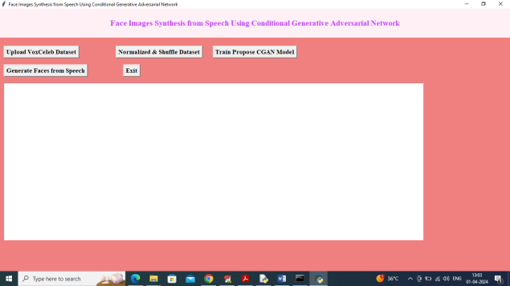

Fig 1. Results screenshot 1

In above screen click on ‘Upload VoxCeleb Dataset’ button to upload dataset and then will get below page.

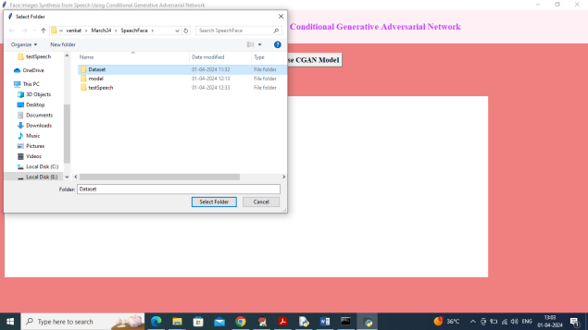

Fig 2. Results screenshot 2

In above screen selecting and uploading dataset folder and then click on ‘Select Folder’ button to load dataset and get below page.

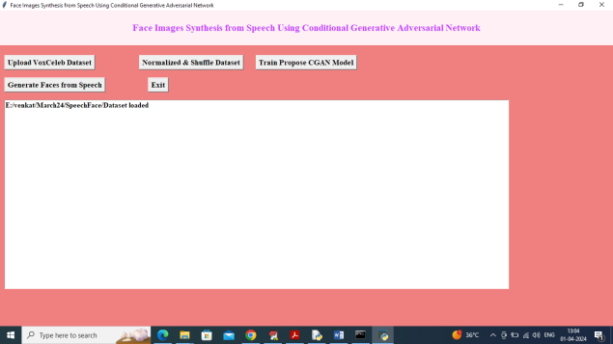

Fig 3. Results screenshot 3

In above screen dataset loaded and now click on ‘Normalized & Shuffle Dataset’ button to extract and normalized features from both speech and faces.

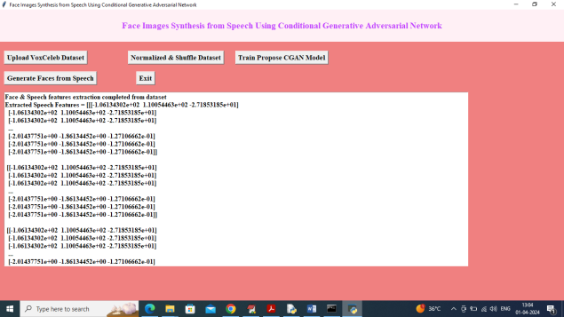

Fig 4. Results screenshot 4

In above screen features extraction and processing completed and now click on ‘Train Propose CGAN Model’ button to train CGAN model and get below page.

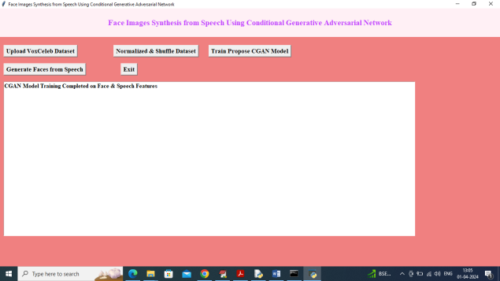

Fig 5. Results screenshot 5

In above screen CGAN model training completed and now click on ‘Generate Faces from Speech’ button to upload test speech and generate faces.

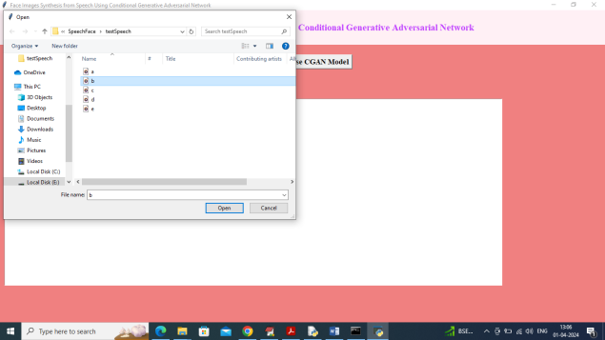

Fig 6. Results screenshot 6

In above screen selecting and uploading test audio speech file and then click on ‘Open’ button to get below output.

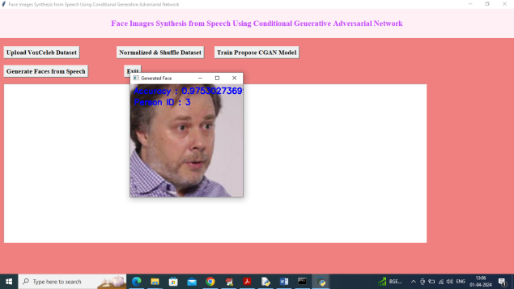

Fig 7. Results screenshot 7

In above screen can see generated face from test speech file and can see recognized person id along with recognition accuracy. Similarly you can upload and test other speech files.

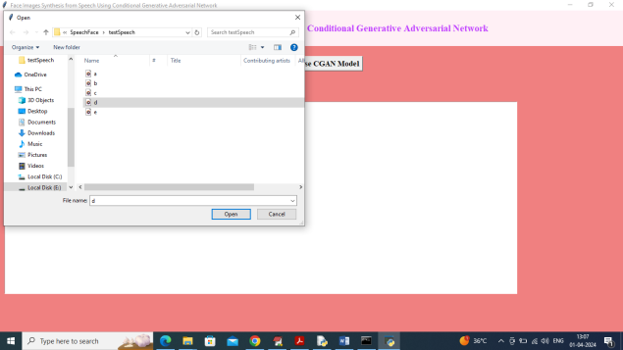

Fig 8. Results screenshot 8

In above screen uploading another speech file

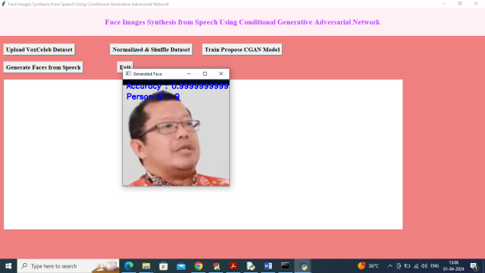

Fig 9. Results screenshot 9

In above screen can see generated face along with recognition.

# **Conclusion**

In conclusion, our proposed system for synthesizing face images from speech using Conditional Generative Adversarial Networks (CGANs) represents a significant advancement in the field of multimedia content generation. Through the integration of advanced speech processing techniques, conditional generation architectures, and multi-scale, multi-modal fusion strategies, we have developed a comprehensive framework capable of generating personalized, realistic, and expressive face images from speech signals.Our system offers several advantages over existing methods, including personalized synthesis, fine-grained control over facial attributes, enhanced realism and fidelity, robustness and generalization across different speakers and emotions, and versatility and applicability to diverse scenarios. By leveraging conditional generation and advanced deep learning techniques, we can produce face images that closely match the content and emotional context of the input speech, enabling a wide range of applications in human-computer interaction, virtual reality, forensics, and beyond.

# **Acknowledgement**

We would like to thank to our Project Guide Mr. Manish Jha Sir for their guidance and for helping us with our project.

# **References**

1. Arik, S. O., & Pfister, T. (2018). Conditional Image Synthesis with Auxiliary Classifier GANs. In: Proceedings of the IEEE Conference on Computer Vision and Pattern Recognition (CVPR).

2. Arjovsky, M., Chintala, S., &Bottou, L. (2017). Wasserstein Generative Adversarial Networks. In: Proceedings of the 34th International Conference on Machine Learning (ICML).

3. Brock, A., Donahue, J., & Simonyan, K. (2018). Large Scale GAN Training for High Fidelity Natural Image Synthesis. In: Proceedings of the International Conference on Learning Representations (ICLR).

4. Chen, L., & Cao, X. (2018). Speech-Driven Facial Animation with Generative Adversarial Networks. In: Proceedings of the IEEE Conference on Computer Vision and Pattern Recognition Workshops (CVPRW).

5. Denton, E. L., Chintala, S., &Szlam, A. (2015). Deep Generative Image Models using a Laplacian Pyramid of Adversarial Networks. In: Advances in Neural Information Processing Systems (NeurIPS).

6. Goodfellow, I., Pouget-Abadie, J., & Mirza, M. (2014). Generative Adversarial Networks. In: Advances in Neural Information Processing Systems (NeurIPS).

7. Gulrajani, I., Ahmed, F., &Arjovsky, M. (2017). Improved Training of Wasserstein GANs. In: Advances in Neural Information Processing Systems (NeurIPS).

8. Isola, P., Zhu, J. Y., & Zhou, T. (2017). Image-to-Image Translation with Conditional Adversarial Networks. In: Proceedings of the IEEE Conference on Computer Vision and Pattern Recognition (CVPR).

9. Karras, T., Aila, T., & Laine, S. (2018). Progressive Growing of GANs for Improved Quality, Stability, and Variation. In: Proceedings of the International Conference on Learning Representations (ICLR).

10. Kingma, D. P., & Welling, M. (2013). Auto-Encoding Variational Bayes. In: Proceedings of the International Conference on Learning Representations (ICLR).

11. Ma, L., Jia, X., & Sun, Q. (2018). Pose Guided Person Image Generation. In: Proceedings of the IEEE Conference on Computer Vision and Pattern Recognition (CVPR).

12. Mirza, M., &Osindero, S. (2014). Conditional Generative Adversarial Nets. arXiv preprint arXiv:1411.1784.

13. Nguyen, T. H., Yosinski, J., & Clune, J. (2016). Multifaceted Feature Visualization: Uncovering the Different Types of Features Learned by Each Neuron in Deep Neural Networks. arXiv preprint arXiv:1602.03616.

14. Radford, A., Metz, L., & Chintala, S. (2015). Unsupervised Representation Learning with Deep Convolutional Generative Adversarial Networks.