**Experience design: A holistic approach to user-centric design**

**Ishan Bhond**

**Blue Ridge Junior College, Pune, India**

[**Ishan.bhond@gmail.com**](mailto:Ishan.bhond@gmail.com)

**ABSTRACT**

The experience design involves the fundamental principles and methods of creating products and experiences that analyses the requirements, expectation and behaviors of users before presenting a prototype of the designed product. This article is highlighting the meaning of experience design and phases of the experience design which begins with the gathering of requirements from the users, then followed by the preparation of a prototype of the product from the defined requirements of the users, then user feedback is taken for transforming the prototype design into the development of final product. The paper is also presenting the paradigm shift from traditional ways of designing the products to innovative digital methods of designing the products by considering user experience. The challenges are also discussed for preparing the product design based on user experience and expectations and considering the user expectations for continuous improvement in the product design. The applications of experience design are also discussed. The practical implications are also demonstrated in the article of experience design. The article is concluding the human centric approach for designing the products. The importance of understanding users' expectations, behaviour, emotions, and motivations to design the products or solutions is also emphasized in the article. The article is presenting a systematic framework for practicing user-centred design where preference is given to the user expectations for designing the solutions.

***Keywords***- Experience (UX) design, UI user-interface, Product design, Prototype, Human-centric design.

1. **INTRODUCTION**

User-centered or human-centric design (UCD) has emerged from the growing expectations of users from the products or solutions designed by the designers [1]. The user experience is very important to consider for designing any solutions or products for meeting the expectations of the users to enhance their statisfaction from the designed products [2]. The design is not directly tranformed into the functional solution or a product, a protoype is prepared based on the user reuirements to consider the feedback of the user before putting the designer ideas into functional mode of product development.

In the last decade, a paradigm shift has been observed from traditional designing methods into digitally defined human-centric designs [3]. The user has ample of choice from digital media to smart gadgets for expressing and defining the design requirements for a product. The digital era has transformed the conventional ways of defining the user requirements and preferences and provided digital platforms to the users to define their expectations and requirements for designing the products [4]. The designers can prepare multiple prototypes based on the user's expectations to get approvals from the users before transforming the prototypes into a developed product. The designers not only understand the user requirements but also analyze their behaviour and satisfaction level from the feedback of users on designed products by the designers [5]. The human-centric designs enhance the prospects of the experience design field where users express their requirements and remain engaged in the entire product development process.

* 1. Related Work

In examining the existing works of human-centered design, various studies have been presented by the designers and researchers as mentioned in this section. In article [1], the authors have evaluated the user experience for designing the 3D products in shopping application. User experience is very important in designing the shopping application where products are displayed in three dimensions. This article evaluates the user perspective for designing the shopping application. In article [2], the authors have presented a comparative study between the designs of public and private library websites on the basis of user experiences. The users are looking for user-friendly interactve solutions for interacting with the desktop or mobile application. In article [3], the authors ate describing the applications of experience design in creating the e-learning portals and websites where users can learn easily by understaing the userinterface properly. In article [4], the authors are explaining the contribution of artificial intelligence in enhacing the user experience. The AI has successfully generated the creative solutions for the user problems by probiding smart designs and easy ways of preparing the proptotypes from user ideas for getting user approvals before making the final product. In article [5], the authors have demostrated the impirtance of AI ind eisgning the fashion. The authirs have given ample fo examples to prove the adantages of using AI I fasion designing. In article [6], the author has highlighted the AI-augmented design fields to demonstrate the contribution of AI in generating designs using the latest technologies. By synthesizing the knowledge from diverse disciplines, the designers can create products and experiences using AI that are not only useful but also meaningful in the lives of users.

* 1. Why user experience is important in designing the solution?

The user experience plays an important role in designing the product as per user expectation and satisfaction [6]. Numerous studies have demonstrated that careful consideration of user ideas in user experience design can yield significant returns on product by enhancing the customer satisfaction, by reducing the product improvement or maintenance costs [7]. The organizations are replying on customer feedback where users are involved from the initial phase of gathering the requirements to design the product till the final delivery of the product or service [8].  The organizations attempt to embrace the user ideas in an innovative way to transform the user ideas into a functional reality in the form of designed products. Artificial intelligence is also used to design the fashion and products by the designers where prototypes are prepared by considering the importance of user experience [9].

The human-centric designs also hold special place in visual communications, product designing and fashion communication. It is relevant to consider the user experience and user perspective before building a prototype based on the needs of the user [10]. By considering the experiences of diverse user groups, designers can create products and services that are more accessible, usable, and appealing as the products evolve from the active participation of the users. There are many domains such as banking, insurance, healthcare, IT industries, utility products where user experience can be applied to create innovative designs for the wonderful products and satisfying services. This article is covering the phases of experience design and also covers the applications where experience design can be applied and challenges are also discussed for developing the product as per user experience and expectations.

Top of Form

1. HUMAN- CENTRIC DESIGN APPROACH

User experience (UX) design is just like creating an exciting story which has a primary theme and multiple secondary subtexts layered over each other. The main focus should be on understanding the target audience and their perceived requirements. This means empathizing with the audience by talking to them, observing how they interact with things, and learning about their likes and dislikes. Once the designer can figure out the needs of the intended audience, the designers can start creating the project. The designer can sketch out his/her concepts, try different versions, and make sure that everything works well together considering all the requirements given by the users during designing the human-centric product design. The process should be like solving a jigsaw puzzle by understanding the big picture. At the end, the designer can share the design concepts with the audience and gather their reaction and feedback before handing over the design to the development team. The detailed process is demonstared below.

1. Initial Phase

In the initial phase of experience design process, a thorough research has to be conducted to gain knowledge about the ideas of the users. Figure 1. is depicting the initial process where a user is involved to provide inputs to the designers. Many ways have to be tried out in order to obtain information from the user such as interviews, quessionaires and observational studies to uncover user preferences and requirements. The involvement of users allow the designers to gather feedback on the design directions and to prepare the prototype of the desired product. The intended audience remains engaged in the requirement gathering phases to ensure the mapping of requirements with the undersating of the designers. The understanding of psychological aspects of user behavior also makes the signficant contribution in experience design process to gain insights into the user behaviour for product design.

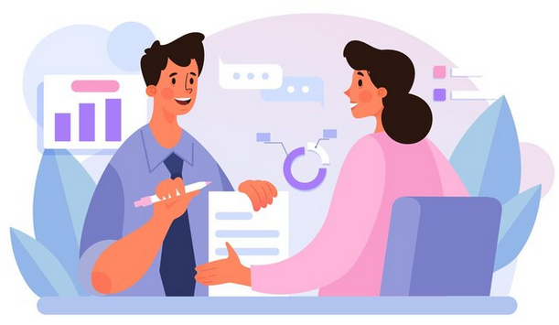

Figure 1. Inputs from the user

The psychological factors can be analysed thoroughly with the team of researchers by providing the user a soothing environment to present their ideas openly as shown in Figure 2. Since it is important to analyse the psychological behaviour of the user before defining the requirements for the product. The physchological factors can certainly help the designers to define the requirements of the product. This involves transformation of the user ideas into actionable insights and design goals. Usability goals and user perspectives are also established to measure the success of the designed product and to ensure that the prototype based on user’s defined requirements will align with the overall objectives of the UX process. By defining user requirements clearly, the designers can focus their efforts on creating wonderful solutions for the users based on the innovative designs.



Figure 2. Analysis of psychological behavior of user by the designer’s team

1. Prototyping and finalization of the product design

After gathering the information from users about the product design and refining user requirements of the experience (UX) design process, the next steps involves development of the prototyping and finalizing the product design as shown in Figure 3. Prototyping helps in generating a rough draft of the designer’s creation to analyse the reactions of the users and to analyse the product usability concerns. Prototypes can range from simple sketches to interactive working versions of the product.

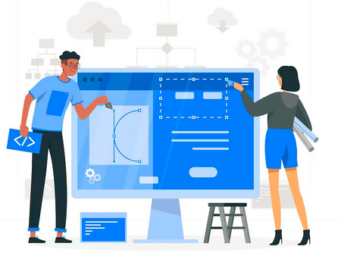

Figure 3. Prototyping of the design

During this prototyping phase of user experience design, the designers can test different prototypes, ideas, features, and interactions to gather fruitful feedback from users. This process helps the designers to identify usability issues or any kind of improvements required to be made before developing the final product. Once the prototype is refined based on the feedback of the user feedback, the development of the final design begins. This involves improving the design, adding more details, and preparing the design for product or project development.

1. Development of the designed product

In the next stage of development of the designed product, the team of designers collaborate closely with developers and users to ensure that the design vision is translated accurately into the final product. Design specifications, colour choices of the users, other preferences of the users, style guides, and final designs are created to guide the implementation process of the product. The team of designers also conduct the quality analysis to ensure that the product meets usability standards and the developed product aligns with the defined requirements of the users.

Once the development of the product starts, continuous monitoring is required to improve the user experience over time. This stage is like bringing the blueprint of a project to life by actually constructing it. Developers work closely with the team if designers to turn the design vision into a functional reality as shown in Figure 4. The product development process involves assimilation of various components to make the product work as intended by the audience. Throughout the product development phase, regular communication and collaboration between designers and developers are essential to address any challenges or changes that may arise during the implementation phase.

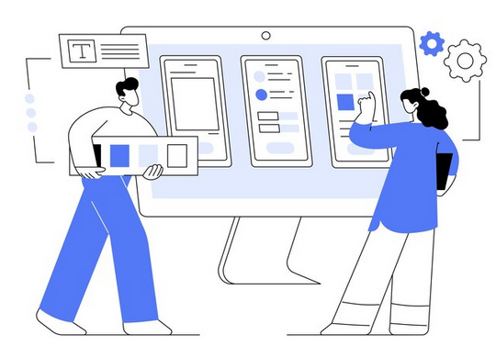

Figure 4. Developing the product on finalized design

To test the usability of the developed product, testing is required at each phase of development to identify the bugs or any kind of issues before the final product is handed over to the end users. Once development of the entire product is completed and the testing is performed by the developers and the designers, it is ready to be launched to the end users.

1. Testing of the product by the users

Although the final product is tested by the team of developers and designers before delivering to the users but user testing is also required for analysing the usability of the developed product as depicted in Figure 5. Usability testing by the users is like trying out a new designed product, such as a website or app, to understand how easy and enjoyable it is to use the developed product. In this stage, real users get their hands on the product and give feedback on the developed product whether any improvement is needed or the delivered product is matching to their expectations.

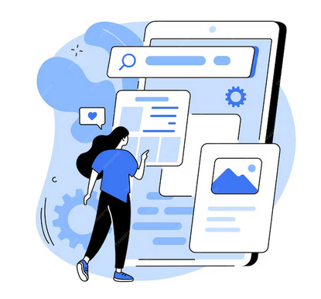

Figure 5. User testing for the product based on UX

During usability testing, users are given specific tasks to complete with the product, like finding information or signing up for a service. Just like trying out a new gadget with different features, the users can explore the product while the designers watch the reactions of the users and take notes. The goal of usability testing is to understand the problems or difficulties faced by the users during testing of the product and to gather information about the user perspective to make further enhancements in the product. In this process, an effort is made to determine whether the designed product is useful and user-friendly. By obtaining the user feedback and observing their reactions, the designers can make changes to ensure that the final developed product meets the requirements and expectations of the users.

1. User Feedback

After usability testing, the next step in the design process is gathering user feedback as shown in Figure 6. User feedback involves obtaining reviews from the audience in a rating chart to determine the user rating of the developed product. It provides valuable insights into what users like, dislike, and what improvements they suggest in the developed product.



Figure 6. User rating for the product

Designers may collect user feedback through various channels, such as interviews, surveys, feedback forms, or direct communication with users. The designers seek input from users to understand their experiences and perspectives during this phase. User feedback helps the designers to identify areas for improvement and fix changes in the final product based on user expectations and preferences. By obtaining the user feedback and incorporating their suggestions into the design process, designers can create a final product that truly meets the requirements and preferences of the users.

1. Customer Satisfaction Survey

Customer satisfaction plays an important role in overall improvement of the designed product because continuous improvement is needed even after the final delivery of the product for several reasons. The satisfied customers generally continue using the developed product or service in its original form and also recommend the product to others if they are satisfied with the product. The customer satisfaction provides valuable feedback to the designers that inform the futuristic improvements in the product (Figure 7). By observing the customer feedback and satisfaction levels, designers can identify areas for improvement, address usability issues, and introduce new features in the products that better meet the expectations and preferences of users. By tracking customer satisfaction over time, designers can analyze the impact of their efforts and identify areas where further improvement is needed.

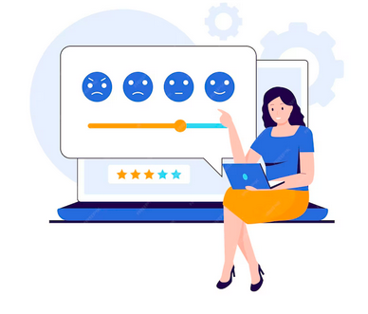

Figure 6. Customer satisfaction survey

1. **Applications, challenges and practical implications of human-centric design**
   1. ***Applications of human-centric or experience design***
2. **Digital products:** UX design is widely applied in designing websites, mobile apps, software, and other digital products to ensure a seamless and enjoyable user experience.
3. **Physical products:** UX principles are increasingly being applied to the design of physical products such as appliances, gadgets, and consumer goods to enhance usability and user satisfaction.
4. **Service based design:** UX design is used to improve the overall experience of services, including retail experiences, customer support interactions, and healthcare services.
5. **Automotive industry:** UX design plays a crucial role in designing the user interface for in-car systems, including infotainment systems, navigation interfaces, and driver assistance features.
6. **Gaming and animation:** UX design is applied in designing video games and animations to create immersive and engaging gameplay experiences that keep players coming back for more.
   1. ***Challenges for human-centric designs***
7. **Understanding the expectations of the users:** Designers must understand the challenges of understanding the expectations of the consumer, preferences of the user, and behaviors aspects of the users from diverse backgrounds to create user-centric designs.
8. **Balancing the functionality and usability of the product:** It is very challenging for the designers to create designs for the products which are both functional and user-friendly as well to balance between user needs and technical constraints.
9. **Consideration of technological advancements:** Nowadays the technologies such as machine intelligence based approaches, AI tools and automated designing tools pose a great challenge to the designers to use the emerging technologies to design the products and services for showing the usage of advanced technologies to the users in designing the products. The designers have to learn advanced technologies to utilize these technologies during the creation of prototypes and development of designed products.
10. **Satisfying the users by meeting their expectations:** Designers must understand the defined requirements by the users along with understanding their psychological behaviour and preferences before designing a product. The priorities of the user are considered before making the human-centric design decisions.
11. **Assessment of designed solution:** It is very challenging for a designer to assess the usability and user-friendliness of the designed solution to measure the effectiveness of user experience in the designed solution. The assessment can be made using the scale of user rating or user feedback.

**Practical implications**

1. **Enhancement in satisfaction of users:** Human-centric design helps to produce services and products as per the expectations of the users which are easy to use, enjoyable for users and meet their defined requirements. Eventually such designed products result in higher levels of user satisfaction.
2. **Involvement of users:** The human-centric designs engage the users from the initial stages of the product design process. The involvement of the users helps in the finalization of the requirements for designing a solution for them and then development of prototypes based on the user needs to seek user approvals before starting the development of the solution in the form of product or services. The final product is designed and developed on the basis of feedback of the users considering their preferences. The user experience based on human centric design allows active participation of users from the initial phase to final delivery of the product. The users are also involved in the continuous improvement of the product.
3. **Minimization in maintenance cost:** Well-designed solutions based on the user involvement require less customer support and allows lower maintenance cost. This helps the organizations also to save the money on maintenance and customer support which allows the designers to get engaged with users for getting their feedback at every phase of product design and development.

In summary, the human –centric design based on user experience has wide-ranging applications in diverse sectors, but it also presents challenges that designers must understand before implementation of the designs to create products and services.

1. **Conclusion**

In conclusion, user experience (UX) is an essential aspect of product design and development. The users are expecting innovative solutions from the designers by covering wide-ranging applications such as physical products, services, and other solutions based on human-centric designs (such as ATM machines). The designers face many challenges in understanding the user expectations, and then attempt to balance the functionality and usability with the user requirements. The advanced technologies should also be employed to design innovative solutions for the users. The users are involved from the initial phase of gathering requirements, followed by designing the prototypes where users approve the design for development of the final product and in the testing of the developed product to give effective feedback on the designed product. This user experience in the entire journey of product development allows successful designing and implementation of the designed solution to enhance the satisfaction of the end user. By prioritizing user preferences, UX design leads to products and services that not only meet user needs but also exceed expectations. Through iterative design processes, continuous feedback loops, and a user-centred approach, designers can create experiences that satisfy users, and differentiate products in global markets. As technology continues to evolve and user expectations evolve with it, the importance of UX design will continue to grow. By embracing user experiences and integrating them into every stage of the design process, the designers can create marvellous products and services. Top of Form

**References**

1. K. Qin et al., "Design and User Experience Evaluation of 3D Product Information in XR Shopping Application," 2023 IEEE Conference on Virtual Reality and 3D User Interfaces Abstracts and Workshops (VRW), Shanghai, China, 2023, pp. 715-716, doi: 10.1109/VRW58643.2023.00200.
2. N. Anwar, E. Rahmandita and Y. Kurniawan, "User Experience (UX): A Comparative Study Between Public and Private Institution Library Website In Indonesia and Malaysia," 2022 8th International HCI and UX Conference in Indonesia (CHIuXiD), Bali, Indonesia, 2022, pp. 82-87, doi: 10.1109/CHIuXiD57244.2022.10009807.
3. E. S. Purwanto, E. B. Jap, E. S. Wijaya, R. Juwanda and A. C. Sari, "Application of Design Thinking in the Creation of UI/UX on E-learning Websites," 2022 4th International Conference on Cybernetics and Intelligent System (ICORIS), Prapat, Indonesia, 2022, pp. 1-6, doi: 10.1109/ICORIS56080.2022.10031471.
4. Virvou, Maria. ‘Artificial Intelligence and User Experience in Reciprocity: Contributions and State of the Art’. 1 Jan. 2023 : 73 – 125.
5. Lee, A.V.Y., Tan, S.C. & Teo, C.L. Designs and practices using generative AI for sustainable student discourse and knowledge creation. Smart Learn. Environ. 10, 59 (2023). https://doi.org/10.1186/s40561-023-00279-1.
6. Choi, W., Jang, S., Kim, H.Y. et al. Developing an AI-based automated fashion design system: reflecting the work process of fashion designers. Fash Text 10, 39 (2023). https://doi.org/10.1186/s40691-023-00360-w.
7. Yuan, P.F. Toward a generative AI-augmented design era. ARIN 2, 16 (2023). https://doi.org/10.1007/s44223-023-00038-9.
8. Murray-Rust, D., Lupetti, M.L., Nicenboim, I. et al. Grasping AI: experiential exercises for designers. AI & Soc (2023). <https://doi.org/10.1007/s00146-023-01794-y>.
9. Y.P. Tsang, C.K.M. Lee, Artificial intelligence in industrial design: A semi-automated literature survey, Engineering Applications of Artificial Intelligence, Volume 112, 2022, p. 104884. DoI.10.1016/j.engappai.2022.104884.

[10]. Wiberg, M., Stolterman Bergqvist, E. Automation of interaction—interaction design at the crossroads of user experience (UX) and artificial intelligence (AI). Pers Ubiquit Comput 27, 2281–2290 (2023). https://doi.org/10.1007/s00779-023-01779-0.

Top of Form

1. Top of Form